Supporting Information

Poly[bis(serine ethyl ester)phosphazene] regulates the degradation rates of vinyl ester photopolymers
Edip Ajvazi¹ ● Felix Bauer¹ ● Milan Kracalik² ● Oliver Brüggemann¹ ● Ian Teasdale¹*

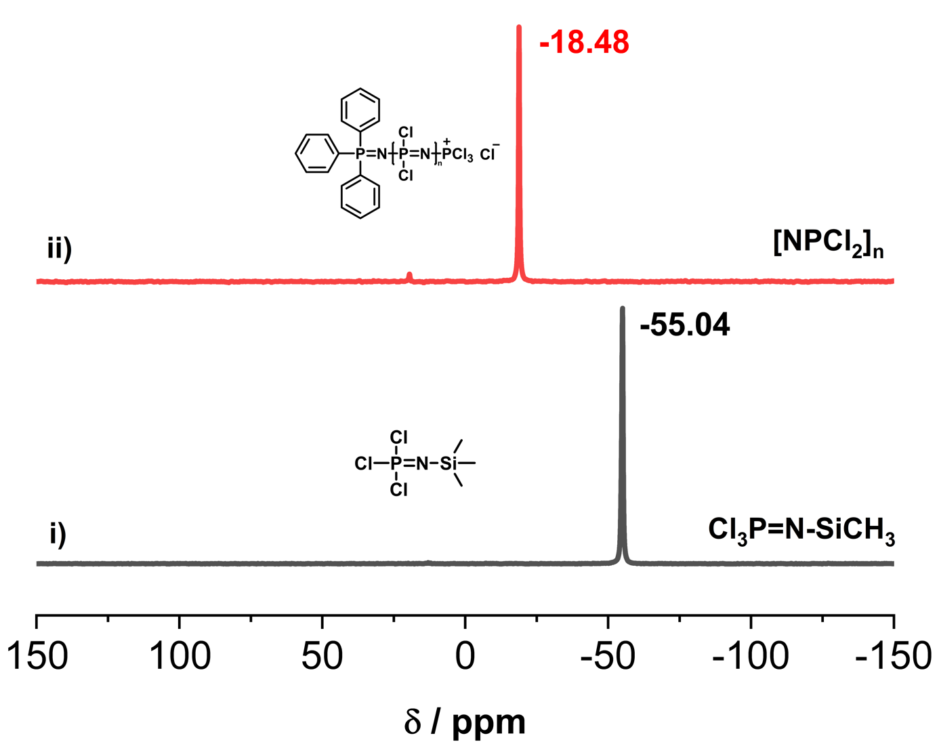

Figure SI-1. The polymerisation of Cl₃P=N-SiMe₃ (i) is converted to [NPCl₂]_{n,} (ii) quantitative yield as observed by ³¹P-NMR spectroscopy.

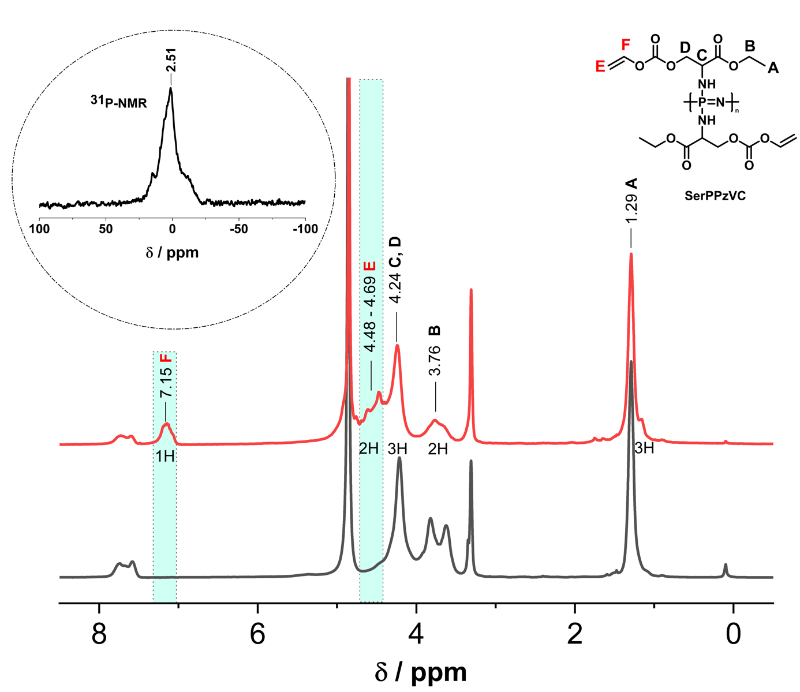
Figure SI-2. ¹H- and ³¹P-NMR spectra of vinyl carbonate functionalised poly[bis(L-serine ethylester)polyphosphazene] (Polymer 1) in MeOD. Comparison of the ¹H spectra of PPz-L serine ethyl ester (black) and the functionalised form (red). Labelling of the peaks of the newly introduced vinyl group at 4.48-4.69 and 7.15 ppm.

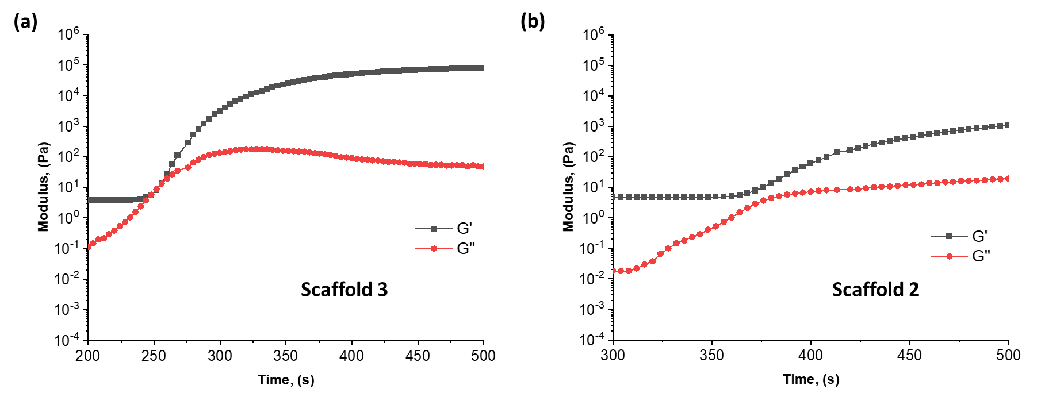SI-3. Rheological experiments demonstrating the thermally initiated polymerisation process.
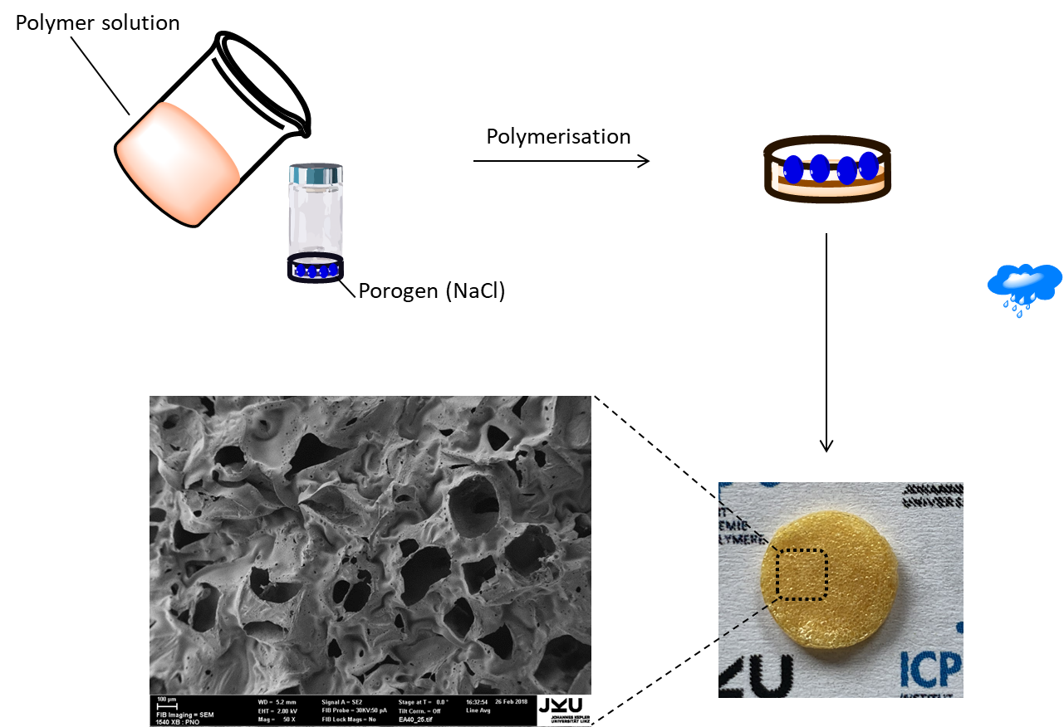
Figure SI-4. Depiction of the preparation process of porous polymer scaffolds.

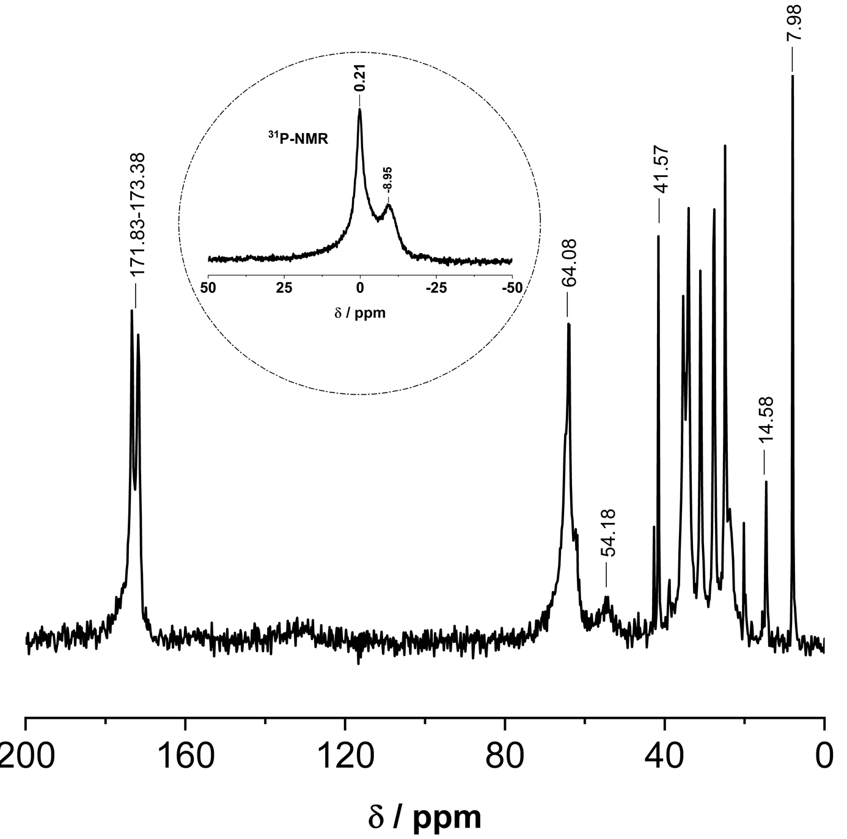
Figure SI-5. Solid-state ³¹P- and ¹³C-NMR spectroscopy were used to confirm the composition of the scaffold 2.

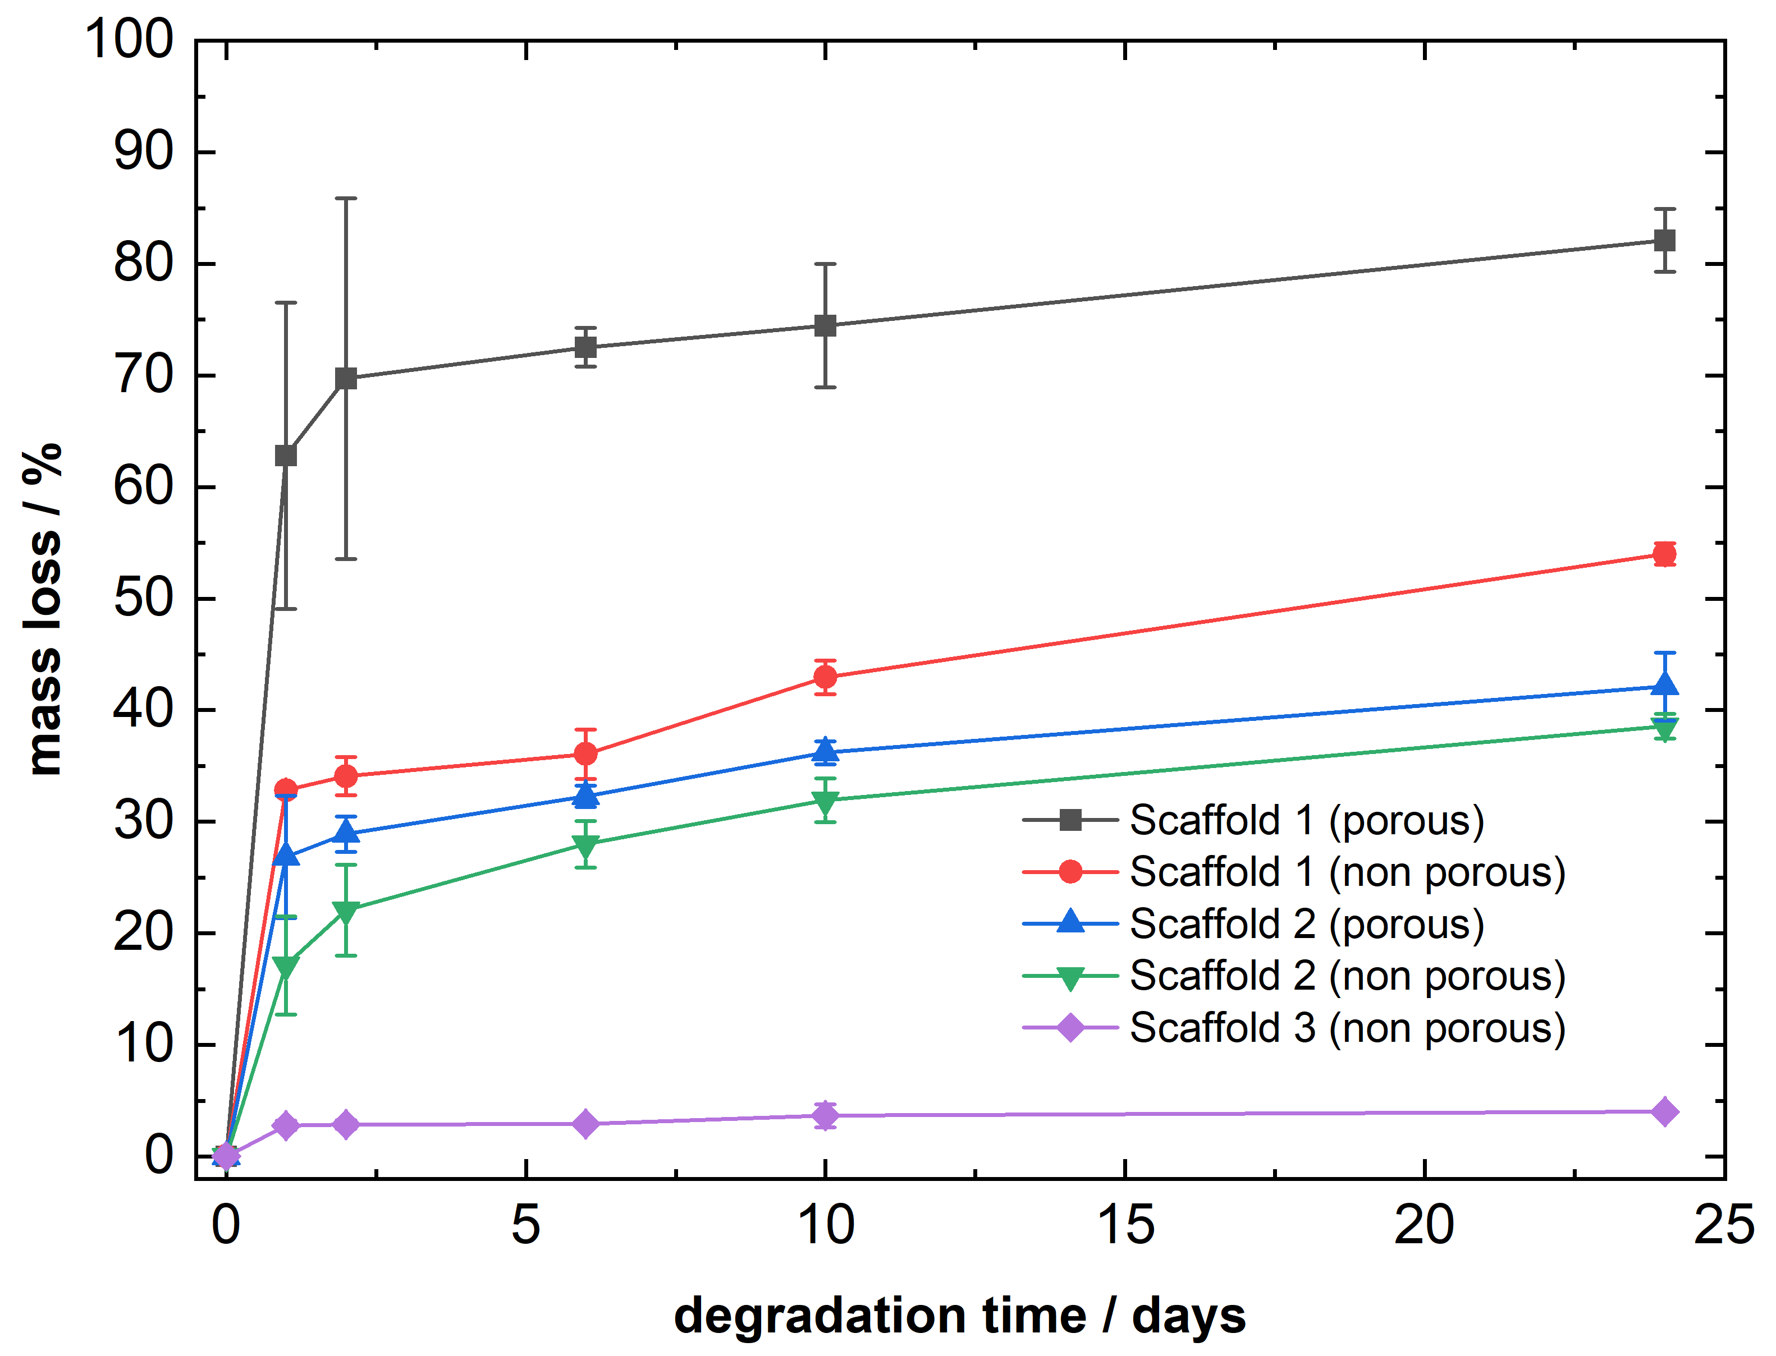

Figure SI-6. Mass loss studies at pH 2.

