Monazite, lanthanide-rich glasses, and other trace elements in copper smelter slags: Constraints on critical metal behaviour in Si-Fe-rich melts
Hassan Gezzaz, Cristiana L. Ciobanu, Nigel J. Cook, Kathy Ehrig, Ashley Slattery, Benajmin Wade, Sarah Gilbert, Yuri T. Campo Rodriguez

Supplementary Materials
Background: smelter operations at Olympic Dam
The Olympic Dam plant produces high-purity cathode copper from a heterogeneous iron-oxide breccia-hosted sulphide ore using a fully integrated circuit. Separation of Cu-sulphides (chalcocite, bornite, chalcopyrite) from Fe-oxides and other gangue minerals (average recovery 91%–95% Cu) is obtained using a froth flotation circuit. Reduction of fluorine concentration and dissolution of U prior to smelting is obtained by leaching at 60–70 °C for 6–12 h. The obtained leached copper concentrates comprise ~85 wt% sulphides and ~15 wt% gangue (pyrite, hematite, quartz, muscovite etc.). These concentrates are pumped into the smelting circuit after dewatering and mixing with controlled ratios of silica flux.
Smelting follows a direct-to-blister Outokumpu approach, employing both a flash furnace (FF) and an electric furnace (EF) (Schlesinger et al. 2022). Copper concentrates are thickened prior to feeding them into the flash furnace where they undergo a series of reactions at 1300 °C under air enriched in oxygen, leading to instantaneous combustion (residence time 1 s). This process includes formation of two immiscible melts: slag and blister, as well as production of SO₂ off-gas obtained from Cu-sulphide oxidation. The blister layer (~99% copper), settles at the bottom of the chamber. A slag layer accumulates above the blister layer and comprises Fe-oxides, silicates, and glasses, but is also rich in dissolved Cu (20–25 wt%). FF slag is directed, by manual tapping, to the electric furnace for recovery of remaining copper. In the electric furnace, coke is employed as a reducing agent (5 wt% of the slag) at 1300 °C to produce blister copper (99.6% Cu). The resulting EF slag, containing 2%–10% Cu, is tapped into pots which are tipped onto the surface in an outside bay and cooled for several days.
Microanalysis: methodology
Electron probe microanalysis
Electron probe microanalysis (EPMA) generated quantitative compositional data for magnetite, fayalite, glass-1, and glass-2 using a Cameca SXFive instrument equipped with tuneable wavelength-dispersive spectrometers at a 15 kV voltage, 20 nA beam current, and a fixed beam diameter of 1 µm.
A combination of natural minerals and synthetic oxides was used for calibration of twenty-six elements with corresponding x-ray lines in script: wollastonite (Ca_{Kα}, Si_{Kα}), barite (Ba_{Lα}), synthetic TiO₂ (Ti _{Kα}), lanthanum phosphate (P_{Kα}, La_{Lα}), NMNH-113312-44 olivine (Mg_{Kα}), corundum (Al_{Kα}), Astimex almandine garnet (Fe_{Kα}), rhodonite (Mn_{Kα}), Cr₂O₃ (Cr_{Kα}), nickel olivine (Ni_{Kα}), cassiterite (Sn_{Lα}), huttonite (Th_{Mα}), cerium phosphate (Ce_{Lα}), NMNH-117288-3 zircon (Zr_{Lα}), UO₂(U_{Mα}), niobium (Nb_{Lα}), K227 (Pb_{Mα}), vanadium (V_{Kα}), cobalt (Co_{Kα}), chalcopyrite (Cu_{Kα}), willemite (Zn_{Kα}), tungsten (W_{Kα}), albite (Na_{Mα}), orthoclase OR-1A (K_{Kα}).
Typical minimum limits of detection (in wt.%) were: Na₂O (0.021-0.029), MgO (0.016-0.024), Al₂O₃ (0.016-0.022), SiO₂ (0.021-0.026), P₂O₅ (0.020-0.022), K₂O (0.009), CaO (0.012-0.013), TiO₂ (0.015-0.016), V₂O₃ (0.025-0.028), Cr₂O₃ (0.025), MnO (0.026-0.030), FeO (0.027-0.032), CoO (0.021-0.025), NiO (0.037-0.040), Cu₂O (0.038-0.046), ZnO (0.046-0.062), ZrO₂ (0.043-0.048), Nb₂O₅ (0.032-0.042), SnO₂ (0.026), BaO (0.030-0.031), La₂O₃ (0.033-0.034), Ce₂O₃ (0.034-0.035), WO₃ (0.147), PbO (0.048-0.055), ThO₂ (0.059-0.067), and UO₂ (0.042-0.048).
Data reduction followed matrix corrections based on Armstrong-Love/Scott φ(ρz) and Henke MACs. Microscope operation was managed by PeakSite v6.2 software, while data acquisition and processing were conducted using 'Probe for EPMA' software. Note that elements consistently below their respective minimum detection limits are excluded from the tables.
Laser ablation inductively coupled plasma mass spectrometry
Quantitative trace element data was obtained by laser ablation inductively coupled plasma mass spectrometry (LA-ICP-MS) using a RESOlution-SE 193 nm excimer laser coupled to an Agilent 8900x quadrupole ICP-MS. Analysis was undertaken on magnetite, fayalite, glass-1, and glass-2 in five FF samples and eight EF samples (1089 measurements in total, 427 and 662 for FF and EF, respectively).
Analysis was carried out at a repetition rate of 5Hz, a fluence of 2.62 J/cm², and with a circular ablation spot 30 µm in diameter. External reference materials were NIST610 (synthetic glass) and GSD-1g, analysed at a frequency of 5Hz, a fluence of 2.61 J/cm², and using a circular, 43 µm-diameter ablation spot. External standards were run prior to every set of 30 measurements on unknowns. Although each ablation spot was positioned to avoid regions hosting inclusions visible at surface, this did not provide insight into the presence of sub-surface inclusions.
Background signals were measured for 30 seconds followed by 30 seconds laser-on analysing unknowns. Forty-eight isotopes with corresponding dwell times in brackets were measured in magnetite, fayalite and glasses: ²³Na (5 ms), ²⁴Mg (5), ²⁷Al (5), ²⁹Si (5), ³¹P (5), ³⁹K (5), ⁴³Ca (5), ⁴⁵Sc (5), ⁴⁷Ti (10), ⁵¹V (10), ⁵³Cr (10), ⁵⁵Mn (10), ⁵⁹Co (20), ⁶⁰Ni (10), ⁶⁵Cu (10), ⁶⁶Zn (10), ⁶⁹Ga (10), ⁷¹Ga (10), ⁷²Ge (10), ⁷³Ge (10), ⁷⁵As (10), ⁸⁵Rb (10), ⁸⁸Sr (10), ⁸⁹Y (10), ⁹⁰Zr (10), ⁹³Nb (10), ¹¹⁸Sn (20), ¹²¹Sb (20), ¹³⁷Ba (10), ¹³⁹La (10), ¹⁴⁰Ce (10), ¹⁴¹Pr (10), ¹⁴⁶Nd (10), ¹⁴⁷Sm (10), ¹⁵³Eu (10), ¹⁵⁷Gd (10), ¹⁵⁹Tb (10), ¹⁶³Dy (10), ¹⁶⁵Ho (10), ¹⁶⁶Er (10), ¹⁶⁹Tm (10), ¹⁷²Yb (10), ¹⁷⁵Lu (10), ²⁰⁶Pb (10), ²⁰⁷Pb (10), ²⁰⁸Pb (10), ²³²Th (10), and ²³⁸U (10). Longer dwell times were selected for isotopes ⁵⁹Co, ¹¹⁸Sn, and ¹²¹Sb to enhance their signal intensities and improve minimum detection limits.
Typical minimum limits of detection in magnetite (in brackets, ppm) are: ²³Na (7), ²⁴Mg (1), ²⁷Al (1.5), ²⁹Si (400), ³¹P (50), ³⁹K (10), ⁴³Ca (400), ⁴⁵Sc (0.3), ⁴⁷Ti (0.6), ⁵¹V (0.1), ⁵³Cr (1), ⁵⁵Mn (1), ⁵⁹Co (0.04), ⁶⁰Ni (0.4), ⁶⁵Cu (0.6), ⁶⁶Zn (1), ⁶⁹Ga (0.1), ⁷¹Ga (0.1), ⁷²Ge (0.6), ⁷³Ge (1.5), ⁷⁵As (1), ⁸⁵Rb (0.6), ⁸⁸Sr (0.01), ⁸⁹Y (0.01), ⁹⁰Zr (0.02), ⁹³Nb (0.01), ¹¹⁸Sn (0.03), ¹²¹Sb (0.05), ¹³⁷Ba (0.02), ¹³⁹La (0.01), ¹⁴⁰Ce (0.01), ¹⁴¹Pr (0.01), ¹⁴⁶Nd (0.01), ¹⁴⁷Sm (0.01), ¹⁵³Eu (0.01), ¹⁵⁷Gd (0.01), ¹⁵⁹Tb (0.01), ¹⁶³Dy (0.01), ¹⁶⁵Ho (0.01), ¹⁶⁶Er (0.01), ¹⁶⁹Tm (0.01), ¹⁷²Yb (0.01), ¹⁷⁵Lu (0.01), ²⁰⁶Pb (0.01), ²⁰⁷Pb (0.01), ²⁰⁸Pb (0.01), ²³²Th (0.01), and ²³⁸U (0.01). Note that Ga and Ge data are averaged values from measurements of ⁶⁹Ga and ⁷¹Ga, and ⁷²Ge and ⁷³Ge, respectively. Fe was used as an internal calibration standard for magnetite. Concentration data for fayalite and glasses was calculated using proportions of each oxide from the total. Additionally, total Pb (Pb_{tot}) was calculated as the sum of ²⁰⁶Pb, ²⁰⁷Pb, and ²⁰⁸Pb, multiplied by 1.014 to account for the contribution from ²⁰⁴Pb (not measured directly).

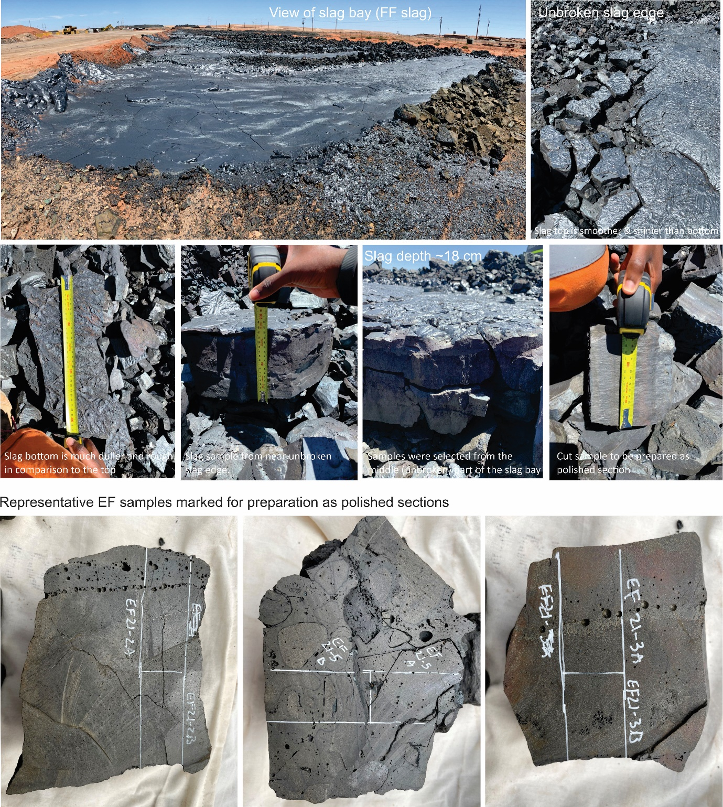

SM Fig. S1. Aspects of slags and samples used in this study. See annotations and main text for additional information.
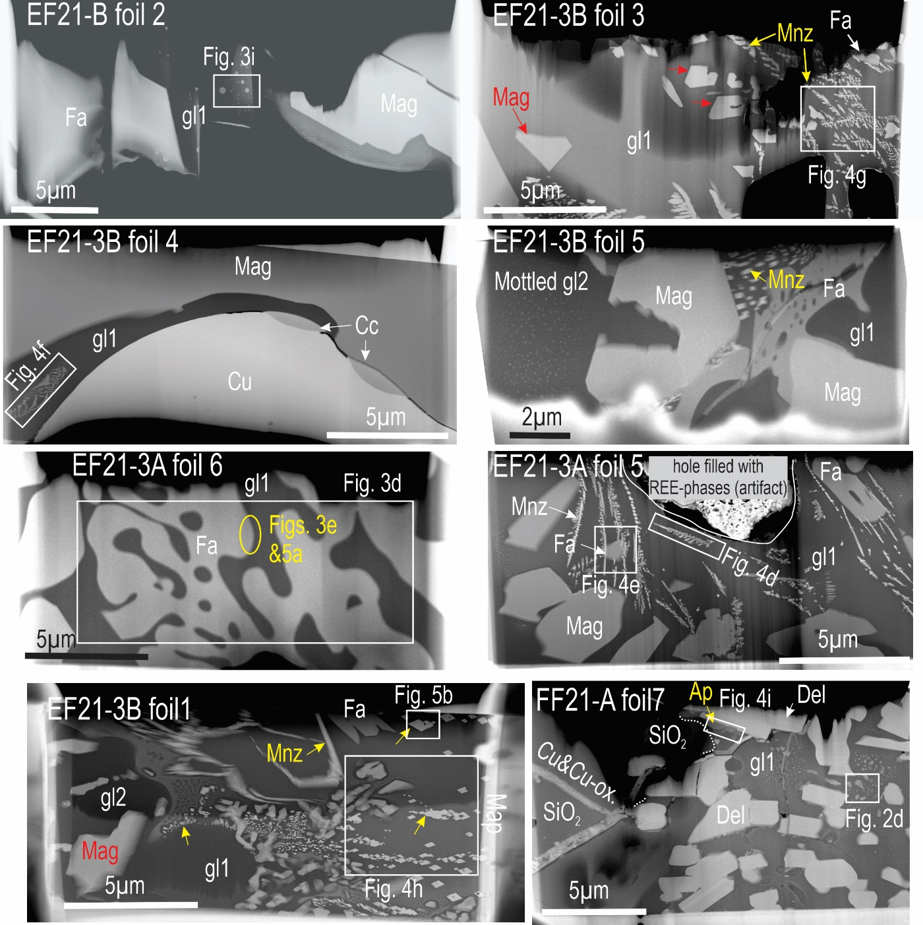

SM Fig. S2. HAADF STEM images showing the eight S/TEM foils (samples as labelled) used for the nanoscale work carried out. Rectangles indicate EDS STEM maps shown in figures as labelled. Abbreviations: Del−delafossite; Fa−fayalite; gl1−glass-1; gl2−glass-2; Mag−magnetite; Mnz−monazite.

