Supplementary Figures
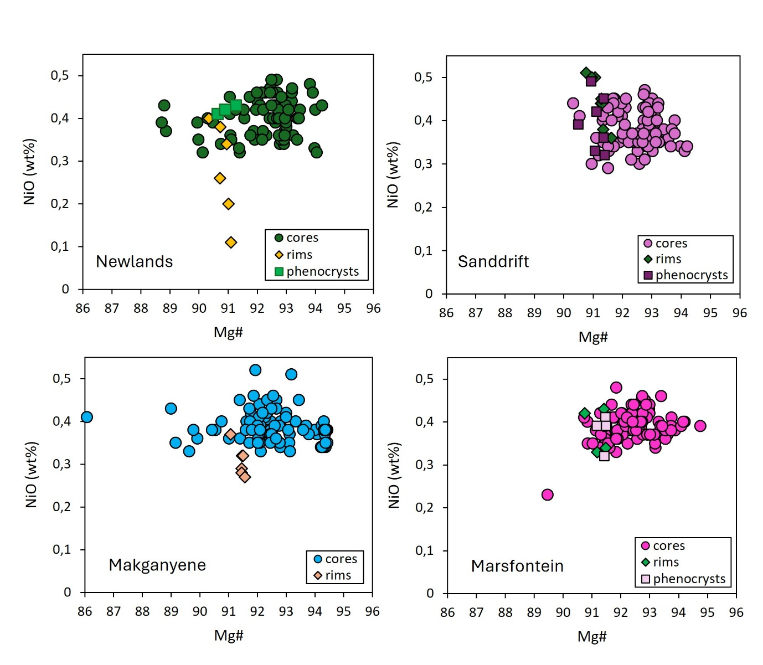
Fig. S1 Major and minor elements plots for olivine cores and rims in Kaapvaal CROLs

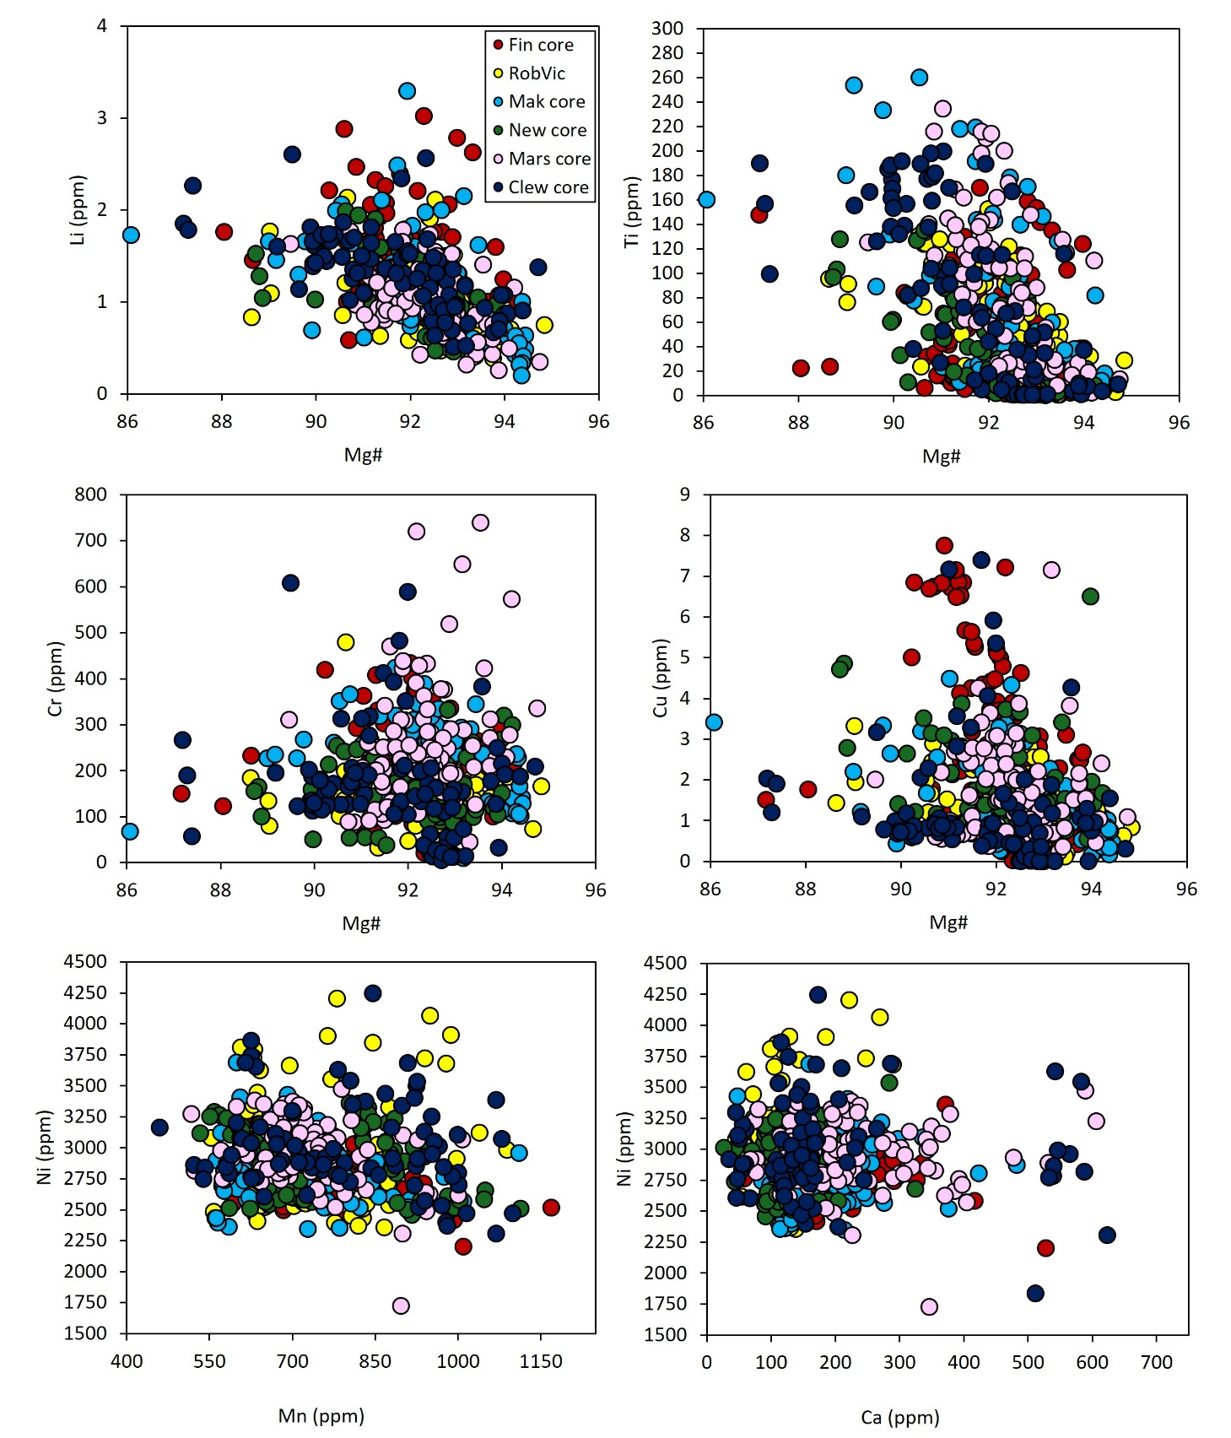
Fig. S2 Major and trace elements plots for olivine cores in Finsch (Fin), Roberts Victor (RoV), Makganyene (Mak), Newlands (New), Marsfontein (Mars), and Clewer dyke (Clew) CROL samples

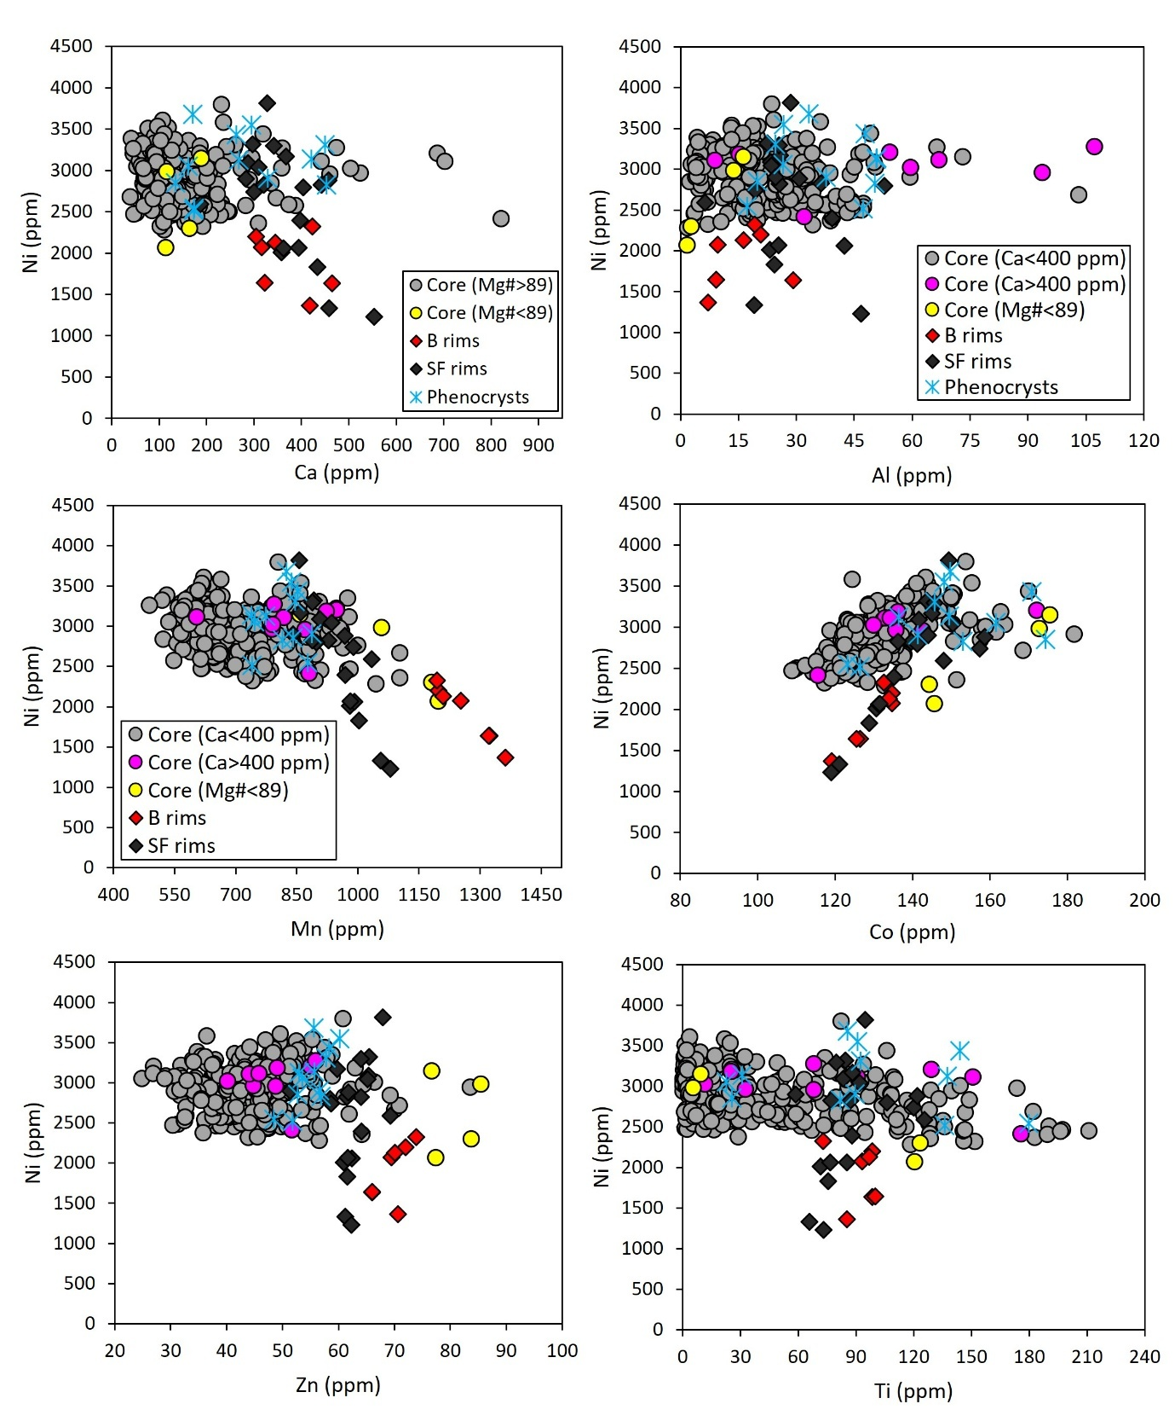
Fig. S3 Comparison of trace element compositions between the olivine cores, rims, and phenocrysts. Additionally, high-Ca and low-Ca peridotitic olivine are compared. B = Bellsbank; SF = Southern Fissures.

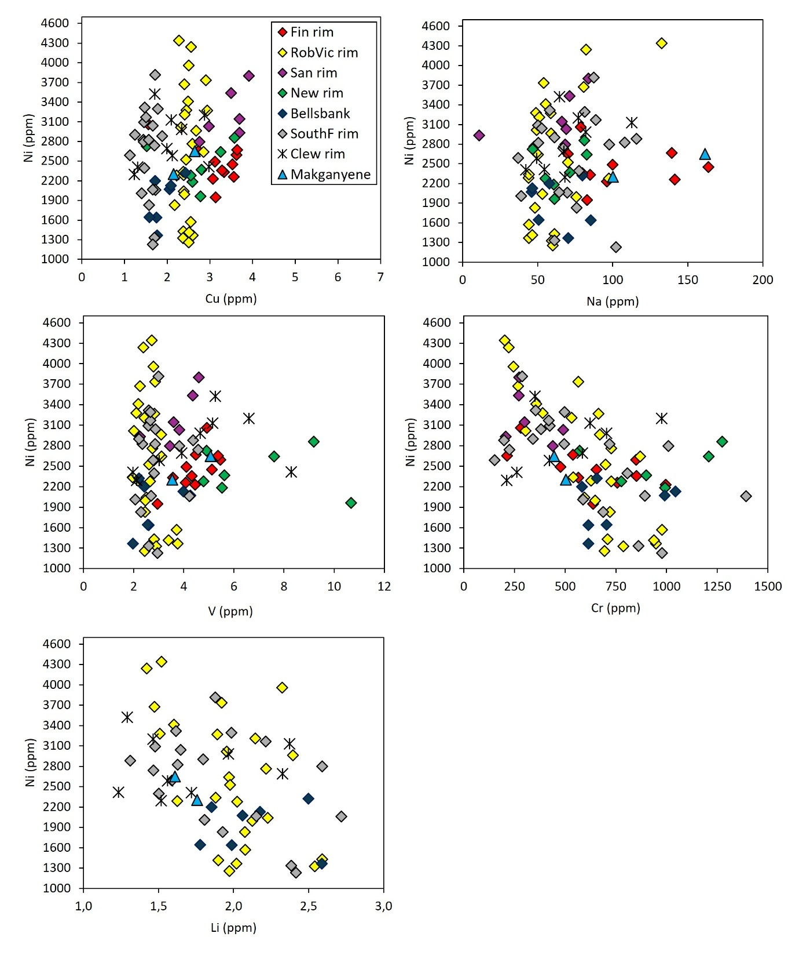
Fig. S4 Trace elements plots for olivine rims in Finsch (Fin), Roberts Victor (RoV), Sanddrift (San), Newlands (New), Southern Fissures (SouthF), Clewer (Clew) dyke, and Makganyene CROL samples

Fig. S5 Plots a) Ca and b) Al content of olivine cores against grain size. Olivine cores with Ca >400 ppm and Al >100 ppm generally occur in small grains (≤2 mm)

Fig. S6 Histogram of depth sampling distributions for garnet xenocrysts from Sanddrift. Dotted line indicates the graphite (Gr)-diamond (Di) transition after Day (2012). LAB = Lithosphere-Asthenosphere Boundary

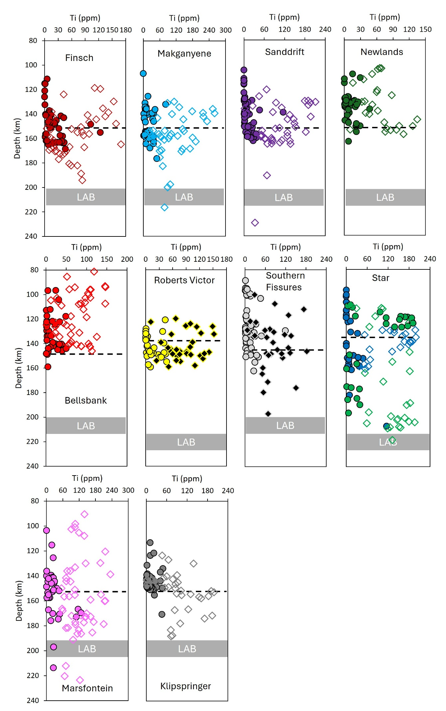
Fig. S7 Variation of Ti of olivine xenocrysts with depth (estimated using Al-in-olivine thermometer). Symbols as in figure 11. Dotted line indicates the graphite (Gr)-diamond (Di) transition after Day (2012). LAB = Lithosphere-Asthenosphere Boundary. Clew = Clewer dyke; Drie = Driekoppies dyke

Fig. S8 Relationship between olivine rim Mg# and diamond grades in CROLs from across the Kaapvaal craron (this study) as well as in worldwide kimberlites from Giuliani et al. (2023). cpht = carats per hundred tonnes. All kimberlites and lamproites with with high diamond grade (>50 cpht) also exhibit high olivine rim Mg# (>89). Kimberlites with olivine rims of Mg#<89 have low to moderate diamond grades. However, not all kimberlites and lamproites with olivine rims that display Mg#>89 have high diamond grades
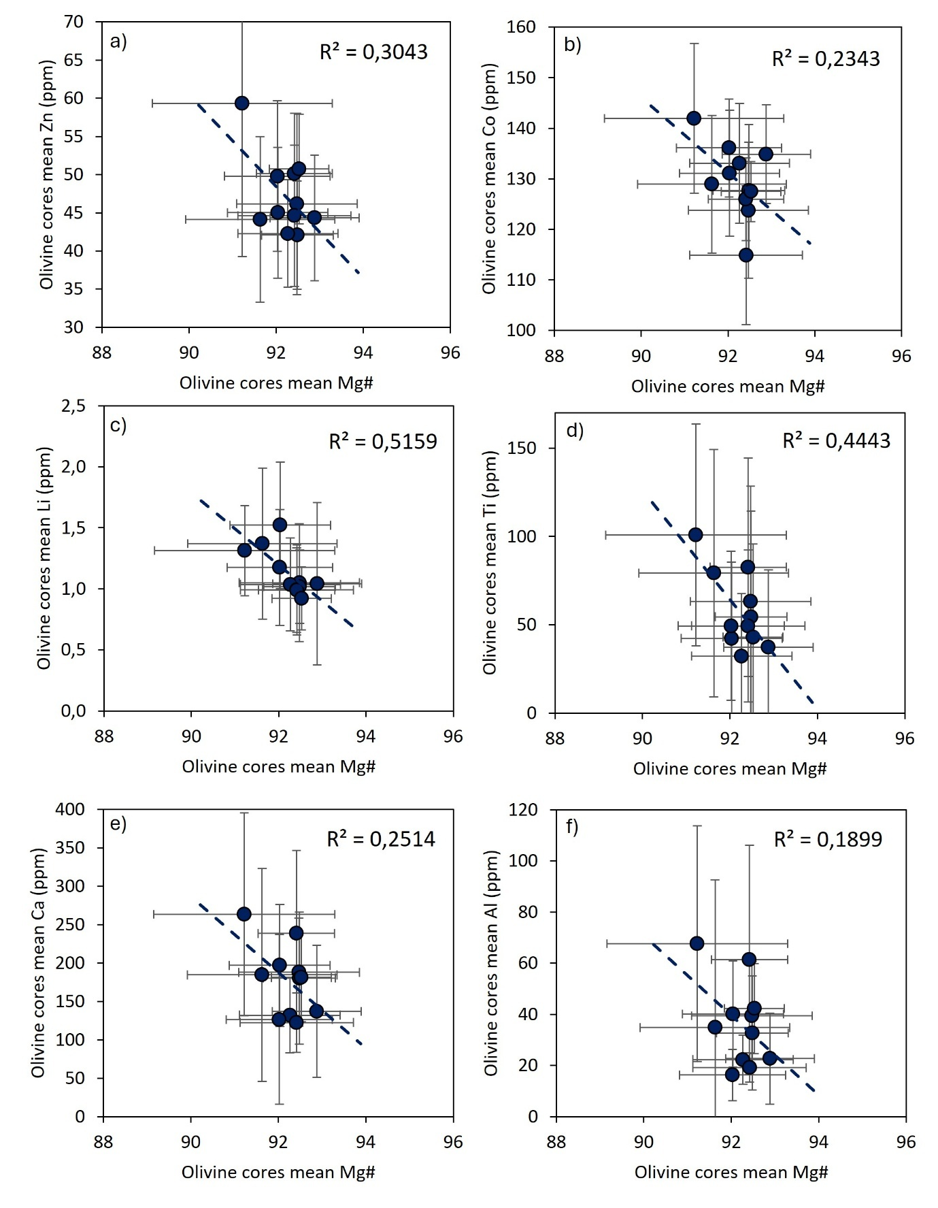
Fig. S9a Comparison between average Mg# and trace elements for olivine cores. Dotted line = regression line. R-squared = coefficient of determination
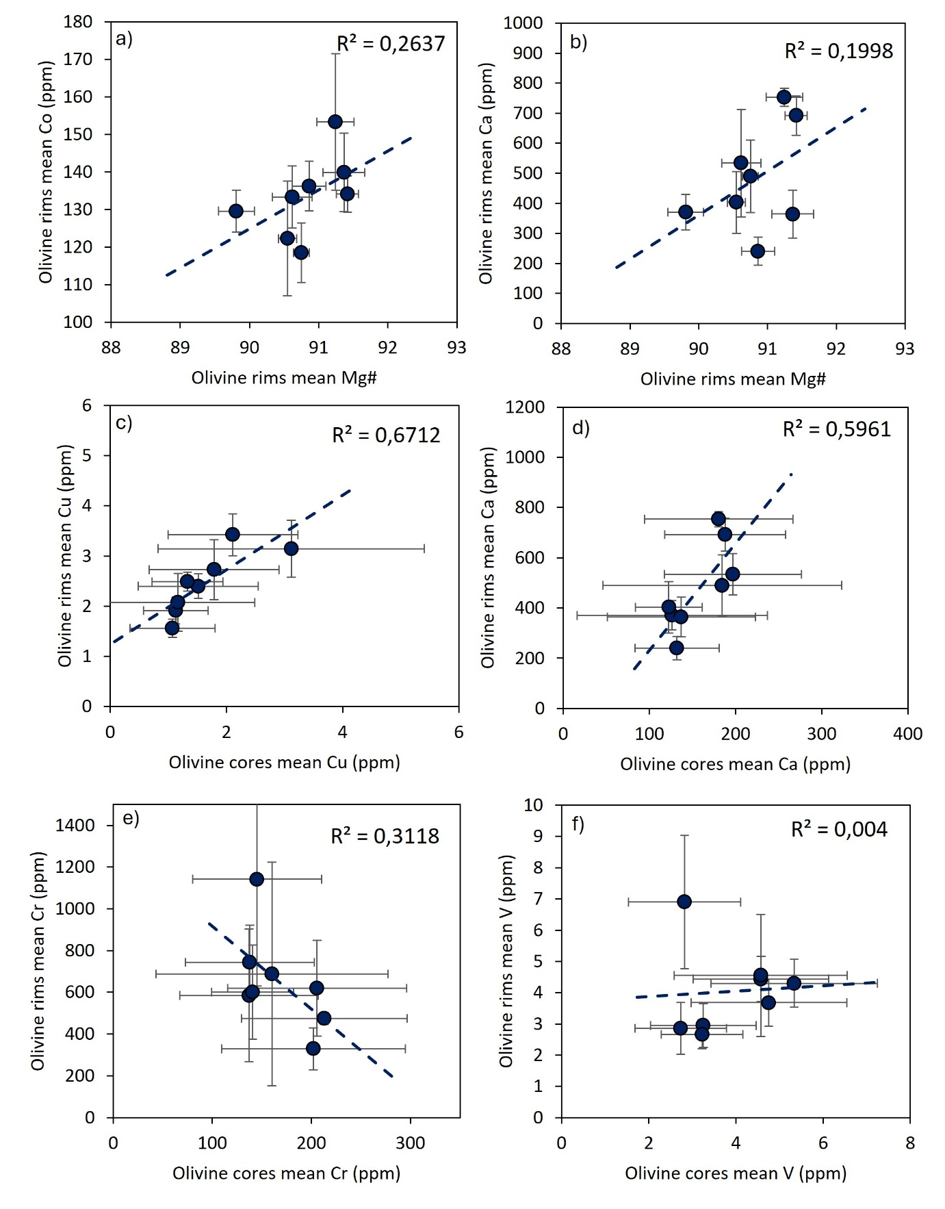
Fig. S9b Comparison between (a-b) average Mg# and temperature-dependent trace elements for olivine rims and (c-f) between olivine cores and rims mean temperature-dependent trace elements. Dotted line = regression line. R-squared = coefficient of determination

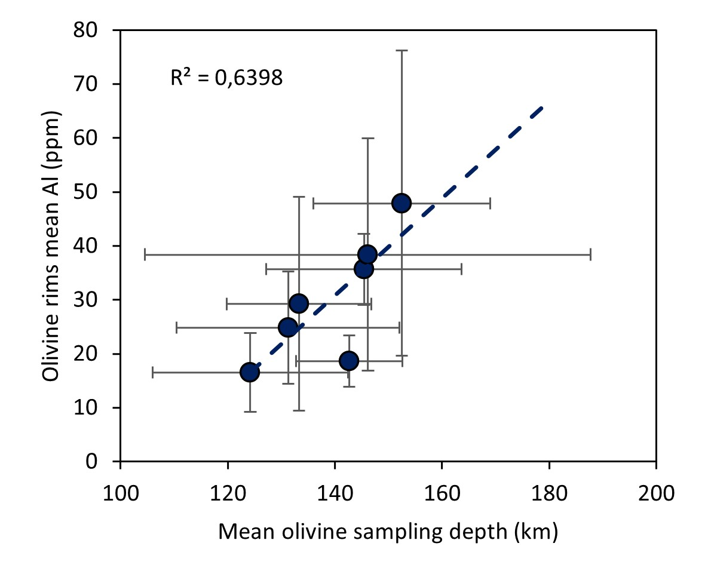
Fig. S10 Comparison between olivine rim average Al and olivine xenocrysts average sampling depth for CROLs from the Kaapvaal craton. Dotted line = regression line. R-squared = coefficient of determination

