SUPPORTING INFORMATION

Low-field NMR spectroscopic control “vegan” food labelling: retrospective analysis of dairy products from Germany
Klaudia Adels¹, Yulia Monakhova^{*1,2}
¹ University of Applied Sciences Aachen, Department of Chemistry and Biotechnology, Heinrich-Mußmann-Straße 1, D-52428 Jülich, Germany
² Saratov State University, Institute of Chemistry, Astrakhanskaya Street 83, 410012 Saratov, Russia
*TO WHOM CORRESPONDENCE SHOULD BE ADDRESSED; EMAIL: MONAKHOVA@FH-AACHEN.DE

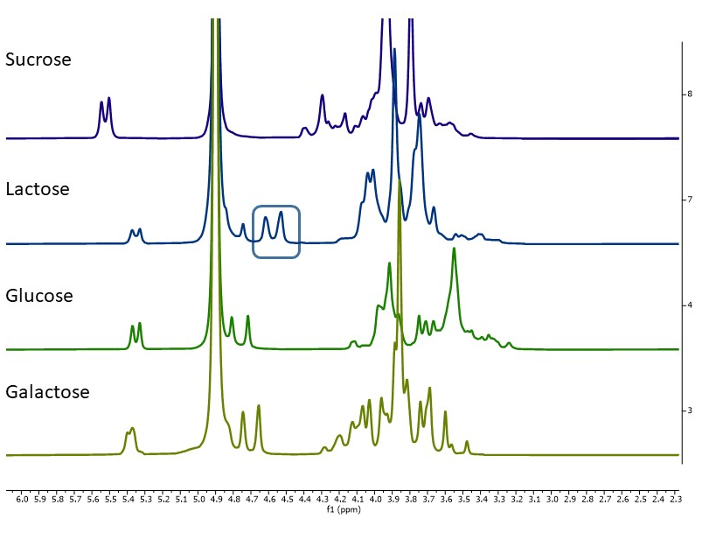
Figure S1. NMR spectra at 80 MHz of carbohydrate standards in D₂O.

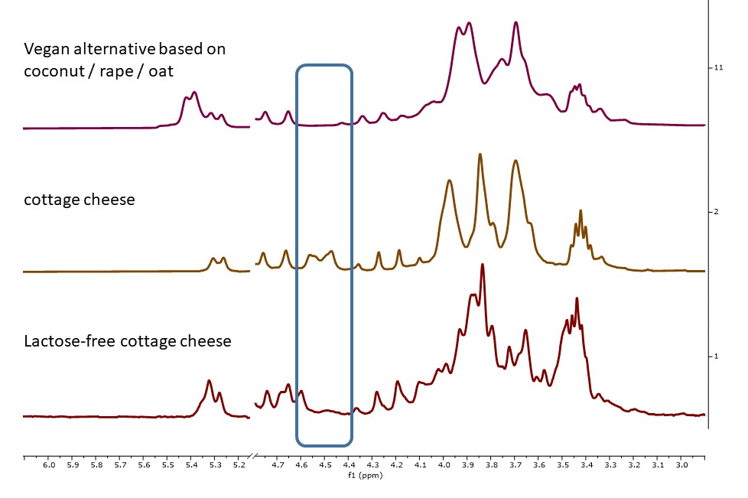
Figure S2. ¹H NMR fingerprint of aqueous phases of cottage cheese products. The region of lactose signal is highlighted in blue (upper plot). PCA score plot of NMR fingerprints of aqueous (middle plot) and organic phases (lower plot). The sample type is shown on the left: LA: cow‘s milk, LF: lactose-free cow‘s milk, RK: rape / coconut-based alternative.
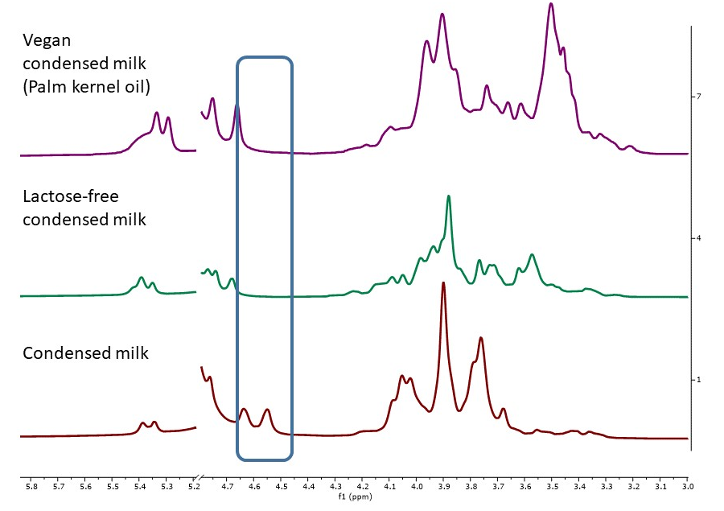
Figure S3. ¹H NMR saccharide fingerprint of condensed milk products. The region of lactose signal is highlighted in blue.

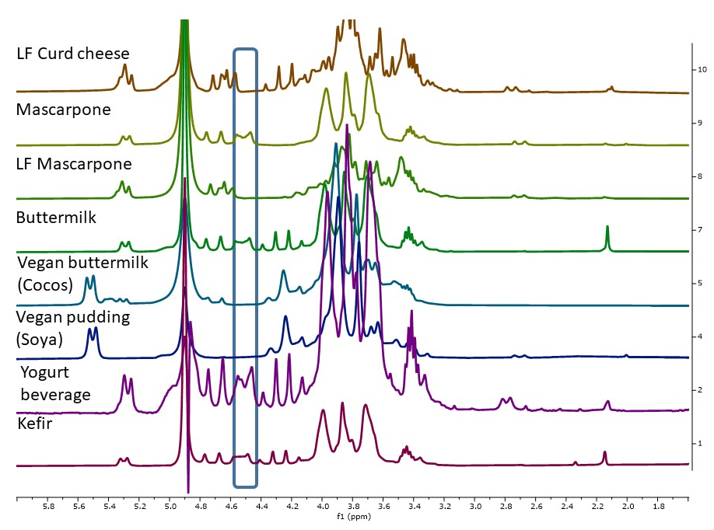
Figure S4. ¹H NMR saccharide fingerprint of vegan and non-vegan dairy cheese products. The region of lactose signal is highlighted in blue (upper plot).

