Electronic supplementary materials

Fig. S1 Scanning electron micrographs of E. coli CCARM 1229 cells in the absence (A) or presence (B) of (KW)₄ peptide (12.5 μM). Bacteria were incubated with the peptide for 1 h at 37°C in PBS (pH 7.2).

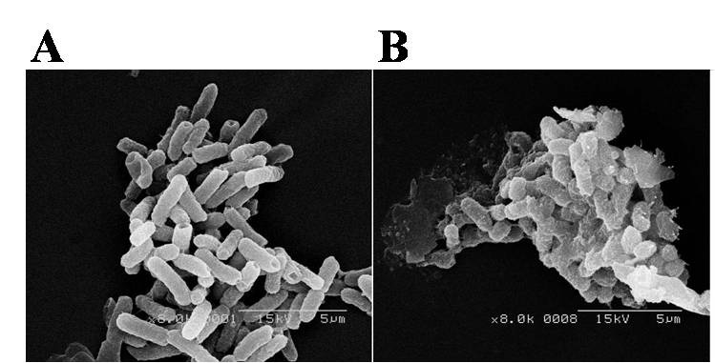

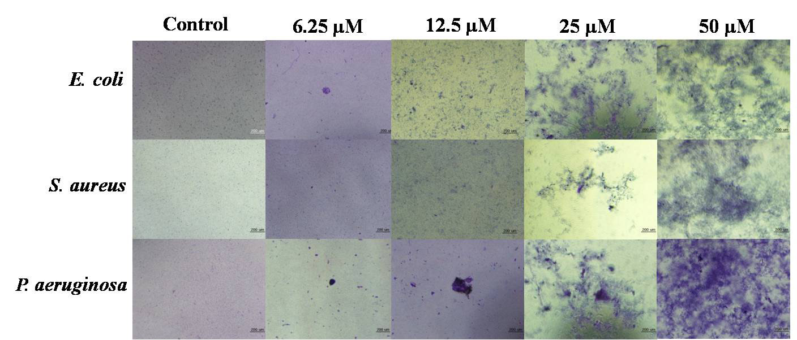
Fig. S2 (KW)₄-induced bacterial agglutination. Peptides were incubated with 2 x 10⁸ CFU/ml of E. coli, S. aureus or P. aeruginosa for 60 min at 37°C, after which bacterial aggregates were stained with 0.1% crystal violet and the supernatants removed. The aggregated bacteria remaining on the bottom of the plate were observed under an inverted microscope. Bar size is 200 μm.

