Supplement to
Lysine and homoarginine are closely interrelated metabolites in the rat
Svetlana Baskal,^{1,a} Laurianne Dimina,^{2,a} Stefanos A. Tsikas,³ Laurent Mosoni,⁴ Didier Remond,⁴ François Mariotti,^{2,b} Dimitrios Tsikas^{1,b}
¹ Institute of Toxicology, Core Unit Proteomics, Hannover Medical School, 30623, Hannover, Germany
² Université Paris-Saclay, AgroParisTech, INRAE, UMR PNCA, 75005, Paris, France
³ Dean of Studies Office, Academic Controlling, Hannover Medical School, Hannover, 30623, Germany
⁴ Université Clermont Auvergne, INRAE, UMR1019, Unité Nutrition Humaine, Clermont-Ferrand, France

ª These authors contributed equally to the work and are both first authors
^{b} These authors contributed equally to the work and are both senior authors

Part A: Lys, hArg, Arg and other metabolites in the study - non-consideration of diet

Table S1: Targeted metabolites analyzed by GC-MS and corresponding chemical identification. NA, not applicable.
Targeted metabolite |  | HMDB ID | PubChem ID | KEGG ID
1 | L-Alanine | HMDB0000161 | 5950 | C00041
2 | L-Threonine | HMDB0000167 | 6288 | C00188
3 | Glycine | HMDB0000123 | 750 | C00037
4 | L-Valine | HMDB0000883 | 6287 | C00183
5 | Serine | HMDB0062263 | 5951 | C00716
6 | Sarcosine | HMDB0000271 | 1088 | C00213
7 | Leucine/Isoleucine | NA | NA | NA
8 | Guanidinoacetic acid (GAA) | HMDB0000128 | 763 | C00581
9 | Aspartic Acid/Asparagine | NA | NA | NA
10 | 4-Hydroxy-proline (4-OH-Pro) | HMDB0000725 | 5810 | C01157
11 | L-Proline | HMDB0000162 | 145742 | C00148
12 | L-Methionine | HMDB0000696 | 6137 | C00073
13 | Glutamic acid/Glutamine | NA | NA | NA
14 | 5-Hydroxy-D-lysine (5_OH_K_D) | NA | NA | NA
15 | 5-Hydroxy-L-lysine (5_OH_K_L) | HMDB0000450 | 4433 | C16741
16 | Ornithine/Citrulline | NA | NA | NA
17 | L-Phenylalanine | HMDB0000159 | 6140 | C00079
18 | L-Tyrosine | HMDB0000158 | 6057 | C00082
19 | L-Lysine | HMDB0000182 | 5962 | C00047
20 | L-Arginine | HMDB0000517 | 6322 | C00062
21 | N^{ε}-Monomethyllysine (MML) | NA | NA | NA
22 | S-Carboxymethyl-L-cysteine (CMC) | HMDB0029415 | 1080
23 | Homo-L-arginine (hArg) | HMDB0000670 | 9085 | C01924
24 | L-Tryptophan | HMDB0000929 | 6305 | C00078
25 | N^{ε}-Carboxymethyllysine (CML) | NA | NA | NA
26 | Asymmetric dimethylarginine (ADMA) | HMDB0001539 | 123831 | C03626
27 | N^{G}-Monomethylarginine (MMA) | NA | NA | NA
28 | L-Furosine | HMDB0029390 | 14497053
29 | Nitrate | HMDB0002878 | 943 | C00244
30 | Nitrite | HMDB0002786 | 946 | C00088
31 | Creatinine | HMDB0000562 | 588 | C00791
32 | Malondialdehyde (MDA) | HMDB0006112 | 10964 | C19440

Table S2. Simple statistics and Pearson correlation analysis between hArg and the targeted metabolites at T0 (rats aged 16 months, n=95 for each variable). Bold characters and numbers indicate statistical significance
Targeted  metabolite | Mean  (µM) | SD  (µM) | Min.  (µM) | Max.  (µM) | Correlation  coefficient r | Prob > |r|  under H0: Rho=0
Ala | 286.2 | 48.3 | 172.0 | 444.0 | 0.18 | 0.090
Thr | 356.6 | 58.4 | 197.0 | 475.0 | 0.15 | 0.136
Gly | 364.5 | 56.7 | 230.0 | 567.0 | 0.06 | 0.584
Val | 237.8 | 27.9 | 170.0 | 327.0 | 0.08 | 0.431
Ser | 274.4 | 37.8 | 183.0 | 439.0 | 0.22 | 0.029
Sarcosine | 1.64 | 0.38 | 1.08 | 3.35 | 0.12 | 0.257
Leu/Ile | 247.8 | 30.5 | 177.0 | 373.0 | 0.10 | 0.316
GAA | 3.38 | 0.89 | 0.87 | 5.68 | 0.02 | 0.825
Asp/Asn | 90.4 | 13.9 | 56.4 | 118.0 | 0.22 | 0.031
OH_Pro | 17.4 | 3.44 | 10.7 | 38.2 | 0.06 | 0.570
Pro | 132.5 | 15.3 | 90.5 | 177.0 | 0.29 | 0.004
Met | 90.6 | 7.94 | 73.9 | 113.0 | 0.24 | 0.017
Glu/Gln | 1044.0 | 129.7 | 766.0 | 1480.0 | 0.26 | 0.010
5_OH_K_D | 0.30 | 0.05 | 0.19 | 0.47 | 0.26 | 0.011
5_OH_K_L | 0.96 | 0.17 | 0.61 | 1.50 | 0.29 | 0.004
Orn/Cit | 87.8 | 33.1 | 35.5 | 215.0 | 0.04 | 0.727
Phe | 86.5 | 9.15 | 67.2 | 111.0 | 0.11 | 0.307
Tyr | 68.2 | 8.96 | 47.4 | 98.5 | 0.09 | 0.398
Lys | 377.2 | 49.6 | 279.0 | 484.0 | 0.68 | <0.0001
Arg | 128.2 | 32.2 | 22.6 | 193.0 | 0.26 | 0.012
MML | 0.77 | 0.10 | 0.54 | 1.00 | 0.08 | 0.433
CMC | 1.77 | 0.43 | 0.86 | 2.98 | 0.24 | 0.021
Trp | 83.7 | 17.2 | 19.9 | 133.0 | 0.26 | 0.012
CML | 0.12 | 0.03 | 0.05 | 0.19 | 0.04 | 0.717
ADMA | 0.50 | 0.10 | 0.26 | 0.77 | 0.24 | 0.018
MMA | 0.13 | 0.03 | 0.06 | 0.23 | 0.24 | 0.020
Furosine | 0.04 | 0.01 | 0.02 | 0.08 | 0.01 | 0.922
hArg | 0.67 | 0.22 | 0.38 | 1.97 | Not applicable

Table S3. Simple statistics and Pearson correlation analysis between hArg and the targeted metabolites at T2 (rats aged 20 months, n=81 for each variable). Bold characters and numbers indicate statistical significance
Targeted  metabolite | Mean  (µM) | SD  (µM) | Min.  (µM) | Max.  (µM) | Correlation  coefficient r | Prob > |r| under  H0: Rho=0
Ala | 285.6 | 69.2 | 115.0 | 429.0 | 0.23 | 0.0375
Thr | 344.8 | 77.6 | 149.0 | 512.0 | 0.41 | 0.0002
Gly | 306.6 | 71.8 | 136.0 | 432.0 | 0.11 | 0.3142
Val | 190.6 | 39.9 | 88.1 | 273.0 | 0.27 | 0.0141
Ser | 290.2 | 60.7 | 139.0 | 425.0 | 0.36 | 0.0008
Sarcosine | 1.04 | 0.26 | 0.50 | 1.83 | 0.08 | 0.4547
Leu_Ile | 206.4 | 43.2 | 91.5 | 292.0 | 0.23 | 0.0381
GAA | 4.89 | 1.60 | 2.20 | 9.65 | 0.54 | <0.0001
Asp/Asn | 78.8 | 23.9 | 26.8 | 138.0 | 0.25 | 0.0252
OH-Pro | 11.5 | 2.81 | 5.33 | 19.9 | 0.28 | 0.0118
Pro | 123.1 | 25.9 | 53.6 | 174.0 | 0.31 | 0.0050
Met | 75.6 | 12.3 | 41.2 | 99.10 | 0.34 | 0.0020
Glu/Gln | 854.8 | 202.9 | 303.0 | 1194.0 | 0.37 | 0.0007
5_OH_K_D | 0.29 | 0.05 | 0.19 | 0.40 | 0.25 | 0.0269
5_OH_K_L | 0.89 | 0.17 | 0.54 | 1.25 | 0.31 | 0.0047
Orn/Cit | 74.5 | 28.9 | 24.1 | 170.0 | -0.05 | 0.6512
Phe | 75.8 | 16.2 | 32.3 | 115.0 | 0.20 | 0.0719
Tyr | 59.9 | 13.9 | 25.6 | 84.3 | 0.22 | 0.0435
Lys | 340.5 | 93.0 | 128.0 | 611.0 | 0.70 | <0.0001
Arg | 113.4 | 38.1 | 32.6 | 200.0 | 0.50 | <0.0001
MML | 0.55 | 0.14 | 0.21 | 0.88 | 0.40 | 0.0002
CMC | 2.01 | 0.43 | 1.22 | 3.24 | 0.16 | 0.1565
Trp | 72.9 | 18.1 | 32.3 | 111.0 | 0.41 | 0.0002
CML | 0.12 | 0.07 | 0.04 | 0.63 | -0.09 | 0.4055
ADMA | 0.40 | 0.11 | 0.16 | 0.68 | 0.35 | 0.0015
MMA | 0.11 | 0.04 | 0.04 | 0.24 | 0.26 | 0.0200
Furosine | 0.04 | 0.01 | 0.02 | 0.08 | 0.04 | 0.7428
hArg | 1.03 | 0.56 | 0.41 | 3.63 | Not applicable

Table S4. Simple statistics and Pearson correlation analysis between hArg and the targeted metabolites at T4 (rats aged 22 months, n=77 for each variable). Bold characters and numbers indicate statistical significance
Targeted  metabolite | Mean  (µM) | SD  (µM) | Min.  (µM) | Max.  (µM) | Correlation  coefficient r | Prob > |r| under  H0: Rho=0
Ala | 283.3 | 43.6 | 194.0 | 436.0 | 0.04 | 0.7230
Thr | 386.3 | 77.9 | 202.0 | 566.0 | 0.25 | 0.0310
Gly | 317.2 | 52.3 | 234.0 | 455.0 | -0.19 | 0.0910
Val | 194.2 | 23.7 | 130.0 | 255.0 | 0.26 | 0.0226
Ser | 309.3 | 56.9 | 214.0 | 466.0 | 0.00 | 0.9753
Sarcosine | 1.13 | 0.22 | 0.61 | 1.70 | 0.13 | 0.2505
Leu/Ile | 205.9 | 24.2 | 130.0 | 272.0 | 0.18 | 0.1133
GAA | 4.57 | 1.47 | 1.26 | 8.13 | 0.27 | 0.0192
Asp/Asn | 75.9 | 13.6 | 46.7 | 104.0 | 0.04 | 0.7127
OH-Pro | 11.5 | 2.94 | 6.04 | 23.2 | 0.00 | 0.9787
Pro | 122.3 | 17.5 | 85.9 | 164.0 | 0.13 | 0.2423
Met | 77.6 | 6.76 | 57.7 | 91.2 | 0.21 | 0.0719
Glu/Gln | 900.7 | 122.1 | 578.0 | 1128.0 | 0.20 | 0.0762
5_OH_K_D | 0.30 | 0.05 | 0.19 | 0.45 | 0.15 | 0.1940
5_OH_K_L | 0.96 | 0.23 | 0.52 | 2.22 | 0.09 | 0.4596
Orn/Cit | 77.0 | 22.4 | 33.5 | 147.0 | -0.11 | 0.3313
Phe | 76.2 | 8.45 | 60.7 | 96.7 | -0.01 | 0.9130
Tyr | 58.1 | 8.13 | 42.0 | 81.1 | -0.12 | 0.2886
Lys | 351.0 | 74.6 | 217.0 | 649.0 | 0.74 | <0.0001
Arg | 114.9 | 34.8 | 23.2 | 195.0 | 0.25 | 0.0316
MML | 0.56 | 0.14 | 0.32 | 1.14 | 0.03 | 0.8198
CMC | 2.00 | 0.44 | 1.21 | 3.50 | 0.06 | 0.6285
Trp | 71.9 | 17.4 | 2.79 | 112.0 | 0.05 | 0.6587
CML | 0.12 | 0.06 | 0.03 | 0.48 | -0.33 | 0.0038
ADMA | 0.45 | 0.13 | 0.24 | 1.12 | 0.17 | 0.1364
MMA | 0.13 | 0.04 | 0.05 | 0.23 | -0.02 | 0.8398
Furosine | 0.04 | 0.02 | 0.02 | 0.22 | -0.07 | 0.5684
hArg | 1.08 | 0.52 | 0.47 | 3.73 | Not applicable

Table S5. Simple statistics and Pearson correlation analysis between hArg and the targeted metabolites across the whole period (n=253 for each variable). Bold characters and numbers indicate statistical significance
Targeted  metabolite | Mean  (µM) | SD  (µM) | Min.  (µM) | Max.  (µM) | Correlation  coefficient r | Prob > |r|  H0: Rho=0
Ala | 285.1 | 54.4 | 115.0 | 444.0 | 0.14 | 0.0281
Thr | 361.9 | 72.8 | 149.0 | 566.0 | 0.30 | <0.0001
Gly | 331.5 | 65.8 | 136.0 | 567.0 | -0.14 | 0.0227
Val | 209.4 | 38.1 | 88.1 | 327.0 | -0.05 | 0.4044
Ser | 290.1 | 53.7 | 139.0 | 466.0 | 0.27 | <0.0001
Sarcosine | 1.29 | 0.41 | 0.50 | 3.35 | -0.19 | 0.0024
Leu/Ile | 221.8 | 39.0 | 91.5 | 373.0 | -0.05 | 0.3898
GAA | 4.23 | 1.49 | 0.87 | 9.65 | 0.47 | <0.0001
Asp/Asn | 82.3 | 18.7 | 26.8 | 138.0 | 0.02 | 0.7262
OH-Pro | 13.7 | 4.21 | 5.33 | 38.2 | -0.18 | 0.0033
Pro | 126.4 | 20.4 | 53.6 | 177.0 | 0.13 | 0.0414
Met | 81.8 | 11.5 | 41.2 | 113.0 | -0.02 | 0.7165
Glu/Gln | 939.8 | 175.3 | 303.0 | 1480.0 | 0.06 | 0.3151
5_OH_K_D | 0.30 | 0.05 | 0.19 | 0.47 | 0.16 | 0.0115
5_OH_K_L | 0.94 | 0.19 | 0.52 | 2.22 | 0.15 | 0.0137
Orn/Cit | 80.4 | 29.3 | 24.1 | 215.0 | -0.11 | 0.0695
Phe | 80.0 | 12.8 | 32.3 | 115.0 | -0.05 | 0.4396
Tyr | 62.5 | 11.5 | 25.6 | 98.5 | -0.07 | 0.2767
Lys | 357.5 | 74.8 | 128.0 | 649.0 | 0.56 | <0.0001
Arg | 119.4 | 35.5 | 22.6 | 200.0 | 0.24 | 0.0001
MML | 0.64 | 0.16 | 0.21 | 1.14 | -0.10 | 0.1120
CMC | 1.92 | 0.45 | 0.86 | 3.50 | 0.21 | 0.0009
Trp | 76.8 | 18.3 | 2.79 | 133.0 | 0.09 | 0.1466
CML | 0.12 | 0.06 | 0.03 | 0.63 | -0.16 | 0.0095
ADMA | 0.45 | 0.12 | 0.16 | 1.12 | 0.10 | 0.1006
MMA | 0.12 | 0.04 | 0.04 | 0.24 | 0.11 | 0.0714
Furosine | 0.04 | 0.02 | 0.02 | 0.22 | -0.02 | 0.7325
hArg | 0.91 | 0.48 | 0.38 | 3.73 | Not applicable

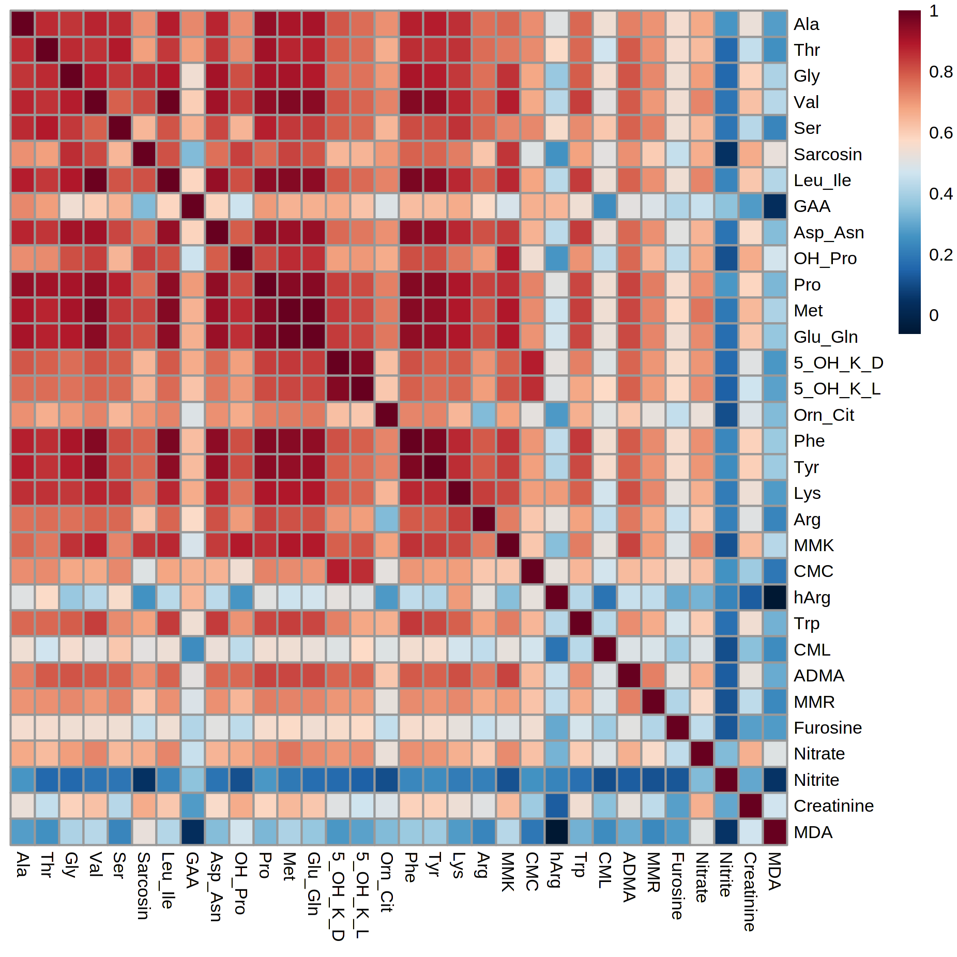Figure S1. Overall correlation heat-map. The heat-maps reflect, in an intuitive manner, the different correlations between each of the targeted data.

Figure S2. Variable importance plot (VIP) representing the contribution of each metabolite in fitting the PLS model for both predictors and response.

Figure S3. Regression coefficients plot representing the importance each metabolite has in the prediction of just the response (i.e., hArg).

Part B: Effects of the different diets on Lys, hArg, Arg and other metabolites
Dietary Lys was present only “protein-bound”, but not as free lysine. The Lys content was (in mg/kg) 7200 for habituation diet, 12570 for high fat milk-based diet, 7020 for high fat plant-based diet, 10470 for standard milk-based diet and 5860 for standard plant-based diet
We considered Lys intake as a covariate in all models that have been used. Lys intake was calculated as the product of diet intake (taken as an average week prior to blood sampling) and the Lys content of the corresponding diet. We also considered the different types of diets so as to fully explore possible effect of diets.
In the PLS regression shown below, the addition of diet parameters (Lys intake, protein source milk/plant and sugar/SFA content) as model effects does not alter the strength of the relationship between hArg, GAA and Lys.
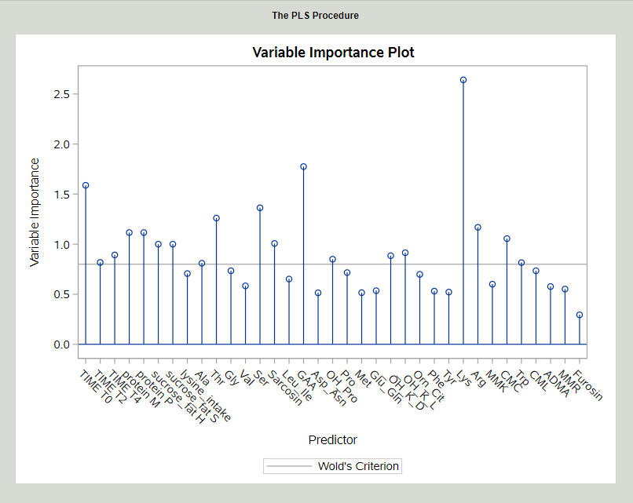
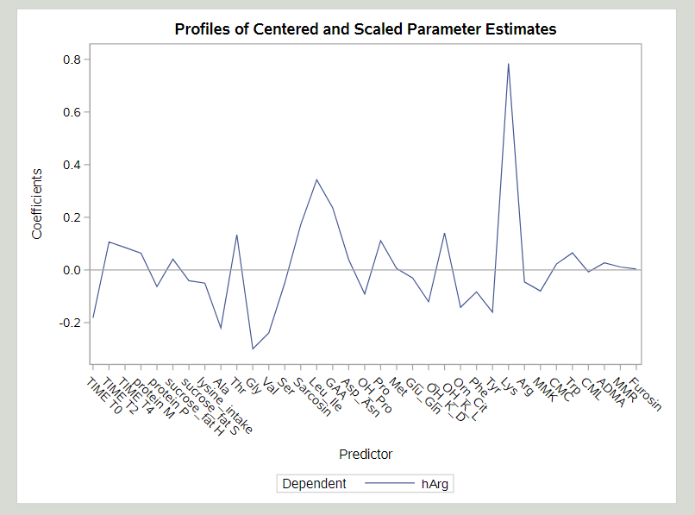
In the selection algorithm used to identify a parsimonious ANOVA model that explain hArg with selected metabolites (see below), we added time, Lys intake, protein source milk/plant and sugar/SFA content as class variables. The relative importance of the selected metabolites in the model was evaluated with the standardized coefficients. The explanatory weight of Lys on Arg in the model is clearly higher than the weight of the different diet effects. GAA, Gly and Ala levels are still selected by the algorithm as relevant to explain variations in hArg levels.

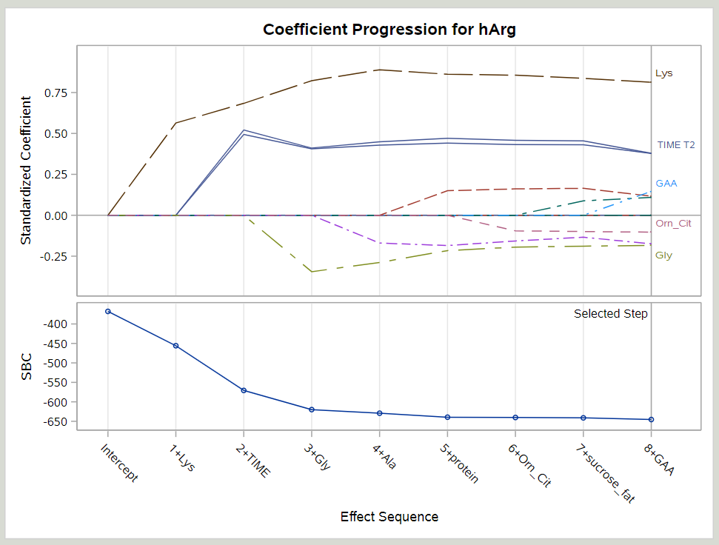

We ran additional univariate analyses in a linear mixed model with fixed effects previously selected by the algorithm or for adjustment purposes (time, protein source, sugar/SFA level, Lys, Gly, Ala, GAA, Orn/Cit contents and Lys intake) and random (subjects). Dietary factors including Lys intake were not significant, whereas the association between hArg and Lys remained strong, significant and independent as shown in the Table below.
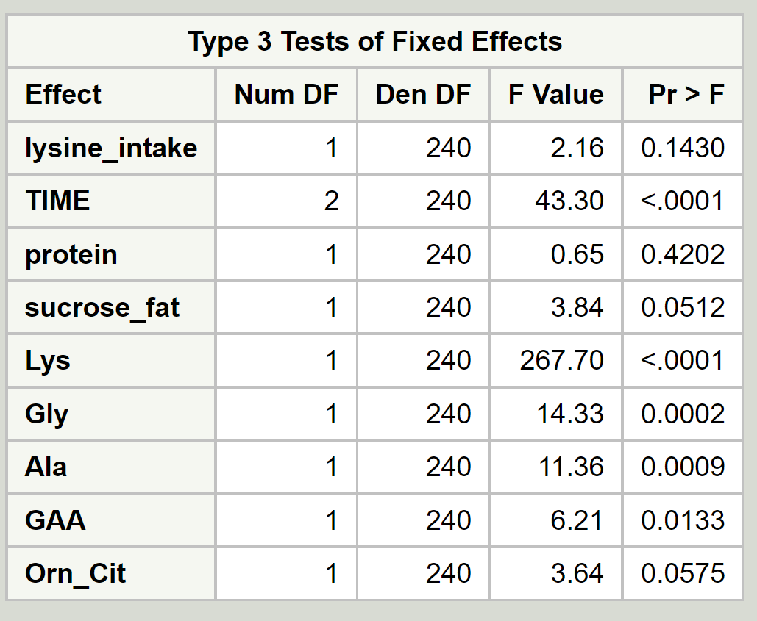

In summary, our additional analyses do not show a specific dietary modulation of the association between hArg and Lys. Accordingly, we remained focused on this relationship irrespective of other factors. In the revised manuscript, we now mention that diet parameters (such as protein, energy and Lys content) were tested in higher models but proved not significant contributors to explain variations in the relation between Lys and hArg.

