Highlights
- Temporin-SHf peptide is synthesized by solid-phase Fmoc chemistry.
- Temporin-SHf is an ultra-short, hydrophobic, cationic peptide.
- Temporin-SHf showed antimicrobial and antitumor activities.
- Temporin-SHf induces an intrinsic pathway of apoptosis in A549 cells.

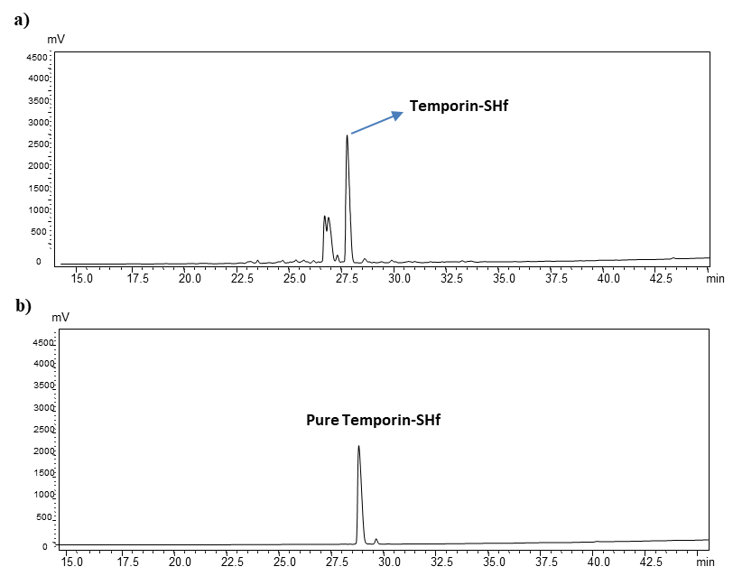

Fig. S1 RP-HPLC profile showing purity of the temporin-SHf peptide.

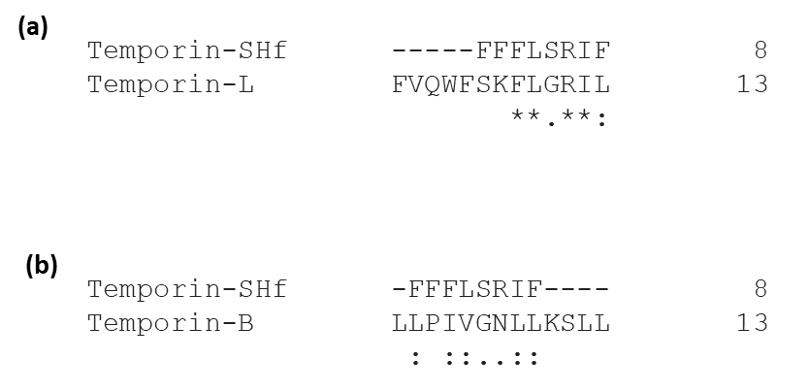

Fig. S2. Multiple sequence alignment of temporin-SHf with (a) temporin-L and (b) temporin-B.

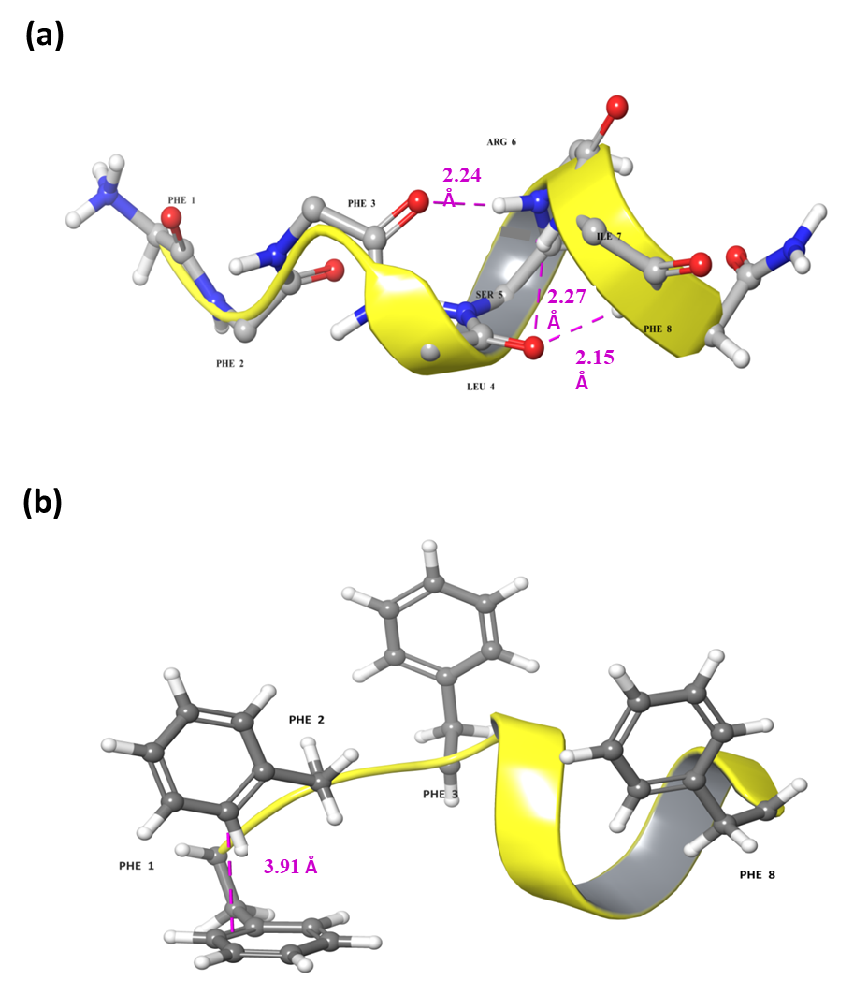

Fig. S3 (a) The Hydrogen bond network in the helical region of the modeled structure of temporin-SHf in micelles. (b) The aromatic Phe-Phe T-shaped interaction was observed in the modeled temporin-SHf in SDS micelles.

