Supplementary data
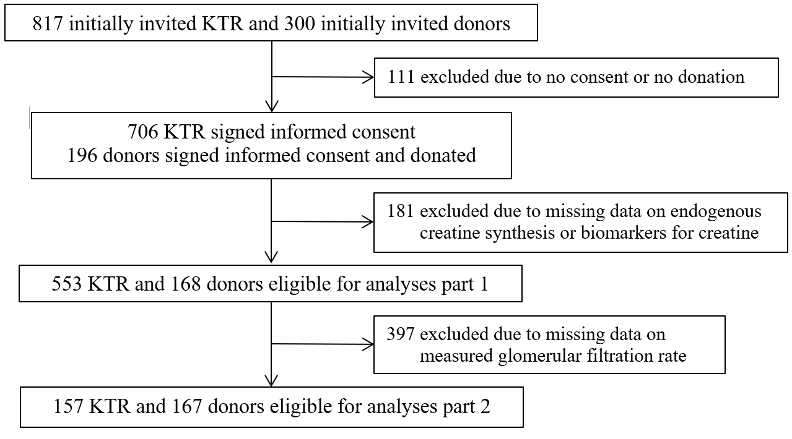
Figure S1. Flowchart of KTR and donors in the study.

Table S1. Baseline characteristics in KTR and controls
 | KTR (n=553) | Controls (n=168) | P-value
Creatine related
Total creatine pool, mmol | 651 ± 178 | 753 ± 239 | <0.001
Creatine intake, mmol/day | 3.5 ± 1.2 | 3.5 ± 1.4 | 0.7
Endogenous creatine synthesis rate, mmol/day | 7.9 ± 3.0 | 10.0 ± 4.1 | <0.001
Demographics
Age, years | 53.1 ± 12.9 | 53.9 ± 10.7 | 0.4
Sex, n male (%) | 316 (57%) | 79 (47%) | 0.03
Weight, kg | 80.1 ± 16.4 | 80.2 ± 13.8 | 0.9
Height, cm | 174 ± 10 | 175 ± 9 | 0.1
Kidney related
eGFR creat+cys 2021, ml/min/1.73m² | 47 ± 20 | 98 ± 15 | <0.001
eGFR creat 2021, ml/min/1.73m² | 56 ± 21 | 94 ± 14 | <0.001
eGFR cys C 2012, ml/min/1.73m² | 42 ± 19 | 96 ± 19 | <0.001
Creatinine clearance, ml/min | 63 ± 30 | 136 ± 62 | <0.001
Liver related
ALAT, U/L | 19 [14; 25] | 22 [17; 30] | <0.001
ASAT, U/L | 22 [18; 27] | 23 [21; 26] | 0.01
Billirubin, µmol/L | 10 [8; 14] | 8 [6; 11] | <0.001
Total protein, g/L | 71 ± 5 | 74 ± 4 | <0.001
Transsulfuration related
Homocysteine, µmol/L | 20 [16; 25] | 11 [10; 15] | <0.001
Vitamin B6, nmol/L | 30 [19; 55] | 43 [29; 65] | <0.001
Vitamin B9, nmol/L | 19 [14; 27] | 22 [17; 27] | 0.03
Vitamin B12, pmol/L | 288 [222; 377] | 263 [213; 354] | 0.3
Sulfate excretion, mmol/24h | 17.8 ± 6.5 | 18.8 ± 6.0 | 0.07
Taurine excretion, µmol/24h | 518 [217; 952] | 495 [232; 966] | 0.7
Other
Hemoglobin, mmol/L | 8.3 ± 1.1 | 8.9 ± 0.8 | <0.001
Hs-CRP, mg/L | 1.6 [0.7; 4.4] | 1.1 [0.5; 1.9] | <0.001
NT-proBNP, ng/L | 254 [104; 608] | 39 [22; 68] | <0.001
Glucose, mmol/L | 5.3 [4.8; 5.9] | 5.3 [5.0; 5.7] | 0.3
SQUASH score, hours×intensity | 5160 [2520; 7980] | n/a | n/a
Protein intake, g/day | 84 ± 21 | 87 ± 20 | 0.07
Calcineurin inhibitor usage, n (%) | 311 (56%) | n/a | n/a
Proliferation inhibitor usage, n (%) | 459 (83%) | n/a | n/a
Prednisolon dosage, mg/24h | 10 [5; 10] | n/a | n/a
Differences between baseline characteristics in KTR and controls were tested using the student t-test, Wilcoxon signed-rank test and Chi-squared test, where appropriate.

Table S2. Sensitivity analyses of a comparison of creatine pool and muscle mass in selected data from the TransplantLines cohort.
 | KTR (n=397) | Controls (n=428) | P-value
Muscle mass
Appendicular muscle mass (Sergi), kg | 20.6 ± 4.3 | 21.1 ± 4.8 | 0.1
Appendicular muscle mass (Kyle), kg | 22.0 ± 5.0 | 22.3 ± 5.4 | 0.3
Total muscle mass (Janssen), kg | 26.4 ± 6.6 | 25.6 ± 6.9 | 0.1
Creatine pool
Creatine pool, mmol | 695 ± 208 | 759 ± 246 | <0.001
Ratio creatine pool to muscle mass
Ratio based on appendicular muscle mass (Sergi), mmol/kg | 33.9 ± 7.7 | 35.9 ± 7.8 | <0.001
Ratio based on appendicular muscle mass (Kyle), mmol/kg | 31.9 ± 7.3 | 34.0 ± 7.3 | <0.001
Ratio based on total muscle mass (Janssen), mmol/kg | 26.7 ± 6.3 | 29.9 ± 6.5 | <0.001
Differences between baseline characteristics in KTR and controls were tested using the student t-test.

Table S3. Comparison of fractional excretions of creatine and its precursors in and controls in the mGFR dataset (part 2 analysis).
 | KTR (n=157) | Controls (n=167) | P-value
Fractional renal excretion
(based on creatinine clearance)
Arginine, % | 0.32 [0.21; 0.46] | 0.18 [0.13; 0.24] | <0.001
Glycine, % | 4.5 [2.8; 7.6] | 4.5 [3.1; 5.9] | 0.7
Guanidinoacetate, % | 69 [45; 105] | 80 [55; 112] | 0.1
Creatine, % | 5.0 [2.9; 8.0] | 4.0 [2.5; 8.7] | 0.1
Fractional renal excretion
(based on measured GFR)
Arginine, % | 0.33 [0.23; 0.48] | 0.19 [0.14; 0.27] | <0.001
Glycine, % | 4.7 [3.1; 8.0] | 4.9 [3.5; 6.7] | 0.8
Guanidinoacetate, % | 79 [53; 112] | 83 [63; 114] | 0.2
Creatine, % | 5.4 [3.5; 8.7] | 4.7 [2.9; 10.2] | 0.1

Table S4. Associations of creatine parameters with the total creatine pool in KTR and controls
 | KTR  (n=553) |  | Controls  (n=168)
 | Std. Beta (95% CI) | P-value | Std. Beta (95% CI) | P-value
Creatine status
Endogenous creatine synthesis rate | 0.77 (0.73; 0.81) | <0.001 | 0.64 (0.57; 0.71) | <0.001
Creatine intake | 0.11 (0.05; 0.17) | <0.001 | 0.07 (-0.04; 0.17) | 0.20
Plasma concentrations
Arginine | -0.01 (-0.07; 0.06) | 0.89 | -0.01 (-0.10; 0.09) | 0.90
Glycine | -0.02 (-0.07; 0.05) | 0.62 | 0.02 (-0.09; 0.12) | 0.76
Guanidinoacetate | 0.11 (0.05; 0.17) | <0.001 | 0.05 (-0.06; 0.15) | 0.39
Creatine | 0.06 (-0.01; 0.13) | 0.06 | -0.01 (-0.11; 0.10) | 0.93
Urinary excretions
Arginine | 0.15 (0.09; 0.21) | <0.001 | 0.14 (0.03; 0.24) | 0.007
Glycine | 0.20 (0.14; 0.26) | <0.001 | 0.10 (-0.01; 0.20) | 0.06
Guanidinoacetate | 0.30 (0.24; 0.35) | <0.001 | 0.22 (0.13; 0.32) | <0.001
Creatine | 0.22 (0.16; 0.28) | <0.001 | 0.10 (0.01; 0.20) | 0.05
Fractional excretion
Arginine | -0.08 (-0.14; -0.02) | 0.009 | 0.01 (-0.10; 0.10) | 0.97
Glycine | 0.01 (-0.06; 0.07) | 0.84 | -0.02 (-0.12; 0.08) | 0.67
Guanidinoacetate | 0.13 (0.07; 0.19) | <0.001 | 0.02 (-0.08; 0.12) | 0.68
Creatine | 0.03 (-0.03; 0.09) | 0.36 | 0.05 (-0.05; 0.15) | 0.30
Analyses are adjusted for age, sex, weight, height and time since transplantation (for KTR).

Table S5. Associations of creatine parameters with the total creatine pool in KTR and controls
 | KTR  (n=553) |  | Controls  (n=168)
 | Std. Beta (95% CI) | P-value | Std. Beta (95% CI) | P-value
Demographics
Age | -0.20 (-0.26; -0.14) | <0.001 | -0.29 (-0.39; -0.19) | <0.001
Sex, male | 0.66 (0.50; 0.82) | <0.001 | 0.73 (0.46; 0.99) | <0.001
Weight | 0.34 (0.27; 0.42) | <0.001 | 0.47 (0.34; 0.60) | <0.001
Height | 0.15 (0.06; 0.24) | <0.001 | 0.01 (-0.15; 0.16) | 0.98
Kidney function markers
eGFR creat+cys 2021 | 0.11 (0.05; 0.17) | <0.001 | -0.01 (-0.12; 0.10) | 0.88
eGFR creat 2021 | 0.03 (-0.04; 0.09) | 0.42 | -0.06 (-0.18; 0.05) | 0.30
eGFR cys C 2012 | 0.16 (0.10; 0.22) | <0.001 | 0.03 (-0.09; 0.14) | 0.64
Creatinine clearance | 0.36 (0.31; 0.42) | <0.001 | 0.21 (0.11; 0.31) | <0.001
Liver function markers
ALAT | 0.02 (-0.04; 0.08) | 0.53 | 0.01 (-0.10; 0.10) | 0.98
ASAT | 0.03 (-0.03; 0.09) | 0.31 | 0.03 (-0.07; 0.13) | 0.58
Billirubin | 0.05 (-0.01; 0.11) | 0.10 | 0.01 (-0.10; 0.10) | 0.99
Total protein | 0.02 (-0.04; 0.08) | 0.51 | -0.01 (-0.10; 0.10) | 0.99
Transsulfuration related
Homocysteine | -0.10 (-0.16; -0.04) | 0.001 | 0.03 (-0.14; 0.20) | 0.68
Vitamin B6 | 0.09 (0.03; 0.15) | 0.003 | 0.11 (0.01; 0.21) | 0.03
Vitamin B9 | 0.03 (-0.04; 0.08) | 0.69 | -0.01 (-0.17; 0.17) | 0.98
Vitamin B12 | 0.02 (-0.04; 0.08) | 0.53 | 0.11 (-0.06; 0.29) | 0.21
Sulfate excretion | 0.43 (0.37; 0.48) | <0.001 | 0.41 (0.32; 0.50) | <0.0001
Taurine excretion | 0.20 (0.14; 0.26) | <0.001 | 0.15 (0.05; 0.25) | 0.005
Other
Hemoglobin | 0.11 (0.05; 0.17) | <0.001 | -0.02 (-0.14; 0.10) | 0.76
Hs-CRP | -0.11 (-0.17; -0.05) | <0.001 | -0.03 (-0.13; 0.07) | 0.58
NT-proBNP | -0.19 (-0.26; -0.13) | <0.001 | -0.07 (-0.17; 0.03) | 0.18
Glucose | -0.09 (-0.15; -0.03) | 0.004 | 0.02 (-0.08; 0.12) | 0.70
SQUASH score | 0.15 (0.09; 0.21) | <0.001 | n/a | n/a
Protein intake | 0.52 (0.46; 0.58) | <0.001 | 0.40 (0.30; 0.49) | <0.001
Calcineurin inhibitor usage | -0.04 (-0.18; 0.09) | 0.6 | n/a | n/a
Proliferation inhibitor usage | 0.17 (0.00; 0.32) | 0.05 | n/a | n/a
Prednisolon dosage | -0.01 (-0.08; 0.05) | 0.7 | n/a | n/a
Analyses are adjusted for age, sex, weight, height and time since transplantation (for KTR).

Table S6. Mediation analyses on the association of measured GFR and total creatine pool with urinary guanidinoacetate excretion as the mediator.
 |  | KTR  n= 157  mean measured GFR: 57 ± 20  95 percentile range: 25 – 87 |  | Controls  n= 167  mean measured GFR: 114 ± 24  95 percentile range: 80 – 157
Total creatine pool
 | Direct path  (measured GFR -> Creatine pool) | 0.02 (-0.12;0.15) | 0.81 | -0.01 (-0.16; 0.14) | 0.86
 | Indirect path  (measured GFR -> GAA excretion -> Creatine pool) | 0.21 (0.12; 0.32) | <0.001 | 0.10 (0.04; 0.18) | <0.001
 | Total path  (sum of direct and indirect) | 0.22 (0.10; 0.33) | <0.001 | 0.09 (-0.06; 0.24) | 0.23
 | Proportion mediated  (multiply by 100 for %) | 0.95 (0.46; 2.09) | <0.001 | No mediation | n/a
Analyses are adjusted for age, sex, weight, height and time since transplantation (for KTR).
Abbreviations: GAA: Guanidinoacetate; GFR: Glomerular filtration rate.

