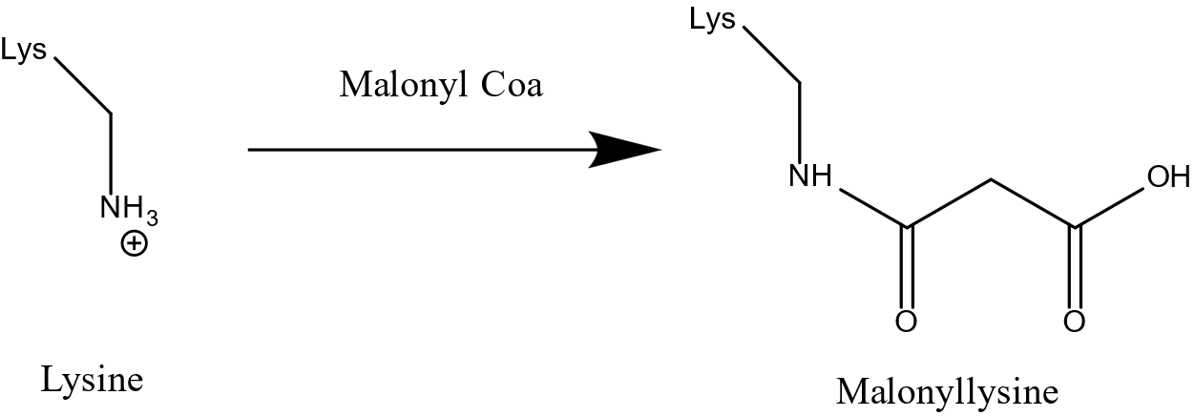

Fig. S1 Changes in the malonylation structure of lysine

