Supplemental information

Supplemental Methods

Metabolomics by CE-TOFMS
Metabolomics using mouse liver tissue was carried out through a facility service at Human Metabolome Technology (HMT) Inc. (Tsuruoka, Japan). Capillary electrophoresis time-of-flight mass spectrometry (CE-TOFMS) was carried out using an Agilent CE Capillary Electrophoresis System equipped with an Agilent 6210 Time of Flight mass spectrometer, Agilent 1100 isocratic HPLC pump, Agilent G1603A CE-MS adapter kit, and Agilent G1607A CE-ESI-MS sprayer kit (Agilent Technologies, Waldbronn, Germany). The systems were controlled by Agilent G2201AA ChemStation software version B.03.01 for CE (Agilent Technologies, Waldbronn, Germany). The metabolites were analyzed by using a fused silica capillary (50 μm i.d. × 80 cm total length) with commercial electrophoresis buffer (Solution ID: H3301-1001 for cation analysis and H3302-1021 for anion analysis, Human Metabolome Technologies) as the electrolyte. The sample was injected at a pressure of 50 mbar for 10 sec (approximately 10 nL) in the cation analysis and 25 sec (approximately 25 nL) in the anion analysis. The spectrometer was scanned from m/z 50 to 1,000. Other conditions followed the methods as described previously. ¹ Peaks were extracted using the automatic integration software MasterHands (Keio University, Tsuruoka, Japan) in order to obtain peak information including m/z, migration time for CE-TOFMS measurement and peak area. ² Signal peaks corresponding to isotopomers, adduct ions, and other product ions of known metabolites were excluded, and remaining peaks were annotated with putative metabolites from the HMT metabolite database based on their migration times and m/z values determined by TOFMS.

Pathway Enrichment Analysis on Metabolites
Results from pathway analysis were shown in supplementary materials. The Total Metabo is the total number of metabolites in the pathway; the Hits is the actually matched number of metabolites. The Impact is the pathway impact value calculated from pathway topology analysis. Pathway topology analysis was performed using MetaboAnalyst, incorporating statistical significance (p-values) and topological measures (e.g., betweenness centrality) to calculate pathway impact values for metabolic pathways.³

RNA sequencing and Data Analysis
RNA sequencing analysis using mouse liver tissue was carried out through a facility service at Amelieff Inc. (Tokyo, Japan).
Library preparation for transcriptome sequencing
Sequencing libraries were generated using NEBNext® UltraTM RNA Library Prep Kit for Illumina®(NEB, USA, Cat No. 7760) following manufacturer’s protocol ³ and index codes were added to attribute sequences to each sample. Finally, the resulting libraries were purified (AMPure XP system) and library quality was assessed on the Agilent Bioanalyzer 2100 system.The purified libraries were sequenced on a Novaseq 6000 (Illumina) with a 150-base pair-end read setting.

NGS read preprocessing and alignment
First, sequence quality was checked using FastQC ⁴ and MultiQC ⁵ with --export option. Next, Trimmomatic ⁶ was used to remove adapter sequences and PRINSEQ-lite ⁷ was used to remove the poly A/T tail, short sequence length reads, and trim low-quality bases at the extremity of the reads. Reads were aligned to the Mus musculus reference genome (mm39) using STAR ⁸.

Quantification of expression levels and differentially expressed genes (DEG) analysis
Gene expression levels were calculated using the featureCount function from the Subread ⁹, and differentially expressed genes (DEG) analysis were determined using the R package edgeR ¹⁰. In DEG analysis, gene expressions were normalized to cpm (counts per million), and genes expressed in less than 2 samples were removed Expression level after TMM normalization was used for DEG analysis.

Supplemental Table S1: Cardiometabolic Criteria for Adult
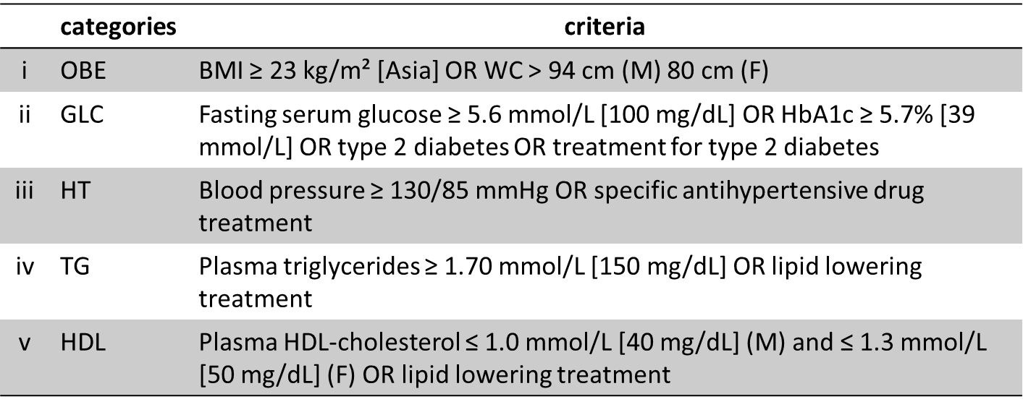
We defined cardiometabolic criteria to 5 categories in this study. M: Male, F: Female.
OBE: obesity, GLC: glucose, HT: hypertension, TG: triglyceride

Supplemental Table S2: Composition of experimental diets for mice.
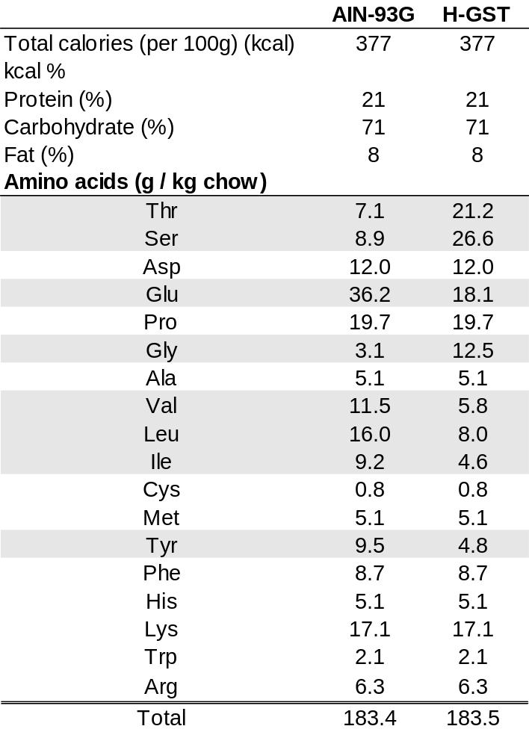
AIN-93G: American Institute of Nutrition 1993 Growth, H-GST: high glycine, serine and threonine

Supplemental Table S3: The comparison of FAAs in MASLD patients with or without insulin resistance.
The homeostatic model assessment for IR (HOMA-IR) above 2.5 defined insulin resistance as positive. Data are presented as means ± SD. *<0.05vs. CC-SLD-

Supplemental Table S4: The difference of FAAs according to pathological features in liver of MASLD.
Data are presented as means ± SD. *<0.05 vs steatosis 1, vs inflammation 0-1, vs ballooning 0

Supplemental Table S5: The change of FAAs by progression in patients with MASH.
Data are presented as means ± SD. *<0.05vs. MASLD
F0-1: fibrosis stage 0 and 1. F2, F3 and F4 were fibrosis stages 2, 3, and 4, respectively.

Supplemental Table S6: The imbalance of FAAs in liver induced by FFC diet.
Fifty-week male C56Bl/6J wild type mice were fed each diet (NC, n = 5; FFC, n = 5) for 20 weeks. Eight-week male C56Bl/6J wild type mice were fed each diet (NC, n = 5; FFC, n = 5) for 20 or 2 weeks. Values were nmol / g (liver). Data are presented as means ± SD. *<0.05 between NC and FFC. NC: normal chow, FFC: high-fat, fructose and cholesterol

Supplemental Figure Legends

Supplemental Figure S1: Age and sex matching between MASLD and CC+SLD- or CC-SLD-.
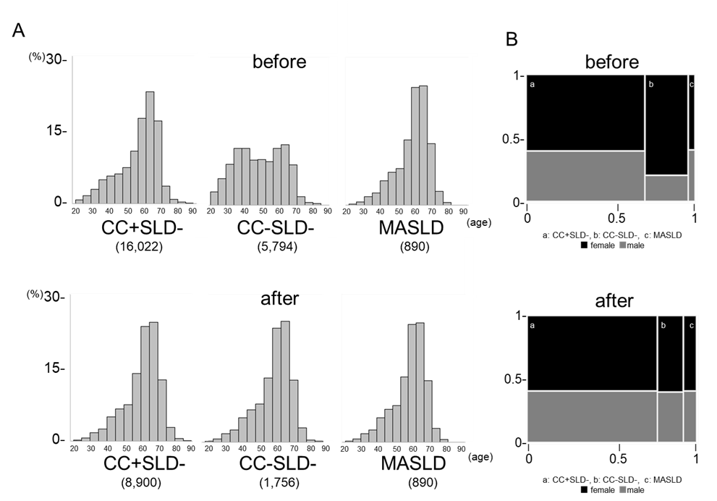
(A) Age distribution in CC+SLD-, CC-SLD- and MASLD before and after matching. The Vertical axis shows the percentage of the total number. The horizontal axis represents age in 10-year intervals. Numbers in parentheses indicate the number of cases. (B) Sex distribution in CC+SLD-, CC-SLD- and MASLD before and after matching. The Vertical axis shows the sex ratio, and horizontal axis shows the ratio of subject numbers among groups. Black tiles mean female and grey tiles mean male.
MASLD: metabolic dysfunction-associated steatotic liver disease
CC+SLD-: cardiometabolic criteria positive and steatotic liver disease negative
CC-SLD-: cardiometabolic criteria negative and steatotic liver disease negative

Supplemental Figure S2: Flow chart of the retrospective study.
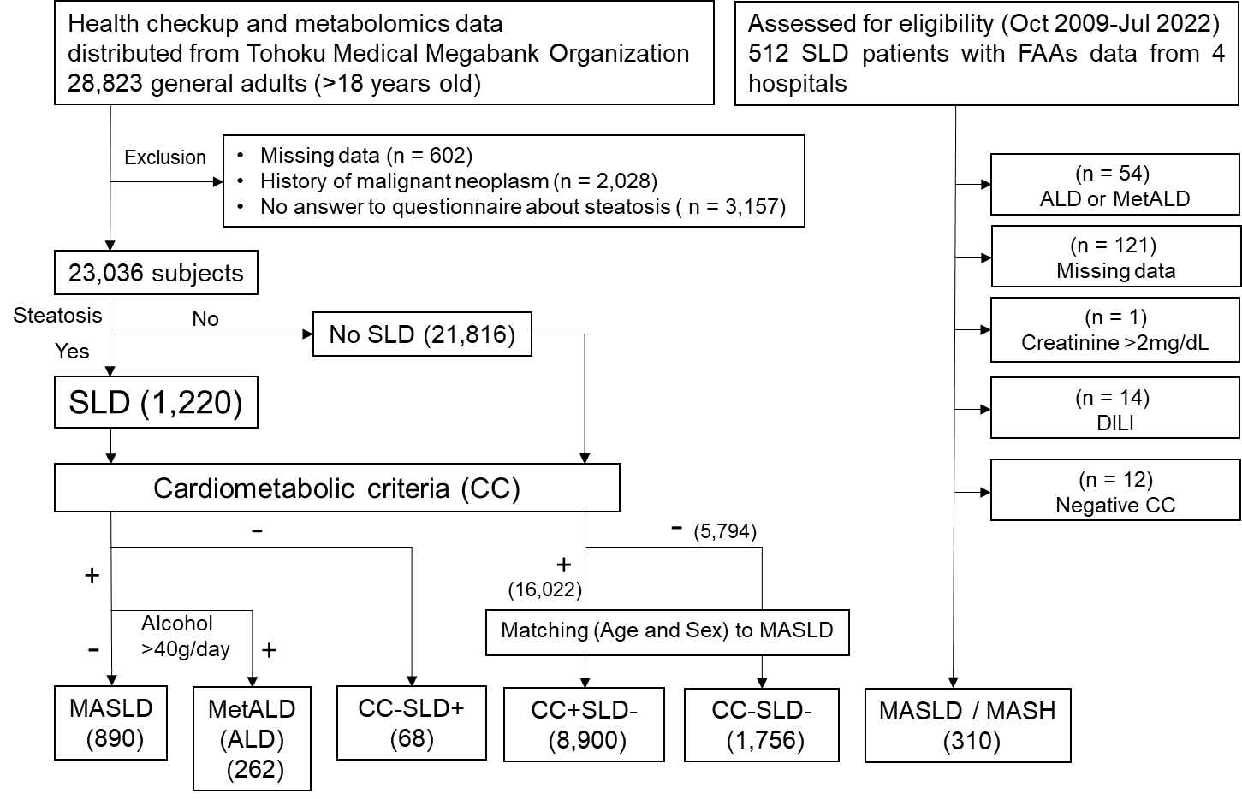
SLD: Steatotic liver disease, ALD: alcoholic liver disease
MASLD: metabolic dysfunction-associated steatotic liver disease
MetALD: metabolic dysfunction and alcohol-associated liver disease
CC-SLD-: cardiometabolic criteria negative and steatotic liver disease negative
CC+SLD-: cardiometabolic criteria positive and steatotic liver disease negative
CC-SLD+: cardiometabolic criteria negative and steatotic liver disease positive
MASH: metabolic dysfunction-associated steatohepatitis
DILI: drug-induced liver injury

Supplemental Figure S3: The percentages of cardiometabolic abnormalities in CC+SLD-, MASLD, and ALD
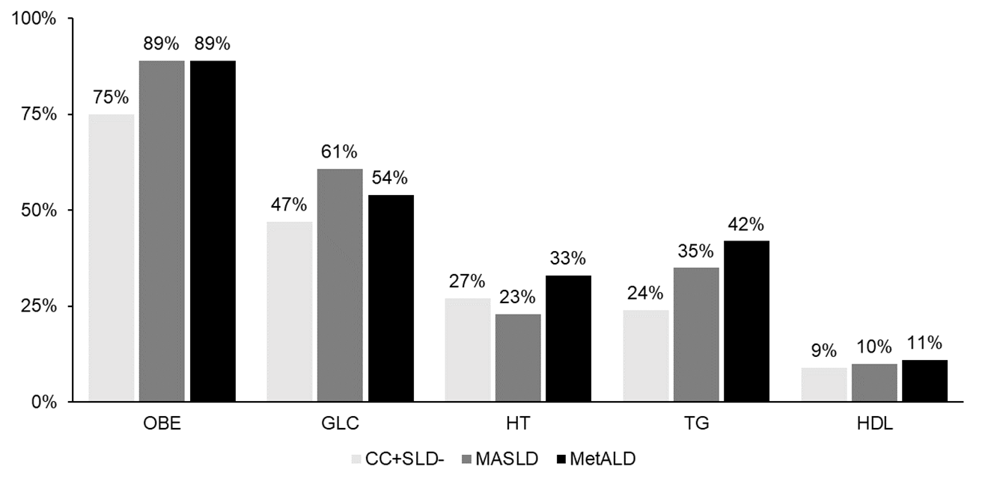
OBE, GLC, HT, TG and HDL were categories in cardiometabolic criteria (Supplementary Table S1). Numbers in parentheses indicate the number of cases. *<0.05vs. CC+SLD-
CC+SLD-: Cardiometabolic criteria positive and steatotic liver disease negative.
MASLD: metabolic dysfunction-associated steatotic liver disease
MetALD: metabolic dysfunction and alcohol-associated liver disease
OBE: obesity, GLC: glucose, HT: hypertension, TG: triglyceride

Supplemental Figure S4: FFC diet induced mitochondrial dysfunction and the imbalance of FAAs in liver
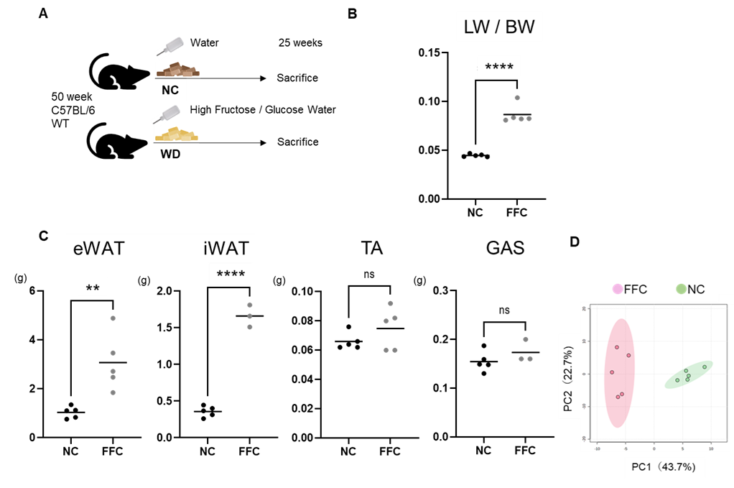
(A) Schematic representation of the experimental. Fifty-week male C56BL/6J wild mice were fed each diet (NC, n = 5; FFC, n = 5) for 25 weeks. (B) liver weight (LW) to body weight (BE) ratio. ****p<0.0001 (C) Comparison of epididymal white adipose tissue (eWAT), intrascapular white adipose tissue (iWAT), tibialis anterior (TA), and gastrocnemius (GAS). **p<0.01, ****p<0.0001. (D) Principal component analysis (PCA) between FFC diet and NC.
NC: normal chow, WD: western diet, FFC: high-fat, fructose and cholesterol

Supplemental Figure S5: Dietary intervention by Gly, Ser and Tyr ameliorated the pathogenesis of MASLD model mice.
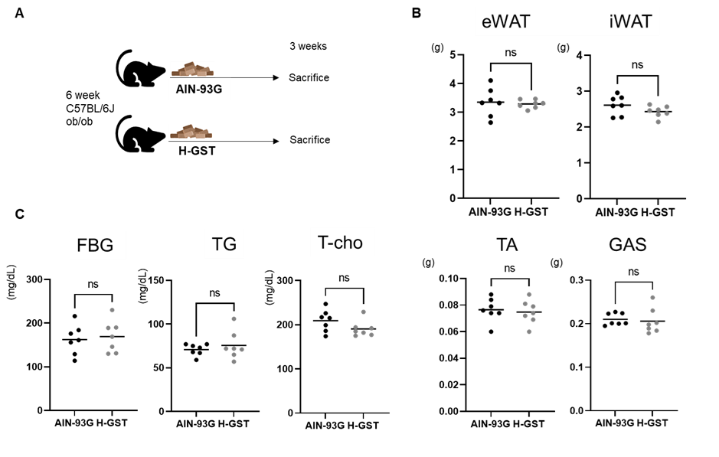
(A) Schematic representation of the experimental. Six-week male C56BL/6J ob/ob mice were fed each diet (AIN-93G, n = 7; H-GST, n = 7) for 3 weeks. (B) Comparison of epididymal white adipose tissue (eWAT), intrascapular white adipose tissue (iWAT), tibialis anterior (TA), and gastrocnemius (GAS). ns: not significant. (C) The comparison of fasting blood glucose, triglyceride, and cholesterol levels between AIN-93G and H-GST. FBG: fasting blood glucose, TG: triglyceride, T-cho: total cholesterol.
AIN-93G: American Institute of Nutrition 1993 Growth, H-GST: high glycine, serine and threonine

References
1. Soga T, Heiger DN (2000) Amino acid analysis by capillary electrophoresis electrospray ionization mass spectrometry. Anal Chem 72:1236–1241
2. Sugimoto M, Wong DT, Hirayama A, et al (2010) Capillary electrophoresis mass spectrometry-based saliva metabolomics identified oral, breast and pancreatic cancer-specific profiles. Metabolomics 6:78–95
3. Aittokallio T, Schwikowski B (2006) Graph-based methods for analysing networks in cell biology. Brief Bioinform 7:243–255
4. NEBNext® Ultra™ II RNA Library Prep Kit for Illumina® manual. Available online at: https://www.neb.com/en/-/media/nebus/files/manuals/manuale7770.pdf
5. Andrews S. (2010) FastQC: a quality control tool for high throughput sequence data. Available online at: http://www.bioinformatics.babraham.ac.uk/projects/fastqc
6. Ewels P. et al. (2016) MultiQC: summarize analysis results for multiple tools and samples in a single report. Bioinformatics
7. Bolger AM. et al. (2014) Trimmomatic: a flexible trimmer for Illumina sequence data. Bioinformatics
8. Schmieder R. et al. (2011) Quality control and preprocessing of metagenomic datasets. Bioinformatics
9. Dobin A. et al. (2013) STAR: ultrafast universal RNA-seq aligner. Bioinformatics
10. Liao Y. et al. (2013) The Subread aligner: fast, accurate and scalable read mapping by seed-and-vote. Nucleic Acids Res
11. Robinson MD. et al. (2010) edgeR: a Bioconductor package for differential expression analysis of digital gene expression data. Bioinformatics

