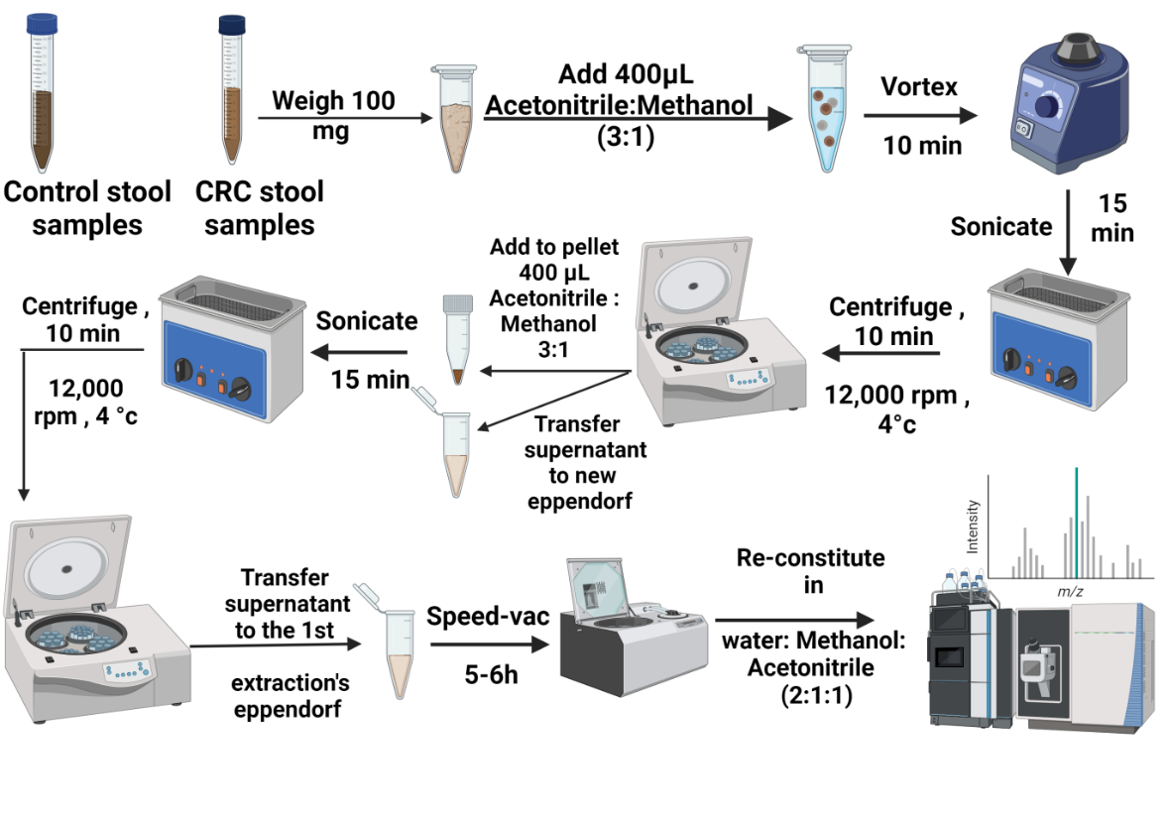
Fig. S1 Schematic representation of the sample processing for metabolomics analysis.

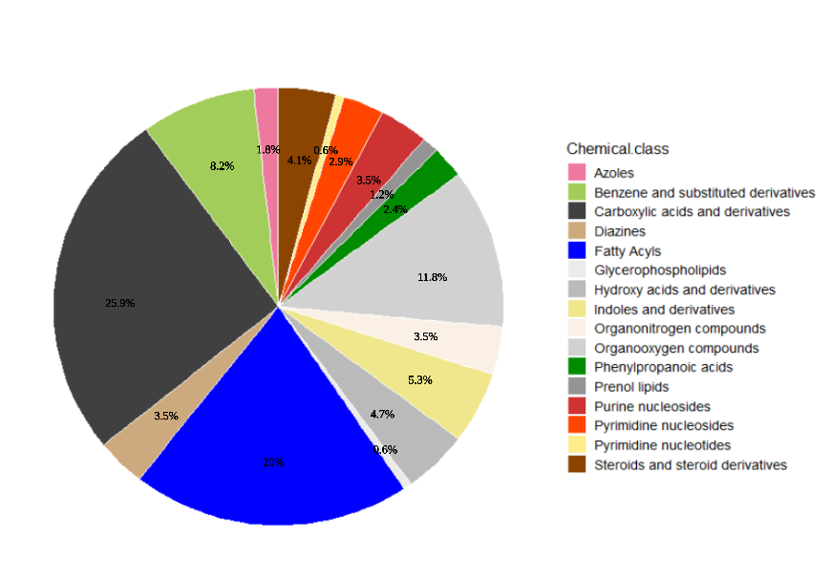
Fig. S2 Pie chart represents the chemical class quantitative enrichment analysis for the profiled metabolites.

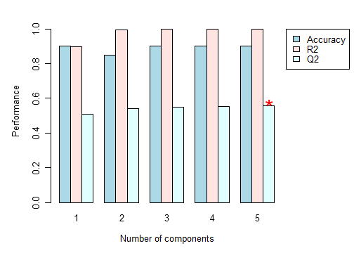
Fig. S3 The validation of PLS-DA.

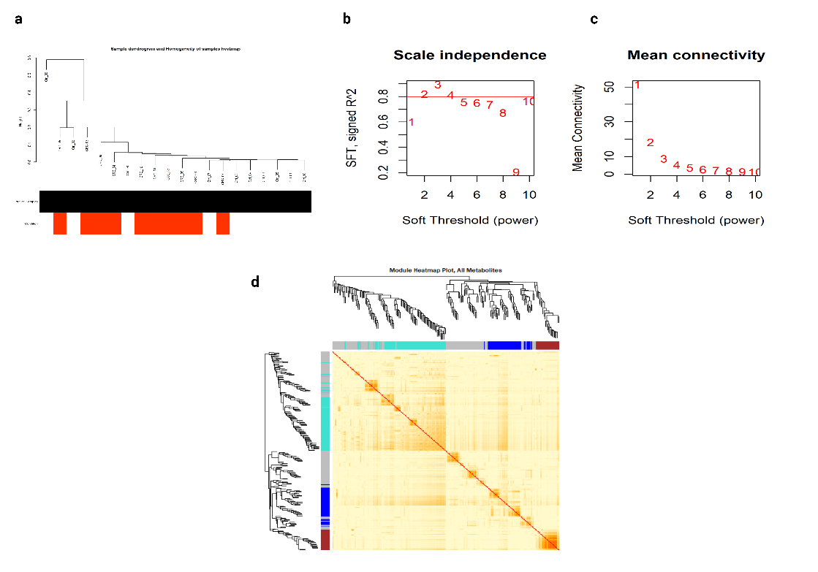
Fig. S4 Analysis of the metabolomics network topology WGCNA. (a) Clustering dendrograms of samples, representing the homogeneity of samples. The light color at the bottom represents the control group, while the orange color represents the CRC group. No outlier was detected. (b) Scatter plot corresponding to the scale-free fit index (y-axis) as a function of the soft-thresholding power (x-axis), the red line represents the cut-off 0.8. (c) Scatter plot corresponding to the mean connectivity (degree, y-axis) as a function of the soft-thresholding power (x-axis). (d) Visualizing metabolite network using a heatmap plot. The heatmap depicts the topological overlap matrix (TOM) among all metabolites in the analysis, together with the assigned module colors.

