Supplementary data

Supplementary file 1: the Menopause Symptom Questionnaire

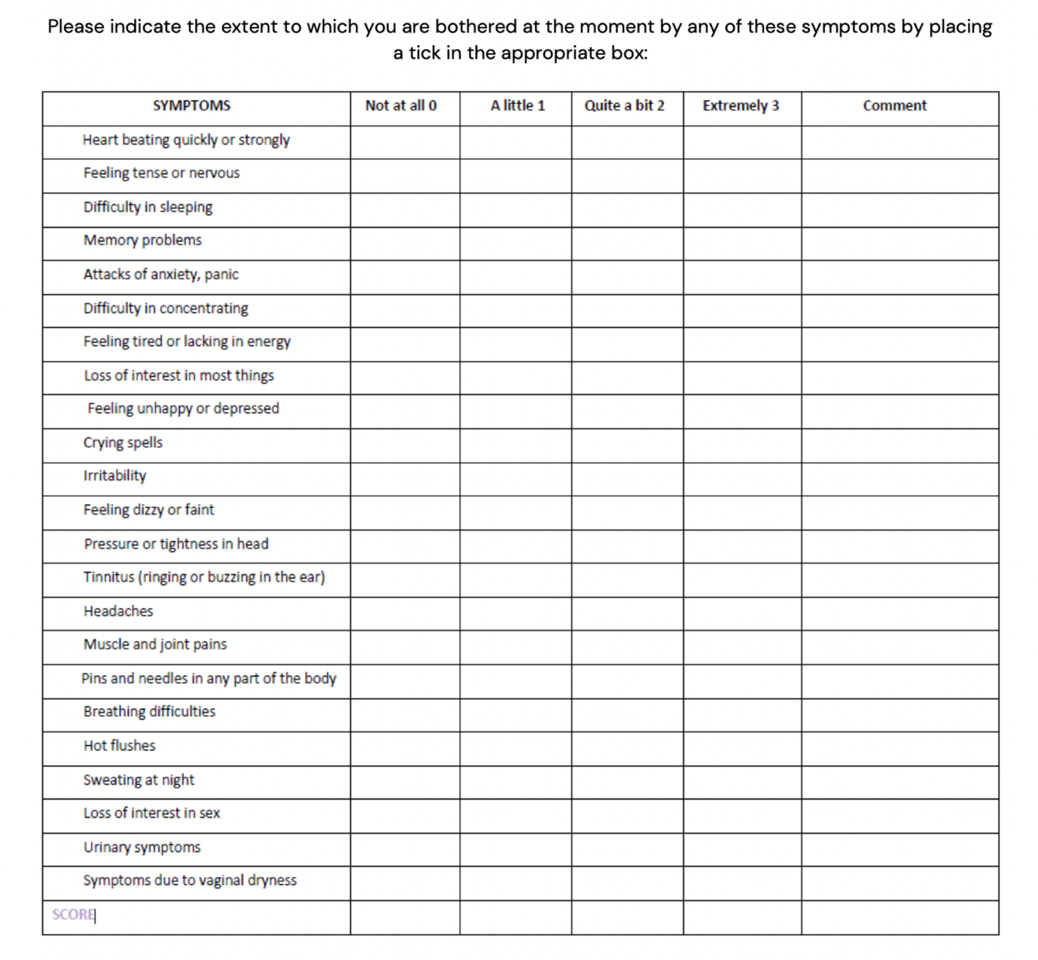

Supplementary file 2: Patient demographic data.

 | N=510
Mean Age (years) | 54.0 [50.0;58.0]
Age Group, n (%)  < 40 years  40-49  50-59  > 60 | 3 (0.59)  116 (22.7)  307 (60.2)  84 (16.5)
Menopausal status, n (%)  Perimenopausal  Postmenopausal | 171 (33.5%)  339 (66.5%)
Mean BMI (+/- SD) | 24.8 [22.6;28.6]
Alcohol, n (%)  Yes  No | 396 (77.6%)  114 (22.4%)
Smoking, n (%)  Yes  No | 13 (2.6%)  497 (97.5%)
HRT regimen, n (%)  Oestrogen-only  Combined (oestrogen + progestogen) | 48 (9.4%)  462 (90.6%)
Testosterone formulation, n (%)  Androfeme  Testim  Testogel | 443 (86.8%)  41 (8.0%  26 (5.2%)
Antidepressant use  Yes  No | 88 (17.3%)  422 (82.7%)

Supplemental file 3: Patients whose symptoms worsened or didn’t change across the study interval.

Symptom | Number of patients who reported no change in score at 4 months |  | Number of patients who reported a worsening of symptoms (increase in score) at 4 months
 | n | % | n | %
Cognitive symptoms
Feeling tired or lacking in energy | 217 | 42.5 | 92 | 18.0
Memory problems | 292 | 57.3 | 61 | 12.0
Difficulty in concentrating | 273 | 53.5 | 63 | 12.4
Mood symptoms
Feeling tense or nervous | 280 | 54.9 | 74 | 14.5
Irritability | 281 | 55.1 | 82 | 16.1
Feeling unhappy or depressed | 299 | 58.6 | 69 | 13.5
Loss of interest in most things | 263 | 51.6 | 64 | 12.5
Attacks of anxiety of panic | 298 | 58.4 | 68 | 13.3
Crying spells | 340 | 66.7 | 53 | 10.4
Loss of interest in sex | 213 | 41.8 | 32 | 6.3

Supplemental file 4: Patients without symptoms at baseline (score 0) who remained without symptoms at 4 months (score 0), or who developed symptoms during the study interval (score 1, 2 or 3).

Symptom | Number of patients without symptoms at baseline  (score 0) |  | Number of patients who reported no change at 4 months  (score 0) |  | Number of patients who reported a worsening of symptoms at 4 months  (score 1, 2 or 3)
 | n | % | n | % | n | %
Cognitive symptoms
Feeling tired or lacking in energy | 40 | 7.8 | 14 | 2.7 | 26 | 5.1
Memory problems | 48 | 9.4 | 30 | 5.9 | 18 | 3.5
Difficulty in concentrating | 83 | 16.3 | 52 | 10.2 | 31 | 6.1
Mood symptoms
Feeling tense or nervous | 95 | 18.6 | 59 | 11.6 | 36 | 7.1
Irritability | 118 | 23.1 | 72 | 14.1 | 46 | 9.0
Feeling unhappy or depressed | 183 | 35.9 | 138 | 27.1 | 45 | 8.8
Loss of interest in most things | 185 | 36.3 | 143 | 28.0 | 42 | 8.2
Attacks of anxiety of panic | 220 | 43.1 | 173 | 33.9 | 47 | 9.2
Crying spells | 298 | 58.4 | 260 | 51.0 | 38 | 7.5
Loss of interest in sex | 0 | 0 | 0 | 0 | 0 | 0

