Supplementary Material A
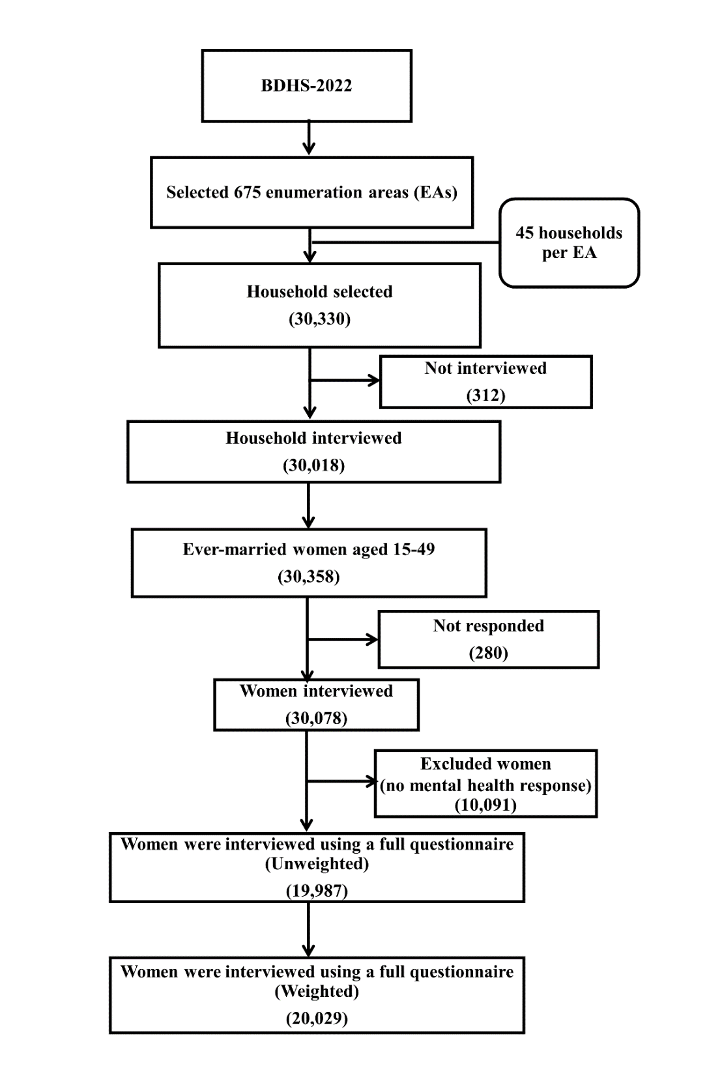
Figure S1: Flowchart of the sample selection

Section 1. Description of GAD-7 and PHQ-9 scale
GAD-7 is a 7-item self-reported tool consisting of seven items that measure the occurrence and intensity of generalised anxiety symptoms during the previous two weeks (Spitzer et al. 2006). Women’s responses were recorded using a four-point Likert scale ranging from 0 (Not at all) to 3 (Nearly every day). Total scores ranged from 0 to 21, with higher scores reflecting greater anxiety. The cumulative score, ranging from 0 to 21, delineates the following severity levels: no anxiety (scores 0–4), mild (scores 5–9), moderate (scores 10–14), and severe (scores 15–21) (Spitzer et al. 2006).
The PHQ-9 is a 9-items self-reported instrument made up of nine items that assess whether or not depressed symptoms have been present over the last two weeks (Kroenke et al. 2001). Participant responses were recorded on a four-point Likert scale ranging from 0 (Not at all) to 3 (Nearly every day). Total scores ranged from 0 to 27, with higher scores reflecting greater depression. The cumulative score, ranging from 0 to 27, delineates the following severity levels: no depression (scores 0–4), mild (scores 5–9), moderate (scores 10–14), moderately severe (scores 15–19), and severe (scores 20–27) (Kroenke et al. 2001). In this study, we combined the percentage of moderately severe and severe to report severe symptoms of depression.

References
Kroenke K, Spitzer RL, Williams JBW (2001) The PHQ-9: Validity of a brief depression severity measure. J Gen Intern Med 16:. https://doi.org/10.1046/j.1525-1497.2001.016009606.x
Spitzer RL, Kroenke K, Williams JBW, Löwe B (2006) A brief measure for assessing generalized anxiety disorder: The GAD-7. Arch Intern Med 166:. https://doi.org/10.1001/archinte.166.10.1092

