Supplementary Materials

- S1 Correlation Matrix
- S2 Correlation Heat Map (between items)
- S3 Correlation Heat Map (between dimensions)
- S4 Bootstrapped CI for Male Group
- S5 Bootstrapped CI for Female Group
- S6 Stability of Node BEI for Male Group
- S7 Stability of Node BEI for Female Group
- S8 Bootstrapped Difference Test for Node BEI and Edge Weights in Male Group
- S9 Bootstrapped Difference Test for Node BEI and Edge Weights in Female Group
- S10 Rumination-depression network structure including age-covariate

S1 Correlation Matrix
Variables | 1 | 2 | 3 | 4 | 5
1. Brooding | -
2. Reflection | 0.796*** | -
3. Negative Attitude | 0.588*** | 0.563*** | -
4. Performance Difficulty | 0.535*** | 0.561*** | 0.885*** | -
5. Somatic Elements | 0.546*** | 0.557*** | 0.832*** | 0.870*** | -
Note. ***p < 0.001. The mean value of each dimension was used as the index for calculation.

S2 Correlation Heat Map (between items)
Note. R5, R10, R13, R15, R16, form the Brooding dimension, R7, R11, R12, R20, R21, form the Reflection dimension. R5 = Think “What am I doing to deserve this?”, R10 = Think “Why do I always react this way?”, R13 = Think about a recent situation, wishing it had gone better, R15 = Think “Why do I have problems other people don’t have?”, R16 = Think “Why can’t I handle things better?”, R7 = Analyze recent events to try to understand why you are depressed, R11 = Go away by yourself and think about why you feel this way, R12 = Write down what you are thinking and analyze it, R20 = Analyze your personality to try to understand why you are depressed, R21 = Go someplace alone to think about your feelings; B1 = Sadness, B2 = Pessimism, B3 = Sense of failure, B4 = Lack of satisfaction, B5 = Guilt, B6 = Sense of punishment, B7 = Self-hate, B8 = Self-accusations, B9 = Self-punitive wishes, B10 = Crying spells, B11 = Irritability, B12 = Social withdrawal, B13 = Indecisiveness, B14 = Body image, B15 = Work inhibition, B16 = Sleep disturbance, B17 = Fatigability, B18 = Loss of appetite, B19 = Weight loss, B20 = Somatic preoccupation, B21 = Loss of libido. Blue indicates a positive correlation and red a negative correlation, with darker colours indicating a stronger correlation, corresponding to a larger correlation coefficient.

S3 Correlation Heat Map (between dimensions)
Note. Blue indicates a positive correlation and red a negative correlation, with darker colours indicating a stronger correlation, corresponding to a larger correlation coefficient. The numbers in the heat map grid indicate the Pearson correlation coefficients.

S4 Bootstrapped CI for Male Group
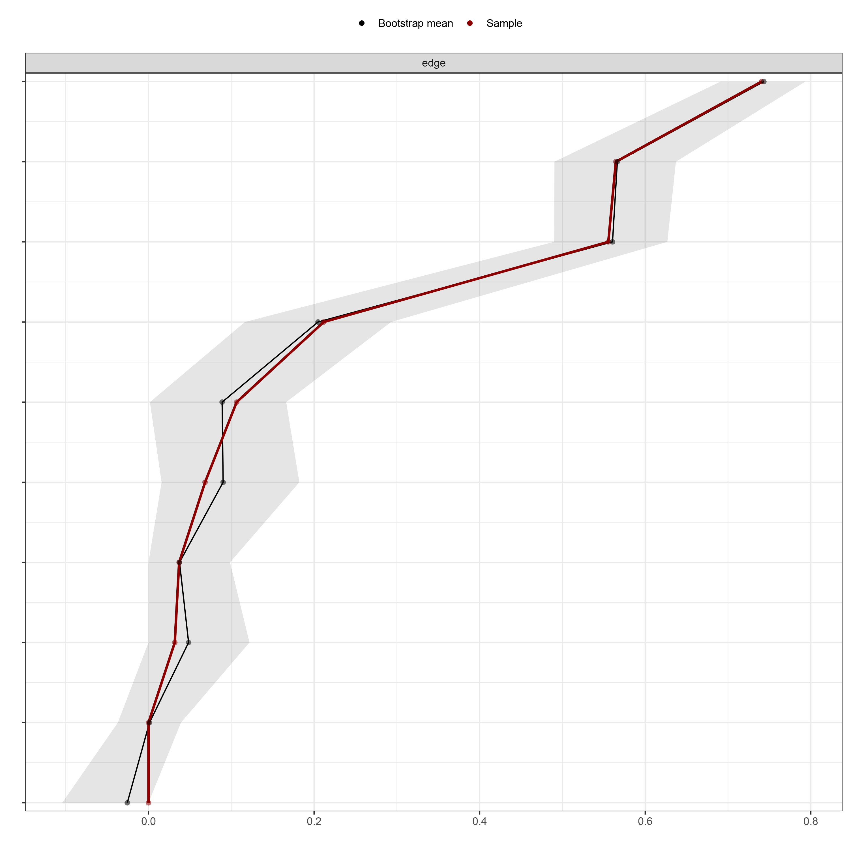
S5 Bootstrapped CI for Female Group
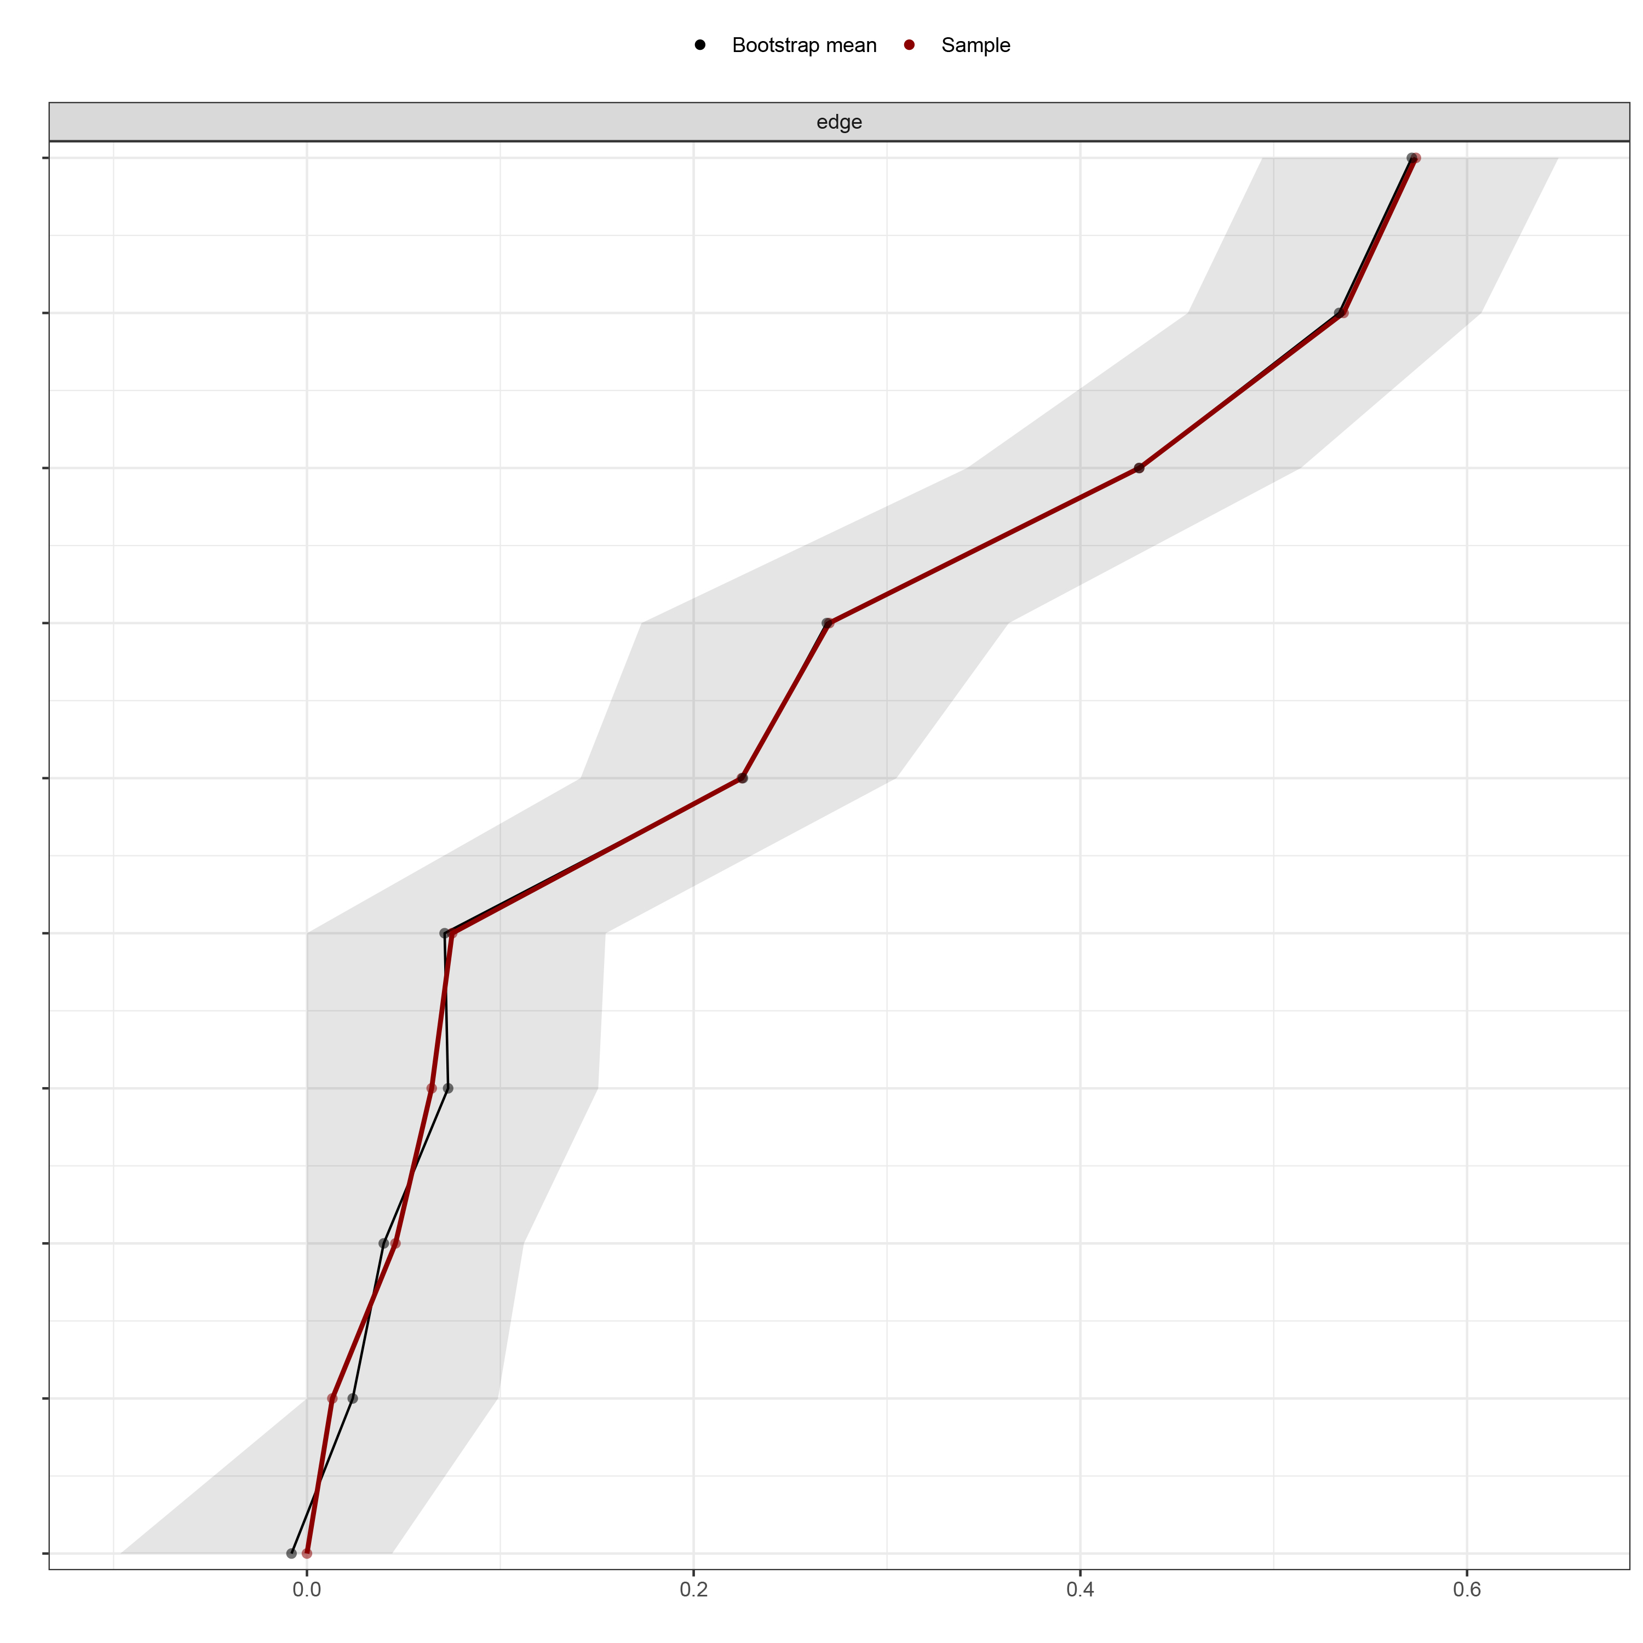
S4 and S5 Note. The red line depicts the sample edge weights and the gray bar depicts the bootstrapped confidence interval.
S6 Stability of Node BEI for Male Group
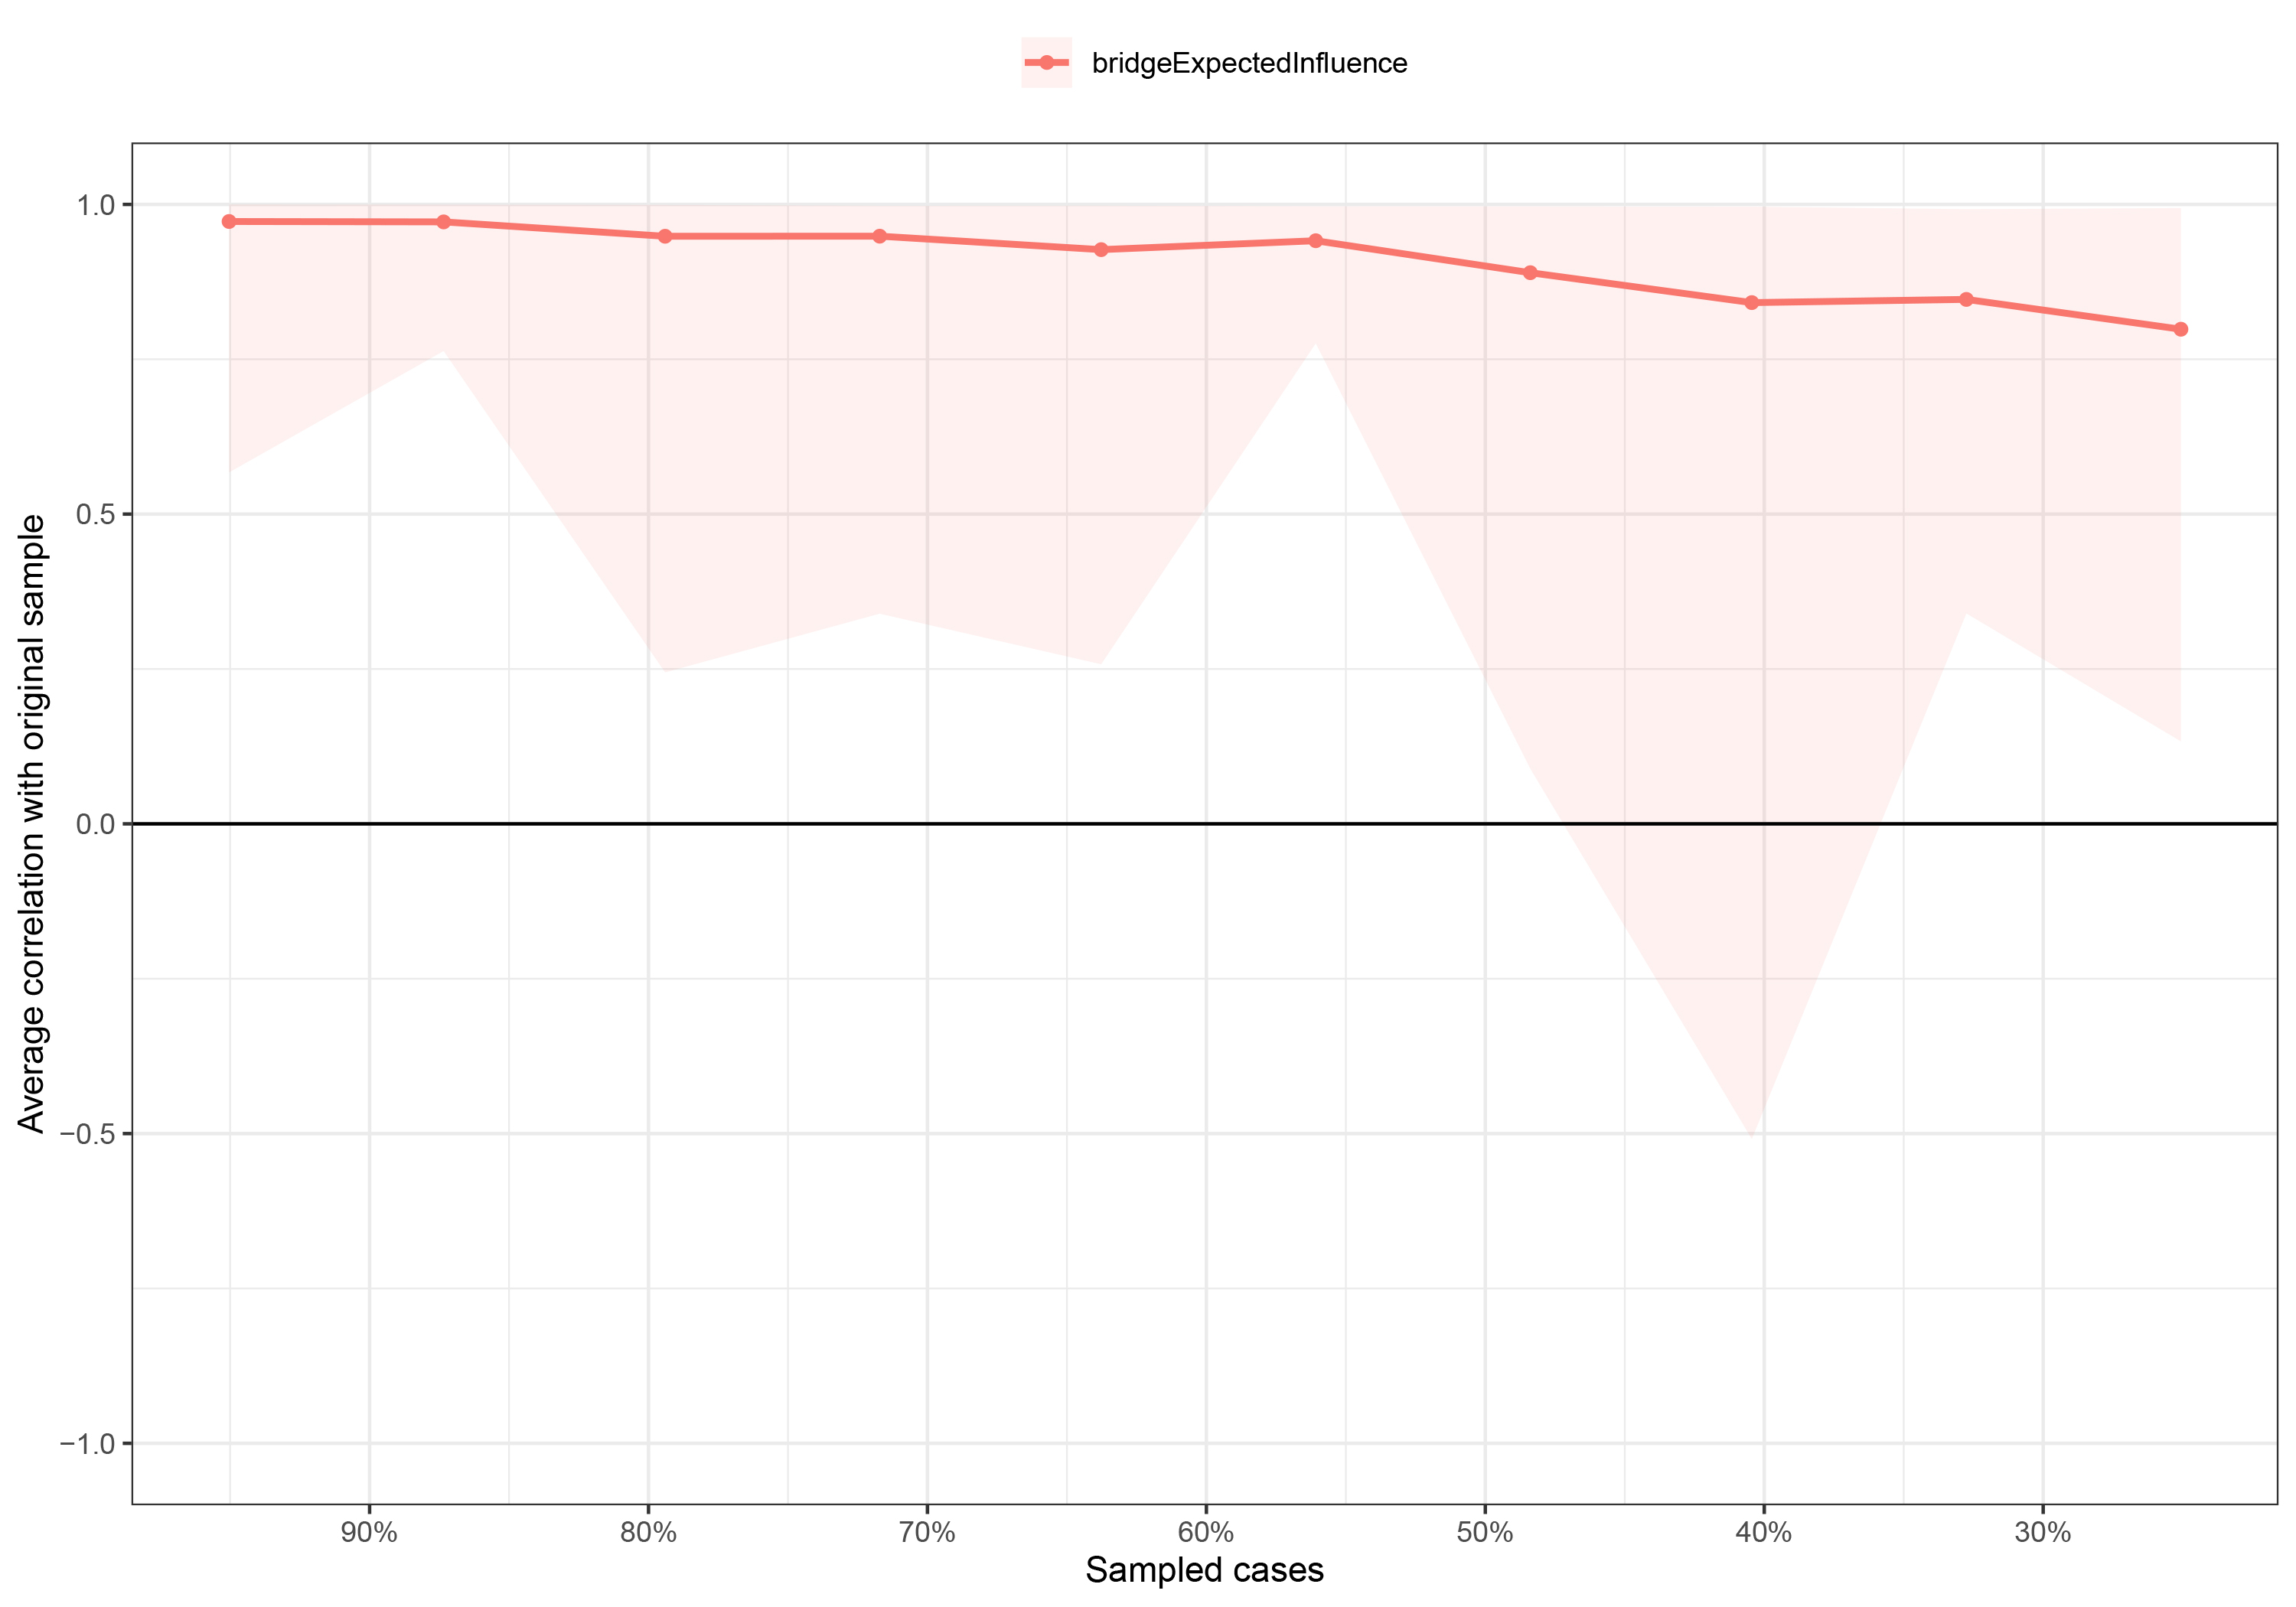

S7 Stability of Node BEI for Female Group
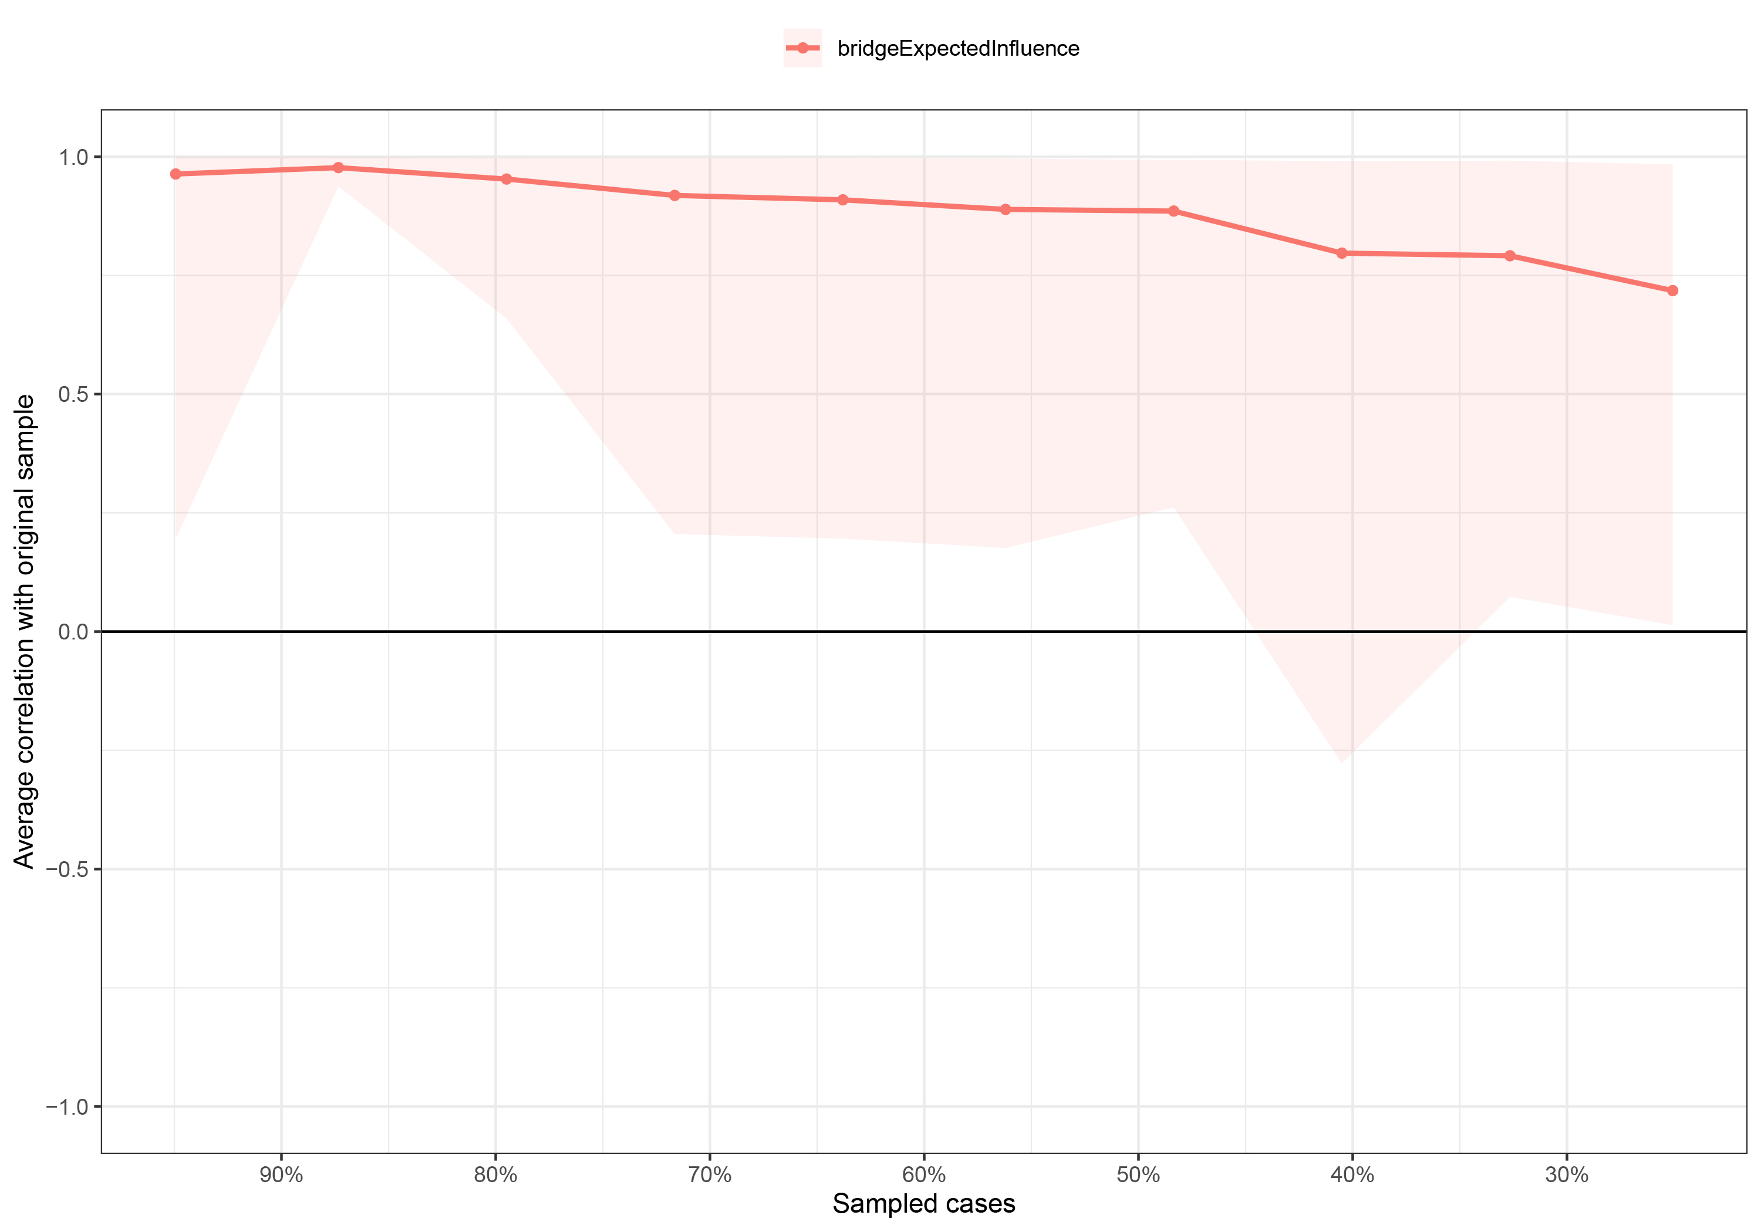
S6 and S7 Note. The red bar represents the average correlation between node bridge expected influences in the full sample and subsample with the red area depicting the 2.5th quantile to the 97.5th quantile.
S8 Bootstrapped Difference Test for Node BEI and Edge Weights in Male Group
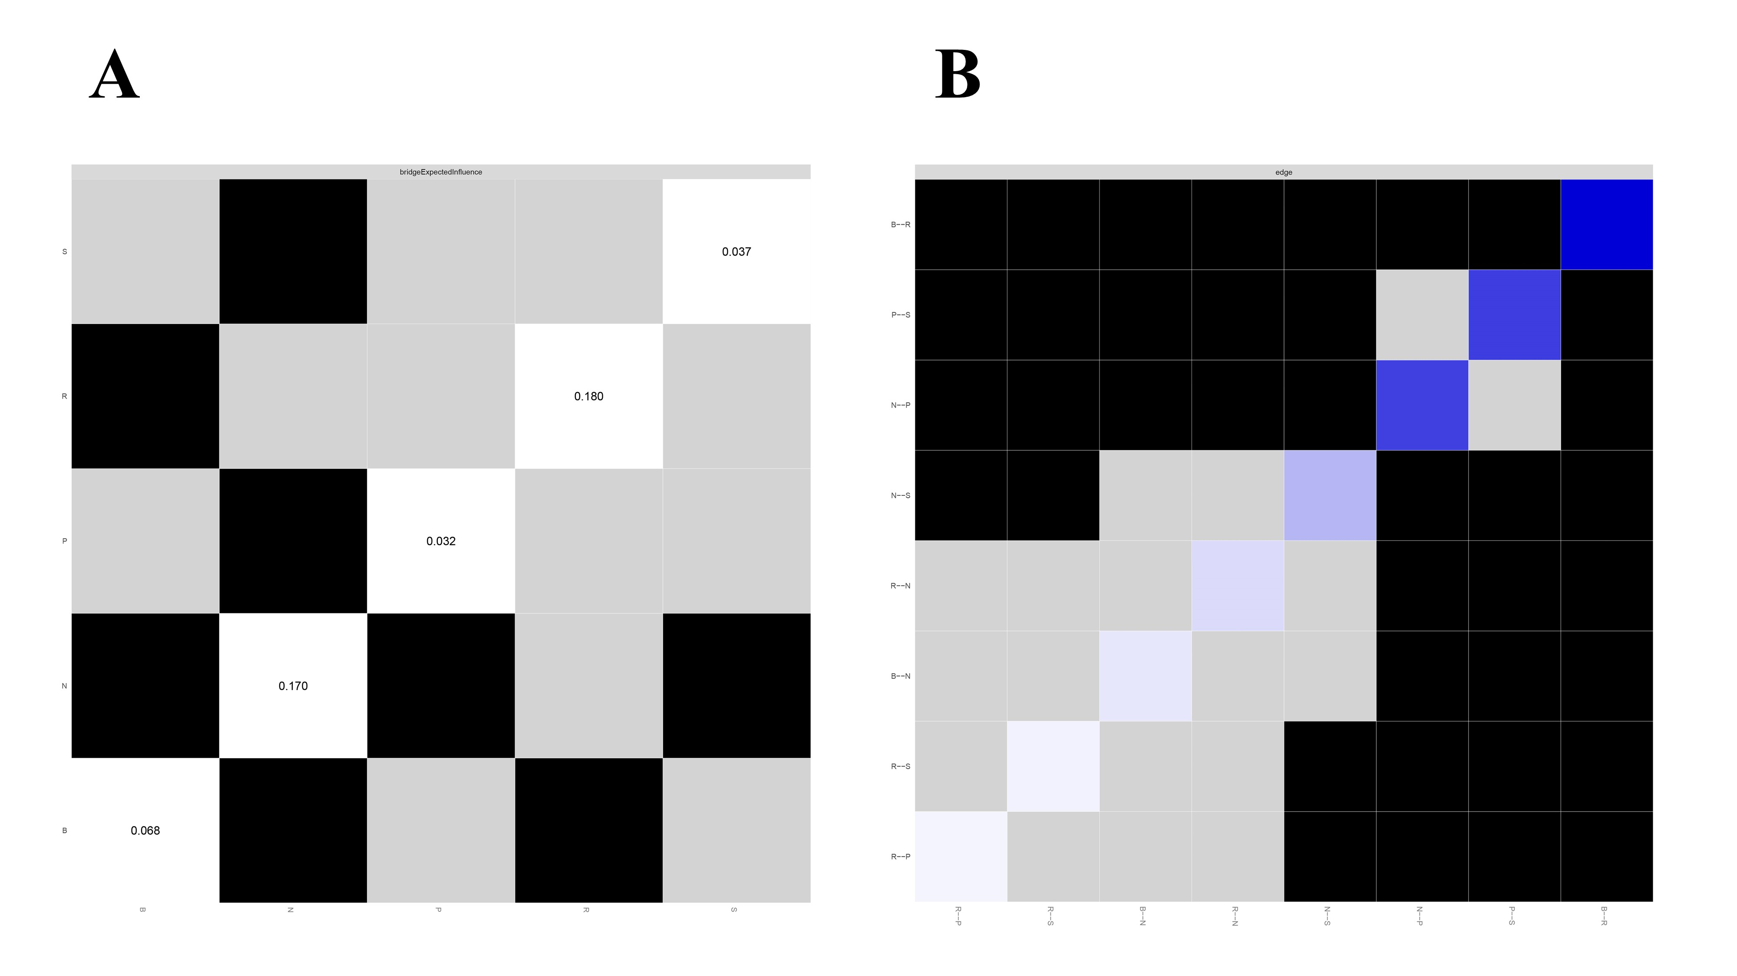
S9 Bootstrapped Difference Test for Node BEI and Edge Weights in Female Group
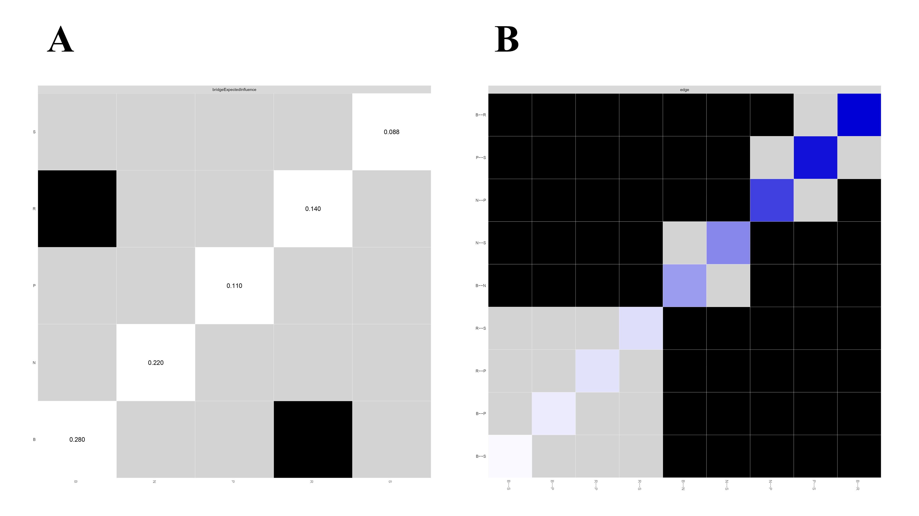
S8 and S9 Note. Graph A represents the node BEI difference test and Graph B represents the edge weight difference test. In graph A, gray boxes indicate node bridge expected influences that do not differ significantly from one another, while black boxes indicate node bridge expected influences that do differ significantly. In graph B, gray boxes indicate edge weights that do not differ significantly from one another, while black boxes indicate edge weights that do differ significantly. Blue and red boxes on the diagonal correspond to edge weights with positive and negative correlations, respectively.

S10 Rumination-depression network structure including age-covariate
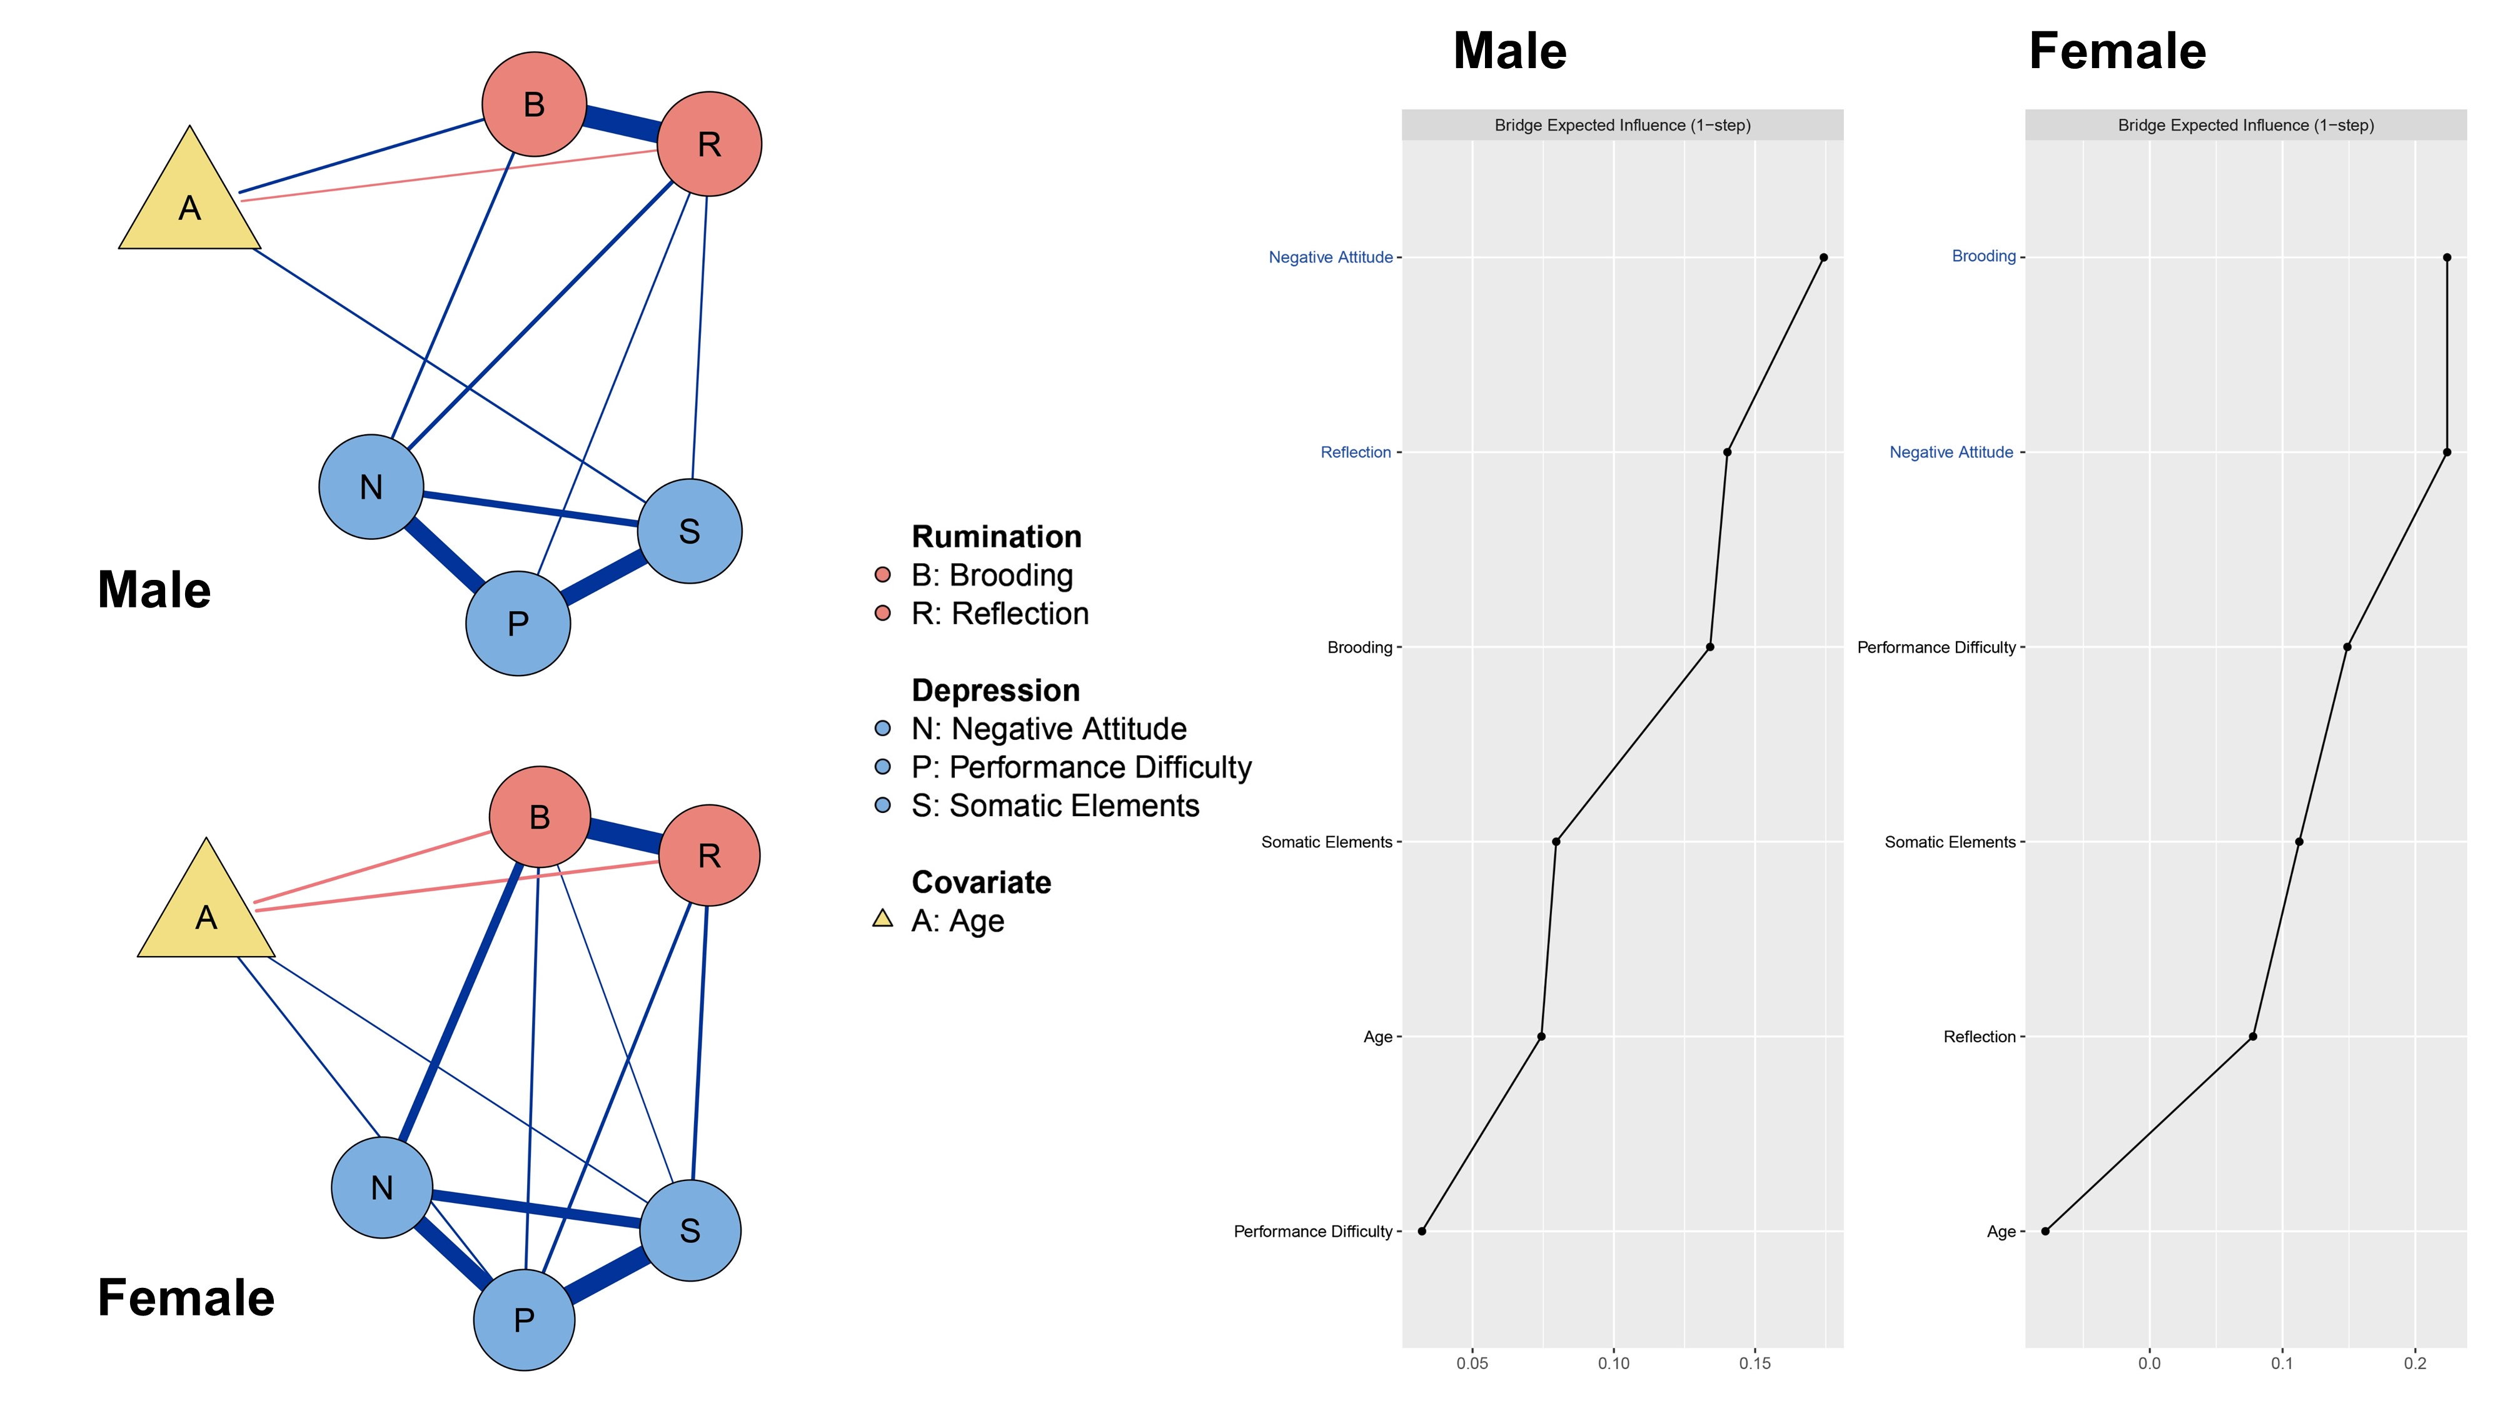
Note. The figure shows the structure of the rumination-depression network with covariates. The upper left figure shows the male group (N = 403) and the lower left figure shows the female group (N = 395); In the network visualization, rumination subtypes are depicted in red, while depressive symptoms are shown in blue. The yellow triangle represents the age covariate; Positive associations are indicated by blue lines, while negative associations are represented by red lines; Comparable subgroup networks have the same network arrangement to compare their internal structural differences more clearly; The line chart (right) depicts the BEI centrality index for each node in the male and female covariate-networks, with scores being z-standardized. The blue highlighted font indicates the highest BEI values in the different subgroups, representing the bridge nodes in the rumination and depression communities.

