Supplementary Figure 1. Flow-chart of the Bright Up study.
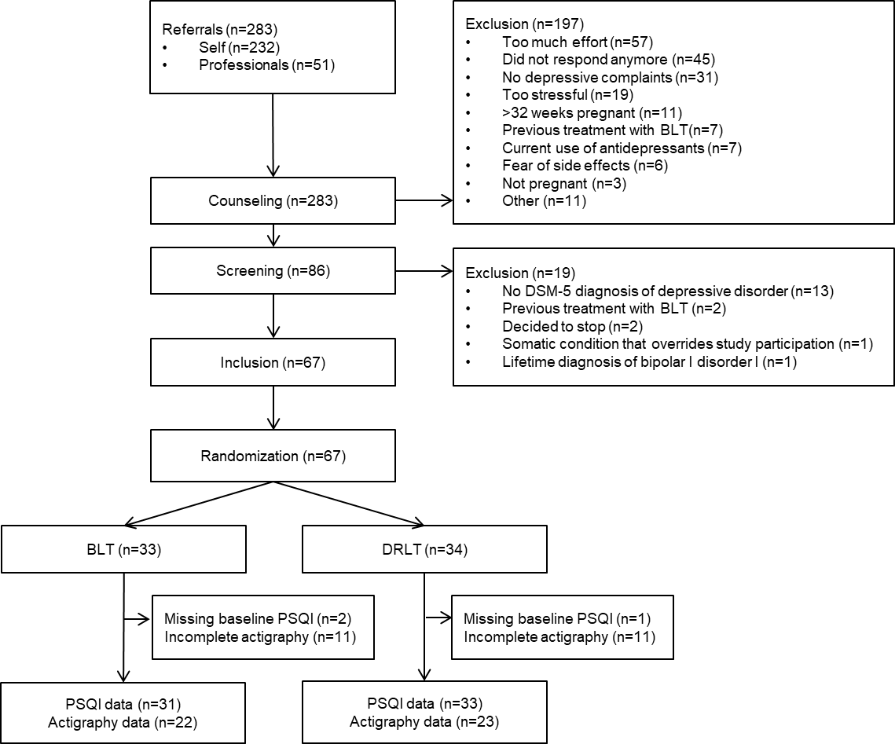

Supplementary Table 1. Effects of allocation on objective parameters of sleep, as measured by actigraphy, through the treatment period: allocation x time interaction term, based on full weeks (Monday through Sunday). Analyses are both crude and adjusted.
Outcome | β (95% CI) | p-value
Sleep efficiency | 0.23 (-0.40 – 0.85) | 0.474
Sleep duration | 4.17 (-5.05 – 13.38) | 0.373
Sleep onset latency | 0.35 (-1.66 - 2.37) | 0.730
* Analyses adjusted for SIGH-SAD score at baseline, gestational age at baseline, level of education as a proxy for socioeconomic status, parity, medication use (benzodiazepines and antidepressants), and chronotype.

