Supplementary Figures
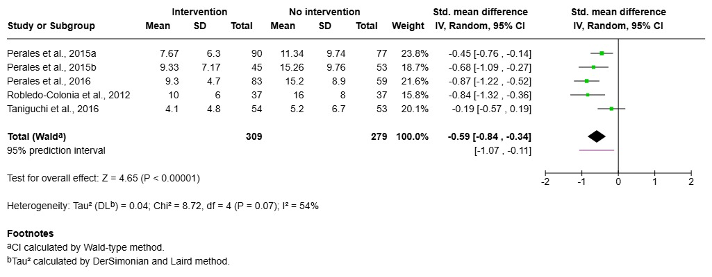
Supplementary Figure S1. Impact of structured physical activity on antenatal depressive symptoms compared with no intervention in prevention-oriented trials.

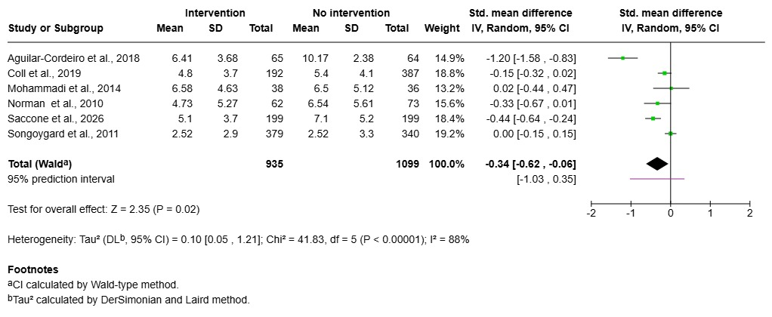
Supplementary Figure S2. Impact of structured physical activity on postpartum depressive symptoms compared with no intervention in prevention-oriented trials.

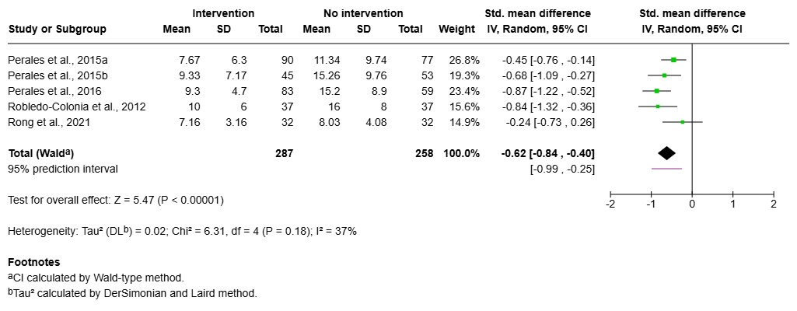
Supplementary Figure S3. Impact of physical activity performed three times per week for approximately 60 minutes on antenatal depressive symptoms compared with no intervention in prevention-oriented trials.

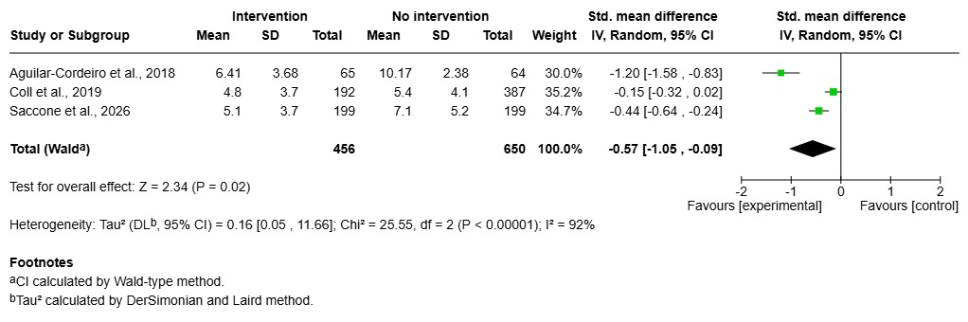
Supplementary Figure S4. Impact of physical activity performed three times per week for approximately 60 minutes on postpartum depressive symptoms compared with no intervention in prevention-oriented trials.

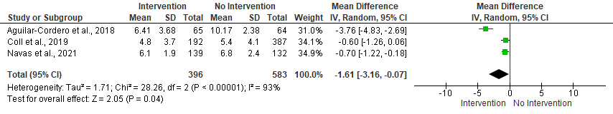
Supplementary Figure S5. Impact of moderate-intensity physical activity on postpartum depressive symptoms compared with no intervention in prevention-oriented trials (MD on EPDS, 0-30).

