Supplementary Figure
Supplementary Figure 1 Scatter plot in the mendelian randomization analysis of reproductive milestones and Major depressive disorder.
Supplementary Figure 2 Top enriched Gene Ontology (GO) terms in Biological Process (BP) .
Supplementary Figure 3 Protein - protein interaction (PPI) network.

A B
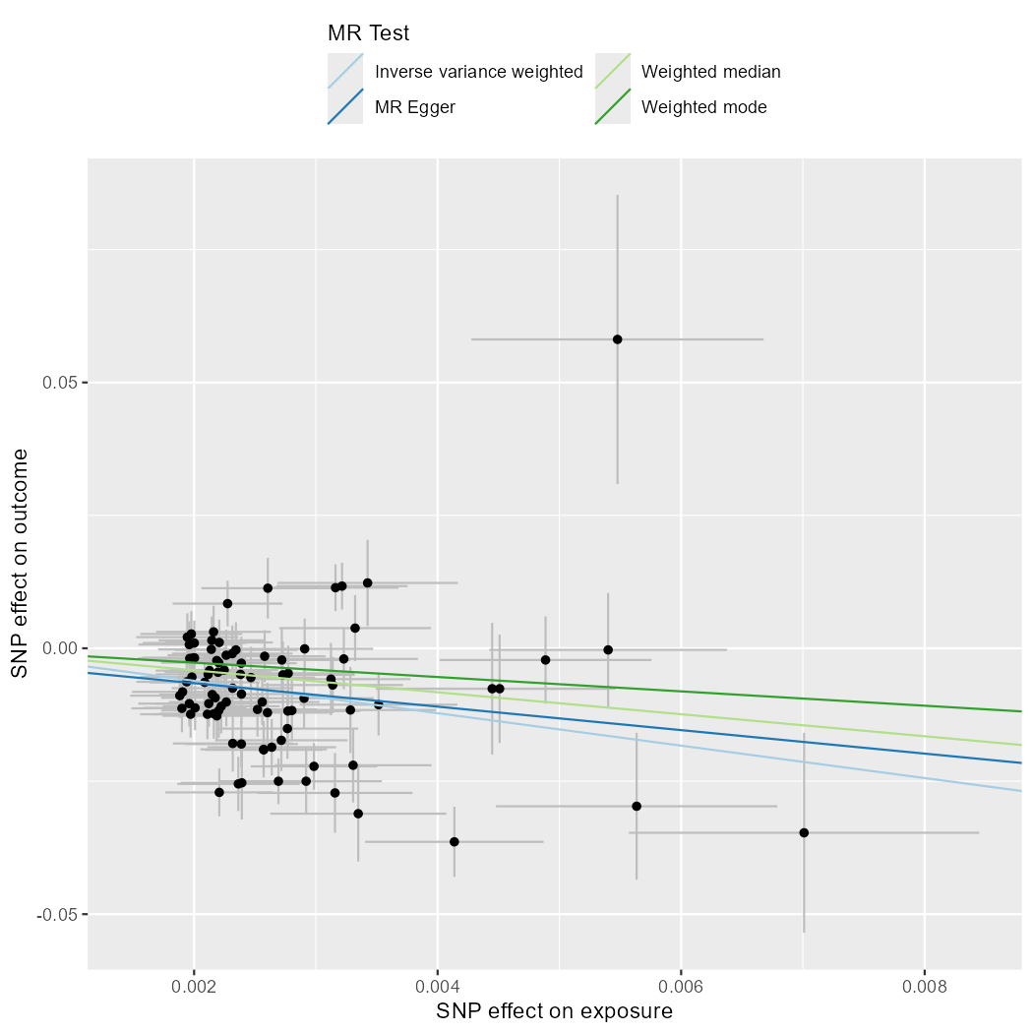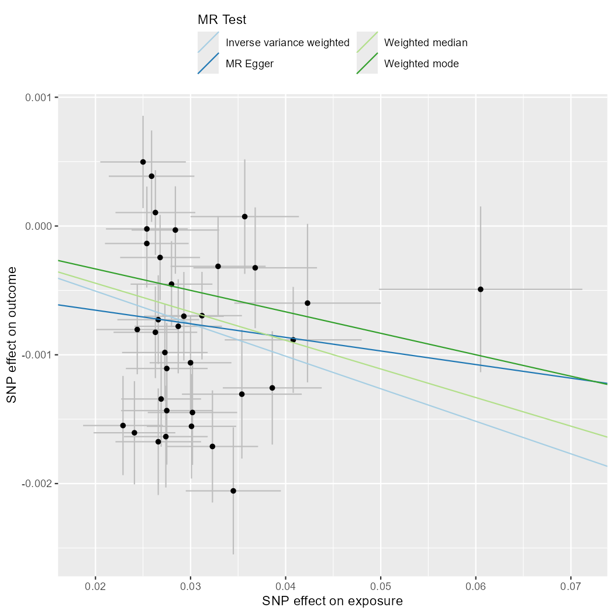

Supplementary Figure 2 Scatter plot in the mendelian randomization analysis of reproductive milestones and Major depressive disorder. (A) Causal effect of Common factor on Major depressive disorder; (B) Causal effect of Major depressive disorder on Common factor ;

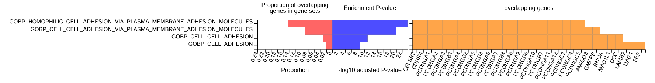
Supplementary Figure 2 Top enriched Gene Ontology (GO) terms in Biological Process (BP) .
The plot displays the top enriched GO terms for Biological Processes , with the x-axis representing the -log10(Adjusted p-value) and the y-axis listing the specific GO terms. Higher -log10(Adjusted p-value) indicates more significant enrichment;

Supplementary Figure 3 Protein - protein interaction (PPI) network.PPI network of PLACO-identified protein-coding genes for common factor and major depressive disorder;

