Supplementary Materials
Real-world Persistence and Compliance of Denosumab Versus Alendronate Among Postmenopausal Women With Osteoporosis in Asia-Pacific

Tang Ching Lau¹, Dong-Gune Chang², Chung-Hwan Chen³, Shuang Huang⁴, Edith MC Lau⁵, Sheung-Wai Law⁶, Young-Kyun Lee⁷, Cae Tolman⁸, Laura Canals⁹, See-Hwee Yeo¹⁰, Jing Yu¹¹, Peter R. Ebeling¹²
¹ Department of Medicine, Yong Loo Lin School of Medicine, National University of Singapore, Singapore, Singapore
² Department of Orthopedic Surgery, Inje University Sanggye Paik Hospital, College of Medicine, Inje University, Seoul, South Korea
³ Department of Orthopedics and Orthopedic Research Center, Kaohsiung Municipal Ta-Tung Hospital and Kaohsiung Medical University Hospital, College of Medicine; Regeneration Medicine and Cell Therapy Research Center, Kaohsiung Medical University, Kaohsiung, Taiwan
⁴ Amgen Inc., Thousand Oaks, California, United States of America
⁵ Hong Kong Orthopaedic and Osteoporosis Center for Treatment and Research, Hong Kong
⁶ Department of Orthopaedics and Traumatology, The Chinese University of Hong Kong, Hong Kong SAR, China
⁷ Seoul National University Hospital, Seoul National University College of Medicine, Seoul, South Korea
⁸ Amgen Australia, Sydney, Australia
⁹ Department of Medicine, Amgen Europe, Switzerland
¹⁰ Real World Solutions, IQVIA Solutions Asia, Singapore, Singapore
¹¹ Real World Solutions, IQVIA Solutions Asia, Beijing, China
¹² Department of Medicine, School of Clinical Sciences at Monash Health, Monash University, Melbourne, Australia

Corresponding authors:
Laura Canals
Address: Amgen GmbH, Suurstoffi 22, 6343 Rotkreuz, Switzerland
Telephone: +41 79 9645
Email: lcanals@amgen.com

Jing Yu
Address: IQVIA Data Science Advanced Analytics, The Exchange Twin Tower (West), B-12 Jianguomenwai Avenue, Chaoyang, Beijing, China
Telephone: +86 15219436846
Email: jyu2@cn.imshealth.com

Supplementary Figures and Tables
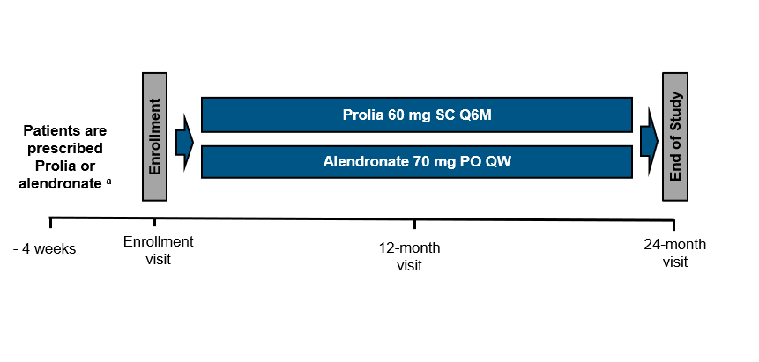
Supplementary Figure 1: Schematic diagram of study design.
Abbreviations: PO, orally; QW, weekly; Q6M, every 6 months; SC, subcutaneously.
ª At least 1 prescription for denosumab or alendronate should be provided to the patient before signing the informed consent form. A patient needs to be enrolled in the study within 4 weeks after receiving the first denosumab injection or first prescription of weekly alendronate for the current course of treatment.
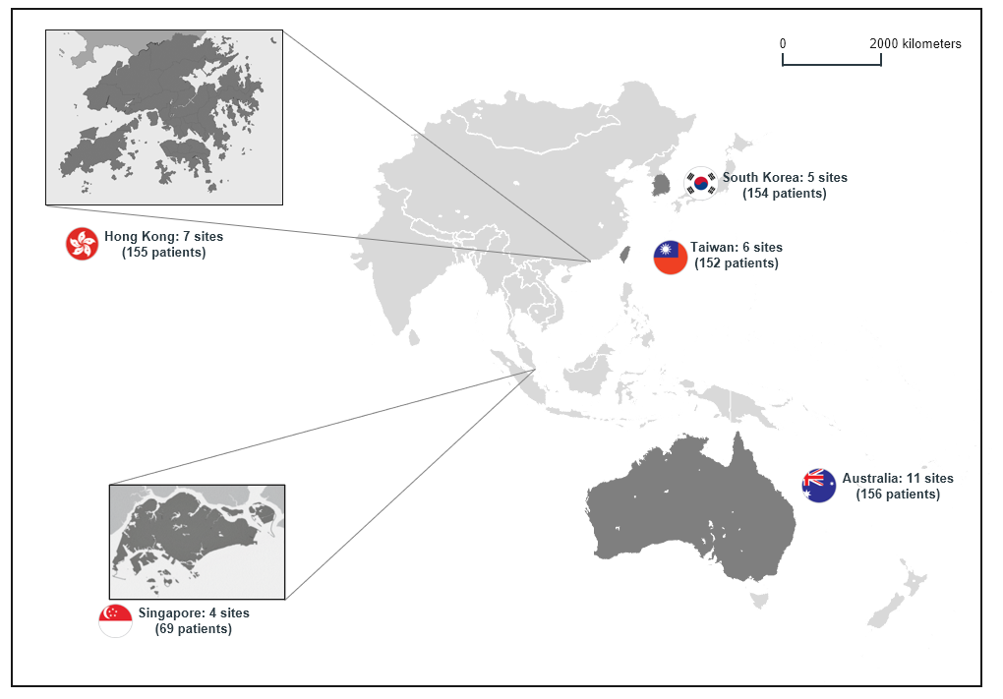
Supplementary Figure 2. Participating territories, sites, and enrolled patients

Supplementary Table 1: Subject accountability at 12-month visit.
Territory | Total | Denosumab | Alendronate | P-value ª
All territories | N = 686 | n = 350 | n = 336
Completion of study | 580 (84.5%) | 301 (86.0%) | 279 (83.0%) | 0.283
Withdrawal of study | 106 (15.5%) | 49 (14.0%) | 57 (17.0%) | 0.283
Australia | n = 156 | n = 75 | n = 81
Completion of study | 142 (91.0%) | 67 (89.3%) | 75 (92.6%) | 0.477
Withdrawal of study | 14 (9.0%) | 8 (10.7%) | 6 (7.4%) | 0.477
Taiwan | N = 152 | N = 77 | n = 75
Completion of study | 109 (71.7%) | 57 (74.0%) | 52 (69.3%) | 0.521
Withdrawal of study | 43 (28.3%) | 20 (26.0%) | 23 (30.7%) | 0.521
South Korea | n = 154 | n= 77 | n = 77
Completion of study | 124 (80.5%) | 65 (84.4%) | 59 (76.6%) | 0.222
Withdrawal of study | 30 (19.5%) | 12 (15.6%) | 18 (23.4%) | 0.222
Hong Kong | N = 155 | n = 76 | n = 79
Completion of study | 141 (91.0%) | 70 (92.1%) | 71 (89.9%) | 0.628
Withdrawal of study | 14 (9.0%) | 6 (7.9%) | 8 (10.1%) | 0.628
Singapore | n = 69 | n = 45 | n = 24
Completion of study | 64 (92.8%) | 42 (93.3%) | 22 (91.7%) | 0.799 ^{b}
Withdrawal of study | 5 (7.2%) | 3 (6.7%) | 2 (8.3%) | 0.799 ^{b}
ª Unless otherwise specified, P-values were generated by chi-square test for categorical variables.
^{b} Fisher's exact test was used to compare patients on denosumab and those on alendronate.
Supplementary Table 2: Adjusted odds ratios and 95% confidence intervals for osteoporosis treatment persistence at 12 months (sensitivity analysis).
Territory | Adjusted odds ratioª | 95% CI | P-value | Reference group^{b}
All territories, (N = 580)
Denosumab group | 3.05 | (2.03–4.60) | <.001* | alendronate
Age | 0.97 | (0.95–1.00) | 0.021* | -
History of fracture | 0.88 | (0.59–1.30) | 0.512 | no
Measurement of BMD | 0.94 | (0.60–1.48) | 0.783 | no
Prior treatment for osteoporosis | 1.48 | (0.99–2.19) | 0.055 | no
Prior treatment with oral glucocorticoids | 0.75 | (0.41–1.40) | 0.371 | no
Reimbursement status^{c} | 0.67 | (0.42–1.06) | 0.088 | no reimbursement
Australia, (n = 142)
Denosumab group | 19.42 | (7.13–52.89) | <.001* | alendronate
Age | 0.94 | (0.89–0.99) | 0.022* | -
History of fracture | 1.19 | (0.51–2.77) | 0.686 | no
Measurement of BMD | 1.39 | (0.38–5.12) | 0.622 | no
Prior treatment for osteoporosis | 0.50 | (0.19–1.30) | 0.155 | no
Prior treatment with oral glucocorticoids | 1.25 | (0.38–4.09) | 0.716 | no
Taiwan, (n = 109)
Denosumab group | 1.62 | (0.56–4.75) | 0.376 | alendronate
Age | 1.01 | (0.95–1.07) | 0.819 | -
History of fracture | 0.46 | (0.12–1.72) | 0.246 | no
Measurement of BMD | 3.40 | (0.80–14.45) | 0.097 | no
Prior treatment for osteoporosis | 2.95 | (0.63–13.69) | 0.168 | no
Prior treatment with oral glucocorticoids | 5.85 | (0.32–106.62) | 0.233 | no
South Korea, (n = 124)
Denosumab group | 1.81 | (0.60–5.45) | 0.291 | alendronate
Age | 0.94 | (0.88–1.00) | 0.048* | -
History of fracture | 0.48 | (0.16–1.45) | 0.195 | no
Measurement of BMD | 2.21 | (0.63–7.77) | 0.218 | no
Prior treatment for osteoporosis | 2.78 | (0.96–8.10) | 0.061 | no
Prior treatment with oral glucocorticoids | 0.46 | (0.13–1.64) | 0.229 | no
Hong Kong, (n = 141)
Denosumab group | 1.46 | (0.59–3.59) | 0.416 | alendronate
Age | 1.00 | (0.95–1.04) | 0.854 | -
History of fracture | 1.04 | (0.44–2.46) | 0.926 | no
Measurement of BMD | 1.72 | (0.55–5.34) | 0.348 | no
Prior treatment for osteoporosis | 2.18 | (0.82–5.83) | 0.119 | no
Prior treatment with oral glucocorticoids | 0.17 | (0.02–1.15) | 0.069 | no
Reimbursement status^{c} | 1.04 | (0.35–3.14) | 0.940 | no reimbursement
Singapore, (n = 64)
Denosumab group | 7.83 | (1.58–38.84) | 0.012* | alendronate
Age | 0.93 | (0.84–1.04) | 0.183 | -
History of fracture | 0.49 | (0.12–2.00) | 0.318 | no
Measurement of BMD | 1.44 | (0.29–7.06) | 0.653 | no
Prior treatment for osteoporosis | 0.96 | (0.23–3.98) | 0.949 | no
Prior treatment with oral glucocorticoids | 5.05 | (0.14–183.87) | 0.378 | no
Abbreviations: BMD, bone mineral density; CI, confidence interval;
* P < 0.05
ª Adjusted odds ratios were generated using multivariable logistic regression models. Treatment persistence was used as the dependent variable, while adjusting for treatment group, age, history of fracture, measurement of BMD, prior treatment for osteoporosis, and prior treatment with oral glucocorticoids.
^{b} Treatment group is categorized as patients on denosumab and those on alendronate. History of fracture includes with fracture and without fracture. Measurement of BMD includes with BMD measurement and without. Prior treatment for osteoporosis includes using and not using osteoporosis drug before starting denosumab or alendronate treatment. Prior treatment with oral glucocorticoids includes using and not using oral glucocorticoids before starting denosumab or alendronate treatment.
^{c} Further adjusted for baseline reimbursement status if there are at least 10% subjects in both treatment groups for reimbursement categories.
Supplementary Table 3: Changes in bone mineral density (T-score) at 12 months and their associations with osteoporosis treatment using multivariable linear regression.
Site | Denosumab (n = 301) |  |  | Alendronate (n = 279) |  |  | Regression coefficient (95% CI)ª
Site | Baseline mean (SD) | 12-month mean (SD) | Change from baseline, mean (SD) | Baseline mean (SD) | 12-month mean (SD) | Change from baseline, mean (SD) | Regression coefficient (95% CI)ª
Lumbar spine
T-score | -2.4 (1.1) | -2.1 (1.0) | 0.3 (0.5) | -2.4 (0.9) | -2.2 (0.9) | 0.3 (0.6) | -0.05 (-0.20–0.10)
Percentage change in T-score from baseline (%) | - | - | 10.5 (27.3) | - | - | 13.0 (36.8) | -1.80 (-11.11–7.51)
Total hip
T-score | -2.0 (0.8) | -1.9 (0.8) | 0.2 (0.4) | -1.9 (0.9) | -1.8 (0.9) | 0.1 (0.3) | -0.06 (-0.15–0.03)
Percentage change in T-score from baseline (%) | - | - | 8.2 (15.7) | - | - | 4.0 (27.4) | -3.44 (-9.67–2.79)
Femoral neck
T-score | -2.4 (0.7) | -2.3 (0.7) | 0.1 (0.3) | -2.3 (0.9) | -2.2 (0.9) | 0.1 (0.5) | -0.01 (-0.12–0.11)
Percentage change in T-score from baseline (%) | - | - | 2.6 (22.9) | - | - | 5.7 (27.1) | 3.00 (-3.80–9.80)
Abbreviations: CI, confidence interval; -, not applicable.
* P < 0.05.
ª Reference group for osteoporosis treatment comprised of patients on alendronate. Linear regression model was adjusted for age, baseline bone mineral density, history of fracture, prior treatment for osteoporosis, prior treatment with glucocorticoids, model of measuring device, history of falls or falls within last year, body mass index, smoking status, and ethnicity.

Supplementary Table 4: Association between variables and change in T-scores from baseline using multivariable linear regression.
Variables | Regression coefficient (95% CI)
Variables | Lumbar spine | Total hip | Femoral neck
Treatment
Denosumab | -0.05 (-0.20–0.10) | -0.06 (-0.15–0.03) | -0.01 (-0.12–0.11)
Alendronate | Reference | Reference | Reference
Age | 0.01 (0.00–0.01) | 0.00 (-0.01–0.00) | 0.00 (-0.01–0.00)
History of fracture
Yes | 0.00 (-0.17–0.17) | -0.09 (-0.19–0.01) | -0.13 (-0.26–-0.01)*
No | Reference | Reference | Reference
Baseline BMD | -0.23 (-0.31–-0.16)* | -0.15 (-0.21–-0.10)* | -0.23 (-0.30–-0.16)*
Prior treatment for osteoporosis
Yes | -0.11 (-0.27–0.05) | -0.03 (-0.13–0.07) | 0.07 (-0.05–0.19)
No | Reference | Reference | Reference
Prior treatment with glucocorticoids
Yes | -0.02 (-0.23–0.19) | 0.07 (-0.07–0.21) | -0.06 (-0.23–0.11)
No | Reference | Reference | Reference
Model of measuring device
GE-Lunar | -0.50 (-0.96–-0.05)* | -0.16 (-0.50–0.18) | 0.06 (-0.33–0.44)
Hologic | -0.52 (-0.99–-0.06)* | -0.18 (-0.53–0.17) | -0.03 (-0.42–0.37)
Missing | Reference | Reference | Reference
History of falls
Yes | 0.23 (0.02–0.44)* | -0.01 (-0.14–0.12) | 0.00 (-0.16–0.15)
No | Reference | Reference | Reference
Body Mass Index | 0.01 (-0.01–0.03) | 0.02 (0.01–0.03)* | 0.01 (0.00–0.03)
Smoking status
Current smoker | 0.60 (-0.14–1.34) | 0.09 (-0.38–0.55) | -0.02 (-0.61–0.56)
Former smoker | 0.17 (-0.13–0.47) | 0.06 (-0.10–0.22) | -0.21 (-0.45–0.03)
Never | Reference | Reference | Reference
Ethnicity
Caucasian | -0.05 (-0.30–0.19) | 0.06 (-0.10–0.22) | 0.27 (0.07–0.46)*
Korean | -0.05 (-0.22–0.11) | 0.01 (-0.09–0.11) | -0.02 (-0.14–0.10)
Othersª | 0.10 (-0.54–0.73) | -0.05 (-0.51–0.41) | -0.01 (-0.59–0.57)
Chinese | Reference | Reference | Reference
Abbreviations: BMD, bone mineral density; CI, confidence interval;
* P < 0.05
ª Malays and Indians were included in other ethnicities.
Supplementary Table 5: Association between variables and percentage change in T-scores from baseline using multivariable linear regression.
Variables | Regression coefficient (95% CI)
Variables | Lumbar spine | Total hip | Femoral neck
Treatment
Denosumab | -1.80 (-11.11–7.51) | -3.44 (-9.67–2.79) | 3.00 (-3.80–9.80)
Alendronate | Reference | Reference | Reference
Age | 0.41 (-0.13–0.95) | -0.22 (-0.58–0.13) | -0.14 (-0.53–0.24)
History of fracture
Yes | -0.25 (-10.60–10.09) | -4.34 (-11.18–2.51) | -6.47 (-13.97–1.02)
No | Reference | Reference | Reference
Baseline BMD | -3.63 (-8.19–0.93) | -7.63 (-11.52–-3.73)* | -9.53 (-13.75–-5.31)*
Prior treatment for osteoporosis
Yes | -6.42 (-16.34–3.51) | 3.70 (-2.98–10.38) | 1.61 (-5.59–8.80)
No | Reference | Reference | Reference
Prior treatment with glucocorticoids
Yes | -8.04 (-21.26–5.18) | -0.65 (-10.29–8.99) | -1.56 (-11.73–8.61)
No | Reference | Reference | Reference
Model of measuring device
GE-Lunar | -10.48 (-38.60–17.64) | 0.05 (-23.07–23.18) | 12.56 (-10.35–35.46)
Hologic | -9.56 (-38.22–19.10) | -5.17 (-28.75–18.42) | 8.16 (-15.19–31.51)
Missing | Reference | Reference | Reference
History of falls
Yes | 13.55 (0.63–26.47)* | 3.52 (-5.13–12.18) | -0.41 (-9.81–8.99)
No | Reference | Reference | Reference
Body Mass Index | 0.64 (-0.52–1.80) | 1.43 (0.60–2.26)* | 0.46 (-0.39–1.31)
Smoking status
Current smoker | 37.44 (-8.28–83.15) | 6.89 (-24.44–38.23) | -3.65 (-38.28–30.97)
Former smoker | 9.24 (-9.15–27.62) | 4.52 (-8.64–17.68) | -11.47 (-25.53–2.59)
Never | Reference | Reference | Reference
Ethnicity
Caucasian | -2.53 (-17.56–12.50) | 2.63 (-8.11–13.37) | 16.81 (5.23–28.39)*
Korean | -2.55 (-12.77–7.67) | -3.92 (-10.60–2.77) | -3.66 (-10.94–3.62)
Othersª | -6.18 (-45.44–33.08) | -5.45 (-36.83–25.92) | -6.02 (-40.73–28.70)
Chinese | Reference | Reference | Reference
Abbreviations: BMD, bone mineral density; CI, confidence interval;
* P < 0.05
ª Malays and Indians were included in other ethnicities.
Supplementary Table 6: Principal investigators and ethic approval authorities for each territory.
Site number | Territory | PI Name | Approval Code | Authority Name
41 | Australia | Arya, Ktut | 2019-08-697-AA-PRE-1 | Bellberry Human Research Ethics Committees
43 | Australia | Clifton-Bligh, Roderick | 2020 /STE01167 | Melbourne Health Human Research Ethics Committee
35 | Australia | Cumming, Oscar | 2019-08-697 | Bellberry Human Research Ethics Committees
39 | Australia | Gilfillan, Christopher | S20-014-56164 | Melbourne Health Human Research Ethics Committee
29 | Australia | Inder, Warrick | HREC /56164 /MH-2019 | Metro South Health Service District Human Research Ethics Committee (RGO)
45 | Australia | Inderjeeth, Charles | 2019-08-697 | Bellberry Human Research Ethics Committees
30 | Australia | Seymour, Hannah | HREC /56164 /MH-2019 | Melbourne Health Human Research Ethics Committee
40 | Australia | Stuckey, Bronwyn | 2019-08-697 | Bellberry Human Research Ethics Committees
22 | Australia | Will, Robert | 2019-08-697 | Bellberry Human Research Ethics Committees
42 | Australia | Wong, Peter | HREC /56164 /MH-2019 | Melbourne Health Human Research Ethics Committee
23 | Australia | Yates, Christopher | HREC /56164 /MH-2019 | Melbourne Health Human Research Ethics Committee
17 | Hong Kong | Cheung, Jason Pui Yin | UW19-545 | Institutional Review Board of the University of Hong Kong/Hospital Authority Hong Kong West Cluster
14 | Hong Kong | Ip, Tai Pang | UW19-749 | Institutional Review Board of the University of Hong Kong/Hospital Authority Hong Kong West Cluster
18 | Hong Kong | Kwok, Timothy Chi Yui | 2019.564 | Joint Chinese University of Hong Kong-New Territories East Cluster Clinical Research Ethics Committee
12 | Hong Kong | Lau, Edith | 2019 /03 | Hong Kong Doctors Union
24 | Hong Kong | Mok, Chi Chiu | NTWC /REC /19122 | New Territories West Cluster Ethics Committee
36 | Hong Kong | Wong, Ronald Man Yeung | 2019.579 | Joint Chinese University of Hong Kong-New Territories East Cluster Clinical Research Ethics Committee
13 | Hong Kong | Woo, Yu Cho | UW19-500 | Institutional Review Board of the University of Hong Kong/Hospital Authority Hong Kong West Cluster
07 | South Korea | Chang, Dong-Gune | SGPAIK | IRB of Inje University Sanggye Paik Hospital
15 | South Korea | Koh, Jung-Min | 2019-04-007-001 | IRB of Asan Medical Center
05 | South Korea | Lee, Jae Hyup | 2019-0923 | IRB of Seoul Metropolitan Government Seoul National University Boramae Medical Center
06 | South Korea | Lee, Sang-Heon | 20190503 / 10 - 2019 - 42 / 061 | IRB of Konkuk University Medical Center
20 | South Korea | Rhee, Yumie | KUMC | IRB of Severance Hospital, Yonsei University Health System
44 | Singapore | Chua, Ivan | 2019-06-035-004 | National healthcare group Domain specific review board.
31 | Singapore | Gani, Linsey | 4-2019-0803 | SingHealth Centralised Institutional Review Board
27 | Singapore | Mak, Anselm | 2019 /00858 | National Healthcare Group Domain Specific Review Board
21 | Singapore | Seng Bin, Ang | 2019 /2743 | SingHealth Centralised Institutional Review Board
01 | Taiwan, Republic of China | Chen, Chung-Hwan | 2019 /00858 | Kaohsiung Medical University Chung-Ho Memorial Hospital, Institutional Review Board
02 | Taiwan, Republic of China | Huang, Tsan-Wen | 2019 /2743 | Chang Gung Medical Foundation, Institutional Review Board
04 | Taiwan, Republic of China | Kuo, Yi-Jie | KMUHIRB-E (I )-20190187 | Taipei Medical University, Joint Institutional Review Board
08 | Taiwan, Republic of China | Lu, Ko-Hsiu | 201900706B0 | Chung Shan Medical University Hospital, Institutional Review Board
10 | Taiwan, Republic of China | Niu, Chi-Chien | N201907008 | Chang Gung Medical Foundation, Institutional Review Board
26 | Taiwan, Republic of China | Wu, Meng-Ting | CSMUH N0:CS2-19052 | Cheng Hsin General Hospital, Institutional Review Board

