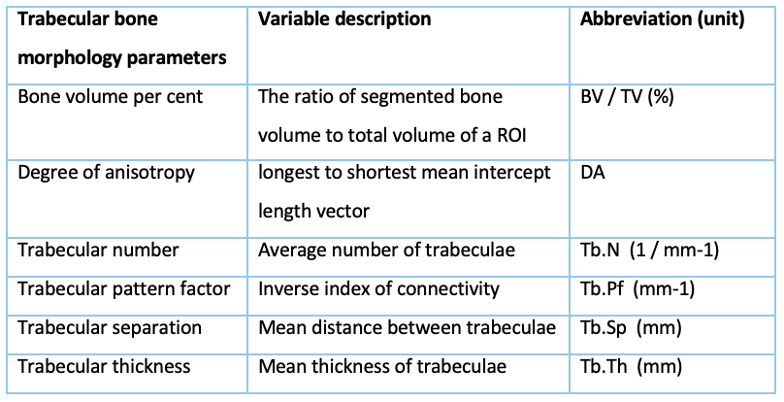
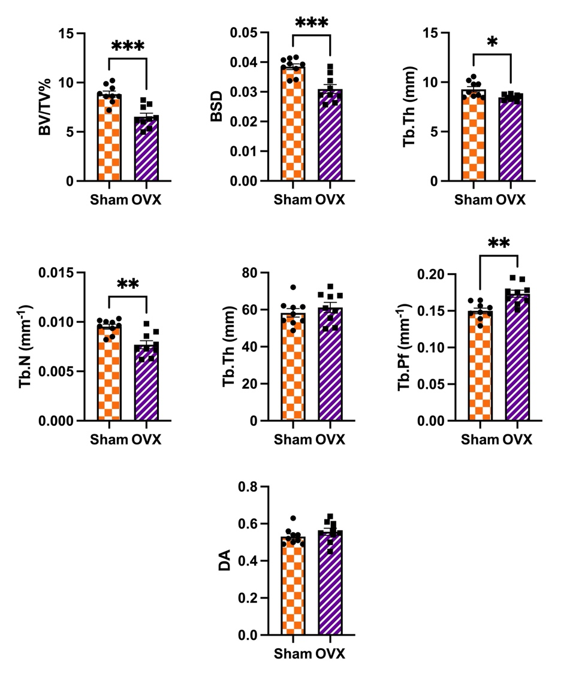

Supplementary Figure 1
Micro-CT analysis of trabecular bone in OVX vs Sham mice revealing a loss of trabecular volume after ovariectomy. 10-12 Week old C57BL/6 female mice were ovariectomised (n=10) or Sham operated (n=10). CT analysis of the trabecular bone in tibia has been performed 6 weeks after OVX. Results show M ± SEM and are normally distributed. For differences between OVX and Sham, sample-t tests have been performed and significance is shown as * (p-value<0.05) **(p-value<0.01) ***(p-value<0.001). Analysed parameters explained in adjacent table.

