Supplementary Information
Microbiota Analysis of Peri-implant Mucositis in Patients with Periodontitis History
Na Zhou^{1†}, Haohao Huang^{2†}, Hui Liu¹, Qiang Li¹, Guangwen Yang¹, Yu Zhang¹, Meng Ding¹, Heng Dong^{1, *} and Yongbin Mou^{1, *}
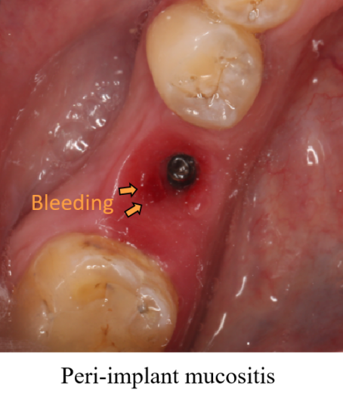
Figure S1. The representative image of peri-implant mucositis

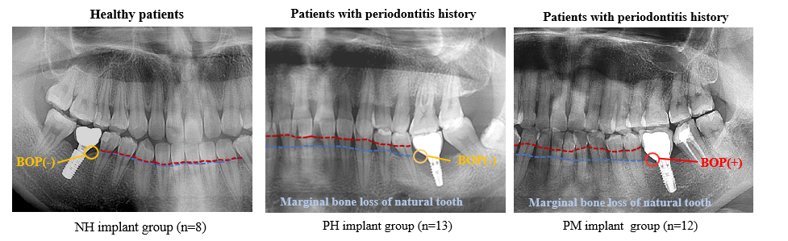
Figure S2. Representative X-ray images of patients in NH implant group, PH implant group and PM implant group.

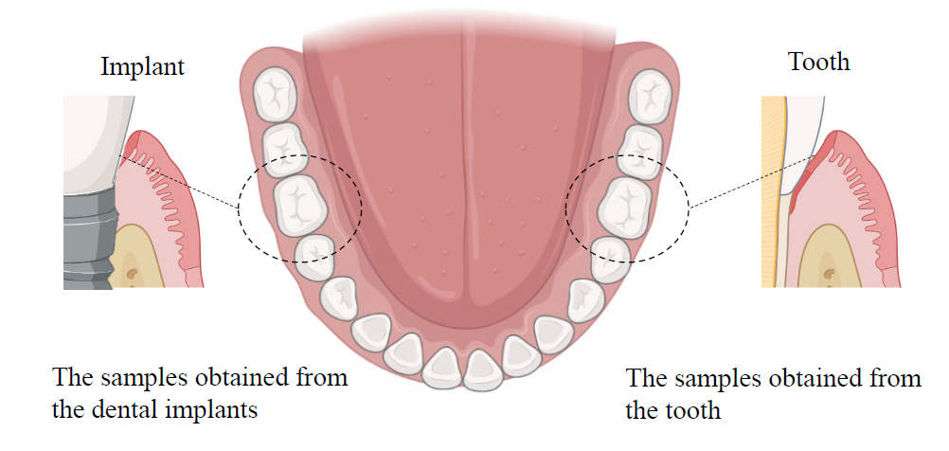
Figure S3. A schematic illustration of the collected plaque samples from the bottom of subgingival crevice

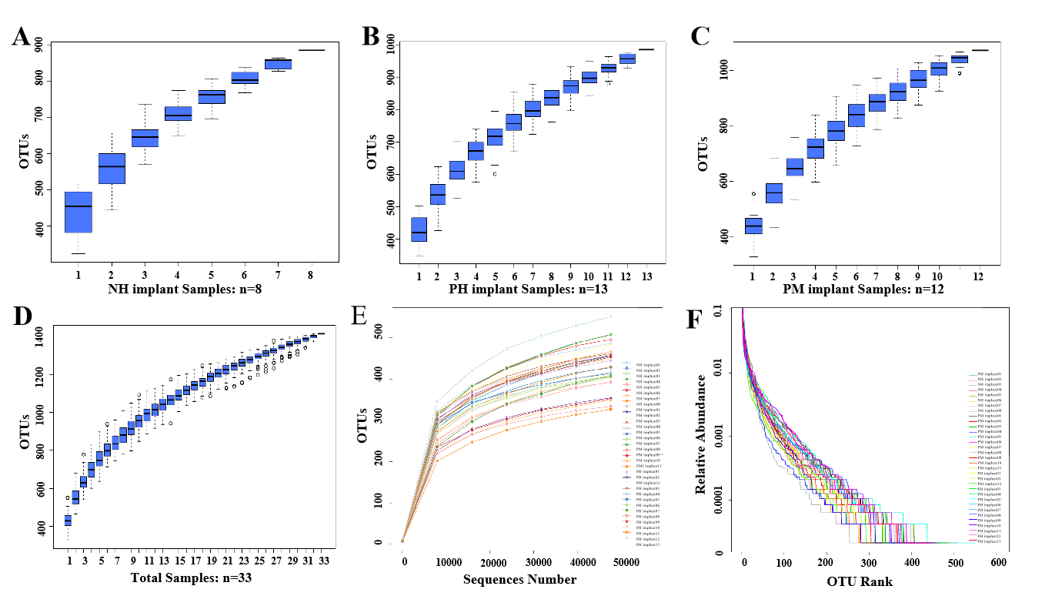
Figure S4. Species accumulation boxplots in (A) NH implant, (B) PH implant and (C) PM implant groups and (D) in all samples. The richness and evenness analysis of species. (E) Rarefaction Curve. (F) Rank abundance curve.

Table S1. Summary of samples, sequences and OTUs based on Illumina HiSeq platform
Sample | Total Tag | Taxon Tag | OTUs (≥97% similarity)
NH implant01 | 69176 | 68610 | 574
NH implant02 | 89849 | 89439 | 534
NH implant03 | 77426 | 76913 | 519
NH implant04 | 84845 | 84421 | 601
NH implant05 | 89156 | 88770 | 488
NH implant06 | 81215 | 80655 | 565
NH implant07 | 65323 | 65113 | 461
NH implant08 | 79596 | 79431 | 389
PH implant01 | 73384 | 72738 | 532
PH implant02 | 84457 | 83886 | 548
PH implant03 | 77489 | 77148 | 481
PH implant04 | 86797 | 86336 | 546
PH implant05 | 83300 | 82696 | 473
PH implant06 | 82131 | 81531 | 473
PH implant07 | 82815 | 82261 | 449
PH implant08 | 84820 | 84276 | 590
PH implant09 | 91497 | 90983 | 459
PH implant10 | 72274 | 72116 | 413
PH implant11 | 84479 | 84263 | 404
PH implant12 | 80844 | 79190 | 498
PH implant13 | 73523 | 72277 | 475
PM implant01 | 70122 | 68546 | 395
PM implant02 | 91666 | 90852 | 571
PM implant03 | 85010 | 84116 | 539
PM implant04 | 76778 | 76190 | 643
PM implant05 | 80945 | 80414 | 486
PM implant06 | 75856 | 74866 | 463
PM implant07 | 69000 | 68769 | 500
PM implant08 | 69161 | 68928 | 392
PM implant09 | 75908 | 75581 | 542
PM implant10 | 76730 | 75272 | 512
PM implant11 | 70846 | 69554 | 556
PM implant12 | 74420 | 72426 | 518

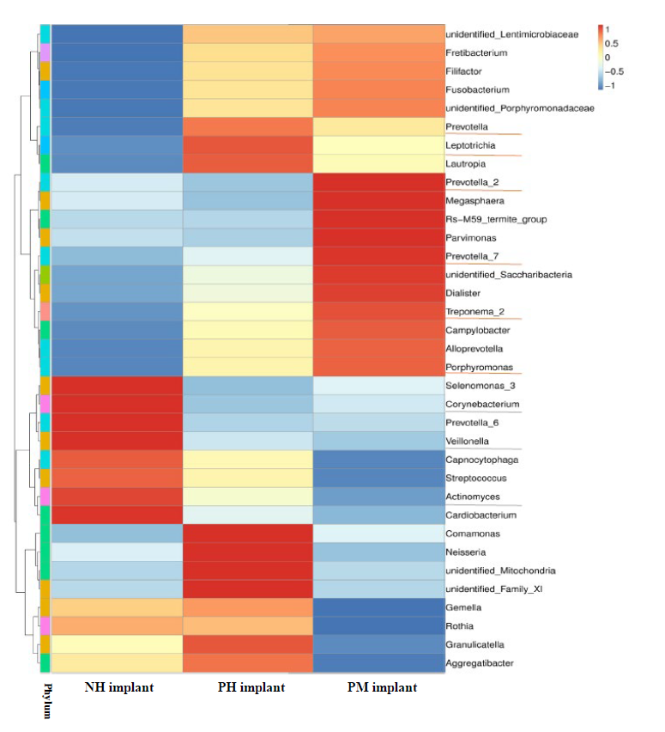
Figure S5. Cluster analysis in generic level for three groups. Each row represents one genus and each column represents one group. Orange lines mark the disease-related genera and gray lines mark the health-related genera.

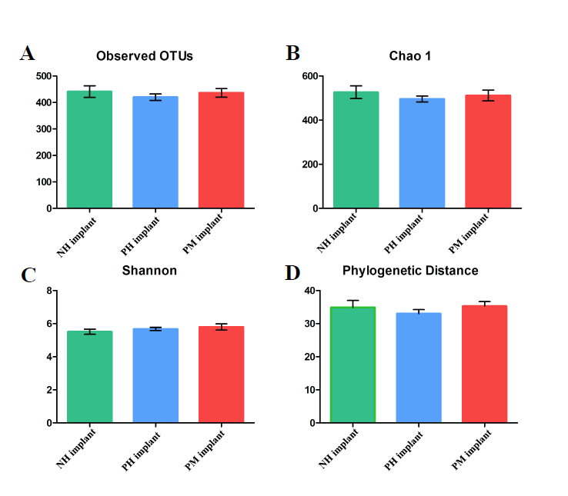
Figure S6. Analysis of microbial diversity in three groups. (A) Numbers of observed OTUs. (B) Analysis of species richness by Chao 1. (C) Analysis of microbial community diversity with Shannon index. (D) Measurement of community diversity with phylogenetic distance.

