Supplementary Materials
Randomized Clinical Study of Injectable Dextrin-based Hydrogel as a Carrier of a Synthetic Bone Substitute
Alexandra Machado, MSc^{1,2}, Isabel Pereira, PhD^{1,2}, Filomena Costa, PhD^{1,2}, Ana Brandão, PhD³, José Eduardo Pereira, PhD^{4,5}, Ana Colette Maurício, PhD^{6,7}, José Domingos Santos, PhD⁸, Inês Amaro, MSc⁹, Rui Falacho, PhD¹⁰, Rui Coelho, PhD¹¹, Nuno Cruz, PhD¹², Miguel Gama, PhD^{1,2*}

¹ CEB, Centre of Biological Engineering, University of Minho, 4710-057 Braga, Portugal.
² LABBELS, Associate Laboratory, Braga, Guimarães, Portugal
³ Biosckin, Molecular and Cell Therapies S.A., TecMaia, Rua Engenheiro Frederico Ulrich 2650, 4470-605 Maia, Portugal.
⁴ CECAV, Animal and Veterinary Research Centre, University of Trás-os-Montes and Alto Douro, Vila Real 5001-801, Portugal.
⁵ Department of Veterinary Sciences, University of Trás-os-Montes and Alto Douro, Vila Real 5001-801, Portugal.
⁶ Departamento de Clínicas Veterinárias, Instituto de Ciências Biomédicas de Abel Salazar (ICBAS), Universidade do Porto (UP), Rua de Jorge Viterbo Ferreira, n° 228, Porto 4050-313, Portugal.
⁷ Centro de Estudos de Ciência Animal (CECA), Instituto de Ciências, Tecnologias e Agroambiente da Universidade do Porto (ICETA), Rua D. Manuel II, Apartado 55142, Porto 4051-401, Portugal.
⁸ REQUIMTE/LAQV, Departamento de Engenharia Metalúrgica e Materiais, Faculdade de Engenharia, Universidade do Porto, Rua Dr. Roberto Frias, Porto 4200-495, Portugal.
⁹ Institute of Integrated Clinical Practice, Faculty of Medicine, University of Coimbra, Coimbra 3004-504, Portugal.
¹⁰ Institute of Oral Implantology and Prosthodontics, Faculty of Medicine, University of Coimbra, Coimbra 3004-504, Portugal.
¹¹ RESDEVMED, Unipessoal Lda., Travessa do Navega, 436 C, Ovar 3885-183, Portugal.
¹² Faculty of Dentistry, Universitat Internacional de Catalunya, Barcelona 08017, Spain.

*Corresponding author: Miguel Gama, CEB, Centre of Biological Engineering, University of Minho, Campus de Gualtar, 4715-057 Braga, Portugal. Tel. (office): +351 253 604 418. E-mail address: fmgama@deb.uminho.pt (M. Gama). ORCID ID: 0000-0002-5655-0015.

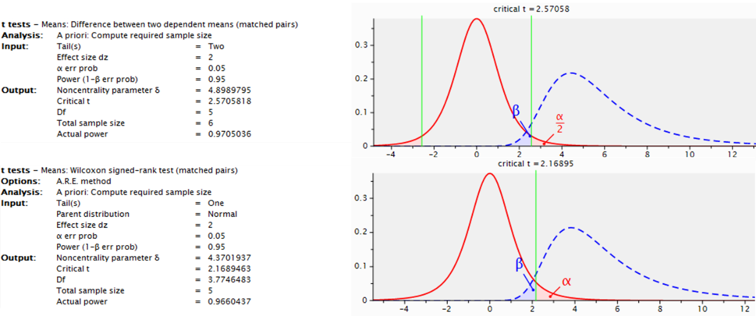
Fig.1 SI Study designed for a two-tailed analysis with Student's t-test or Wilcoxon signed rank test (depending on the normality of the results), with a confidence interval (statistical power) of 95% (1-β=0.95). G*Power 3.1.9.2 software was used to define sample size.

Table 1 SI. Gelation time of HG upon mixture of ODEX and ADH, expressed in seconds (n=3). After production and sterilization, ODEX (30% w/v) and ADH (3.76% w/v) solutions were separately kept at 4⁰C and a gelling test was performed at different time-points by mixing both in a proportion of 7:3 volume, respectively. Freshly prepared ADH was also used for crosslinking in each time-point with the ODEX stored over time.
Mixture (7:3 ratio) | Initial | 3 months | 1 year | 3 years
ODEX + ADH | 30 ± 2 sec | 30 ± 2 sec | 30 ± 2 sec | -
ODEX + fresh ADH | 30 ± 2 sec | 30 ± 2 sec | 30 ± 2 sec | 30 ± 2 sec
ODEX, oxidized dextrin; ADH, Adipic dihydrazide.

Table 2 SI. Bone density classification by Misch [36].
Classification | Hounsfield Units | Description | Typical Anatomical location
D1 | >1250 | Dense cortical | Anterior mandible
D2 | 850-1250 | Thick dense to porous cortical and coarse trabecular | Anterior and posterior mandible, anterior maxila
D3 | 350-850 | Thin porous cortical and fine trabecular | Posterior mandible, anterior and posterior maxila
D4 | 150-350 | Fine trabecular bone | Posterior maxila
D5 | <150 | Poorly mineralized bone

