Crosslinked Hyaluronic Acid vs Enamel Matrix for Periodontal Regeneration: Randomized Clinical Trial

Rodríguez-A Manuel¹, Montiel-Company Jose María¹, Alpiste-Illueca Francisco¹, Rodríguez-A Lucía¹, Paredes- Gallardo Vanessa¹, López-Roldán Andrés¹

¹Department of Stomatology, Faculty of Medicine and Odontology, University of Valencia, Valencia, Spain

Corresponding Author: Vanessa Paredes-Gallardo
vanessa.paredes@uv.es

APPENDIX FIGURES AND TABLES

APPENDIX FIGURES

Appendix figure 1. Reference points for evaluation of radiographic change. Variables recorded: (1) distance from the cemento-enamel junction (CEJ) to the bottom of the defect (BD; CEJ-BD), expressed to the nearest mm; (2) distance from the CEJ to the most coronal extension of the interdental bone crest (BC; CEJ-BC), expressed to the nearest mm; (3) INFRA (the intrabony component of the defect, calculated as [CEJ-BD–CEJ-BC]), expressed in mm; (4) wall component (x-WALL), representing the number of walls affected by the intrabony defect; (5) angle of intrabony defect, defined by the two lines representing the root surface and bone defect surface (A1-D1/B1-D1); (6) area of regeneration, referring to the measurement of the surface of regeneration compared with the radiograph at t1, measured at t2–t4, expressed in mm²; (7) 100% area defect, defined as the area of full regenerative capacity of the initial bone defect, corresponding to the area included in the infrabony defect between A1D1 and B1B; and (8) percentage defect filling, referring to the percentage of regeneration in tX compared with the 100% area defect.

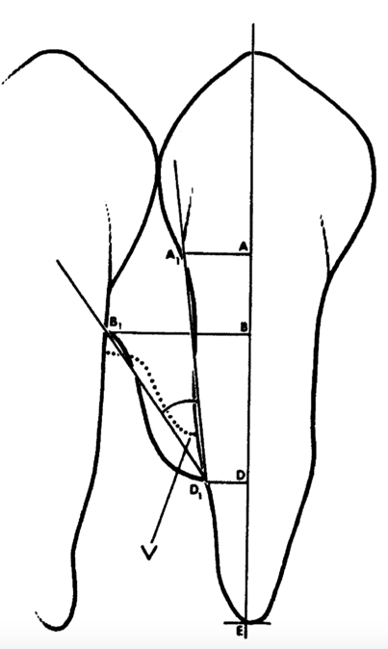

Appendix figure 2. Correlation between the number of bone defect walls and CAL gain at 6 (t2), 12 (t3) and 18 (t4) months in the test group.

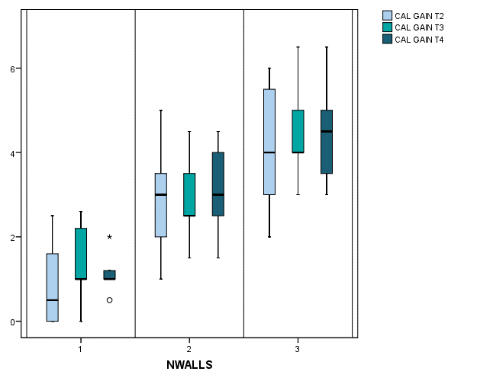

Appendix figure 3. Frequency distribution of clinical (a) and radiographic (b) parameters: CAL gain, PD reduction, and REC increase and % defect filling and radiographic regeneration area (mm²) at 6 (T2), 12 (T3), and 18 (T4) months.

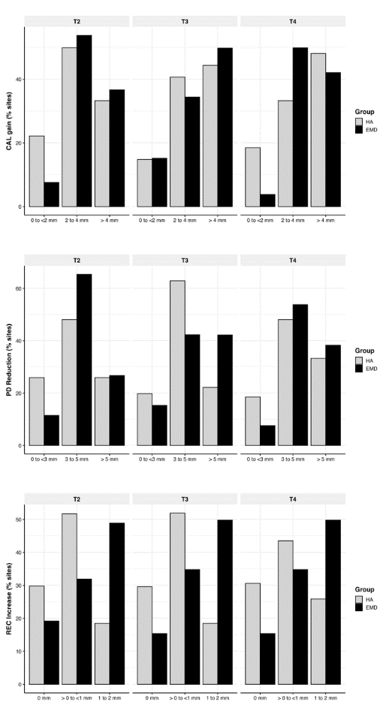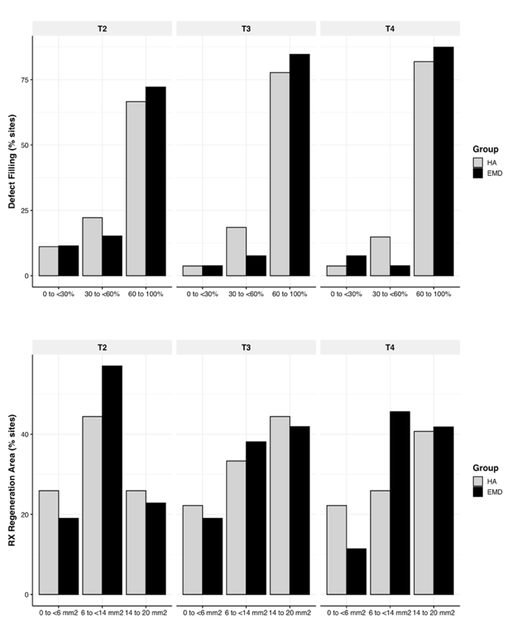
a.
b.

Appendix figure 4. Correlation between the number of walls of the bone defect and the radiographic regeneration area at 6 (t2), 12 (t3) and 18 (t4) months in the test and control group.

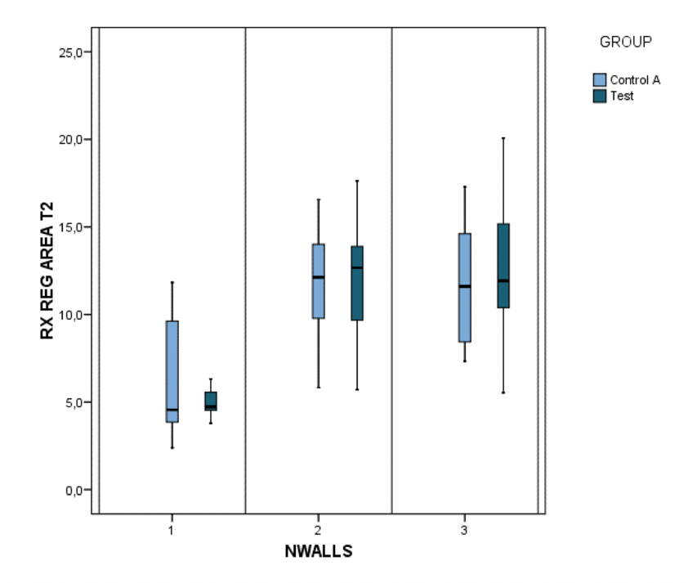
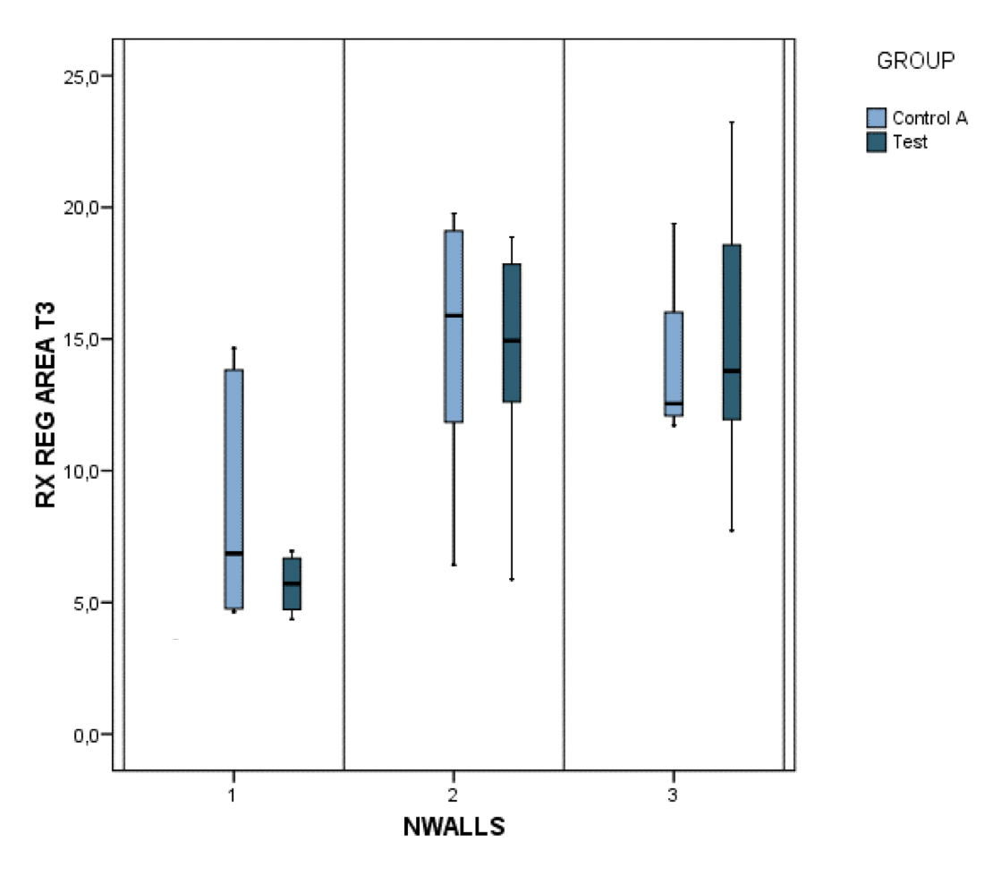
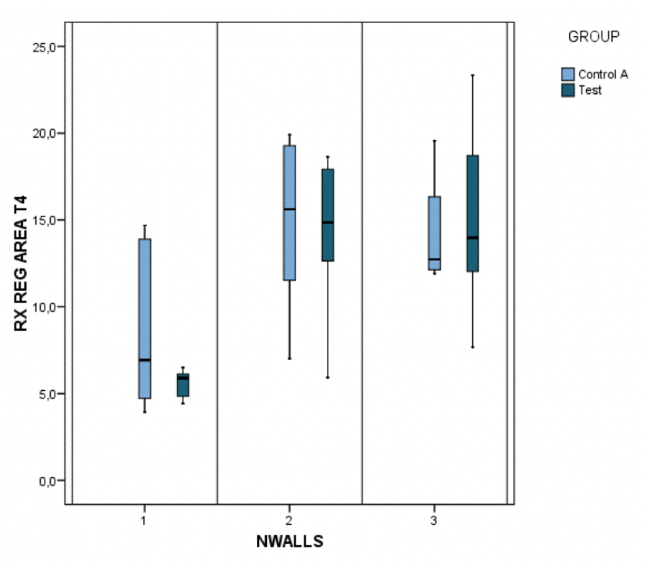

Appendix figure 5. Correlation in a scatter diagram of the values of the prediction model for CAL (mm) with a linear correlation of Pearson R= 0.673 and radiographic regeneration area (mm²) with R=0.797.

APPENDIX TABLE

Appendix table 1. Predictive models of CAL (mm) and radiographic regeneration area (mm²). In the predictive model of CAL (R²=0.453), both the follow-up (for each month between 1 and 18 months the CAL decreases 0.18 mm) and the number of defect walls (2 or 3 initial defect walls predict a decrease of 2.06 mm) showed its significance. They did not show significant intragroup differences (HA or EMD) or smoking. In the predictive model of the radiographic regeneration area (R²=0.653), both the follow-up (for each month the defect area decreases 0.70 percentage units) and the number of defect walls (2 or 3 initial defect walls predict a decrease of 6.1 percentage units) showed its significance. Smoking, radiographic angle, CEJ-BC, or CEJ-BD did not show significant intergroup differences.

 |  | Coefficient B non-standardized | Desv. error | Coefficient B standardized | p-value
CAL (mm)  R=0.673; R²=0.453  p-valor <0.001 | Intercept | 10.249 | 0.344 |  | <0.001
CAL (mm)  R=0.673; R²=0.453  p-valor <0.001 | Follow-up (months)* | -0.181 | 0.017 | -0.565 | <0.001
CAL (mm)  R=0.673; R²=0.453  p-valor <0.001 | 2 or 3 walls* | -2.063 | 0.284 | -0.376 | <0.001
CAL (mm)  R=0.673; R²=0.453  p-valor <0.001 | Smoker | -0.147 | 0.241 | -0.032 | 0.544
CAL (mm)  R=0.673; R²=0.453  p-valor <0.001 | Hyaluronic acid | 0.124 | 0.222 | 0.029 | 0.578
RX REG AREA (mm²)  R=0.673; R²=0.453  p-valor <0.001 | Intercept | 15.250 | 2.739 |  | <0.001
RX REG AREA (mm²)  R=0.673; R²=0.453  p-valor <0.001 | Follow up (months)* | -0.697 | 0.043 | -0.698 | <0.001
RX REG AREA (mm²)  R=0.673; R²=0.453  p-valor <0.001 | 2 or 3 walls* | -6.134 | 0.776 | -0.358 | <0.001
RX REG AREA (mm²)  R=0.673; R²=0.453  p-valor <0.001 | Radiographic angle baseline | 0.042 | 0.038 | 0.049 | 0.273
RX REG AREA (mm²)  R=0.673; R²=0.453  p-valor <0.001 | Hyaluronic acid | 0.616 | 0.612 | 0.046 | 0.315
RX REG AREA (mm²)  R=0.673; R²=0.453  p-valor <0.001 | CEJBD baseline | 0.204 | 0.221 | 0.045 | 0.356
RX REG AREA (mm²)  R=0.673; R²=0.453  p-valor <0.001 | Smoker | 0.423 | 0.650 | 0.030 | 0.516
RX REG AREA (mm²)  R=0.673; R²=0.453  p-valor <0.001 | CEJBC baseline | -0.171 | 0.332 | -0.027 | 0.606

