Supplements:

Supplementary Figure 1 a+b: Standardized oral health screening during the Special Olympics World Games Berlin 2023.
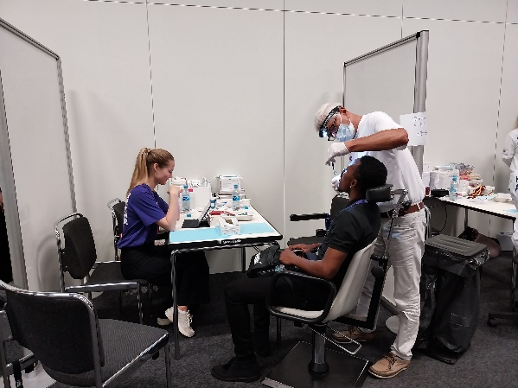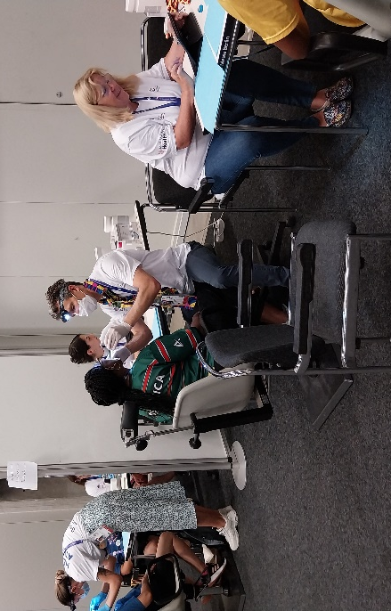
Supplementary Figure 2: Distribution of sports