IMPLANT STABILITY IN THE POSTERIOR MAXILLA: CLINICAL AND RADIOGRAPHIC COMPARISON OF OSSEODENSIFICATION AND CONVENTIONAL DRILLING: A RANDOMIZED CLINICAL TRIAL
CLINICAL ORAL INVESTIGATIONS

Authors: Sara Amr Abdelraouf^{1,3} MSc,
Omnia Aboul Dahab¹ PhD,
Basma Mostafa³ PhD,
Sarah Mohammed Kenawy² PhD,
Omnia K Tawfik¹ PhD

Author affiliation:
¹Oral Medicine and Periodontology Department, Faculty of Dentistry, Cairo University, Cairo, Egypt
²Oral and Maxillofacial Radiology Department, Faculty of Dentistry, Cairo University, Cairo, Egypt
³Surgery and Oral Medicine Department, Oral and Dental Research Institute, National Research Centre, Cairo, Egypt

Corresponding author:
Sara Amr Abdelraouf , PhD Candidate, Oral Medicine and Periodontology Department, Faculty of Dentistry, Cairo University, 11 El-Saraya St., Manial, Cairo, Egypt.
sara.amr@dentistry.cu.edu.eg

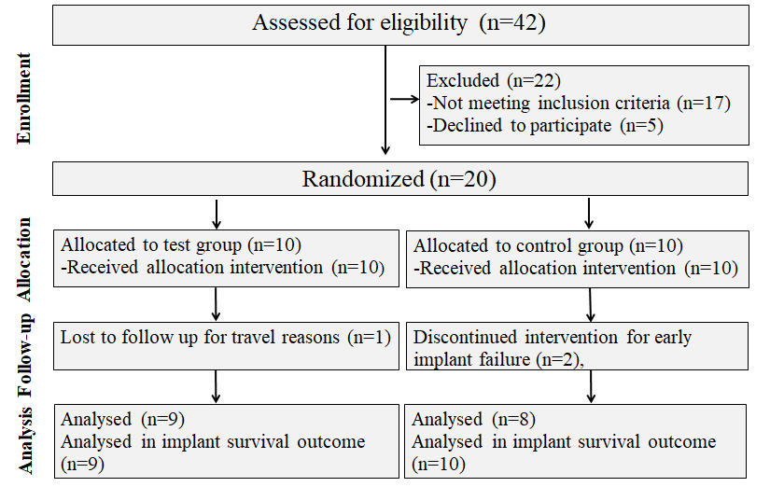
ONLINE RESOURCE 2: CONSORT diagram of the progress through the phases of the study (enrollment, allocation, follow-up and analysis)

