Research Article, Clinical Oral Investigations
Automated Detection of C-Shaped Canals in Mandibular Second Molars from Panoramic Radiographs: Comparing Single and Ensemble Convolutional Neural Networks within a 2-Stage Pipeline
Yunus Emre Çakmak, Kürşat Er
Department of Endodontics, Faculty of Dentistry, Akdeniz University, Antalya, Türkiye
Corresponding Author:
Yunus Emre Çakmak, DDS
Department of Endodontics, Faculty of Dentistry, Akdeniz University, Dumlupınar Bulv., 07058 Campus, Antalya, Türkiye

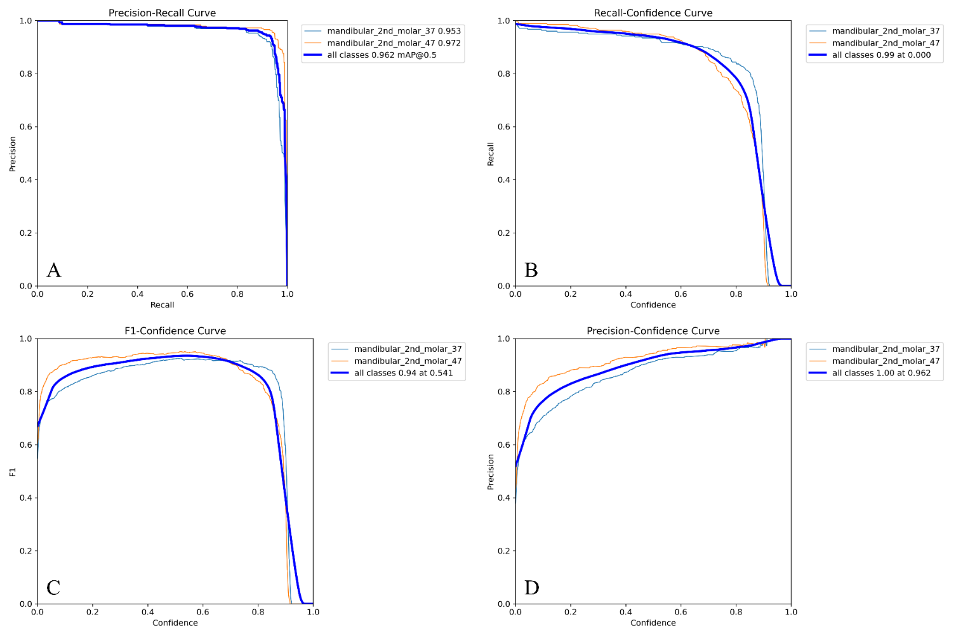
Supplementary Figure S1. Extended training-time diagnostics for the YOLO model (computed on the validation split during training). (A) Box, classification, and DFL losses showing steady convergence without overfitting. (B) mAP@0.5 and mAP@[0.5:0.95] trajectories across epochs indicating continual performance gains. (C) Per-class precision–recall curves for tooth #37 and tooth #47, with macro-averaged PR in bold. (D) Threshold analysis (precision–confidence, recall–confidence, and F1–confidence), highlighting the operating region used in downstream experiments. Error bands denote fold-to-fold variability where applicable.

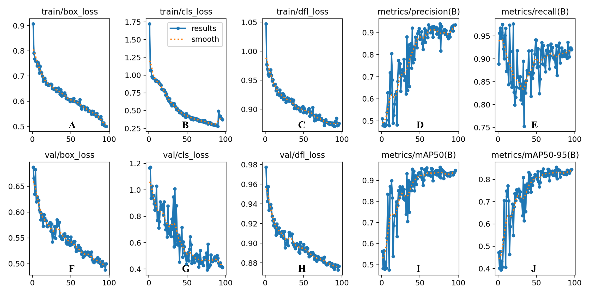
Supplementary Figure S2. YOLO training progress and validation metrics over 100 epochs. (A) Training box loss, (B) training classification loss (trend-smoothed), (C) training DFL loss, (D) training precision, (E) training recall. (F) Validation box loss, (G) validation classification loss, (H) validation DFL loss, (I) mAP@0.5, (J) mAP@[0.5:0.95]. All curves indicate successful convergence, with stable performance plateaus emerging around epoch ~75.
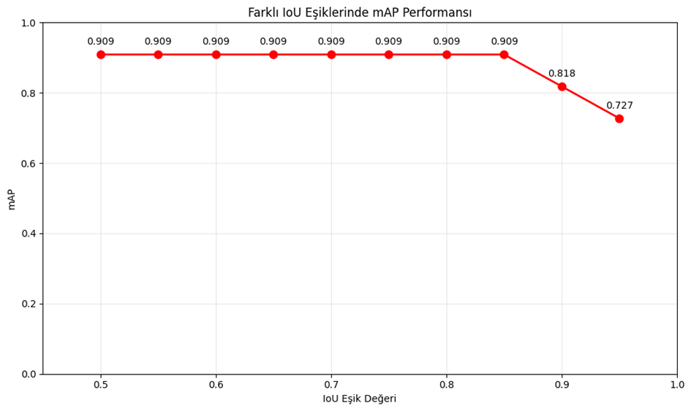
Map performance of YOLOv8 model at different IoU thresholds.
IoU thresholds

Supplementary Figure S3. Mean Average Precision (mAP) of the YOLOv8 model across varying IoU thresholds (0.50–0.95 in 0.05 increments), illustrating detection performance robustness over stricter localization criteria.
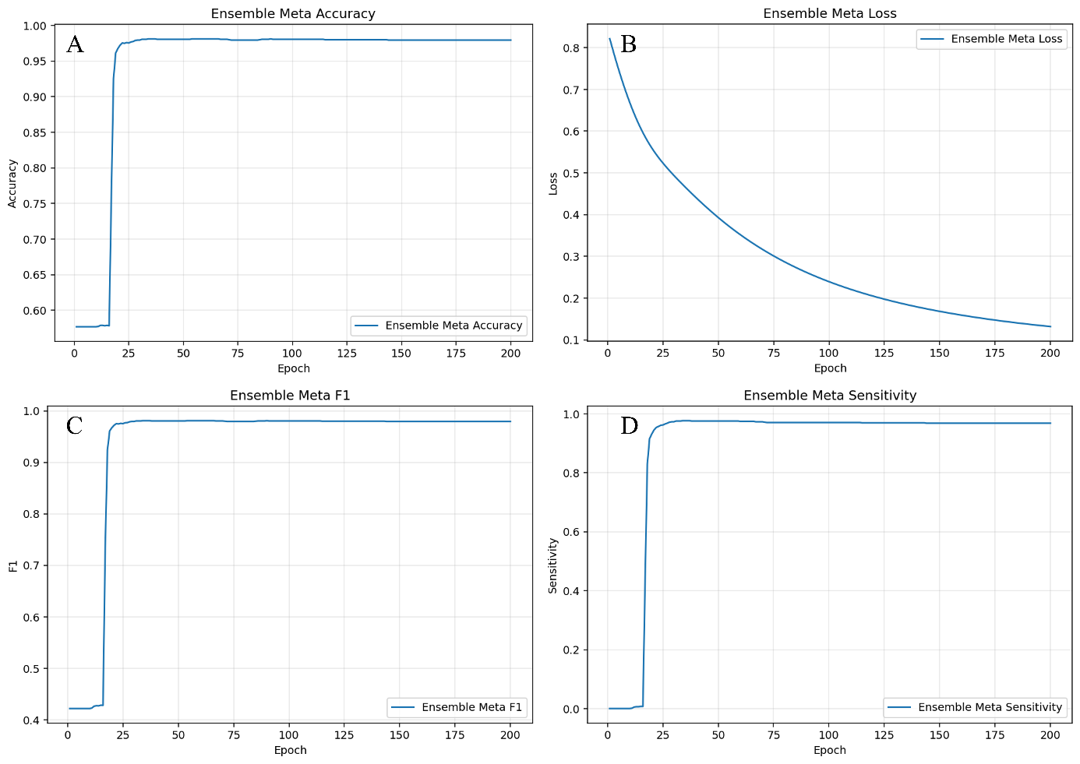
Supplementary Figure S4. Metrics of the ensemble meta-model over 100 training epochs: (A) trajectory of meta-accuracy, (B) decreasing meta-loss indicating convergence, (C) evolution of meta–F1 score reflecting the precision–recall balance, and (D) meta-sensitivity trends demonstrating the model’s ability to detect positive cases during training.

