Supplementary file

Table 1 Mean total victimization score (with standard deviation) for each type of victimization type (total sample)

 |  | Victim types
 |  | Non-victims | Pure DV | Pure RV | Pure CV | DV & RV | DV & CV | RV & CV | DV, RV, & CV
Total victimization score (Mean ± SD) |  | 1.46 (1.83) | 5.77 (2.70) | 5.67 (2.61) | 6.12 (2.79) | 10.33 (3.82) | 10.05 (3.77) | 9.54 (3.66) | 16.71 (6.85)
Note: The total victimization score was computed by summing the responses to the 13 victimization items (range 0-39); pupils were asked how often they had been victimized directly (5 items), relationally (4 items) and through cyber means (4 items) within the last six months (never=0; occasionally [1-3 times]=1; often [more than 4 times]=2; or frequently [at least once a week])=3). Pupils who responded “often” or “frequently” to any item (n=807; 29.3%) were categorized as victims and seven distinct victim types could be distinguished: (1) pure direct victims (pure DV); (2) pure relational victims (pure RV); (3) pure cyber-victims (pure CV); (4) direct and relational victims (DV & RV); (5) direct and cyber-victims (DV & CV); (6) relational and cyber-victims (RV & CV); or (7) direct, relational, and cyber-victims (DV, RV, & CV). Grouping in this way allowed a comparison in outcomes across each possible victim type.

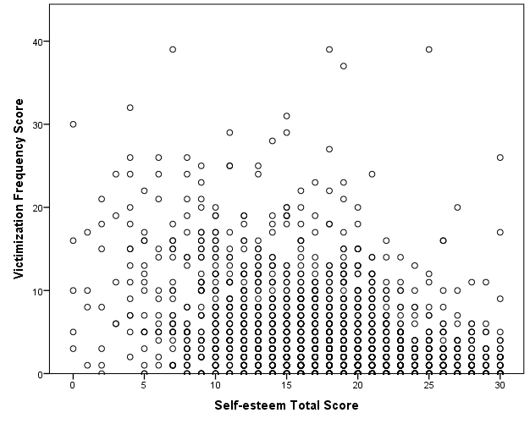
(r=-.378, n=2706, p<.001)

Figure 1 Scatter diagram of the association between total victimization frequency and self-esteem total scores.

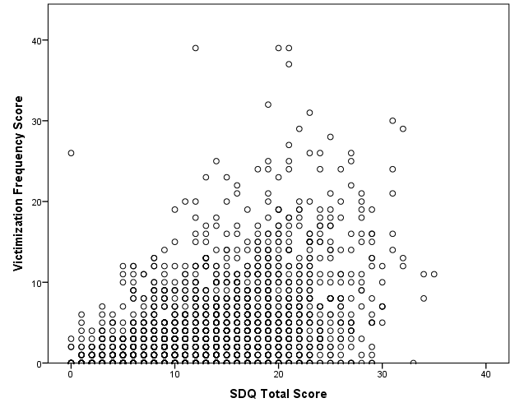
(r=.460, n=2677, p<.001)

Figure 2 Scatter diagram of the association between total victimization frequency and SDQ total scores.

