4) Related to this, because of the early age at follow up, the results as they are wouldn't convince me that adolescent-onset conduct problems are anything other than normative. It is quite possible that the adolescent-onset group will desist from their cannabis and alcohol use and criminal and aggressive behaviour when they are age 19 or 20. Again, it would be helpful here to know the results without the study (or studies) that used an extremely early age at follow-up. My guess is that the results will hold, supporting the authors' conclusions. However, as it is, the statements in the Discussion about the AO group aren't quite justified.
Thank you for this helpful comment. We have run the analysis again without those studies with early age at follow up (Kretschmer et al., 2014 and Sentse et al., 2016). Results still hold (in fact, in nearly all cases the ORs have increased) – a summary in the table below:
Supplemental material. The table shows the results from the additional analyses run without studies with very early age of outcome (17 and 18 years old).
Outcome | With all studies (OR, 95%CI) | Without studies using very early outcome (OR, 95%CI)
Mental Health | EOP: 2.24(1.67-3.01)  AO: 1.58(1.19-2.08)  CL: 1.29(1.00-1.68) | EOP: 2.93(2.12-4.05)  AO: 1.78(1.29-2.46)  CL: 1.23(0.45-1.80)
Cannabis use | EOP: 3.34(2.53-4.41)  AO: 3.78(2.54-5.63)  CL: 1.14(0.89-1.47) | EOP: 3.45(2.42-4.90)  AO:4.01(2.54-6.33)  CL:1.16(0.85-1.57)
Alcohol use | EOP:1.85(1.04-3.28)  AO:1.72(1.23-2.41)  CL:1.14(0.80-1.63) | EOP:1.76(0.71-4.33)  AO:1.72(1.13-2.63)  CL:1.23(0.83-1.83)
General Health | EOP:2.35(1.48-3.73)  AO:2.38(1.25-4.53)  CL:1.36(0.89-2.10) | EOP:2.55(1.56-4.18)  AO:2.64(1.29-5.41)  CL:1.49(0.80-2.79)
Self-reported aggression | EOP:5.40(2.80-10.43)  AO:3.55(2.07-6.08)  CL:1.75(1.21-2.53) | EOP:8.46(4.62-15.51)  AO:5.09(3.06-8.44)  CL:2.02(1.10-3.72)
Official records of criminal behaviour | EOP:3.18(1.73-5.85)  AO:2.29(1.43-3.67)  CL:1.28(0.99-1.66) | EOP:4.26(1.82-9.97)  AO:2.64(1.53-4.55)  CL:1.37(0.92-2.05)

For more details please check the forest plots below.

Mental health (depression/depressive mood)
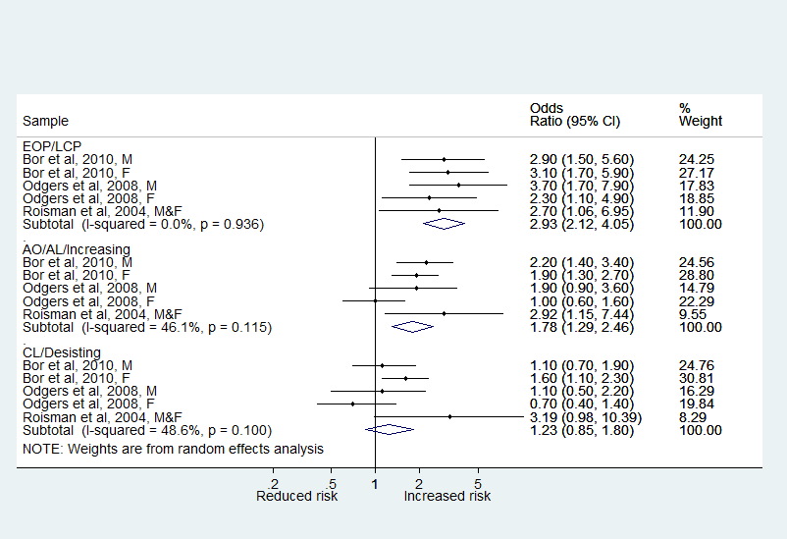

Cannabis Use:
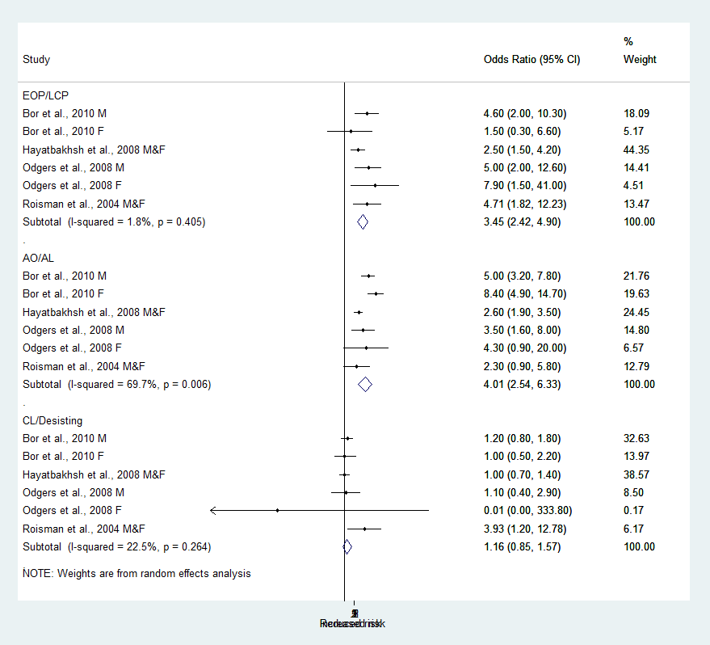

Alcohol use:
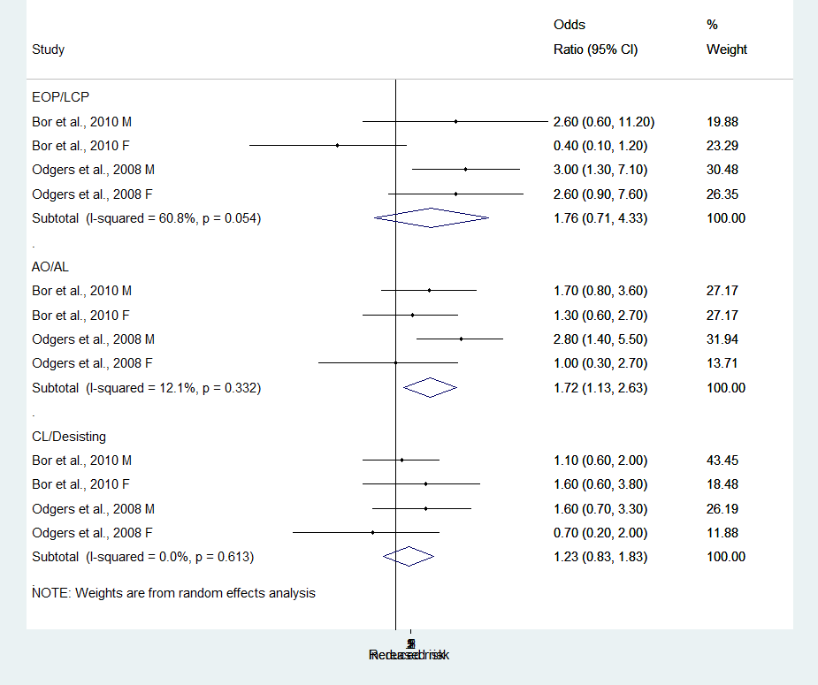

General Health:
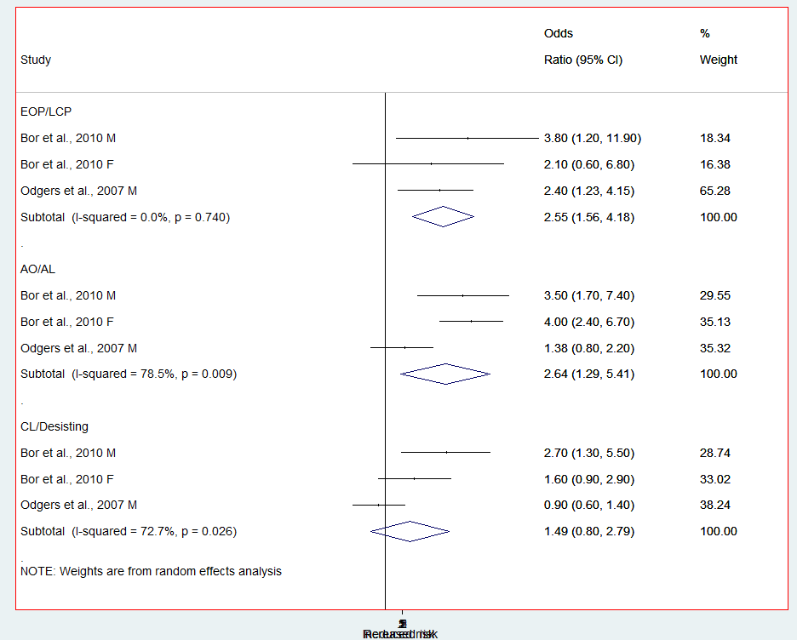
Self-reported aggression:
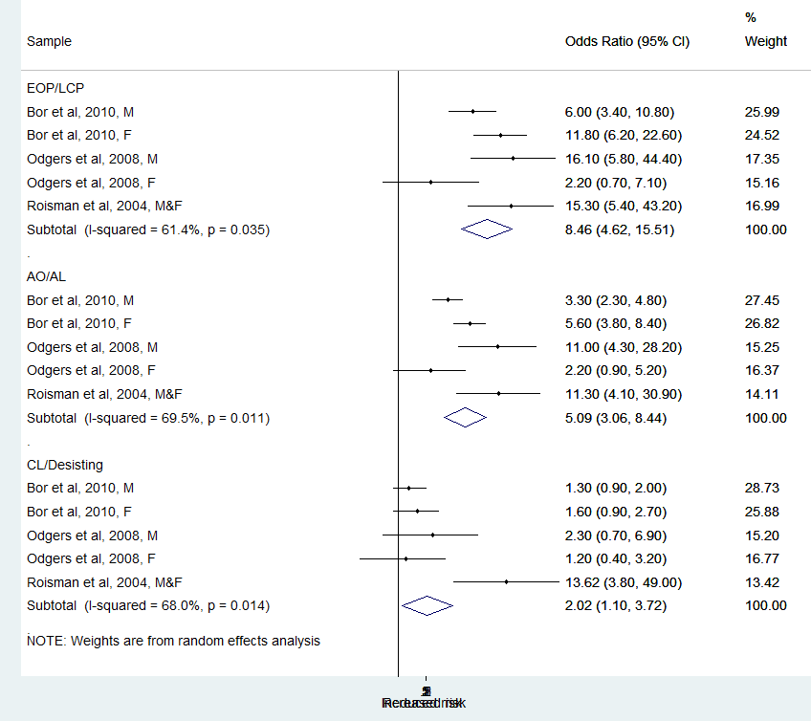

Official records of antisocial behaviour:
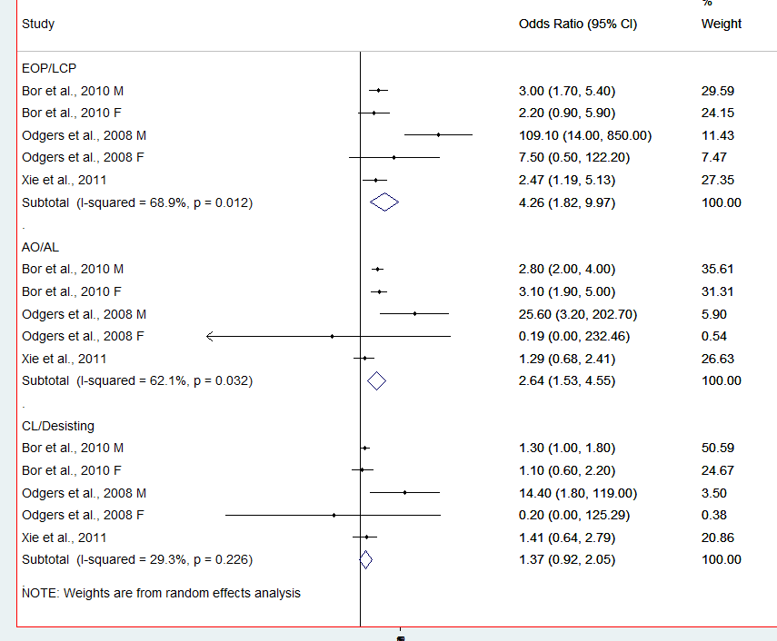

We have acknowledged this in the manuscript and added in the “Strengths and Limitations”:
“It could be argued that this may have resulted in outcomes being particularly negative for AO individuals, due to the relatively short gap between onset of behavioural problems and outcome measurement. However, ORs for AO individuals did not decrease in size when we run the meta-analyses without those studies with very early age at outcome, but slightly increased (results available in supplemental information)”.
Please let us know whether it would be appropriate to provide this info in supplemental information.
5) It looks like most of the studies included in the analyses used growth mixture modeling to identify trajectories (is that so?). However, these models have been quite critically discussed (I think the authors know this literature) and this should be acknowledged in the limitations.
Thanks for this comment – indeed these methods have been critically discussed - recent work by Heron et al., 2015 pointed out that estimates obtained using three-step models carry a certain risk of bias, particularly when classification quality (entropy) is poor but also when entropy has acceptable values. Although entropy in the growth models studies included in our review were acceptable to high (please see tables/pictures below) we have now acknowledged limitations in growth models which include overfitting the number of trajectories (which can lead to biased estimates of covariate effects), based on Heron et al., 2015. This can be found in the “Strengths and Limitation” section, paragraph 2. We appreciate the importance of this issue and we thank you again for this comment.

Barker and Maughan, 2009 (trajectories used by Kretschmer et al., 2009)
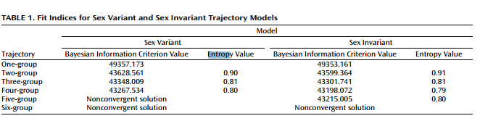

Sentse et al., 2016:
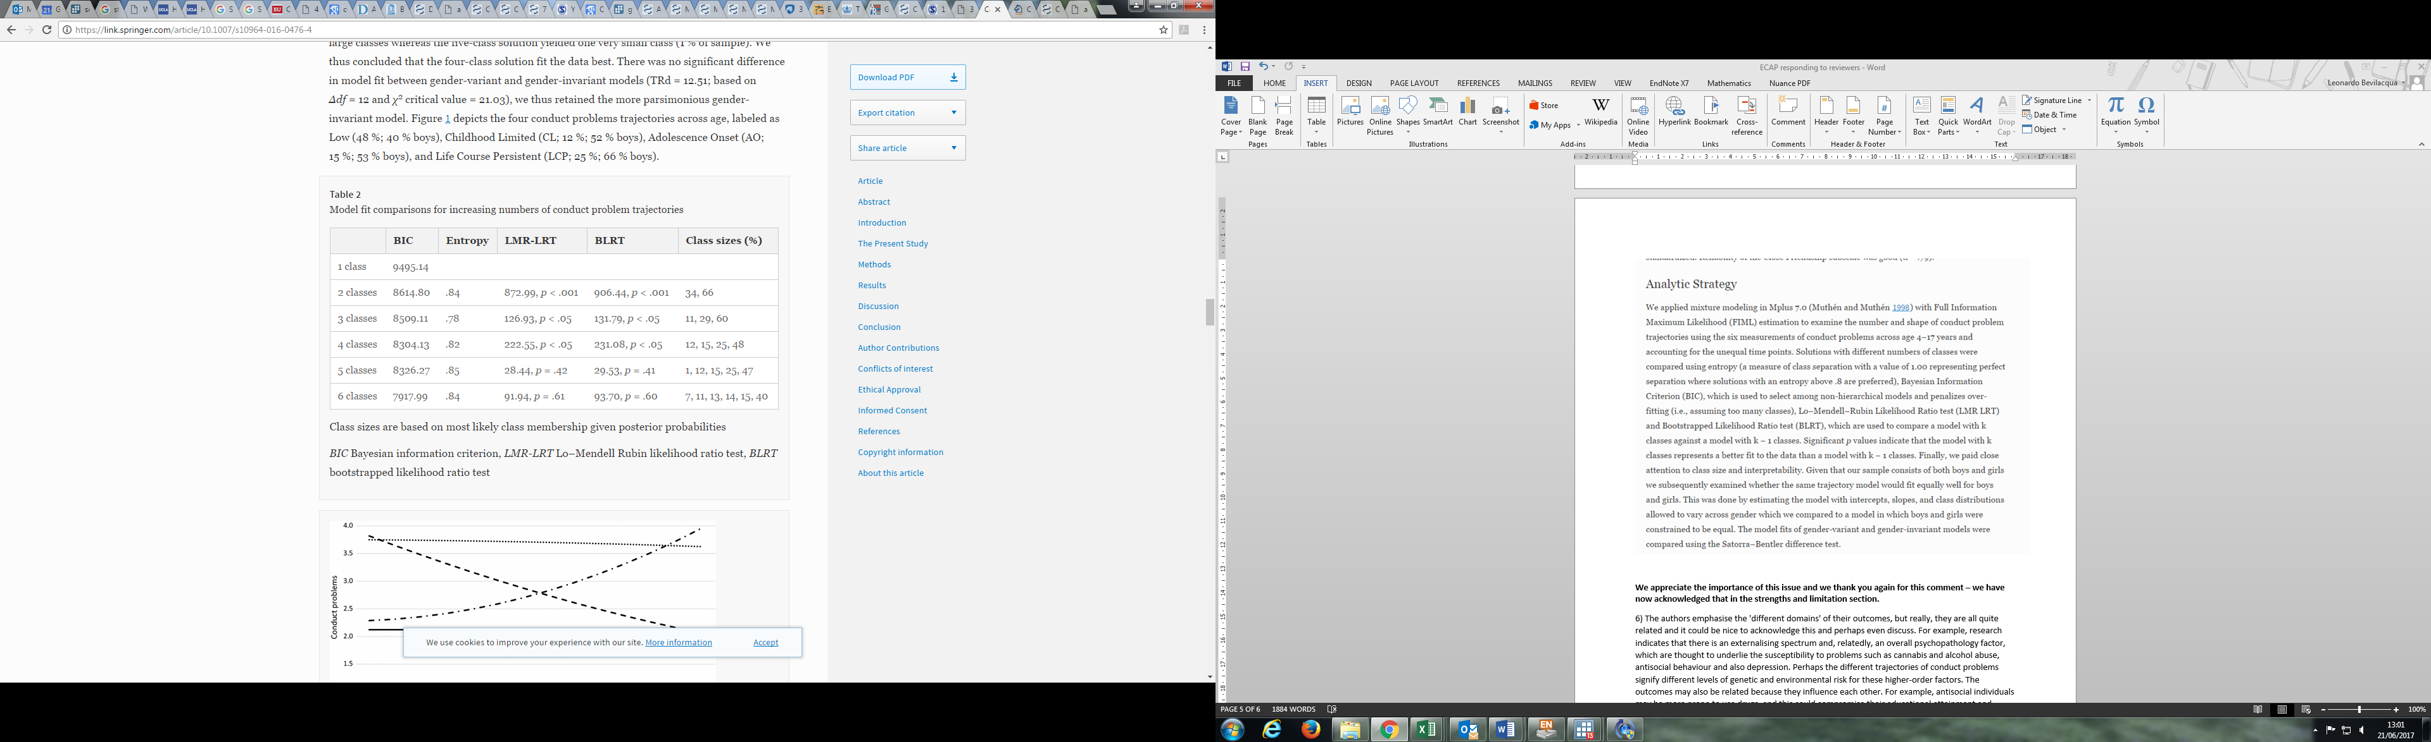

Odgers et al., 2008:
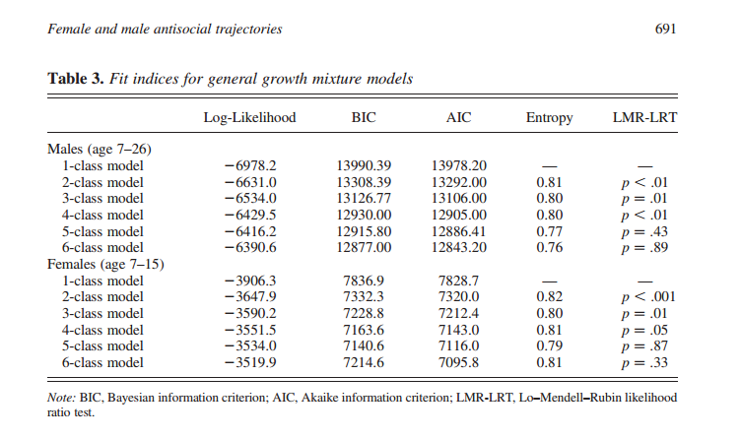

6) The authors emphasise the 'different domains' of their outcomes, but really, they are all quite related and it could be nice to acknowledge this and perhaps even discuss. For example, research indicates that there is an externalising spectrum and, relatedly, an overall psychopathology factor, which are thought to underlie the susceptibility to problems such as cannabis and alcohol abuse, antisocial behaviour and also depression. Perhaps the different trajectories of conduct problems signify different levels of genetic and environmental risk for these higher-order factors. The outcomes may also be related because they influence each other. For example, antisocial individuals may be more prone to use drugs, and this could compromise their educational attainment and impair their health.
Thank you for this – yes we absolutely agree that the outcomes we are looking at are related to each other and this could be for a number of reasons which do not necessarily exclude each other (i.e. genetic susceptibility and also mutual influence across different stages of development) - We have specified the concept of “developmental snares” in the introduction, which should help the reader understand how closely interconnected life domains such as health, drug use and employment are. In our discussion we have treated the outcomes more as a “whole”, rather than different and unrelated aspects of life and we apologies if this was not clear enough. We have added in the discussion section: “Given the interconnectedness of the outcomes considered, it is not surprising to see a trend across domains” to emphasise this.
Small comments:
7) This is personal preference but can the authors write out "conduct problems" rather than shortening it. It would make it much easier to follow and not make it seem like another type of trajectory.
This has now been amended throughout – track changes mode has not been used for this particular set of changes to not make the manuscript look too confusing
8) Please add "the" before the trajectories (e.g. "the" EOP trajectory) on page 9 and throughout the text
Yes this has been amended accordingly throughout the whole manuscript
9) In the mental health results section (page 9 paragraph 4), please specify the outcome for which the EOP trajectory had a large effect size (was it depressive feelings or a diagnosis of depression?)
Thank you for pointing this out – both of them were treated as one outcome. We indicated “including but not limited to depressive feelings and clinical diagnosis of depression” – full details regarding measures are reported in table 2.
10) Please report ORs even for non-significant findings (e.g. on page 9, 4th paragraph) and ideally report all ORs with 95%CIs if space allows.
All ORs and 95% CIs now added

Again thank you very much for your comments. It helped us thinking more deeply about some areas of our work. We hope that you will find this revised manuscript much stronger than the previous one. Of particular importance, is the addition of the sensitivity analysis excluding studies with very early age of outcome. This led to similar results and adds solidity to our findings. Thank you again for suggesting to do this.

