Supplementary material

Table S1. Pearson correlation coefficients main measures.
 |  | 1 | 2 | 3 | 4 | 5 | 6 | 7 | 8 | 9 | 10 | 11 | 12 | 13
1 | No. of tubers | -
2 | No. of tubers frontal | 0.97** | -
3 | No. of tubers parietal | 0.84** | 0.73** | -
4 | No. of tubers temporal | 0.84** | 0.77** | 0.63** | -
5 | No. of tubers occipital | 0.71** | 0.61** | 0.55** | 0.55** | -
6 | No. of RMLs | 0.71** | 0.69** | 0.61** | 0.52** | 0.54** | -
7 | No. of RMLs frontal | 0.54** | 0.61** | 0.37** | 0.35* | 0.29* | 0.90** | -
8 | No. of RMLs parietal | 0.59** | 0.48** | 0.80** | 0.37** | 0.46** | 0.70** | 0.48** | -
9 | No. of RMLs temporal | 0.51** | 0.49** | 0.30* | 0.54** | 0.46** | 0.67** | 0.49** | 0.20 | -
10 | No. of RMLs occipital | 0.51** | 0.41** | 0.45** | 0.40** | 0.74** | 0.58** | 0.35* | 0.46** | 0.41** | -
11 | ADOS total CSS | 0.46** | 0.41** | 0.43** | 0.38** | 0.39** | 0.40** | 0.31* | 0.35* | 0.24 | 0.39** | -
12 | ADOS SA domain CSS | 0.37** | 0.32* | 0.40** | 0.26 | 0.35* | 0.41** | 0.33* | 0.35* | 0.23 | 0.39** | 0.92** | -
13 | ADOS RRB domain CSS | 0.49** | 0.49** | 0.36** | 0.43** | 0.31* | 0.33* | 0.27 | 0.25 | 0.25 | 0.26 | 0.64** | 0.39** | -
14 | IQ / DQ | -0.56** | -0.56** | -0.47** | -0.45** | -0.31* | -0.42** | -0.40** | -0.322* | -0.22 | -0.20 | -0.60** | -0.53** | -0.52**
Note: n=52. ADOS=Autism Diagnostic Observation Scale, CSS=calibrated severity score, SA=Social Affect, RMLs=Radial migration lines, RRB=Restricted and Repetitive Behaviors, IQ=intelligence quotient, DQ=developmental quotient. **p<0.01, *p<0.05

Table S2. T-test comparing individuals without and with an ADOS ASD classification on number of tubers
 | ADOS classification | n | Mean | SD | t | df | p
Total number of tubers | non-spectrum | 27 | 19.22 | 16.97 | -3.38 | 50 | 0.001
Total number of tubers | ASD | 25 | 36.52 | 19.88 | -3.38 | 50 | 0.001
Frontal lobes | non-spectrum | 27 | 11.44 | 10.06 | -3.04 | 50 | 0.004
Frontal lobes | ASD | 25 | 20.88 | 12.30 | -3.04 | 50 | 0.004
Parietal lobes | non-spectrum | 27 | 3.56 | 3.59 | -3.37 | 50 | 0.001
Parietal lobes | ASD | 25 | 7.52 | 4.84 | -3.37 | 50 | 0.001
Temporal lobes | non-spectrum | 27 | 2.70 | 2.66 | -2.42 | 50 | 0.019
Temporal lobes | ASD | 25 | 4.84 | 3.66 | -2.42 | 50 | 0.019
Occipital lobes | non-spectrum | 27 | 1.56 | 2.31 | -2.53 | 50 | 0.015
Occipital lobes | ASD | 25 | 3.28 | 2.61 | -2.53 | 50 | 0.015
Note: ADOS=Autism Diagnostic Observation Scale. ASD=autism spectrum disorder.

Table S3. Logistic regression analyses: association ADOS classification (non-spectrum/ASD) and tuber count
 | Model I |  |  |  |  |  | Model I + IQ/DQ
 | B | SE | OR | p | p_{corr}ª |  | B | SE | OR | p | p_{corr}ª
Total number of tubers | 0.05 | 0.02 | 1.05 | 0.004 | - |  | 0.02 | 0.02 | 1.02 | 0.224 | -
Number of tubers frontal lobes | 0.08 | 0.03 | 1.08 | 0.008 | 0.023 |  | 0.03 | 0.03 | 1.03 | 0.395 | 1
Number of tubers parietal lobes | 0.23 | 0.08 | 1.26 | 0.005 | 0.014 |  | 0.16 | 0.09 | 1.17 | 0.083 | 0.247
Number of tubers temporal lobes | 0.22 | 0.10 | 1.24 | 0.026 | 0.077 |  | 0.07 | 0.11 | 1.07 | 0.536 | 1
Number of tubers occipital lobes | 0.30 | 0.13 | 1.35 | 0.023 | 0.068 |  | 0.17 | 0.13 | 1.19 | 0.187 | 0.559
Note: n_{tot}=52, n_{ASD}=25, n_{non-spectrum}=27. ADOS=Autism Diagnostic Observation Scale. ASD=autism spectrum disorder. ªMultiple testing correction (2.98 effective tests) applied.

Table S4. Association ADOS total calibrated severity score and cystic/calcified tuber count
 |  | Model I |  |  |  |  |  |  | Model I + IQ/DQ
 |  | B | 95% CI | β | p | p_{corr}ª | R²_{adj} |  | B | 95% CI | β | p | p_{corr}ª | R²_{adj}
Cystic tubers
 | Total number | 0.10 | -0.09;0.30 | 0.15 | 0.281 | - | 0.004 |  | -0.00 | -0.16;0.16 | -0.00 | 0.994 | - | 0.332
 | Frontal lobes | 0.19 | -0.14;0.53 | 0.16 | 0.257 | 0.874 | 0.006 |  | -0.02 | -0.31;0.27 | -0.02 | 0.897 | 1 | 0.333
 | Parietal lobes | 0.33 | -0.31;0.96 | 0.14 | 0.308 | 1 | 0.001 |  | 0.04 | -0.50;0.57 | 0.02 | 0.894 | 1 | 0.333
 | Temporal lobes | 0.26 | -0.50;1.03 | 0.10 | 0.492 | 1 | -0.010 |  | 0.13 | -0.50;0.75 | 0.05 | 0.671 | 1 | 0.335
 | Occipital lobes | -0.75 | -3.08;1.58 | -0.09 | 0.519 | 1 | -0.011 |  | -0.95 | -2.83;0.93 | -0.12 | 0.313 | 1 | 0.346
Calcified tubers
 | Total number | 0.10 | -0.20;0.39 | 0.09 | 0.523 | - | -0.012 |  | 0.28 | 0.05;0.52 | 0.27 | 0.020 | - | 0.403
 | Frontal lobes | 0.00 | -0.57;0.57 | 0.00 | 1 | 1 | -0.020 |  | 0.40 | -0.07;0.87 | 0.20 | 0.094 | 0.269 | 0.370
 | Parietal lobes | 0.24 | -0.76;1.25 | 0.07 | 0.628 | 1 | -0.015 |  | 0.78 | -0.02;1.59 | 0.22 | 0.057 | 0.163 | 0.380
 | Temporal lobes | -0.62 | -3.07;1.83 | -0.07 | 0.612 | 1 | -0.015 |  | 1.04 | -1.03;3.10 | 0.12 | 0.318 | 0.909 | 0.346
 | Occipital lobes | 1.39 | 0.23;2.55 | 0.32 | 0.020 | 0.057 | 0.086 |  | 1.41 | 0.51;2.32 | 0.33 | 0.003 | 0.009 | 0.445
Note: n=52. ADOS=Autism Diagnostic Observation Scale, IQ=intelligence quotient, DQ=developmental quotient. R²_{adj}=Adjusted R squared model. ªMultiple testing correction (3.40 effective tests for cystic tuber analyses, and 2.86 effective tests for calcified tuber analyses) applied.

Table S5. Association ADOS subdomain calibrated severity scores and cystic/calcified tuber count
 |  |  | Model I |  |  |  |  |  |  | Model I + IQ/DQ
 |  |  | B | 95% CI | β | p | p_{corr}ª | R²_{adj} |  | B | 95% CI | β | p | p_{corr}ª | R²_{adj}
Cystic tubers
 | Total number | SA domain CSS | 0.09 | -0.10;0.27 | 0.13 | 0.354 | - | -0.002 |  | -0.00 | -0.17;0.16 | -0.01 | 0.965 | - | 0.255
 | Total number | RRB domain CSS | 0.21 | 0.01;0.40 | 0.28 | 0.043 | - | 0.061 |  | 0.12 | -0.07;0.30 | 0.16 | 0.207 | - | 0.263
 | Frontal lobes | SA domain CSS | 0.18 | -0.15;0.50 | 0.15 | 0.275 | 0.935 | 0.004 |  | -0.00 | -0.30;0.29 | -0.00 | 0.993 | 1 | 0.255
 | Frontal lobes | RRB domain CSS | 0.30 | -0.05;0.66 | 0.24 | 0.091 | 0.309 | 0.037 |  | 0.12 | -0.21;0.45 | 0.09 | 0.463 | 1 | 0.247
 | Parietal lobes | SA domain CSS | 0.35 | -0.26;0.96 | 0.16 | 0.252 | 0.857 | 0.007 |  | 0.11 | -0.43;0.65 | 0.05 | 0.693 | 1 | 0.257
 | Parietal lobes | RRB domain CSS | 0.51 | -0.15;1.18 | 0.21 | 0.128 | 0.435 | 0.027 |  | 0.26 | -0.34;0.86 | 0.11 | 0.393 | 1 | 0.250
 | Temporal lobes | SA domain CSS | -0.01 | -0.74;0.74 | -0.00 | 0.990 | 1 | -0.020 |  | -0.12 | -75;0.52 | -0.05 | 0.709 | 1 | 0.257
 | Temporal lobes | RRB domain CSS | 0.85 | 0.07;1.63 | 0.30 | 0.033 | 0.112 | 0.069 |  | 0.73 | 0.06;1.41 | 0.26 | 0.034 | 0.116 | 0.306
 | Occipital lobes | SA domain CSS | -0.54 | -2.79;1.72 | -0.07 | 0.635 | 1 | -0.015 |  | -0.71 | -2.63;1.22 | -0.09 | 0.464 | 1 | 0.263
 | Occipital lobes | RRB domain CSS | 0.64 | -1.84;3.12 | 0.07 | 0.608 | 1 | -0.015 |  | 0.46 | -1.69;2.61 | 0.05 | 0.670 | 1 | 0.242
Calcified tubers
 | Total number | SA domain CSS | 0.06 | -0.23;0.35 | 0.06 | 0.691 | - | -0.017 |  | 0.22 | -0.03;0.47 | 0.21 | 0.084 | - | 0.299
 | Total number | RRB domain CSS | 0.17 | -0.14;0.49 | 0.16 | 0.271 | - | 0.005 |  | 0.36 | 0.09;0.62 | 0.32 | 0.010 | - | 0.336
 | Frontal lobes | SA domain CSS | -0.01 | -0.56;0.54 | -0.01 | 0.960 | 1 | -0.020 |  | 0.33 | -0.16;0.81 | 0.17 | 0.180 | 0.515 | 0.282
 | Frontal lobes | RRB domain CSS | 0.14 | -0.46;0.75 | 0.07 | 0.633 | 1 | -0.015 |  | 0.53 | -0.00;1.06 | 0.25 | 0.051 | 0.146 | 0.296
 | Parietal lobes | SA domain CSS | 0.16 | -0.81;1.13 | 0.05 | 0.745 | 1 | -0.018 |  | 0.62 | -0.22;1.45 | 0.18 | 0.143 | 0.409 | 0.287
 | Parietal lobes | RRB domain CSS | 0.48 | -0.58;1.54 | 0.13 | 0.366 | 1 | -0.003 |  | 0.99 | 0.09;1.90 | 0.26 | 0.033 | 0.094 | 0.307
 | Temporal lobes | SA domain CSS | -0.81 | -3.17;1.54 | -0.10 | 0.491 | 1 | -0.010 |  | 0.58 | -1.54;2.70 | 0.07 | 0.583 | 1 | 0.259
 | Temporal lobes | RRB domain CSS | 0.97 | -1.62;3.57 | 0.11 | 0.455 | 1 | -0.009 |  | 2.65 | 0.41;4.89 | 0.29 | 0.021 | 0.060 | 0.318
 | Occipital lobes | SA domain CSS | 0.99 | -0.16;2.13 | 0.24 | 0.089 | 0.255 | 0.038 |  | 1.01 | 0.05;1.98 | 0.24 | 0.041 | 0.117 | 0.316
 | Occipital lobes | RRB domain CSS | 1.29 | 0.04;2.54 | 0.28 | 0.043 | 0.123 | 0.061 |  | 1.31 | 0.25;2.37 | 0.29 | 0.016 | 0.046 | 0.324
Note: n=52. ADOS=Autism Diagnostic Observation Scale, CSS=calibrated severity score, SA=Social Affect, RRB=Restricted and Repetitive Behaviors, IQ=intelligence quotient, DQ=developmental quotient. R²_{adj}=Adjusted R squared model. ªMultiple testing correction (3.40 effective tests for cystic tuber analyses, and 2.86 effective tests for calcified tuber analyses) applied.

Table S6. T-test comparing individuals without and with an ADOS ASD classification on number of radial migration lines
 | ADOS classification | n | Mean | SD | t | df | p
Total number of RMLs | non-spectrum | 27 | 13.22 | 9.16 | -2.11 | 50 | 0.040
Total number of RMLs | ASD | 25 | 19.00 | 10.55 | -2.11 | 50 | 0.040
Frontal lobes | non-spectrum | 27 | 6.96 | 5.20 | -1.63 | 50 | 0.110
Frontal lobes | ASD | 25 | 9.52 | 6.12 | -1.63 | 50 | 0.110
Parietal lobes | non-spectrum | 27 | 3.15 | 2.64 | -1.81 | 50 | 0.076
Parietal lobes | ASD | 25 | 4.80 | 3.86 | -1.81 | 50 | 0.076
Temporal lobes | non-spectrum | 27 | 2.52 | 2.97 | -1.23 | 50 | 0.226
Temporal lobes | ASD | 25 | 3.52 | 2.92 | -1.23 | 50 | 0.226
Occipital lobes | non-spectrum | 27 | 0.59 | 0.84 | -1.81 | 50 | 0.077
Occipital lobes | ASD | 25 | 1.16 | 1.37 | -1.81 | 50 | 0.077
Note: ADOS=Autism Diagnostic Observation Scale. ASD=autism spectrum disorder. RML=radial migration line.

Table S7. Logistic regression analyses: association ADOS classification (non-spectrum/ASD) and radial migration lines
 | B | SE | OR | p | p_{corr}ª |  | B | SE | OR | p | p_{corr}ª
Total number of tubers | 0.06 | 0.03 | 1.06 | 0.046 | - |  | 0.02 | 0.04 | 1.02 | 0.630 | -
Number of radial migration lines frontal lobes | 0.08 | 0.05 | 1.09 | 0.113 | 0.404 |  | -0.00 | 0.06 | 1.00 | 0.991 | 1
Number of radial migration lines parietal lobes | 0.16 | 0.10 | 1.18 | 0.088 | 0.313 |  | 0.10 | 0.12 | 1.10 | 0.409 | 1
Number of radial migration lines temporal lobes | 0.12 | 0.10 | 1.13 | 0.226 | 0.808 |  | 0.03 | 0.11 | 1.03 | 0.799 | 1
Number of radial migration lines occipital lobes | 0.47 | 0.27 | 1.60 | 0.087 | 0.310 |  | 0.36 | 0.31 | 1.43 | 0.244 | 0.871
Note: n_{tot}=52, n_{ASD}=25, n_{non-spectrum}=27. ADOS=Autism Diagnostic Observation Scale. ASD=autism spectrum disorder. ªMultiple testing correction (3.57 effective tests) applied.

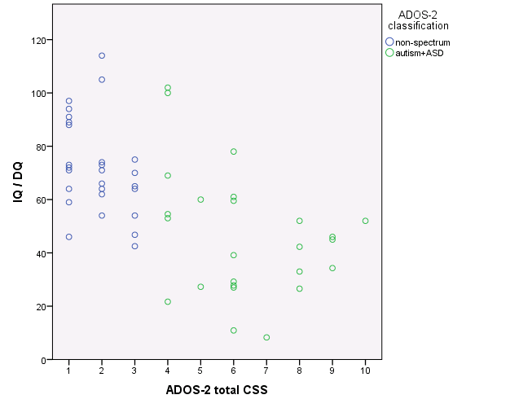
Figure S1. Distribution of ADOS total calibrated severity scores (CSS) by IQ/DQ, split by ADOS classification.

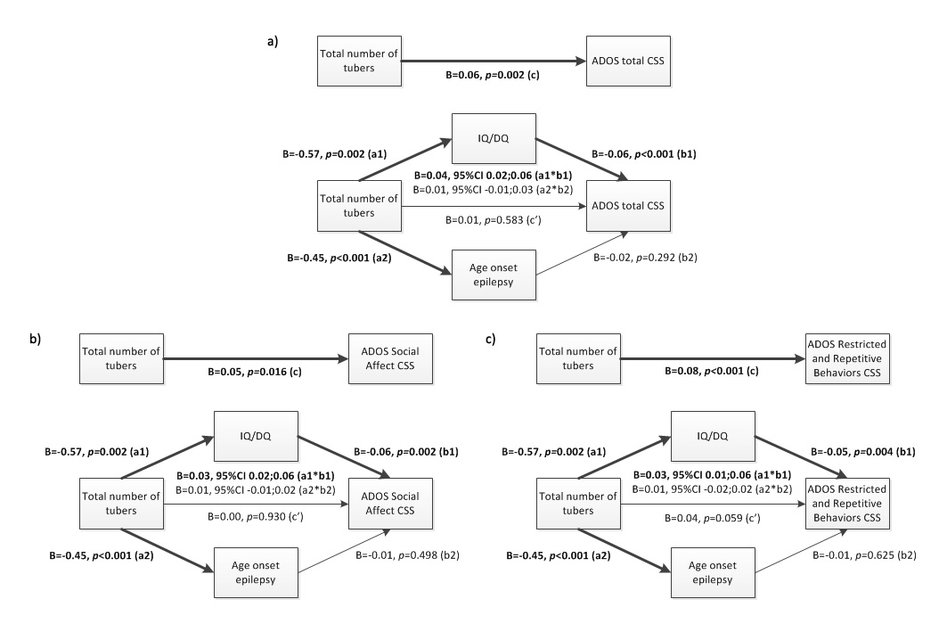
Figure S2. Mediation analyses tuber count and ASD severity score, with IQ/DQ and age of epilepsy onset as mediators. a) ADOS total severity score, b) ADOS Social Affect (SA) domain severity score, c) ADOS Restricted and Repetitive Behaviors (RRB) domain severity score. n=46 (only in children with epilepsy).

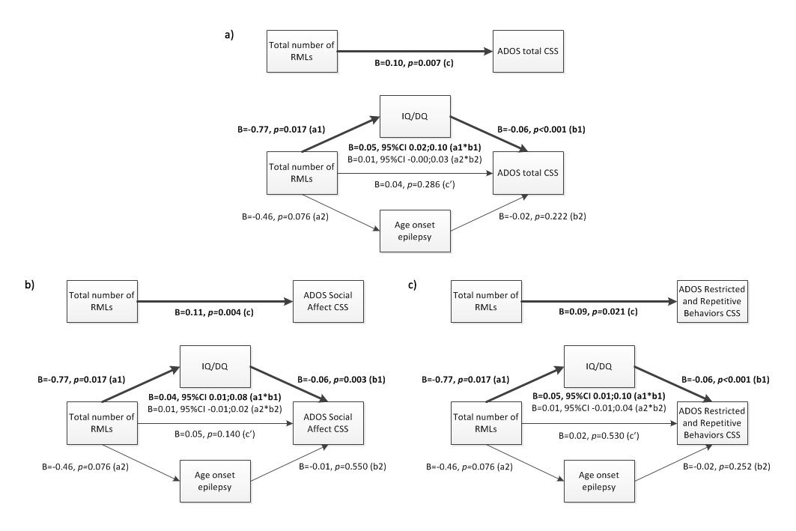
Figure S3. Mediation analyses RML count and ASD severity score, with IQ/DQ and age of epilepsy onset as mediators. a) ADOS total severity score, b) ADOS Social Affect (SA) domain severity score, c) ADOS Restricted and Repetitive Behaviors (RRB) domain severity score. n=46 (only in children with epilepsy).

