Additional material 3: Results of the Meta-Analyses

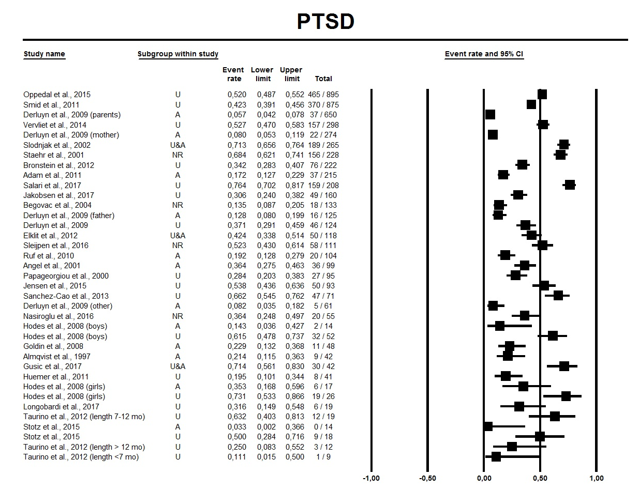
Figure 1 Meta-Analysis of the reported point prevalences of PTSD. Random effects meta-analysis; I²=96%, Tau²=0.88
Abbreviations: A, accompanied minors; NR, not reported; U, unaccompanied minors

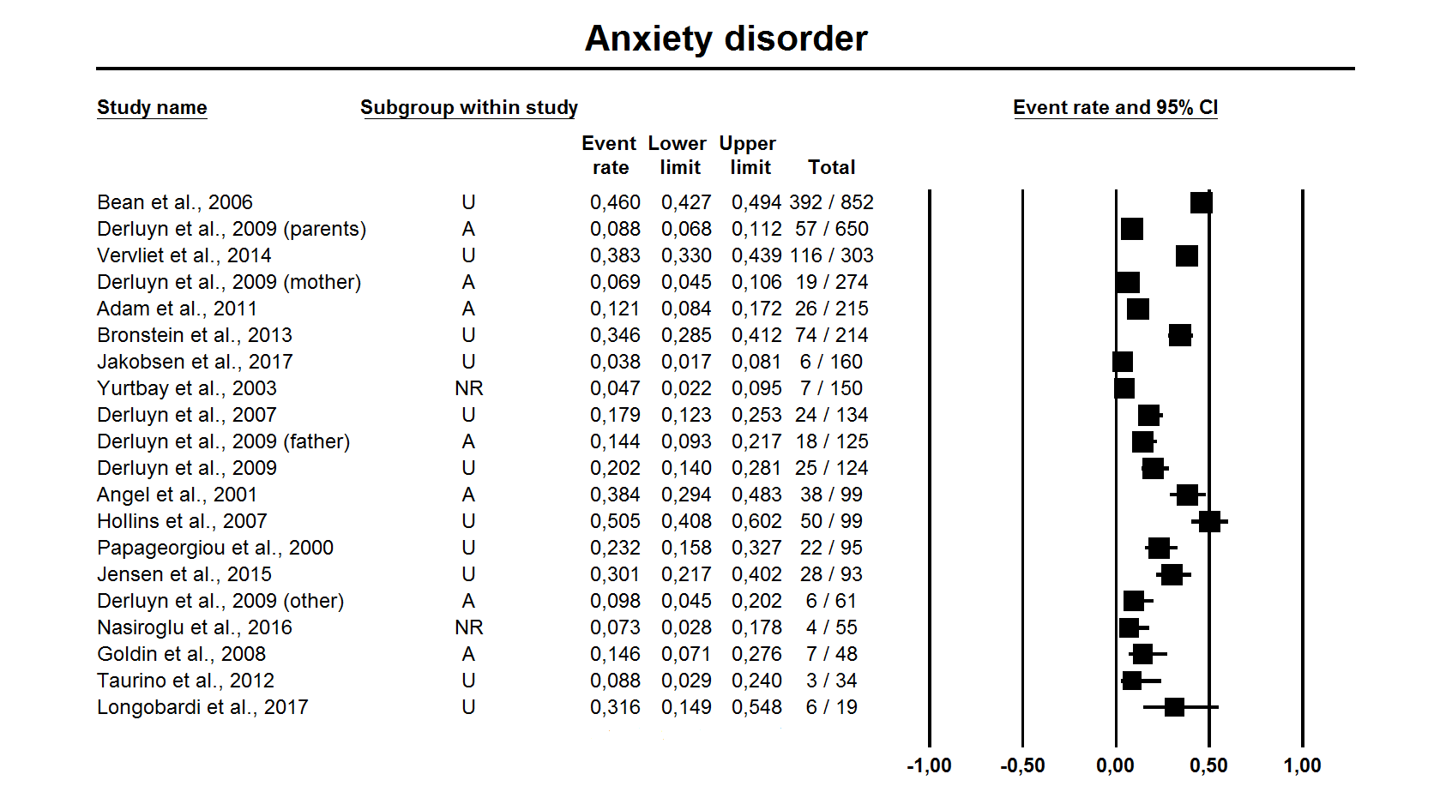
Figure 2 Meta-Analysis of the reported point prevalences of anxiety disorders. Random effects meta-analysis; I²=96%, Tau²=0.88
Abbreviations: A, accompanied minors; NR, not reported; U, unaccompanied minors

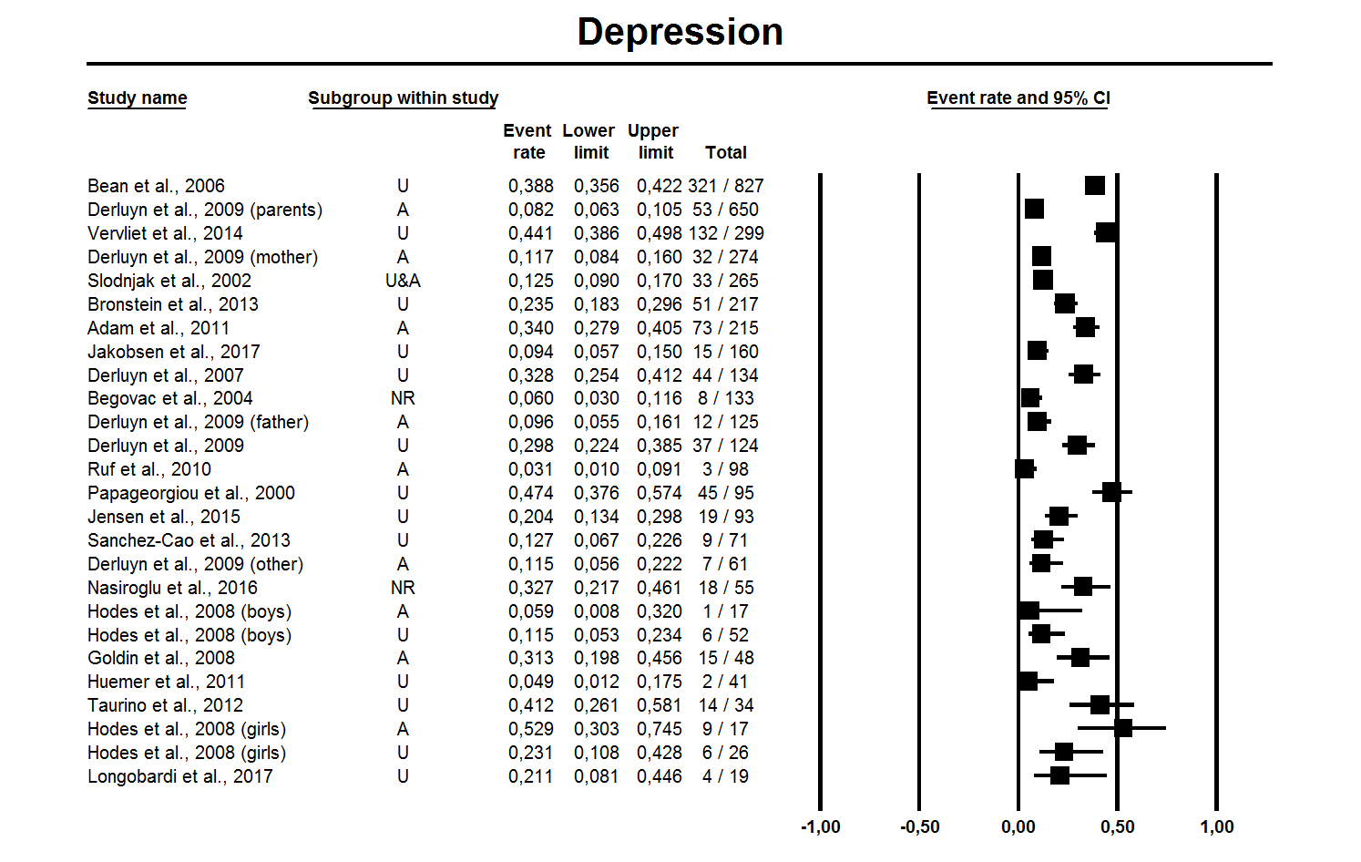
Figure 3 Meta-Analysis of the reported point prevalences of depression. Random effects meta-analysis; I²=94%, Tau²=0.96
Abbreviations: A, accompanied minors; NR, not reported; U, unaccompanied minors

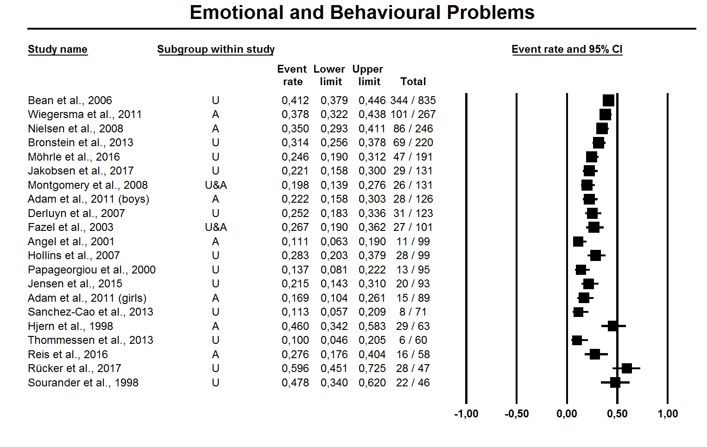
Figure 4 Meta-Analysis of the reported point prevalences of emotional and behavioural problems. Random effects meta-analysis; I²=87%, Tau²=0.25
Abbreviations: A, accompanied minors; U, unaccompanied minors

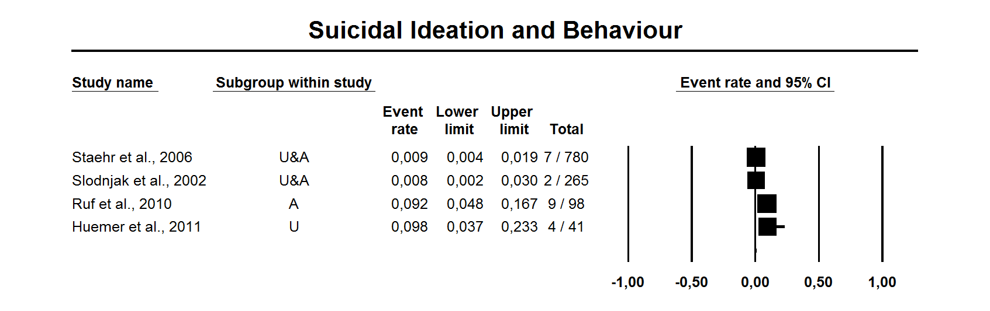
Figure 5 Meta-Analysis of the reported point prevalences of suicidal ideation and behaviour. Random effects meta-analysis; I²=90%, Tau²=1.96
Abbreviations: A, accompanied minors, U, unaccompanied minors

