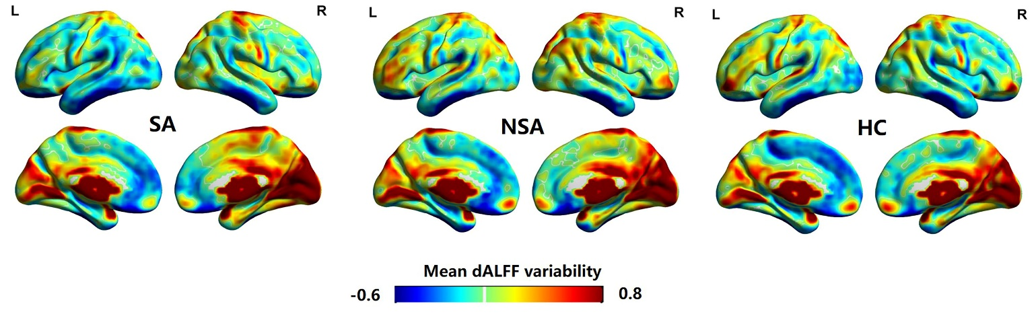
Figure S1. Spatial distribution of dALFF variability in the MDD-SA, MDD-NSA, and HC groups. Brain regions with high temporal variability were mainly located in the occipital cortices and postmedial, lateral frontal, parietal, limbic and sensorimotor cortices. SA, prior suicide attempt; NSA, no prior suicide attempt; HC, healthy control; dALFF, dynamic amplitude of low-frequency fluctuations.

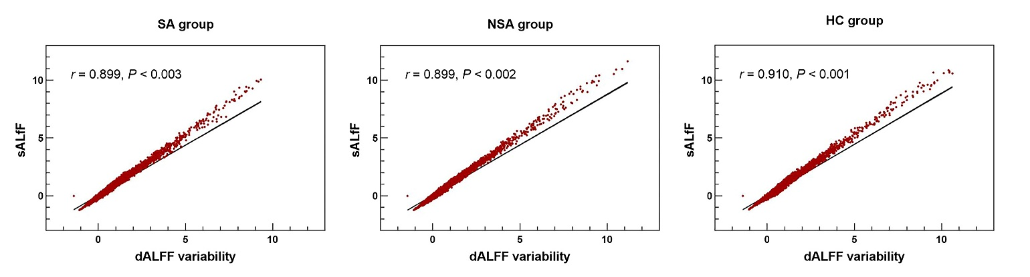
Figure S2 Correlation between sALFF and dALFF variability in the MDD-SA, MDD-NSA, and HC groups. Pearson’s correlation analysis showed sALFF metrics were all highly and positively correlated with dALFF variability in MDD-SA, MDD-NSA, and HC groups. SA, prior suicide attempt; NSA, no prior suicide attempt; HC, healthy control; sALFF, static amplitude of low-frequency fluctuations; dALFF, dynamic amplitude of low-frequency fluctuations

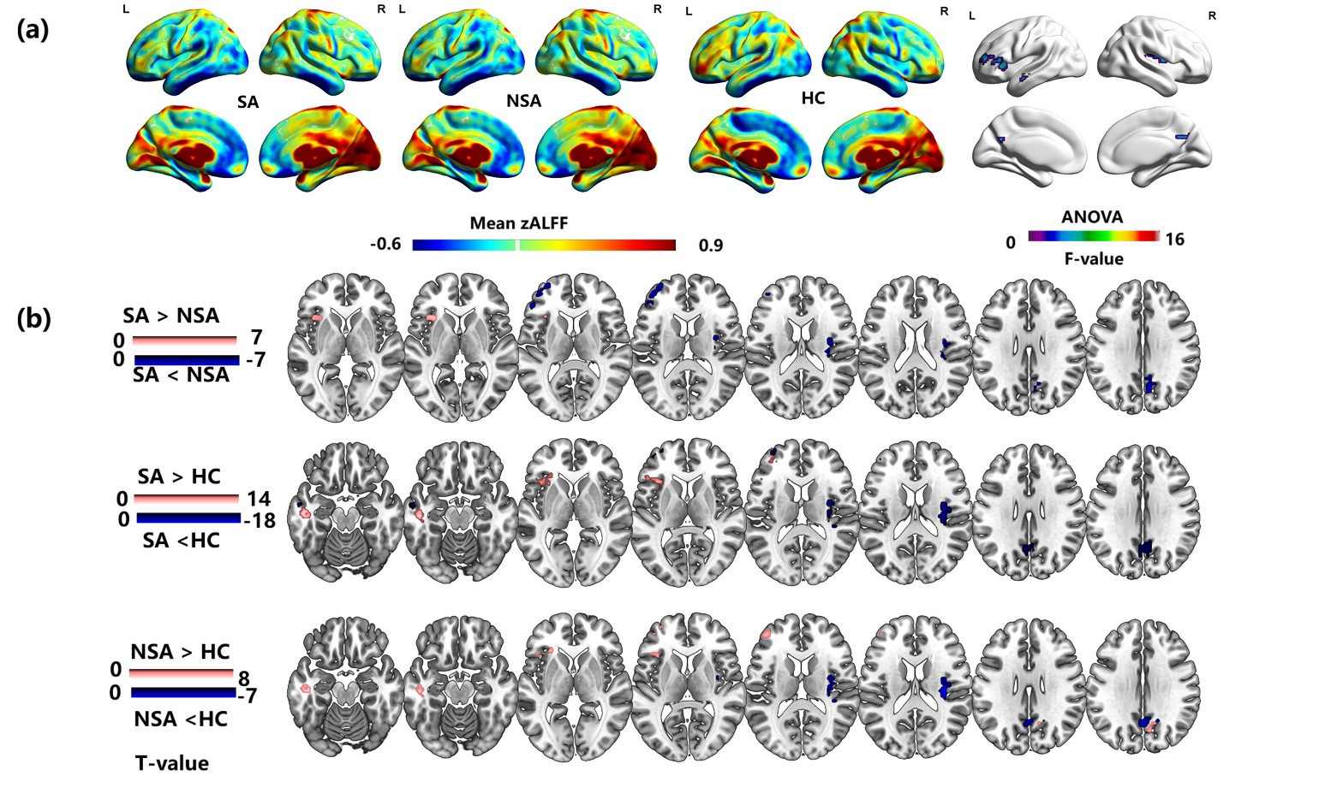
Figure S3. Spatial distribution pattern of sALFF and between-group differences. (a) Spatial distribution of mean sALFF in the MDD-SA, MDD-NSA, and HC groups and ANOVA results among the three groups. (b) Post hoc results among the MDD-SA, MDD-NSA and HC groups. The spatial distribution pattern and between-group differences of sALFF maps were highly consistent with that of the dALFF variability. SA, prior suicide attempt; NSA, no prior suicide attempt; HC, healthy control; sALFF, static amplitude of low-frequency fluctuations.

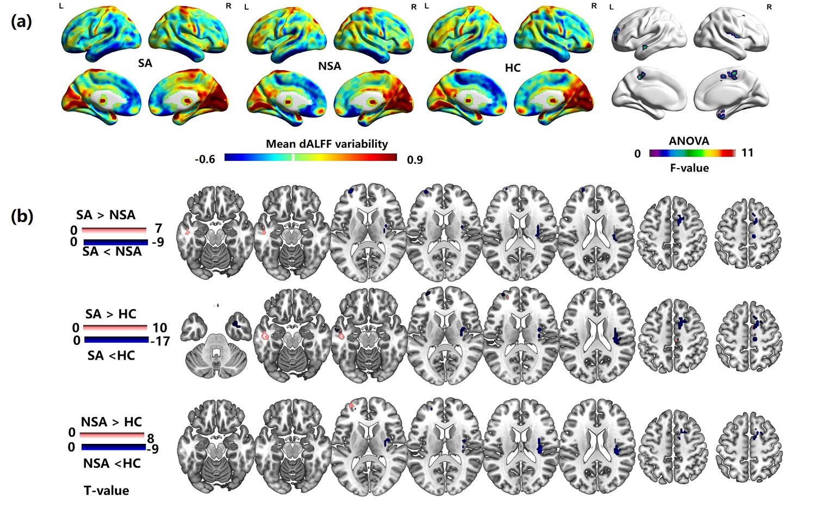
Figure S4. Results calculated with widow size of 40 TRs. (a) Spatial distribution of dALFF variability in the MDD-SA, MDD-NSA, and HC groups and ANOVA results among the three groups. (b) Post hoc results among the MDD-SA, MDD-NSA and HC groups. Results calculated with widow size of 40 TRs were highly similar to our main findings. SA, prior suicide attempt; NSA, no prior suicide attempt; HC, healthy control; dALFF, dynamic amplitude of low-frequency fluctuations.

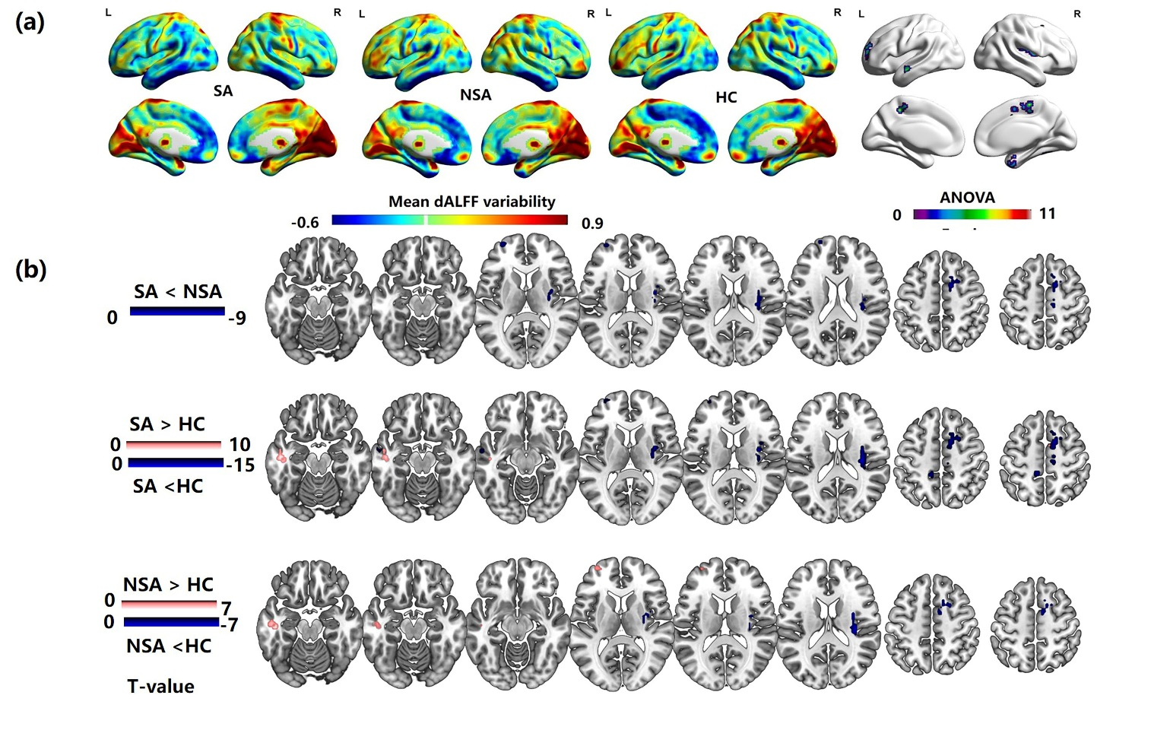Figure S5. Results calculated with widow size of 50 TRs. (a) Spatial distribution of dALFF variability in the MDD-SA, MDD-NSA, and HC groups and ANOVA results among the three groups. (b) Post hoc results among the MDD-SA, MDD-NSA and HC groups. Results calculated with widow size of 50 TRs were also largely consistent with our main findings. SA, prior suicide attempt; NSA, no prior suicide attempt; HC, healthy control; dALFF, dynamic amplitude of low-frequency fluctuations.

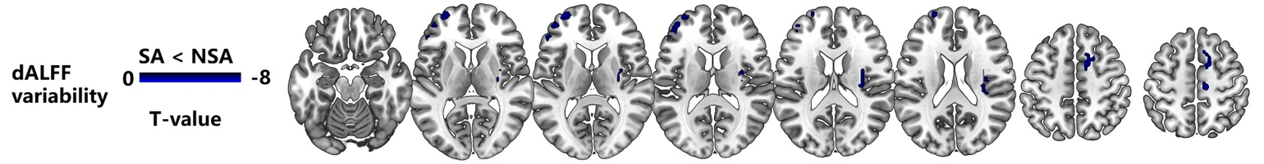
Figure S6. Post hoc analysis of dALFF variability between the MDD-SA and MDD-NSA groups with age at onset as an additional covariate. The result was highly similar to our main findings. SA, prior suicide attempt; NSA, no prior suicide attempt.

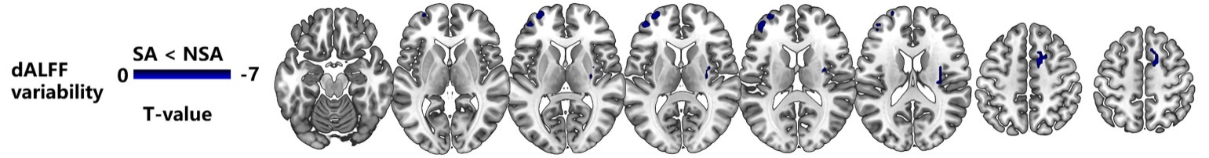
Figure S7. Post hoc analysis of dALFF variability between the MDD-SA and MDD-NSA groups with disease duration as an additional covariate. The result was highly similar to our main findings. SA, prior suicide attempt; NSA, no prior suicide attempt.

