Supplementary Material

European Child & Adolescent Psychiatry

Fear conditioning and fear generalization in children and adolescents with anxiety disorders

Julia Reinhard^{1*}, Anna Mittermeier¹, Lisa Brandstetter¹, Kimberly Mowat¹, Anna Slyschak¹, Andrea M.F. Reiter¹, Matthias Gamer², Marcel Romanos¹

¹ Center of Mental Health, Department of Child and Adolescent Psychiatry, Psychosomatics and Psychotherapy, University Hospital of Würzburg, Germany
² Department of Psychology (Experimental Clinical Psychology), University of Würzburg, Würzburg, Germany.

*Corresponding author: Email: Reinhard_J@ukw.de

 | Stimulus Type | Phase | Stimulus Type x Phase
Arousal | F (1,77) = 25.75,  p < .001, η² = .25 | F (2,142) = 11.33,  p < .001, η² = .13 | F (2,154) = 12.28,  p < .001, η² = .14
Valence | F (1,77) = 16.00,  p < .001, η² = .17 | F (2,127) = 2.61,  p = .088, η² = .03 | F (2,137) = 12.09,  p < .001, η² = .14
US Expectancy | F (1,77) = 51.15,  p < .001, η² = .40 | F (2,123) = 21.60,  p < .001, η² = .22 | F (2,154) = 34.00,  p < .001, η² = .31
Table A.1. Results of ANOVAs at pre- acquisition/acquisition. Main effects of stimulus type and phase as well as their interaction effects on arousal, valence, and US expectancy ratings

Table A.2. Descriptive Statistics at pre- acquisition (PA)/acquisition (A) on arousal, valence, and US expectancy ratings

Arousal | PA_CS- | PA_CS+ | A_CS-_1 | A_CS+_1 | A_CS-_2 | A_CS+_2
Mean | 3.29 | 3.20 | 3.49 | 4.44 | 3.43 | 4.66
Std. Deviation | 1.84 | 1.85 | 2.08 | 2.30 | 2.13 | 2.33
Valence | PA_CS- | PA_CS+ | A_CS-_1 | A_CS+_1 | A_CS-_2 | A_CS+_2
Mean | 5.66 | 5.80 | 5.79 | 5.18 | 5.92 | 4.79
Std. Deviation | 1.92 | 1.87 | 1.89 | 2.05 | 2.14 | 2.19
US Expectancy | PA_CS- | PA_CS+ | A_CS-_1 | A_CS+_1 | A_CS-_2 | A_CS+_2
Mean | 4.63 | 4.39 | 4.90 | 6.96 | 4.01 | 7.94
Std. Deviation | 2.78 | 2.82 | 2.75 | 2.86 | 3.10 | 3.04

Table A.3. Results of ANOVAs at generalization. Main effects of stimulus type and trends of arousal, valence, and US expectancy ratings

 | Stimulus Type | linear | quadratic
Arousal | F (3,231) = 27.64,  p < .001, η² = .26 | F (1,77) = 54.93,  p < .001, η² = .42 | F (1,77) = 5.86,  p = .018, η² = .07
Valence | F (3,240) = 18.33,  p < .001, η² = .19 | F (1,77) = 34.69  p < .001, η² = .31 | F (1,77) = 9.60,  p = .003, η² = .11
US Expectancy | F (2,187) =65.38,  p < .001, η² = .46 | F (1,77) = 106.12  p <.001, η² = .58 | F (1,77) = 32.23  p < .001, η² = .30

Table A.4. Descriptive Statistics at generalization (GEN) on arousal, valence, and US expectancy ratings

Arousal | GEN_CS+ |  |  | GEN_CS- |  |  | GEN_GS1 |  |  | GEN_GS2 |  |  | GEN_GS3 |  |  | GEN_GS4
Mean | 4.65 |  |  | 2.99 |  |  | 4.14 |  |  | 3.61 |  |  | 3.35 |  |  | 3.18
Std. Deviation | 2.33 |  |  | 1.97 |  |  | 2.12 |  |  | 1.96 |  |  | 2.05 |  |  | 2.02
Valence |  | GEN_CS+ |  |  | GEN_CS- |  |  | GEN_GS1 |  |  | GEN_GS2 |  |  | GEN_GS3 |  |  | GEN_GS4
Mean |  | 4.78 |  |  | 6.08 |  |  | 5.15 |  |  | 5.85 |  |  | 6.06 |  |  | 6.01
Std. Deviation |  | 2.19 |  |  | 2.15 |  |  | 2.05 |  |  | 1.80 |  |  | 1.87 |  |  | 1.95
US Expectancy |  |  | GEN_CS+ |  |  | GEN_CS- |  |  | GEN_GS1 |  |  | GEN_GS2 |  |  | GEN_GS3 |  |  | GEN_GS4
Mean |  |  | 7.10 |  |  | 2.98 |  |  | 6.19 |  |  | 4.16 |  |  | 3.39 |  |  | 3.19
Std. Deviation |  |  | 2.89 |  |  | 2.42 |  |  | 3.03 |  |  | 2.57 |  |  | 2.12 |  |  | 2.28

Fig. A.1
Fig1. Schematic overview of the fear conditioning and generalization paradigm. During Pre-Acquisition phase four CS+/CS- were presented. During Acquisition phases 12 CS+/CS- were presented. During Generalization phases 12 CS+/CS- as well as 12 GS1/GS2/GS3/GS4, resulting in 72 stimuli during generalization phases.

Fig A.2
(a)
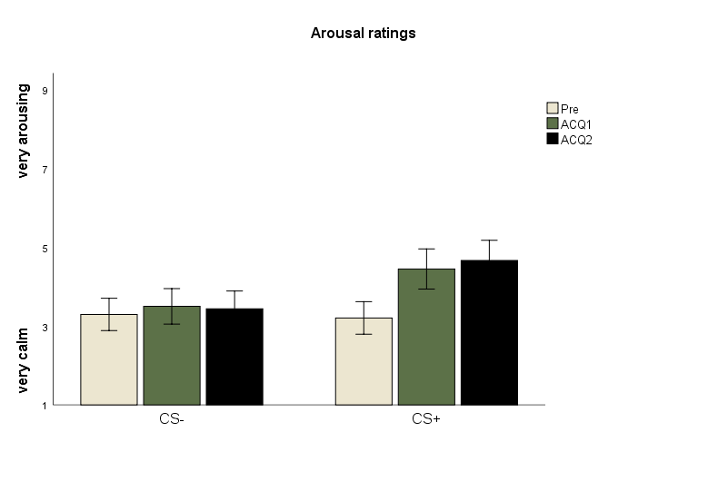
*
*
(b)
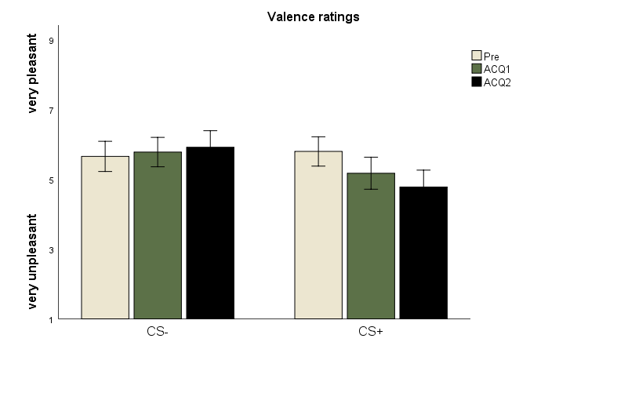
*
*

(c)

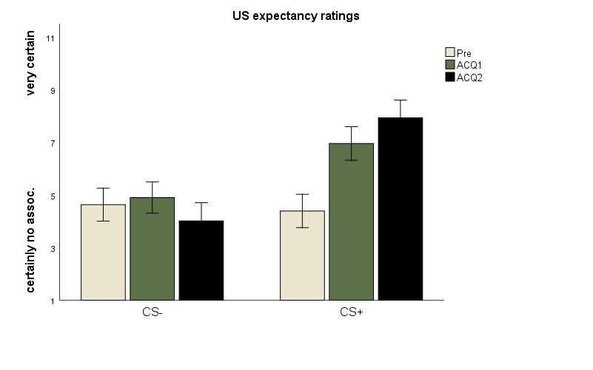
*
*
*
*
Fig2. Average ratings (with standard errors) of (a) arousal, (b) valence, and (c) US expectancy to CS- and CS+ after pre-acquisition (Pre), Acquisition 1 (ACQ 1) and Acquisition 2 (ACQ 2). Asterisks indicate significant differences between stimuli (p<.001).

Fig A.3

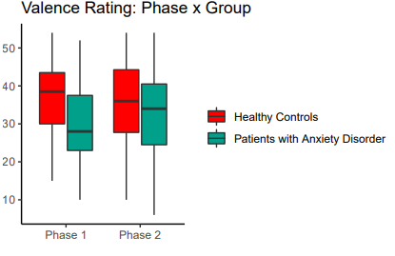
*
Valence Ratings

Fig3. Phase x group interaction effect for valence ratings. The lower and upper hinges correspond to the first and third quartiles (i.e., the 25th and 75th percentiles). The horizontal line shows the median value. Whiskers (vertical lines) extend from the hinge to the lowest/largest individual data point, no further than 1.5 * inter-quartile ranges from the hinge. Asterisks indicate significant group differences (p<.01).

