Comorbidity between neurodevelopmental, internalising, and externalising disorders in childhood: A network approach

Oliver J Watkeys, PhD^{1,2}, Kirstie O’Hare, PhD¹, Kimberlie Dean, PhD^{1,3}, Kristin R Laurens PhD^{1,4}, Felicity Harris, MAClinEpi ¹, Vaughan J Carr, MD^{1,2,5}, Melissa J Green, PhD^{1,2}
Author Affiliations
1. School of Clinical Medicine, Discipline of Psychiatry and Mental Health, University of New South Wales (UNSW), Sydney, Australia
2. Neuroscience Research Australia, Sydney, Australia
3. Justice Health & Forensic Mental Network, Matraville, Australia
4. Queensland University of Technology (QUT), School of Psychology and Counselling, Brisbane, Australia
5. Department of Psychiatry, Monash University, Melbourne, Australia

Table of Contents

Table S1. Frequencies for psychiatric disorder groups analysed, and the individual ICD-10-AM codes of which they were comprised. 2
Table S2. Frequency of different mental disorders in early (0-5 years) and middle (6-12 years) childhood 3
Table S3. Network edge-weights between mental disorders in children up to age 12 years 3
Table S4. Strength-centrality invariance test between networks in boys and girls 4
Table S5. Edge-weight invariance test between mental disorder networks in boys and girls 4
Figure S1. Age at time of any presentation for each type of mental disorder. 5
Figure S2. Stability of network edge-weights derived via bootstrapping 6
Figure S3. Stability of network centrality derived by bootstrapping across using different percentages of original sample. 7
Figure S4. Stability of network edge-weights derived via bootstrapping for boy’s mental disorder network. 8
Figure S5. Stability of network centrality derived by bootstrapping across using different percentages of original sample for boy’s mental disorder network. 9
Figure S6. Stability of network edge-weights derived via bootstrapping for girl’s mental disorder network. 10
Figure S7. Stability of network centrality derived by bootstrapping across using different percentages of original sample for girl’s mental disorder network. 11

Table S1. Frequencies for psychiatric disorder groups analysed, and the individual ICD-10-AM codes of which they were comprised.
Name | Acronym | Code | N
Developmental disorders | DDS | Total | 632
Developmental disorders | DDS | F80 (Specific developmental disorders of speech and language) | 156
Developmental disorders | DDS | F81 (Specific developmental disorders of scholastic skills) | 56
Developmental disorders | DDS | F82 (Specific developmental disorder of motor function) | 21
Developmental disorders | DDS | F83 (Mixed specific developmental disorders) | 72
Developmental disorders | DDS | F84 (Pervasive developmental disorders) | 346
Developmental disorders | DDS | F88 (Other disorders of psychological development) | n<15
Developmental disorders | DDS | F89 (Unspecified disorder of psychological development) | 108
Anxiety/phobia disorders | ANX | Total | 531
Anxiety/phobia disorders | ANX | F40 (Phobic anxiety disorders) | 36
Anxiety/phobia disorders | ANX | F41 (Other anxiety disorders) | 504
Sleep disorders | SLD | F51 (Nonorganic sleep disorders) | 479
Childhood affective/emotional disorders | CAE | Total | 391
Childhood affective/emotional disorders | CAE | F32 (Depressive episode) | 68
Childhood affective/emotional disorders | CAE | F34 (Persistent mood disorders) | n<15
Childhood affective/emotional disorders | CAE | F93 (Emotional disorders with onset specific to childhood) | 203
Childhood affective/emotional disorders | CAE | F98 (Other behavioural and emotional disorders with onset usually occurring in childhood and adolescence) | 179
Conduct disorders | CON | F91 (Conduct disorders) | 330
Hyperkinetic disorders | HYP | F90 (Hyperkinetic disorders) | 227
Stress reactions | STR | F43 (Reaction to severe stress, and adjustment disorders) | 194
Intellectual disability | IND | Total | 136
Intellectual disability | IND | F70 (Mild mental retardation) | 17
Intellectual disability | IND | F71 (Moderate mental retardation) | n<15
Intellectual disability | IND | F72 (Severe mental retardation) | n<15
Intellectual disability | IND | F73 (Profound mental retardation) | n<15
Intellectual disability | IND | F78 (Other mental retardation) | n<15
Intellectual disability | IND | F79 (Unspecified mental retardation) | 113
Note: n<15 = minimum cell size conditions apply to the use of this data. Also note that disorders are not mutually exclusive, even within the broader disorder groups used in analyses. ICD-10-AM = International Classification of Diseases 10th Edition Australian Modification.

Table S2. Frequency of different mental disorders in early (0-5 years) and middle (6-12 years) childhood
 | 0-5 years | 6-12 years
Disorder | n (column %) | n (column %)
Anxiety and phobia disorders (ANX) | 32 (0.04%) | 508 (0.56%)
Childhood affective and emotional disorders (CAE) | 55 (0.06%) | 355 (0.39%)
Conduct disorders (CON) | 76 (0.08%) | 264 (0.29%)
Developmental disorders (DDS) | 279 (0.31%) | 447 (0.50%)
Hyperkinetic disorders (HYP) | 23 (0.03%) | 211 (0.23%)
Intellectual disability (IND) | 69 (0.08%) | 82 (0.09%)
Sleep disorders (SLD) | 460 (0.51%) | 23 (0.03%)
Stress reactions (STR) | 22 (0.02%) | 180 (0.20%)

Table S3. Network edge-weights between mental disorders in children up to age 12 years
 | ANX | CAE | CON | DDS | HYP | IND | SLD
 | Overall
CAE | 2.80
CON | 0.79 | 1.09
DDS | 1.61 | 1.93 | 0.70
HYP | 0.52 | 0.75 | 0.00 | 1.06
IND | 0.00 | 0.37 | 0.00 | 4.82 | 0.00
SLD | 0.00 | 1.40 | 0.00 | 1.14 | 0.00 | 0.00
STR | 1.40 | 2.97 | 1.01 | 0.31 | 0.00 | 0.00 | 0.00
 | Boys
CAE | 2.60
CON | 1.42 | 2.26
DDS | 1.68 | 1.91 | 1.23
HYP | 1.02 | 1.30 | 3.74 | 1.92
IND | 0.00 | 0.32 | 0.27 | 4.64 | 0.00
SLD | 0.00 | 0.00 | 0.00 | 0.65 | 0.00 | 0.00
STR | 0.64 | 2.87 | 1.53 | 0.55 | 0.00 | 0.00 | 0.00
 | Girls
CAE | 3.01
CON | 1.04 | 0.88
DDS | 0.52 | 0.89 | 0.00
HYP | 0.00 | 0.72 | 0.00 | 0.00
IND | 0.00 | 0.00 | 0.00 | 0.00 | 0.00
SLD | 0.00 | 1.92 | 0.00 | 0.00 | 0.00 | 0.00
STR | 1.67 | 2.99 | 1.31 | 0.00 | 0.00 | 0.00 | 0.00
Note. ANX = Anxiety/phobia disorders; CAE = Childhood affective/emotional disorders; CON = Conduct disorders; DDS = Developmental disorders; HYP = Hyperkinetic disorders; IND = Intellectual disability; SLD = Sleep disorders; STR = Stress reactions.

Table S4. Strength-centrality invariance test between networks in boys and girls
Disorder | Strength centrality in boys | Strength centrality in girls | p-value for strength-centrality invariance test
ANX | 7.35 | 6.24 | 0.40
CAE | 11.26 | 10.42 | 0.66
CON | 10.45 | 3.23 | 0.1
DDS | 12.58 | 1.41 | <0.01
HYP | 7.99 | 0.72 | 0.02
IND | 5.24 | 0.00 | <0.01
SLD | 0.65 | 1.92 | 0.4
STR | 5.59 | 5.97 | 0.81
Note: ANX = Anxiety/phobia disorders; CAE = Childhood affective/emotional disorders; CON = Conduct disorders; DDS = Developmental disorders; HYP = Hyperkinetic disorders; MHN = Mental health not otherwise specified; IND = Intellectual disability; SLD = Sleep disorders; STR = Stress reactions.

Table S5. Edge-weight invariance test between mental disorder networks in boys and girls
From | To | Edge-weight in boys | Edge-weight in girls | p-value
ANX | CAE | 2.60 | 3.01 | 0.28
ANX | CON | 1.42 | 1.04 | 0.26
CAE | CON | 2.26 | 0.88 | 0.02
ANX | DDS | 1.68 | 0.52 | 0.12
CAE | DDS | 1.91 | 0.89 | 0.39
CON | DDS | 1.23 | 0.00 | 0.05
ANX | HYP | 1.02 | 0.00 | 0.13
CAE | HYP | 1.30 | 0.72 | 0.28
CON | HYP | 3.74 | 0.00 | 0.04
DDS | HYP | 1.92 | 0.00 | 0.05
ANX | IND | 0.00 | 0.00 | 1.00
CAE | IND | 0.32 | 0.00 | 0.68
CON | IND | 0.27 | 0.00 | 0.34
DDS | IND | 4.64 | 0.00 | 0.00
HYP | IND | 0.00 | 0.00 | 1.00
ANX | SLD | 0.00 | 0.00 | 1.00
CAE | SLD | 0.00 | 1.92 | 0.09
CON | SLD | 0.00 | 0.00 | 1.00
DDS | SLD | 0.65 | 0.00 | 0.53
HYP | SLD | 0.00 | 0.00 | 1.00
IND | SLD | 0.00 | 0.00 | 1.00
ANX | STR | 0.64 | 1.67 | 0.39
CAE | STR | 2.87 | 2.99 | 0.91
CON | STR | 1.53 | 1.31 | 0.73
DDS | STR | 0.55 | 0.00 | 0.19
HYP | STR | 0.00 | 0.00 | 1.00
IND | STR | 0.00 | 0.00 | 1.00
SLD | STR | 0.00 | 0.00 | 1.00
Note: ANX = Anxiety/phobia disorders; CAE = Childhood affective/emotional disorders; CON = Conduct disorders; DDS = Developmental disorders; HYP = Hyperkinetic disorders; MHN = Mental health not otherwise specified; IND = Intellectual disability; SLD = Sleep disorders; STR = Stress reactions.
Figure S1. Age at time of any presentation for each type of mental disorder. Note. ANX = Anxiety/phobia disorders; CAE = Childhood affective/emotional disorders; CON = Conduct disorders; DDS = Developmental disorders; HYP = Hyperkinetic disorders; MHN = Mental health not otherwise specified; IND = Intellectual disability; SLD = Sleep disorders; STR = Stress reactions.

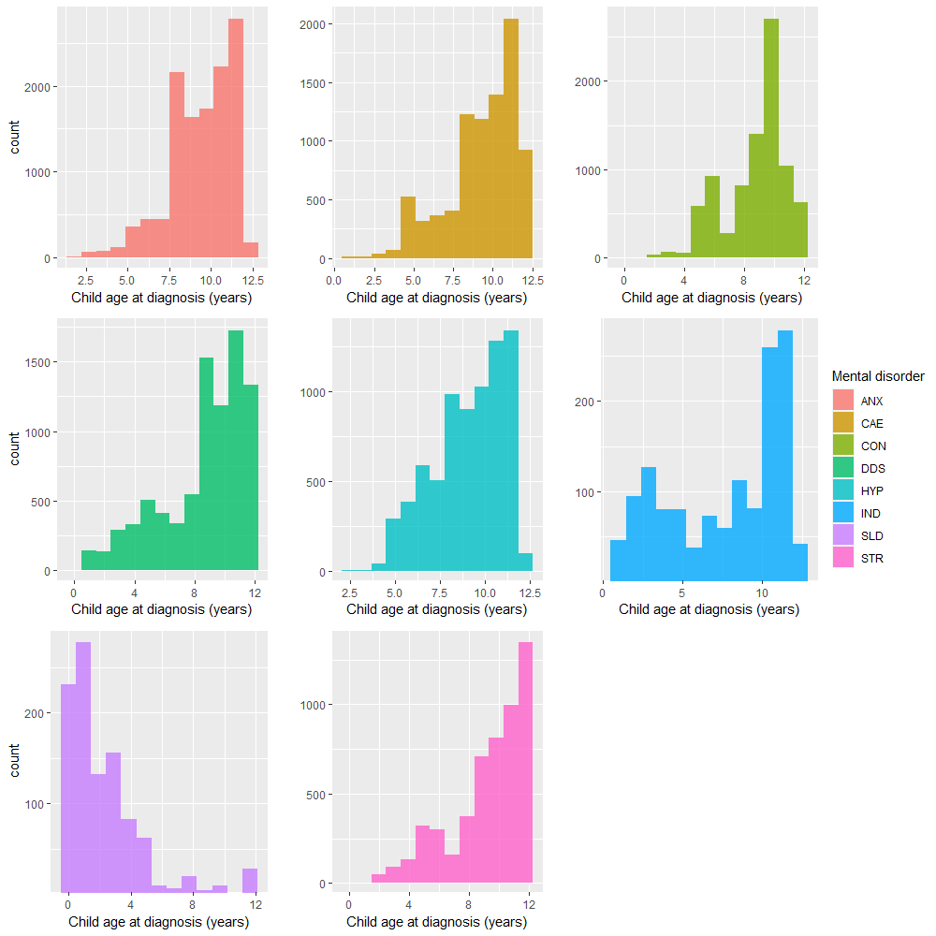

Figure S2. Stability of network edge-weights derived via bootstrapping 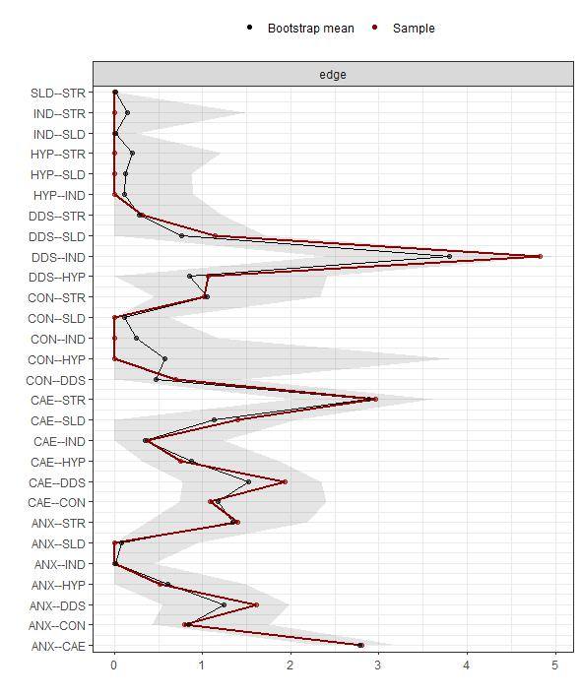
Note: ANX = Anxiety/phobia disorders; CAE = Childhood affective/emotional disorders; CON = Conduct disorders; DDS = Developmental disorders; HYP = Hyperkinetic disorders; MHN = Mental health not otherwise specified; IND = Intellectual disability; SLD = Sleep disorders; STR = Stress reactions.

Figure S3. Stability of network centrality derived by bootstrapping across using different percentages of original sample.
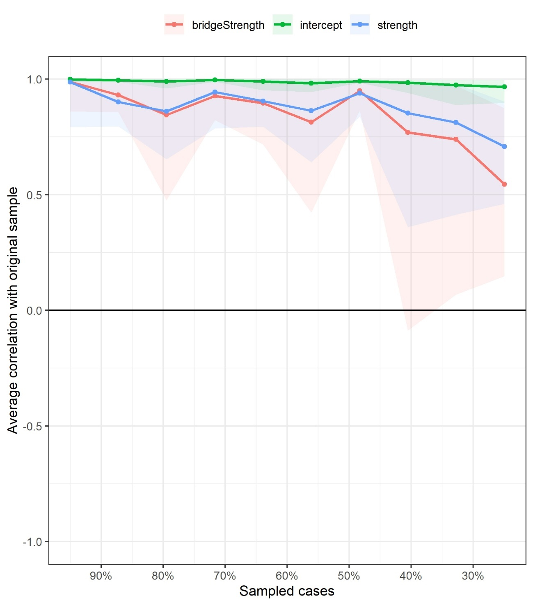

Figure S4. Stability of network edge-weights derived via bootstrapping for boy’s mental disorder network.
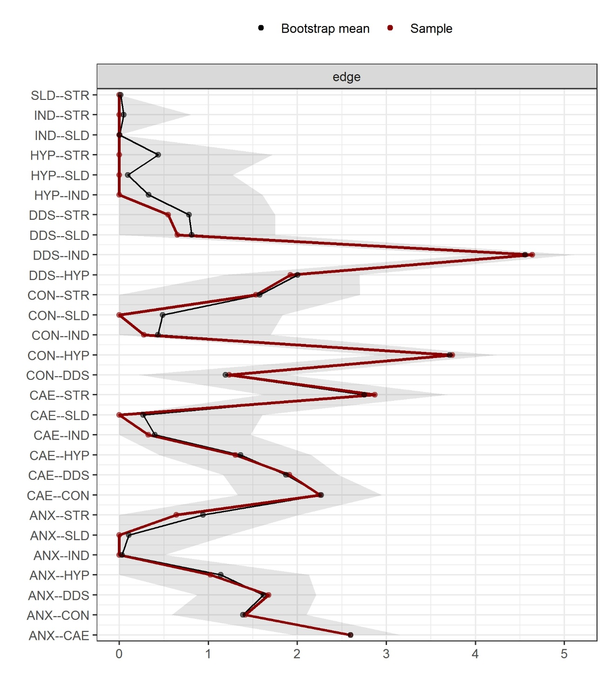
Note: ANX = Anxiety/phobia disorders; CAE = Childhood affective/emotional disorders; CON = Conduct disorders; DDS = Developmental disorders; HYP = Hyperkinetic disorders; MHN = Mental health not otherwise specified; IND = Intellectual disability; SLD = Sleep disorders; STR = Stress reactions.

Figure S5. Stability of network centrality derived by bootstrapping across using different percentages of original sample for boy’s mental disorder network.
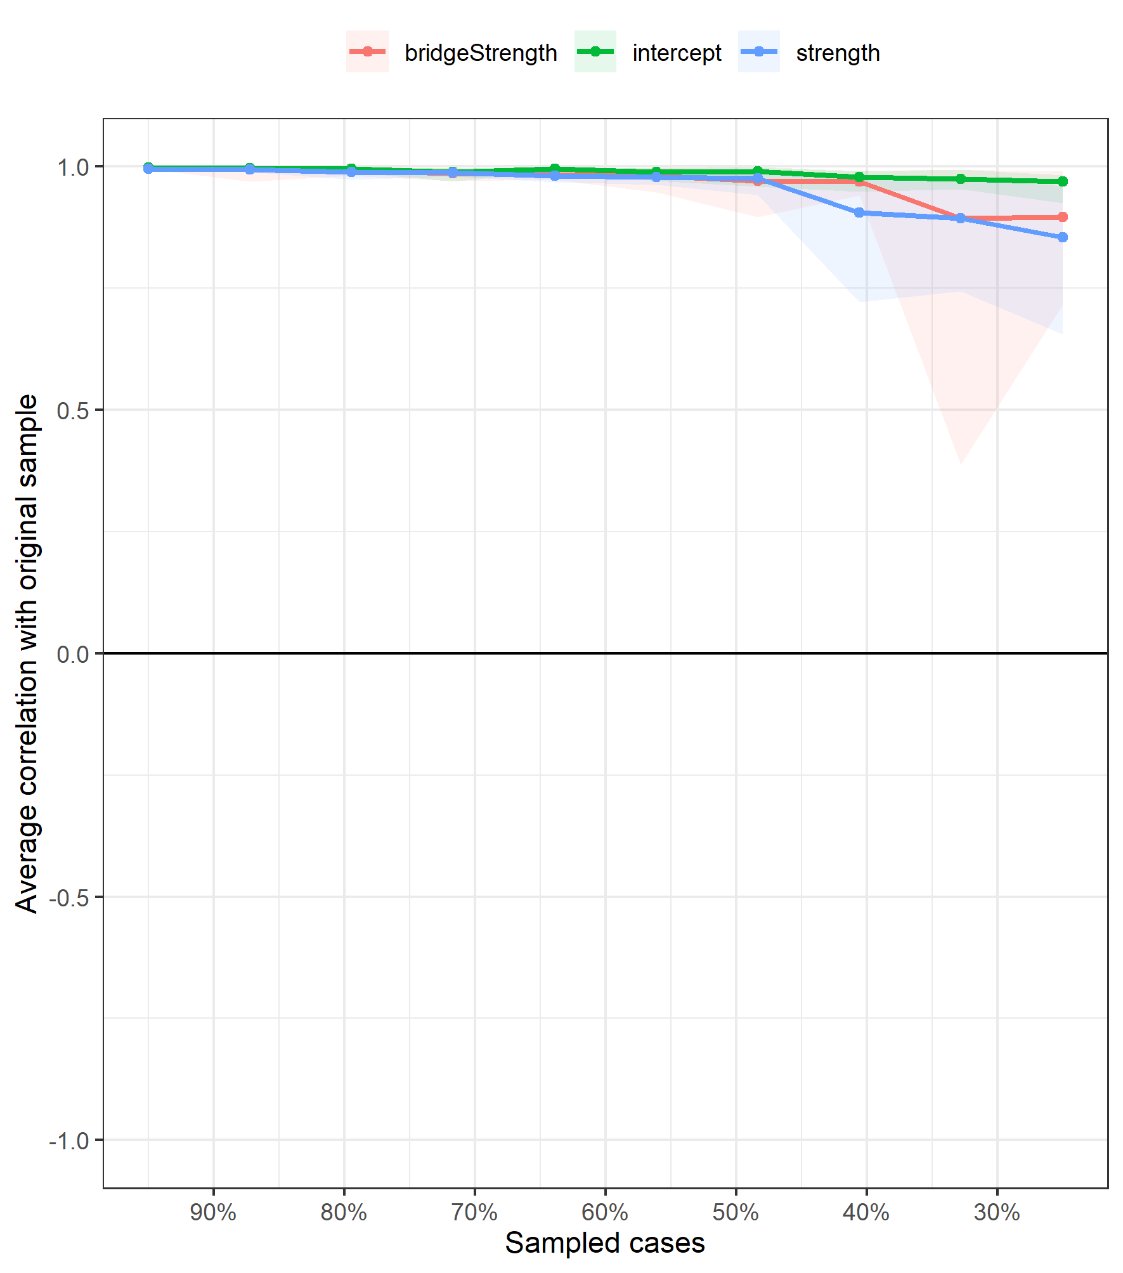

Figure S6. Stability of network edge-weights derived via bootstrapping for girl’s mental disorder network.
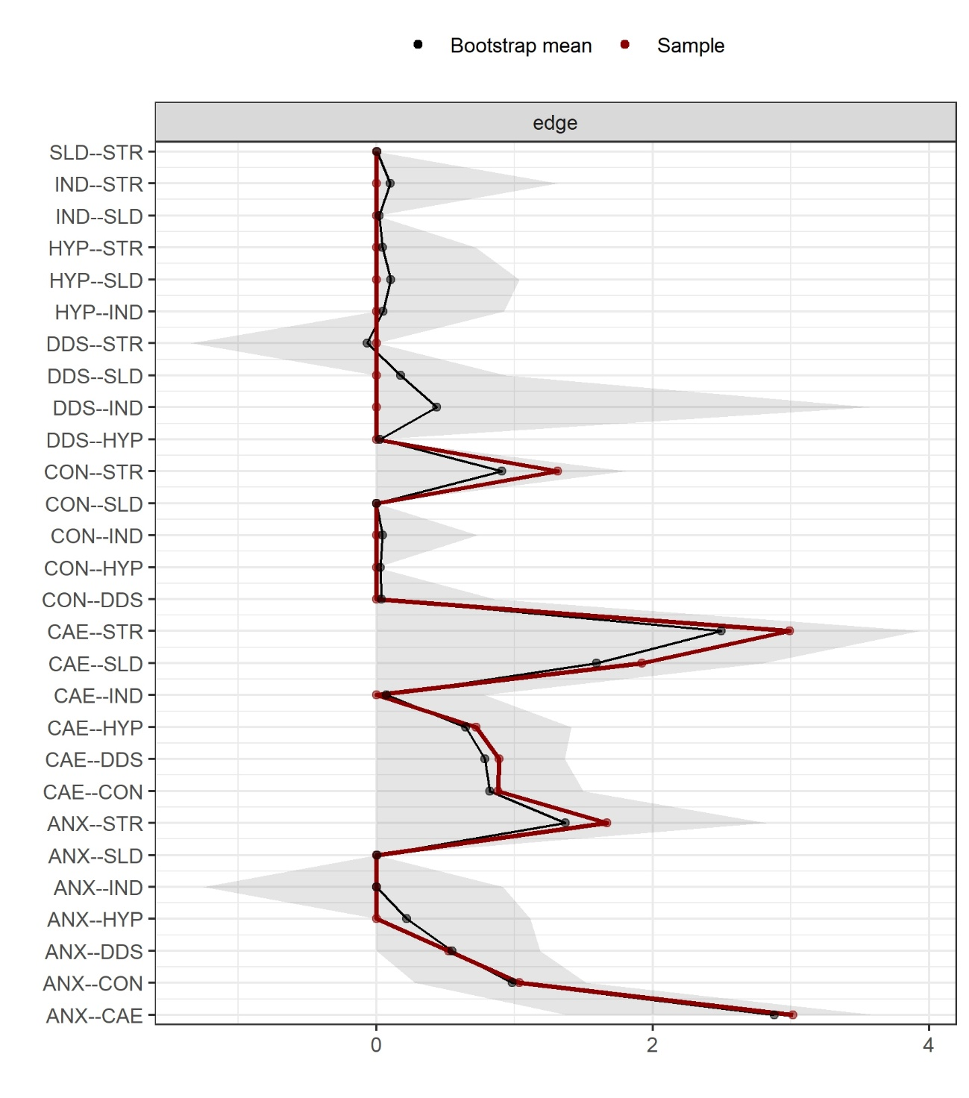
Note: ANX = Anxiety/phobia disorders; CAE = Childhood affective/emotional disorders; CON = Conduct disorders; DDS = Developmental disorders; HYP = Hyperkinetic disorders; MHN = Mental health not otherwise specified; IND = Intellectual disability; SLD = Sleep disorders; STR = Stress reactions.

Figure S7. Stability of network centrality derived by bootstrapping across using different percentages of original sample for girl’s mental disorder network.
