Appendix A. Model fit indices of LCMM with group size of classes for SDQ-total and ADHD symptoms in boys and girls
Table A1. Model fit indices to identify trajectory classes of SDQ-total in boys
 | LogLik | BIC | AIC | Entropy | Class 1 | Class 2 | Class 3 | Class 4 | Class 5
Class 1 | -42457.84 | 84951.88 | 84923.68 | 1.00 | 100.00
Class 2 | -41284.77 | 82641.94 | 82585.54 | 0.75619 | 16.6490 | 83.3509
Class 3 | -40965.42 | 82039.44 | 81954.84 | 0.6920 | 28.3667 | 5.7649 | 65.8682
Class 4 | -40859.99 | 81864.77 | 81751.97 | 0.6700 | 24.5039 | 67.6059 | 4.6495 | 3.2405
Class 5 | -40775.91 | 81732.82 | 81591.83 | 0.6581 | 1.8081 | 63.6022 | 26.4412 | 4.2503 | 3.8980

Table A2. Model fit indices to identify trajectory classes of SDQ-total in girls
 | LogLik | BIC | AIC | Entropy | Class 1 | Class 2 | Class 3 | Class 4 | Class 5
Class 1 | -40654.70 | 81345.48 | 81317.40 | 1.00 | 100.00
Class 2 | -39557.28 | 79186.72 | 79130.56 | 0.7476 | 82.6639 | 17.3360
Class 3 | -39257.68 | 78623.60 | 78539.36 | 0.7173 | 23.8688 | 72.1025 | 4.0285
Class 4 | -39124.53 | 78393.37 | 78281.06 | 0.6878 | 3.4478 | 67.2876 | 25.3205 | 3.9438
Class 5 | -39037.69 | 78255.77 | 78115.37 | 0.6296 | 3.6051 | 2.4921 | 24.0987 | 60.5008 | 9.3031

Table A3. Model fit indices to identify trajectory classes of ADHD symptoms in boys
 | LogLik | BIC | AIC | Entropy | Class 1 | Class 2 | Class 3 | Class 4 | Class 5
Class 1 | -31067.13 | 62170.47 | 62142.26 | 1.00 | 100.00
Class 2 | -30176.66 | 60425.73 | 60369.32 | 0.6086 | 23.9178 | 76.0821
Class 3 | -29914.28 | 59937.17 | 59852.56 | 0.5936 | 40.7390 | 51.1319 | 8.12903
Class 4 | -29866.68 | 59878.17 | 59765.36 | 0.5778 | 39.2375 | 7.30791 | 50.8504 | 2.60410
Class 5 | -29793.93 | 59768.87 | 59627.86 | 0.5572 | 5.1378 | 47.8944 | 2.4398 | 35.7653 | 8.7624

Table A4. Model fit indices to identify trajectory classes of ADHD symptoms in girls
 | LogLik | BIC | AIC | Entropy | Class 1 | Class 2 | Class 3 | Class 4 | Class 5
Class 1 | -29217.33 | 58470.74 | 58442.65 | 1.00 | 100.00
Class 2 | -28216.56 | 56505.30 | 56449.13 | 0.6942 | 78.4730 | 21.5269
Class 3 | -27960.12 | 56028.49 | 55944.23 | 0.6604 | 31.2515 | 5.7743 | 62.9741
Class 4 | -27879.83 | 55904.00 | 55791.66 | 0.5826 | 11.6211 | 62.2010 | 5.7985 | 20.3793
Class 5 | -27813.29 | 55807.00 | 55666.58 | 0.5899 | 2.4039 | 20.2826 | 50.2899 | 4.6146 | 22.4087

Appendix B. The fit indices and group size of classes for LCMM model of PA in boys and girls
Table B1. Model fit indices to identify trajectory classes of PA in boys
 | LogLik | BIC | AIC | Entropy | Class 1 | Class 2 | Class 3 | Class 4
Class 3 | -15544.22 | 31197.38 | 31112.45 | 0.5314 | 1.4279 | 58.3162 | 40.255
Class 4 | -15521.05 | 31187.33 | 31074.09 | 0.5403 | 0.1941 | 65.5471 | 27.4274 | 6.8311

Figure B1. PA trajectories for boys for the three-class model
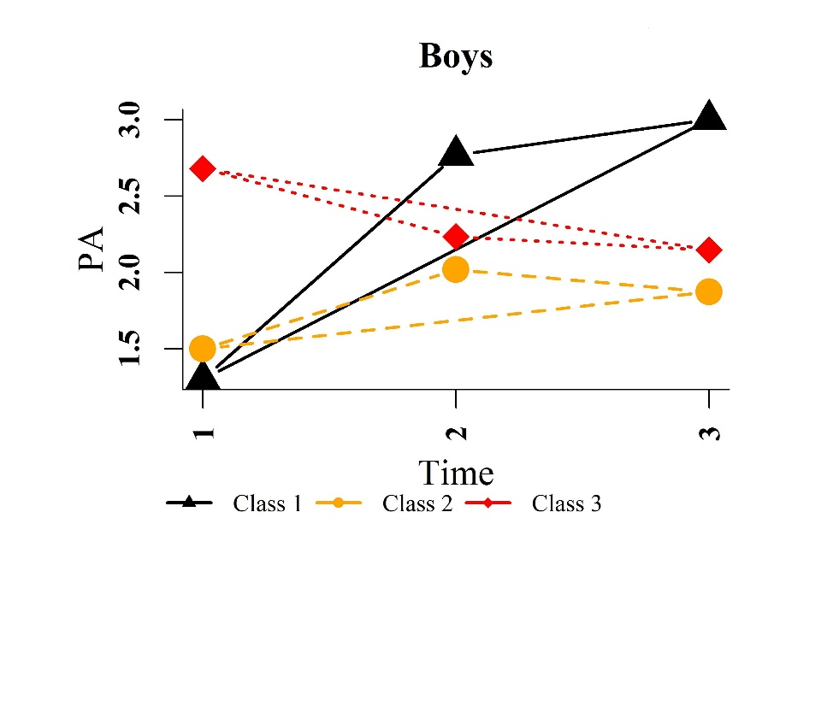

Table B 2. Model fit indices to identify trajectory classes of PA in Girls
 | LogLik | BIC | AIC | Entropy | Class 1 | Class 2 | Class 3 | Class 4
Class 4 | -15330.32 | 30805.25 | 30692.63 | 0.6082 | 1.3773 | 71.4913 | 0.6649 | 26.4664

Figure B1. PA trajectories for girls for the four-class model

