Disentangling the effects of self-control and the use of tobacco and cannabis on violence perpetration from childhood to early adulthood
Supplement

Michelle Loher, Annekatrin Steinhoff, Laura Bechtiger, Denis Ribeaud, Manuel Eisner, Lilly Shanahan♣ & Boris B. Quednow♣

♣These authors contributed equally.

Journal name: European Child & Adolescent Psychiatry

Corresponding author:
Michelle Loher, MSc
Jacobs Center for Productive Youth Development
University of Zurich
Andreasstrasse 15, P.O. Box 12
8050 Zurich, Switzerland
E-Mail: michelle.loher@jacobscenter.uzh.ch

Appendix A. Specification of Variables (Main Model and Sensitivity Analysis)

Self-Control (adapted from Grasmick et al [1]; later modified by Longshore et al [2])
Below are various statements. Please mark with a cross, how true these statements are for you.
- I often act on the spur of the moment without stopping to think.
- I try to get what I want even if it causes problems for others.
- I like to do dangerous things just for the fun of it.
- If I don’t get something I want immediately, I get angry pretty quickly.
- I prefer to go out and do something instead of reading or thinking.
- If others get angry about something I've done, I don't really care.
- When I can, I prefer to do something with my hands rather than my head.
- I always do what I feel like doing at the moment, without thinking about what the consequences might be.
- I lose my temper pretty easily.
- Excitement and adventure are more important to me than safety.

Substance Use (created by the study team)
How many times in the last 12 months (i.e., since April 2014) have you taken …
- Cigarettes, tobacco, or shisha?
- Hash, “pot,” cannabis, or marijuana?
- Beer, wine, or “mixed drinks”?
- Vodka, whiskey, or schnapps?
Alcohol. Alcohol use was measured using two items from a larger set of items assessing different types of self-reported substances. One item assessed the use of beer/wine/“mixed drinks,” whereas the other assessed the use of liquor (e.g., vodka, whiskey, schnapps). Answer categories concerning the frequency of consumption (in the last 12 months) were provided on a 6-point Likert scale (never–daily). For each participant, the maximum value from both items was computed (from the age 13, 15, 17, and 20 assessments) and used for analysis.

Physical Violence Perpetration

Social Behaviour Questionnaire [3]
Please indicate which of these things you have done in the last 12 months (i.e., since April 2014).
- You physically attacked other people.
- You got into fights.

Peer aggression questionnaire [4]
This part is about bullying. Adolescents can be very mean to each other sometimes. And you? In the last year, i.e., since April 2014, have you bullied other adolescents? (This could have happened, for example, on the way to school, when being out, at home, or on the internet.) How many times since April 2014 have you...
- Hit, bitten, kicked or pulled their hair?

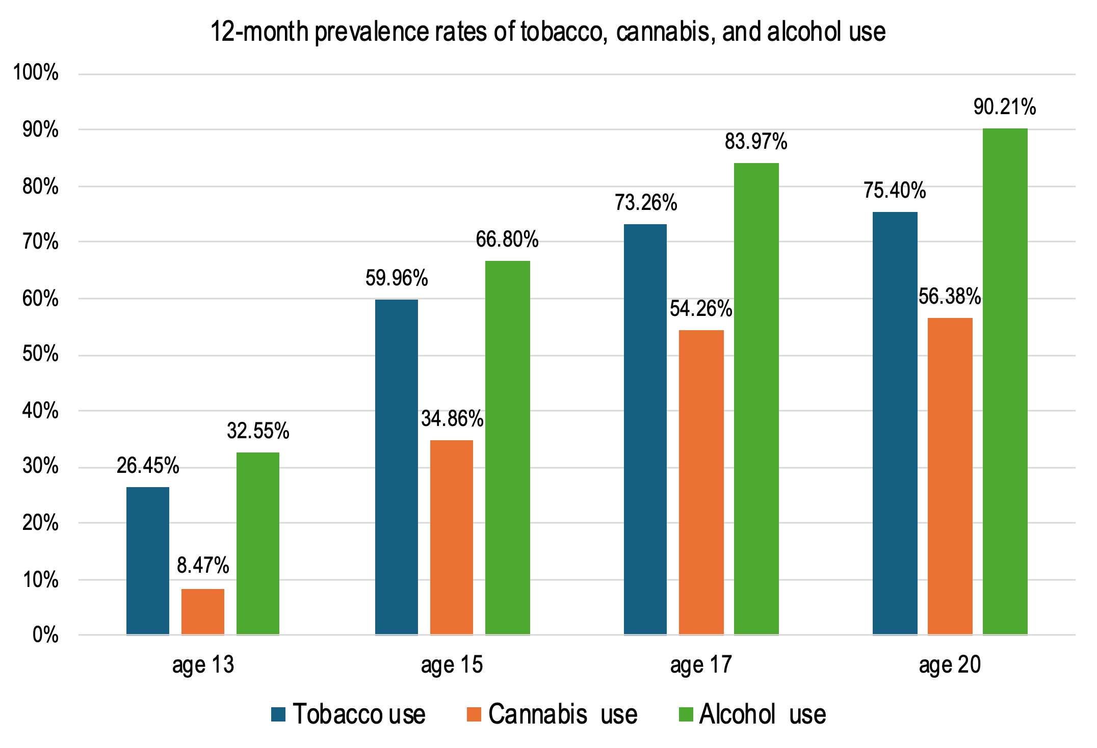
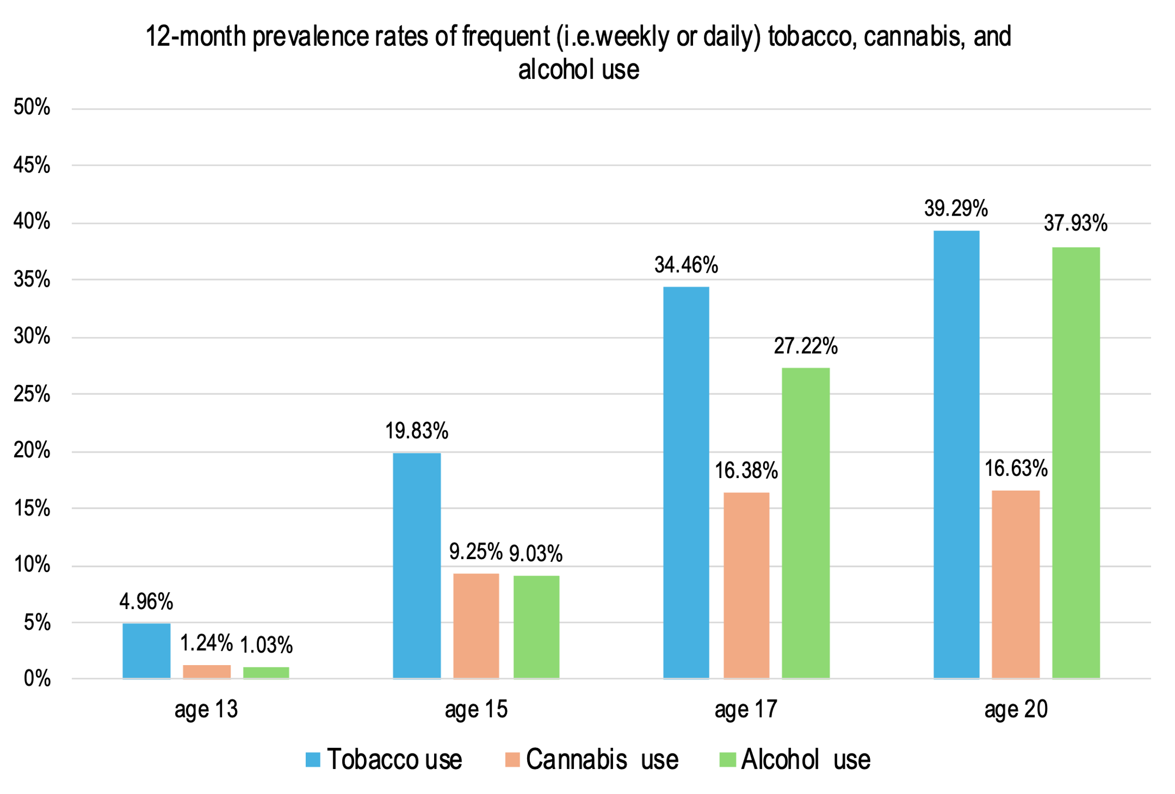
Fig. S1a-b 12-month prevalence rates of tobacco, cannabis, and alcohol use. Frequent use refers to weekly or daily use, n = 1,056.

Appendix B. Coefficients Main Model and Sensitivity Analysis

Main Model
Table S1
Standardized and Unstandardized Coefficients for Autoregressive and Cross-Lagged Paths (Main Model)
CLPM |  | Unstandardized beta |  | SE |  | p-value |  | Standardized beta (β)
Autoregressive paths
Self-control _{age 11} → Self-control _{age 13} |  | 0.43 |  | 0.03 |  | < .001 |  | 0.44
Self-control _{age 13} → Self-control _{age 15} |  | 0.45 |  | 0.03 |  | < .001 |  | 0.48
Self-control _{age 15} → Self-control _{age 17} |  | 0.56 |  | 0.03 |  | < .001 |  | 0.59
Self-control _{age 17} → Self-control _{age 20} |  | 0.57 |  | 0.03 |  | < .001 |  | 0.57
Tobacco use _{age 13} → Tobacco use _{age 15} |  | 0.61 |  | 0.05 |  | < .001 |  | 0.42
Tobacco use _{age 15} → Tobacco use _{age 17} |  | 0.65 |  | 0.03 |  | < .001 |  | 0.60
Tobacco use _{age 17} → Tobacco use _{age 20} |  | 0.62 |  | 0.03 |  | < .001 |  | 0.61
Cannabis use _{age 13} → Cannabis use _{age 15} |  | 0.40 |  | 0.10 |  | < .001 |  | 0.18
Cannabis use _{age 15} → Cannabis use _{age 17} |  | 0.46 |  | 0.05 |  | < .001 |  | 0.40
Cannabis use _{age 17} → Cannabis use _{age 20} |  | 0.54 |  | 0.04 |  | < .001 |  | 0.53
Violence _{age 13} → Violence _{age 15} |  | 0.33 |  | 0.05 |  | < .001 |  | 0.33
Violence _{age 15} → Violence _{age 17} |  | 0.40 |  | 0.05 |  | < .001 |  | 0.39
Violence _{age 17} → Violence _{age 20} |  | 0.31 |  | 0.05 |  | < .001 |  | 0.34
Cross-lagged paths
Self-control _{age 11} → Tobacco use _{age 13} |  | −0.55 |  | 0.09 |  | < .001 |  | −0.22
Self-control _{age 11} → Cannabis use _{age 13} |  | −0.35 |  | 0.06 |  | < .001 |  | −0.25
Self-control _{age 11} → Violence _{age 13} |  | −0.37 |  | 0.06 |  | < .001 |  | −0.22
Self-control _{age 13} → Tobacco use _{age 15} |  | −0.64 |  | 0.11 |  | < .001 |  | −0.17
Self-control _{age 13} → Cannabis use _{age 15} |  | −0.46 |  | 0.10 |  | < .001 |  | −0.15
Self-control _{age 13} → Violence _{age 15} |  | −0.20 |  | 0.06 |  | < .001 |  | −0.12
Self-control _{age 15} → Tobacco use _{age 17} |  | −0.71 |  | 0.12 |  | < .001 |  | −0.17
Self-control _{age 15} → Cannabis use _{age 17} |  | −0.35 |  | 0.12 |  | .003 |  | −0.09
Self-control _{age 15} → Violence _{age 17} |  | −0.09 |  | 0.07 |  | .182 |  | −0.05
Self-control _{age 17} → Tobacco use _{age 20} |  | −0.17 |  | 0.13 |  | .171 |  | −0.04
Self-control _{age 17} → Cannabis use _{age 20} |  | −0.26 |  | 0.12 |  | .033 |  | −0.07
Self-control _{age 17} → Violence _{age 20} |  | −0.10 |  | 0.06 |  | .093 |  | −0.05
Tobacco use _{age 13} → Cannabis use _{age 15} |  | 0.29 |  | 0.05 |  | < .001 |  | 0.24
Tobacco use _{age 13} → Self-control _{age 15} |  | −0.01 |  | 0.01 |  | .591 |  | −0.02
Tobacco use _{age 13} → Violence _{age 15} |  | 0.08 |  | 0.03 |  | .007 |  | 0.12
Tobacco use _{age 13} → Violence _{age 17} |  | −0.02 |  | 0.03 |  | .534 |  | −0.03
Tobacco use _{age 13} → Violence _{age 20} |  | −0.03 |  | 0.03 |  | .416 |  | −0.04
Tobacco use _{age 15} → Cannabis use _{age 17} |  | 0.16 |  | 0.04 |  | < .001 |  | 0.17
Tobacco use _{age 15} → Self-control _{age 17} |  | −0.01 |  | 0.01 |  | .445 |  | −0.03
Tobacco use _{age 15} → Violence _{age 17} |  | 0.03 |  | 0.02 |  | .135 |  | 0.07
Tobacco use _{age 15} → Violence _{age 20} |  | 0.03 |  | 0.03 |  | .223 |  | 0.08
Tobacco use _{age 17} → Cannabis use _{age 20} |  | 0.07 |  | 0.03 |  | .023 |  | 0.07
Tobacco use _{age 17} → Self-control _{age 20} |  | −0.01 |  | 0.01 |  | .144 |  | −0.05
Tobacco use _{age 17} → Violence _{age 20} |  | 0.04 |  | 0.02 |  | .025 |  | 0.09
Cannabis use _{age 13} → Tobacco use _{age 15} |  | 0.01 |  | 0.07 |  | .858 |  | 0.01
Cannabis use _{age 13} → Self-control _{age 15} |  | −0.01 |  | 0.02 |  | .751 |  | −0.01
Cannabis use _{age 13} → Violence _{age 15} |  | −0.01 |  | 0.06 |  | .865 |  | −0.01
Cannabis use _{age 13} → Violence _{age 17} |  | 0.08 |  | 0.06 |  | .220 |  | 0.07
Cannabis use _{age 13} → Violence _{age 20} |  | 0.07 |  | 0.08 |  | .425 |  | 0.06
Cannabis use _{age 15} → Tobacco use _{age 17} |  | −0.00 |  | 0.04 |  | .923 |  | −0.00
Cannabis use _{age 15} → Self-control _{age 17} |  | −0.01 |  | 0.01 |  | .153 |  | −0.05
Cannabis use _{age 15} → Violence _{age 17} |  | 0.01 |  | 0.02 |  | .679 |  | 0.02
Cannabis use _{age 15} → Violence _{age 20} |  | 0.00 |  | 0.03 |  | .986 |  | 0.00
Cannabis use _{age 17} → Tobacco use _{age 20} |  | 0.10 |  | 0.04 |  | .006 |  | 0.09
Cannabis use _{age 17} → Self-control _{age 20} |  | 0.01 |  | 0.01 |  | .594 |  | 0.02
Cannabis use _{age 17} → Violence _{age 20} |  | −0.03 |  | 0.02 |  | .217 |  | −0.06
Violence _{age 13} → Tobacco use _{age 15} |  | 0.22 |  | 0.08 |  | .004 |  | 0.10
Violence _{age 13} → Cannabis use _{age 15} |  | 0.10 |  | 0.07 |  | .169 |  | 0.05
Violence _{age 13} → Self-control _{age 15} |  | −0.04 |  | 0.02 |  | .042 |  | −0.07
Violence _{age 15} → Tobacco use _{age 17} |  | −0.08 |  | 0.06 |  | .201 |  | −0.03
Violence _{age 15} → Cannabis use _{age 17} |  | −0.01 |  | 0.08 |  | .919 |  | −0.00
Violence _{age 15} → Self-control _{age 17} |  | −0.01 |  | 0.02 |  | .481 |  | −0.02
Violence _{age 17} → Tobacco use _{age 20} |  | 0.01 |  | 0.07 |  | .835 |  | 0.01
Violence _{age 17} → Cannabis use _{age 20} |  | −0.00 |  | 0.07 |  | .981 |  | −0.00
Violence _{age 17} → Self-control _{age 20} |  | −0.01 |  | 0.02 |  | .739 |  | −0.01
Note. CLPM connecting self-control, tobacco use, cannabis use, and physical violence perpetration; n = 1,056.

Table S2
Standardized and Unstandardized Coefficients for Cross-Sectional Covariances of Residuals (Main Model)
CLPM |  | Unstandardized r (covariance) |  | SE |  | p-value |  | Standardized r (correlation)
Cross-sectional covariances of residuals
Self-control _{age 13} with Tobacco use _{age 13} |  | −0.15 |  | 0.02 |  | < .001 |  | −0.30
Self-control _{age 15} with Tobacco use _{age 15} |  | −0.11 |  | 0.02 |  | < .001 |  | −0.20
Self-control _{age 17} with Tobacco use _{age 17} |  | −0.08 |  | 0.02 |  | < .001 |  | −0.17
Self-control _{age 20} with Tobacco use _{age 20} |  | −0.04 |  | 0.02 |  | .013 |  | −0.08
Self-control _{age 13} with Cannabis use _{age 13} |  | −0.04 |  | 0.01 |  | < .001 |  | −0.14
Self-control _{age 15} with Cannabis use _{age 15} |  | −0.07 |  | 0.02 |  | < .001 |  | −0.15
Self-control _{age 17} with Cannabis use _{age 17} |  | −0.07 |  | 0.02 |  | < .001 |  | −0.16
Self-control _{age 20} with Cannabis use _{age 20} |  | −0.08 |  | 0.02 |  | < .001 |  | −0.19
Self-control _{age 13} with Violence _{age 13} |  | −0.11 |  | 0.01 |  | < .001 |  | −0.37
Self-control _{age 15} with Violence _{age 15} |  | −0.06 |  | 0.01 |  | < .001 |  | −0.25
Self-control _{age 17} with Violence _{age 17} |  | −0.05 |  | 0.01 |  | < .001 |  | −0.22
Self-control _{age 20} with Violence _{age 20} |  | −0.04 |  | 0.01 |  | < .001 |  | −0.20
Cannabis use _{age 13} with Tobacco use _{age 13} |  | 0.37 |  | 0.06 |  | < .001 |  | 0.51
Cannabis use _{age 15} with Tobacco use _{age 15} |  | 0.90 |  | 0.07 |  | < .001 |  | 0.50
Cannabis use _{age 17} with Tobacco use _{age 17} |  | 0.63 |  | 0.07 |  | < .001 |  | 0.34
Cannabis use _{age 20} with Tobacco use _{age 20} |  | 0.53 |  | 0.07 |  | < .001 |  | 0.29
Cannabis use _{age 13} with Violence _{age 13} |  | 0.12 |  | 0.03 |  | < .001 |  | 0.25
Cannabis use _{age 15} with Violence _{age 15} |  | 0.08 |  | 0.03 |  | .009 |  | 0.10
Cannabis use _{age 17} with Violence _{age 17} |  | 0.06 |  | 0.04 |  | .114 |  | 0.07
Cannabis use _{age 20} with Violence _{age 20} |  | 0.05 |  | 0.04 |  | .226 |  | 0.06
Violence _{age 13} with Tobacco use _{age 13} |  | 0.28 |  | 0.04 |  | < .001 |  | 0.33
Violence _{age 15} with Tobacco use _{age 15} |  | 0.19 |  | 0.04 |  | < .001 |  | 0.19
Violence _{age 17} with Tobacco use _{age 17} |  | 0.13 |  | 0.03 |  | < .001 |  | 0.14
Violence _{age 20} with Tobacco use _{age 20} |  | 0.07 |  | 0.03 |  | .039 |  | 0.07
Note. CLPM connecting self-control, tobacco use, cannabis use, and physical violence perpetration; n = 1,056.

Table S3
Standardized and Unstandardized Coefficients for Control Variables (Main Model)
CLPM |  | Unstandardized beta |  | SE |  | p-value |  | Standardized beta (β)
Control variables
Sex → Self-control _{age 13} |  | −0.06 |  | 0.03 |  | .029 |  | −0.06
Sex → Self-control _{age 17} |  | −0.06 |  | 0.02 |  | .011 |  | −0.07
Sex → Self-control _{age 20} |  | −0.06 |  | 0.03 |  | .013 |  | −0.08
Sex → Tobacco use _{age 13} |  | 0.17 |  | 0.07 |  | .020 |  | 0.07
Sex → Tobacco use _{age 15} |  | −0.18 |  | 0.09 |  | .048 |  | −0.05
Sex → Cannabis use _{age 13} |  | 0.22 |  | 0.04 |  | < .001 |  | 0.17
Sex → Cannabis use _{age 15} |  | 0.18 |  | 0.08 |  | .025 |  | 0.06
Sex → Cannabis use _{age 17} |  | 0.36 |  | 0.09 |  | < .001 |  | 0.11
Sex → Cannabis use _{age 20} |  | 0.33 |  | 0.09 |  | < .001 |  | 0.10
Sex → Violence _{age 13} |  | 0.53 |  | 0.05 |  | < .001 |  | 0.33
Sex → Violence _{age 15} |  | 0.28 |  | 0.04 |  | < .001 |  | 0.17
Sex → Violence _{age 17} |  | 0.36 |  | 0.05 |  | < .001 |  | 0.22
Sex → Violence _{age 20} |  | 0.18 |  | 0.05 |  | .001 |  | 0.12
Migration background → Cannabis use _{age 15} |  | −0.22 |  | 0.08 |  | .005 |  | −0.08
Migration background → Cannabis use _{age 17} |  | −0.33 |  | 0.09 |  | < .001 |  | −0.10
Migration background → Cannabis use _{age 20} |  | −0.24 |  | 0.09 |  | .007 |  | −0.07
Migration background → Violence _{age 13} |  | 0.10 |  | 0.05 |  | .030 |  | 0.06
Migration background → Violence _{age 17} |  | 0.09 |  | 0.05 |  | .052 |  | 0.05
SES → Self-control _{age 15} |  | 0.00 |  | 0.00 |  | .024 |  | 0.06
SES → Self-control _{age 17} |  | 0.00 |  | 0.00 |  | .009 |  | 0.06
SES → Tobacco use _{age 20} |  | −0.01 |  | 0.00 |  | < .001 |  | −0.09
SES → Cannabis use _{age 15} |  | 0.01 |  | 0.00 |  | < .001 |  | 0.13
SES → Cannabis use _{age 17} |  | 0.01 |  | 0.00 |  | < .001 |  | 0.10
SES → Violence _{age 13} |  | −0.00 |  | 0.00 |  | < .001 |  | −0.11
SES → Violence _{age 15} |  | −0.00 |  | 0.00 |  | .002 |  | −0.08
SES → Violence _{age 17} |  | −0.00 |  | 0.00 |  | .018 |  | −0.07
SES → Violence _{age 20} |  | −0.00 |  | 0.00 |  | .039 |  | −0.06
Note. CLPM connecting self-control, tobacco use, cannabis use, and physical violence perpetration; n = 1,056.

Sensitivity Analysis
Table S4
Correlations, Means, and Standard Deviations of Study Variables (Sensitivity Analysis)
Variables | 1 | 2 | 3 | 4 | 5 | 6 | 7 | 8 | 9 | 10 | 11 | 12 | 13 | 14 | 15 | 16 | 17 | n | M (SD)
1. Self-control _{age11} | 1 |  |  |  |  |  |  |  |  |  |  |  |  |  |  |  |  | 1056 | 3.05(.47)
2. Self-control _{age13} | .44*** | 1 |  |  |  |  |  |  |  |  |  |  |  |  |  |  |  | 979 | 2.80(.47)
3. Self-control _{age15} | .33*** | .52*** | 1 |  |  |  |  |  |  |  |  |  |  |  |  |  |  | 1035 | 2.73(.44)
4. Self-control _{age17} | .32*** | .43*** | .62*** | 1 |  |  |  |  |  |  |  |  |  |  |  |  |  | 947 | 2.79(.42)
5. Self-control _{age20} | .23*** | .33*** | .46*** | .60*** | 1 |  |  |  |  |  |  | . |  |  |  |  |  | 879 | 2.94(.42)
6. Alcohol use _{age 13} | −.24*** | −.28*** | −.16*** | −.14*** | −.09** | 1 |  |  |  |  |  |  |  |  |  |  |  | 974 | 1.61(.99)
7. Alcohol use _{age 15} | −.25*** | −.31*** | −.26*** | −.23*** | −.12*** | .42*** | 1 |  |  |  |  |  |  |  |  |  |  | 1030 | 2.58(1.35)
8. Alcohol use _{age 17} | −.23*** | −.19*** | −.18*** | −.25*** | −.11** | .28*** | .55*** | 1 |  |  |  |  |  |  |  |  |  | 948 | 3.49(1.38)
9. Alcohol use _{age 20} | −.12*** | −.13*** | −.08* | −.14*** | −.10** | .16*** | .37*** | .61*** | 1 |  |  |  |  |  |  |  |  | 878 | 3.95(1.29)
10. Cannabis use _{age13} | −.27*** | −.25*** | −.17*** | −.14*** | −.15*** | .46*** | .22*** | .13*** | .05 | 1 |  |  |  |  |  |  |  | 968 | 1.18(.67)
11. Cannabis use _{age15} | −.22*** | −.32*** | −.28*** | −.23*** | −.17*** | .39*** | .55*** | .34*** | .22*** | .38*** | 1 |  |  |  |  |  |  | 1027 | 1.93(1.46)
12. Cannabis use _{age17} | −.26*** | −.29*** | −.24*** | −.29*** | −.18*** | .29*** | .45*** | .50*** | .34*** | .29*** | .57*** | 1 |  |  |  |  |  | 940 | 2.54(1.67)
13. Cannabis use _{age20} | −.20*** | −.25*** | −.20*** | −.24*** | −.28*** | .23*** | .33*** | .38*** | .36*** | .21*** | .40*** | .61*** | 1 |  |  |  |  | 878 | 2.56(1.68)
14. Violence _{age13} | −.26*** | −.44*** | −.30*** | −.26*** | −.24*** | .33*** | .18*** | .10** | .08* | .33*** | .26*** | .23*** | .22*** | 1 |  |  |  | 982 | −.01(.81)
15. Violence _{age15} | −.19*** | −.34*** | −.38*** | −.29*** | −.25*** | .20*** | .21*** | .06* | .00 | .24*** | .26*** | .20*** | .17*** | .50*** | 1 |  |  | 1037 | −.03(.79)
16. Violence _{age17} | −.19*** | −.21*** | −.23*** | −.33*** | −.23*** | .17*** | .11*** | .09** | .01 | .21*** | .20*** | .19*** | .14*** | .34*** | .51*** | 1 |  | 954 | −.04(.81)
17. Violence _{age20} | −.11** | −.09** | −.17*** | −.21*** | −.31*** | .10** | .08* | −.02 | .01 | .18*** | .14*** | .08* | .13*** | .21*** | .36*** | .41*** | 1 | 880 | −.02(.74)
Controls
Sex (1) | −.17*** | −.14*** | −.08** | −.11*** | −.14*** | .16*** | .06 | .09** | .10** | .21*** | .18*** | .17*** | .19*** | .36*** | .32*** | .35*** | .23*** | 1056 | 51%
Migration  background (1) | .11*** | .05 | −.02 | −.03 | −.05 | −.07* | −.18*** | −.30*** | −.26*** | −.03 | −.15*** | −.19*** | −.17*** | .08* | .07* | .10** | .11** | 1056 | 45%
Family SES | −.08** | −.02 | .06 | .10** | .11** | .03 | .22*** | .32*** | .31*** | −.01 | .15*** | .19*** | .15*** | −.13*** | −.12*** | −.14*** | −.14*** | 1056 | 47.81(19.7)
Note. N = 1,056; M = mean, SD = standard deviation; *p < .05, **p < .01, ***p < .001. Missing = pairwise. Dummy coding: Sex assigned at birth (1) = male; parental migration background (1) = both parents born abroad.

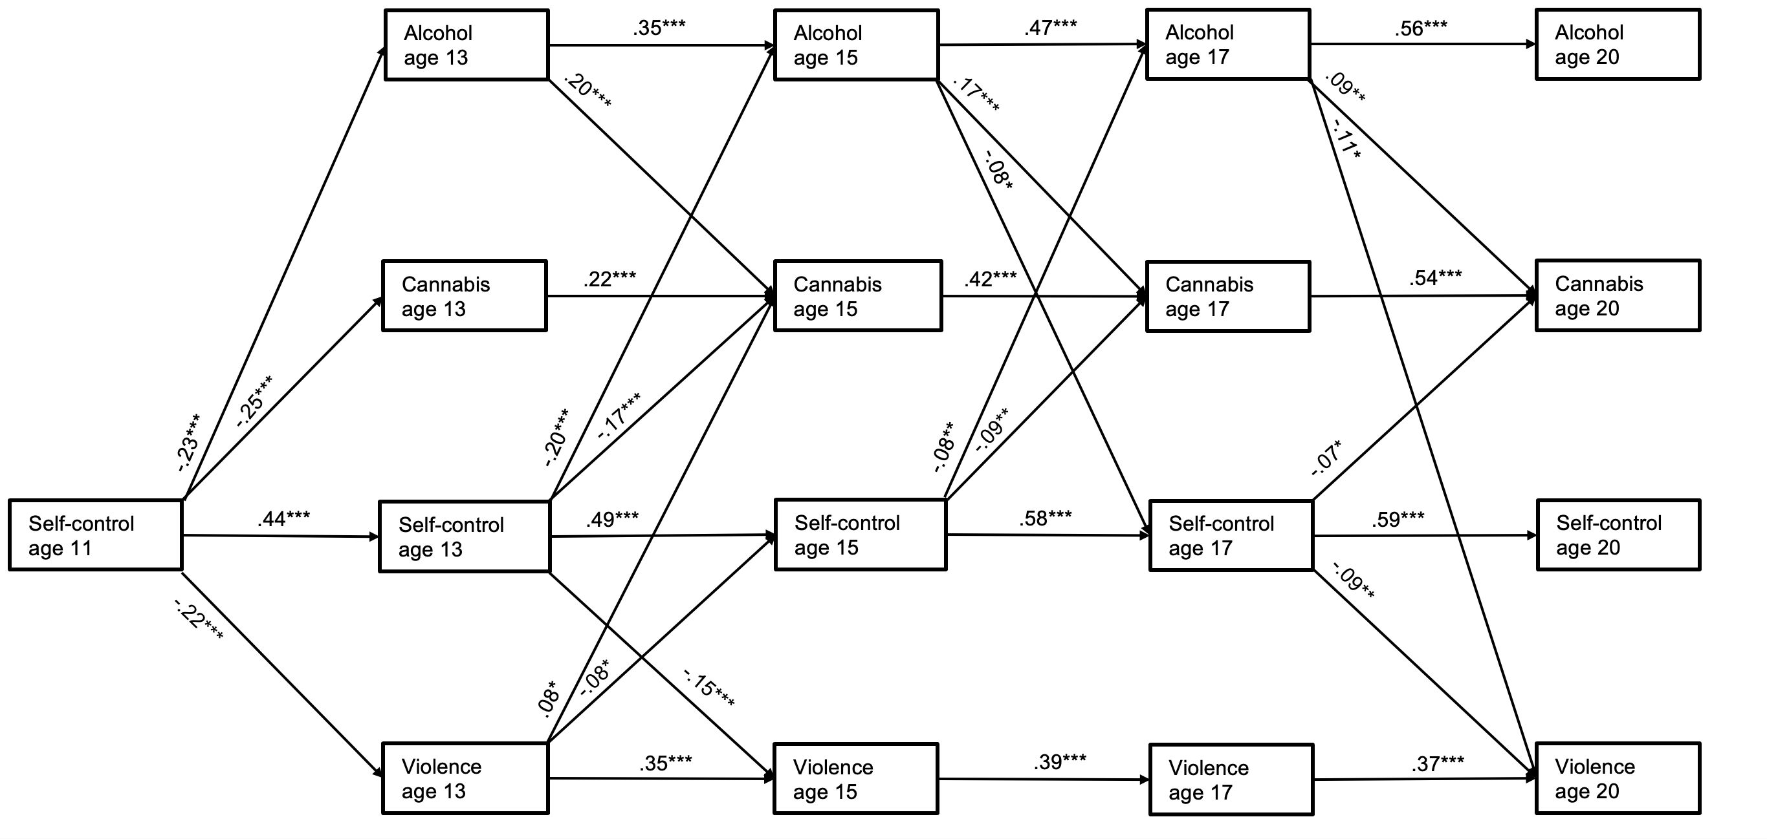

Fig. S2 Fit estimates of CLPM (sensitivity analysis): $χ$² (73) = 168.607, p <.001; CFI = .984; TLI = .960; RMSEA = .035; SRMR = .029. Cross-lagged panel model connecting self-control, alcohol use, cannabis use, and physical violence perpetration; n = 1,056, *p < .05, **p < .01, ***p < .001. Significant standardized path coefficients. For the sake of simplicity, cross-sectional covariances of residuals are omitted. The model is adjusted for sex assigned at birth, parental migration background, and family SES

Table S5
Autoregressive and Cross-Lagged Paths Among Self-control, Alcohol Use, Cannabis Use, and Physical Violence Perpetration (Sensitivity Analysis)
Outcome variable at age 13 |  |  |  |  |  |  |  |  | Outcome variable at age 15
 | Cannabis use |  | Alcohol use |  | Self-control |  | Violence |  |  | Cannabis use |  | Alcohol use |  | Self-control |  | Violence
 | β (SE) |  | β (SE) |  | β (SE) |  | β (SE) |  |  | β (SE) |  | β (SE) |  | β (SE) |  | β (SE)
Predictors
 |  |  |  |  |  |  |  |  | Cannabis use _{age13} | .22(.09)*** |  | .01(.07) |  | −.03(.02) |  | .05(.06)
Self-control _{age11} | −.25(.06)*** |  | −.23(.07)*** |  | .44(.03)*** |  | −.22(.06)*** |  | Alcohol use _{age 13} | .20(.06)*** |  | .35(.04)*** |  | .02(.01) |  | −.01(.03)
 |  |  |  |  |  |  |  |  | Self-control _{age13} | −.17(.10)*** |  | −.20(.09)*** |  | .49(.03)*** |  | −.15(.06)***
 |  |  |  |  |  |  |  |  | Violence _{age13} | .08(.07)* |  | −.00(.06) |  | −.08(.02)* |  | .35(.05)***
Controls |  |  |  |  |  |  |  |  | Controls
Sex (1) | .17(.04)*** |  | .11(.06)*** |  | −.06(.03)* |  | .33(.05)*** |  | Sex (1) |  |  |  |  |  |  | .17(.04)***
Migration background (1) |  |  |  |  |  |  | .07(.05)* |  | Migration background (1) | −.07(.09)* |  | −.07(.08)*
Family SES |  |  |  |  |  |  | −.11(.00)*** |  | Family SES | .12(.00)*** |  | .17(.00)*** |  | .06(.00)* |  | −.08(.00)**
Outcome variable at age 17 |  |  |  |  |  |  |  |  | Outcome variable at age 20
 | Cannabis use |  | Alcohol use |  | Self-control |  | Violence |  |  | Cannabis use |  | Alcohol use |  | Self-control |  | Violence
 | β (SE) |  | β (SE) |  | β (SE) |  | β (SE) |  |  | β (SE) |  | β (SE) |  | β (SE) |  | β (SE)
Cannabis use _{age13} |  |  |  |  |  |  | .05(.06) |  | Cannabis use _{age13} |  |  |  |  |  |  | .06(.08)
Cannabis use _{age15} | .42(.04)*** |  | .02(.03) |  | −.03(.01) |  | .04(.02) |  | Cannabis use _{age15} |  |  |  |  |  |  | .02(.02)
 |  |  |  |  |  |  |  |  | Cannabis use _{age17} | .54(.04)*** |  | .04(.02) |  | −.02(.01) |  | −.00(.02)
Alcohol use _{age 13} |  |  |  |  |  |  | .02(.04) |  | Alcohol use _{age 13} |  |  |  |  |  |  | −.02(.03)
Alcohol use _{age 15} | .17(.04)*** |  | .47(.03)*** |  | −.08(.01)* |  | −.00(.02) |  | Alcohol use _{age 15} |  |  |  |  |  |  | .07(.03)
 |  |  |  |  |  |  |  |  | Alcohol use _{age17} | .09(.04)** |  | .56(.04)*** |  | .05(.01) |  | −.11(.02)*
Self-control _{age15} | −.09(.12)** |  | −.08(.10)** |  | .58(.03)*** |  | −.05(.07) |  | Self-control _{age17} | −.07(.12)* |  | −.01(.10) |  | .59(.03)*** |  | −.09(.06)**
Violence _{age15} | .02(.08) |  | −.06(.06) |  | −.02(.02) |  | .39(.05)*** |  | Violence _{age17} | .01(.07) |  | −.05(.06) |  | −.02(.02) |  | .37(.05)***
Controls |  |  |  |  |  |  |  |  | Controls
Sex (1) | .09(.09)** |  | .06(.08)* |  | −.06(.02)* |  | .21(.05)*** |  | Sex (1) | .09(.09)** |  | .07(.07)* |  | −.07(.03)* |  | .09(.05)**
Migration background (1) | −.09(.10)** |  | −.15(.08)*** |  |  |  | .06(.05)* |  | Migration background (1)
Family SES | .06(.00) |  | .14(.00)*** |  | .08(.00)** |  | −.08(.00)* |  | Family SES |  |  | .11(.00)***
Note. CLPM connecting self-control, alcohol use, cannabis use, and physical violence perpetration; n = 1,056; *p < .05, **p < .01, ***p < .001. Control variables p < .1 included in model. Dummy coding: sex assigned at birth (1) = male; parental migration background (1) = both parents born abroad.
Table S6
Standardized and Unstandardized Coefficients for Cross-Sectional Covariances of Residuals (Sensitivity Analysis)
CLPM |  | Unstandardized  r (covariance) |  | SE |  | p-value |  | Standardized  r (correlation)
Cross-sectional covariances of residuals
Self-control _{age 13} with Violence _{age 13} |  | −0.11 |  | 0.01 |  | < .001 |  | −0.37
Self-control _{age 15} with Violence _{age 15} |  | −0.06 |  | 0.01 |  | < .001 |  | −0.25
Self-control _{age 17} with Violence _{age 17} |  | −0.05 |  | 0.01 |  | < .001 |  | −0.22
Self-control _{age 20} with Violence _{age 20} |  | −0.05 |  | 0.01 |  | < .001 |  | −0.21
Self-control _{age 13} with Cannabis use _{age 13} |  | −0.04 |  | 0.01 |  | < .001 |  | −0.14
Self-control _{age 15} with Cannabis use _{age 15} |  | −0.07 |  | 0.02 |  | < .001 |  | −0.15
Self-control _{age 17} with Cannabis use _{age 17} |  | −0.07 |  | 0.02 |  | < .001 |  | −0.16
Self-control _{age 20} with Cannabis use _{age 20} |  | −0.09 |  | 0.02 |  | < .001 |  | −0.20
Self-control _{age 13} with Alcohol use _{age 13} |  | −0.08 |  | 0.01 |  | < .001 |  | −0.20
Self-control _{age 15} with Alcohol use _{age 15} |  | −0.07 |  | 0.02 |  | < .001 |  | −0.16
Self-control _{age 17} with Alcohol use _{age 17} |  | −0.07 |  | 0.01 |  | < .001 |  | −0.19
Self-control _{age 20} with Alcohol use _{age 20} |  | −0.02 |  | 0.01 |  | .090 |  | −0.06
Cannabis use _{age 13} with Alcohol use _{age 13} |  | 0.25 |  | 0.04 |  | < .001 |  | 0.41
Cannabis use _{age 15} with Alcohol use _{age 15} |  | 0.61 |  | 0.06 |  | < .001 |  | 0.42
Cannabis use _{age 17} with Alcohol use _{age 17} |  | 0.46 |  | 0.05 |  | < .001 |  | 0.32
Cannabis use _{age 20} with Alcohol use _{age 20} |  | 0.23 |  | 0.05 |  | < .001 |  | 0.17
Cannabis use _{age 13} with Violence _{age 13} |  | 0.11 |  | 0.03 |  | < .001 |  | 0.25
Cannabis use _{age 15} with Violence _{age 15} |  | 0.10 |  | 0.03 |  | .001 |  | 0.12
Cannabis use _{age 17} with Violence _{age 17} |  | 0.07 |  | 0.04 |  | .089 |  | 0.07
Cannabis use _{age 20} with Violence _{age 20} |  | 0.05 |  | 0.04 |  | .204 |  | 0.06
Violence _{age 13} with Alcohol use _{age 13} |  | 0.19 |  | 0.03 |  | < .001 |  | 0.27
Violence _{age 15} with Alcohol use _{age 15} |  | 0.11 |  | 0.03 |  | < .001 |  | 0.15
Violence _{age 17} with Alcohol use _{age 17} |  | 0.06 |  | 0.03 |  | .027 |  | 0.08
Violence _{age 20} with Alcohol use _{age 20} |  | 0.03 |  | 0.04 |  | .510 |  | 0.04
Note. CLPM connecting self-control, alcohol use, cannabis use, and physical violence perpetration; n = 1,056.

Table S7
Unstandardized Estimates of Indirect Effects, Standard Errors, and 95% Bias-Corrected Bootstrap Confidence Intervals (Sensitivity Analysis)
 |  |  |  | Confidence intervals
 | Estimate | SE |  | Lower | Upper
A_{age 13} SC_{age 15} V_{age 17} V_{age 20} | −.000 | .001 |  | −.002 | .000
A_{age 13} SC_{age 15} V_{age 17} | −.001 | .002 |  | −.006 | .002
A_{age 13} A_{age 15} SC_{age 17} V_{age 20} | .002 | .001 |  | .000 | .005
A_{age 15} SC_{age 17} V_{age 20} | .004 | .002 |  | .001 | .010
A_{age 13} SC_{age 15} SC_{age 17} V_{age 20} | −.001 | .001 |  | −.004 | .002
C_{age 13} SC_{age 15} V_{age 17} V_{age 20} | .001 | .001 |  | −.001 | .004
C_{age 13} SC_{age 15} V_{age 17} | .002 | .003 |  | −.002 | .011
C_{age 13} C_{age 15} SC_{age 17} V_{age 20} | .001 | .001 |  | .000 | .003
C_{age 15} SC_{age 17} V_{age 20} | .001 | .002 |  | −.001 | .006
C_{age 13} SC_{age 15} SC_{age 17} V_{age 20} | .002 | .002 |  | −.002 | .007
Note. A = alcohol use, C = cannabis use, SC = self-control, V = physical violence perpetration. Bold typeface displays regression estimates where the confidence interval does not include 0 (i.e., significance); n = 1,056. Direct associations included cross-lagged paths from alcohol and cannabis use at age 13 to physical violence perpetration at age 17 and age 20 as well as from alcohol and cannabis use at age 15 to physical violence perpetration at age 20.

References
1. Grasmick HG, Tittle CR, Bursik Jr RJ, Arneklev BJ (1993) Testing the core empirical implications of Gottfredson and Hirschi’s general theory of crime. J Res Crime Delinq 30:5–29. https://doi.org/10.1177/0022427893030001002
2. Longshore D, Rand ST, Stein JA (1996) Self-control in a criminal sample: An examination of construct validity. Criminology 34:209–228. https://doi.org/10.1111/j.1745-9125.1996.tb01203.x
3. Tremblay RE, Loeber R, Gagnon C, Charlebois P, Larivée S, LeBlanc M (1991) Disruptive boys with stable and unstable high fighting behavior patterns during junior elementary school. J Abnorm Child Psychol 19:285–300. https://doi.org/10.1007/BF00911232
4. Olweus D (1993) Victimization by peers: Antecedents and long‐term outcomes. In: Rubin KH, Asendorpf JB (eds) Social withdrawal, inhibition, and shyness in childhood. Psychology Press, New York, pp 315–341. https://doi.org/10.4324/9781315799544

