Table S.1:
Sample size calculation a priori based on full sample at 5-years (n=11248) and then () based on participants included in analysis (n=9768).
Shrinkage and over-fitting is much less of a concern if the sample size is appropriate for the number of predictors and events/participants with the outcome of interest. For our binary outcome at 5-years, we have 697/11248 (595/9768) with the event. Therefore, the following sample size calculations apply:
Assumed C-statistic | Inputs | EPP
0.84 | 135 (114) | 5.17 (5.14)
0.74 | 59 (50) | 11.82 (11.72)
0.70 | 40 (33) | 17.43 (17.76)
0.64 | 19 (16) | 36.7 (36.6)
Aiming for a modest C-statistic (0.70), we input a maximum of 33 candidate predictors. It is important to note that each level of a factor variable is considered one input.
Table S.2: list of all pre-conception, perinatal or birth characteristics considered as candidate predictors:
Variable name | Timepoint Measured &  Respondent | Question used/code
Sociodemographic risk
Maternal Age at birth (years)  Mean (SD) | In maternity unit at childs birth, Mother self-report
Mother born in France  (No) | In maternity unit at childs birth, Mother self-report | What is your nationality? French acquired, foreign and stateless coded as No, French born coded as yes
Maternal Education Level | Survey when child was 2 months old, Mother self-report | M_educ@2m: based on ISCED, none, primaire and secondaire coded as 3, lycee coded as 2, bac+2 coded as 1 and >bac+2 coded as 0. (higher code equates with less education).
Postgrad | Survey when child was 2 months old, Mother self-report
Degree | Survey when child was 2 months old, Mother self-report
Leaving Cert | Survey when child was 2 months old, Mother self-report
None up to & incl J. Cert | Survey when child was 2 months old, Mother self-report
Family income | Survey when child was 2 months old, Mother self-report | Taking account of all types of income in the household what is current amount of net monthly resources? ELFE Team made derived variable of equivalised income quintiles.
Highest two quintiles | Survey when child was 2 months old, Mother self-report
Middle quintile | Survey when child was 2 months old, Mother self-report
Lowest two quintiles | Survey when child was 2 months old, Mother self-report
Mother in a relationship at birth | In maternity unit at childs birth, Mother self-report | Are you currently in a couple? (yes/no)
Cumulative Sociodemographic Risk (SR) |  | Constructed variable from summing maternal age & education level, relationship, migrancy and family income.
Each pregnancy specific experience
Biological:
Late bleed (2nd/3rd trimester) in this pregnancy | In maternity unit at childs birth, Medical file | No, placenta previa, retroplacental haematoma, other (all responses except NO considered as YES)
High blood pressure (HBP) in this pregnancy | In maternity unit at childs birth, Medical file | HBP developed during pregnancy (systolic ≥140mmHg or diastolic ≤90mmHg): No, yes with proteinuria, yes without proteinuria (all responses except NO considered as YES)
Gestational Diabetes Mellitus (GDM) in this pregnancy | In maternity unit at childs birth, Medical file | Gestational Diabetes: no, yes, Don’t Know coded as no.
Did you have infertility treatment for this pregnancy? | In maternity unit at childs birth, mother self report | yes/no
Psychological:
Prefer not to be pregnant/would have liked it later | In maternity unit at childs birth, Mother self-report | When you found out you were pregnant: happy, liked it earlier, (coded NO) liked it later, prefer not to be pregnant (coded YES)
Persistent psychological difficulties in this pregnancy | In maternity unit at childs birth, Mother self-report | During the pregnancy did you have any persistent psychological difficulties? Yes/no
>1 previous miscarriages | Survey at 2 months old, Mother self-report | How many miscarriages have you had before this pregnancy? #coded as >1 (yes) v 0/1 (no)
Difficult pregnancy | Survey at 2 months old, Mother self-report | How would you describe your pregnancy? A pleasant time, fairly pleasant, (coded NO) a difficult time (coded YES)
Social:
Father not at delivery | In maternity unit at childs birth, Mother self-report | Was the father present at the delivery? yes/no
Not enough support | Survey at 2 months old, Mother self-report | If had (no) partner – during your pregnancy do you think (people close to you) your partner supported you: very well, well, not much, not at  all (not much & not much at all coded as not enough support, rest coded as enough support)
>5 people in house | Survey at 2 months old, Mother self-report | How many people generally live in your household? Number given was recoded as >/<5.
Criticisms about home | Survey at 2 months old, Mother self-report | Do the following criticisms apply to your dwelling?: too Small, too damp, mould on walls, noisy (internal/external) – counted #yes/4
Total number pregnancy-specific-experiences (total of previous 12 endorsed). |  | Range 0-4+
Maternal health behaviours in pregnancy:

Smoked in pregnancy | In maternity unit at childs birth, Mother self-report | Did you smoke during your pregnancy even just from time to time? Yes/No/(Don’t Know coded as No)
Alcohol in pregnancy | In maternity unit at childs birth, Mother self-report | During your pregnancy how often did you consume alcoholic drinks? Never (coded no), once/month or special occasions, 2-4times per month, 2-3times per week, 4+times/week but not daily, everyday, only before knew pregnant, prefer not to answer (all got 1 indicating yes other than never)
Pre-conception Maternal health:
Before pregnant saw a mental health professional | Questionnaire @1year, Mother self-report | Before you were pregnant, did you see a Psychiatrist, psychologist/ therapist or doctor for psychological problems for yourself? yes/no/ don’t know assumed yes.
History of Blood Pressure problems before pregnancy/in prior pregnancy | In maternity unit at childs birth, Medical file | Prior history: None, chronic pre-morbid high blood pressure (HBP), only in a previous pregnancy
History of diabetes before pregnant/in prior pregnancy | In maternity unit at childs birth, Medical file | Prior history: no, type1, type2, only in a previous pregnancy
During a previous pregnancy were you depressed/anxious? | In maternity unit at childs birth, maternal self report | 8249 were first-pregnancies so coded as never pregnant. No, don’t know coded as no, yes as yes
Birth/delivery factors:
Sex of child | In maternity unit at childs birth, Medical File | Male, female, unknown
Spontaneous labour | In maternity unit at childs birth, Medical File | Start of labour: spontaneous, induced, caesarean before start of labour
Mode of delivery | In maternity unit at childs birth, Medical File | Delivery: spontaneous vaginal, forceps/spatulas/vacuum, caesarean, don’t know
Neonatal Intensive Care Unit (NICU) | In maternity unit at childs birth, Medical File | Transfer of the child: No/Yes/don’t know – only babies needing NICU are transferred
Gestational age (GA) (weeks) | In maternity unit at childs birth, Medical File | Gestational age in weeks at delivery

Fig S.1: Frequencies of total number of pregnancy-specific-experiences (PSEs) groups.
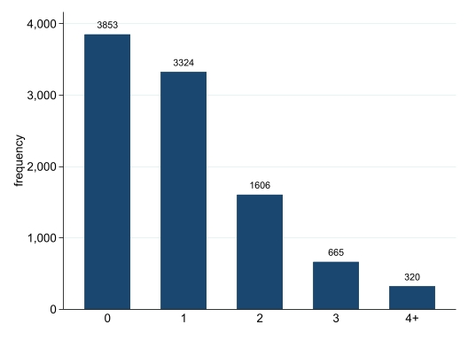
Table S.3:
Validating ªSociodemographic risk measure with financial comfort question
Household is: (n=9768) | No socio-demographic risk (%) | Low socio-demographic risk  (%) | Moderate socio-demographic risk (%) | High socio-demographic risk (%)
Financially comfortable (1568) | 26.1 | 10.8 | 4.6 | 5.1
Financially OK (4185) | 52.3 | 42.1 | 28.5 | 23.7
Financially tight (3235) | 20.5 | 40.3 | 49.5 | 47.1
Financially difficult (564) | 0.9 | 5.9 | 14.5 | 18.6
Always in debt (106) | 0.2 | 0.8 | 2.9 | 5.5
Don’t want to answer (4) | 0.02 | 0.1 | 0 | 0
Note: ªsociodemographic risk comprised of maternal age, education, relationship, migrancy and family income quintile.
Table S.4:
List of all sensory indicators used and their prevalence (N=9768)
At 1-year: |  | Weighted prevalence for regressions | Unweighted
Suck fingers | Q: Does your child suck their thumb/finger?  0 – never, sometimes, don’t know  1 - Often and all of the time | 16.5% | 16.6% often
Easy to calm | Q: Is it easy or difficult for you to calm your child when they are upset?  0– difficult  1 - very easy, quite easy, don’t know | 8.7% | 7.3% difficult
Accepts confined | Q: How does your child react when placed in a confined/restricted area (eg car seat, baby seat etc?)  0– generally protests  1 - mostly accepts, sometimes accepts, don’t know | 11.0% | 11.6% protests
Adapts new | Q:Does your child adapt easily to new things (eg people, places, food etc.)?  0 - almost never  1- always, often, sometimes, don’t know | 16.6% | 13.4% never
Child anxious | Q: Have you noticed in the last few months that your child is fearful/anxious?  0-time to time, rarely/never, don’t know  1-often | 6.1% | 5.0% often
Unable still | Q: In the last few months, have you found that during the day your child has been particularly worked up, unable to keep still?:  0-time to time, rarely/never, don’t know  1-often | 25.1% | 23.3% often
Concern food | Q: are you concerned about your child’s diet?  0– no  1-yes | 2.2% | 2.1% yes
Problems to sleep | Q: When you put your child to bed, do they have problems going asleep (e.g. call you/cry for a long time?):  0-sometimes, never, don’t know  1-always | 16.4% | 13.7% always
Suck to sleep | Q: Do they need a bottle or dummy to go to sleep?  0 – no, don’t know  1 - yes | 9.6% | 7.3%
Accepts new food | Q: Since your child has been weaned, do they like new food?  0-often rejects it  1-Accept it easily, depends on the food, don’t know | 1.6% | 1.2% rejects
 | Derived from the latent class analysis in a previous study
Typical sensory processing group | Derived from the latent class analysis in a previous study | 80.4% | 84.7%
Possible sensory difficulties group | Derived from the latent class analysis in a previous study | 6.5% | 4.9%
Definite sensory difficulties group | Derived from the latent class analysis in a previous study | 13.1% | 10.4%

Table S.5:
Univariate associations between each candidate predictor and outcome of poor mental health compared to adequate mental health (n=9768)
Predictor | Odds Ratio (95% Confidence Interval) | P-value | Coefficient (95% Confidence Interval)
No sociodemographic risk (base)
Low | 1.7 (1.2-2.2) | .001 | .51 (.22-.80)
Moderate | 2.6 (2.0-3.4) | .000 | .96 (.68-1.23)
High | 3.3 (2.0-5.7) | .000 | 1.21 (.67-1.74)
Number pregnancy-specific-experiences (base none)
1 | 1.2 (0.9-1.6) | .26 | .17 (-.13-.48)
2 | 1.8 (1.3 – 2.5) | .00 | .59 (.28-.89)
3 | 1.8 (1.2-2.8) | .01 | .58 (.14-1.02)
4+ | 2.9 (1.8-4.7) | .00 | 1.06 (.59-1.54)
Sex (male base)
Female | .6 (.5-.8) | .00 | -.53 (-.78- -.28)
Pre-morbid psychological difficulties (no base)
yes | 1.5 (1.2-1.9) | .002 | .40 (.15-.65)
History of high blood pressure (no base)
Yes outside a pregnancy | 3.0 (1.5-6.3) | .003 | 1.11 (.39-1.84)
Yes during a previous pregnancy | 1.0 (.4-2.5) | .96 | .02 (-.89-.93)
History of Diabetes (no base)
Yes outside a pregnancy | .7 (.3-1.7) | .45 | -.33 (-1.20-.54)
Yes during a previous pregnancy | 1.3 (.7-2.5) | .45 | .25 (-.40-.91)
Mental health difficulties in a previous pregnancy (never pregnant before base)
No mental health difficulties in previous pregnancy | .7 (.5-.9) | .004 | -.37 (-.62- -.12)
Yes mental health difficulties in previous pregnancy | 1.6 (1.1-2.3) | .013 | .46 (.10-.82)
Smoked in this pregnancy | 1.8 (1.3-2.4) | .000 | .58 (.30-.86)
Drank alcohol in this pregnancy | 1.0 (.8-1.4) | .76 | .04 (-.24- .32)
How labour started (spontaneous base)
Induced | 1.2 (.9-1.6) | .31 | .16 (-.15-.48)
Section (planned or emergency) | .7 (.5-1.1) | .13 | -.32 (-.73-.09)
Mode of delivery (Normal Vaginal Delivery base)
assisted | 1.4 (1.0-2.0) | .04 | .36 (.03-.70)
Planned C-section | .8 (.5-1.2) | .22 | -.29 (-.76-.17)
Emergency C-section | 1.4 (.9-2.0) | .11 | .30 (-.07 - .68)
Neonatal Intensive Care Unit (NICU) | 1.5 (.9-2.4) | .10 | .39 (-.07-.86)
Gestational Age in weeks (GA) | .9 (.9-1.0) | .16 | -.06 (-.14-.02)
Sensory @ 1-year (typical base)
Possible | 1.0 (.6-1.7) | .98 | -.01 (-.55-.54)
Definite | 2.7 (2.1-3.6) | .000 | 1.00 (.73-1.27)

Figure S.2:
Calculating risk score formula for each participant
The log-odds (Y) can be calculated using the regression equation as follows:
Y= constant + [estimate1 x predictor1] + [estimate2 x predictor2] + [estimate n x predictor n]
The log-odds (Y) is then converted into probability (P) as follows:
P= 1/[1+ exp(-Y)]
Where P is the probability of developing the outcome and Y is the log-odds estimated using the model.

Figure S.3:
Standard 2x2 contingency table depicting possible outcomes of a binary classification test.
Observed outcome
Predicted group |  | Poor mental health | Adequate mental health
Predicted group | Predicted high-risk | True positive (TP) | False positive (FP) | PPV=TP/(TP+FP)
Predicted group | Predicted low-risk | False negative (FN) | True negative (TN) | NPV=TN/(TN+FN)
Predicted group |  | Sensitivity = TP/(TP+FN) | Specificity = TN/(TN+FP)
Note: PPV (positive predictive value); NPV (negative predictive value).
Table S.6a:
Comparing those included in the analysis for the prediction model (n=9768) with those excluded due to withdrawing/not participating @ 5-year follow-up (n=7081) or having missing data on some of the variables (n=1480)

 | Total n=18329 | Included n=9768 | Excluded n=8561 | P-value
Maternal Age (Mean/SD) | 30.7 (5.04) | 30.8(5.01) | 30.6 (5.22) | .52
Mother born in France (%yes) | 85.6 | 86.2 | 81.1 | <.01
Maternal Education Level (%) |  |  |  | .35
MSc/PhD | 33.5 | 33.6 | 33.3
Degree | 19.0 | 19.0 | 19.5
Leaving Cert | 39.2 | 39.5 | 36.9
None/Junior Cert | 8.2 | 7.9 | 10.3
Family income (%) |  |  |  | .19
Top 2 quintiles | 38.0 | 38.1 | 36.7
Middle quintile | 17.1 | 16.8 | 20.2
Lowest 2 quintiles | 44.9 | 45.2 | 43.0
Mother NOT in relationship (%yes) | 5.5 | 5.2 | 7.9 | .06
Cumulative Sociodemographic Risk (%) |  |  |  | .02
None | 31.4 | 31.5 | 30.7
Low | 30.2 | 29.5 | 35.8
Moderate | 31.4 | 32.2 | 25.5
High | 7.0 | 6.8 | 8.1
Total# pregnancy-specific-experiences (%) |  |  |  | .27
0 | 34.0 | 34.4 | 31.0
1 | 33.7 | 33.5 | 35.2
2 | 18.7 | 18.4 | 20.7
3 | 8.5 | 8.7 | 7.0
4+ | 5.1 | 5.0 | 6.1
Mental health problems in previous pregnancy (%) |  |  |  | .09
Never pregnant before | 29.6 | 29.2 | 35.0
No | 62.1 | 62.4 | 57.6
Yes | 8.3 | 8.4 | 7.4
History of High Blood Pressure (%) |  |  |  | .49
No | 97.4 | 97.3 | 98.0
Yes | 1.2 | 1.3 | 0.6
Only in previous pregnancy | 1.4 | 1.4 | 1.3
History of Diabetes (%) |  |  |  | .75
No | 96.4 | 96.4 | 96.3
Yes | .96 | .98 | .73
Only in previous pregnancy | 2.6 | 2.6 | 3.0
History of psychological difficulties (%yes) | 23.6 | 23.1 | 27.4 | .04
Sex of baby (%male) | 50.4 | 50.1 | 52.8 | .30
Smoked in pregnancy (%yes) | 19.7 | 19.5 | 21.5 | .37
Alcohol in pregnancy (%yes) | 24.1 | 24.0 | 24.8 | .73
Start Labour (%) |  |  |  | <.001
Spontaneous | 71.3 | 71.9 | 64.8
Induced | 18.9 | 19.0 | 18.7
Section | 9.8 | 9.1 | 16.5
Mode of delivery (%) |  |  |  | .05
Normal Vaginal Delivery | 70.5 | 71.0 | 64.2
Assisted | 11.7 | 11.5 | 13.6
Planned C-section | 7.4 | 7.1 | 10.7
Emergency C-section | 10.5 | 10.4 | 11.4
Neonatal Intensive Care Unit (NICU) (%yes) | 5.3 | 5.2 | 6.1 | .46
Gestational Age (weeks) (mean/SD) | 39.19(1.46) | 39.22(1.45) | 38.91(1.47) | <.001

Table S.6b:
The amount of missing data for the n=11248 who took part @5-years.
# variables missing | Frequency | Percent
0 | 9768 | 86.8
1 | 778 | 6.9
2 | 152 | 1.4
3 | 41 | 0.4
4 | 9 | 0.08
5 | 15 | 0.1
6 | 64 | 0.6
7 | 12 | 0.1
8 | 6 | 0.05
9 | 9 | 0.08
12 | 394 | 3.5

Table S.6c:
The % of cases missing for each variable for the model of the n=11248 who took part at 5-years.
Variable | Number of observations missing | Percent
Sociodemographic risk | 394 | 3.5
Total# pregnancy specific experiences | 394 | 3.5
Sex | 484 | 4.3
Psychological difficulties before pregnancy | 423 | 3.8
History of high blood pressure outside of pregnancy | 609 | 5.4
History of diabetes outside of pregnancy | 694 | 6.2
Mental health difficulties in a previous pregnancy | 774 | 6.9
Smoking in current pregnancy | 500 | 4.5
Alcohol use in current pregnancy | 508 | 4.5
Start labour | 588 | 5.2
Mode of delivery | 719 | 6.4
Neonatal Intensive care unit (NICU) | 0 | 0
Gestational age in weeks | 554 | 4.9
Sensory group for 1-year model | 394 | 3.5

Figure S.4:
Flow-diagram of participants

N=18329 babies recruited

N=11248 took part at 5-years and thus had outcome

N=9768 no missing data

Table S.7:
Model performance statistics for the model after internal validation using bootstrapping.
Model: | Performance
Statistic | Original apparent | Optimism | Optimism adjusted
C-statistic | 0.67 (0.64-0.69) | -.01 | 0.66 (0.57-0.71)
CITL | 0 (-0.03) | -.004 | -.02
C-slope | 1 (1.04) | -.02 | 1.02
Note. Slope >1 = under fitted. CITL <0 = over predicting. There was minimal optimism adjustment to the C-statistic indicating good internal performance in terms of discrimination. The mis-calibration in CITL is very small at <1% basically zero miscalibration in overall risks. The calibration slope suggests a moderate amount of shrinkage is required to adjust the predictor effects in the model ie under fitted but over predicting.

Fig S.5a: Calibration instability plot

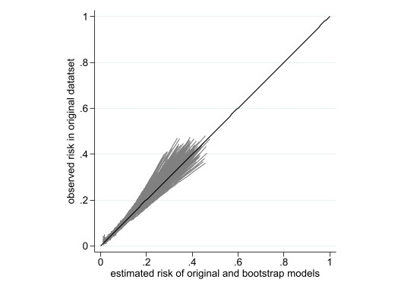
Note. The bootstrapped curves are overlaid on this plot with the original calibration curve (the wider the spread of the curves, the greater the instability concern).
Fig S.5b: Classification instability plot

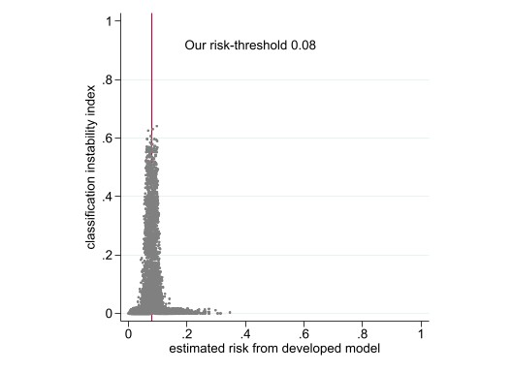
Note. Each individuals classification index (y-axis) from bootstrapped models is plotted against their original predicted value (X-axis). A narrow distribution with values close to zero for most people except those close to the threshold indicates stable classifications.
Fig S.5c:
C-statistic histogram

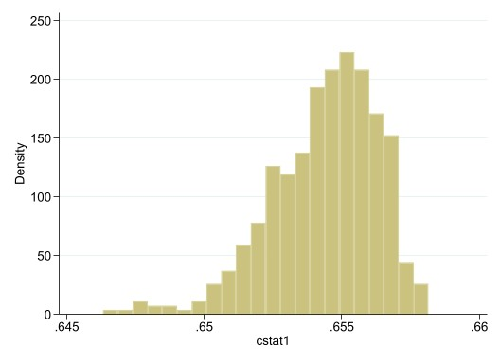
Note. In terms of discrimination, the C-statistic histogram shows very little variability in the C-statistic estimates across bootstrap samples, again showing good stability.
Fig S.5d:
Mean Absolute prediction error (MAPE) plot

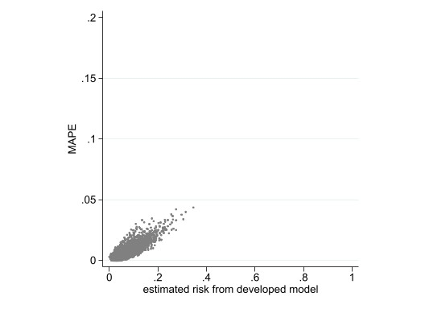
Note. The average MAPE is 0.006 indicating very low instability in each individual’s prediction between the original model and the bootstrapped models on average.
Fig S.6:
Accuracy of classification at ≥8% risk-threshold.

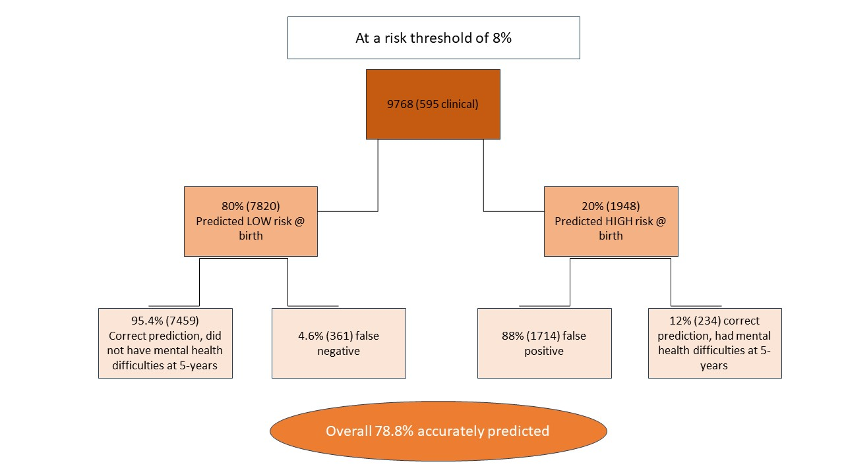

Table S.8:
The proportion of children with poor mental health at 5-years examined across sex, social risk and Neonatal Intensive Care Unit (NICU)
 | % poor mental health (95%CI)
Sex:
Male (n=4940) | .08 (.07-.08)
Female (n=4828) | .05 (.04-.05)
Cumulative sociodemographic risk:
None (n=4406) | .04 (.04-.05)
Low (n=3064) | .06 (.05-.07)
Moderate (n=2023) | .09 (.08-.10)
High (n=275) | .13 (.09-.18)
NICU:
No NICU (n=8014) | .06 (.06-.07)
Yes NICU (n=477) NB only ≥33weeks gestation | .07 (.05-.10)

Table S.9:
Comparing the model performance in our different subgroups of interest (sex, sociodemographic risk and Neonatal Intensive Care Unit (NICU)).
Group | N= | ROC area | Standard Error | 95% CI
All | 9768 | 0.67 | 0.01 | 0.64-0.69
Sex
Male | 4940 | 0.64 | 0.02 | 0.61-0.67
Female | 4828 | 0.66 | 0.02 | 0.62-0.70
Sociodemographic Risk
None | 4406 | 0.65 | 0.02 | 0.61-0.69
Low | 3064 | 0.63 | 0.02 | 0.59-0.67
Moderate | 2023 | 0.63 | 0.02 | 0.59-0.67
High | 275 | 0.65 | 0.05 | 0.54-0.75
NICU
No | 9291 | 0.66 | 0.01 | 0.64-0.68
Yes | 477 | 0.78 | 0.04 | 0.70-0.87

Table S.10:
Co-efficient values for the sensory variable and model performance of the sensory model at 1-year when included as a possible candidate predictor and later start-point.
Predictors | 1-year model
 | Coefficient*
Intercept | -2.92
Total number of pregnancy-specific adverse experiences:
0 | Ref
1 | .05
2 | .46
3 | .48
4+ | 1.12
Cumulative sociodemographic risk:
None | Ref
Low | .12
Moderate | .53
High | .56
History of pre-morbid blood pressure:
No | Ref
Yes | .004
History of psychological difficulties before being pregnant:
Yes | Ref
No | -0.10
Mental health difficulties in a previous pregnancy:
Yes | Ref
No | -0.38
Never pregnant before | .006
Smoked during the pregnancy:
Yes | Ref
No | -0.30
Start of labour:
C-section (plan/emergency) | Ref
Spontaneous | -0.02
Induced | 0.04
Infant sex:
Female | Ref
Male | 0.38
Sensory profile @1-year:
Typical | Ref
Possible | -.06
Definite | 0.87
Discrimination & calibration performance metrics:
Area-Under-the-Curve (AUC) | 0.69 (0.67-0.71)
Calibration slope | 1.05
Expected/Observed (E/O) | 1.02
Calibration-in-the-large (CITL) | -0.02
Brier Score | 0.06
*coefficient from LASSO ie includes shrinkage

