SUPPLEMENTARY TABLES AND FIGURES

Title: Age-related differences in psychopathology within sex chromosome trisomies

Authors: Melissa R. Roybal (melissa.roybal@nih.gov)¹, Siyuan Liu (siyuan.liu@nih.gov)¹, Isabella G. Larsen (bella.larsen@nih.gov, OrcID: 0000-0001-8520-5539)¹, Anastasia Wass (a.c.e.wass@gmail.com)², Lukas Schaffer (luke.schaffer@gmail.com)^{3,4}, Tiffany Ajumobi (tajumobi@gmail.com)⁵, Ethan T. Whitman (ethan.whitman@gmail.com)⁶, Allysa Warling (allysawarling@gmail.com, OrcID: 0000-0001-9412-6357)⁷, Liv Clasen (clasenl@mail.nih.gov)¹, Jonathan Blumenthal (jonathanblumenthal@mail.nih.gov)¹, Srishti Rau (srrau@childrensnational.org)⁸*, Armin Raznahan (raznahana@mail.nih.gov)¹*

¹ Section on Developmental Neurogenomics, National Institute of Mental Health, National Institutes of Health, Bethesda, MD, United States
² Georgetown University School of Medicine, Washington, D.C., United States
³ Institute for Behavioral Genetics, University of Colorado Boulder, Boulder, CO, United States
⁴ Department of Psychology and Neuroscience, University of Colorado Boulder, Boulder, CO, United States
⁵ School of Medicine, The Johns Hopkins University, Baltimore, MD, United States
⁶ Department of Psychology & Neuroscience, Duke University, Durham, NC, United States
⁷ Harvard Medical School, Boston, MA, United States
⁸ Children’s National Health System, Center for Autism Spectrum Disorders and Division of Neuropsychology, Washington, D.C., United States

*These authors contributed equally to this work.

Corresponding author identification and email address: Armin Raznahan raznahana@mail.nih.gov

 |  |  |  |  |  |  | Group Comparisons
 | Total | XX | XY | XXX | XXY | XYY | Comparing all groups | SCTs vs. controls | Comparing SCT groups only
Federal Race Category: N(%)
Asian | 11 (2.2) | 3 (2.0) | 3 (2.0) | 3 (6.0) | 1 (1.1) | 1 (1.7) | χ2= 35.87* | χ2= 34.99** | χ2= 9.94
Black | 34 (6.7) | 17 (11.3) | 13 (8.5) | 0 (0) | 4 (4.3) | 0 (0)
American Indian / Alaska Native | 1 (0.2) | 0 (0) | 0 (0) | 0 (0) | 1 (1.1) | 0 (0)
White | 424 (84) | 123 (81.5) | 120 (78.4) | 44 (88.0) | 81 (88.0) | 56 (95.0)
More than one race | 33 (6.5) | 6 (4.0) | 17 (11.1) | 3 (6.0) | 5 (5.4) | 2 (3.4)
Unknown / not reported | 2 (0.4) | 2 (1.3) | 0 (0) | 0 (0) | 0 (0) | 0 (0)
Federal Ethnicity Category: N(%)
Hispanic | 34 (6.7) | 10 (6.6) | 6 (4) | 4 (8) | 9 (9.8) | 5 (8.5) | χ2= 9.23 | χ2= 3.60 | χ2= 2.58
Non-Hispanic | 468 (92.7) | 141 (93.4) | 146 (95.4) | 46 (92) | 81 (88) | 54 (91.5)
Unknown | 3 (0.6) | 0 (0) | 1 (0.7) | 0 (0) | 2 (2.2)

Supplementary Table 1 Additional demographic variables * p < .05, **p < .001
CBCL Scale | CBCL T-score by group, M(SD)
 | XX | XY | XXX | XXY | XYY
anxdep | 51 (0.5) | 51.3 (0.5) | 60.3 (1.1)* | 57.9 (0.8)* | 59.7 (1.0)*
withdep | 51.5 (0.5) | 52.0 (0.5) | 61.7 (1.1)* | 58.9 (0.8)* | 61.3 (1.0)*
somatic | 52.2 (0.5) | 52.3 (0.5) | 62.6 (1.1)* | 59.2 (0.9)* | 63.3 (1.0)*
social | 50.6 (0.5) | 51.2 (0.5) | 63.5 (1.0)* | 60.7 (0.8)* | 68.1 (0.9)*
thought | 51.1 (0.5) | 51.7 (0.5) | 60.5 (1.0)* | 60.0 (0.8)* | 66.0 (1.0)*
attention | 50.9(0.5) | 51.4 (0.5) | 67.1 (1.1)* | 60.9 (0.8)* | 68.6 (1.0)*
rulebreak | 51.3 (0.4) | 51.4 (0.4) | 56.6 (0.9)* | 56.1 (0.7)* | 59.0 (0.8)*
aggressive | 50.7 (0.5) | 51.0 (0.5) | 58.1 (1.0)* | 56.5 (0.8)* | 62.6 (0.9)*
internal | 42.5 (0.8) | 43.6 (0.8) | 61.7 (1.6)* | 57.6 (1.3)* | 62.2 (1.5)*
external | 42.0 (0.8) | 42.6 (0.8) | 53.9 (1.6)* | 53.8 (1.2)* | 59.4 (1.5)*
totalprob | 40.0 (0.8) | 41.3 (0.7) | 61.4 (1.6)* | 58.7 (1.2)* | 65.8 (1.4)*

Supplementary Table 2 Mean CBCL T-score for each CBCL dimension in each karyotype group (estimated at mean age of the combined cohort). Asterisk denotes Tukey post hoc adjusted p-value for comparison of each SCT group’s CBCL T-score distribution relative to their respective gonadal control group (p < .05).

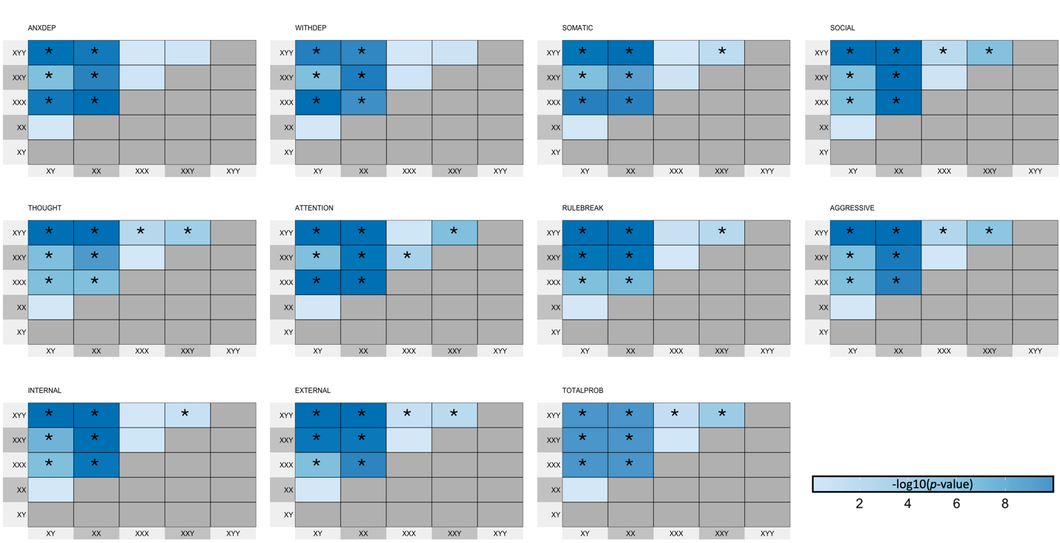Supplementary Fig. 1 Pairwise tests for inter-group differences in mean CBCL T-score for each CBCL dimension. Colors encode the -log10(p-value) from Tukey test for each group difference. Asterisks denote statistically significant contrasts (adjusted p-value < .05). Directions of group differences are detailed in Supplementary Table 2.

