Supplement 2 Metaanalyses and Summary of Findings tables

Contents
Appendix 4 Metaanalyses and Summary of Findings tables 1
Contents 1
Cognitive behavioral therapy (CBT) 2
Dialectical Behavior Therapy for Adolescents (DBT-A) 8
Internet-delivered emotion regulation individual therapy (IERITA) 13
Mentalization-Based Treatment for Adolescents (MBT-A) 16
Motivational interviewing 19
Brief Admission by Self-Referral 21
Group therapy versus TAU 22
Family therapy 26
References 28

Cognitive behavioral therapy (CBT)

Metaanalyses
Figure S1 SA in last six months at post-intervention (3–6 months post-allocation)*.
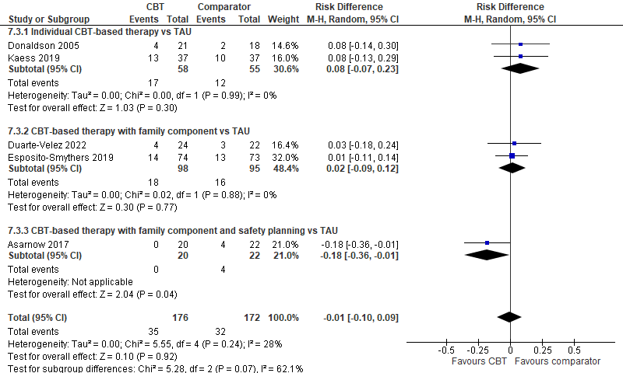
*Data from Kaess 2019 has been received upon request
SA = Suicide Attempts

Figure S2 SA in last six months at 10–12 months post-allocation*.
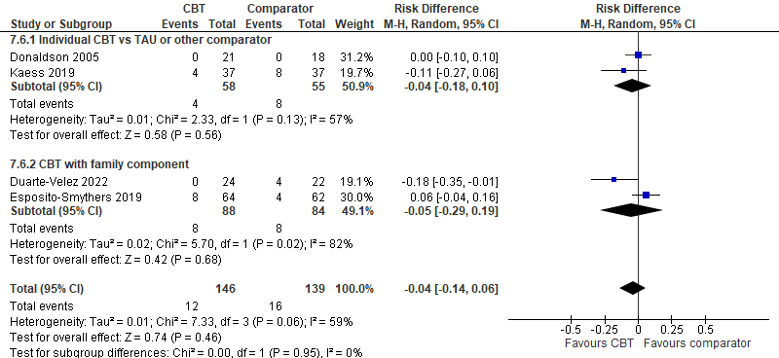
*Data from Kaess 2019 has been received upon request
SA = Suicide Attempts
Figure S3 NSSI during last month, at post-intervention (4–6 months post-allocation)*.
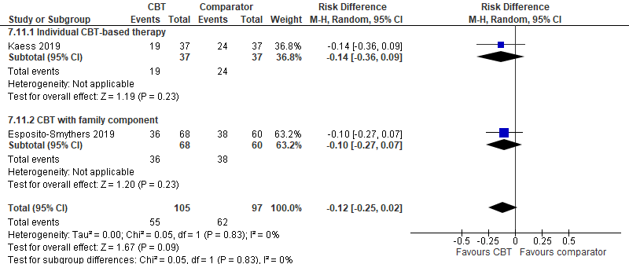
*Data from Kaess 2019 has been received upon request
NSSI = Non-Suicidal Self-Injury

Figure S4 Suicide ideation scores* at post-intervention.
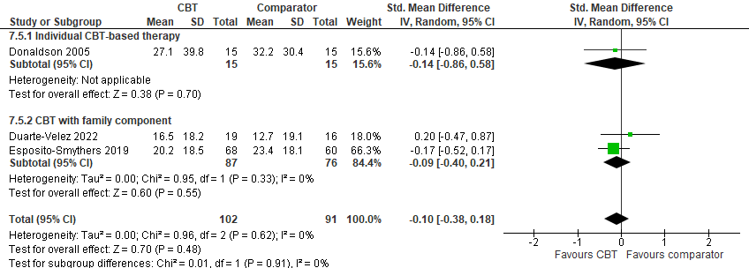
*(Donaldson: SIQ, Duarte-Velez and Esposito-Smythers: SIQ-JR)
SIQ = Suicidal Ideation Questionnaire (range 0–180); SIQ-JR = Suicidal Ideation Questionnaire, Junior Version (range 0–90)

Figure S5 Suicide ideation scores at 10–12 months post-allocation.
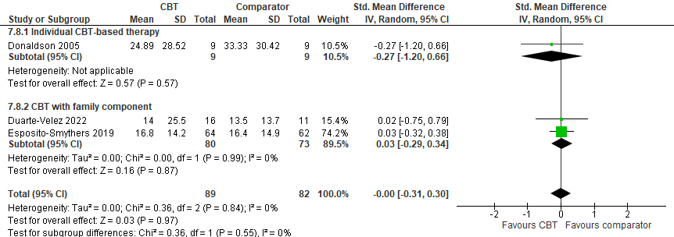

Figure S6 Depression scores* post-intervention.
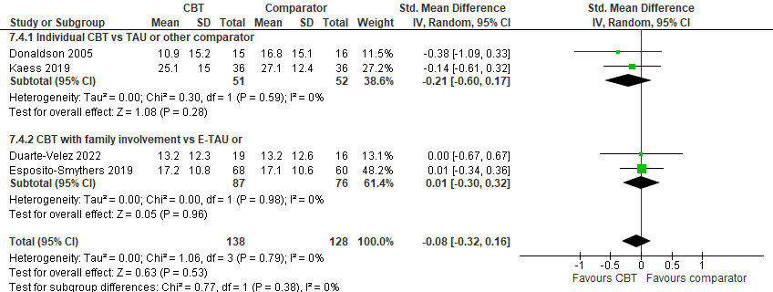
*Kaess 2019: BDI-II, Donaldsson: CES-D, Duarte-Velez 2022: CDI-II, Esposito-Smythers 2019: CDI-II
BDI-II = Beck-Depression-Inventory-II (range 0-63); CDI-II = Children’s Depression Inventory-2nd Edition (range 0–56); CES-D = The Center for Epidemiologic Studies-Depression Scale (range 0-60)

Figure S7 Depression scores* at 10–12 months post-allocation.
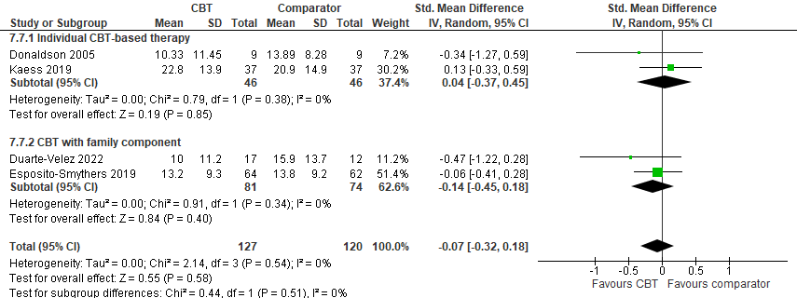
*Kaess 2019: BDI-II, Donaldsson: CES-D, Duarte-Velez 2022: CDI-II, Esposito-Smythers 2019: CDI-II
BDI-II = Beck-Depression-Inventory-II (range 0-63); CDI-II = Children’s Depression Inventory-2nd Edition (range 0–56); CES-D = The Center for Epidemiologic Studies-Depression Scale (range 0-60)

Table S3. Summary of findings for CBT-based therapy versus TAU

Outcome | Number of participants  (Number of studies)  References | Absolute effect  (95% CI) | Certainty of the evidence (GRADE) | Downrating (GRADE) | Comment
Number of participants with suicide attempts at post-intervention | 348  (5 RCT)  [1-5] | RD= –0.01 (–0.10 to 0.09) | ⊕⊕  Low | Imprecision¹ | Evidence suggests CBT results in little to no difference
Number of participants with suicide attempts at 10–12 months post-allocation | 285  (4 RCT)  [2-5] | RD= –0.04 (–0.14 to 0.06) | ⊕⊕  Low | Imprecision¹ | Evidence suggests CBT results in little to no difference
Number of participants with suicidal attempts at 18 months post-allocation | 124  (1 RCT)  [4] | RD=0.06 (–0.02 to 0.15) | ⊕yyy  Very low | Imprecision²
Number of participants with suicidal attempts at 2-4 years post-allocation | 74  (1 RCT  [6] | RD=0.05 (–0.14 to 0.03) | ⊕yyy  Very low | Imprecision² | Follow-up study of Kaess 2019, data were received upon request
Number of participants with NSSI at post-intervention | 202  (2 RCT)  [4, 5] | RD= –0.12 (–0.25 to 0.02) | ⊕yyy  Very low | Imprecision²
Number of participants with NSSI at follow-up | 124  (1 RCT)  [4] | At 12 months:  RD= –0.09 (–0.25 to 0.07)  At 18 months: RD=0.06 (–0.08 to 0.20) | ⊕yyy  Very low | Imprecision²
Number of participants with NSSI at 2-4 years post-allocation | 74  (1 RCT)  [6] | RD=0.03 (–0.16 to 0.21) | ⊕yyy  Very low | Imprecision² | Follow-up study of Kaess 2019, data were received upon request
Completed suicides | 31  (1 RCT)  [2] | KBT: 0  TAU: 0 | ⊕yyy  Very low | Imprecision³ | Metaanalysis not performed because of 0 events
Suicidal ideation (SIQ or SIQ-JR), at post-intervention | 193  (3 RCT)  [2-4] | SMD= –0.10 (–0.38 to 0.18) | ⊕yyy  Very low | Imprecision²
Suicidal ideation (SIQ or SIQ-JR), at 10–12 months post-allocation | 171  (3 RCT)  [2-4] | SMD= –0.00 (–0.31 to 0.30) | ⊕yyy  Very low | Imprecision²
Suicidal ideation (SIQ or SIQ-JR), at 18 months post-allocation | 124  (1 RCT)  [4] | MD=2.40 (–1.30 to 6.10) | ⊕yyy  Very low | Imprecision²
Depression (BDI-II, CES-D, CDI-II), at post-intervention | 266  (4 RCT)  [2-5] | SMD= –0.08 (–0.32 to 0.16) | ⊕yyy  Very low | Imprecision²
Depression (BDI-II, CES-D, CDI-II), at 10-12 months post-allocation | 247  (4 RCT)  [2-5] | SMD= –0.07 (–0.32 to 0.18) | ⊕yyy  Very low | Imprecision²
Depression (CDI-II), at 18 months post-allocation | 124  (1 RCT)  [4] | MD=5.30 (1.95 to 8.65) | ⊕yyy  Very low | Imprecision²
Anxiety | 0  (0 RCT) | - | - | - | Outcome not reported in any study
General function | 0  (0 RCT) | - | - | - | Outcome not reported in any study
BDI-II = Beck-Depression-Inventory-II (range 0-63); BSSI = Beck Scale for Suicide Ideation (range 0–38); CDI-II = Children’s Depression Inventory-2nd Edition (range 0–56); CES-D = The Center for Epidemiologic Studies-Depression Scale (range 0-60); CI = Confidence Interval; GRADE = The Grading of Recommendations Assessment, Development and Evaluation; MD = Mean Difference; NSSI = Non-Suicidal Self-Injury; RCT = Randomized controlled trial; RD = Risk Difference; SIQ = Suicidal Ideation Questionnaire (range 0–180); SIQ-JR = Suicidal Ideation Questionnaire, Junior Version (range 0–90); SMD = Standardized Mean Difference; TAU = Treatment As Usual
¹ Downrated –2 because of imprecision: few participants
² Downrated –3 because of imprecision: non-significant results and few participants
³ Downrated –3 because of imprecision: few participants and very few events

Dialectical Behavior Therapy for Adolescents (DBT-A)

Metaanalyses

Figure S8 Number of participants with self-harm* at post-intervention.
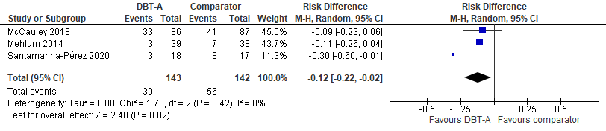
*Mehlum 2014: self-harm leading to hospital/ED visit during the trial (last 19 weeks); McCauley 2018: self-harm (any, NSSI or SA) during trial/ last 6 months; Santa-Maria Perez: NSSI in last 4 weeks
NSSI = Non-Suicidal Self-Injury

Figure S9 Frequency of self-harm* at post-intervention.
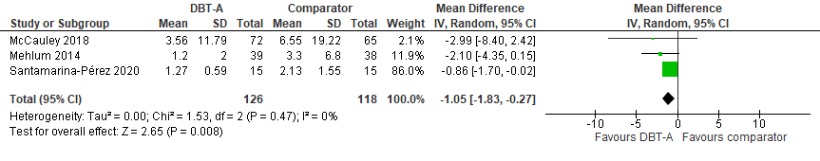*Santa-Maria Perez 2020: NSSI last 4 weeks; McCauley 2018: Number of self-harm episodes in last 6 months (from baseline to end of study)
NSSI = Non-Suicidal Self-Injury

Figure S10 Number of participants with suicide attempts at post-intervention.
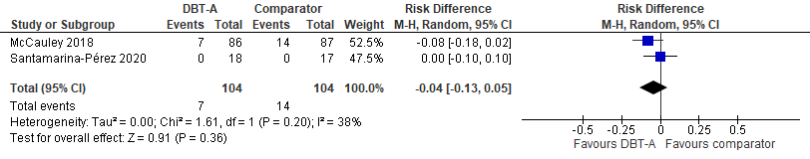

Figure S11 Number of participants with suicide attempts at 12–19 months* post-allocation.
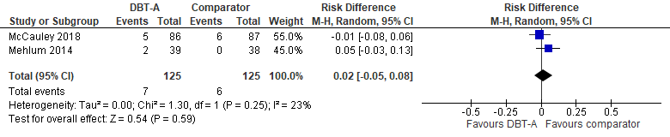
Mehlum 2014: 19 months (71 weeks) post-allocation; McCauly 2018: 12 months post-allocation
Figure S12 Suicidal ideation scores (SIQ-JR) at post-intervention.
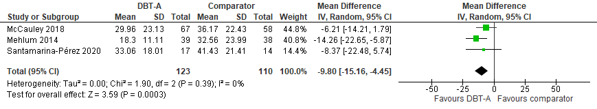
SIQ-JR = Suicidal Ideation Questionnaire, Junior Version (range 0–90)
Figure S13 Suicidal ideation (SIQ-JR) at 12–19 months post-allocation.
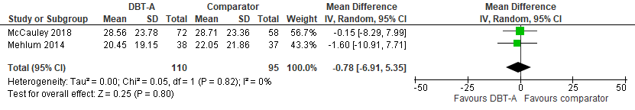
SIQ-JR = Suicidal Ideation Questionnaire, Junior Version (range 0–90)
Figure S14 Depression symptoms* at post-intervention.
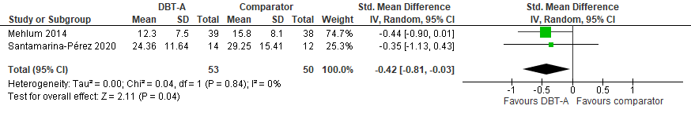
*Mehlum 2014: MADRS; Santamarina-Perez 2020: BDI-II
BDI-II = Beck-Depression-Inventory-II (range 0-63); MADRS = (Montgomery-Åsberg Depression Rating Scale (range 0–60)

Figure S15 General function scores (C-GAS) at post-intervention.
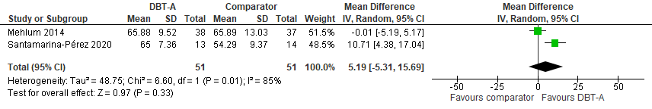
C-GAS = Children's Global Assessment Scale (range 1–100)

Table S4. Summary of findings for DBT-A versus alternative psychotherapy

Outcome | Number of participants  (Number of studies)  References | Absolute effect  (95% CI) | Certainty of the evidence (GRADE) | Downrating (GRADE) | Comment
Number of participants with self-harm at post-intervention | 285  (3 RCT)  [7-9] | RD= –0.12 (-0.22 to –0.02) | ⊕⊕⊕  Moderate | Imprecision¹ | DBT-A probably reduces outcome
Number of participants with self-harm at 12 months post-allocation | 173  (1 RCT)  [7] | RD= –0.03 (–0.17 to –0.11) | ⊕  Very low | Imprecision²
Frequency of self-harm at post-intervention | 244  (3 RCT)  [7-9] | MD= –1.05 (–1.83 to –0.27) | ⊕⊕⊕  Moderate | Imprecision¹ | DBT-A probably reduces outcome
Frequency of self-harm at 12-19 months post-allocation | 202  (2 RCT)  [7, 10] | MD= –9.30 (–14.00 to –4.60) Mehlum 2016  OR=0.60 (0.24 to 1.52) McCauley 2018 | ⊕  Very low | Imprecision² | Metaanalysis not performed since data were reported on different formats
Frequency of self-harm at 3 years post-allocation | 71  (1 RCT)  [11] | MD=12.62 (–1.76 to 27.00) | ⊕  Very low | Imprecision²
Number of participants with suicide attempts at post-intervention | 208  (2 RCT)  [7, 9] | RD= –0.04 (–0.13 to 0.05) | ⊕  Very low | Imprecision²
Number of participants with suicide attempts at 12-19 months post-allocation | 250  (2 RCT)  [7, 11] | RD=0.02 (–0.05 to 0.08) | ⊕  Very low | Imprecision²
Number of participants with suicide attempts at 3 years post-allocation | 77  (1 RCT)  [11] | RD= –0.11 (–0.24 to 0.03) | ⊕  Very low | Imprecision²
Completed suicides | 285  (3 RCT) | DBT-A: 0  ComparatOR=1 | ⊕  Very low | Imprecision³ | Metaanalysis not performed because of very few events
Suicidal ideation (SIQ-JR), at post-intervention | 233  (3 RCT)  [7-9] | MD= –9.80 (–15.16 to –4.45) | ⊕⊕⊕  Moderate | Imprecision¹ | DBT-A probably reduces outcome
Suicidal ideation (SIQ-JR), at 12-19 months post-allocation | 205  (2 RCT)  [7, 10] | MD= –0.78 (–6.91 to 5.35) | ⊕  Very low | Imprecision²
Suicidal ideation (SIQ-JR), at 3 years post-allocation | 71  (1 RCT)  [11] | MD= –3.51 (–12.04 to 5.02) | ⊕  Very low | Imprecision²
Depression (MADRS or BDI-II), at post-intervention | 103  (2 RCT)  [8, 9] | SMD= –0.42 (–0.81 to –0.03) | ⊕⊕  Low | Imprecision⁴ | DBT-A may reduce outcome
Depression (MADRS), at 19 months post-allocation | 75  (1 RCT)  [10] | MD= –0.64 (–4.53 to 3.25) | ⊕  Very low | Imprecision²
Depression (MADRS), at 3 years post-allocation | 71  (1 RCT)  [11] | MD=1.36 (–1.96 to 4.68) | ⊕  Very low | Imprecision²
Anxiety | 0  (0 RCT) | - | - | - | Outcome not reported in any study
General function (C-GAS), at post-intervention | 102  (2 RCT)  [8, 9] | MD=5.19 (–5.31 to 15.69) | ⊕  Very low | Imprecision²
General function (C-GAS), at 19 months post-allocation | 75  (1 RCT)  [10] | MD=1.50 (–4.40 to 7.40) | ⊕  Very low | Imprecision²
General function (C-GAS), at 3 years post-allocation | 71  (1 RCT)  [11] | MD= –1.15 (–6.49 to 4.19) | ⊕  Very low | Imprecision²
BDI-II = Beck-Depression-Inventory-II (range 0-63); C-GAS = Children's Global Assessment Scale (range 1–100); CI = Confidence Interval; GRADE = The Grading of Recommendations Assessment, Development and Evaluation; MADRS = (Montgomery-Åsberg Depression Rating Scale (range 0–60); MD = Mean Difference; RCT = Randomized controlled trial; RD = Risk Difference; SIQ-JR = Suicidal Ideation Questionnaire, Junior Version (range 0–90); SMD = Standardized Mean Difference
¹ Downrated –1 because of precision: few participants
² Downrated –3 because of precision: non-significant results and few participants
³ Downrated –3 because of precision: few participants and very few events
⁴ Downrated –2 because of precision: few participants

Internet-delivered emotion regulation individual therapy (IERITA)

Metaanalyses

Figure S16 Number of participants with NSSI* at post-intervention**.
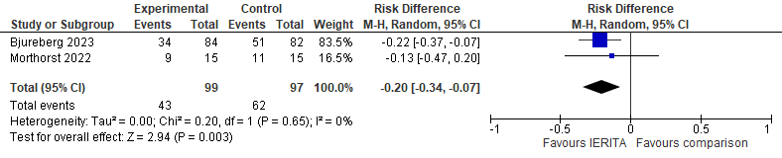
*Bjureberg 2023: Clinicians-rated version of DSHI-Y; Morthorst 2022: Self-reported DSHI-Y. Data from Bjureberg 2023 were received upon request.
** Bjureberg 2023: Outcome was assessed 1 month post-treatment; Morthorst 2022: Outcome was assessed post-treatment. Treatment length was 12 weeks in both studies.
DSHI-Y = Deliberate Self Harm Inventory - Youth version; NSSI = Non-Suicidal Self-Injury

Figure S17 Frequency of NSSI episodes* at post-intervention.
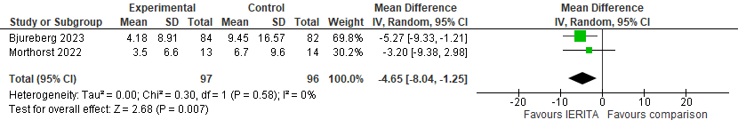
*Number of NSSI episodes within the last 4 weeks: Bjureberg 2023: clinicians-rated version of DSHI-Y; Morthorst 2022: self-reported DSHI-Y
DSHI-Y = Deliberate Self Harm Inventory - Youth version; NSSI = Non-Suicidal Self-Injury

Figure S18 Depression scores (DASS-21 subscale depression) at post-intervention*.
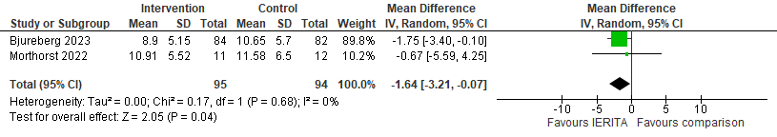
*Data from Bjureberg 2023 were received upon request.
DASS-21 = Depression, Anxiety and Stress Scale, 21 items (range 0–42)

Figure S19 Anxiety scores (DASS-21 subscale anxiety) at post-intervention*.
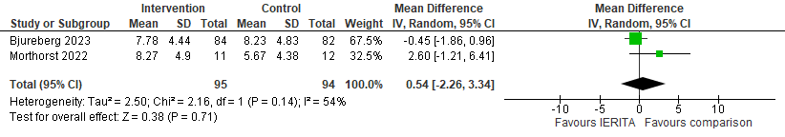
*Data from Bjureberg 2023 were received upon request.
DASS-21 = Depression, Anxiety and Stress Scale, 21 items (range 0–42)

Table S5. Summary of findings for IERITA versus TAU.

Outcome | Number of participants  (Number of studies)  References | Absolute effect  (95% CI) | Certainty of the evidence (GRADE) | Downrating (GRADE) | Comment
Number of participants with NSSI at post-intervention | 196  (2 RCT)  [12, 13] | RD= –0.20 (–0.34 to –0.07) | ⊕⊕  Low | Imprecision¹ | IERITA may reduce outcome
Frequency of NSSI at post-intervention | 193  (2 RCT)  [12, 13] | MD= –4.65 (–8.04 to -1.25) | ⊕⊕  Low | Imprecision¹ | IERITA may reduce outcome
Frequency of NSSI at 6 months post-allocation | 166  (1 RCT)  [12] | MD= –1.47 (–3.51 to 0.57) | ⊕  Very low | Imprecision²
Number of participants with suicide attempts at post-intervention | 166  (1 RCT)  [12] | RD= –0.05 (–0.13 to 0.03) | ⊕  Very low | Imprecision²
Completed suicides | 0  (0 RCT) | - | - | - | Outcome not reported in any study
Suicidal ideation | 0  (0 RCT) | - | - | - | Outcome not reported in any study
Depression (DASS-21 subscale), at post-intervention | 189  (2 RCT)  [12, 13] | MD= –1.64 (–3.21 to -0.07) | ⊕⊕  Low | Imprecision² | IERITA may reduce outcome
Depression (DASS-21 subscale), at 6 months post-allocation | 166  (1 RCT)  [12] | MD= –0.69 (–2.50 to 1.12) | ⊕  Very low | Imprecision²
Anxiety (DASS-21 subscale), at post-intervention | 189  (2 RCT)  [12, 13] | MD=0.54 (–2.26 to 3.34) | ⊕  Very low | Imprecision²
Anxiety (DASS-21 subscale), at 6 months post-allocation | 166  (1 RCT)  [12] | MD=–0.18 (–1.63 to 1.27) | ⊕  Very low | Imprecision²
General function (C-GAS), at post-intervention | 159  (1 RCT)  [12] | MD=1.98 (–0.71 to 4.67) | ⊕  Very low | Imprecision²
C-GAS = Children's Global Assessment Scale (range 1–100); CI = Confidence Interval; DASS-21 = Depression, Anxiety and Stress Scale, 21 items (range 0–42); GRADE = The Grading of Recommendations Assessment, Development and Evaluation; MD = Mean Difference; NSSI = Non-Suicidal Self-Injury; RCT = Randomized controlled trial; RD = Risk Difference; TAU = Treatment As Usual
¹ Downrated –2 because of imprecision: few participants
² Downrated –3 because of imprecision: non-significant results and few participants

Mentalization-Based Treatment for Adolescents (MBT-A)

Metaanalyses

Figure S20 Number of participants with self-harm* at post-intervention**.
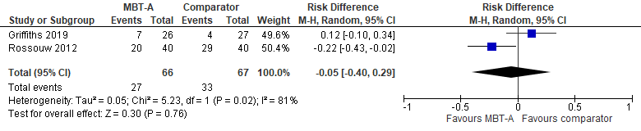
*Length of intervention: Rossouw 2012: 12 months; Griffith 2019:12 weeks.
**Griffith: data on self-harm with ED presentation self-harm were received from author upon request. Rossouw: self-reported self-harm from RT from RTSHI questionnaire.
ED = Emergency Department; RTSHI = Risk-Taking and Self-Harm Inventory

Figure S21 Number of participants with self-harm at 3 months treatment.
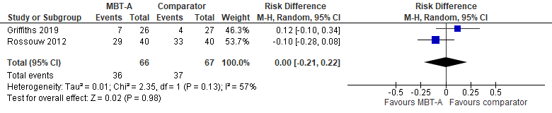

Figure S22 Number of participants with self-harm at 9 months post-allocation.
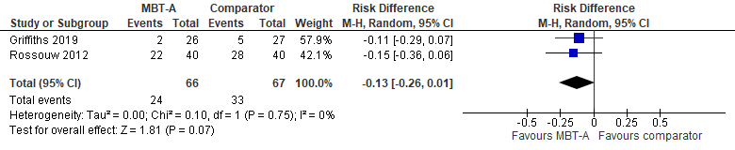

Figure S23 Depression scores at post-intervention.
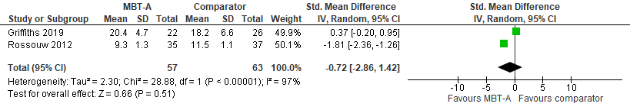
*Rossouw: MFQ; Griffiths: RCADS MD
MD = Mean Difference; MFQ = Mood and Feelings Questionnaire (range 0–26); RCADS MD = Revised Child Anxiety and Depression Scale, Major Depression subscale (range 0–30)

Figure S24 Anxiety scores post-intervention*.
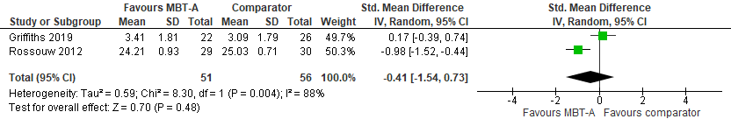
*Rossouw: ECRS anxiety subscale; Griffiths, ECRS revised Child version, anxiety subscale.
ECRS = Experiences in Close Relationships Scale

Table S6. Summary of findings for MBT-A versus TAU.

Outcome | Number of participants  (Number of studies)  ref | Absolute effect  (95% CI) | Certainty of the evidence (GRADE) | Downrating (GRADE) | Comment
Number of participants with self-harm | 133  (2 RCT)  [14, 15] | At post-intervention:  RD= –0.05 (–0.40 to 0.29)  At 3 months post-allocation:  RD=0.00 (–0.20 to 0.21)  At 8–9 months post-allocation:  RD= –0.13 (–0.26 to 0.01) | ⊕  Very low | Imprecision, Inconsistency¹
Suicide attempts | 0  (0 RCT) | - | - | - | Outcome not reported in any study
Completed suicides | 133  (2 RCT) | MBT-A: 0  TAU: 0 | ⊕  Very low | Imprecision² | Metaanalysis not performed because of 0 events
Suicidal ideation | 0  (0 RCT) | - | - | - | Outcome not reported in any study
Depression scores (MFQ and RADSC MD) at post-intervention | 120  (2 RCT)  [14, 15] | SMD= –0.72 (–2.86 to 1.42) | ⊕  Very low | Imprecision³
Anxiety (ECRS and ECRS Child version, subscales for anxiety) at post-intervention | 107  (2 RCT)  [14, 15] | SMD= –0.41 (–1.54 to 0.73) | ⊕  Very low | Imprecision³
General function | 0  (0 RCT) | - | - | - | Outcome not reported in any study
CI = Confidence Interval; ECRS = Experiences in Close Relationships Scale; GRADE = The Grading of Recommendations Assessment, Development and Evaluation; MFQ = Mood and Feelings Questionnaire (range 0–26); RCT = Randomized controlled trial; RD = Risk Difference; SMD = Standardized Mean Difference; TAU = Treatment As Usual
¹ Downrated –2 because of imprecision: non-significant results (CI includes both important benefit and harm), and -1 because of inconsistency: the results of the three studies are substantially different
² Downrated –3 because of imprecision: very few events and few participants
³ Downrated –3 because of imprecision: non-significant results and few participants
Brief interventions

Table S7. Summary of findings for As Safe as Possible (ASAP) versus TAU.
Outcome | Number of participants  (Number of studies)  Reference | Absolute effect  (95% CI) | Certainty of the evidence (GRADE) | Downrating (GRADE) | Comment
Number of participants with NSSI, at 6 months post-allocation | 66  (1 RCT)  [16] | RD=0.01 (–0.23 to 0.24) | ⊕  Very low | Imprecision¹
Number of participants with suicide attempts, at 6 months post-allocation | 66  (1 RCT)  [16] | RD= –0.13 (–0.33 to 0.06) | ⊕  Very low | Imprecision¹
Completed suicides | 0  (0 RCT) | - | - | - | Outcome not reported in study
Number of participants with uicidal ideation (SIQ-JR) | 66  (1 RCT)  [16] | RD= –0.07 (–0.30 to 0.16) | ⊕  Very low | Imprecision¹
Depression | 0  (0 RCT) | - | - | - | Outcome not reported in study
Anxiety | 0  (0 RCT) | - | - | - | Outcome not reported in study
General function | 0  (0 RCT) | - | - | - | Outcome not reported in study
CI = Confidence Interval; GRADE = The Grading of Recommendations Assessment, Development and Evaluation; NSSI = Non-Suicidal Self-Injury; RCT = Randomized controlled trial; RD = Risk Difference; SIQ-JR = Suicidal Ideation Questionnaire, Junior Version (range 0–90); TAU =Treatment As Usual
¹ Downrated –3 because of imprecision: non-significant results, few participants and only one study

Table S8. Summary of findings for Therapeutic Assessment (TA) versus Assessment As Usual (AAU).

Outcome | Number of participants  (Number of studies)  Reference | Absolute effect  (95% CI) | Certainty of the evidence (GRADE) | Downrating (GRADE) | Comment
Number of participants with self-harm leading to hospital admission, at 2 years post-allocation | 70  (1 RCT)  [17] | RD= –0.06 (–0.25 to 0.14) | ⊕  Very low | Imprecision¹ | Outcome not reported at earlier timepoints
Suicide attempts | 0  (0 RCT) | - | - | - | Outcome not reported in study
Completed suicides | 0  (0 RCT) | TA: 0  AAU: 0 | ⊕  Very low | Imprecision¹
Suicidal ideation | 0  (0 RCT) | - | - | - | Outcome not reported in study
Depression | 0  (0 RCT) |  | - |  | Outcome not reported in study
Anxiety | 0  (0 RCT) | - | - | - | Outcome not reported in study
General function, at 3 months post-allocation  (C-GAS) | 70  (1 RCT)  [17] | MD=4.49 (−0.98 to 9.96) | ⊕  Very low | Imprecision¹
AAU = Assessment As Usual; C-GAS = Children's Global Assessment Scale (range 1–100); CI = Confidence Interval; GRADE = The Grading of Recommendations Assessment, Development and Evaluation; MD = Mean Difference; RCT = Randomized controlled trial; RD = Risk Difference
¹ Downrated –3 because of imprecision: non-significant results, few participants an only one study
² Downrated –3 because of imprecision: very few events and few participants

Brief Admission by Self-Referral

Table S9. Summary of findings for Brief Admission by Self-Referral versus TAU.

Outcome | Number of participants  (Number of studies)  Reference | Absolute effect  (95% CI) | Certainty of the evidence (GRADE) | Downrating (GRADE) | Comment
Self-harm | 0  (0 RCT) | - | - | - | Outcome not reported in study
Number of participants with suicide attempts, at 1 year post-allocation | 105  (1 RCT)  [18] | RD= –0.06 (–0.17 to 0.05) | ⊕  Very low | Imprecision¹
Completed suicides | 0  (0 RCT) | - | - | - | Outcome not reported in study
Suicidal ideation | 0  (0 RCT) | - | - | - | Outcome not reported in study
Depression | 0  (0 RCT) | - | - | - | Outcome not reported in study
Anxiety | 0  (0 RCT) | - | - | - | Outcome not reported in study
General function | 0  (0 RCT) | - | - | - | Outcome not reported in study
CI = Confidence Interval; GRADE = The Grading of Recommendations Assessment, Development and Evaluation; RCT = Randomized controlled trial; RD = Risk Difference; TAU =Treatment As Usual
¹ Downrated –3 because of imprecision: non-significant results, few participants an only one study

Group therapy versus TAU

Metaanalyses

Figure S25 Repetition of self-harm* at 6 months post-allocation**.
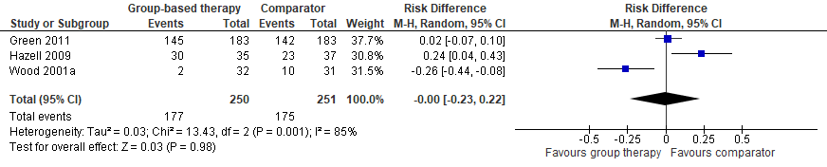
* All studies reported interviewed-assessed self-harm during last 6 months. No study reported SA or NSSI
** Post-intervention analysis was not performed since it was not clear in all studies when the interventions stopped
NSSI = Non-Suicidal Self-Injury; SA = Suicide Attempts

Figure S26 Repetition of self-harm at 12 months post-allocation.
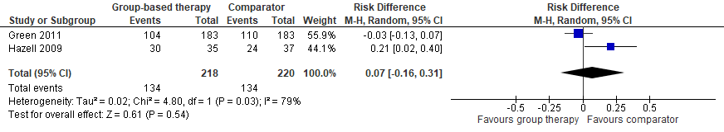

Figure S27 Suicidal ideation scores (SIQ) at 6 months post-allocation.
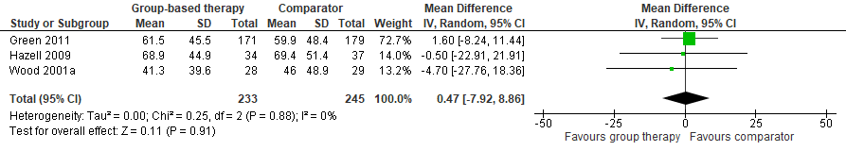
SIQ = Suicidal Ideation Questionnaire (range 0–180)

Figure S28 Suicidal ideation scores (SIQ) at 12 months post-allocation.
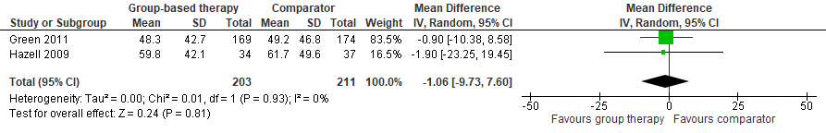
SIQ = Suicidal Ideation Questionnaire (range 0–180)
Figure S29 Depression scores (MFQ) at 6 months.
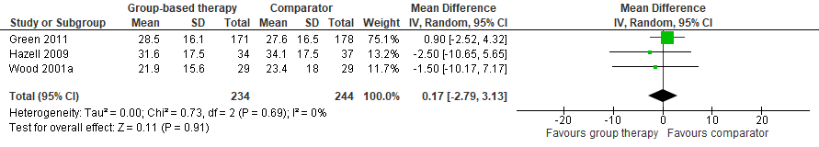
MFQ = Mood and Feelings Questionnaire (range 0–26)

Figure S30 Depression scores (MFQ) at 12 months.
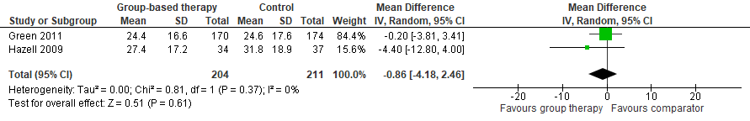
MFQ = Mood and Feelings Questionnaire (range 0–26)

Figure S31 General functioning scores (HoNOSCA) at 6 months.
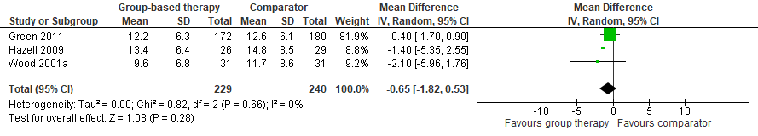
HoNOSCA = Health of the Nation Outcome Scales (range 0–52)

Figure S32 General functioning scores (HoNOSCA) at 12 months.
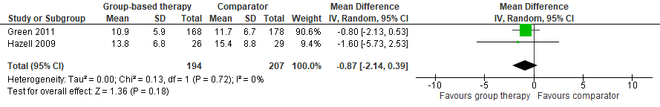
HoNOSCA = Health of the Nation Outcome Scales (range 0–52)

Table S10. Summary of findings for group therapy versus TAU.

Utfallsmått | Antal deltagare  (Antal studier, Studiedesign)  Reference | Effekt  (95% KI) | Resultatets tillförlitlighet | Avdrag |  | Kommentar
Number of participants with self-harm at 6 months post-allocation | 501  (3, RCT)  [19-21] | RD= –0.00 (–0.23 to 0.22) | ⊕yyy  Very low |  | Imprecision,  Inconsistency¹
Number of participants with self-harm at 12 months post-allocation | 438  (2 RCT) | RD=0.07 (–0.16 to 0.31) | ⊕yyy  Very low | Imprecision,  Inconsistency¹
Suicide attempts | 0  (0 RCT) | - | − | - |  | Outcome not reported in any study
Completed suicides | 478  (3 RCT) | Group therapy: 0  TAU: 0 | ⊕yyy  Very low | Imprecision² |  | Metaanalysis not performed because of 0 events
Suicidal ideation scores (SIQ) at 6 months post-allocation | 478  (3 RCT)  [19-21] | MD=0.47 (–7.92 to 8.86) | ⊕⊕⊕y  Moderate | Imprecision and risk of bias³ |  | Group therapy probably results in little to no difference
Suicidal ideation scores (SIQ) at 12 months post-allocation | 414  (2 RCT)  [19, 20] | MD=–1.06 (–9.73 to 7.60) | ⊕⊕⊕y  Moderate | Imprecision and risk of bias³ |  | Group therapy probably results in little to no difference
Depression scores (MFQ) at 6 months post-allocation | 478  (3 RCT)  [19-21] | MD=0.17 (–2.79 to 3.13) | ⊕yyy  Very low | Imprecision⁴
Depression scores (MFQ) at 12 months post-allocation | 415  (2 RCT)  [19, 20] | MD=0.86 (–4.18 to 2.46) | ⊕yyy  Very low | Imprecision⁴
Anxiety | 0  (0 RCT) | - | - | - |  | Outcome not reported in any study
General function scores (HoNOSCA) at 6 months post-allocation | 469  (3 RCT)  [19-21] | MD= –0.65 (–1.82 to 0.53) | ⊕yyy  Very low | Imprecision⁴
General function scores (HoNOSCA) at 12 months post-allocation | 401  (2 RCT)  [19, 20] | MD= –0.87 (–2.14 to 0.39) | ⊕yyy  Very low | Imprecision⁴
CI = Confidence Interval; GRADE = The Grading of Recommendations Assessment, Development and Evaluation; HoNOSCA = Health of the Nation Outcome Scales (range 0–52); MD = Mean Difference; MFQ = Mood and Feelings Questionnaire (range 0–26); RCT = Randomized controlled trial; RD = Risk Difference; SIQ = Suicidal Ideation Questionnaire (range 0–180); TAU =Treatment As Usual
¹ Downrated –2 because of imprecision: CI includes both considerable benefit and harm, and -1 because of inconsistency: the results of the three studies are very different
² Downrated –3 because of imprecision: very few events Downrated –2 because of imprecision: CI includes both important benefit and harm, and -1 because of inconsistency: the results of the three studies are very different
³ Downrated -1 because of precision: few participants; and risk of bias: some concerns regarding randomization and reporting
⁴ Downrated –3 because of imprecision: non-significant results and few participants

Family therapy

Table S11. Summary of findings for systemic family therapy versus TAU.
Outcome | Number of participants  (Number of studies)  References | Effect  (95% CI) | Certainty of the evidence (GRADE) | Downrating (GRADE) | Comment
Number of participants with self-harm, at post-treatment | 0  (0 RCT) | - | - | - | Outcome only reported at later follow-up
Number of participants with self-harm, at follow-up | 832  (1 RCT)  [22-24] | At 12 months post-allocation:  RD=0.04 (–0.02 to 0.10)  At 3 years post-allocation:  RD=0.01 (–0.06 to 0.07) | ⊕⊕  Low | Imprecision¹ | Evidence suggests family therapy results in little to no difference
Suicide attempts | 0  (0 RCT) | - | - | - | Outcome not reported in study
Completed suicides, at 3 years follow-up | 832  (1 RCT)  [24] | FT: 1  TAU: 0 | ⊕  Very low | Imprecision² | Meta-analysis not performed because of 0 events
Number of participants with suicidal ideation (BSSI screening), at 12 months post-allocation | 832  (1 RCT)  [22, 23] | OR=0.64 (0.44 to 0.94) | ⊕⊕⊕  Moderate | Risk of bias and imprecision³ | Family therapy probably reduces outcome. Data for calculating RD was not reported in study
Number of participants with suicidal ideation (BSSI screening), at 18 months post-allocation | 832  (1 RCT)  [24] | OR=0.76 (0.49 to 1.16) | ⊕  Very low | Imprecision⁴ | Data for calculating RD was not reported in study
Depression | 832  (1 RCT)  [22-24] | At 12 months post-allocation: MD= –0.6 (–3.1 to 1.9)  At 18 months post-allocation: MD= –1.0 (–3.5 to 1.5) | ⊕  Very low | Imprecision⁴ | Multiple imputation of missing data was used by study authors
Anxiety | 0  (0 RCT) | - | - | - | Outcome not reported in study
General function | 0  (0 RCT) | - | - | - | Outcome not reported in study
BSSI = Beck Scale for Suicide Ideation (range 0–38); CI = Confidence Interval; GRADE = The Grading of Recommendations Assessment, Development and Evaluation; MD = Mean Difference; RCT = Randomized controlled trial; RD = Risk Difference; TAU =Treatment As Usual
¹ Downrated –2 because of precision: few participants (only one study)
² Downrated –3 because of imprecision: very few events and few particiapants (only one study)
³ Downrated –1 because of risk of bias: high attrition rate; and precision: few participants (only one study)
⁴ Downrated –3 because of non-significant results and few participants (only one study)

Table S12. Summary of findings for home-based family therapy versus TAU.
Outcome | Number of participants  (Number of studies)  References | Absolute effect  (95% CI) | Certainty of the evidence (GRADE) | Downrating (GRADE) | Comment
Number of participants with self-harm, at 6 months post-allocation | 162  (1 RCT)  [25] | At 6 months post-allocation:  RD= –0.01 (–0.12 to 0.09) | ⊕  Very low | Imprecision¹
Suicide attempts | 0  (0 RCT) | - | - | - | Outcome not reported in study
Completed suicides | 162  (1 RCT) | FT: 1  TAU: 0 | ⊕  Very low | Imprecision² | Metaanalysis not performed because of very few events
Suicidal ideation (SIQ) | 154  (1 RCT) | At 2 months post-allocation: MD= –3.40 (–19.18 to 12.38)  At 6 months post-allocation: MD= –5.10 (–17.37 to 7.17) | ⊕  Very low | Imprecision¹
Depression, diagnosis of major depression | 162  (1 RCT) | At 2 months post-allocation: RD=0.05 (–0.09 to 0.18)  At 6 months post-allocation: RD= –0.08 (–0.20 to 0.04) | ⊕  Very low | Imprecision¹ | Clinical diagnosis of depression according to DSM-IV
Anxiety | 0  (0 RCT) | - | - | - | Outcome not reported in study
General function | 0  (0 RCT) | - | - | - | Outcome not reported in study
CI = Confidence Interval; GRADE = The Grading of Recommendations Assessment, Development and Evaluation; MD = Mean Difference; RCT = Randomized controlled trial; RD = Risk Difference; SIQ = Suicidal Ideation Questionnaire (range 0–180); TAU =Treatment As Usual
¹ Downrated –3 because of non-significant results and few participants
² Downrated –3 because of imprecision: very few events

References
1. Asarnow JR, Hughes JL, Babeva KN, Sugar CA. Cognitive-Behavioral Family Treatment for Suicide Attempt Prevention: A Randomized Controlled Trial. J Am Acad Child Adolesc Psychiatry. 2017;56(6):506-14. Available from: https://doi.org/10.1016/j.jaac.2017.03.015.
2. Donaldson D, Spirito A, Esposito-Smythers C. Treatment for adolescents following a suicide attempt: results of a pilot trial. J Am Acad Child Adolesc Psychiatry. 2005;44(2):113-20. Available from: https://doi.org/10.1097/00004583-200502000-00003.
3. Duarte-Velez Y, Jimenez-Colon G, Jones RN, Spirito A. Socio-Cognitive Behavioral Therapy for Latinx Adolescent with Suicidal Behaviors: A Pilot Randomized Trial. Child Psychiatry Hum Dev. 2022. Available from: https://doi.org/10.1007/s10578-022-01439-z.
4. Esposito-Smythers C, Wolff JC, Liu RT, Hunt JI, Adams L, Kim K, et al. Family-focused cognitive behavioral treatment for depressed adolescents in suicidal crisis with co-occurring risk factors: a randomized trial. J Child Psychol Psychiatry. 2019;60(10):1133-41. Available from: https://doi.org/10.1111/jcpp.13095.
5. Kaess M, Edinger A, Fischer-Waldschmidt G, Parzer P, Brunner R, Resch F. Effectiveness of a brief psychotherapeutic intervention compared with treatment as usual for adolescent nonsuicidal self-injury: a single-centre, randomised controlled trial. Eur Child Adolesc Psychiatry. 2020;29(6):881-91. Available from: https://doi.org/10.1007/s00787-019-01399-1.
6. Rockstroh F, Edinger A, Josi J, Fischer-Waldschmidt G, Brunner R, Resch F, Kaess M. Brief Psychotherapeutic Intervention Compared with Treatment as Usual for Adolescents with Nonsuicidal Self-Injury: Outcomes over a 2-4-Year Follow-Up. Psychother Psychosom. 2023;92(4):243-54. Available from: https://doi.org/10.1159/000531092.
7. McCauley E, Berk MS, Asarnow JR, Adrian M, Cohen J, Korslund K, et al. Efficacy of dialectical behavior therapy for adolescents at high risk for suicide a randomized clinical trial. JAMA Psychiatry. 2018;75(8):777-85. Available from: https://doi.org/10.1001/jamapsychiatry.2018.1109.
8. Mehlum L, Tormoen AJ, Ramberg M, Haga E, Diep LM, Laberg S, et al. Dialectical behavior therapy for adolescents with repeated suicidal and self-harming behavior: a randomized trial. J Am Acad Child Adolesc Psychiatry. 2014;53(10):1082-91. Available from: https://doi.org/10.1016/j.jaac.2014.07.003.
9. Santamarina-Perez P, Mendez I, Singh MK, Berk M, Picado M, Font E, et al. Adapted Dialectical Behavior Therapy for Adolescents with a High Risk of Suicide in a Community Clinic: A Pragmatic Randomized Controlled Trial. Suicide Life Threat Behav. 2020;50(3):652-67. Available from: https://doi.org/10.1111/sltb.12612.
10. Mehlum L, Ramberg M, Tormoen AJ, Haga E, Diep LM, Stanley BH, et al. Dialectical Behavior Therapy Compared With Enhanced Usual Care for Adolescents With Repeated Suicidal and Self-Harming Behavior: Outcomes Over a One-Year Follow-Up. J Am Acad Child Adolesc Psychiatry. 2016;55(4):295-300. Available from: https://doi.org/10.1016/j.jaac.2016.01.005.
11. Mehlum L, Ramleth RK, Tormoen AJ, Haga E, Diep LM, Stanley BH, et al. Long term effectiveness of dialectical behavior therapy versus enhanced usual care for adolescents with self-harming and suicidal behavior. J Child Psychol Psychiatry. 2019;60(10):1112-22. Available from: https://doi.org/10.1111/jcpp.13077.
12. Bjureberg J, Ojala O, Hesser H, Habel H, Sahlin H, Gratz KL, et al. Effect of Internet-Delivered Emotion Regulation Individual Therapy for Adolescents With Nonsuicidal Self-Injury Disorder: A Randomized Clinical Trial. JAMA Netw Open. 2023;6(7):e2322069. Available from: https://doi.org/10.1001/jamanetworkopen.2023.22069.
13. Morthorst B, Olsen MH, Jakobsen JC, Lindschou J, Gluud C, Heinrichsen M, et al. Internet based intervention (Emotion Regulation Individual Therapy for Adolescents) as add-on to treatment as usual versus treatment as usual for non-suicidal self-injury in adolescent outpatients: The TEENS randomised feasibility trial. JCPP Adv. 2022;2(4):e12115. Available from: https://doi.org/10.1002/jcv2.12115.
14. Griffiths H, Duffy F, Duffy L, Brown S, Hockaday H, Eliasson E, et al. Efficacy of Mentalization-based group therapy for adolescents: the results of a pilot randomised controlled trial. BMC Psychiatry. 2019;19(1):167. Available from: https://doi.org/10.1186/s12888-019-2158-8.
15. Rossouw TI, Fonagy P. Mentalization-based treatment for self-harm in adolescents: a randomized controlled trial. J Am Acad Child Adolesc Psychiatry. 2012;51(12):1304-13 e3. Available from: https://doi.org/10.1016/j.jaac.2012.09.018.
16. Kennard BD, Goldstein T, Foxwell AA, McMakin DL, Wolfe K, Biernesser C, et al. As Safe as Possible (ASAP): A Brief App-Supported Inpatient Intervention to Prevent Postdischarge Suicidal Behavior in Hospitalized, Suicidal Adolescents. Am J Psychiatry. 2018;175(9):864-72. Available from: https://doi.org/10.1176/appi.ajp.2018.17101151.
17. Ougrin D, Zundel T, Ng A, Banarsee R, Bottle A, Taylor E. Trial of Therapeutic Assessment in London: randomised controlled trial of Therapeutic Assessment versus standard psychosocial assessment in adolescents presenting with self-harm. Arch Dis Child. 2011;96(2):148-53. Available from: https://doi.org/10.1136/adc.2010.188755.
18. Cotgrove A, Zirinsky L, Black D, Weston D. Secondary prevention of attempted suicide in adolescence. J Adolesc. 1995;18(5):569-77. Available from: https://doi.org/10.1006/jado.1995.1039.
19. Green JM, Wood AJ, Kerfoot MJ, Trainor G, Roberts C, Rothwell J, et al. Group therapy for adolescents with repeated self harm: randomised controlled trial with economic evaluation. BMJ. 2011;342:d682. Available from: https://doi.org/10.1136/bmj.d682.
20. Hazell PL, Martin G, McGill K, Kay T, Wood A, Trainor G, Harrington R. Group therapy for repeated deliberate self-harm in adolescents: failure of replication of a randomized trial. J Am Acad Child Adolesc Psychiatry. 2009;48(6):662-70. Available from: https://doi.org/10.1097/CHI.0b013e3181aOacec.
21. Wood A, Trainor G, Rothwell J, Moore A, Harrington R. Randomized trial of group therapy for repeated deliberate self-harm in adolescents. J Am Acad Child Adolesc Psychiatry. 2001;40(11):1246-53. Available from: https://doi.org/10.1097/00004583-200111000-00003.
22. Cottrell DJ, Wright-Hughes A, Collinson M, Boston P, Eisler I, Fortune S, et al. Effectiveness of systemic family therapy versus treatment as usual for young people after self-harm: a pragmatic, phase 3, multicentre, randomised controlled trial. Lancet Psychiatry. 2018;5(3):203-16. Available from: https://doi.org/10.1016/S2215-0366(18)30058-0.
23. Cottrell DJ, Wright-Hughes A, Collinson M, Boston P, Eisler I, Fortune S, et al. A pragmatic randomised controlled trial and economic evaluation of family therapy versus treatment as usual for young people seen after second or subsequent episodes of self-harm: the Self-Harm Intervention - Family Therapy (SHIFT) trial. Health Technol Assess. 2018;22(12):1-222. Available from: https://doi.org/10.3310/hta22120.
24. Cottrell DJ, Wright-Hughes A, Eisler I, Fortune S, Green J, House AO, et al. Longer-term effectiveness of systemic family therapy compared with treatment as usual for young people after self-harm: An extended follow up of pragmatic randomised controlled trial. EClinicalMedicine. 2020;18:100246. Available from: https://doi.org/10.1016/j.eclinm.2019.100246.
25. Harrington R, Kerfoot M, Dyer E, McNiven F, Gill J, Harrington V, et al. Randomized Trial of a Home-Based Family Intervention for Children Who Have Deliberately Poisoned Themselves. J Am Acad Child Adolesc Psychiatry. 1998;37(5):512-8. Available from: https://doi.org/10.1016/s0890-8567(14)60001-0.

