Supplement

Neural Responses to Error in Youth: The Impact of Social Context, Anxiety, and Worry

Journal: European Child and Adolescents Psychiatry

Parmis Khosravi*, PhD, Anjali Poe, BA , Eleanor P. Malone, BA, Jessica L Bezek, MS, Marisa L Meyer, MA, Olivia Siegal, BA, Elise M Cardinale, PhD, Katharina Kircanski, PhD, Melissa A Brotman, PhD, PhD, Simone P Haller, DPhil, Daniel S Pine, MD

Corresponding Author:
Parmis Khosravi, Ph.D.
National Institute of Mental Health,
National Institutes of Health
Parmis.khosravi@nih.gov

II. Conflict Processing

 |  | Conflict Processing
 |  | Conflict Processing |  | SCARED |  | EMA
 |  | HV  n = 37 | ANX  n = 41 | HV  n =35 | ANX  n = 41 | HV  n = 21 | ANX  n = 37
 |  | N(%) |  | N(%) |  | N(%)
Demographics
Sex | Female | 21(57) | 28(68) | 20(57) | 28(68) | 13(62) | 26(70)
Sex | Male | 16(43) | 13(32) | 15(43) | 13(32) | 8(38) | 11(30)
Race | White | 14(38) | 29(71) | 12(34) | 29(71) | 7(33) | 26(70)
Race | Black or African American | 10(27) | 2(5) | 10(29) | 2(5) | 6(29) | 1(3)
Race | Asian American | 2(5) | 0 | 2(6) | 0 | 1(5) | 0
Race | Multiple Race | 9(24) | 7(17) | 9(56) | 7(17) | 5(24) | 7(19)
Race | American Indian or Alaskan Native | 0 | 1(2) | 0 | 1(2) | 0 | 1(3)
Race | Not Reported | 2(5) | 2(5) | 2(6) | 2(5) | 2(10) | 2(5)
Ethnicity | Latino or Hispanic | 2(5) | 10(24) | 1(3) | 10(24) | 2(10) | 9(24)
Ethnicity | Not Latino or Hispanic | 34(99) | 30(73) | 33(94) | 30(73) | 18(86) | 27(73)
Ethnicity | Not Reported | 1(3) | 1(2) | 1(3) | 1(2) | 1(5) | 1(3)
Combined Family Income | <$14,999 | 0 | 0 | 0 | 0 | 0 | 0
Combined Family Income | $15,000 - $24,999 | 2(5) | 0 | 2(6) | 0 | 0 | 0
Combined Family Income | $25,000 - $39,999 | 2(5) | 0 | 2(6) | 0 | 1(5) | 0
Combined Family Income | $40,000 – 59,999 | 0 | 0 | 0 | 0 | 0 | 0
Combined Family Income | $60,000 – 89,999 | 3(8) | 7(17) | 3(9) | 7(17) | 3(14) | 6(16)
Combined Family Income | $90,000 - $179,999 | 12(32) | 11(27) | 10(29) | 11(27) | 10(48) | 9(24)
Combined Family Income | > $180,000 | 9(24) | 18(44) | 9(56) | 18(44) | 4(19) | 18(49)
Combined Family Income | Unknown | 9(24) | 5(12) | 9(56) | 5(12) | 3(14) | 4(11)
Highest Level of Household Education | < High School | 0 | 1(2) | 0 | 1(2) | 0 | 1(3)
Highest Level of Household Education | High School | 1(3) | 0 | 1(3) | 0 | 1(5) | 0
Highest Level of Household Education | Partial College | 7(19) | 0 | 7(20) | 0 | 5(24) | 0
Highest Level of Household Education | 4-Year College | 8(22) | 7(17) | 8(23) | 7(17) | 5(24) | 6(16)
Highest Level of Household Education | Graduate/professional | 14(38) | 32(78) | 12(34) | 32(78) | 7(33) | 29(78)
Highest Level of Household Education | Unknown | 7(19) | 1(2) | 7(20) | 1(2) | 3(14) | 1(3)
Anxiety Diagnoses | Generalized Anxiety |  | 29(71) |  | 29(71) |  | 27(73)
Anxiety Diagnoses | Social Anxiety |  | 15(37) |  | 15(37) |  | 12(34)
Anxiety Diagnoses | Separation Anxiety |  | 2(5) |  | 2(5) |  | 2(5)
Anxiety Diagnoses | Specific Phobia |  | 10(24) |  | 11(27) |  | 8(22)
Anxiety Diagnoses | Panic disorder |  | 2(5) |  | 2(5) |  | 1(3)
 |  | Mean (SD) |  | Mean (SD) |  | Mean (SD)
 | Age | 14.3(2.8) | 14.0(2.3) | 14.2(2.8) | 14.0(2.3) | 14.4(2.8) | 13.8(2.3)
Individual Differences
 | IQa | 110.3(22.2) | 115.5(13.1) | 109.7(22.6) | 115.2(13.1) | 109.4(27.5) | 115.9(13.5)
Anxiety Severity | SCARED^{b} Child | 6.9(5.9) | 31.9(15.2) | 6.9(6.0) | 31.9(15.2) | 8.0(6.2) | 32.5(15.4)
Anxiety Severity | SCARED^{b} Parent | 3.1(3.8) | 23.3(11.6) | 3.0(3.7) | 23.3(11.6) | 3.2(4.4) | 23.6(11.9)
 | EMA^{c} | 1.2(0.32) | 1.5(0.44) | - | - | 1.2(0.32) | 1.5(0.44)
Task Performance | Reaction Time | 473.7(113.0) | 461.7(64.8) | 476.5(114.5) | 461.7(64.8) | 472.7(94.9) | 463.4(67.6)
Task Performance | Accuracy | 0.9(0.05) | 0.9(0.05) | 0.86(0.05) | 0.86(0.05) | 0.87(0.05) | 0.86(0.05)
Table S5. Sample Characteristics. The sample characteristics are based on the conflict processing (correct responses at incongruent trials – correct responses at congruent trials) analyses with individual difference measures.
Note.; ; ^{d} WASI-II IQ score n = 1 missing, ^{b} SCARED = Screen for Child Anxiety Related Disorders (average reported here are from total scores); ^{c} EMA = Ecological Momentary Assessment; n= 20 missing EMA scores

S4. METHOD
Ecological Momentary Assessment (EMA)
All participants completed at least three days of EMA on a lab-provided or personal smartphone. Participants were prompted three times a day to answer questions about their momentary affect and recent interactions with peers. EMA questions assessed emotions at the time of the prompt and since the last prompt (e.g., “At the time of the beep, I felt worried or scared”, “Since the last beep, I felt worried or scared”). The current study focused on worry at the time of beep.

S5. Statistical Analyses
Supplemental analyses examined correct responses between incongruent and congruent trials (i.e., conflict processing) in the peer versus alone context, mirroring the analyses conducted on error contrast. A whole brain group-level analysis using a linear mixed effect model (AFNI’s 3dLMEr, Chen et al., 2013) contrasted. For all the models, the subject was set as the random effect, with age as a covariate. All continuous variables were mean-centered. Between-subjects variables for each model are described below. Whole-brain analyses were conducted using a whole brain gray matter mask with voxels where at least 90% of participants had a signal (k= 56). The voxel wise threshold was set to 2-sided, p < .005, with multiple testing corrections at a = .05 using the Monte Carlo cluster size simulation with a Gaussian plus monoexponential spatial autocorrelation function to estimate smoothness (AFNI’s 3dClustSim -acf flag). Based on these parameters, cluster sizes k > 56 were considered significant. The mean activity values for each significant clusters were extracted and use in exploratory post-hoc analyses using R (v. 4.3.1, R Core Team, 2023). All reported associations are from these exploratory post-hoc analyses, which were two-sided test with no additional correction.

fMRI Model 1. To examine how social context impacted conflict processing, a whole-brain group-level LME model (n = 78) was performed on conflict processing (incongruent correct, congruent correct) with social context (peer, alone) as a within-subjects categorical variable.

fMRI Model 2. The impact of anxiety symptoms severity was examined using the child and parent combined averaged total scores from the SCARED questionnaire (SCARED–composite). A whole brain group-level LME model (n = 76) was performed on conflict processing with social context as a within-subjects categorical variable and SCARED composite score as a between-subjects continuous variable

fMRI Model 3. The impact of being worried at the moment was examined using the average rating from the EMA’s momentary worried item (EMA–worried). A whole brain group-level LME model (n = 58) was performed on conflict processing with social context as a within-subjects categorical variable and EMA–worried as a between-subjects continuous variable.

Behavioral Analyses. Trials with reaction times shorter than 150 milliseconds and three standard deviations (SD) above the mean were excluded from the analysis. Studies suggest that trials with short reaction times tend to be faster than standard motor response times, representing anticipatory responses (Ulrich & Miller, 1994; Wühr & Heuer, 2017).

Separate sets of LME models were run for reaction times and accuracy (percent correct trials), including social context (peer, alone) and trial types (congruent, incongruent) as within-subjects variables while SCARED–composite and EMA–worried were entered as continuous between-subjects variables. Additionally, a comparable model to the fMRI analysis was conducted examining error contrast (calculated by subtracting incongruent commission error trials from incongruent correct trials) for both accuracy (accuracy-error) and reaction times (RT-error). The models included accuracy-error and social context as within subject variables while SCARED–composite and EMA–worried were entered as continuous between-subjects variables. A comparable model was run for RT-error.

S6. RESULTS
Significant clusters for conflict processing appear in Table S6.

fMRI Model 1. While no significant conflict-by-social context interactions arose, five clusters reflected the main effect of conflict processing (incongruent error, incongruent correct). Additionally, 20 clusters reflected the main effect of social context (peer, alone). In the peer relative to alone context, decreased activity manifested in regions such as left precuneus, left middle & posterior cingulate cortex (t (309) = -4.28, p < .0001, Figure S2A). Further, there was an increased activity during the peer compared to alone context in regions such left amygdala and insula (t(309) = - 5.81, p < .0001, Fig S4B)

fMRI Model 2. The conflict-by-social context-by-SCARED-composite model did not reveal any significant results.

fMRI Model 3. While no conflict-by-social context-by-EMA-worried interaction arose, three clusters reflected a significant social context-by-EMA-worried interaction. Higher worry related to increased activity during the peer compared to alone context in the left middle frontal gyrus (t(227) =3.50, p = .0.

k | CM RL | CM AP | CM IS | Mean | SEM | t | p | Region
Conflict Processing
636 | -27.6 | 62.9 | 48.8 | 15.35 | 0.17 | 3.97 | < .0001 | R Superior Parietal Lobule; R Superior Occipital Gyrus;  R Angular Gyrus
395 | -45.1 | 74.6 | -6.5 | 15.61 | 0.22 | 3.07 | < .0001 | R Inferior Occipital Gyrus; R Inferior Temporal Gyrus;  R Fusiform Gyrus; R Lingual Gyrus
211 | 43.3 | 82.9 | -3.6 | 14.26 | 0.19 | 2.56 | < .0001 | L Inferior Occipital Gyrus; L Middle Occipital Gyrus;  L Fusiform Gyrus
193 | 25.3 | 63.6 | 57.9 | 14.60 | 0.25 | 3.40 | .001 | L Superior Parietal Lobule
126 | 2.8 | 70.6 | -15.2 | 13.67 | 0.24 | 3.23 | < .0001 | L Cerebellum (VI); Cerebellar Vermis (6); L Cerebellum (Crus_1); Cerebellar Vermis (7); L Cerebellum (Crus_2)
Main Effect of Social Context
785 | 9.5 | 80.4 | -13.6 | 3.72 | 0.02 | 4.59 | < .0001 | L Cerebellum (Crus_1, Crus_2, V1); Lingual Gyrus
353 | -47.4 | 23.4 | 32.2 | -3.46 | 0.03 | -4.28 | < .0001 | R SupraMarginal Gyrus; R Postcentral Gyrus
269 | 28.2 | 6.1 | -10.8 | -3.61 | 0.04 | -5.83 | < .0001 | L Amygdala; L Hippocampus; L Putamen; L Pallidum; L Insula Lobe
238 | -27.9 | 9.6 | -7.7 | -3.58 | 0.04 | -6.23 | < .0001 | R Hippocampus; R Amygdala; R Putamen; R Pallidum
238 | -59.9 | 12.3 | 9.6 | -3.51 | 0.03 | -4.31 | < .0001 | R Superior Temporal Gyrus; R Rolandic Operculum;  R Heschls Gyrus; R Postcentral Gyrus
183 | 56.1 | 9.8 | -6 | -3.47 | 0.04 | -5.43 | < .0001 | L Middle Temporal Gyrus; L Superior Temporal Gyrus
180 | 5.9 | -58.6 | -8.3 | -3.58 | 0.05 | -4.45 | < .0001 | L Mid Orbital Gyrus; L Superior Orbital Gyrus;  L Superior Medial Gyrus; L Anterior Cingulate Cortex
168 | 7.1 | 50.6 | 39.4 | -3.53 | 0.05 | -4.28 | < .0001 | L Precuneus; L Middle Cingulate Cortex;  L Posterior Cingulate Cortex
148 | 5.7 | -57 | 24.2 | -3.34 | 0.03 | -3.76 | < .001 | L Superior Medial Gyrus; L Superior Frontal Gyrus
113 | 28.1 | -28.7 | -13.2 | -3.44 | 0.05 | -4.83 | < .0001 | L Inferior Frontal Gyrus (p. Orbitalis); L Middle Orbital Gyrus; L Superior Orbital Gyrus; L Insula Lobe
110 | -30.4 | 58.7 | 54.8 | 3.31 | 0.04 | 2.94 | .004 | R Superior Parietal Lobule; R Angular Gyrus; R Inferior Parietal Lobule
108 | -1.1 | 56.7 | -19 | -3.37 | 0.05 | -5.26 | < .0001 | Cerebellar Vermis (8, 6, 9, 4/5, 7, 10); L Cerebellum (IV-V); R Cerebellum (IV-V)
96 | 28.2 | 28.3 | 57 | -3.47 | 0.05 | -3.58 | < .001 | L Postcentral Gyrus; L Precentral Gyrus
90 | -31.8 | -32.9 | -13.4 | -3.46 | 0.06 | -4.25 | < .0001 | R Inferior Frontal Gyrus (p. Orbitalis); R Middle Orbital Gyrus; R Superior Orbital Gyrus
90 | 44.6 | 16.1 | 38.1 | -3.48 | 0.05 | -3.47 | .001 | L Postcentral Gyrus; L Inferior Parietal Lobule;  L SupraMarginal Gyrus
68 | 1.6 | 55.6 | -38 | 3.42 | 0.05 | 4.92 | < .0001 | L Cerebellum (IX); R Cerebellum (IX); Cerebellar Vermis (9); L Cerebellum (VIII)
59 | 6.4 | 5 | -10.2 | -3.39 | 0.06 | -5.42 | < .0001 | L Hippocampus; L ParaHippocampal Gyrus; L Amygdala
58 | 12.4 | 39.9 | -17.4 | 3.65 | 0.08 | 4.67 | < .0001 | L Cerebellum (IV-V, III); L Fusiform Gyrus
58 | -52 | 64.2 | 38.1 | -3.52 | 0.08 | -4.16 | < .0001 | R Angular Gyrus; R Inferior Parietal Lobule
58 | 48.3 | 70.2 | 40.3 | -3.59 | 0.09 | -4.25 | < .0001 | L Middle Occipital Gyrus; L Angular Gyrus
Social Context X EMA-worried
109 | 26.1 | -53.4 | 22.8 | 15.02 | 0.35 | 3.50 | .001 | L Middle Frontal Gyrus; L Superior Frontal Gyrus
59 | -51.7 | -29.5 | 14.7 | 14.0 | 0.37 | 3.47 | .001 | R Inferior Frontal Gyrus (p. Triangularis); R Middle Frontal Gyrus
56 | 1 | -4.6 | 35.9 | 14.61 | 0.64 | 4.80 | .001 | L Middle Cingulate Cortex; R Middle Cingulate Cortex; L SMA; R SMA
Table S6. Significant Association of Neural Activity with Main Effect of Conflict Processing, and Context and Interaction Between Context with EMA-worried. Anatomical locations are based on Eickhoff-Zilles macro labels from N27 (MNI space); K = voxel size of cluster, L = Left, R = Right, CM = Center Mass (Coordinates are in LPI where negative x is left, negative y is posterior, and negative z is inferior), RL = Right to Left (x), AP = Anterior to Posterior (y), IS = Inferior to Superior (z)

a.  𝛘²  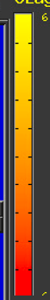  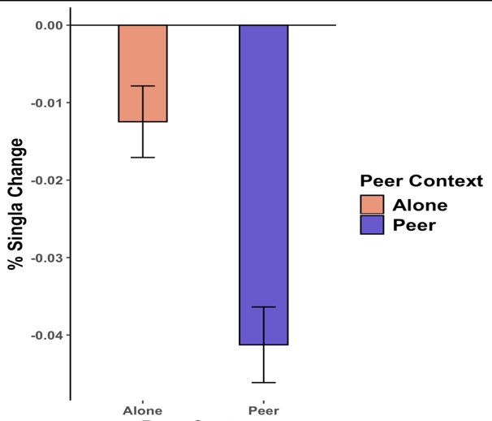  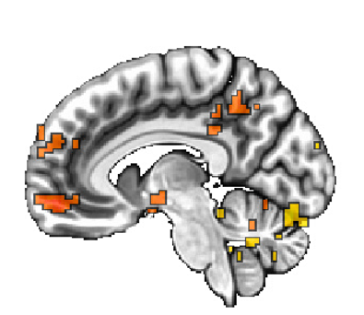  x = 7 | 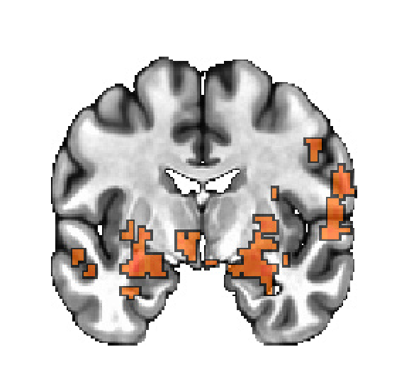  b.  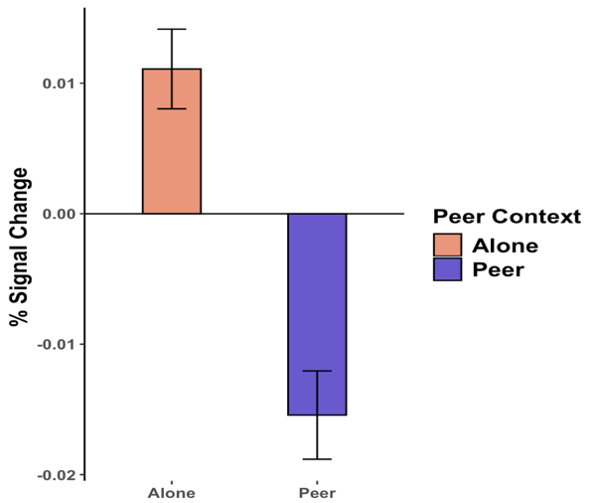  y = 6

Fig.S4 Neural responses to context. Shown are selected significant clusters and their associated plot. (a) left precuneus/ left middle and posterior cingulate cortex and (b) left amygdala/ left hippocampus showing the main effect of context

