Supplement

Neural Responses to Error in Youth: The Impact of Social Context, Anxiety, and Worry

Journal: European Child and Adolescents Psychiatry

Parmis Khosravi*, PhD, Anjali Poe, BA , Eleanor P. Malone, BA, Jessica L Bezek, MS, Marisa L Meyer, MA, Olivia Siegal, BA, Elise M Cardinale, PhD, Katharina Kircanski, PhD, Melissa A Brotman, PhD, PhD, Simone P Haller, DPhil, Daniel S Pine, MD

Corresponding Author:
Parmis Khosravi, Ph.D.
National Institute of Mental Health,
National Institutes of Health
Parmis.khosravi@nih.gov

S1. Statistical Analyses
Reliability Analysis. A subset of participants (n = 59) completed the flanker task twice, the second time only the standard flanker task was completed without the social context. Interclass correlation coefficients (ICC [3,1]) were calculated using AFNI’s 3dICC to examine the reliability between session one and session two of the alone flanker task. Only participants who completed the two sessions ≤ 8 months apart (M = 48.14 +/- 51.26 days) were included in the model. Forty-six participants were included in the analysis for the error contrast (incongruent error > incongruent correct), and 59 participants were included in the conflict processing (incongruent correct > congruent correct). The ICC threshold was set to 0.4.

S2. Results
Reliability
Error contrast. Sixteen [16] clusters passed the ICC value greater than .4 suggesting that these regions are reliably active during error processing. Specifically, incongruent error versus incongruent correct contrast signal in the left middle and inferior frontal gyrus was reliable at ICC greater than .4 across sessions (Figure S2).
Task versus Fixation. One cluster passed the ICC value greater than .4 suggesting that this cluster is active during task processing (Figure S3).
Conflict Processing. In our reliability sample, there were no regions reliable at ICC great than .4 for incongruent versus congruent correct contrast.
0
1
ICC

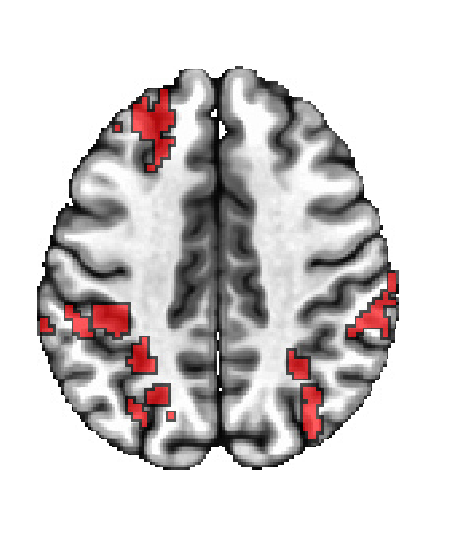  z = 3 | 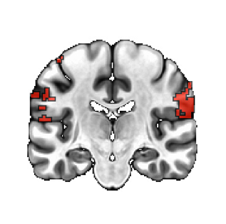  y = 26 | 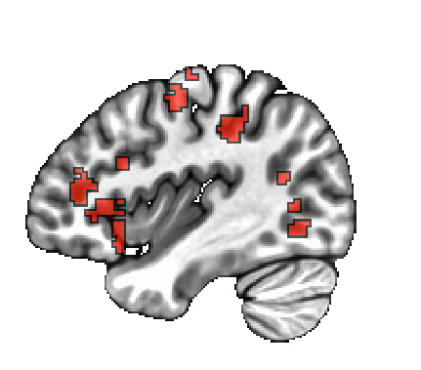  x = 39

Fig.S2 Reliable regions across sessions for error condition at ICC > .4
ICC > .75 = ‘excellent’, .59-.75 = ‘good’, .40-.58 = ‘fair’, and ICC <.40 = ‘poor’ (Cicchetti & Sparrow, 1981).

ICC
1  0  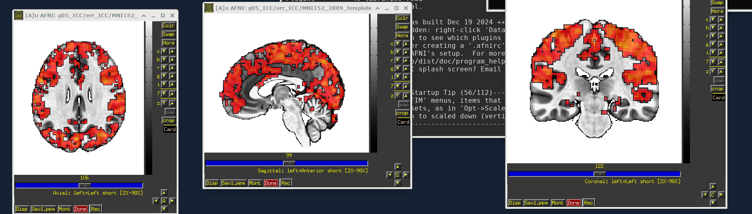  z = 24 | y = 27 | x = -2

Fig.S3 Reliable regions across sessions for task versus fixation at ICC > .4
ICC > .75 = ‘excellent’, .59-.75 = ‘good’, .40-.58 = ‘fair’, and ICC <.40 = ‘poor’ (Cicchetti & Sparrow, 1981).

Table S4. Regions Showing Reliable Clusters across sessions for Error Condition at ICC > .4

K | CM RL | CM AP | CM IS | MI RL | MI AP | MI IS | Mean ICC | SEM ICC | Region
562 | 40.5 | 49.6 | 42.3 | 65 | 54.2 | 23 | 0.48 | 0.00 | L Inferior Parietal Lobule; L Angular Gyrus
417 | -36.2 | -41.8 | 22.4 | -52.5 | -35.8 | 20.5 | 0.46 | 0.00 | R Middle Frontal Gyrus; R Inferior Frontal Gyrus (p._Triangularis)
343 | -59.7 | 26.4 | 30.8 | -57.5 | 19.2 | 30.5 | 0.49 | 0.00 | R SupraMarginal Gyrus; R Postcentral Gyrus
309 | -20.4 | 61.7 | 53.2 | -15 | 54.2 | 70.5 | 0.49 | 0.00 | R Superior Parietal Lobule; R Superior Occipital Gyrus; R Precuneus; R Angular Gyrus
275 | 48.9 | 65.4 | 11.4 | 47.5 | 64.2 | 18 | 0.47 | 0.00 | L Middle Temporal Gyrus; L Middle Occipital Gyrus
261 | 38.7 | -26.7 | 3.3 | 40 | -35.8 | 8 | 0.48 | 0.00 | L Inferior Frontal Gyrus (p. Triangularis); L Insula Lobe
229 | -53.3 | -5.8 | 12.8 | -57.5 | -8.2 | 15.5 | 0.47 | 0.00 | R Rolandic Operculum; R Inferior Frontal Gyrus (p. Opercularis); R Precentral Gyrus; R Postcentral Gyrus
205 | 54.2 | -5.9 | 14.1 | 52.5 | -3.2 | 18 | 0.47 | 0.00 | L Precentral Gyrus; L Inferior Frontal Gyrus (p. Opercularis); L Rolandic Operculum; L Postcentral Gyrus
192 | -39 | -27.8 | -1.9 | -37.5 | -30.8 | 3 | 0.47 | 0.00 | R Inferior Frontal Gyrus (p. Orbitalis); R Insula Lobe; R Inferior Frontal Gyrus (p. Triangularis)
133 | -57.5 | 47.9 | 7.9 | -52.5 | 36.8 | -2 | 0.46 | 0.00 | R Middle Temporal Gyrus; R Superior Temporal Gyrus
125 | 19.1 | 72.3 | 3.7 | 22.5 | 66.8 | 5.5 | 0.48 | 0.01 | L Lingual Gyrus; L Calcarine Gyrus; L Fusiform Gyrus; L Middle Occipital Gyrus
123 | -2.4 | -61 | 7.3 | 5 | -70.8 | 8 | 0.48 | 0.00 | R Superior Medial Gyrus; L Superior Medial Gyrus; R Anterior Cingulate Cortex
117 | -6.1 | -10.8 | 61.1 | -22.5 | -8.2 | 68 | 0.47 | 0.01 | R SMA; L SMA
114 | 36 | 11.2 | 60.8 | 45 | 21.8 | 65.5 | 0.47 | 0.00 | L Precentral Gyrus
99 | 24.4 | -37.8 | 43.4 | 32.5 | -35.8 | 45.5 | 0.47 | 0.01 | L Superior Frontal Gyrus; L Middle Frontal Gyrus
93 | 57.5 | 22.1 | 26.1 | 57.5 | 21.8 | 13 | 0.47 | 0.00 | L SupraMarginal Gyrus; L Postcentral Gyrus; L Superior Temporal Gyrus
62 | -41.5 | 38.4 | 55.4 | -42.5 | 39.2 | 55.5 | 0.48 | 0.01 | R Superior Parietal Lobule; R Postcentral Gyrus; R Inferior Parietal Lobule
57 | -29.9 | 2.9 | 57 | -30 | 1.8 | 60.5 | 0.47 | 0.01 | R Superior Frontal Gyrus; R Middle Frontal Gyrus; R Precentral Gyrus

Note. Anatomical locations are based on Eickhoff-Zilles macro labels from N27 (MNI space); K = voxel size of cluster, L = Left, R = Right, CM = Center Mass (Coordinates are in LPI where negative x is left, negative y is posterior, and negative z is inferior), MI = Maxima Intensity (i.e., Peak) Coordinate; RL = Right to Left (x), AP = Anterior to Posterior (y). IS = Inferior to Superior (z)

