Supplemental Materials

Identifying Prospective Temperament Predictors of Callous-Unemotional Traits Using Machine Learning

European Child & Adolescent Psychiatry

Alexis Broussard, MA, Sarah C. Vogel, PhD, Patrick K. Goh, PhD, Emily R. Perkins, PhD, Yael Paz, PhD, Nicole Huth, BA. Anthony J. Rosellini, PhD, William R. Mills-Koonce, PhD, Michael T. Willoughby, PhD, ^Nicholas J. Wagner, PhD, ^Rebecca Waller, PhD.

Dr. Rebecca Waller is with the Department of Psychology at the University of Pennsylvania, Philadelphia, Pennsylvania. Dr. Nicholas J. Wagner is with the Department of Brain and Psychological Science at Boston University, Boston, Massachusetts.

Correspondence: Dr. Rebecca Waller, Department of Psychology, Stephen A. Levin Building, 425 South University Avenue, Philadelphia, PA, 19104; email: rwaller@sas.upenn.edu; phone: 215-898-9394. Dr. Nicholas Wagner, Department of Psychological and Brain Sciences, Boston University, 64 Cummington Mall, Boston, MA, 02215; Email: njwagner@bu.edu. Phone: 6​1​7​-3​5​3​-7370 (^joint senior authors)

Table of Contents
Table S1. Associations between exclusion status, sample demographics, and outcomes 2
Table S2. Pearson’s correlations between ratings from two visits at one timepoint 3
Table S3. Data dictionary of study variables 4
Table S4. Confirmatory factor analyses of domain-level constructs included in post-hoc regression models predicting CU traits, CD, and ADHD 0
Table S5. Descriptive statistics for CU traits, CD symptoms, and ADHD symptoms 0
Table S6. Model results across full and RFE models and t-tests reporting no significant differences in performance 1
Table S7. Pairwise correlations between predictors and outcomes 2
Table S8. Variable importance values from full and RFE models predicting CU traits 0
Table S9. Variable importance values from full and RFE models predicting CD symptoms 1
Figure S1. Top predictors of original CU traits scores and residualized CU traits scores 2
Figure S2. Example of a decision tree from the random forest model predicting CU traits. 3

Table S1. Associations between exclusion status, sample demographics, and outcomes
 | X² or t | p
Race | .08 | .78
Sex | .24 | .62
Site | 2.02 | .16
Income-to-needs-ratio | -.79 | .43
CU Traits | 1.92 | .06
CD symptoms | .95 | .35
ADHD symptoms | .41 | .35

Note. Sites included North Carolina and Pennsylvania.

Table S2. Pearson’s correlations between ratings from two visits at one timepoint
 | Ages
 | 6 months (IBR) |  | 24 months (IBR) |  | 35 months (OCTS)
Variable Pairs | r | p | r | p | r | p
Attention (Visit A – B) | .53 | < .001 | .59 | < .001
Gross movement/Activity (Visit A – B) | .60 | < .001 | .59 | < .001 | .58 | < .001
Irritability (Visit A – B) | .35 | < .001 | .50 | < .001
Responsiveness to persons (Visit A – B) | .51 | < .001 | .58 | < .001
Responsiveness to examiner (Visit A – B) | .53 | < .001 | .67 | < .001 | .60 | < .001
Responsiveness to caregiver (Visit A – B) | .58 | < .001 | .56 | < .001
Reaction to new/strange (Visit A – B) | .43 | < .001 | .55 | < .001 | .60 | < .001
Happiness/Positive Affect (Visit A – B) | .45 | < .001 | .56 | < .001 | .55 | < .001
Frustration (Visit A – B) |  |  |  |  | .64 | < .001
Persistence (Visit A – B) |  |  |  |  | .61 | < .001
Note. IBR = Infant Behavior Record. OCTS = Observation of Child Temperament Scale. For 6-, 24-, and 35-month data, there were two visits (A and B) and data was collected from two interviewers at each visit. However, there was only one visit at 15 and 48 months, and data was collected at that visit from two interviewers. Only intercorrelations between ratings where two visits were completed are shown.

Table S3. Data dictionary of study variables

Measure | Variable Name | ICC | Variable Description
Inventory of Callous-Unemotional Traits (ICU)¹ | cu_var_numeric |  | ICU scores
Disruptive Behavior Disorder Rating Scale (DBDRS)² | cd_var_numeric |  | Conduct disorder symptoms
Diagnostic and Statistical Manual of Mental Disorders-IV(DSM-IV-TR)³ | ADHD_var_numeric |  | ADHD symptoms
The Mask Task⁴ | LTrctM_comp_6, _15, _24 |  | Fear reactivity to mask at 6,15,24 months
Infant Behavior Record (IBR)⁵ | IBRResp_psn_6, _15, _24 | .54 - .61 | Responsiveness to persons at 6,15,24 months
Infant Behavior Record (IBR)⁵ | IBRResp_exmr_6, _15, _24 | .59 - .82 | Responsiveness to examiner at 6,15,24 months
Infant Behavior Record (IBR)⁵ | IBRResp_cgr_6, _15, _24 | .50 - .72 | Responsiveness to caregiver at 6, 15, 24 months
Infant Behavior Record (IBR)⁵ | IBRrct_new_6, _15, _24 | .53 - .74 | Reaction to new/strange at 6, 15, 24 months
Infant Behavior Record (IBR)⁵ | IBRAttn_6, _15, _24 | .71 - .82 | Attention at 6, 15, 24 months
Infant Behavior Record (IBR)⁵ | IBRGmov_6, _15, _24 | .67 - .74 | Gross movement at 6, 15, 24 months
Infant Behavior Record (IBR)⁵ | IBRIrit_6, _15, _24 | .73 - .79 | Irritability at 6, 15, 24 months
Infant Behavior Record (IBR)⁵ | IBRHapp_6, _15, _24 | .66 - .83 | Happiness at 6, 15, 24 months
Observation of Child Temperament Scale (OCTS)⁵ | OCT_new_psn_35, _48 | .68 - .73 | Responsiveness to examiner at 35, 48 months
Observation of Child Temperament Scale (OCTS)⁵ | OCT_act_35, _48 | .68 - .70 | Activity at 35, 48 months
Observation of Child Temperament Scale (OCTS)⁵ | OCT_frust_35, _48 | .68 - .80 | Frustration at 35, 48 months
Observation of Child Temperament Scale (OCTS)⁵ | OCT_posaff_35, _48 | .60 - .70 | Positive affect at 35, 48 months
Observation of Child Temperament Scale (OCTS)⁵ | OCT_shyfear_35, _48 | .69 - .81 | Fear to new/strange at 35, 48 months
Observation of Child Temperament Scale (OCTS)⁵ | OCT_tskpers_35, _48 | .71 - .75 | Persistence at 35, 48 months
Note. ICC = Intraclasss Correlation Coefficient.

Table S4. Confirmatory factor analyses of domain-level constructs included in post-hoc regression models predicting CU traits, CD symptoms, and ADHD symptoms

 | CFI | RMSEA | X² | df
Fear | .96 | .04 | 42.50*** | 15
Affiliation | .94 | .06 | 383.80*** | 83
Self -Regulation | .97 | .07 | 23.87*** | 4
Activity | .96 | .07 | 20.56*** | 4
Negative Emotionality | .97 | .05 | 13.85** | 4
Note. ***p < .001, **p < .01, *p < .05. A unidimensional model was created for each domain-level construct, with all within-domain items loading onto a single domain-level factor. Within-domain items were subjected to CFA with robust maximum likelihood estimation. We allowed for within-timepoint correlations between observed indicators of each domain-level construct to account for the shared variance between indicators measured at the same timepoint. The latent factor fear included 8 items indexing fear reactivity and fear to new/strange across 6, 15, 24, 35, and 48 months. After checking modification indices for the unidimensional fear model, fear reactivity at 15 and 24 months were allowed to correlate with each other, along with fear reactivity at 6 and 15 months, to improve model fit. The latent factor affiliation included 16 items indexing responsiveness to persons, examiner, and caregiver as well as happiness/positive affect across 6, 15, 24, 35, and 48 months. After checking modification indices for the unidimensional affiliation model, responsiveness to examiner at 35 and 48 months were allowed to correlate with each other to improve model fit. The latent factor self-regulation included 5 items indexing attention and persistence across 6, 15, 24, 35, and 48 months. After checking modification indices for the unidimensional self-regulation model, persistence at 35 and 48 months were allowed to correlate with each other to improve model fit. The latent factor activity included 5 items indexing gross movement/activity across 6, 15, 24, 35, and 48 months. After checking modification indices for the unidimensional activity model, activity at 35 and 48 months were allowed to correlate with each other to improve model fit. The latent factor negative emotionality included 5 items indexing irritability and frustration across 6, 15, 24, 35, and 48 months. After checking modification indices for the unidimensional negative emotionality model, frustration at 35 and 48 months were allowed to correlate with each other to improve model fit.

Table S5. Descriptive statistics for CU traits, CD symptoms, and ADHD symptoms
 | Mean | SD | Median | Range | Skew | Kurtosis | $$α$$
CU traits | 16.61 | 9.77 | 15 | 0 - 53 | .60 | -.13 | .71
CD symptoms | .23 | .90 | 0 | 0 - 9 | 5.66 | 39.17 | .92
ADHD symptoms | 15.54 | 11.67 | 12.67 | 0 - 57 | 1.01 | 0.73 | .95

Table S6. Model results across full and RFE models and t-tests reporting no significant differences in performance
CU Traits
 | Training Data |  |  |  | Testing Data |  |  |  | Model Differences
 | Full Model (39 features) |  | Post-RFE Model (37 features) |  | Full Model (39 features) |  | Post-RFE Model (37 features) |  | t |  |  | p
mtry | 3 |  | 2
Rsquared | .06 |  | .07 |  | .02 |  | .02 |  | -.75 |  |  | .46
RMSE | 9.65 |  | 9.63 |  | 9.20 |  | 9.17 |  | .17 |  |  | .86
CD Symptoms
 |  | Training Data |  |  |  | Testing Data |  |  |  | Model Differences
 |  | Full Model (39 features) |  | Post-RFE Model (4 features) |  | Full Model (39 features) |  | Post-RFE Model (4 features) |  | t | p
mtry |  | 9 |  | 4
Rsquared |  | .03 |  | .09 |  | .01 |  | .04 |  | -1.89 | .07
RMSE |  | .89 |  | .88 |  | .90 |  | .91 |  | .02 | .98

Note. ***p < .001, **p < .01, *p < .05.

Table S7. Pairwise correlations between predictors and outcomes

Separate excel file attachment.

Note. ***p < .001, **p < .01, *p < .05. See Table S3 for data dictionary of study variables.

Table S8. Variable importance values from full and RFE models predicting CU traits
Full Model (39 features) |  | RFE (37 features) |  | Post-RFE Model (37 features)
Features | Importance | Features | Importance | Features | Importance
OCT_posaff_48 | 100 | OCT_posaff_48 | 8.64083887 | OCT_posaff_48 | 100
OCT_new_psn_48 | 61.48801712 | OCT_frust_48 | 5.82349715 | OCT_tskpers_48 | 92.017364
IBRResp_exmr_24 | 61.38181659 | IBRAttn_24 | 4.68545164 | OCT_frust_48 | 88.3117005
OCT_tskpers_48 | 58.23848663 | IBRHapp_24 | 3.92428362 | OCT_new_psn_48 | 81.2005214
OCT_tskpers_35 | 54.99747519 | OCT_tskpers_48 | 3.78475218 | IBRHapp_24 | 79.552511
IBRResp_psn_15 | 52.71650433 | IBRResp_psn_24 | 3.73810367 | OCT_tskpers_35 | 73.8954521
OCT_frust_48 | 52.11967325 | OCT_tskpers_35 | 3.69494099 | IBRIrit_24 | 72.1362038
IBRResp_psn_24 | 52.10117467 | OCT_act_48 | 3.55406402 | IBRGmov_24 | 7.1613714
IBRAttn_15 | 49.90042914 | OCT_posaff_35 | 3.32054358 | IBRResp_exmr_24 | 67.6526488
IBRHapp_24 | 49.75946378 | OCT_shyfear_48 | 3.19891704 | OCT_posaff_35 | 65.937035
OCT_act_35 | 46.23485874 | IBRIrit_24 | 3.14225688 | IBRAttn_24 | 62.1074801
IBRAttn_24 | 45.54114628 | OCT_new_psn_48 | 3.01435395 | OCT_act_48 | 59.0078614
OCT_posaff_35 | 45.28035201 | OCT_act_35 | 2.94717306 | OCT_act_35 | 55.5857195
OCT_act_48 | 39.19626145 | IBRResp_exmr_24 | 2.6262397 | IBRResp_psn_24 | 54.2783599
OCT_shyfear_48 | 36.57189149 | IBRGmov_24 | 2.56543751 | IBRHapp_15 | 51.2260568
IBRResp_psn_6 | 36.01125441 | IBRResp_psn_15 | 2.19739207 | IBRResp_psn_15 | 49.8646674
IBRGmov_15 | 35.41736578 | IBRrct_new_24 | 2.00138418 | IBRIrit_15 | 46.2080487
IBRrct_new_6 | 32.7160685 | IBRrct_new_6 | 1.86448492 | IBRResp_psn_6 | 43.035897
IBRrct_new_24 | 32.39181218 | IBRGmov_15 | 1.80016661 | IBRrct_new_6 | 42.7009972
IBRIrit_24 | 3.79011606 | IBRResp_exmr_15 | 1.79533541 | OCT_new_psn_35 | 42.3943369
OCT_new_psn_35 | 28.06336775 | IBRHapp_6 | 1.78956739 | IBRAttn_15 | 41.6122544
IBRResp_cgr_24 | 27.1794235 | OCT_new_psn_35 | 1.74650102 | OCT_frust_35 | 39.2907323
IBRHapp_15 | 26.43435803 | IBRAttn_6 | 1.69878942 | IBRrct_new_15 | 39.2852642
LTrctM_comp_6 | 24.74923131 | IBRResp_cgr_15 | 1.65017028 | IBRResp_exmr_15 | 39.1248223
OCT_shyfear_35 | 23.87707073 | IBRGmov_6 | 1.62159393 | IBRResp_cgr_15 | 38.265796
IBRGmov_6 | 23.71075985 | IBRAttn_15 | 1.60937075 | IBRAttn_6 | 35.2085195
IBRrct_new_15 | 23.53091645 | IBRHapp_15 | 1.44860441 | IBRrct_new_24 | 34.6778598
IBRResp_cgr_15 | 23.210404 | IBRIrit_15 | 1.44018737 | IBRResp_exmr_6 | 32.3561777
OCT_frust_35 | 22.55101646 | LTrctM_comp_6 | 1.43242101 | IBRGmov_15 | 26.5558402
IBRResp_exmr_6 | 21.92030911 | IBRResp_exmr_6 | 1.36485309 | IBRResp_cgr_6 | 25.5463968
IBRHapp_6 | 18.49833325 | IBRResp_psn_6 | 1.21085132 | LTrctM_comp_6 | 23.4682958
IBRGmov_24 | 15.85856868 | IBRrct_new_15 | 1.18206371 | OCT_shyfear_48 | 21.3741128
IBRIrit_6 | 14.89158061 | OCT_frust_35 | .82231828 | IBRHapp_6 | 2.4892386
IBRResp_exmr_15 | 14.58538857 | OCT_shyfear_35 | .73419926 | IBRIrit_6 | 16.821555
IBRAttn_6 | 13.79475102 | IBRIrit_6 | .62216673 | LTrctM_comp_24 | 1.854842
LTrctM_comp_15 | 12.16775165 | LTrctM_comp_24 | .48890288 | IBRGmov_6 | 8.00946289
LTrctM_comp_24 | 8.057686741 | IBRResp_cgr_6 | .21542195 | OCT_shyfear_35 | 0
IBRIrit_15 | 6.96736728
IBRResp_cgr_6 | 0
Note. See Table S3 for data dictionary of study variables.

Table S9. Variable importance values from full and RFE models predicting CD symptoms
Note. See Table S3 for data dictionary of study variables.

Full Model (39 features) |  | RFE (4 features) |  | Post-RFE Model (4 features)
Features | Importance | Features | Importance | Features | Importance
IBRAttn_24 | 100 | IBRAttn_24 | 8.79525489 | IBRrct_new_24 | 100
IBRrct_new_24 | 99.80250298 | IBRrct_new_24 | 7.73187688 | IBRAttn_24 | 75.9261373
IBRHapp_24 | 76.10227323 | IBRHapp_24 | 6.73885662 | IBRHapp_24 | 37.9435335
IBRHapp_15 | 75.37794653 | OCT_shyfear_48 | 6.73313361 | OCT_tskpers_48 | 0
OCT_shyfear_48 | 71.13589402
IBRResp_psn_6 | 69.42416839
OCT_act_35 | 69.16451773
IBRIrit_24 | 69.10970223
IBRResp_psn_24 | 66.81145626
OCT_new_psn_35 | 66.06085582
IBRResp_psn_15 | 65.95867221
IBRAttn_15 | 65.32707719
OCT_new_psn_48 | 64.41919642
IBRResp_exmr_24 | 63.18130701
OCT_tskpers_35 | 62.47885358
OCT_frust_35 | 57.60143814
OCT_posaff_48 | 54.59704681
IBRGmov_6 | 54.28452395
OCT_posaff_35 | 51.11114181
IBRrct_new_6 | 5.79420393
OCT_tskpers_48 | 5.50358319
OCT_act_48 | 49.66692343
IBRResp_exmr_6 | 49.59493025
OCT_shyfear_35 | 49.54759255
IBRAttn_6 | 48.04721867
IBRIrit_6 | 47.72815131
IBRrct_new_15 | 46.94522376
IBRHapp_6 | 45.5092704
IBRGmov_15 | 43.57413075
IBRResp_cgr_6 | 32.3371485
OCT_frust_48 | 3.60497743
LTrctM_comp_6 | 3.43087107
IBRGmov_24 | 26.75226359
IBRResp_cgr_15 | 23.95207587
IBRIrit_15 | 2.45950084
LTrctM_comp_24 | 19.74918076
IBRResp_cgr_24 | 16.71864689
LTrctM_comp_15 | 11.89053746
IBRResp_exmr_15 | 0

Figure S1. Top predictors of original CU traits scores and residualized CU traits scores

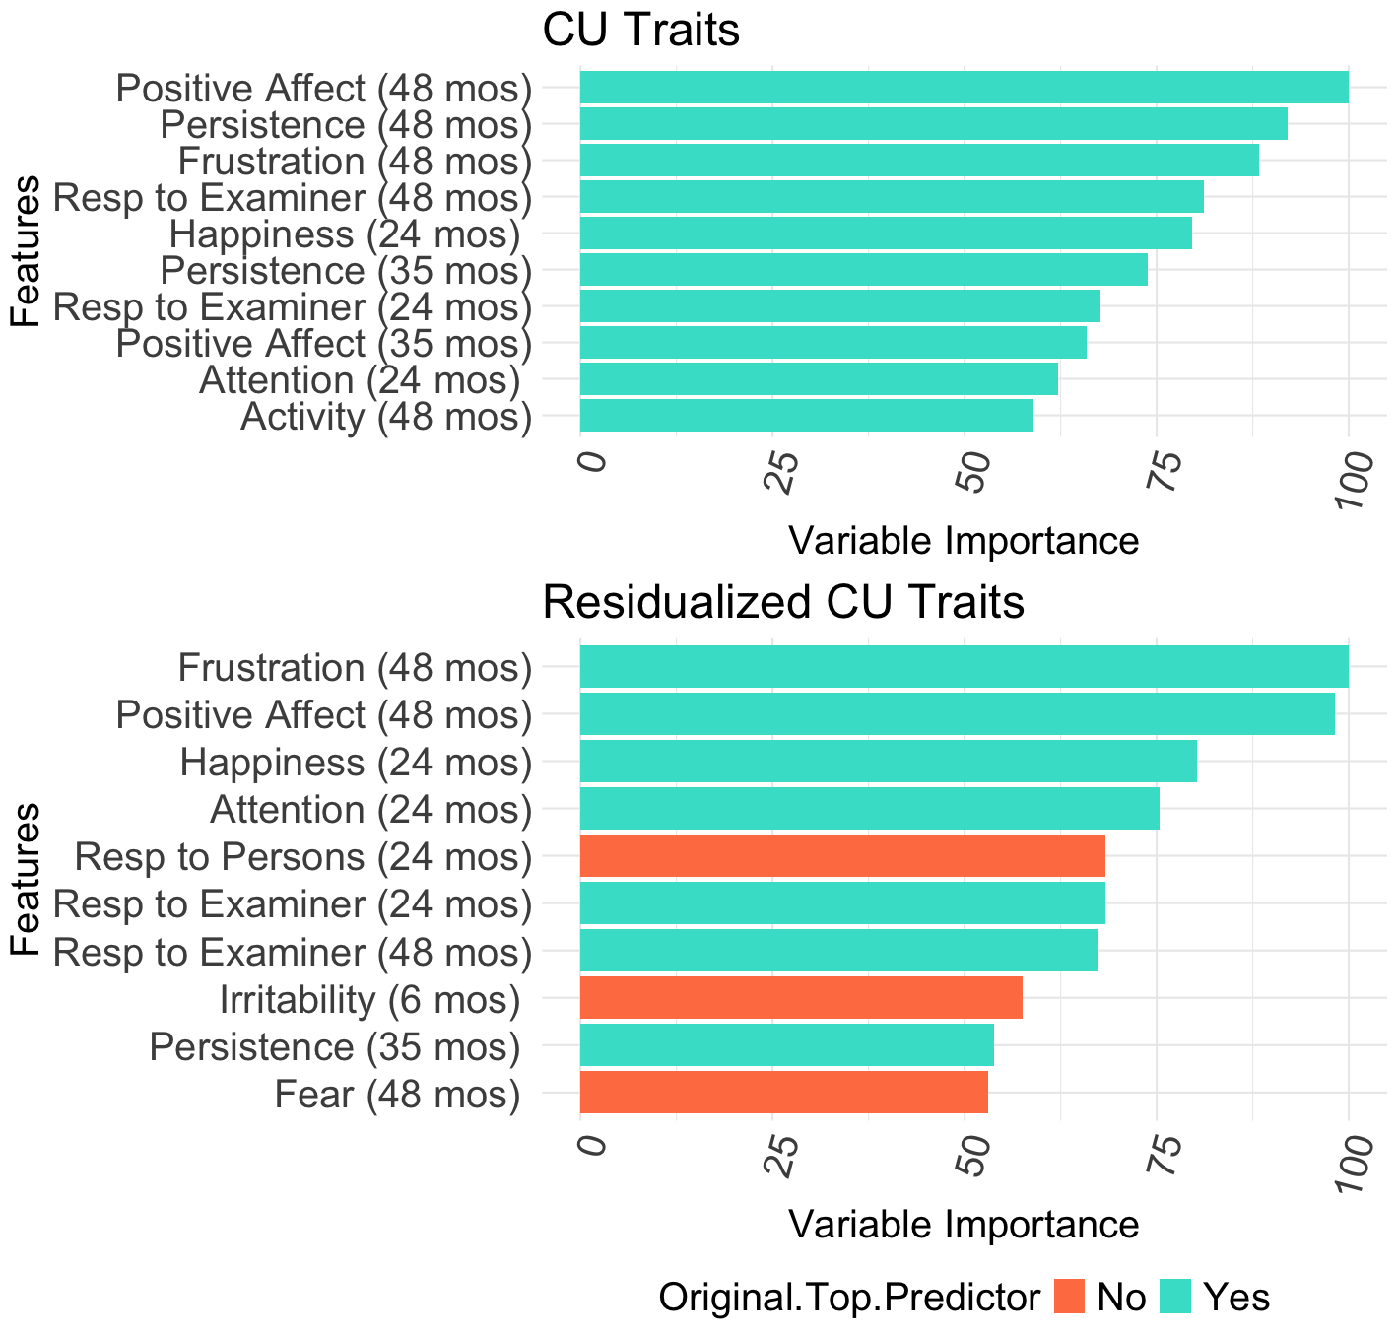Note. Residualized CU traits scores were created by regressing out the variance explained by conduct disorder symptoms. The random forest algorithm used all 39 features to predict residualized CU traits scores, explaining 1% of the variance in the outcome. Figure S1b presents the top 10 predictors of the residualized outcome; 70% (N=7) of the predictors overlap with the original top 10 predictors of CU traits at age 7 (presented in Figure S1a). Only 30% (N=3) are new predictors.
b.

Figure S2. Example of a decision tree from the random forest model predicting CU traits.

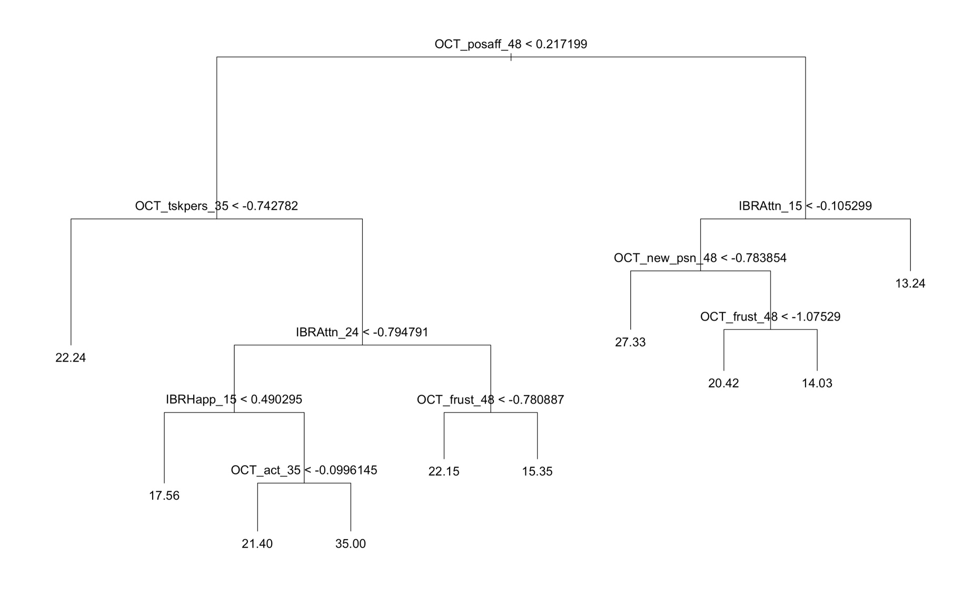
Note. This representative tree models the continuous outcome, CU traits, using the 20 top features and was extracted from a single random forest tree using the R “tree” package.⁶ Each node contains the feature selected for splitting at that node and the value on which it was split represented by a mathematical condition. The cases split to the left daughter node are those for which the condition was met; those in the right node are those for which the condition was not met. The numeric values displayed at each terminal node are the mean values of the outcome variable for participants residing in that terminal node

Supplemental References
1. Frick PJ. Inventory of Callous–Unemotional Traits. Unpublished rating scale: University of
New Orleans; 2004.

2. Pelham WE, Gnagy EM, Greenslade KE, Milich R. Teacher ratings of DSM-III-R symptoms
for the disruptive behavior disorders. J Am Acad Child Adolesc Psychiatry. 1992;31(2):210-218. doi:10.1097/00004583-199203000-00006

3. American Psychiatric Association. Diagnostic and Statistical Manual of Mental Disorders. 4th ed, text rev. Washington, DC: American Psychiatric Association; 2000.
4. Planalp EM, Van Hulle C, Gagne JR, Goldsmith HH. The infant version of the laboratory temperament assessment battery (Lab-TAB): measurement properties and implications for concepts of temperament. Front Psychol. 2017;8:846. doi:10.3389/fpsyg.2017.00846
5. Bayley N. Bayley scales of infant development: manual. New York, NY: The Psychological
Corporation; 1969: 1-178.

6. Ripley B. tree: classification and regression trees. Published online 2023:1.0-44.
doi:1.32614/CRAN.package.tree

