Table of Content
eMethod 1. Protocol deviations from PROSPERO (CRD420251123663)
eMethod 2. Preferred Reporting Items for Systematic Reviews and Meta-Analyses (PRISMA) 2020 checklist
eMethod 3. Detailed Search Strategy
eMethod 4. Dose-equivalence conversions for methylphenidate and amphetamines
eMethod 5. Prior Distributions Used in the Model
eMethod 6. Rationale for spline-based dose-response modelling
eMethod 7. Rationale for responder threshold and sensitivity analyses
eMethod 8. Rationale for the harm endpoint
eMethod 9. Derivation of the link between discrete choice experiment (DCE) preferences and likelihood to be helped or harmed (LHH) thresholds
eResult 1. PRISMA 2020 flow diagram
eResult 2. Excluded studies
eResult 3. Individual study characteristics
eResult 4. Network plots for efficacy
eResult 5. Network plots for dropouts due to side effects
eResult 6. Diagnostic comparison of one-knot and linear models
eResult 7. Complete arm-level outcomes from included studies
eResult 8. Scatter plot of posterior mean residual deviance (resdev) for the unrelated mean effects (UME) and network meta-analysis (NMA) models
eResult 9. Risk of Bias (RoB 2.0) summary across included studies
eResult 10. Meta-regression parameter estimates
eResult 11. Dose-response efficacy curves for methylphenidate and amphetamine in low risk of bias studies
eResult 12. Dose-response efficacy curves for methylphenidate and amphetamine in trials excluding concomitant psychotherapy
eResult 13. Sensitivity analyses of dose-response efficacy curves for methylphenidate and amphetamine: comparison of all trials, low-risk-of-bias trials, and trials excluding concomitant psychotherapy
eResult 14. Dose-response curves for absolute risk reduction with methylphenidate and amphetamine.
eResult 15. Dose-response curves for absolute risk increase with methylphenidate and amphetamine
eResult 16. Posterior mean differences in maximal net clinical benefit between amphetamine and methylphenidate and probability that amphetamine yields greater benefit across risk-preference values
eResult 17. Posterior medians and 95% credible intervals of dose-equivalents (mg) corresponding to maximal net clinical benefit for amphetamine and methylphenidate across risk-preference values
eResult 18. Heatmap of probabilities of optimal target doses across different values across risk-preference values
eResult 19. Posterior mean differences in maximal net clinical benefit between amphetamine and methylphenidate and probability that amphetamine yields greater benefit across risk-preference values (λ), using a 0.4-SD response threshold
eResult 20. Posterior mean differences in maximal net clinical benefit between amphetamine and methylphenidate and probability that amphetamine yields greater benefit across risk-preference values (λ), using a 0.6-SD response threshold
eResult 21. Optimal target dose ranges across risk-preference values, using a 0.4-SD response threshold
eResult 22. Optimal target dose ranges across risk-preference values, using a 0.6-SD response threshold

eMethod 1. Protocol deviations from PROSPERO (CRD420251123663)
1. Scope (population and interventions)
The PROSPERO protocol planned to analyse three age strata separately (children, adolescents, adults) and to conduct model-based dose-response syntheses across both stimulant and non-stimulant oral monotherapies (methylphenidate, amphetamines, atomoxetine, guanfacine, clonidine, bupropion, modafinil, viloxazine) versus placebo or each other. In the present review, we restricted the population to pediatric patients (children and adolescents aged 5-18 years), who were synthesised as a single pediatric population, and adults were not analysed. The intervention scope was also narrowed to stimulants (methylphenidate [MPH] and amphetamines [AMP]) and non-stimulant medications were not included in the dose-response network. This deviation reflects the available randomized evidence, which was dominated by stimulant trials with comparable pharmacodynamics and overlapping dose ranges, whereas non-stimulant data were sparse and used heterogeneous dosing schemes that would have produced unstable network geometry. Because our primary objective was to clarify clinically actionable stimulant dosing in youth, adult and non-stimulant syntheses were deferred to future work.
2. Exposure definition and dose format
The protocol allowed oral monotherapy at various dosages provided that sufficient dose information was available (e.g. fixed-dose arms or mean and standard deviation of the final dose in flexible-dose trials). In the review, we required that trials include at least one fixed-dose treatment arm with MPH or AMP and excluded trials using flexible-dose titration only or combining MPH/AMP with other ADHD medications. This stricter exposure definition reduced reliance on imputed or aggregated flexible-dose information, improved comparability of dosing across formulations, and helped to minimise clinical and statistical heterogeneity in the dose-response network.
3. Minimum treatment duration
The PROSPERO protocol specified a minimum double-blind treatment duration of at least one week. In the review, we accepted trials with a minimum duration of five days, while continuing to exclude single-day classroom observation studies and other single-session designs. This change allowed inclusion of short, rigorously blinded inpatient or laboratory trials with validated symptom outcomes, which are informative for acute treatment effects, while preserving a clear distinction from very short-term studies that are not comparable to clinical treatment courses.
4. Outcome definitions and handling
The protocol planned separate analyses by informant (clinician ratings, teacher/observer ratings, and self-ratings in adults). In practice, to avoid multiple correlated effect estimates from the same randomized comparison, we applied a prespecified hierarchy to select a single symptom outcome per trial: clinician ratings were preferred, followed by teacher ratings, then parent ratings, and only the highest-priority informant available in each study contributed to the dose-response network. All-cause discontinuation (dropout for any reason) was prespecified in PROSPERO as an acceptability outcome, but we did not perform a separate dose-response network analysis for this endpoint and instead focused on discontinuation due to adverse events as the primary tolerability outcome alongside symptom efficacy, because reporting of all-cause discontinuation was heterogeneous and often overlapped with adverse-event-related discontinuation. In addition, changes in systolic and diastolic blood pressure, heart rate, and body weight at approximately 12 weeks were prespecified as additional continuous outcomes but were not synthesised in the present dose-response network because reporting at relevant timepoints was sparse and inconsistent across eligible stimulant trials, and available data did not support a coherent model-based dose-response analysis.
5. Additional analyses and data sources not prespecified
Several exploratory analyses were conducted that were not prespecified in PROSPERO. We restricted analyses to studies judged at low risk of bias using the RoB 2 tool, and repeated analyses after excluding trials with co-administered psychotherapy to isolate pharmacologic effects. We also carried out univariable network meta-regressions on the primary efficacy outcome, examining dosing regimen, study duration (mean-centred), and informant category as potential effect modifiers. These analyses were used to probe between-study heterogeneity and were interpreted as exploratory. In addition, where available, study data extracted in a prior dose-response meta-analysis were incorporated after verification against original reports; this reuse of validated data was not explicitly described in the protocol.
6. Benefit-harm trade-off framework
The PROSPERO protocol specified separate dose-response analyses for efficacy and tolerability but did not prespecify a formal framework to integrate benefit and harm. In the completed review, we added a decision-analytic net clinical benefit (NCB) framework based on the likelihood to be helped or harmed (LHH), defined as the ratio of number needed to harm (NNH) to number needed to treat (NNT). We operationalised NCB as NCB = ARR − λ × ARI, where ARR and ARI represent the absolute probabilities of clinical benefit and harm, respectively, and λ denotes the maximum acceptable risk-benefit trade-off threshold. Using published discrete choice experiments, we mapped λ to risk-tolerant, risk-neutral, and risk-averse preference ranges and, for each λ, identified the dose range that maximised posterior net benefit. This framework translates separate efficacy and adverse-event dose-response surfaces into preference-sensitive dose ranges that better reflect real-world decision making, without changing the underlying efficacy or tolerability estimates.
7. Summary
Overall, deviations from the PROSPERO protocol narrowed the review to the most informative segment of the evidence base and introduced pragmatic adjustments to exposure definition, outcome handling, and exploratory analyses to preserve internal validity and enhance clinical interpretability; these changes represent operational clarifications rather than alterations of the core research question.
eMethod 2. Preferred Reporting Items for Systematic Reviews and Meta-Analyses (PRISMA) 2020 checklist
Section and Topic | Item # | Checklist item | Location where item is reported
TITLE
Title | 1 | Identify the report as a systematic review. | Title
ABSTRACT
Abstract | 2 | See the PRISMA 2020 for Abstracts checklist. | Abstract.
INTRODUCTION
Rationale | 3 | Describe the rationale for the review in the context of existing knowledge. | Introduction, paragraphs 1-3
Objectives | 4 | Provide an explicit statement of the objective(s) or question(s) the review addresses. | Introduction, final paragraph
METHODS
Eligibility criteria | 5 | Specify the inclusion and exclusion criteria for the review and how studies were grouped for the syntheses. | Method, Eligibility Criteria section
Information sources | 6 | Specify all databases, registers, websites, organisations, reference lists and other sources searched or consulted to identify studies. Specify the date when each source was last searched or consulted. | Method, Search Strategy, Selection and Data Extraction section
Search strategy | 7 | Present the full search strategies for all databases, registers and websites, including any filters and limits used. | Method, Search Strategy, Selection and Data Extraction section
Selection process | 8 | Specify the methods used to decide whether a study met the inclusion criteria of the review, including how many reviewers screened each record and each report retrieved, whether they worked independently, and if applicable, details of automation tools used in the process. | Method, Search Strategy... & subsequent paragraph
Data collection process | 9 | Specify the methods used to collect data from reports, including how many reviewers collected data from each report, whether they worked independently, any processes for obtaining or confirming data from study investigators, and if applicable, details of automation tools used in the process. | Method, Search Strategy... & subsequent paragraph
Data items | 10a | List and define all outcomes for which data were sought. Specify whether all results that were compatible with each outcome domain in each study were sought (e.g. for all measures, time points, analyses), and if not, the methods used to decide which results to collect. | Outcome section & Method, Search Strategy... section
Data items | 10b | List and define all other variables for which data were sought (e.g. participant and intervention characteristics, funding sources). Describe any assumptions made about any missing or unclear information. | Method, Search Strategy, Selection and Data Extraction section (last paragraph)
Study risk of bias assessment | 11 | Specify the methods used to assess risk of bias in the included studies, including details of the tool(s) used, how many reviewers assessed each study and whether they worked independently, and if applicable, details of automation tools used in the process. | Method, Search Strategy... & subsequent paragraph
Effect measures | 12 | Specify for each outcome the effect measure(s) (e.g. risk ratio, mean difference) used in the synthesis or presentation of results. | Meta-analytic Process section
Synthesis methods | 13a | Describe the processes used to decide which studies were eligible for each synthesis (e.g. tabulating the study intervention characteristics and comparing against the planned groups for each synthesis (item #5)). | Eligibility Criteria & Meta-analytic Process sections
Synthesis methods | 13b | Describe any methods required to prepare the data for presentation or synthesis, such as handling of missing summary statistics, or data conversions. | Dose Equivalency Conversion section
Synthesis methods | 13c | Describe any methods used to tabulate or visually display results of individual studies and syntheses. | Meta-analytic Process section
Synthesis methods | 13d | Describe any methods used to synthesize results and provide a rationale for the choice(s). If meta-analysis was performed, describe the model(s), method(s) to identify the presence and extent of statistical heterogeneity, and software package(s) used. | Meta-analytic Process section; Benefit-Risk Trade-off Analysis section
Synthesis methods | 13e | Describe any methods used to explore possible causes of heterogeneity among study results (e.g. subgroup analysis, meta-regression). | Meta-analytic Process section
Synthesis methods | 13f | Describe any sensitivity analyses conducted to assess robustness of the synthesized results. | Meta-analytic Process section
Reporting bias assessment | 14 | Describe any methods used to assess risk of bias due to missing results in a synthesis (arising from reporting biases). | NA
Certainty assessment | 15 | Describe any methods used to assess certainty (or confidence) in the body of evidence for an outcome. | NA
RESULTS
Study selection | 16a | Describe the results of the search and selection process, from the number of records identified in the search to the number of studies included in the review, ideally using a flow diagram. | Results, Study Selection and Characteristics section
Study selection | 16b | Cite studies that might appear to meet the inclusion criteria, but which were excluded, and explain why they were excluded. | Results, Study Selection and Characteristics section
Study characteristics | 17 | Cite each included study and present its characteristics. | Results, Study Selection and Characteristics section
Risk of bias in studies | 18 | Present assessments of risk of bias for each included study. | Results, Study Selection and Characteristics section
Results of individual studies | 19 | For all outcomes, present, for each study: (a) summary statistics for each group (where appropriate) and (b) an effect estimate and its precision (e.g. confidence/credible interval), ideally using structured tables or plots. | Results, Study Selection... & Efficacy and Dropout Analysis sections
Results of syntheses | 20a | For each synthesis, briefly summarise the characteristics and risk of bias among contributing studies. | Results, Study Selection... & Efficacy and Dropout Analysis sections
Results of syntheses | 20b | Present results of all statistical syntheses conducted. If meta-analysis was done, present for each the summary estimate and its precision (e.g. confidence/credible interval) and measures of statistical heterogeneity. If comparing groups, describe the direction of the effect. | Efficacy and Dropout Analysis & Net Clinical Benefit Analysis section
Results of syntheses | 20c | Present results of all investigations of possible causes of heterogeneity among study results. | Meta-Regression and Sensitivity Analysis section
Results of syntheses | 20d | Present results of all sensitivity analyses conducted to assess the robustness of the synthesized results. | Efficacy and Dropout Analysis & Meta-Regression and Sensitivity Analysis sections
Reporting biases | 21 | Present assessments of risk of bias due to missing results (arising from reporting biases) for each synthesis assessed. | NA
Certainty of evidence | 22 | Present assessments of certainty (or confidence) in the body of evidence for each outcome assessed. | NA
DISCUSSION
Discussion | 23a | Provide a general interpretation of the results in the context of other evidence. | Discussion section
Discussion | 23b | Discuss any limitations of the evidence included in the review. | Discussion section (final paragraph)
Discussion | 23c | Discuss any limitations of the review processes used. | Discussion section (final paragraph)
Discussion | 23d | Discuss implications of the results for practice, policy, and future research. | Discussion & Conclusion sections
OTHER INFORMATION
Registration and protocol | 24a | Provide registration information for the review, including register name and registration number, or state that the review was not registered. | Method section (first paragraph)
Registration and protocol | 24b | Indicate where the review protocol can be accessed, or state that a protocol was not prepared. | Method section (first paragraph)
Registration and protocol | 24c | Describe and explain any amendments to information provided at registration or in the protocol. | Method section (first paragraph)
Support | 25 | Describe sources of financial or non-financial support for the review, and the role of the funders or sponsors in the review. | Support
Competing interests | 26 | Declare any competing interests of review authors. | Competing interests
Availability of data, code and other materials | 27 | Report which of the following are publicly available and where they can be found: template data collection forms; data extracted from included studies; data used for all analyses; analytic code; any other materials used in the review. | Availability of data, code and other materials

eMethod 3. Detailed Search Strategy
EMBASE
('attention deficit hyperactivity disorder'/exp OR 'adhd':ti,ab,kw OR 'attention-deficit/hyperactivity':ti,ab,kw OR 'attention deficit hyperactiv*':ti,ab,kw OR 'hyperkine*':ti,ab,kw OR (('attention':ti,ab,kw OR 'attentional':ti,ab,kw) AND 'deficit*':ti,ab,kw AND ('disorder*':ti,ab,kw OR 'hyperactiv*':ti,ab,kw)) OR 'inattentive':ti,ab,kw OR 'impulsiv*':ti,ab,kw) AND ('amphetamine derivative'/exp OR 'methylphenidate'/exp OR 'dexmethylphenidate' OR 'lisdexamfetamine dimesylate' OR 'atomoxetine'/exp OR 'guanfacine'/exp OR 'clonidine'/exp OR 'amfebutamone'/exp OR 'modafinil'/exp OR 'viloxazine'/exp OR 'adderall':ti,ab,kw OR 'adderall xr':ti,ab,kw OR 'mixed amphetamine salts':ti,ab,kw OR 'mydayis':ti,ab,kw OR 'dyanavel xr':ti,ab,kw OR 'evekeo':ti,ab,kw OR 'attentin':ti,ab,kw OR 'lisdexamfetamine':ti,ab,kw OR 'vyvanse':ti,ab,kw OR 'elvanse':ti,ab,kw OR 'methylphenidate':ti,ab,kw OR 'ritalin':ti,ab,kw OR 'ritalin la':ti,ab,kw OR 'ritalin sr':ti,ab,kw OR 'concerta':ti,ab,kw OR 'equasym':ti,ab,kw OR 'medikinet':ti,ab,kw OR 'metadate':ti,ab,kw OR 'daytrana':ti,ab,kw OR 'aptensio xr':ti,ab,kw OR 'jornay pm':ti,ab,kw OR 'adhansia xr':ti,ab,kw OR 'quillivant xr':ti,ab,kw OR 'quillichew er':ti,ab,kw OR 'methylin':ti,ab,kw OR 'biphentin':ti,ab,kw OR 'dexmethylphenidate':ti,ab,kw OR 'focalin':ti,ab,kw OR 'focalin xr':ti,ab,kw OR 'atomoxetine':ti,ab,kw OR 'strattera':ti,ab,kw OR 'guanfacine':ti,ab,kw OR 'intuniv':ti,ab,kw OR 'tenex':ti,ab,kw OR 'clonidine':ti,ab,kw OR 'kapvay':ti,ab,kw OR 'catapres':ti,ab,kw OR 'bupropion':ti,ab,kw OR 'wellbutrin':ti,ab,kw OR 'zyban':ti,ab,kw OR 'modafinil':ti,ab,kw OR 'provigil':ti,ab,kw OR 'viloxazine':ti,ab,kw OR 'qelbree':ti,ab,kw) AND ('randomized controlled trial':it OR 'controlled clinical trial':it OR 'randomized':ti,ab,kw OR 'randomised':ti,ab,kw OR 'randomly':ti,ab,kw OR 'placebo':ti,ab,kw OR 'trial':ti,ab,kw OR 'clinical trial (topic)'/de) NOT ('animal'/exp NOT 'human'/exp)
1 'attention deficit hyperactivity disorder'/exp OR (ADHD OR "attention-deficit/hyperactivity" OR "attention deficit hyperactiv*" OR hyperkine* OR ((attention NEAR/2 deficit*) NEAR/3 (disorder* OR hyperactiv*)) OR inattentive OR impulsiv*):ti,ab
2 'amphetamine'/exp OR 'amphetamine derivative'/exp OR 'methylphenidate'/exp OR 'dexmethylphenidate'/exp OR 'lisdexamfetamine'/exp OR 'atomoxetine'/exp OR 'guanfacine'/exp OR 'clonidine'/exp OR 'bupropion'/exp OR 'modafinil'/exp OR 'viloxazine'/exp OR (Adderall OR "Adderall XR" OR "mixed amphetamine salts" OR Mydayis OR "Dyanavel XR" OR Evekeo OR Attentin OR Dexedrine OR Zenzedi OR ProCentra OR Lisdexamfetamine OR Vyvanse OR Elvanse OR Methylphenidate OR Ritalin OR "Ritalin LA" OR "Ritalin SR" OR Concerta OR Equasym OR Medikinet OR Metadate OR Daytrana OR "Aptensio XR" OR "Jornay PM" OR "Adhansia XR" OR "Quillivant XR" OR "QuilliChew ER" OR Methylin OR Biphentin OR Dexmethylphenidate OR Focalin OR "Focalin XR" OR Atomoxetine OR Strattera OR Guanfacine OR Intuniv OR Tenex OR Clonidine OR Kapvay OR Catapres OR Bupropion OR Wellbutrin OR Zyban OR Modafinil OR Provigil OR Viloxazine OR Qelbree):ti,ab
3 (random* OR factorial* OR crossover* OR "cross over" OR cross-over OR placebo* OR (doubl* NEAR/1 blind*) OR (singl* NEAR/1 blind*) OR assign* OR allocat* OR volunteer*):ti,ab
OR 'randomized controlled trial'/exp OR 'randomization'/exp OR 'double blind procedure'/exp OR 'single blind procedure'/exp OR 'crossover procedure'/exp OR 'placebo'/exp OR 'clinical trial'/exp
4 [humans]/lim
5 1 AND 2 AND 4

PubMed
(
"Attention Deficit Disorder with Hyperactivity"[Mesh]
OR ADHD[tiab]
OR "attention-deficit/hyperactivity"[tiab]
OR "attention deficit hyperactiv*"[tiab]
OR hyperkine*[tiab]
OR ((attention[tiab] OR attentional[tiab]) AND deficit*[tiab] AND (disorder*[tiab] OR hyperactiv*[tiab]))
OR inattentive[tiab] OR impulsiv*[tiab]
)
AND
(
"Amphetamines"[Mesh] OR "Methylphenidate"[Mesh]
OR "Dexmethylphenidate"[Supplementary Concept]
OR "Lisdexamfetamine Dimesylate"[Supplementary Concept]
OR "Atomoxetine Hydrochloride"[Mesh]
OR "Guanfacine"[Mesh] OR "Clonidine"[Mesh]
OR "Bupropion"[Mesh] OR "Modafinil"[Mesh]
OR "Viloxazine"[Mesh]
OR Adderall[tiab] OR "Adderall XR"[tiab] OR "mixed amphetamine salts"[tiab]
OR Mydayis[tiab] OR "Dyanavel XR"[tiab] OR Evekeo[tiab] OR Attentin[tiab]
OR Lisdexamfetamine[tiab] OR Vyvanse[tiab] OR Elvanse[tiab]
OR Methylphenidate[tiab] OR Ritalin[tiab] OR "Ritalin LA"[tiab] OR "Ritalin SR"[tiab]
OR Concerta[tiab] OR Equasym[tiab] OR Medikinet[tiab] OR Metadate[tiab]
OR Daytrana[tiab] OR "Aptensio XR"[tiab] OR "Jornay PM"[tiab]
OR "Adhansia XR"[tiab] OR "Quillivant XR"[tiab] OR "QuilliChew ER"[tiab]
OR Methylin[tiab] OR Biphentin[tiab]
OR Dexmethylphenidate[tiab] OR "Focalin"[tiab] OR "Focalin XR"[tiab]
OR Atomoxetine[tiab] OR Strattera[tiab]
OR Guanfacine[tiab] OR Intuniv[tiab] OR Tenex[tiab]
OR Clonidine[tiab] OR Kapvay[tiab] OR Catapres[tiab]
OR Bupropion[tiab] OR Wellbutrin[tiab] OR Zyban[tiab]
OR Modafinil[tiab] OR Provigil[tiab]
OR Viloxazine[tiab] OR Qelbree[tiab]
)
AND
(
randomized controlled trial[pt] OR controlled clinical trial[pt]
OR randomized[tiab] OR randomised[tiab] OR randomly[tiab]
OR placebo[tiab] OR trial[tiab]
OR clinical trials as topic[mesh:noexp]
)
NOT (animals[mh] NOT humans[mh])

Cochrane Library（CENTRAL）
#1 MeSH descriptor: [Attention Deficit Disorder with Hyperactivity] explode all trees
#2 (ADHD OR hkd OR addh OR hyperkine* OR "attention deficit*" OR "attention-deficit/hyperactivity"
OR hyper-activ* OR hyperactiv* OR overactive OR inattentive OR impulsiv*):ti,ab,kw
#3 MeSH descriptor: [Amphetamines] explode all trees
#4 MeSH descriptor: [Methylphenidate] explode all trees
#5 MeSH descriptor: [Dexmethylphenidate Hydrochloride] explode all trees
#6 MeSH descriptor: [Lisdexamfetamine Dimesylate] explode all trees
#7 MeSH descriptor: [Atomoxetine Hydrochloride] explode all trees
#8 MeSH descriptor: [Guanfacine] explode all trees
#9 MeSH descriptor: [Clonidine] explode all trees
#10 MeSH descriptor: [Bupropion] explode all trees
#11 MeSH descriptor: [Modafinil] explode all trees
#12 MeSH descriptor: [Viloxazine] explode all trees
#13 (Adderall OR "Adderall XR" OR "mixed amphetamine salts" OR Mydayis OR "Dyanavel XR"
OR Evekeo OR Attentin OR Lisdexamfetamine OR Vyvanse OR Elvanse
OR Methylphenidate OR Ritalin OR "Ritalin LA" OR "Ritalin SR" OR Concerta
OR Equasym OR Medikinet OR Metadate OR Daytrana OR "Aptensio XR" OR "Jornay PM"
OR "Adhansia XR" OR "Quillivant XR" OR "QuilliChew ER" OR Methylin OR Biphentin
OR Dexmethylphenidate OR "Focalin" OR "Focalin XR"
OR Atomoxetine OR Strattera
OR Guanfacine OR Intuniv OR Tenex
OR Clonidine OR Kapvay OR Catapres
OR Bupropion OR Wellbutrin OR Zyban
OR Modafinil OR Provigil
OR Viloxazine OR Qelbree):ti,ab,kw
#14 #1 OR #2
#15 #3 OR #4 OR #5 OR #6 OR #7 OR #8 OR #9 OR #10 OR #11 OR #12 OR #13
#16 #14 AND #15

eMethod 4. Dose-equivalence conversions for methylphenidate and amphetamines
MPH-equivalents | Conversion factor
Methylphenidate hydrochloride
Aptensio XR, Metadate CD, Metadate ER, Ritalin LA, Ritalin SR, Quillivant XR, Quillichew ER, Medikinet XL/MR | x 1
Concerta | x 0.83
Dexmethylphenidate hydrochloride
Focalin, Focalin XR | x 2
Methylphenidate base
Cotempla XR-ODT | x 1.16
Daytrana (9 hours) | x 1.5
AMP-equivalents | Conversion factor
Mixed amphetamine salts
Adderall-XR, Mydayis | x 1
Amphetamine base
Adzenys ER, Adzenys XR-ODT, Dyanavel XR | x 1.6
Amphetamine sulfate
Evekeo, Evekeo ODT | x 1.16
Dextroamphetamine sulfate
Zenzedi, Dexedrine Spansule | x 1.16
Lisdexamfetamine dimesylate | x 0.45
AMP, amphetamines; MPH, methylphenidate
For MPH formulations, standard immediate-release methylphenidate hydrochloride served as the reference (equivalent = 1.0). While most standard long-acting formulations were treated as equivalent on a total daily dose basis (Application Number 205831; 21-259; 21-284; 202-100), specific adjustments were made for products with unique delivery systems. Doses of osmotic-release methylphenidate (e.g., Concerta®) were multiplied by 0.83, reflecting evidence that an 18 mg dose is comparable to 15 mg of the immediate-release reference (Application Number 21-121). Consequently, dexmethylphenidate doses were multiplied by two to account for it containing only the active d-enantiomer (Application Number 21-278; 21-802). Doses of methylphenidate base (e.g., Cotempla XR-ODT®) were multiplied by 1.16 to standardize for the weight difference relative to the hydrochloride salt (Application Number 205489). Transdermal formulations (e.g., Daytrana®) were multiplied by 1.5, based on equivalency studies establishing that a 10 mg/9-hour patch is comparable to an 18 mg dose of Concerta (Application Number 21-514).
For AMP formulations, mixed amphetamine salts (e.g., Adderall®) served as the reference standard (equivalent = 1.0) (FDA-Approved Drugs Database Application Number 11-522/S-030; 022063). Doses of amphetamine base were multiplied by 1.6 to correct for the difference from mixed salts (Application Number 204326). Doses of amphetamine sulfate and dextroamphetamine were multiplied by 1.16 based on their relative potencies (Application Number 208147). Finally, doses of the prodrug lisdexamfetamine were multiplied by 0.45 to reflect the amount of active d-amphetamine released after metabolism (Application Number 21-977).
eMethod 5. Prior Distributions Used in the Model
Agent level parameter: $d_{p,a}∼N\left(0,10000\right)$
Network-wide hyper-mean: $β_{p}∼N\left(0,10000\right)$
Between-study heterogeneity SD (often written τ): $σ∼N\left(0,400\right) \text{ limited to }x∈\left[0,∞\right)$
Within-class, between-agent SD: $σ_{p}∼N\left(0,400\right) \text{ limited to }x∈\left[0,∞\right)$
Class-level mean: $D_{p,c}∼N\left(0,1000\right)$
Between-class SD: $σ_{p}^{D}∼N\left(0,400\right) \text{ limited to }x∈\left[0,∞\right)$
SD, standard deviation.

eMethod 6. Rationale for spline-based dose-response modelling
Splines were chosen for their flexibility: they avoid strong a priori assumptions about the shape of the dose–response relationship (e.g., linear, quadratic) and are less complex than purely pharmacological models (e.g., Emax). We selected three knots to balance flexibility against the risk of overfitting, which is a particular concern in a meta-analytic context where data points are study-level summaries rather than dense individual patient data. Following Harrell’s recommendations, knots were placed at the 10th, 50th, and 90th percentiles of the observed dose distribution to allow greater flexibility in the central range of commonly used doses while constraining the tails, where data are sparse, to be approximately linear.

eMethod 7. Rationale for responder threshold and sensitivity analyses
Because efficacy outcomes were measured on multiple continuous scales, we expressed treatment effects as standardized mean differences (SMDs) and required an operational definition of a clinically important response that could be applied across instruments. We prespecified a ≥0.5 SD improvement as the primary responder threshold, in line with the widely used distribution-based half–standard deviation rule for minimal important change ^{1,2}. For ADHD symptom scales specifically, minimal clinically important differences of about 5.2–7.7 points or ≈30% change on the ADHD Rating Scale have been proposed ³, and Cochrane reviews of methylphenidate have considered a 6.6-point change as the minimal clinically relevant difference ⁴. In our dataset, the pooled standard deviation of ADHD-RS total scores in placebo arms was approximately 11–12 points, so these anchor-based thresholds correspond to effect sizes of roughly 0.45–0.6 SD. On this basis, we treated 0.5 SD as a plausible central value and performed sensitivity analyses using thresholds of 0.4 and 0.6 SD to represent lower and upper bounds of the minimal clinically important change.

1. Norman GR, Sloan JA, Wyrwich KW. Interpretation of changes in health-related quality of life: the remarkable universality of half a standard deviation. Med Care. 2003;41(5):582-592. doi:10.1097/01.MLR.0000062554.74615.4C
2. Farivar SS, Liu H, Hays RD. Half standard deviation estimate of the minimally important difference in HRQOL scores? Expert Rev Pharmacoecon Outcomes Res. 2004;4(5):515-523. doi:10.1586/14737167.4.5.515
3. VALIDITY OF OUTCOME MEASURES. In: Guanfacine Hydrochloride Extended Release (Intuniv XR) Tablets: For the Treatment of Attention-Deficit/Hyperactivity Disorder [Internet]. Canadian Agency for Drugs and Technologies in Health; 2015. https://www.ncbi.nlm.nih.gov/books/NBK349436/
4. Storebø OJ, Ramstad E, Krogh HB, et al. Methylphenidate for children and adolescents with attention deficit hyperactivity disorder (ADHD). Cochrane Database Syst Rev. 2015;2015(11):CD009885. doi:10.1002/14651858.CD009885.pub2

eMethod 8. Rationale for the harm endpoint
In the net clinical benefit framework, we defined harm as the absolute risk increase (ARI) in discontinuation due to adverse events over the acute trial period. This choice was motivated by both clinical and methodological considerations. Clinically, discontinuation because of adverse events represents the point at which tolerability problems become sufficiently severe or persistent that patients and clinicians are no longer willing to continue treatment. As such, it captures the dimension of harm that is most directly relevant to real-world adherence and to the availability of a given dose as a viable long-term option. Methodologically, discontinuation due to adverse events is one of the few safety outcomes that is consistently collected and comparably defined across stimulant trials, and it has been widely used as a composite tolerability endpoint in benefit–risk assessments of other psychotropic medications.
In this framework, we focused on treatment-limiting tolerability problems rather than the full spectrum of mild or transient adverse effects. Non-discontinuation adverse events and long-term or rare harms are therefore outside the scope of the harm term in our net clinical benefit function. Net clinical benefit curves should be interpreted as quantifying the trade-off that is most directly relevant for clinical decision making in acute dosing: how much additional improvement justifies the increased risk that a patient will discontinue treatment because of adverse events.
eMethod 9. Derivation of the link between discrete choice experiment (DCE) preferences and likelihood to be helped or harmed (LHH) thresholds
We justify the use of discrete choice experiment (DCE)-derived marginal rates of substitution (MRS) as thresholds for λ in the likelihood-to-be-helped-or-harmed (LHH) framework by considering maximization of net clinical benefit.
We define the total utility $U$ of a treatment as a weighted difference between the probability of benefit (absolute risk reduction, ARR) and the probability of harm (absolute risk increase, ARI):
$$U=w_{\text{benefit}}×\text{ARR} - w_{\text{harm}}×\text{ARI}$$
where $w_{\text{benefit}}$ and $w_{\text{harm}}$ represent the utility weight of efficacy and the disutility weight of adverse events, respectively. A treatment is deemed acceptable when net utility is positive, $U>0$. Rearranging this inequality separates clinical quantities from preference parameters:
$$w_{\text{benefit}}×\text{ARR} > w_{\text{harm}}×\text{ARI }⟹ \frac{\text{ARR}}{\text{ARI}} > \frac{w_{\text{harm}}}{w_{\text{benefit}}}$$
The left-hand side, $\frac{\text{ARR}}{\text{ARI}}$, is the likelihood to be helped or harmed (LHH), defined as the ratio between incremental probability of benefit and incremental probability of harm. The right-hand side, $\frac{w_{\text{harm}}}{w_{\text{benefit}}}$, captures the relative disutility of harm versus benefit. Under the linear specification above, the marginal rate of substitution (MRS), representing the trade-off between benefit and harm to maintain constant utility (U), is the ratio of their utility weights:
$$\text{MRS}=\frac{w_{harm}}{w_{benefit}}$$
Thus, the condition for a positive net utility can be written as
$$\text{LHH} = \frac{\text{ARR}}{\text{ARI}} > \text{MRS}$$
In the main text, we define net clinical benefit as
$$\text{NCB}=\text{ARR}-λ×\text{ARI}$$
Comparing the utility function U and the NCB equation, dividing $U$ by $w_{\text{benefit}}$ shows that NCB is a rescaled version of $U$:
$$\frac{U}{w_{\text{benefit}}}=\text{ARR}-\frac{w_{\text{harm}}}{w_{\text{benefit}}}\text{ARI}=\text{ARR}-λ×\text{ARI}$$
where we identify
$$λ = \frac{w_{\text{harm}}}{w_{\text{benefit}}} = \text{MRS}$$
Therefore, a treatment yields positive net clinical benefit ($\text{NCB}>0$) if and only if the observed LHH exceeds the preference-based threshold λ.
eResult 1. PRISMA 2020 flow diagram
eResult 2. Excluded studies
Studies screened after 16 June 2020 (from 2022 systematic review searched date) that appeared relevant but were excluded with primary reason:
1.
Childress, A. C., Lloyd, E., Jacobsen, L., Gunawardhana, L., Johnson, S. A., Jr, & Findling, R. L. (2022). Efficacy and Safety of Lisdexamfetamine in Preschool Children With Attention-Deficit/Hyperactivity Disorder. Journal of the American Academy of Child and Adolescent Psychiatry, 61(12), 1423-1434. https://doi.org/10.1016/j.jaac.2022.03.034
Primary reason (Population): Preschool participants (aged 4-5 years), outside our inclusion age range.
2.
Huang, Y. S., Yeh, C. B., Chen, C. H., Shang, C. Y., & Gau, S. S. (2021). A Randomized, Double-Blind, Placebo-Controlled, Two-Way Crossover Clinical Trial of ORADUR-Methylphenidate for Treating Children and Adolescents with Attention-Deficit/Hyperactivity Disorder. Journal of child and adolescent psychopharmacology, 31(3), 164-178. https://doi.org/10.1089/cap.2020.0104
Primary reason (Study design/Intervention): Enriched design with open-label dose optimization prior to randomization
3.
Huang, W., & Wang, Y. (2025). Clinical effects of methylphenidate hydrochloride extended-release tablets on improvement of intelligence and behavior in children with attention deficit hyperactivity disorder. African journal of reproductive health, 29(6), 141-149. https://doi.org/10.29063/ajrh2025/v29i6.13
Primary reason (Outcomes): No quantitative efficacy/safety data extractable for meta-analysis
4.
Vertessen, K., Luman, M., Swanson, J. M., Bottelier, M., Stoffelsen, R., Bet, P., Wisse, A., Twisk, J. W. R., & Oosterlaan, J. (2024). Methylphenidate dose-response in children with ADHD: evidence from a double-blind, randomized placebo-controlled titration trial. European child & adolescent psychiatry, 33(2), 495-504. https://doi.org/10.1007/s00787-023-02176-x
Vertessen, K., Oosterlaan, J., Bet, P., Bottelier, M., Stoffelsen, R., Swanson, J. M., Wisse, A., Twisk, J., & Luman, M. (2025). Placebo-related improvement with methylphenidate treatment in children with ADHD. European child & adolescent psychiatry, 34(3), 1161-1170. https://doi.org/10.1007/s00787-024-02550-3
Primary reason (Study design): Placebo-controlled titration trials with within-patient dose adjustment to an individualized optimal dose
5.
Zheng, Y., Liu, H., Wang, X., Li, H., Ruhmann, M., Mayer, A., Dangel, O., & Ammer, R. (2025). Randomized, Double-Blind, Placebo-Controlled Trial on the Efficacy, Safety and Tolerability of Modified-Release Methylphenidate (MPH-MR) in Chinese Children and Adolescents with Attention-Deficit/Hyperactivity Disorder (ADHD). CNS drugs, 39(3), 289-304. https://doi.org/10.1007/s40263-024-01136-6
Primary reason: Flexible-dose study.
eResult 3. Individual study characteristics
Study | Year | Country | Age (Mean) | Age (SD) | Boys (%) | Participants | Trial design | Medication | Daily dose (mg) | Time (weeks)
Barkley (1991) | 1991 | US | 8.5 | 1.3 | 90 | 40 | Crossover | MPH | 10, 20, 30 | 1
Barkley (2000) | 2000 | US | 14 | NA | 89 | 35 | Crossover | MPH/MAS | 10, 20, 20, 40 | 1
Biederman (2002) | 2002 | US | 8.6 | 1.7 | 77 | 584 | Parallel | MAS-ER | 10, 20, 30 | 3
Biederman (2007) | 2007 | US | 9 | 1.8 | 69 | 290 | Parallel | LDX | 30, 50, 70 | 4
Brown (1986) | 1986 | US | 9 | 1.8 | 80 | 35 | Parallel | MPH | 20 | 12
Brown (1988) | 1988 | US | 13.6 | 0.6 | 100 | 11 | Crossover | MPH | 10, 25, 42.5 | 2
Buitelaar (1996) | 1996 | NE | 7-13 (range) | NA | 94 | 21 | Crossover | MPH | 20 | 2
Childress (2009) | 2009 | US | 8.7 | 1.8 | 64 | 253 | Parallel | d-MPH-ER | 10, 20, 30 | 5
Corkum (2007) | 2007 | CA | 8.5 | 1.6 | 71 | 28 | Crossover | MPH | 30, 45 | 1
Corkum (2020) | 2020 | CA | 8.7 | 2 | 89 | 26 | Crossover | MPH-ER | 30 | 2
Döpfner (2003) | 2003 | DE | 9.8 | 2.2 | 88 | 85 | Parallel | MPH-MR | 40 | 4
DuPaul (1996) | 1996 | US | 11.1 | 1.7 | 79 | 24 | Crossover | MPH | 10, 20, 30 | 1
Findling (2011) | 2011 | US | 14.6 | 1.3 | 70 | 314 | Parallel | LDX | 30, 50, 70 | 4
Froehlich (2018) | 2018 | US | 8.4 | 1.2 | 71 | 171 | Crossover | MPH-ER | 18, 36, 54 | 4
Gadow (2007) | 2007 | US | 8.9 | 1.9 | 81 | 71 | Crossover | MPH | 10, 20, 30 | 2
Gorman (2006) | 2006 | US | 9.1 | 2 | 51 | 41 | Crossover | MPH | 30 | 3
Greenhill (2001) | 2001 | US | 8.5 | 0.8 | 80 | 289 | Crossover | MPH | 15, 25, 50 | ~1
Handen (1996) | 1996 | US | 8.7 | 2 | 52 | 44 | Crossover | MPH | 15, 30 | 1
Hoeppner (1997) | 1997 | US | 9.6 | 2.6 | 78 | 50 | Crossover | MPH | 10, 20 | 1
Ialongo (1994) | 1994 | US | 8 | 1.4 | 73 | 48 | Parallel | MPH | 10, 20 | 14
Ichikawa (2020) | 2020 | JP | 10 | 2.7 | 83 | 76 | Parallel | LDX | 30, 50, 70 | 4
Klorman (1990) | 1990 | US | 14.1 | 1.7 | 88 | 48 | Crossover | MPH | 35 | 3
Kupietz (1988) | 1988 | US | 9.7 | NA | NA | 58 | Parallel | MPH | 10, 15, 20 | 2
Lin (2014) | 2014 | Multiple | 10.9 | NA | 70 | 114 | Parallel | MPH-ER | 36 | 8
Luft (2007) | 2007 | IL | 9.5 | 1.6 | 63 | 19 | Crossover | MPH | 12.5 | 3
Mattingly (2020) | 2020 | US | 8.8 | 2.1 | 64 | 89 | Parallel | MAS-ER | 6.25 | 4
McBride (1988) | 1988 | US | 8.8 | NA | 75 | 70 | Crossover | MPH | 15 | 2
Newcorn (2017) | 2017 | Multiple | 14.6 | 1.4 | 66 | 549 | Parallel | LDX/MPH-ER | 70/ 72 | 6
Pelham (1993) | 1993 | US | 8.2 | 1.3 | 100 | 31 | Crossover | MPH | 15, 30 | ~1
Pelham (1999) | 1999 | US | 9.6 | 1.6 | 84 | 25 | Crossover | MPH/MAS | 20, 35/ 15, 25 | ~1
Pelham (2005) | 2005 | US | 9.8 | 2.1 | 93 | 27 | Crossover | MTS | 10, 20, 30 | ~1
Pelham (2014) | 2014 | US | 9.4 | 2 | 98 | 48 | Crossover | MPH | 15, 30, 60 | ~2
Pliszka (1989) | 1989 | US | 8.9 | 1.7 | NA | 43 | Crossover | MPH | 20, 40 | 1
Pliszka (2000) | 2000 | US | 8.1 | 1.4 | NA | 58 | Parallel | MAS/MPH | 30/ 50 | 1
Rapport (1987) | 1987 | US | 8.5 | NA | 86 | 76 | Crossover | MPH | 5, 10, 15, 20 | 1
Riggs (2011) | 2011 | US | 16.5 | 1.3 | 79 | 303 | Parallel | MPH-ER | 72 | 16
Smith (1998) | 1996 | US | 13.8 | 1.2 | 88 | 45 | Crossover | MPH | 25, 50 | ~1
Smithee (1998) | 1998 | US | 9.6 | 1.5 | 77 | 26 | Crossover | MPH | 27.5 | 2
Solanto (2009) | 2009 | US | 8.8 | 1.4 | 44 | 30 | Crossover | MPH | 15, 25, 50 | 1
Spencer (2006) | 2006 | US | 14.2 | 1.2 | 66 | 224 | Parallel | MAS-ER | 10, 20, 30 | 4
Stein (2003) | 2003 | US | 9 | 2.5 | 70 | 47 | Crossover | MPH-ER | 18, 36, 54 | 1
Tervo (2002) | 2002 | US | 9.8 | 2.8 | 82 | 49 | Crossover | MPH | 20, 30 | ~1
van der Meere (1999) | 1999 | NE | 9 | NA | 81 | 48 | Parallel | MPH | 10 | 7
Varley (1993) | 1993 | US | 14.3 | NA | 77 | 22 | Crossover | MPH | 15, 30 | 1
Wigal (2015) | 2015 | US | 10.8 | 3 | 67 | 230 | Parallel | MPH-ER | 10, 15, 20, 40 | 1
Wigal (2019) | 2019 | US | 14.5 | 1.3 | 75 | 84 | Crossover | MAS/MAS-ER | 12.5/ 25 | 1
Wilens (2010) | 2010 | US | 9.2 | 8.4 | 84 | 30 | Crossover | MTS | 20 | 2
Zeiner (1999) | 1999 | NO | 8.7 | 1.2 | 100 | 35 | Crossover | MPH | 15 | 3
AMP, amphetamines; MPH, methylphenidate; SD, standard deviation
eResult 4. Network plots for efficacy
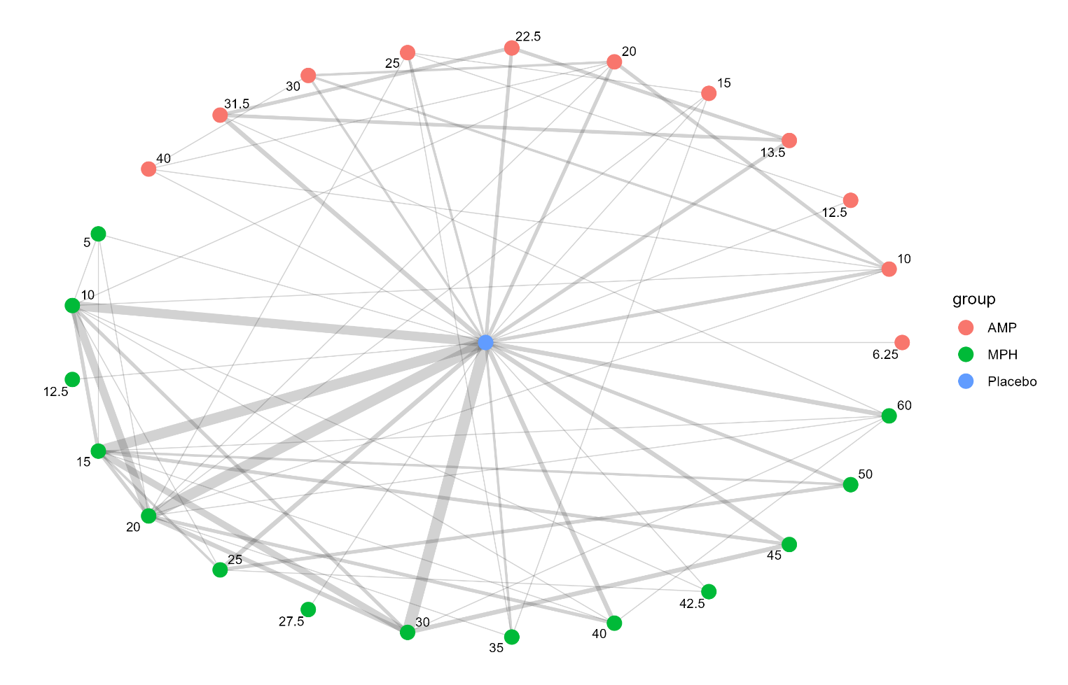
AMP, amphetamines; MPH, methylphenidate

eResult 5. Network plots for dropouts due to side effects
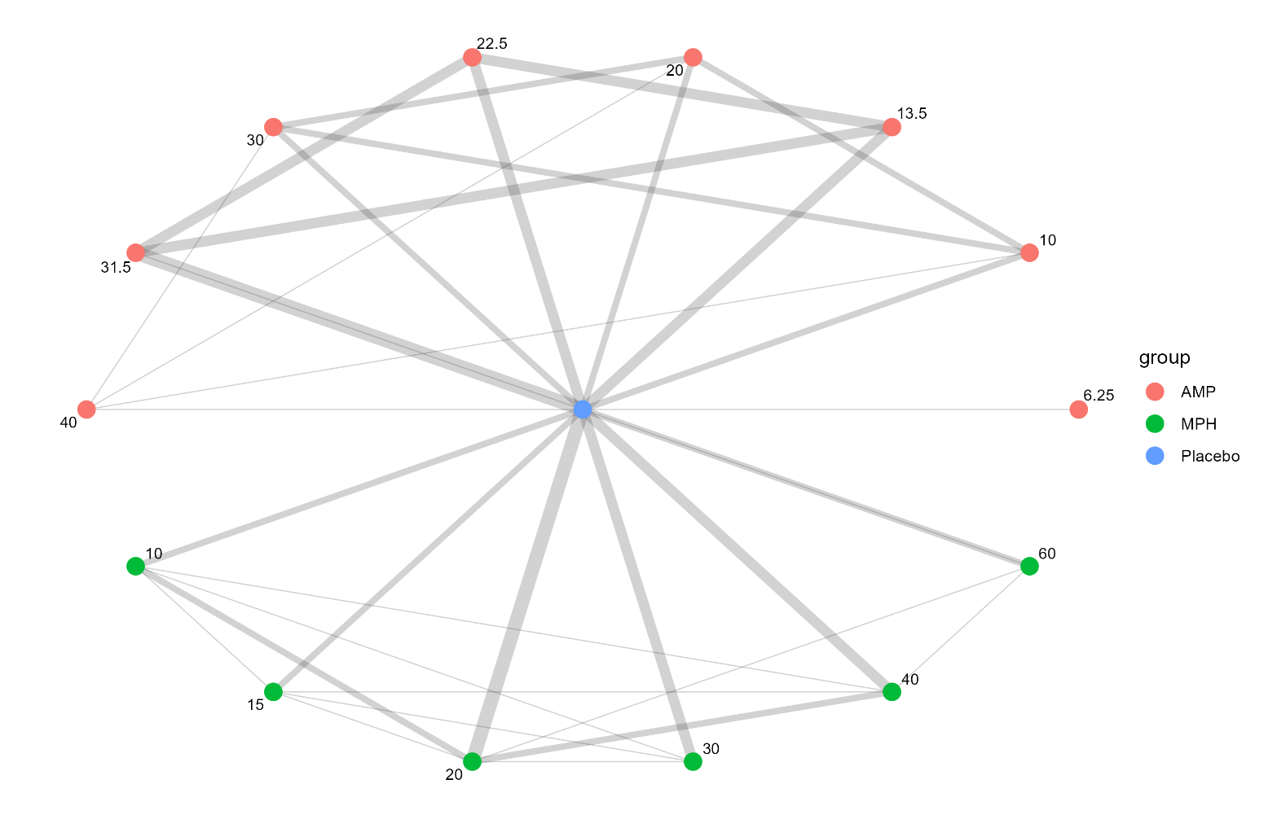
AMP, amphetamines; MPH, methylphenidate

eResult 6. Diagnostic comparison of one-knot and linear models
 | Linear | knot=1 (spline)
Deviance | 116.5 | 117.7
Residual deviance | 35.8 | 37
Deviance Information Criterion (DIC) | 135.6 | 140.8

eResult 7. Complete arm-level outcomes from included studies
Study | Compound | Dosing  design | Dose  meq | N of  Efficacy | Rating scale | Informant | Mean | SD | Dropouts  (SE) | Dropouts  (AC) | N of  Randomized | Duration
Barkley (1991) | Placebo | fixed | 0 | 40 | ADHD-RS Total | parent | -22.47 | 11.13 |  |  |  | 1
Barkley (1991) | MPH | fixed | 10 | 40 | ADHD-RS Total | parent | -18.67 | 8.89 |  |  |  | 1
Barkley (1991) | MPH | fixed | 20 | 40 | ADHD-RS Total | parent | -15.82 | 10 |  |  |  | 1
Barkley (1991) | MPH | fixed | 30 | 40 | ADHD-RS Total | parent | -14.19 | 9.78 |  |  |  | 1
Barkley (2000) | Placebo | fixed | 0 | 31 | ADHD-RS-IV Total | parent | -21.9 | 12.5 |  |  |  | 1
Barkley (2000) | AMP | fixed | 10 | 31 | ADHD-RS-IV Total | parent | -21.3 | 8.7 |  |  |  | 1
Barkley (2000) | AMP | fixed | 20 | 31 | ADHD-RS-IV Total | parent | -19 | 9.2 |  |  |  | 1
Barkley (2000) | MPH | fixed | 10 | 31 | ADHD-RS-IV Total | parent | -21.01 | 11.4 |  |  |  | 1
Barkley (2000) | MPH | fixed | 20 | 31 | ADHD-RS-IV Total | parent | -16.8 | 9.7 |  |  |  | 1
Biederman (2002) | Placebo | fixed | 0 | 203 | CTRS Hyperactivity Index | teacher | 0.9 | 7.12 | 6 | 37 | 210 | 3
Biederman (2002) | AMP | fixed | 10 | 128 | CTRS Hyperactivity Index | teacher | 5.3 | 5.6 | 0 | 10 | 129 | 3
Biederman (2002) | AMP | fixed | 20 | 112 | CTRS Hyperactivity Index | teacher | 6 | 2.29 | 4 | 16 | 121 | 3
Biederman (2002) | AMP | fixed | 30 | 120 | CTRS Hyperactivity Index | teacher | 6.4 | 5.47 | 5 | 12 | 124 | 3
Biederman (2007) | Placebo | fixed | 0 | 72 | ADHD-RS-IV Total | clinician | -36.64 | 12.64 | 1 | 18 | 72 | 4
Biederman (2007) | AMP | fixed | 13.5 | 69 | ADHD-RS-IV Total | clinician | -21.22 | 13.02 | 6 | 15 | 71 | 4
Biederman (2007) | AMP | fixed | 22.5 | 71 | ADHD-RS-IV Total | clinician | -19.63 | 14.49 | 4 | 14 | 74 | 4
Biederman (2007) | AMP | fixed | 31.5 | 73 | ADHD-RS-IV Total | clinician | -17.88 | 14.41 | 10 | 13 | 73 | 4
Brown (1986) | Placebo | fixed | 0 | 18 | CTRS Hyperactivity Index | teacher | -15.22 | 5.79 |  |  |  | 12
Brown (1986) | MPH | fixed | 20 | 17 | CTRS Hyperactivity Index | teacher | -11.29 | 3.82 |  |  |  | 12
Brown (1988) | Placebo | fixed | 0 | 11 | CTRS Hyperactivity Index | teacher | -24.5 | 2.81 |  |  |  | 2
Brown (1988) | MPH | fixed | 10 | 11 | CTRS Hyperactivity Index | teacher | -22.16 | 3.12 |  |  |  | 2
Brown (1988) | MPH | fixed | 25 | 11 | CTRS Hyperactivity Index | teacher | -18.33 | 3.07 |  |  |  | 2
Brown (1988) | MPH | fixed | 42.5 | 11 | CTRS Hyperactivity Index | teacher | -17.33 | 3.72 |  |  |  | 2
Buitelaar (1996) | Placebo | fixed | 0 |  |  |  |  |  | 0 | 0 | 11 | 2
Buitelaar (1996) | MPH | fixed | 20 |  |  |  |  |  | 2 | 2 | 21 | 2
Childress (2009) | Placebo | fixed | 0 | 63 | CTRS ADHD/DSM-IV | teacher | -30 | 13.01 | 0 | 8 | 65 | 5
Childress (2009) | MPH | fixed | 20 | 61 | CTRS ADHD/DSM-IV | teacher | -18.3 | 13.12 | 1 | 10 | 66 | 5
Childress (2009) | MPH | fixed | 40 | 59 | CTRS ADHD/DSM-IV | teacher | -18.1 | 13.31 | 1 | 8 | 62 | 5
Childress (2009) | MPH | fixed | 60 | 57 | CTRS ADHD/DSM-IV | teacher | -16.4 | 13.44 | 4 | 9 | 60 | 5
Corkum (2007) | Placebo | fixed | 0 | 21 | CTRS ADHD/DSM-IV | teacher | -67.4 | 10.49 |  |  |  | 1
Corkum (2007) | MPH | fixed | 30 | 21 | CTRS ADHD/DSM-IV | teacher | -59.95 | 10.72 |  |  |  | 1
Corkum (2007) | MPH | fixed | 45 | 21 | CTRS ADHD/DSM-IV | teacher | -59.65 | 11.46 |  |  |  | 1
Corkum (2020) | Placebo | fixed | 0 | 26 | CTRS ADHD/DSM-IV | teacher | -64 | 13.5 |  |  |  | 2
Corkum (2020) | MPH | fixed | 30 | 26 | CTRS ADHD/DSM-IV | teacher | -58.4 | 11.2 |  |  |  | 2
Dopfner (2003) | Placebo | fixed | 0 | 42 | ADHD Symptom Checklist Total | teacher | -1.64 | 0.69 | 0 | 3 | 42 | 4
Dopfner (2003) | MPH | fixed | 40 | 43 | ADHD Symptom Checklist Total | teacher | -0.85 | 0.62 | 2 | 3 | 43 | 4
DuPaul (1996) | Placebo | fixed | 0 | 24 | ADHD-RS Total | teacher | -23 | 9.35 |  |  |  | 1
DuPaul (1996) | MPH | fixed | 10 | 24 | ADHD-RS Total | teacher | -19.46 | 9.28 |  |  |  | 1
DuPaul (1996) | MPH | fixed | 20 | 24 | ADHD-RS Total | teacher | -19.04 | 11.64 |  |  |  | 1
DuPaul (1996) | MPH | fixed | 30 | 24 | ADHD-RS Total | teacher | -15.17 | 9.19 |  |  |  | 1
Findling (2011) | Placebo | fixed | 0 | 77 | ADHD-RS-IV Total | clinician | 12.8 | 10.97 | 1 | 10 | 79 | 4
Findling (2011) | AMP | fixed | 13.5 | 78 | ADHD-RS-IV Total | clinician | 18.3 | 11.03 | 3 | 15 | 78 | 4
Findling (2011) | AMP | fixed | 22.5 | 76 | ADHD-RS-IV Total | clinician | 21.1 | 11.16 | 3 | 13 | 79 | 4
Findling (2011) | AMP | fixed | 31.5 | 78 | ADHD-RS-IV Total | clinician | 20.7 | 11.03 | 4 | 11 | 78 | 4
Froehlich (2018) | Placebo | fixed | 0 | 168 | VADTRS Total | teacher | -23.7 | 9.76 |  |  |  | 4
Froehlich (2018) | MPH | fixed | 15 | 168 | VADTRS Total | teacher | -22.7 | 9.76 |  |  |  | 4
Froehlich (2018) | MPH | fixed | 30 | 168 | VADTRS Total | teacher | -18.8 | 9.22 |  |  |  | 4
Froehlich (2018) | MPH | fixed | 45 | 168 | VADTRS Total | teacher | -17.4 | 8.71 |  |  |  | 4
Gadow (2007) | Placebo | fixed | 0 | 71 | IOWA I/O | teacher | -7.4 | 3.9 | 0 | 0 | 71 | 2
Gadow (2007) | MPH | fixed | 10 | 71 | IOWA I/O | teacher | -5.2 | 3.5 | 0 | 0 | 71 | 2
Gadow (2007) | MPH | fixed | 20 | 71 | IOWA I/O | teacher | -4.7 | 3.4 | 0 | 0 | 71 | 2
Gadow (2007) | MPH | fixed | 30 | 71 | IOWA I/O | teacher | -3.8 | 3.1 | 0 | 0 | 71 | 2
Gorman (2006) | Placebo | fixed | 0 | 41 | IOWA I/O | teacher | -1.35 | 1.11 |  | 1 | 42 | 3
Gorman (2006) | MPH | fixed | 30 | 41 | IOWA I/O | teacher | -0.64 | 0.88 |  | 1 | 42 | 3
Greenhill (2001) | Placebo | fixed | 0 | 256 | CLAM I/O | teacher | -1.34 | 0.77 |  |  |  | 1
Greenhill (2001) | MPH | fixed | 15 | 256 | CLAM I/O | teacher | -0.9 | 0.61 |  |  |  | 1
Greenhill (2001) | MPH | fixed | 25 | 256 | CLAM I/O | teacher | -0.68 | 0.52 |  |  |  | 1
Greenhill (2001) | MPH | fixed | 50 | 256 | CLAM I/O | teacher | -0.55 | 0.52 |  |  |  | 1
Handen (1996) | Placebo | fixed | 0 | 44 | CTRS Hyperactivity Index | teacher | -16 | 7.9 |  |  |  | 1
Handen (1996) | MPH | fixed | 15 | 44 | CTRS Hyperactivity Index | teacher | -10 | 8.9 |  |  |  | 1
Handen (1996) | MPH | fixed | 30 | 44 | CTRS Hyperactivity Index | teacher | -8.4 | 7.5 |  |  |  | 1
Hoeppner (1997) | Placebo | fixed | 0 | 50 | CTRS Hyperactivity Index | teacher | -13.54 | 8.66 |  |  |  | 1
Hoeppner (1997) | MPH | fixed | 10 | 50 | CTRS Hyperactivity Index | teacher | -8.48 | 7.42 |  |  |  | 1
Hoeppner (1997) | MPH | fixed | 20 | 50 | CTRS Hyperactivity Index | teacher | -8.2 | 6.85 |  |  |  | 1
Ialongo (1994) | Placebo | fixed | 0 | 12 | CTRS Hyperactivity Index | teacher | -15.25 | 7.27 |  | 4 | 16 | 14
Ialongo (1994) | MPH | fixed | 10 | 16 | CTRS Hyperactivity Index | teacher | -13.87 | 7.71 |  | 0 | 16 | 14
Ialongo (1994) | MPH | fixed | 20 | 13 | CTRS Hyperactivity Index | teacher | -7.53 | 7.41 |  | 3 | 16 | 14
Ichikawa (2020) | Placebo | fixed | 0 | 19 | ADHD-RS-IV Total | clinician | 2.78 | 9.8 | 0 | 0 | 19 | 4
Ichikawa (2020) | AMP | fixed | 13.5 | 18 | ADHD-RS-IV Total | clinician | 16.38 | 9.5 | 0 | 1 | 19 | 4
Ichikawa (2020) | AMP | fixed | 22.5 | 17 | ADHD-RS-IV Total | clinician | 18.1 | 9.69 | 1 | 1 | 19 | 4
Ichikawa (2020) | AMP | fixed | 31.5 | 17 | ADHD-RS-IV Total | clinician | 16.47 | 9.44 | 2 | 3 | 19 | 4
Klorman (1990) | Placebo | fixed | 0 | 40 | Conners ADHD Index | teacher | -0.97 | 0.67 |  |  |  | 3
Klorman (1990) | MPH | fixed | 35 | 40 | Conners ADHD Index | teacher | -0.73 | 0.67 |  |  |  | 3
Kupietz (1998) | Placebo | fixed | 0 | 11 | CPRS Hyperactivity Index | parent | -2.44 | 0.93 |  |  |  | 2
Kupietz (1998) | MPH | fixed | 10 | 14 | CPRS Hyperactivity Index | parent | -2.18 | 0.54 |  |  |  | 2
Kupietz (1998) | MPH | fixed | 15 | 10 | CPRS Hyperactivity Index | parent | -2.5 | 0.8 |  |  |  | 2
Kupietz (1998) | MPH | fixed | 20 | 10 | CPRS Hyperactivity Index | parent | -1.95 | 0.36 |  |  |  | 2
Lin (2014) | Placebo | fixed | 0 | 63 | ADHD-RS-IV Total | clinician | 10.4 | 11.96 | 3 | 15 | 78 | 8
Lin (2014) | MPH | fixed | 30 | 26 | ADHD-RS-IV Total | clinician | 19.5 | 12.74 | 3 | 7 | 36 | 8
Lufi (2007) | Placebo | fixed | 0 | 19 | CTRS Hyperactivity Index | teacher | -12.56 | 6.69 |  |  |  | 3
Lufi (2007) | MPH | fixed | 12.5 | 19 | CTRS Hyperactivity Index | teacher | -6.97 | 3.8 |  |  |  | 3
Mattingly (2020) | Placebo | fixed | 0 | 42 | ADHD-RS-5 Total | parent | -31 | 10 | 0 | 3 | 44 | 4
Mattingly (2020) | AMP | fixed | 6.25 | 45 | ADHD-RS-5 Total | parent | -28 | 12 | 0 | 3 | 45 | 4
McBride (1988) | Placebo | fixed | 0 | 70 | CTRS Hyperactivity Index | teacher | -16.25 | 7.2 |  |  |  | 2
McBride (1988) | MPH | fixed | 15 | 70 | CTRS Hyperactivity Index | teacher | -9.1 | 6.3 |  |  |  | 2
Newcorn (2017) | Placebo | fixed | 0 | 93 | ADHD-RS-IV Total | clinician | 17 | 9.93 | 1 | 13 | 110 | 6
Newcorn (2017) | AMP | fixed | 31.5 | 175 | ADHD-RS-IV Total | clinician | 25.4 | 9.78 | 15 | 37 | 219 | 6
Newcorn (2017) | MPH | fixed | 60 | 181 | ADHD-RS-IV Total | clinician | 22.1 | 9.82 | 14 | 33 | 220 | 6
Pelham (1993) | Placebo | fixed | 0 | 31 | IOWA I/O | teacher | -5.45 | 3.8 |  |  |  | 1
Pelham (1993) | MPH | fixed | 15 | 31 | IOWA I/O | teacher | -2.05 | 2.08 |  |  |  | 1
Pelham (1993) | MPH | fixed | 30 | 31 | IOWA I/O | teacher | -1.6 | 1.94 |  |  |  | 1
Pelham (1999) | Placebo | fixed | 0 | 25 | IOWA I/O | teacher | -5.6 | 2.9 |  |  |  | 1
Pelham (1999) | AMP | fixed | 15 | 25 | IOWA I/O | teacher | -2.4 | 1.3 |  |  |  | 1
Pelham (1999) | AMP | fixed | 25 | 25 | IOWA I/O | teacher | -2.2 | 1.3 |  |  |  | 1
Pelham (1999) | MPH | fixed | 20 | 25 | IOWA I/O | teacher | -3.4 | 1.8 |  |  |  | 1
Pelham (1999) | MPH | fixed | 35 | 25 | IOWA I/O | teacher | -2.6 | 1.4 |  |  |  | 1
Pelham (2005) | Placebo | fixed | 0 | 21 | IOWA I/O | teacher | -7.45 | 2.8 |  |  |  | 1
Pelham (2005) | MPH | fixed | 15 | 21 | IOWA I/O | teacher | -5.15 | 2.4 |  |  |  | 1
Pelham (2005) | MPH | fixed | 30 | 21 | IOWA I/O | teacher | -4.4 | 2.24 |  |  |  | 1
Pelham (2005) | MPH | fixed | 45 | 19 | IOWA I/O | teacher | -4 | 1.9 |  |  |  | 1
Pelham (2014) | Placebo | fixed | 0 | 46 | IOWA I/O | teacher | -5.1 | 3.41 |  |  |  | 2
Pelham (2014) | MPH | fixed | 15 | 46 | IOWA I/O | teacher | -3.27 | 2.38 |  |  |  | 2
Pelham (2014) | MPH | fixed | 30 | 46 | IOWA I/O | teacher | -2.55 | 2.15 |  |  |  | 2
Pelham (2014) | MPH | fixed | 60 | 46 | IOWA I/O | teacher | -1.95 | 1.74 |  |  |  | 2
Pliszka (1989) | Placebo | fixed | 0 | 43 | IOWA I/O | teacher | -66.94 | 10.3 |  |  |  | 1
Pliszka (1989) | MPH | fixed | 20 | 43 | IOWA I/O | teacher | -55.14 | 8.6 |  |  |  | 1
Pliszka (1989) | MPH | fixed | 40 | 43 | IOWA I/O | teacher | -51.12 | 8.4 |  |  |  | 1
Rapport (1987) | Placebo | fixed | 0 | 76 | CTRS Hyperactivity Index | teacher | -14.41 | 10.46 |  |  |  | 1
Rapport (1987) | MPH | fixed | 5 | 76 | CTRS Hyperactivity Index | teacher | -9.94 | 10.46 |  |  |  | 1
Rapport (1987) | MPH | fixed | 10 | 76 | CTRS Hyperactivity Index | teacher | -7.59 | 10.46 |  |  |  | 1
Rapport (1987) | MPH | fixed | 15 | 76 | CTRS Hyperactivity Index | teacher | -6.85 | 10.46 |  |  |  | 1
Rapport (1987) | MPH | fixed | 20 | 76 | CTRS Hyperactivity Index | teacher | -6.48 | 10.46 |  |  |  | 1
Riggs (2011) | Placebo | fixed | 0 | 152 | ADHD-RS-IV Total | clinician | 21.8 | 11.9 |  | 43 | 152 | 16
Riggs (2011) | MPH | fixed | 60 | 151 | ADHD-RS-IV Total | clinician | 20.6 | 11.1 |  | 33 | 151 | 16
Smith (1998) | Placebo | fixed | 0 | 45 | IOWA I/O | teacher | -4.4 | 3.5 |  |  |  | 1
Smith (1998) | MPH | fixed | 25 | 45 | IOWA I/O | teacher | -2.7 | 2.7 |  |  |  | 1
Smith (1998) | MPH | fixed | 50 | 45 | IOWA I/O | teacher | -1.7 | 2.2 |  |  |  | 1
Smithee (1998) | Placebo | fixed | 0 | 23 | IOWA I/O | teacher | -1.52 | 0.67 |  |  |  | 2
Smithee (1998) | MPH | fixed | 27.5 | 23 | IOWA I/O | teacher | -0.84 | 0.67 |  |  |  | 2
Solanto (2009) | Placebo | fixed | 0 | 25 | ADHD-RS-IV Total | clinician | -26.58 | 11.39 |  |  |  | 1
Solanto (2009) | MPH | fixed | 15 | 25 | ADHD-RS-IV Total | clinician | -18.63 | 10.45 |  |  |  | 1
Solanto (2009) | MPH | fixed | 25 | 25 | ADHD-RS-IV Total | clinician | -18.21 | 10.34 |  |  |  | 1
Solanto (2009) | MPH | fixed | 50 | 25 | ADHD-RS-IV Total | clinician | -15.91 | 9.21 |  |  |  | 1
Spencer (2006) | Placebo | fixed | 0 | 52 | ADHD-RS-IV Total | clinician | -25.7 | 13.4 | 0 | 4 | 54 | 4
Spencer (2006) | AMP | fixed | 10 | 54 | ADHD-RS-IV Total | clinician | -20 | 11.8 | 1 | 7 | 56 | 4
Spencer (2006) | AMP | fixed | 20 | 53 | ADHD-RS-IV Total | clinician | -13.3 | 10.3 | 1 | 5 | 56 | 4
Spencer (2006) | AMP | fixed | 30 | 58 | ADHD-RS-IV Total | clinician | -16.1 | 11 | 1 | 3 | 58 | 4
Spencer (2006) | AMP | fixed | 40 | 61 | ADHD-RS-IV Total | clinician | -16.2 | 11 | 2 | 10 | 63 | 4
Stein (2003) | Placebo | fixed | 0 | 47 | ADHD-RS-IV Total | clinician | -23.22 | 10.8 |  | 1 | 47 | 1
Stein (2003) | MPH | fixed | 15 | 47 | ADHD-RS-IV Total | clinician | -20.99 | 12.99 |  | 0 | 47 | 1
Stein (2003) | MPH | fixed | 30 | 47 | ADHD-RS-IV Total | clinician | -17.61 | 12.03 |  | 2 | 47 | 1
Stein (2003) | MPH | fixed | 45 | 47 | ADHD-RS-IV Total | clinician | -14.8 | 10.27 |  | 5 | 47 | 1
Tervo (2002) | Placebo | fixed | 0 | 49 | CPRS Hyperactivity Index | parent | -69.64 | 17.34 |  |  |  | 3
Tervo (2002) | MPH | fixed | 20 | 49 | CPRS Hyperactivity Index | parent | -65.85 | 16.7 |  |  |  | 3
Tervo (2002) | MPH | fixed | 30 | 49 | CPRS Hyperactivity Index | parent | -58.2 | 3.76 |  |  |  | 3
vanderMeere (1999) | Placebo | fixed | 0 | 24 | CTRS Hyperactivity Index | teacher | -14.2 | 5.38 |  |  |  | 7
vanderMeere (1999) | MPH | fixed | 10 | 24 | CTRS Hyperactivity Index | teacher | -12.3 | 4.41 |  |  |  | 7
Varley (1983) | Placebo | fixed | 0 | 22 | CPRS Hyperactivity Index | teacher | -18.08 | 5.15 | 0 | 0 | 22 | 1
Varley (1983) | MPH | fixed | 15 | 22 | CPRS Hyperactivity Index | teacher | -13.48 | 5.15 | 0 | 0 | 22 | 1
Varley (1983) | MPH | fixed | 30 | 22 | CPRS Hyperactivity Index | teacher | -11.96 | 5.15 | 0 | 0 | 22 | 1
Wigal (2015) | Placebo | fixed | 0 | 46 | ADHD-RS-IV Total | clinician | 5.1 | 10.3 | 0 | 1 | 47 | 1
Wigal (2015) | MPH | fixed | 10 | 48 | ADHD-RS-IV Total | clinician | 9.3 | 8.9 | 0 | 1 | 49 | 1
Wigal (2015) | MPH | fixed | 15 | 40 | ADHD-RS-IV Total | clinician | 11.2 | 12.1 | 1 | 4 | 44 | 1
Wigal (2015) | MPH | fixed | 20 | 44 | ADHD-RS-IV Total | clinician | 12.3 | 9.8 | 0 | 1 | 45 | 1
Wigal (2015) | MPH | fixed | 40 | 43 | ADHD-RS-IV Total | clinician | 13.2 | 10.3 | 2 | 2 | 45 | 1
Wigal (2019) | Placebo | fixed | 0 | 84 | ADHD-RS Total | clinician | -31.7 | 11.5 |  |  |  | 1
Wigal (2019) | AMP | fixed | 12.5 | 83 | ADHD-RS Total | clinician | -24.6 | 9.46 |  |  |  | 1
Wigal (2019) | AMP | fixed | 25 | 43 | ADHD-RS Total | clinician | -20.4 | 10.6 |  |  |  | 1
Wilens (2010) | Placebo | fixed | 0 | 30 | ADHD-RS-IV Total | clinician | -28.33 | 15.75 |  |  |  | 2
Wilens (2010) | MPH | fixed | 30 | 30 | ADHD-RS-IV Total | clinician | -14.76 | 14.48 |  |  |  | 2
Zeiner (1999) | Placebo | fixed | 0 | 35 | CTRS Hyperactivity Index | teacher | -14.69 | 6.17 |  | 0 | 36 | 3
Zeiner (1999) | MPH | fixed | 15 | 35 | CTRS Hyperactivity Index | teacher | -8.83 | 6.49 |  | 0 | 36 | 3
AMP, amphetamines; MPH, methylphenidate; SE, side effect; AC, all-caused; meq, equivalents(mg); SD, standard deviation

eResult 8. Scatter plot of posterior mean residual deviance (resdev) for the unrelated mean effects (UME) and network meta-analysis (NMA) models
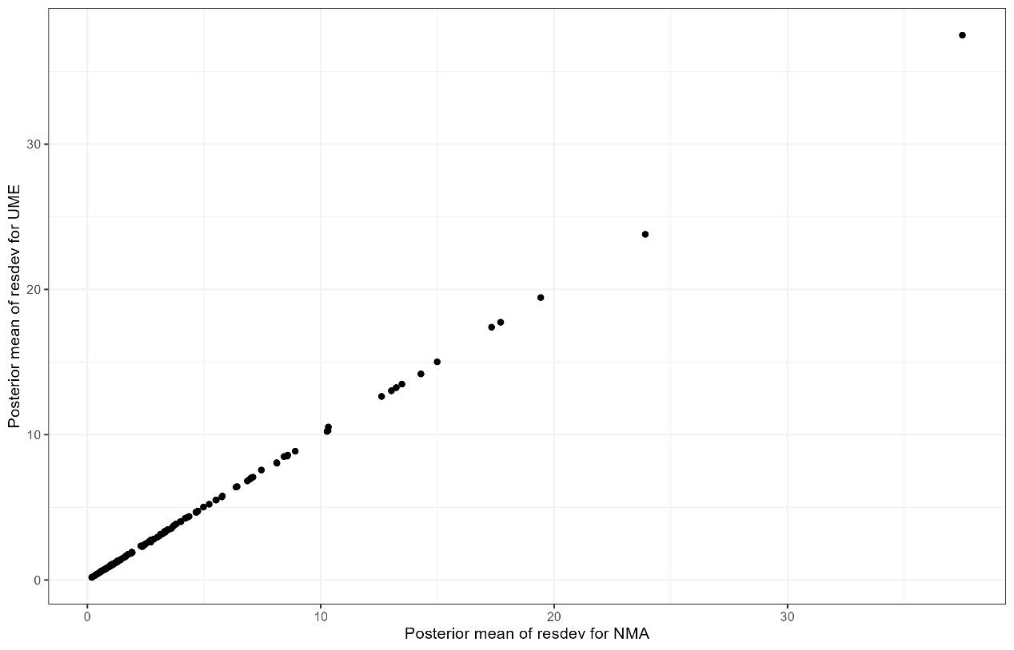

eResult 9. Risk of Bias (RoB 2.0) summary across included studies
Study | Randomization | Deviations | Missing data | Measurement | Selection | Overall | Sponsorship
Barkley (1991) | Some concerns | Some concerns | Some concerns | Low | Some concerns | Some concerns | Academic
Barkley (2000) | Some concerns | Some concerns | Some concerns | Some concerns | Some concerns | Some concerns | Industry
Biederman (2002) | Low | Low | Low | Low | Low | Low | Industry
Biederman (2007) | Low | Low | High | Low | Low | Some concerns | Industry
Brown (1986) | Some concerns | Some concerns | Low | Low | Some concerns | Some concerns | Academic
Brown (1988) | Some concerns | Some concerns | Some concerns | Some concerns | Some concerns | Some concerns | Academic
Buitelaar (1996) | Some concerns | Some concerns | Low | Low | Some concerns | Some concerns | Not reported
Childress (2009) | Low | Low | Low | Low | Low | Low | Industry
Corkum (2020) | Some concerns | Some concerns | Some concerns | Low | Some concerns | Some concerns | Academic
Corkum (2020) | Low | Some concerns | Some concerns | Low | Some concerns | Some concerns | Academic
Döpfner (2003) | Low | Low | Low | Low | Low | Low | Industry
DuPaul (1996) | Some concerns | Some concerns | Some concerns | Low | Some concerns | Some concerns | Not reported
Findling (2011) | Low | Low | Low | Low | Low | Low | Industry
Froehlich (2018) | Some concerns | Some concerns | Low | Low | Low | Some concerns | Academic
Gadow (2007) | Some concerns | Some concerns | Some concerns | Low | Some concerns | Some concerns | Academic
Gorman (2006) | Some concerns | Some concerns | Low | Low | Some concerns | Some concerns | Academic
Greenhill (2001) | Low | Low | Some concerns | Low | Low | Low | Academic
Handen (1996) | Low | Some concerns | Some concerns | Some concerns | Some concerns | Some concerns | Academic
Hoeppner (1997) | Low | Low | Some concerns | Low | Some concerns | Low | Not reported
Ialongo (1994) | Some concerns | Some concerns | Some concerns | Some concerns | Some concerns | Some concerns | Not reported
Ichikawa (2020) | Some concerns | Some concerns | Low | Some concerns | Low | Some concerns | Industry
Klorman (1990) | Some concerns | Some concerns | Some concerns | Low | Some concerns | Some concerns | Academic
Kupietz (1988) | Some concerns | Some concerns | Some concerns | Some concerns | Some concerns | Some concerns | Academic
Lin (2014) | Low | Some concerns | Low | Some concerns | Low | Low | Industry
Luft (2007) | Some concerns | Some concerns | Some concerns | Some concerns | Some concerns | Some concerns | Not reported
Mattingly (2020) | Low | Low | Low | Low | Low | Low | Industry
McBride (1988) | Low | Low | Low | Low | Some concerns | Low | Not reported
Newcorn (2008) | Low | Low | Some concerns | Low | Low | Low | Industry
Newcorn (2017) | Low | Low | Low | Low | Low | Low | Industry
Pelham (1993) | Some concerns | Some concerns | Some concerns | Some concerns | Some concerns | Some concerns | Academic
Pelham (1999) | Some concerns | Some concerns | Low | Low | Some concerns | Some concerns | Industry
Pelham (2005) | Low | Some concerns | Some concerns | Low | Some concerns | Some concerns | Industry
Pelham (2014) | Low | Low | Low | Low | Some concerns | Low | Academic
Pliszka (2000) | Low | Low | Low | Low | Low | Low | Industry
Rapport (1987) | Some concerns | Some concerns | Some concerns | Low | Some concerns | Some concerns | Not reported
Riggs (2011) | Low | Low | Some concerns | Low | Low | Low | Academic
Smith (1998) | Some concerns | Some concerns | Some concerns | Low | Some concerns | Some concerns | Academic
Smithee (1998) | Some concerns | Some concerns | Some concerns | Low | Some concerns | Some concerns | Academic
Solanto (2009) | Some concerns | Some concerns | Low | Some concerns | Some concerns | Some concerns | Academic
Spencer (2006) | Low | Low | Low | Low | Low | Low | Industry
Stein (2003) | Some concerns | Some concerns | Low | Some concerns | Some concerns | Some concerns | Academic
Tervo (2002) | Low | Low | High | Low | Some concerns | High | Not reported
van der Meere (1999) | Low | Some concerns | Some concerns | Some concerns | Some concerns | Some concerns | Academic
Varley (1993) | Some concerns | Some concerns | Low | Low | Some concerns | Some concerns | Not reported
Wigal (2015) | Low | Some concerns | Low | Some concerns | Low | Low | Industry
Wigal (2019) | Low | Low | Low | Low | Some concerns | Low | Industry
Wilens (2010) | Some concerns | Some concerns | Some concerns | Low | Low | Some concerns | Industry
Zeiner (1999) | Some concerns | Some concerns | Some concerns | Some concerns | Some concerns | Some concerns | Academic

eResult 10. Meta-regression parameter estimates
Parameter | Beta (coefficient) | Tau (between-study standard deviation for relative efficacy)
dose_weight1 | 0.24 (0.06-0.41) | 0.197 (0.144, 0.259)
informantparent | -0.08 (-0.36, 0.20) | 0.198 (0.145, 0.256)
informantteacher | 0.26 (0.08, 0.44) | 0.198 (0.145, 0.256)
duration_wk | -0.05 (-0.08, -0.03) | 0.163 (0.105, 0.229)
dose_weight1: mg/kg dosing vs non-mg/kg dosing; dosing_designflexible; informantparent — parent-rated outcomes vs clinician-rated; informantteacher — teacher-rated outcomes vs clinician-rated; duration_wk — mean trial duration (weeks), mean-centered; coefficients reflect the change per +1 week relative to the mean.

eResult 11. Dose-response efficacy curves for methylphenidate and amphetamine in low risk of bias studies
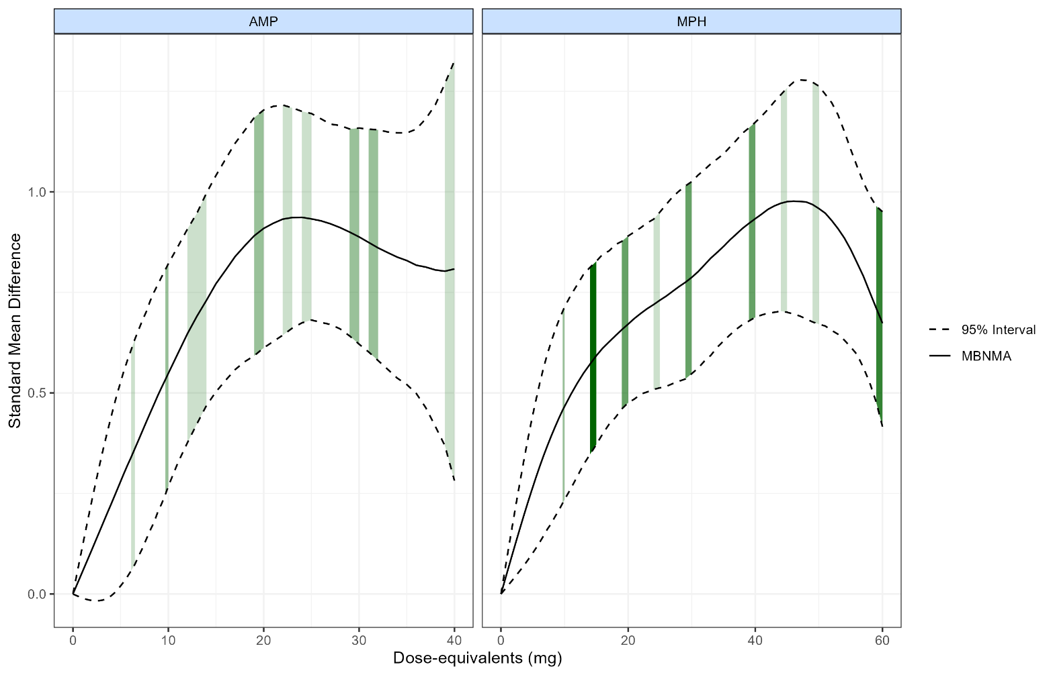
Darker shading indicates more study arms at that dose. AMP, amphetamines; MPH, methylphenidate; MBNMA, model-based network meta-analysis

eResult 12. Dose-response efficacy curves for methylphenidate and amphetamine in trials excluding concomitant psychotherapy
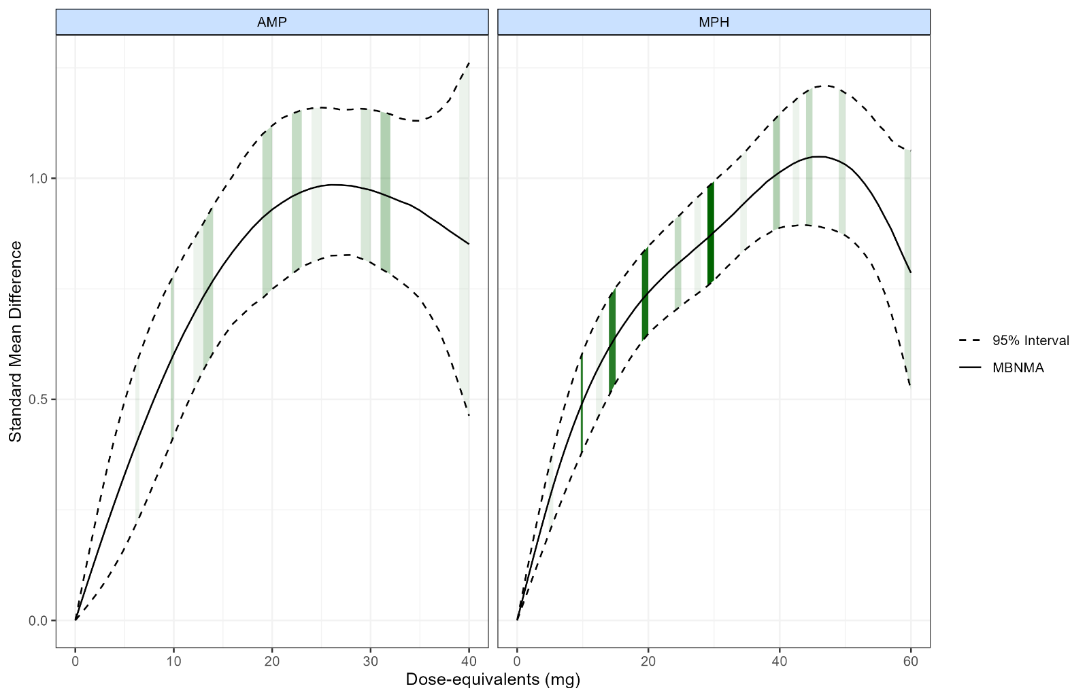
eResult 13. Sensitivity analyses of dose-response efficacy curves for methylphenidate and amphetamine: comparison of all trials, low-risk-of-bias trials, and trials excluding concomitant psychotherapy
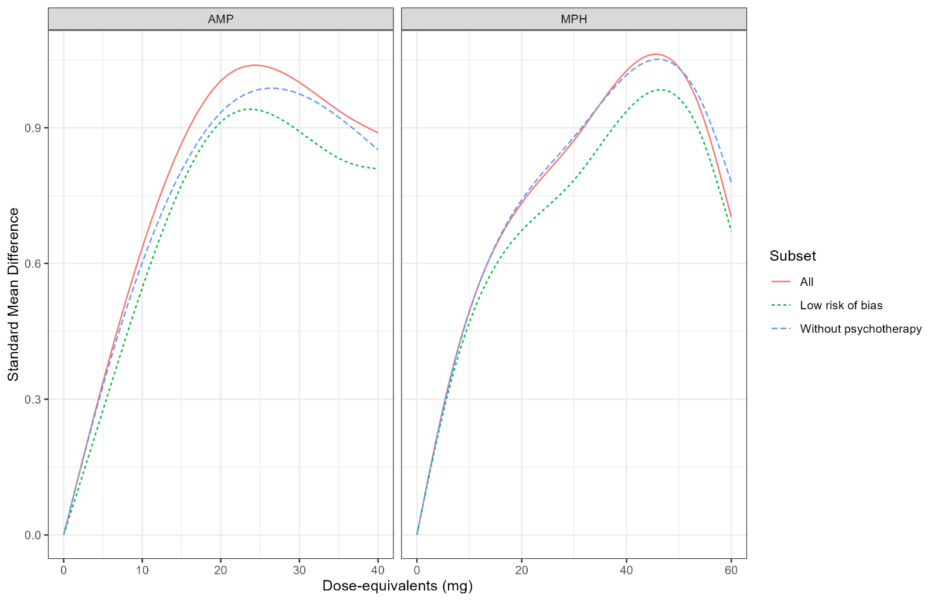
AMP, amphetamines; MPH, methylphenidate
eResult 14. Dose-response curves for absolute risk reduction with methylphenidate and amphetamine
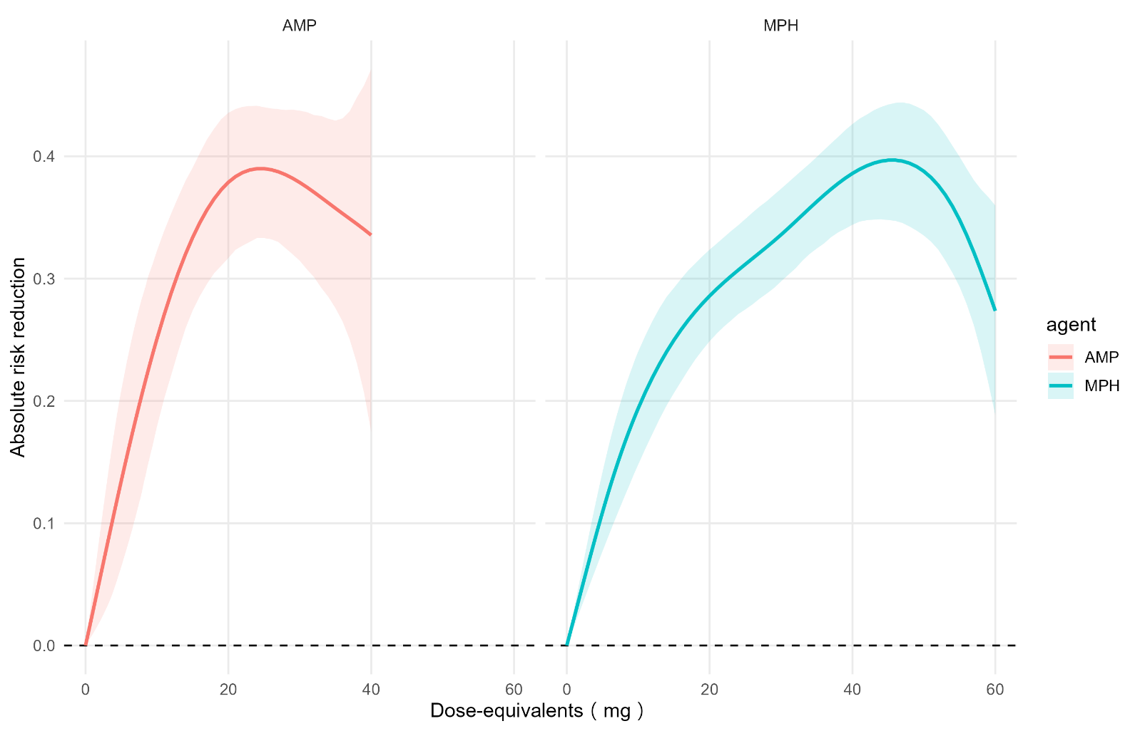
AMP, amphetamines; MPH, methylphenidate

eResult 15. Dose-response curves for absolute risk increase with methylphenidate and amphetamine
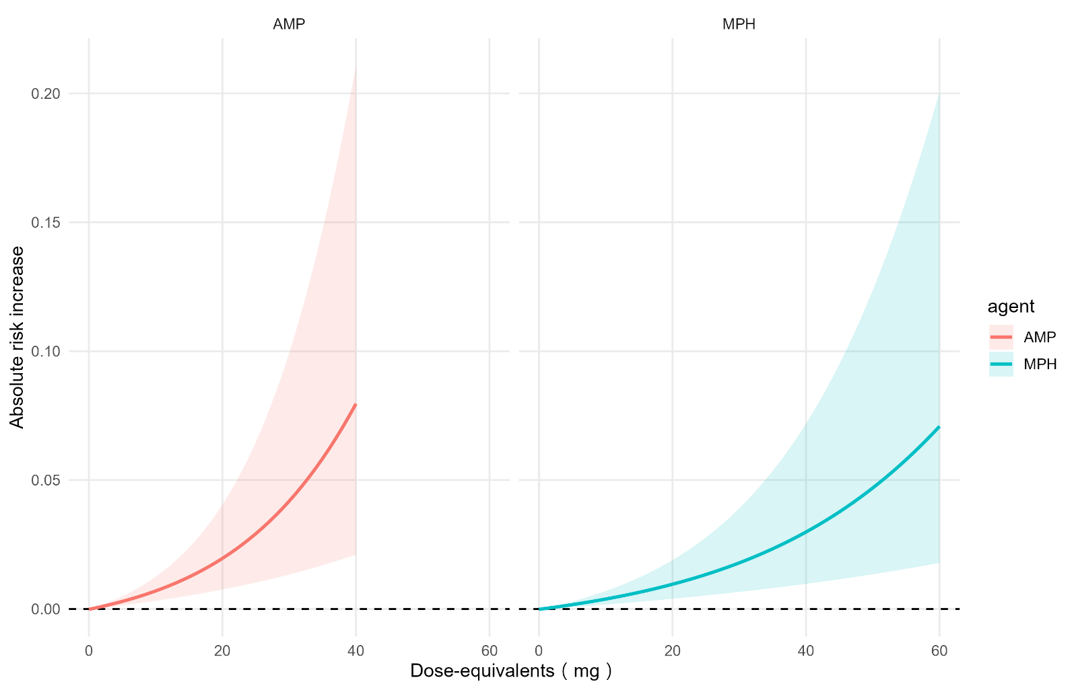
AMP, amphetamines; MPH, methylphenidate

eResult 16. Posterior mean differences in maximal net clinical benefit between amphetamine and methylphenidate and probability that amphetamine yields greater benefit across risk-preference values (λ)
Lambda | Mean maximal NCB difference (AMP - MPH) | AMP benefit better probability
1.0 | 0.009 | 0.595
1.2 | 0.010 | 0.608
1.4 | 0.011 | 0.614
1.6 | 0.013 | 0.613
1.8 | 0.014 | 0.626
2.0 | 0.015 | 0.633
2.2 | 0.016 | 0.637
2.4 | 0.017 | 0.639
2.6 | 0.018 | 0.642
2.8 | 0.019 | 0.650
3.0 | 0.019 | 0.655
3.2 | 0.020 | 0.661
3.4 | 0.021 | 0.667
3.6 | 0.021 | 0.671
3.8 | 0.022 | 0.674
4.0 | 0.022 | 0.677
4.2 | 0.023 | 0.682
4.4 | 0.023 | 0.685
4.6 | 0.023 | 0.688
4.8 | 0.024 | 0.688
5.0 | 0.024 | 0.688
5.2 | 0.024 | 0.689
5.4 | 0.024 | 0.688
5.6 | 0.024 | 0.687
5.8 | 0.024 | 0.684
6.0 | 0.024 | 0.687
6.2 | 0.024 | 0.684
6.4 | 0.024 | 0.683
6.6 | 0.024 | 0.679
6.8 | 0.024 | 0.679
7.0 | 0.023 | 0.676
7.2 | 0.023 | 0.674
7.4 | 0.023 | 0.669
7.6 | 0.023 | 0.668
7.8 | 0.022 | 0.663
8.0 | 0.022 | 0.660
8.2 | 0.022 | 0.658
8.4 | 0.021 | 0.655
8.6 | 0.021 | 0.652
8.8 | 0.021 | 0.649
9.0 | 0.020 | 0.646
9.2 | 0.020 | 0.643
9.4 | 0.019 | 0.637
9.6 | 0.019 | 0.635
9.8 | 0.018 | 0.631
10.0 | 0.018 | 0.625

eResult 17. Posterior medians and 95% credible intervals of dose-equivalents (mg) corresponding to maximal net clinical benefit for amphetamine and methylphenidate across risk-preference values (λ)

Agent | Lambda | Lower | Median | Upper
AMP | 1.0 | 19.0 | 23 | 40
AMP | 1.2 | 18.0 | 23 | 40
AMP | 1.4 | 18.0 | 22 | 40
AMP | 1.6 | 17.0 | 22 | 40
AMP | 1.8 | 17.0 | 22 | 40
AMP | 2.0 | 16.0 | 21 | 40
AMP | 2.2 | 16.0 | 21 | 40
AMP | 2.4 | 15.0 | 21 | 36
AMP | 2.6 | 15.0 | 21 | 32
AMP | 2.8 | 15.0 | 21 | 31
AMP | 3.0 | 14.0 | 20 | 30
AMP | 3.2 | 14.0 | 20 | 29
AMP | 3.4 | 14.0 | 20 | 29
AMP | 3.6 | 13.0 | 20 | 29
AMP | 3.8 | 13.0 | 20 | 28
AMP | 4.0 | 13.0 | 20 | 28
AMP | 4.2 | 13.0 | 19 | 27
AMP | 4.4 | 13.0 | 19 | 27
AMP | 4.6 | 13.0 | 19 | 27
AMP | 4.8 | 12.0 | 19 | 26
AMP | 5.0 | 12.0 | 19 | 26
AMP | 5.2 | 12.0 | 19 | 26
AMP | 5.4 | 12.0 | 18 | 26
AMP | 5.6 | 12.0 | 18 | 25
AMP | 5.8 | 12.0 | 18 | 25
AMP | 6.0 | 12.0 | 18 | 25
AMP | 6.2 | 11.0 | 18 | 25
AMP | 6.4 | 11.0 | 18 | 24
AMP | 6.6 | 11.0 | 18 | 24
AMP | 6.8 | 11.0 | 17 | 24
AMP | 7.0 | 11.0 | 17 | 24
AMP | 7.2 | 11.0 | 17 | 23
AMP | 7.4 | 11.0 | 17 | 23
AMP | 7.6 | 11.0 | 17 | 23
AMP | 7.8 | 10.0 | 17 | 23
AMP | 8.0 | 10.0 | 17 | 22
AMP | 8.2 | 10.0 | 17 | 22
AMP | 8.4 | 10.0 | 16 | 22
AMP | 8.6 | 10.0 | 16 | 22
AMP | 8.8 | 9.9 | 16 | 22
AMP | 9.0 | 9.8 | 16 | 22
AMP | 9.2 | 9.7 | 16 | 22
AMP | 9.4 | 9.7 | 16 | 22
AMP | 9.6 | 9.6 | 16 | 21
AMP | 9.8 | 9.5 | 16 | 21
AMP | 10.0 | 9.4 | 15 | 21
MPH | 1.0 | 35.0 | 44 | 47
MPH | 1.2 | 34.0 | 43 | 47
MPH | 1.4 | 33.0 | 43 | 47
MPH | 1.6 | 32.0 | 42 | 47
MPH | 1.8 | 29.0 | 42 | 47
MPH | 2.0 | 26.0 | 42 | 46
MPH | 2.2 | 23.0 | 41 | 46
MPH | 2.4 | 22.0 | 41 | 46
MPH | 2.6 | 21.0 | 41 | 46
MPH | 2.8 | 20.0 | 40 | 46
MPH | 3.0 | 19.0 | 40 | 46
MPH | 3.2 | 19.0 | 39 | 46
MPH | 3.4 | 19.0 | 39 | 46
MPH | 3.6 | 18.0 | 39 | 45
MPH | 3.8 | 18.0 | 38 | 45
MPH | 4.0 | 18.0 | 38 | 45
MPH | 4.2 | 17.0 | 37 | 45
MPH | 4.4 | 17.0 | 36 | 45
MPH | 4.6 | 17.0 | 36 | 45
MPH | 4.8 | 17.0 | 35 | 45
MPH | 5.0 | 16.0 | 35 | 45
MPH | 5.2 | 16.0 | 34 | 45
MPH | 5.4 | 16.0 | 33 | 44
MPH | 5.6 | 16.0 | 32 | 44
MPH | 5.8 | 16.0 | 30 | 44
MPH | 6.0 | 15.0 | 29 | 44
MPH | 6.2 | 15.0 | 27 | 44
MPH | 6.4 | 15.0 | 26 | 44
MPH | 6.6 | 15.0 | 26 | 44
MPH | 6.8 | 15.0 | 25 | 44
MPH | 7.0 | 15.0 | 24 | 44
MPH | 7.2 | 15.0 | 24 | 44
MPH | 7.4 | 14.0 | 23 | 44
MPH | 7.6 | 14.0 | 23 | 43
MPH | 7.8 | 14.0 | 22 | 43
MPH | 8.0 | 14.0 | 22 | 43
MPH | 8.2 | 14.0 | 22 | 43
MPH | 8.4 | 14.0 | 21 | 43
MPH | 8.6 | 13.0 | 21 | 43
MPH | 8.8 | 13.0 | 21 | 43
MPH | 9.0 | 13.0 | 20 | 43
MPH | 9.2 | 13.0 | 20 | 43
MPH | 9.4 | 13.0 | 20 | 42
MPH | 9.6 | 13.0 | 20 | 42
MPH | 9.8 | 13.0 | 20 | 42
MPH | 10.0 | 13.0 | 19 | 42

eResult 18. Heatmap of probabilities of optimal target doses across different values across risk-preference values (λ)
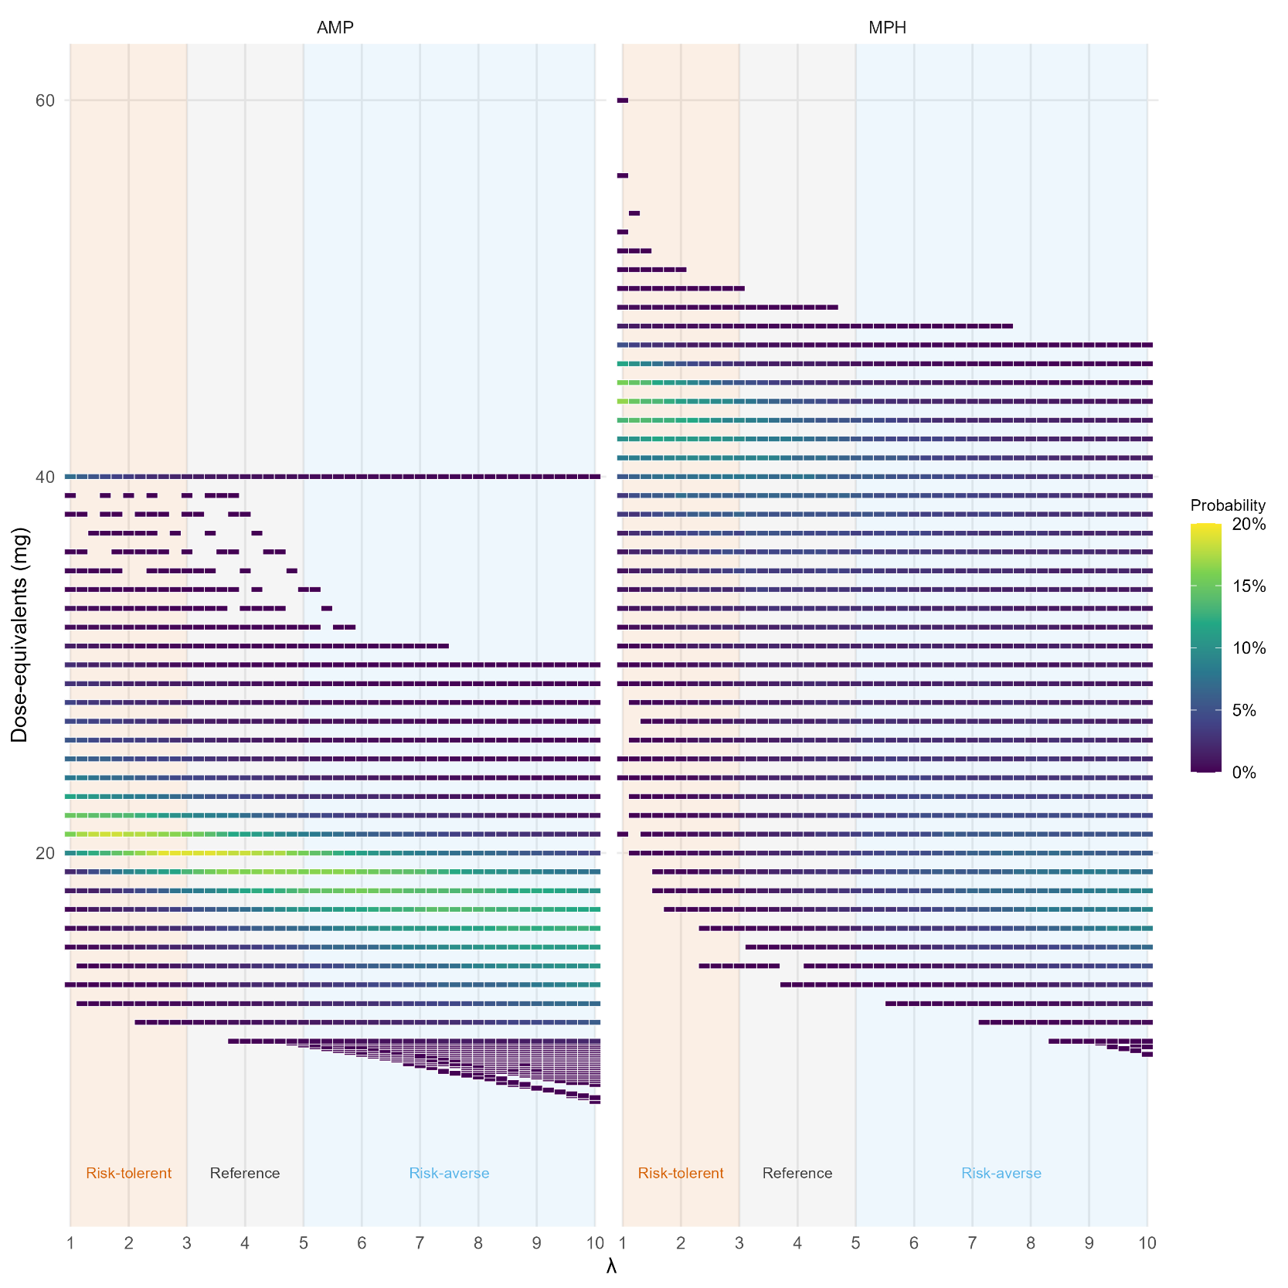
AMP, amphetamines; MPH, methylphenidate; lambda (λ), how many patients benefit before one discontinues due to adverse events

eResult 19. Posterior mean differences in maximal net clinical benefit between amphetamine and methylphenidate and probability that amphetamine yields greater benefit across risk-preference values (λ), using a 0.4-SD response threshold
Lambda | Mean maximal NCB difference (AMP - MPH) | AMP benefit better probability
1.0 | 0.009 | 0.601
1.2 | 0.010 | 0.610
1.4 | 0.011 | 0.614
1.6 | 0.012 | 0.621
1.8 | 0.013 | 0.631
2.0 | 0.014 | 0.635
2.2 | 0.015 | 0.638
2.4 | 0.016 | 0.642
2.6 | 0.017 | 0.650
2.8 | 0.018 | 0.656
3.0 | 0.019 | 0.661
3.2 | 0.019 | 0.668
3.4 | 0.020 | 0.671
3.6 | 0.021 | 0.675
3.8 | 0.021 | 0.679
4.0 | 0.022 | 0.684
4.2 | 0.022 | 0.687
4.4 | 0.022 | 0.688
4.6 | 0.022 | 0.688
4.8 | 0.023 | 0.690
5.0 | 0.023 | 0.688
5.2 | 0.023 | 0.688
5.4 | 0.023 | 0.687
5.6 | 0.023 | 0.687
5.8 | 0.023 | 0.685
6.0 | 0.023 | 0.683
6.2 | 0.023 | 0.681
6.4 | 0.022 | 0.679
6.6 | 0.022 | 0.678
6.8 | 0.022 | 0.675
7.0 | 0.022 | 0.671
7.2 | 0.022 | 0.668
7.4 | 0.021 | 0.664
7.6 | 0.021 | 0.661
7.8 | 0.021 | 0.658
8.0 | 0.020 | 0.655
8.2 | 0.020 | 0.652
8.4 | 0.020 | 0.649
8.6 | 0.019 | 0.646
8.8 | 0.019 | 0.641
9.0 | 0.018 | 0.639
9.2 | 0.018 | 0.635
9.4 | 0.018 | 0.630
9.6 | 0.017 | 0.625
9.8 | 0.017 | 0.621
10.0 | 0.016 | 0.617

eResult 20. Posterior mean differences in maximal net clinical benefit between amphetamine and methylphenidate and probability that amphetamine yields greater benefit across risk-preference values (λ), using a 0.6-SD response threshold
Lambda | Mean maximal NCB difference (AMP - MPH) | AMP benefit better probability
1.0 | 0.010 | 0.593
1.2 | 0.011 | 0.606
1.4 | 0.012 | 0.610
1.6 | 0.013 | 0.613
1.8 | 0.014 | 0.617
2.0 | 0.015 | 0.628
2.2 | 0.016 | 0.635
2.4 | 0.017 | 0.638
2.6 | 0.018 | 0.640
2.8 | 0.019 | 0.643
3.0 | 0.020 | 0.651
3.2 | 0.021 | 0.655
3.4 | 0.021 | 0.660
3.6 | 0.022 | 0.666
3.8 | 0.022 | 0.671
4.0 | 0.023 | 0.674
4.2 | 0.023 | 0.676
4.4 | 0.024 | 0.681
4.6 | 0.024 | 0.684
4.8 | 0.025 | 0.686
5.0 | 0.025 | 0.688
5.2 | 0.025 | 0.687
5.4 | 0.025 | 0.689
5.6 | 0.025 | 0.688
5.8 | 0.025 | 0.686
6.0 | 0.025 | 0.684
6.2 | 0.025 | 0.684
6.4 | 0.025 | 0.685
6.6 | 0.025 | 0.683
6.8 | 0.025 | 0.681
7.0 | 0.025 | 0.679
7.2 | 0.025 | 0.677
7.4 | 0.025 | 0.676
7.6 | 0.024 | 0.673
7.8 | 0.024 | 0.670
8.0 | 0.024 | 0.667
8.2 | 0.023 | 0.663
8.4 | 0.023 | 0.659
8.6 | 0.023 | 0.657
8.8 | 0.022 | 0.654
9.0 | 0.022 | 0.651
9.2 | 0.022 | 0.650
9.4 | 0.021 | 0.647
9.6 | 0.021 | 0.643
9.8 | 0.020 | 0.638
10.0 | 0.020 | 0.634

eResult 21. Optimal target dose ranges across risk-preference values, using a 0.4-SD response threshold
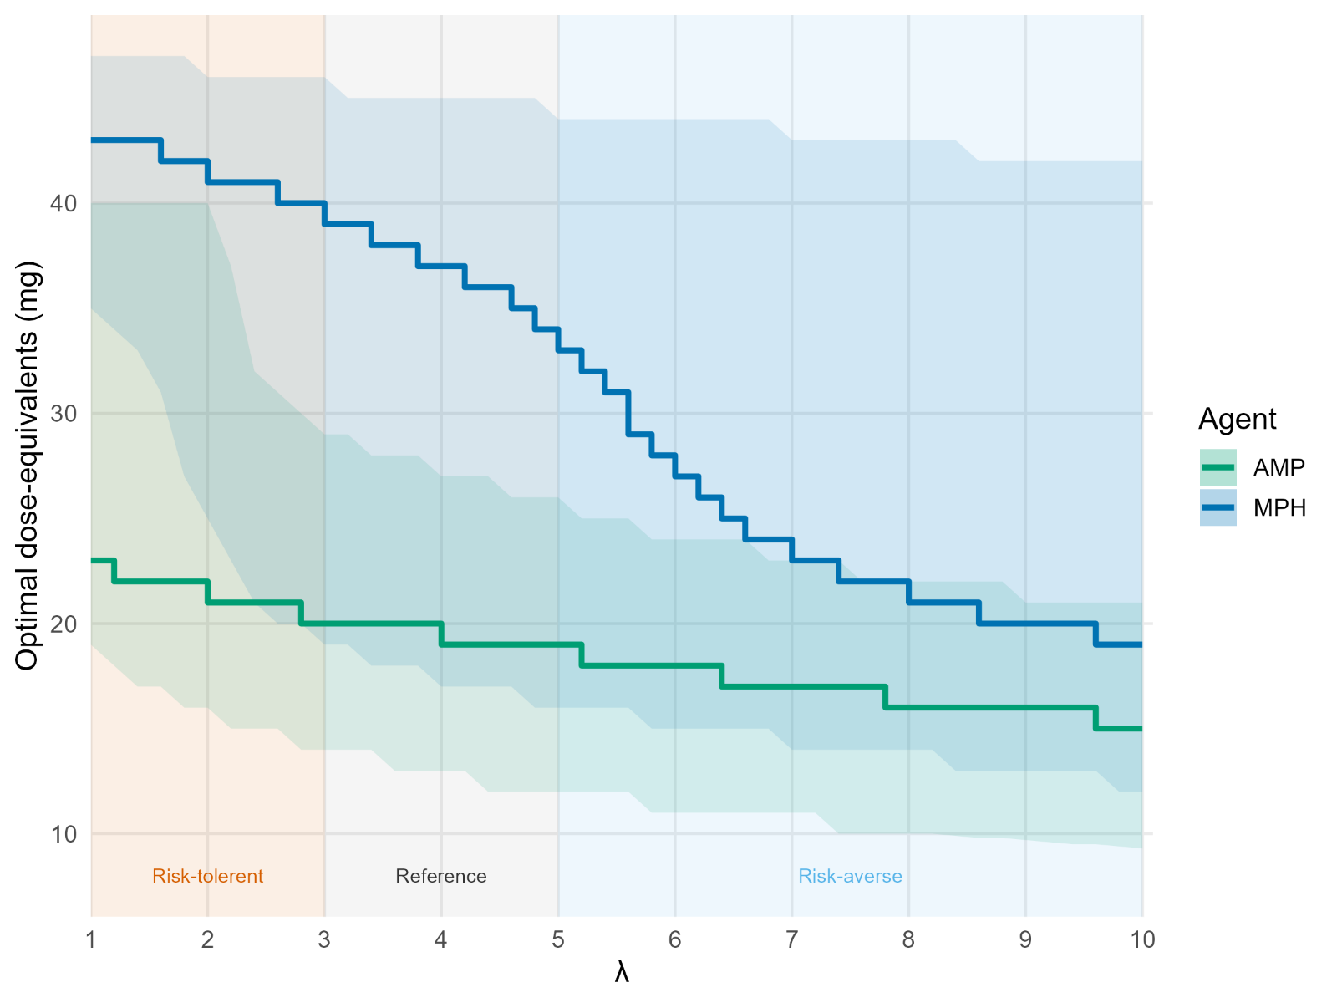

eResult 22. Optimal target dose ranges across risk-preference values, using a 0.6-SD response threshold
