Title: Prescribing Trends and Spontaneous Reporting Patterns of Adverse Drug Reactions of ADHD Medications in Children and Adolescents in Germany: A Retrospective Analysis (2013-2022)

Journal: European Child & Adolescent Psychiatry

Authors:
Diana Dubrall^{1,2}, Mona Reifferscheid³, Karin Egberts^{4,5}, Stefanie Fekete⁴, Antje Neubert⁶, Hans W Rock⁷, Paul Plener^{8,9}, Maike Below³, Marcel Romanos⁴, Matthias Schmid¹, Bernhardt Sachs^{2,10}

¹ University of Bonn, University Hospital Bonn, Institute for Medical Biometry, Informatics and Epidemiology, Bonn, Germany
² Research Division, Federal Institute for Drugs and Medical Devices (BfArM), Bonn, Germany
³ Central Research Institute for Ambulatory Health Care in Germany, Berlin, Germany
⁴ Department of Child and Adolescent Psychiatry, Psychosomatics and Psychotherapy, Center of Mental Health, University Hospital of Wuerzburg, Wuerzburg, Germany
⁵ Department of Child and adolescent Psychiatry, GGZ Reinier van Arkel, ‘s-Hertogenbosch, The Netherlands
⁶ Friedrich Alexander Universität, Erlangen Nürnberg, Medical Faculty, Department of Paediatric and Adolescents Medicine, Erlangen, Germany
⁷ CIO Marburg GmbH, Lohra, Germany
⁸ Department of Child and Adolescent Psychiatry, Medical University Vienna, Vienna, Austria
⁹ Department of Child and Adolescent Psychiatry, University of Ulm, Ulm, Germany
¹⁰ Department for Dermatology and Allergy, University Hospital RWTH Aachen, Aachen, Germany

Corresponding author:
Dr. Diana Dubrall
University of Bonn, University Hospital Bonn, Institute for Medical Biometry, Informatics and Epidemiology, Bonn, Germany
Research Division, Federal Institute of Drugs and Medical Devices (BfArM), Bonn, Germany
E-mail: Diana.Dubrall@bfarm.de

Online Resource 4) Sex-stratified analyses of ADHD drug prescriptions.

Online Resource 4 Table 1) Cumulative number of drug prescriptions for females and males between 2013 and 2022.
Rank | Females | Males
1.  2.  3.  4.  5. | Methylphenidate (n= 2,095,582)  Lisdexamfetamine (n= 265,104)  Atomoxetine (n= 151,143)  Guanfacine (n= 37,641)  Dexamfetamine (n= 27,782) | Methylphenidate (n= 8,090,178)  Lisdexamfetamine (n= 1,275,170)  Atomoxetine (n= 564,204)  Guanfacine (n= 188,401)  Dexamfetamine (n= 124,019)

Online Resource 4 Table 1 shows the total number of ADHD drug prescriptions between 2013 and 2022 for females and males. Notably, Guanfacine received approval in 2015, which may explain its lower counts. Data regarding guanfacine were available from 2020 onwards.

Online Resource 4 Figure 1) Number of ADHD prescriptions for males.
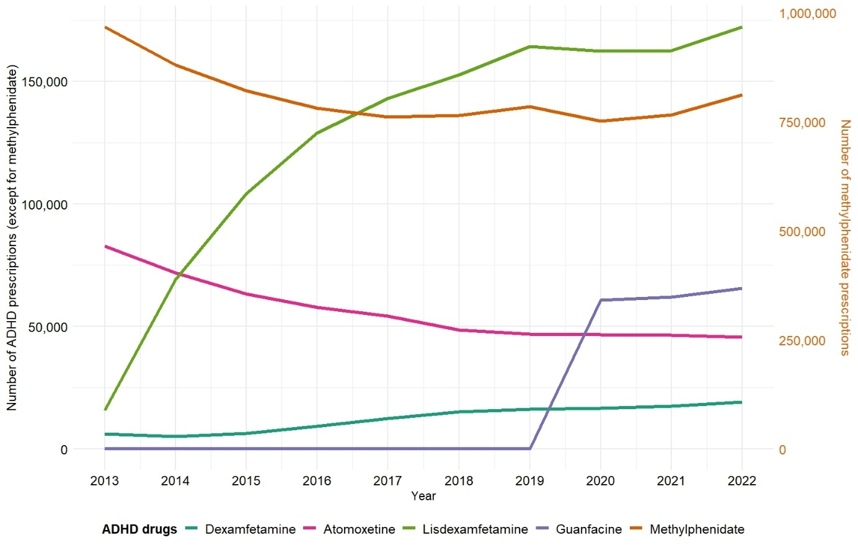
Online Resource 4 Figure 1 shows the number of prescriptions of ADHD drugs per year for males. Notably, the number of methylphenidate prescriptions is shown on the secondary y-axis. Guanfacine received approval in 2015, which may explain its lower counts. Data regarding guanfacine were available from 2020 onwards.
Online Resource 4 Figure 2) Number of ADHD prescriptions for females.
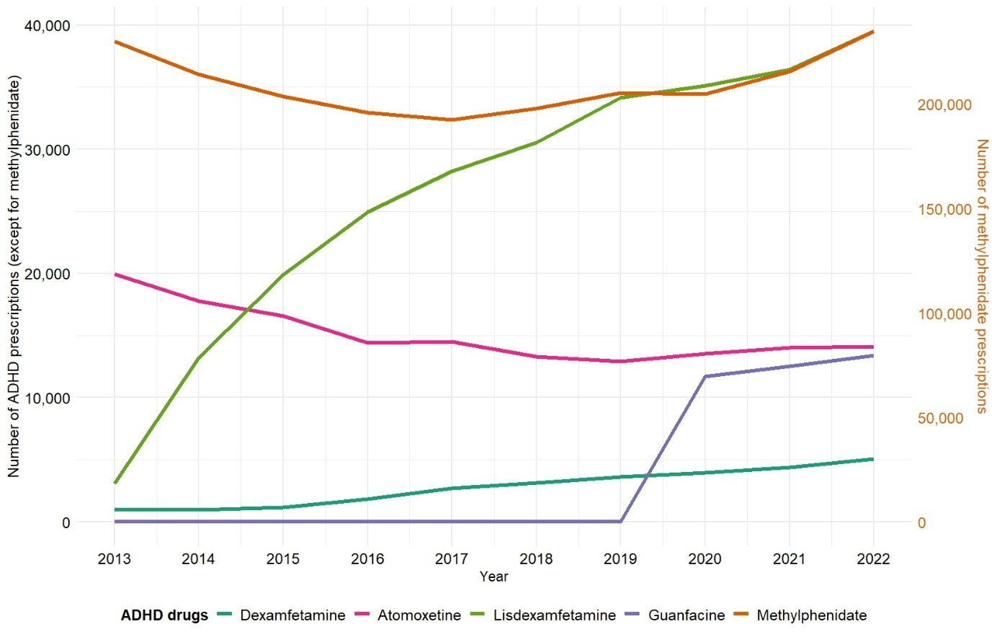
Online Resource 4 Figure 2 shows the number of prescriptions of ADHD drugs per year for females. Notably, the number of methylphenidate prescriptions is shown on the secondary y-axis. Guanfacine received approval in 2015, which may explain its lower counts. Data regarding guanfacine were available from 2020 onwards.

