Supplementary Figures:

Figure S2. Forest plot showing Odds Ratios and 95% Confidence Intervals for the TS vs TS+FTLB comparisons.

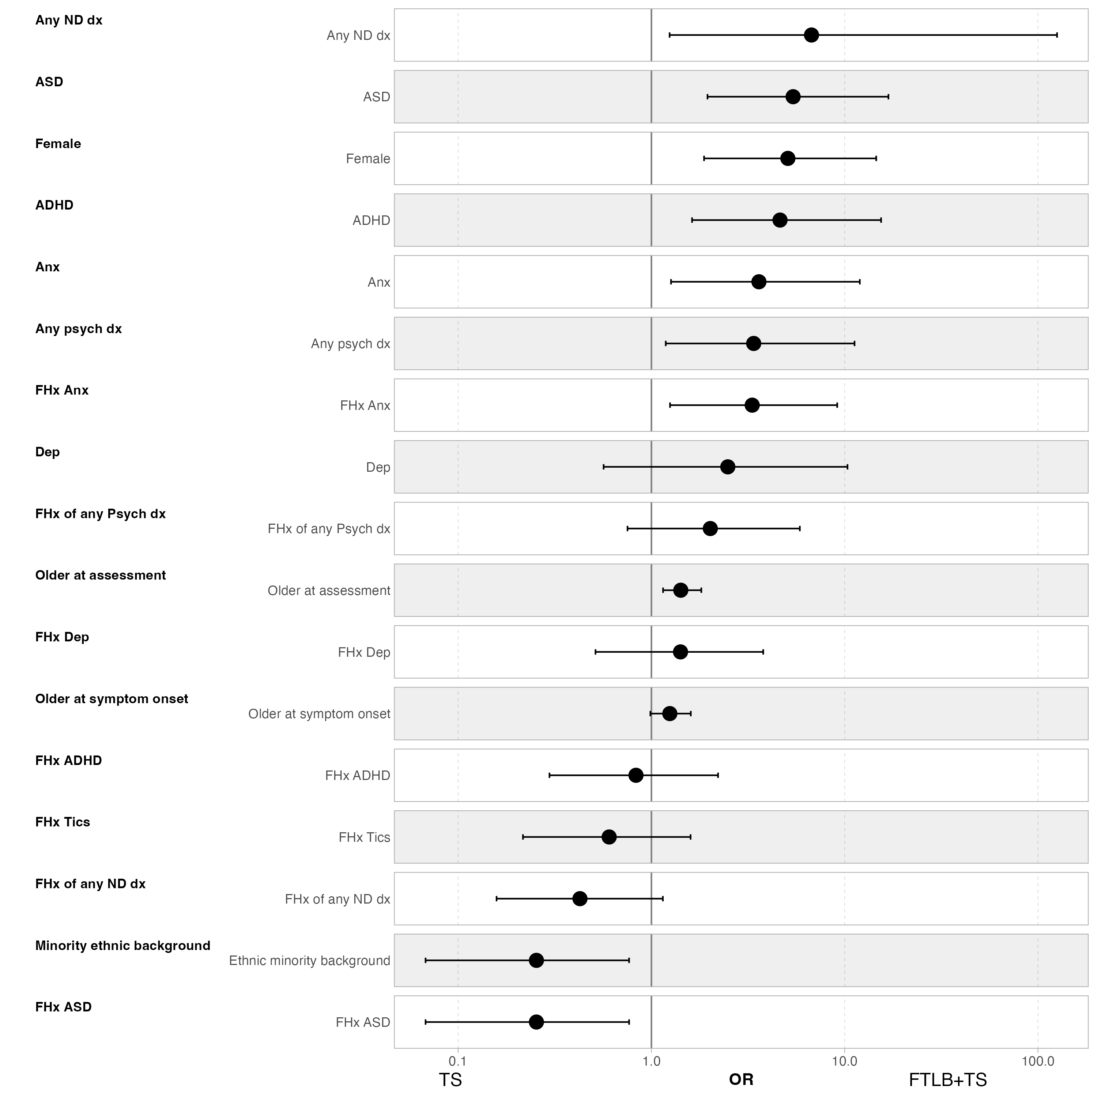

Figure S3. Forest plot showing Odds Ratios and 95% Confidence Intervals for the FTLB vs TS+FTLB comparisons.

