Title: Sensory processing and neurodevelopmental disorder traits in 4- to 5-year-old Dutch children adjusted for sex, neurodevelopment in infancy and IQ
Journal name: European Child and Adolescence Psychiatry
Author names: Selena J Rosinda, Pieter J Hoekstra, Mijna Hadders-Algra, Kirsten R. Heineman, Annelies de Bildt
Corresponding author information: s.j.rosinda@umcg.nl | University of Groningen, University Medical Center Groningen, Department of Paediatrics, Beatrix Children’s Hospital, Division of Developmental Neurology, Groningen, the Netherlands | Accare Child Study Center, Groningen, the Netherlands | The Research School of Behavioural and Cognitive Neurosciences, University of Groningen, Groningen, the Netherlands

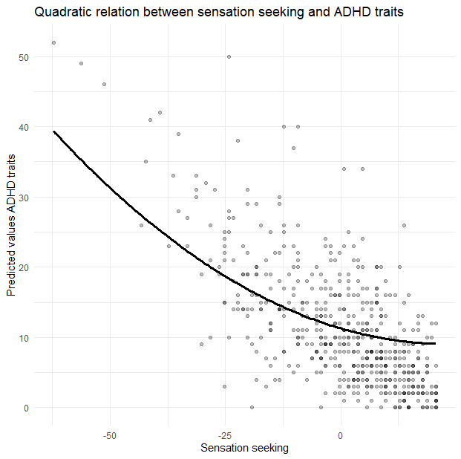
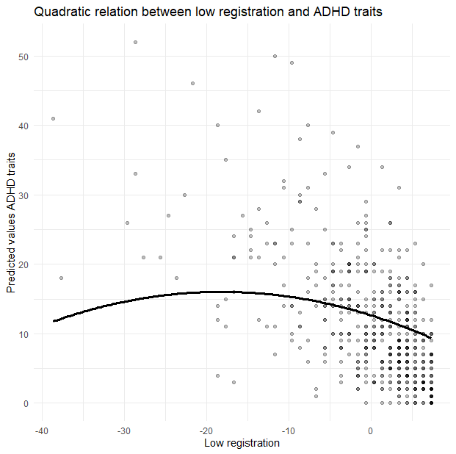
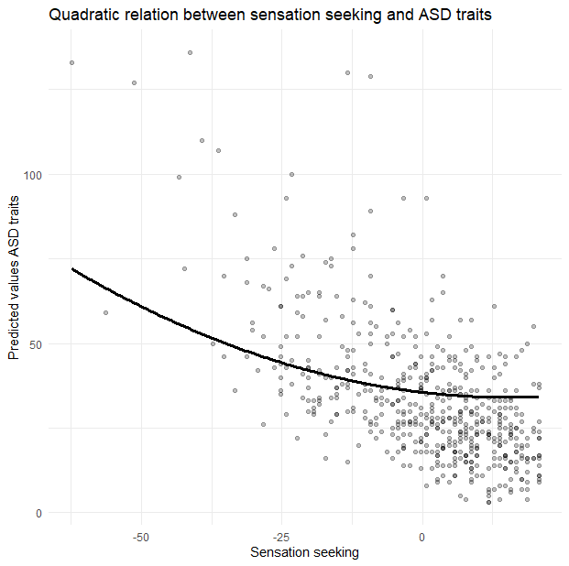
Supplementary Figure 1. Plots significant nonlinear regression lines.

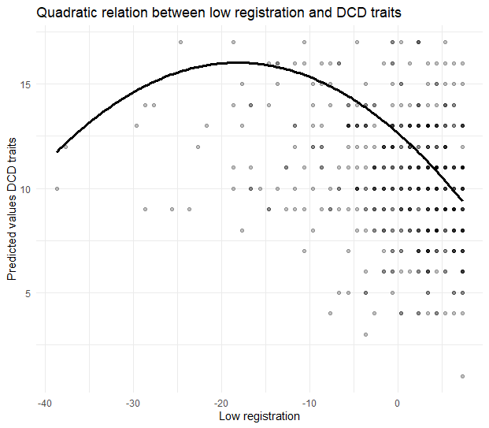

Supplementary Table S1a. Scores sensory processing and neurodevelopmental disorder traits for the children with a typical and atypical infant neurodevelopment.
 | Typical infant neurodevelopment  (n = 317) | Atypical infant neurodevelopment  (n = 240)
SP-NL; Low registration: 1/2/3/4ª; n (%) | 54 (17%), 213 (67%), 29 (9%), 14 (4%) | 36 (15%), 148 (62%), 19 (8%), 29 (12%)
SP-NL; Sensation seeking: 1/2/3/4ª; n (%) | 72 (23%), 186 (59%), 39 (12%), 13 (4%) | 58 (24%), 133 (55%), 28 (12%), 13 (5%)
SP-NL; Sensory sensitivity: 1/2/3/4ª; n (%) | 73 (23%), 184 (58%), 34 (11%), 19 (6%) | 57 (24%), 125 (52%), 27 (11%), 23 (10%)
SP-NL; Sensation avoiding: 1/2/3/4ª; n (%) | 79 (25%), 190 (60%), 28 (9%), 13 (4%) | 56 (23%), 143 (60%), 20 (8%), 13 (5%)
SRS-2; above the cut-off: n (%) | 44 (14%) | 43 (18%)
CPRS-R; above the cut-off: n (%) | 31 (10%) | 20 (8%)
SDQ | * | *
CTRS-R; above the cut-off: n (%) | 8 (3%) | 7 (3%)
M-ABC-2; below the cut-off: n (%) | 73 (23%) | 72 (30%)
SRS-2 and CPRS-R above the cut-off: n (%) | 13 (4%) | 15 (6%)
SRS-2 above and M-ABC-2 below the cut-off: n (%) | 15 (5%) | 23 (10%)
CPRS-R above and M-ABC-2 below the cut-off: n (%) | 10 (3%) | 10 (4%)
SRS-2, CPRS-R above and M-ABC-2 below the cut-off: n (%) | 0 (0%) | 3 (1%)
WPPSI-IV-NL; below the cut-off: n (%) | 2 (1%) | 8 (3%)
Note. SP-NL = Sensory Profile, SRS-2 = Social Responsiveness Scale, SDQ = Strengths and Difficulties Questionnaire, CPRS-R = Conners Parent Rating Scale Revised, CTRS-R = Conners Teacher Rating Scale Revised, WPPSI-IV-NL = Wechsler Preschool and Primary Scale of Intelligence, M-ABC-2 = Movement Assessment Battery for Children second edition.
ª 1: less than others, 2: comparable to others, 3: more than others, 4: much more than others
* No cut-off scores are available for the SDQ teacher-based proxy for the severity of ASD traits

Supplementary Table 1b. Scores severity of neurodevelopmental disorder traits for children with different sensory processing patterns, per quadrant.
Low registration
 | Less  than others  (n = 90) | Comparable  to others  (n = 361) | More  than others  (n = 48) | Much more than others  (n = 43)
SRS-2; above the cut-off: n (%) | 0 (0%) | 36 (10%) | 15 (31%) | 29 (67%)
CPRS-R; above the cut-off: n (%) | 1 (1%) | 17 (5%) | 14 (29%) | 17 (40%)
SDQ | * | * | * | *
CTRS-R; above the cut-off: n (%) | 0 (0%) | 10 (3%) | 4 (8%) | 1 (2%)
M-ABC-2; below the cut-off: n (%) | 13 (14%) | 87 (24%) | 21 (44%) | 19 (44%)
SRS-2 and CPRS-R above the cut-off: n (%) | 0 (0%) | 2 (1%) | 8 (17%) | 16 (37%)
SRS-2 above and M-ABC-2 below the cut-off: n (%) | 0 (0%) | 12 (3%) | 9 (19%) | 14 (33%)
CPRS-R above and M-ABC-2 below the cut-off: n (%) | 1 (1%) | 6 (2%) | 6 (13%) | 7 (16%)
SRS-2, CPRS-R above and M-ABC-2 below the cut-off: n (%) | 0 (0%) | 1 (0.3%) | 2 (4%) | 0 (0%)
WPPSI-IV-NL; below the cut-off: n (%) | 1 (1%) | 5 (1%) | 0 (0%) | 3 (7%)
Sensation seeking
 | Less  than others  (n = 130) | Comparable  to others  (n = 319) | More  than others  (n = 67) | Much more than others  (n = 26)
SRS-2; above the cut-off: n (%) | 2 (2%) | 36 (11%) | 23 (34%) | 19 (73%)
CPRS-R; above the cut-off: n (%) | 2 (2%) | 18 (6%) | 14 (21%) | 15 (58%)
SDQ | * | * | * | *
CTRS-R; above the cut-off: n (%) | 0 (0%) | 9 (3%) | 4 (6%) | 2 (8%)
M-ABC-2; below the cut-off: n (%) | 33 (25%) | 69 (22%) | 22 (33%) | 16 (62%)
SRS-2 and CPRS-R above the cut-off: n (%) | 0 (0%) | 7 (2%) | 7 (10%) | 12 (46%)
SRS-2 above and M-ABC-2 below the cut-off: n (%) | 1 (1%) | 11 (3%) | 12 (18%) | 11 (42%)
CPRS-R above and M-ABC-2 below the cut-off: n (%) | 0 (0%) | 8 (3%) | 3 (5%) | 9 (35%)
SRS-2, CPRS-R above and M-ABC-2 below the cut-off: n (%) | 0 (0%) | 1 (0.3%) | 2 (3%) | 0 (0%)
WPPSI-IV-NL; below the cut-off: n (%) | 1 (1%) | 4 (1%) | 3 (5%) | 1 (4%)
Sensory sensitivity
 | Less  than others  (n = 130) | Comparable  to others  (n = 309) | More  than others  (n = 61) | Much more than others  (n = 42)
SRS-2; above the cut-off: n (%) | 2 (2%) | 30 (10%) | 18 (30%) | 30 (71%)
CPRS-R; above the cut-off: n (%) | 1 (1%) | 23 (7%) | 6 (10%) | 19 (45%)
SDQ | * | * | * | *
CTRS-R; above the cut-off: n (%) | 0 (%) | 9 (3%) | 3 (5%) | 3 (7%)
M-ABC-2; below the cut-off: n (%) | 27 (21%) | 69 (22%) | 23 (38%) | 21 (50%)
SRS-2 and CPRS-R above the cut-off: n (%) | 0 (0%) | 4 (1%) | 5 (8%) | 17 (41%)
SRS-2 above and M-ABC-2 below the cut-off: n (%) | 1 (1%) | 10 (3%) | 8 (13%) | 16 (38%)
CPRS-R above and M-ABC-2 below the cut-off: n (%) | 0 (0%) | 8 (3%) | 2 (3%) | 10 (24%)
SRS-2, CPRS-R above and M-ABC-2 below the cut-off: n (%) | 0 (0%) | 1 (0.3%) | 0 (0%) | 2 (5%)
WPPSI-IV-NL; below the cut-off: n (%) | 3 (2%) | 3 (1%) | 0 (0%) | 3 (7%)
Sensation avoiding
 | Less  than others  (n = 135) | Comparable  to others  (n = 333) | More  than others  (n = 48) | Much more than others  (n = 26)
SRS-2; above the cut-off: n (%) | 3 (2%) | 38 (11%) | 16 (33%) | 23 (89%)
CPRS-R; above the cut-off: n (%) | 4 (3%) | 23 (7%) | 8 (17%) | 14 (54%)
SDQ | * | * | * | *
CTRS-R; above the cut-off: n (%) | 1 (1%) | 12 (4%) | 0 (0%) | 2 (8%)
M-ABC-2; below the cut-off: n (%) | 27 (20%) | 85 (26%) | 16 (33%) | 12 (46%)
SRS-2 and CPRS-R above the cut-off: n (%) | 0 (0%) | 9 (3%) | 4 (8%) | 13 (50%)
SRS-2 above and M-ABC-2 below the cut-off: n (%) | 0 (0%) | 17 (5%) | 6 (13%) | 10 (38%)
CPRS-R above and M-ABC-2 below the cut-off: n (%) | 1 (1%) | 11 (3%) | 3 (6%) | 5 (19%)
SRS-2, CPRS-R above and M-ABC-2 below the cut-off: n (%) | 0 (0%) | 2 (1%) | 0 (0%) | 1 (4%)
WPPSI-IV-NL; below the cut-off: n (%) | 1 (1%) | 5 (15%) | 0 (0%) | 3 (12%)
Note. SP-NL = Sensory Profile, SRS-2 = Social Responsiveness Scale, SDQ = Strengths and Difficulties Questionnaire, CPRS-R = Conners Parent Rating Scale Revised, CTRS-R = Conners Teacher Rating Scale Revised, WPPSI-IV-NL = Wechsler Preschool and Primary Scale of Intelligence, M-ABC-2 = Movement Assessment Battery for Children second edition. * No cut-off scores are available for the SDQ teacher-based proxy for the severity of ASD traits
Table S2. Multivariate effects of the initial multivariate polynomial regression models examining the relation between sensory processing and neurodevelopmental traits including the moderating role of the child’s sex (boy/girl), infant neurodevelopment (typical/atypical) and intelligence level (continuous) at 4-5 years.
Parent-reported model (n=536)

 | Pillai’s Trace | F(3,524) | p | ηp²
Low registration | .0035 | .560 | .623 | .0035
Sensation seeking | .015 | 2.5 | .063 | .015
Sensory sensitivity | .011 | 1.8 | .149 | .011
Sensation avoiding | .0084 | 1.4 | .240 | .0084
Low registration quadratic term | .0046 | .77 | .512 | .0046
Sensation seeking quadratic term | .0040 | .66 | .576 | .0040
Sensory sensitivity quadratic term | .0054 | .90 | .441 | .0054
Sensation avoiding quadratic term | .0088 | 1.5 | .222 | .0088
Sex | .010 | 1.7 | .171 | .010
Infant neurodevelopment | .0067 | 1.1 | .339 | .0067
Intelligence | .10 | 19 | <.001 | .10
Low registration x Sex | .0038 | .63 | .599 | .0038
Sensation seeking x Sex | .0023 | .39 | .762 | .0023
Sensory sensitivity x Sex | .0053 | .89 | .446 | .0053
Sensation avoiding x Sex | .0055 | .92 | .430 | .0055
Low registration quadratic term x Sex | .0039 | .65 | .582 | .0039
Sensation seeking quadratic term x Sex | .0022 | .37 | .777 | .0022
Sensory sensitivity quadratic term x Sex | .0021 | .35 | .787 | .0021
Sensation avoiding quadratic term x Sex | .0024 | .40 | .755 | .0024
Low registration x Infant neurodevelopment | .0012 | .21 | .893 | .0012
Sensation seeking x Infant neurodevelopment | .0088 | 1.5 | .220 | .0088
Sensory sensitivity x Infant neurodevelopment | .0045 | .76 | .518 | .0045
Sensation avoiding x Infant neurodevelopment | .0034 | .57 | .634 | .0034
Low registration quadratic term x Infant neurodevelopment | .0076 | 1.3 | .285 | .0076
Sensation seeking quadratic term x Infant neurodevelopment | .010 | 1.7 | .164 | .010
Sensory sensitivity quadratic term x Infant neurodevelopment | .0043 | .71 | .546 | .0043
Sensation avoiding quadratic term x Infant neurodevelopment | .0044 | .74 | .531 | .0044
Low registration x Intelligence | .00081 | .13 | .940 | .00081
Sensation seeking x Intelligence | .00072 | .12 | .948 | .00072
Sensory sensitivity x Intelligence | .0050 | .84 | .471 | .0050
Sensation avoiding x Intelligence | .0044 | .73 | .534 | .0044
Low registration quadratic term x Intelligence | .0067 | 1.1 | .344 | .0067
Sensation seeking quadratic term x Intelligence | .0059 | .99 | .398 | .0059
Sensory sensitivity quadratic term x Intelligence | .0060 | 1.0 | .390 | .0060
Sensation avoiding quadratic term x Intelligence | .0094 | 1.6 | .193 | .0094
Teacher-reported model (n=296)

 | Pillai’s Trace | F(3,286) | p | ηp²
Low registration | .0039 | .34 | .800 | .0039
Sensation seeking | .011 | .96 | .413 | .011
Sensory sensitivity | .014 | 1.2 | .316 | .014
Sensation avoiding | .022 | 1.9 | .129 | .022
Low registration quadratic term | .013 | 1.1 | .341 | .013
Sensation seeking quadratic term | .0033 | .28 | .838 | .0033
Sensory sensitivity quadratic term | .0074 | .64 | .592 | .0074
Sensation avoiding quadratic term | .0044 | .38 | .767 | .0044
Sex | .043 | 3.9 | .010† | .043
Infant neurodevelopment | .0043 | .37 | .777 | .0043
Intelligence | .046 | 4.2 | .007† | .046
Low registration x Sex | .0033 | .29 | .834 | .0033
Sensation seeking x Sex | .0081 | .70 | .552 | .0081
Sensory sensitivity x Sex | .015 | 1.3 | .273 | .015
Sensation avoiding x Sex | .010 | .85 | .470 | .010
Low registration quadratic term x Sex | .022 | 1.9 | .130 | .022
Sensation seeking quadratic term x Sex | .0030 | .26 | .856 | .0030
Sensory sensitivity quadratic term x Sex | .014 | 1.2 | .297 | .014
Sensation avoiding quadratic term x Sex | .0016 | .14 | .936 | .0016
Low registration x Infant neurodevelopment | .015 | 1.30 | .276 | .015
Sensation seeking x Infant neurodevelopment | .0070 | .61 | .611 | .0070
Sensory sensitivity x Infant neurodevelopment | .0095 | .82 | .484 | .0095
Sensation avoiding x Infant neurodevelopment | .0040 | .35 | .791 | .0040
Low registration quadratic term x Infant neurodevelopment | .015 | 1.3 | .280 | .015
Sensation seeking quadratic term x Infant neurodevelopment | .016 | 1.4 | .257 | .016
Sensory sensitivity quadratic term x Infant neurodevelopment | .013 | 1.1 | .334 | .013
Sensation avoiding quadratic term x Infant neurodevelopment | .016 | 1.4 | .245 | .016
Low registration x Intelligence | .0064 | .56 | .644 | .0064
Sensation seeking x Intelligence | .017 | 1.5 | .228 | .017
Sensory sensitivity x Intelligence | .015 | 1.3 | .262 | .015
Sensation avoiding x Intelligence | .0018 | .15 | .929 | .0018
Low registration quadratic term x Intelligence | .013 | 1.1 | .332 | .013
Sensation seeking quadratic term x Intelligence | .014 | 1.2 | .300 | .014
Sensory sensitivity quadratic term x Intelligence | .0054 | .47 | .705 | .0054
Sensation avoiding quadratic term x Intelligence | .0051 | .44 | .722 | .0051
Note. †P-value does not remain significant after correcting for multiple testing. The bold p-value indicates statistical significance.

Table S3. Multivariate effects of the multivariate polynomial regression models examining the relation between sensory processing and neurodevelopmental traits, while adjusting for the child’s sex (boy/girl), infant neurodevelopment (typical/atypical) and intelligence level (continuous) at 4-5 years.
Parent-reported model (n=536)

 | Pillai’s Trace | F(3,524) | p | ηp²
Low registration | .075 | 14 | <.001 | .075
Sensation seeking | .10 | 19 | <.001 | .10
Sensory sensitivity | .035 | 6.4 | <.001 | .035
Sensation avoiding | .017 | 3.0 | .031† | .017
Low registration quadratic term | .042 | 7.7 | <.001 | .042
Sensation seeking quadratic term | .031 | 5.5 | <.001 | .031
Sensory sensitivity quadratic term | .0033 | .56 | .630 | .0033
Sensation avoiding quadratic term | .012 | 2.1 | .094 | .012
Sex | .021 | 3.8 | .011† | .021
Infant neurodevelopment | .0022 | .39 | .762 | .0022
Intelligence | .20 | 42 | <.001 | .20
Teacher-reported model (n=296)

 | Pillai’s Trace | F(3,286) | p | ηp²
Low registration | .046 | 4.5 | .004 | .046
Sensation seeking | .073 | 7.4 | <.001 | .073
Sensory sensitivity | .012 | 1.1 | .344 | .012
Sensation avoiding | .031 | 3.0 | .031† | .031
Low registration quadratic term | .012 | 1.2 | .316 | .012
Sensation seeking quadratic term | .039 | 3.8 | .011† | .039
Sensory sensitivity quadratic term | .019 | 1.9 | .135 | .019
Sensation avoiding quadratic term | .0041 | .39 | .764 | .0041
Sex | .061 | 6.1 | <.001 | .061
Infant neurodevelopment | .0055 | .52 | .671 | .0055
Intelligence | .14 | 15 | <.001 | .14
Note. †P-value does not remain significant after correcting for multiple testing. Bold p-values indicate statistical significance.
Supplementary Table S4. The association between sensory processing¹ and neurodevelopmental disorder traits adjusted for sex, neurodevelopment in infancy and intelligence
 | Model with parent-reported ASD/ADHD traits  (n = 536) |  |  |  | Model with teacher-reported ASD/ADHD traits  (n = 296)
Low registration | Pillai’s Trace=.073, F(3,524)=13.8, p<.001, ηp²=.073 |  |  |  | Pillai’s Trace=.036, F(3,286)=3.53, p=.015, ηp²=.036†
 | b (SE) |  | 95%CI | ηp² | b (SE) |  | 95%CI | ηp²
ASD traits | -.57 (.17) |  | [-.89, -.26] | .024 | -.0058 (.028) |  | [-.050, .039] | .00023
ADHD traits | -.37 (.075) |  | [-.52, -.23] | .047 | -.15 (.094) |  | [-.34, .038] | .0085
DCD traits | -.13 (.032) |  | [-.19, -.067] | .030 | -.13 (.042) |  | [-.21, -.044] | .030
Sensation seeking | Pillai’s Trace=.091, F(3,524)=17.4, p<.001, ηp²=.091 |  |  |  | Pillai’s Trace=.047, F(3,286)=4.70, p=.003, ηp²=.047
ASD traits | -.19 (.065) |  | [-.32, -.067] | .017 | -.010 (.011) |  | [-.028, .0085] | .0038
ADHD traits | -.19 (.028) |  | [-.25, -.13] | .073 | -.13 (.048) |  | [-.21, -.054] | .037
DCD traits | .030 (.013) |  | [.0041, .055] | .010 | .019 (.017) |  | [-.015, .053] | .0043
Sensory sensitivity | Pillai’s Trace=.042, F(3,524)=7.66, p<.001, ηp²=.042 |  |  |  | Pillai’s Trace=.0028, F(3,286)=.265, p=.851, ηp²=.0028
ASD traits | -.36 (.12) |  | [-.56, -.15] | .022 | -.0068 (.020) |  | [-.040, .027] | .00055
ADHD traits | -.19 (.048) |  | [-.29, -.097] | .029 | -.043 (.084) |  | [-.19, .10] | .0012
DCD traits | -.044 (.022) |  | [-.086, -.0023] | .0081 | -.024 (.033) |  | [-.087, .039] | .0020
Sensation avoiding | Pillai’s Trace=.022, F(3,524)=3.88, p=.009, ηp²=.022 |  |  |  | Pillai’s Trace=.031, F(3,286)=3.01, p=.031, ηp²=.031†
ASD traits | -.22 (.095) |  | [-.38, -.068] | .015 | -.012 (.013) |  | [-.037, .013] | .0033
ADHD traits | .020 (.039) |  | [-.051, .092] | .0060 | .11 (.059) |  | [.0050, .22] | .015
DCD traits | .016 (.015) |  | [-.015, .047] | .0020 | .023 (.021) |  | [-.023, .070] | .0033
Low registration quadratic term | Pillai’s Trace=.054, F(3,524)=10.0, p<.001, ηp²=.054 |  |  |  | ††
ASD traits | .012 (.010) |  | [-.00053, .025] | .0067
ADHD traits | -.010 (.0032) |  | [-.016, -.0042] | .021
DCD traits | -.0044 (.0015) |  | [-.0070, -.0017] | .020
Sensation seeking quadratic term | Pillai’s Trace=.042, F(3,524)=7.64, p<.001, ηp²=.042 |  |  |  | ††
ASD traits | .0063 (.0038) |  | [.0022, .010] | .017
ADHD traits | .0042 (.0010) |  | [.0023, .0061] | .034
DCD traits | .00074 (.00043) |  | [-.000091, .0016] | .0058
Sex | Pillai’s Trace=.021, F(3,524)=3.72, p=.011, ηp²=.021 |  |  |  | Pillai’s Trace=.059, F(3,286)=5.99, p<.001, ηp²=.059
ASD traits | -2.4 (1.1) |  | [-4.6, -.22] | .0088 | -.64 (.18) |  | [-.98, -.29] | .043
ADHD traits | -.80 (.51) |  | [-1.8, .22] | .0045 | -2.4 (.75) |  | [-3.9, -.88] | .033
DCD traits | -.60 (.23) |  | [-1.0, -.16] | .013 | -.70 (.34) |  | [-1.4, -.053] | .015
Infant neurodevelopment | Pillai’s Trace=.0031, F(3,524)=.545, p=.652, ηp²=.0031 |  |  |  | Pillai’s Trace=.0062, F(3,286)=.595, p=.619, ηp²=.0062
ASD traits | .80 (1.1) |  | [-1.4, 3.0] | .0095 | -.20 (.18) |  | [-.55, .16] | .0042
ADHD traits | .54 (.52) |  | [-.48, 1.6] | .0021 | .18 (.77) |  | [-1.3, 1.7] | .00019
DCD traits | -.11 (.23) |  | [-.55, .34] | .00042 | -.027 (.34) |  | [-.69, .64] | .000022
Intelligence | Pillai’s Trace=.194, F(3,524)=42.1, p<.001, ηp²=.194 |  |  |  | Pillai’s Trace=.134, F(3,286)=14.8, p<.001, ηp²=.134
ASD traits | -.26 (.041) |  | [-.34, -.18] | .072 | -.0056 (.0079) |  | [-.018, .0070] | .0027
ADHD traits | -.044 (.018) |  | [-.081, -.0073] | .010 | -.081 (.027) |  | [-.13, -.027] | .029
DCD traits | -.080 (.0083) |  | [-.096, -.064] | .155 | -.076 (.012) |  | [-.10, -.052] | .122
Note. ¹ Low registration, sensation seeking, sensory sensitivity and sensation avoiding. † P-value does not remain significant after correcting for multiple testing. †† variable not included in the model, as the prior model showed that the multivariate effect of this variable was not significant. ASD = Autism Spectrum Disorder, ADHD = Attention Deficit Hyperactivity Disorder, DCD = Developmental Coordination Disorder. Lower scores on sensory quadrants indicate more sensory-related behaviour. For all neurodevelopmental disorder traits, higher values indicate more severe difficulties. Bold values indicate statistical significance.
Supplementary Table S5. Comparison mean scores sensory quadrants between the current sample and the Sensory Profile Dutch norm sample.
 | Current sample (n = 542)  M (SD) | Dutch norm sample (n = 667)  M (SD) | p
Low registration | 67.66 (7.20) | 67.58 (5.50) | .831
Sensation seeking | 109.29 (14.26) | 107.98 (12.35) | .092
Sensory sensitivity | 87.88 (9.96) | 88.07 (7.64) | .715
Sensation avoiding | 124.63 (13.14) | 122.32 (11.74) | .001
Note. Bold p-value indicates statistical significance.

