- Supplementary material
  - Tables
Table S1. Logistic regression results for PGS across group comparisons.
 | PGS | Estimate (CI 95%) | P value | P_{FDR} | Nagelkerke's pseudo R² |  |  | LRT P value | LRT_{FDR}
FEOP vs.  HC | PRS_{SZ} | 0.32 (0.01, 0.63) | 0.04 | 0.09 |  | 0.02 | 0.04 |  |  | 0.08
FEOP vs.  HC | PRS_{BP} | 0.40 (0.10, 0.70) | 0.01 | 0.03 |  | 0.03 | 0.01 |  |  | 0.03
FEOP vs.  HC | PRS_{MDD} | 0.27 (-0.03, 0.57) | 0.08 | 0.13 |  | 0.01 | 0.08 |  |  | 0.13
FEOP vs.  HC | PRS_{ADHD} | 0.59 (0.26, 0.93) | <0.01 | <0.01 |  | 0.05 | <0.01 |  |  | <0.01
FEOP vs.  HC | PRS_{ANX} | -0.19 (-0.46, 0.09) | 0.19 | 0.25 |  | 0.01 | 0.18 |  |  | 0.24
FEOP vs.  HC | PRS_{IQ} | -0.15 (-0.43, 0.13) | 0.30 | 0.34 |  | <0.01 | 0.30 |  |  | 0.34
FEOP vs.  HC | PRS_{CP} | -0.10 (-0.38, 0.17) | 0.46 | 0.46 |  | <0.01 | 0.46 |  |  | 0.46
FEOP vs.  HC | PRS_{EA} | -0.37 (-0.67, -0.07) | 0.01 | 0.04 |  | 0.02 | 0.01 |  |  | 0.03
SzBpO vs.  HC | PRS_{SZ} | 0.23 (-0.04, 0.50) | 0.10 | 0.20 |  | 0.01 | 0.10 |  |  | 0.19
SzBpO vs.  HC | PRS_{BP} | 0.36 (0.09, 0.64) | 0.01 | 0.04 |  | 0.03 | 0.01 |  |  | 0.03
SzBpO vs.  HC | PRS_{MDD} | 0.29 (0.02, 0.56) | 0.04 | 0.10 |  | 0.02 | 0.04 |  |  | 0.09
SzBpO vs.  HC | PRS_{ADHD} | 0.49 (0.20, 0.78) | <0.01 | 0.01 |  | 0.05 | <0.01 |  |  | 0.01
SzBpO vs.  HC | PRS_{ANX} | 0.05 (-0.21, 0.31) | 0.72 | 0.83 |  | <0.01 | 0.72 |  |  | 0.83
SzBpO vs.  HC | PRS_{IQ} | 0.21 (-0.06, 0.49) | 0.13 | 0.20 |  | 0.01 | 0.13 |  |  | 0.20
SzBpO vs.  HC | PRS_{CP} | 0.00 (-0.27, 0.27) | 0.99 | 0.99 |  | <0.01 | 0.99 |  |  | 0.99
SzBpO vs.  HC | PRS_{EA} | -0.20 (-0.48, 0.07) | 0.15 | 0.20 |  | 0.01 | 0.15 |  |  | 0.20
FEOP vs. SzBpO | PRS_{SZ} | 0.04 (-0.22, 0.30) | 0.76 | 1.00 |  | <0.01 | 0.76 |  |  | 1.00
FEOP vs. SzBpO | PRS_{BP} | 0.07 (-0.18, 0.31) | 0.58 | 1.00 |  | <0.01 | 0.58 |  |  | 1.00
FEOP vs. SzBpO | PRS_{MDD} | 0.00 (-0.26, 0.26) | 1.00 | 1.00 |  | <0.01 | 1.00 |  |  | 1.00
FEOP vs. SzBpO | PRS_{ADHD} | 0.02 (-0.24, 0.28) | 0.89 | 1.00 |  | <0.01 | 0.89 |  |  | 1.00
FEOP vs. SzBpO | PRS_{ANX} | -0.19 (-0.43, 0.06) | 0.13 | 0.53 |  | 0.01 | 0.13 |  |  | 0.52
FEOP vs. SzBpO | PRS_{IQ} | -0.29 (-0.56, -0.03) | 0.03 | 0.25 |  | 0.02 | 0.03 |  |  | 0.23
FEOP vs. SzBpO | PRS_{CP} | -0.06 (-0.31, 0.20) | 0.66 | 1.00 |  | <0.01 | 0.66 |  |  | 1.00
FEOP vs. SzBpO | PRS_{EA} | -0.17 (-0.42, 0.09) | 0.20 | 0.53 |  | 0.01 | 0.19 |  |  | 0.52
Note: ADHD, attention deficit and hyperactivity disorder; ANX, anxiety disorder; BP, bipolar disorder; CP, cognitive performance; EA, educational attainment; FEOP, first episode early-onset psychosis; HC, healthy controls; IQ, general intelligence; LRT, likelihood-ratio test; MDD, major depressive disorder; P_{FDR}, false discovery rate–corrected p-value; PGS, polygenic scores; SzBpO, offspring of patients with schizophrenia or bipolar disorder; SZ, schizophrenia. Bold numbers indicate significance at P_{FDR} < 0.05.

Table S2. Logistic regression results for PGS across subgroup comparisons.

 | PGS | Estimate (95% CI) | P value | P_{FDR} | Nagelkerke's pseudo R² | LRT P value | LRT_{FDR}
Na-FEOP vs.  HC | PRS_{SZ} | 0.72 (0.28, 1.17) | <0.01 | <0.01 | 0.06 | <0.01 | <0.01
Na-FEOP vs.  HC | PRS_{BP} | 0.46 (0.07, 0.85) | 0.02 | 0.03 | 0.03 | 0.02 | 0.02
Na-FEOP vs.  HC | PRS_{MDD} | 0.39 (-0.01, 0.80) | 0.06 | 0.07 | 0.02 | 0.05 | 0.06
Na-FEOP vs.  HC | PRS_{ADHD} | 0.94 (0.47, 1.41) | <0.01 | <0.01 | 0.10 | <0.01 | <0.01
Na-FEOP vs.  HC | PRS_{ANX} | -0.26 (-0.61, 0.09) | 0.15 | 0.15 | 0.01 | 0.15 | 0.15
Na-FEOP vs.  HC | PRS_{IQ} | -0.69 (-1.11, -0.26) | <0.01 | <0.01 | 0.06 | <0.01 | <0.01
Na-FEOP vs.  HC | PRS_{CP} | -0.56 (-0.95, -0.17) | 0.01 | 0.01 | 0.05 | <0.01 | 0.01
Na-FEOP vs.  HC | PRS_{EA} | -0.83 (-1.27, -0.39) | <0.01 | <0.01 | 0.09 | <0.01 | <0.01
A-FEOP vs.  HC | PRS_{SZ} | 0.08 (-0.33, 0.48) | 0.69 | 0.83 | <0.01 | 0.69 | 0.83
A-FEOP vs.  HC | PRS_{BP} | 0.25 (-0.13, 0.64) | 0.19 | 0.51 | 0.01 | 0.18 | 0.49
A-FEOP vs.  HC | PRS_{MDD} | 0.07 (-0.31, 0.44) | 0.73 | 0.83 | <0.01 | 0.73 | 0.83
A-FEOP vs.  HC | PRS_{ADHD} | 0.34 (-0.06, 0.74) | 0.09 | 0.46 | 0.02 | 0.09 | 0.45
A-FEOP vs.  HC | PRS_{ANX} | 0.00 (-0.35, 0.35) | 0.99 | 0.99 | <0.01 | 0.99 | 0.99
A-FEOP vs.  HC | PRS_{IQ} | 0.19 (-0.17, 0.56) | 0.30 | 0.60 | 0.01 | 0.30 | 0.59
A-FEOP vs.  HC | PRS_{CP} | 0.30 (-0.08, 0.67) | 0.12 | 0.46 | 0.02 | 0.11 | 0.45
A-FEOP vs.  HC | PRS_{EA} | -0.15 (-0.51, 0.22) | 0.43 | 0.69 | <0.01 | 0.43 | 0.68
Na-FEOP vs.  A-FEOP | PRS_{SZ} | 0.23 (-0.18, 0.65) | 0.28 | 0.38 | 0.01 | 0.28 | 0.37
Na-FEOP vs.  A-FEOP | PRS_{BP} | 0.14 (-0.25, 0.52) | 0.51 | 0.51 | <0.01 | 0.51 | 0.51
Na-FEOP vs.  A-FEOP | PRS_{MDD} | 0.32 (-0.09, 0.73) | 0.13 | 0.20 | 0.02 | 0.12 | 0.19
Na-FEOP vs.  A-FEOP | PRS_{ADHD} | 0.43 (-0.01, 0.86) | 0.06 | 0.11 | 0.04 | 0.05 | 0.10
Na-FEOP vs.  A-FEOP | PRS_{ANX} | -0.15 (-0.51, 0.22) | 0.43 | 0.49 | 0.01 | 0.43 | 0.49
Na-FEOP vs.  A-FEOP | PRS_{IQ} | -0.59 (-1.02, -0.17) | 0.01 | 0.02 | 0.08 | <0.01 | 0.02
Na-FEOP vs.  A-FEOP | PRS_{CP} | -0.58 (-1.00, -0.17) | 0.01 | 0.02 | 0.08 | <0.01 | 0.02
Na-FEOP vs.  A-FEOP | PRS_{EA} | -0.50 (-0.90, -0.09) | 0.02 | 0.04 | 0.06 | 0.01 | 0.03
SzO  vs.  HC | PRS_{SZ} | 0.76 (0.29, 1.22) | <0.01 | 0.01 | 0.08 | <0.01 | 0.01
SzO  vs.  HC | PRS_{BP} | 0.60 (0.14, 1.05) | 0.01 | 0.04 | 0.05 | 0.01 | 0.03
SzO  vs.  HC | PRS_{MDD} | 0.37 (-0.05, 0.78) | 0.08 | 0.16 | 0.02 | 0.08 | 0.15
SzO  vs.  HC | PRS_{ADHD} | 0.37 (-0.07, 0.81) | 0.10 | 0.16 | 0.02 | 0.10 | 0.16
SzO  vs.  HC | PRS_{ANX} | 0.15 (-0.24, 0.55) | 0.45 | 0.59 | <0.01 | 0.45 | 0.59
SzO  vs.  HC | PRS_{IQ} | 0.13 (-0.27, 0.54) | 0.52 | 0.59 | <0.01 | 0.52 | 0.59
SzO  vs.  HC | PRS_{CP} | 0.10 (-0.31, 0.51) | 0.64 | 0.64 | <0.01 | 0.64 | 0.64
SzO  vs.  HC | PRS_{EA} | -0.47 (-0.90, -0.03) | 0.04 | 0.10 | 0.03 | 0.03 | 0.08
BpO  vs.  HC | PRS_{SZ} | 0.06 (-0.23, 0.35) | 0.69 | 0.92 | <0.01 | 0.69 | 0.92
BpO  vs.  HC | PRS_{BP} | 0.29 (-0.01, 0.58) | 0.06 | 0.16 | 0.02 | 0.06 | 0.15
BpO  vs.  HC | PRS_{MDD} | 0.26 (-0.03, 0.56) | 0.08 | 0.16 | 0.02 | 0.07 | 0.15
BpO  vs.  HC | PRS_{ADHD} | 0.49 (0.18, 0.80) | <0.01 | 0.02 | 0.06 | <0.01 | 0.01
BpO  vs.  HC | PRS_{ANX} | 0.01 (-0.27, 0.28) | 0.97 | 0.97 | <0.01 | 0.97 | 0.97
BpO  vs.  HC | PRS_{IQ} | 0.30 (0.01, 0.59) | 0.04 | 0.16 | 0.03 | 0.04 | 0.15
BpO  vs.  HC | PRS_{CP} | 0.01 (-0.28, 0.29) | 0.95 | 0.97 | <0.01 | 0.95 | 0.97
BpO  vs.  HC | PRS_{EA} | -0.06 (-0.35, 0.23) | 0.68 | 0.92 | <0.01 | 0.68 | 0.92
SzO  vs.  BpO | PRS_{SZ} | 0.66 (0.19, 1.13) | 0.01 | 0.05 | 0.06 | <0.01 | 0.03
SzO  vs.  BpO | PRS_{BP} | 0.35 (-0.07, 0.76) | 0.10 | 0.41 | 0.02 | 0.09 | 0.37
SzO  vs.  BpO | PRS_{MDD} | 0.27 (-0.15, 0.68) | 0.20 | 0.41 | 0.01 | 0.20 | 0.40
SzO  vs.  BpO | PRS_{ADHD} | -0.10 (-0.51, 0.31) | 0.64 | 0.73 | <0.01 | 0.63 | 0.72
SzO  vs.  BpO | PRS_{ANX} | 0.21 (-0.20, 0.62) | 0.32 | 0.52 | 0.01 | 0.32 | 0.52
SzO  vs.  BpO | PRS_{IQ} | -0.01 (-0.44, 0.42) | 0.97 | 0.97 | <0.01 | 0.97 | 0.97
SzO  vs.  BpO | PRS_{CP} | 0.17 (-0.26, 0.60) | 0.44 | 0.58 | <0.01 | 0.43 | 0.58
SzO  vs.  BpO | PRS_{EA} | -0.29 (-0.71, 0.13) | 0.18 | 0.41 | 0.01 | 0.17 | 0.40
Na-FEOP  vs.  SzO | PRS_{SZ} | -0.31 (-0.72, 0.11) | 0.15 | 0.22 | 0.02 | 0.15 | 0.22
Na-FEOP  vs.  SzO | PRS_{BP} | -0.03 (-0.42, 0.35) | 0.86 | 0.86 | <0.01 | 0.86 | 0.86
Na-FEOP  vs.  SzO | PRS_{MDD} | 0.06 (-0.35, 0.47) | 0.79 | 0.86 | <0.01 | 0.79 | 0.86
Na-FEOP  vs.  SzO | PRS_{ADHD} | 0.41 (-0.04, 0.86) | 0.07 | 0.22 | 0.04 | 0.07 | 0.22
Na-FEOP  vs.  SzO | PRS_{ANX} | -0.29 (-0.69, 0.10) | 0.15 | 0.22 | 0.02 | 0.14 | 0.22
Na-FEOP  vs.  SzO | PRS_{IQ} | -0.51 (-0.95, -0.07) | 0.02 | 0.19 | 0.06 | 0.02 | 0.15
Na-FEOP  vs.  SzO | PRS_{CP} | -0.36 (-0.78, 0.06) | 0.10 | 0.22 | 0.03 | 0.09 | 0.22
Na-FEOP  vs.  SzO | PRS_{EA} | -0.29 (-0.70, 0.12) | 0.17 | 0.22 | 0.02 | 0.16 | 0.22
A-FEOP vs.  SzO | PRS_{SZ} | -0.50 (-0.99, -0.01) | 0.05 | 0.20 | 0.04 | 0.04 | 0.18
A-FEOP vs.  SzO | PRS_{BP} | -0.29 (-0.74, 0.15) | 0.21 | 0.56 | 0.02 | 0.20 | 0.54
A-FEOP vs.  SzO | PRS_{MDD} | -0.58 (-1.09, -0.06) | 0.03 | 0.20 | 0.05 | 0.02 | 0.17
A-FEOP vs.  SzO | PRS_{ADHD} | -0.07 (-0.54, 0.41) | 0.81 | 0.81 | <0.01 | 0.81 | 0.81
A-FEOP vs.  SzO | PRS_{ANX} | -0.12 (-0.53, 0.29) | 0.55 | 0.74 | <0.01 | 0.55 | 0.74
A-FEOP vs.  SzO | PRS_{IQ} | -0.06 (-0.53, 0.41) | 0.81 | 0.81 | <0.01 | 0.81 | 0.81
A-FEOP vs.  SzO | PRS_{CP} | 0.16 (-0.31, 0.63) | 0.50 | 0.74 | <0.01 | 0.50 | 0.74
A-FEOP vs.  SzO | PRS_{EA} | 0.17 (-0.29, 0.62) | 0.46 | 0.74 | 0.01 | 0.46 | 0.74
Na-FEOP vs.  BpO | PRS_{SZ} | 0.53 (0.12, 0.95) | 0.01 | 0.03 | 0.05 | 0.01 | 0.02
Na-FEOP vs.  BpO | PRS_{BP} | 0.25 (-0.11, 0.62) | 0.18 | 0.24 | 0.01 | 0.17 | 0.23
Na-FEOP vs.  BpO | PRS_{MDD} | 0.17 (-0.23, 0.56) | 0.41 | 0.41 | <0.01 | 0.41 | 0.41
Na-FEOP vs.  BpO | PRS_{ADHD} | 0.35 (-0.03, 0.74) | 0.07 | 0.12 | 0.02 | 0.07 | 0.11
Na-FEOP vs.  BpO | PRS_{ANX} | -0.23 (-0.60, 0.13) | 0.21 | 0.25 | 0.01 | 0.21 | 0.24
Na-FEOP vs.  BpO | PRS_{IQ} | -0.94 (-1.39, -0.48) | <0.01 | <0.01 | 0.13 | <0.01 | <0.01
Na-FEOP vs.  BpO | PRS_{CP} | -0.48 (-0.86, -0.10) | 0.01 | 0.03 | 0.04 | 0.01 | 0.02
Na-FEOP vs.  BpO | PRS_{EA} | -0.68 (-1.10, -0.27) | <0.01 | <0.01 | 0.08 | <0.01 | <0.01
A-FEOP vs.  BpO | PRS_{SZ} | 0.06 (-0.33, 0.46) | 0.75 | 0.83 | <0.01 | 0.75 | 0.83
A-FEOP vs.  BpO | PRS_{BP} | 0.05 (-0.32, 0.42) | 0.78 | 0.83 | <0.01 | 0.78 | 0.83
A-FEOP vs.  BpO | PRS_{MDD} | -0.10 (-0.46, 0.27) | 0.60 | 0.83 | <0.01 | 0.60 | 0.83
A-FEOP vs.  BpO | PRS_{ADHD} | -0.16 (-0.55, 0.23) | 0.44 | 0.83 | <0.01 | 0.44 | 0.83
A-FEOP vs.  BpO | PRS_{ANX} | -0.04 (-0.39, 0.30) | 0.80 | 0.83 | <0.01 | 0.80 | 0.83
A-FEOP vs.  BpO | PRS_{IQ} | -0.04 (-0.43, 0.34) | 0.83 | 0.83 | <0.01 | 0.82 | 0.83
A-FEOP vs.  BpO | PRS_{CP} | 0.33 (-0.05, 0.72) | 0.09 | 0.68 | 0.02 | 0.08 | 0.65
A-FEOP vs.  BpO | PRS_{EA} | -0.08 (-0.45, 0.29) | 0.67 | 0.83 | <0.01 | 0.67 | 0.83
Note: A-FEOP, affective first-episode early-onset psychosis; ADHD, attention deficit and hyperactivity disorder; ANX, anxiety disorder; BP, bipolar disorder; BpO, offspring of patients with bipolar disorder; CP, cognitive performance; EA, educational attainment; HC, healthy controls; IQ, general intelligence; LRT, likelihood-ratio test; MDD, major depressive disorder; Na-FEOP, non-affective first episode early-onset psychosis; P_{FDR}, false discovery rate–corrected p-value; PGS, polygenic scores; SzO, offspring of patients with schizophrenia; SZ, schizophrenia. Bold numbers indicate significance at P_{FDR} < 0.05.

Table S3. Results of logistic regression models for sensitivity analysis A (four MDS covariates).
 | PGS | Estimate (CI 95%) | P value | P_{FDR} | Nagelkerke's pseudo R² | LRT P value | LRT_{FDR}
Group-level
FEOP vs.  HC | PRS_{BP} | 0.39 (0.09, 0.69) | 0.01 | 0.02 | 0.03 | 0.01 | 0.01
FEOP vs.  HC | PRS_{ADHD} | 0.61 (0.28, 0.95) | <0.01 | <0.01 | 0.05 | <0.01 | <0.01
FEOP vs.  HC | PRS_{EA} | -0.36 (-0.66, -0.06) | 0.02 | 0.02 | 0.02 | 0.02 | 0.02
SzBpO vs.  HC | PRS_{BP} | 0.36 (0.08, 0.63) | 0.01 | 0.01 | 0.03 | 0.01 | 0.01
SzBpO vs.  HC | PRS_{ADHD} | 0.50 (0.20, 0.79) | <0.01 | <0.01 | 0.05 | <0.01 | <0.01
Subgroup-level
Na-FEOP  vs.  HC | PRS_{SZ} | 0.71 (0.27, 1.16) | <0.01 | <0.01 | 0.06 | <0.01 | <0.01
Na-FEOP  vs.  HC | PRS_{BP} | 0.45 (0.06, 0.83) | 0.02 | 0.02 | 0.03 | 0.02 | 0.02
Na-FEOP  vs.  HC | PRS_{ADHD} | 0.98 (0.50, 1.46) | <0.01 | <0.01 | 0.10 | <0.01 | <0.01
Na-FEOP  vs.  HC | PRS_{IQ} | -0.72 (-1.15, -0.28) | <0.01 | <0.01 | 0.07 | <0.01 | <0.01
Na-FEOP  vs.  HC | PRS_{CP} | -0.80 (-1.23, -0.36) | <0.01 | <0.01 | 0.08 | <0.01 | <0.01
Na-FEOP  vs.  HC | PRS_{EA} | -0.58 (-0.98, -0.18) | <0.01 | 0.01 | 0.05 | <0.01 | <0.01
Na-FEOP  vs.  A-FEOP | PRS_{IQ} | -0.58 (-1.01, -0.15) | 0.01 | 0.01 | 0.07 | 0.01 | 0.01
Na-FEOP  vs.  A-FEOP | PRS_{CP} | -0.50 (-0.91, -0.09) | 0.02 | 0.02 | 0.06 | 0.01 | 0.01
Na-FEOP  vs.  A-FEOP | PRS_{EA} | -0.57 (-0.99, -0.15) | 0.01 | 0.01 | 0.07 | 0.01 | 0.01
SzO  vs.  HC | PRS_{SZ} | 0.75 (0.28, 1.22) | <0.01 | <0.01 | 0.07 | <0.01 | <0.01
SzO  vs.  HC | PRS_{BP} | 0.61 (0.14, 1.07) | 0.01 | 0.01 | 0.05 | 0.01 | 0.01
BpO  vs. HC | PRS_{ADHD} | 0.49 (0.17, 0.80) | <0.01 | <0.01 | 0.06 | <0.01 | <0.01
Na-FEOP vs. BpO | PRS_{SZ} | 0.54 (0.11, 0.97) | 0.01 | 0.02 | 0.04 | 0.01 | 0.01
Na-FEOP vs. BpO | PRS_{IQ} | -0.92 (-1.39, -0.46) | <0.01 | <0.01 | 0.11 | <0.01 | <0.01
Na-FEOP vs. BpO | PRS_{CP} | -0.62 (-1.04, -0.20) | <0.01 | 0.01 | 0.06 | <0.01 | <0.01
Na-FEOP vs. BpO | PRS_{EA} | -0.44 (-0.83, -0.05) | 0.03 | 0.03 | 0.03 | 0.02 | 0.02
Note: A-FEOP, affective first-episode early-onset psychosis; ADHD, attention deficit and hyperactivity disorder; ANX, anxiety disorder; BP, bipolar disorder; BpO, offspring of patients with bipolar disorder; CP, cognitive performance; EA, educational attainment; FEOP, first episode early-onset psychosis; HC, healthy controls; IQ, general intelligence; LRT, likelihood-ratio test; MDD, major depressive disorder; Na-FEOP, non-affective first episode early-onset psychosis; P_{FDR}, false discovery rate–corrected p-value; PGS, polygenic scores; SzBpO, offspring of patients with schizophrenia or bipolar disorder; SzO, offspring of patients with schizophrenia; SZ, schizophrenia. Bold numbers indicate significance at P_{FDR} < 0.05.
Table S4. Results of logistic regression models for sensitivity analysis B (one participant per family).
 | PGS | Estimate (CI 95%) | P value | P_{FDR} | Nagelkerke's pseudo R² | LRT P value | LRT_{FDR}
Group-level
FEOP vs.  HC | PRS_{BP} | 0.35 (0.04, 0.65) | 0.03 | 0.04 | 0.02 | 0.02 | 0.04
FEOP vs.  HC | PRS_{ADHD} | 0.60 (0.25, 0.95) | <0.01 | <0.01 | 0.06 | <0.01 | <0.01
FEOP vs.  HC | PRS_{EA} | -0.30 (-0.61, 0.00) | 0.05 | 0.05 | 0.02 | 0.05 | 0.05
SzBpO vs.  HC | PRS_{BP} | 0.39 (0.07, 0.71) | 0.02 | 0.02 | 0.04 | 0.02 | 0.02
SzBpO vs.  HC | PRS_{ADHD} | 0.50 (0.16, 0.84) | <0.01 | 0.01 | 0.05 | <0.01 | 0.01
Subgroup-level
Na-FEOP  vs.  HC | PRS_{SZ} | 0.72 (0.27, 1.18) | <0.01 | <0.01 | 0.07 | <0.01 | <0.01
Na-FEOP  vs.  HC | PRS_{BP} | 0.40 (0.01, 0.79) | 0.04 | 0.04 | 0.03 | 0.04 | 0.04
Na-FEOP  vs.  HC | PRS_{ADHD} | 0.95 (0.46, 1.44) | <0.01 | <0.01 | 0.11 | <0.01 | <0.01
Na-FEOP  vs.  HC | PRS_{IQ} | -0.71 (-1.15, -0.26) | <0.01 | <0.01 | 0.07 | <0.01 | <0.01
Na-FEOP  vs.  HC | PRS_{CP} | -0.56 (-0.96, -0.16) | 0.01 | 0.01 | 0.05 | <0.01 | <0.01
Na-FEOP  vs.  HC | PRS_{EA} | -0.75 (-1.18, -0.30) | <0.01 | <0.01 | 0.08 | <0.01 | <0.01
Na-FEOP  vs.  A-FEOP | PRS_{IQ} | -0.60 (-1.02, -0.17) | 0.01 | 0.01 | 0.08 | <0.01 | 0.01
Na-FEOP  vs.  A-FEOP | PRS_{CP} | -0.59 (-1.00, -0.17) | 0.01 | 0.01 | 0.08 | <0.01 | 0.01
Na-FEOP  vs.  A-FEOP | PRS_{EA} | -0.50 (-0.90, -0.09) | 0.02 | 0.02 | 0.06 | 0.01 | 0.01
SzO  vs.  HC | PRS_{SZ} | 0.78 (0.26, 1.29) | <0.01 | 0.01 | 0.08 | <0.01 | <0.01
SzO  vs.  HC | PRS_{BP} | 0.63 (0.13, 1.12) | 0.01 | 0.01 | 0.06 | 0.01 | 0.01
BpO  vs. HC | PRS_{ADHD} | 0.54 (0.18, 0.91) | <0.01 | <0.01 | 0.08 | <0.01 | <0.01
Na-FEOP vs. BpO | PRS_{SZ} | 0.51 (0.07, 0.96) | 0.02 | 0.03 | 0.05 | 0.02 | 0.03
Na-FEOP vs. BpO | PRS_{IQ} | -0.92 (-1.42, -0.42) | <0.01 | <0.01 | 0.13 | <0.01 | <0.01
Na-FEOP vs. BpO | PRS_{CP} | -0.44 (-0.86, -0.02) | 0.04 | 0.04 | 0.04 | 0.03 | 0.03
Na-FEOP vs. BpO | PRS_{EA} | -0.53 (-0.97, -0.09) | 0.02 | 0.03 | 0.05 | 0.01 | 0.03
Note: A-FEOP, affective first-episode early-onset psychosis; ADHD, attention deficit and hyperactivity disorder; ANX, anxiety disorder; BP, bipolar disorder; BpO, offspring of patients with bipolar disorder; CP, cognitive performance; EA, educational attainment; FEOP, first episode early-onset psychosis; HC, healthy controls; IQ, general intelligence; LRT, likelihood-ratio test; MDD, major depressive disorder; Na-FEOP, non-affective first episode early-onset psychosis; P_{FDR}, false discovery rate–corrected p-value; PGS, polygenic scores; SzBpO, offspring of patients with schizophrenia or bipolar disorder; SzO, offspring of patients with schizophrenia; SZ, schizophrenia. Bold numbers indicate significance at P_{FDR} < 0.05.
Table S5. Results of logistic regression models for sensitivity analysis C (FEOP without first-degree relatives with schizophrenia or bipolar disorder).
 | PGS | Estimate (CI 95%) | P value | P_{FDR} | Nagelkerke's pseudo R² | LRT P value | LRT_{FDR}
Group-level
FEOP vs. HC | PRS_{BP} | 0.39 (0.08, 0.70) | 0.01 | 0.02 | 0.03 | 0.01 | 0.02
FEOP vs. HC | PRS_{ADHD} | 0.58 (0.23, 0.92) | <0.01 | <0.01 | 0.05 | <0.01 | <0.01
FEOP vs. HC | PRS_{EA} | -0.30 (-0.60, -0.01) | 0.05 | 0.05 | 0.02 | 0.04 | 0.04
Subgroup-level
Na-FEOP vs. HC | PRS_{SZ} | 0.71 (0.25, 1.18) | <0.01 | 0.01 | 0.06 | <0.01 | <0.01
Na-FEOP vs. HC | PRS_{BP} | 0.48 (0.07, 0.88) | 0.02 | 0.02 | 0.03 | 0.02 | 0.02
Na-FEOP vs. HC | PRS_{ADHD} | 0.86 (0.38, 1.33) | <0.01 | <0.01 | 0.08 | <0.01 | <0.01
Na-FEOP vs. HC | PRS_{IQ} | -0.61 (-1.03, -0.19) | <0.01 | 0.01 | 0.05 | <0.01 | <0.01
Na-FEOP vs. HC | PRS_{CP} | -0.47 (-0.86, -0.07) | 0.02 | 0.02 | 0.03 | 0.02 | 0.02
Na-FEOP vs. HC | PRS_{EA} | -0.73 (-1.17, -0.30) | <0.01 | <0.01 | 0.07 | <0.01 | <0.01
Na-FEOP vs.  A-FEOP | PRS_{IQ} | -0.50 (-0.93, -0.07) | 0.02 | 0.04 | 0.06 | 0.02 | 0.03
Na-FEOP vs.  A-FEOP | PRS_{CP} | -0.51 (-0.94, -0.09) | 0.02 | 0.04 | 0.06 | 0.01 | 0.03
Na-FEOP vs.  A-FEOP | PRS_{EA} | -0.42 (-0.84, 0.00) | 0.05 | 0.05 | 0.04 | 0.04 | 0.04
Na-FEOP vs. BpO | PRS_{SZ} | 0.49 (0.06, 0.92) | 0.02 | 0.03 | 0.04 | 0.02 | 0.03
Na-FEOP vs. BpO | PRS_{IQ} | -0.83 (-1.27, -0.39) | <0.01 | <0.01 | 0.11 | <0.01 | <0.01
Na-FEOP vs. BpO | PRS_{CP} | -0.39 (-0.77, -0.01) | 0.04 | 0.04 | 0.03 | 0.04 | 0.04
Na-FEOP vs. BpO | PRS_{EA} | -0.60 (-1.00, -0.19) | <0.01 | 0.01 | 0.06 | <0.01 | 0.01
Note: A-FEOP, affective first-episode early-onset psychosis; ADHD, attention deficit and hyperactivity disorder; ANX, anxiety disorder; BP, bipolar disorder; BpO, offspring of patients with bipolar disorder; CP, cognitive performance; EA, educational attainment; FEOP, first episode early-onset psychosis; HC, healthy controls; IQ, general intelligence; LRT, likelihood-ratio test; MDD, major depressive disorder; Na-FEOP, non-affective first episode early-onset psychosis; P_{FDR}, false discovery rate–corrected p-value; PGS, polygenic scores; SzBpO, offspring of patients with schizophrenia or bipolar disorder; SzO, offspring of patients with schizophrenia; SZ, schizophrenia. Bold numbers indicate significance at P_{FDR} < 0.05.

  - Figures

Fig. S1 Description of sample divided according to group and subgroup.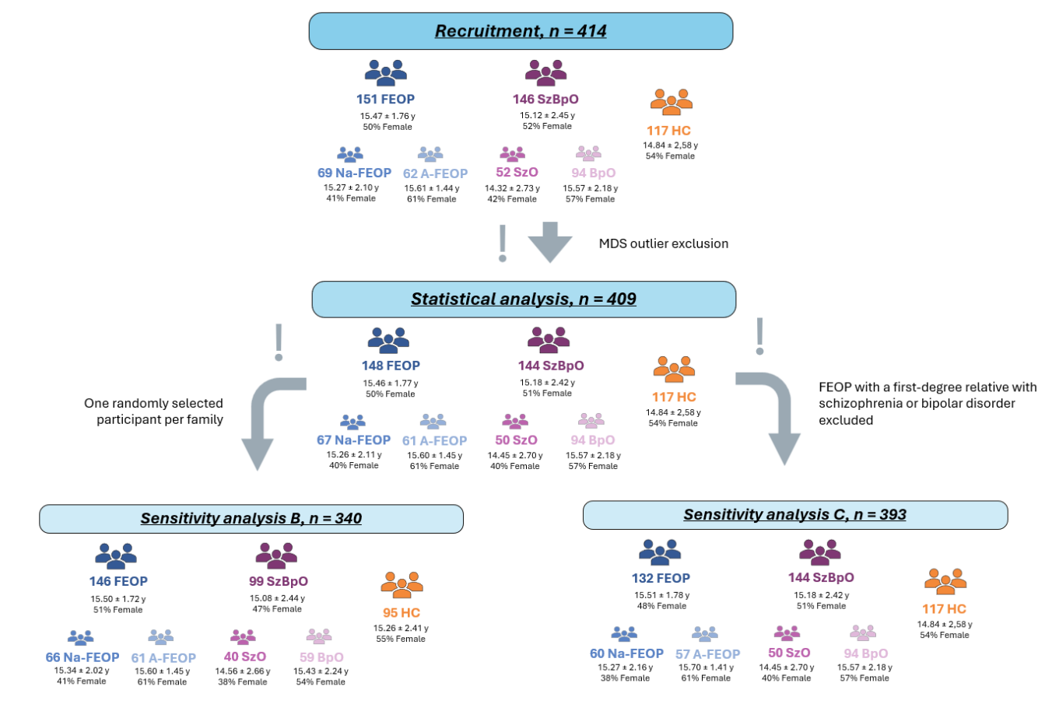
Note: A-FEOP, affective first-episode early-onset psychosis; BpO, offspring of patients with bipolar disorder; FEOP, first-episode early-onset psychosis; HC, healthy controls; Na-FEOP, non-affective first-episode early-onset psychosis; n, sample size; SzBpO, offspring of patients with schizophrenia or bipolar disorder; SzO, offspring of patients with schizophrenia; y, years.

Fig. S2 Multidimensional scaling plot.
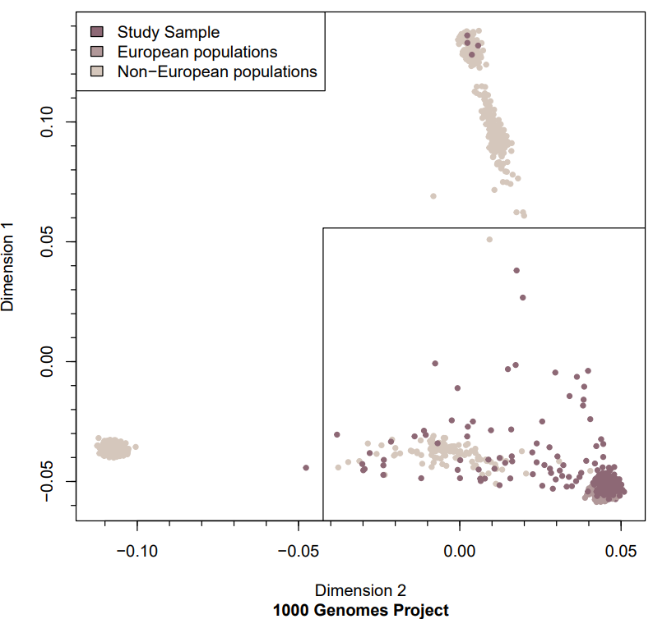
Note: Squares indicate participants excluded as ancestral outliers (±5 SD on the first two MDS components).

Fig. S3 Correlation plot of PGS across all participants.
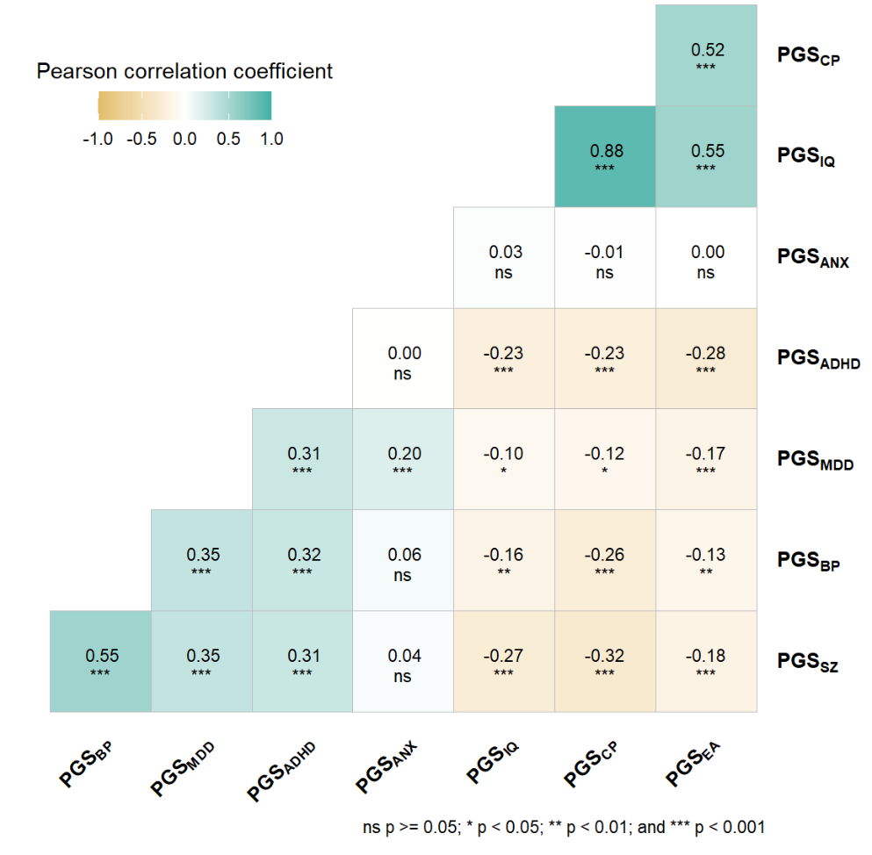
Note: ADHD, attention deficit and hyperactivity disorder; ANX, anxiety disorder; BP, bipolar disorder; CP, cognitive performance; EA, educational attainment; IQ, general intelligence; MDD, major depressive disorder; ns, non-significant; PGS, polygenic scores; SZ, schizophrenia. Asterisks denote the level of significance after FDR correction: * P < 0.05, ** P < 0.01, *** P < 0.005.

