Supplementary Material
Supplementary Methods
Linear mixed-effects model equations
For age-based analyses, the full linear model was:

$$Y_{ij}=β_{0}+u0i+β_{1}×g_{i}+β_{2}×x_{ij}+β_{3}×g_{i}×x_{ij}+u1i × x_{ij}+β_{cov}×C_{i}+ε_{ij}$$

Y: IQ measure (FSIQ, VIQ, or PIQ). i,j: [subject, assessment] index, β: fixed effects, g: group (SSRI-treated vs SSRI-untreated), x: age in years, u0i, u1i: normally distributed random effect, C: covariate vector (sex, center, Wechsler version), ε: normally distributed error term.

For TP-based analyses, the same model structure was applied with TP replacing age as the primary independent variable (x), and raw age added as a fourth covariate.

We assessed the significance of the between-group differences in the intercept and in the slope by means of a log-likelihood ratio test between the full model and any of the reduced models

Reduced group effect model:

$$Y_{ij}=β_{0}+u0i+β_{2}×x_{ij}+u1i×x_{ij}+β_{cov}×C_{i}+ε_{ij}$$

Reduced slope model:

$$Y_{ij}=β_{0}+u0i+β_{1}×g_{i}+β_{2}×x_{ij}+β_{cov}×C_{i}+ε_{ij}$$

Supplementary Tables
Center | Service type | Age range | Ascertainment | Genetic confirmation
Geneva | Longitudinal research cohort | 5–35 years | Recruited through Swiss, French, and Belgian family associations following external diagnosis | FISH
Paris | Reference center for rare diseases | Across lifespan | Referred following external diagnosis | aCGH
Los Angeles | Longitudinal research cohort | Across lifespan | Recruited through clinics, support groups, and online advertisements following external diagnosis | aCGH/FISH
Tel Aviv | Behavioral neurogenetics clinic | Across lifespan | Referred from genetic services and family associations in Israel following external diagnosis | aCGH/FISH
Maastricht | National 22q11DS expertise center | ≥16 years | Referred by GPs or specialists or recruited via research pathways following external diagnosis | aCGH/FISH/MLPA
Utrecht | Specialized 22q11DS psychiatric clinic | 12–25 years | Referred from academic clinical genetics centers following internal or external diagnosis | aCGH/FISH/MLPA
Madrid | Specialized 22q11DS psychiatric clinic | Across lifespan | Referred by clinical geneticists and medical specialists | aCGH/FISH
Leuven | Clinical genetics center | Across lifespan | Referred by primary care providers or medical specialists, or self-referred following internal or external diagnosis | FISH
Noordwijk | Specialized 22q11DS adult clinic | ≥16 years | Referred by primary care providers or medical specialists, following external diagnosis | aCGH/FISH/MLPA
Supplementary Table 1. Recruitment pathways, ascertainment procedures, and genetic confirmation methods across participating centers.
aCGH = array comparative genomic hybridization; FISH = fluorescence in situ hybridization; MLPA = multiplex ligation-dependent probe amplification; 22q11DS = 22q11.2 deletion syndrome.

Supplementary Table 2. Clinical and treatment data available by study center.

 | Proportion of data available
Center | N | Type of SSRI | Indication | Perceived effectiveness | Side effects
Geneva | 54 | 54/54 (100%) | 54/54 (100%) | 35/54 (65%) | 0
Paris | 31 | 31/31 (100%) | 0 | 5/31 (16%) | 0
Los Angeles | 28 | 28/28 (100%) | 20/28 (71%) | 0 | 0
Tel Aviv | 19 | 19/19 (100%) | 19/19 (100%) | 19/19 (100%) | 19/19 (100%)
Maastricht | 18 | 18/18 (100%) | 15/18 (83%) | 13/18 (72%) | 14/18 (78%)
Utrecht | 12 | 12/12 (100%) | 9/12 (75%) | 0 | 1/12 (8%)
Madrid | 11 | 11/11 (100%) | 2/11 (18%) | 0 | 0
Leuven | 9 | 9/9 (100%) | 9/9 (100%) | 6/9 (67%) | 6/9 (67%)
Noordwijk | 8 | 8/8 (100%) | 8/8 (100%) | 8/8 (100%) | 6/8 (75%)
Total | 190 | 190/190 (100%) | 136/190 (72%) | 86/190 (45%) | 40/190 (21%)

Supplementary Table 3. SSRI-treated participant characteristics (on-SSRI treatment vs. pre-post SSRI initiation) at first time-point.
 | Group |  | Comparison
 | On-SSRI treatment | Pre-post SSRI initiation | Pearson’s  Chi square | Mann Whitney test | t-test | p value
N (% of full sample) | 24 (23.76%) | 77 (76.24%)
Sex, N male (%) | 12 (50%) | 33 (42.6%) | 0.615 |  |  | 0.5387
Age, y; M (SD) | 18.7 (6.76) | 15.6 (5.66) |  | 668 |  | 0.0407
FSIQ, M (SD) | 77.4 (15.3) | 71.4 (12.1) |  |  | 1.987 | 0.0496

FSIQ = Full-scale Intelligence Quotient; y = years

Supplementary Table 4. Participant characteristics (SSRI-treated vs. SSRI-untreated) at first time-point.
 | Group |  | Comparison
 | SSRI-treated | SSRI-untreated | Pearson’s  Chi square | Mann Whitney test | t-test | p value
N (% of full sample) | 101 (32.2%) | 213 (67.8%)
Sex, N male (%) | 45 (44.6%) | 92 (43.2%) | 0.227 |  |  | 0.820
Age, y; M (SD) | 16.3 (6.06) | 15.6 (8.06) |  | 9975 |  | 0.264
FSIQ, M (SD) | 73.0 (13.1) | 74.5 (12.9) |  |  | 0.988 | 0.324
PIQ, M (SD) | 70.9 (11) | 70.2 (13.8) |  | 3880 |  | 0.571
VIQ, M (SD) | 76.6 (14.7) | 76.1 (14.1) |  |  | 0.263 | 0.793

FSIQ = Full-scale Intelligence Quotient; PIQ = Performance Intelligence Quotient; VIQ = Verbal Intelligence Quotient ; y = years

Supplementary Table 5. Participant characteristics (SSRI+PS vs. noSSRI+PS vs. SSRI+noPS vs. noSSRI+noPS) at first time-point.
 |  | Group |  |  |  | Comparison
 | SSRI+PS |  | noSSRI+PS | SSRI+noPS | noSSRI+noPS | p value
N (% of full sample) | 25 (7.94%) |  | 38 (12.06%) | 44 (13.97%) | 208 (66.03%)
Sex, N male (%) | 15 (60%) |  | 22 (57.9%) | 16 (36.4%) | 90 (43.3%) | 0.095ª
Age, y; M (SD) | 13.2 (3.47) |  | 13 (4.03) | 14.4 (3.91) | 15.5 (8.07) | 0.323^{b}
FSIQ, M (SD) | 79.7 (13.2)† |  | 77.3 (12.7)† | 69.5 (14.2) | 74.7 (13)† | 0.008^{c}

Probability values refer to Pearson chi-square testª, Kruskal–Wallis test^{b}, and one-way ANOVA^{c}. Post-hoc pairwise comparisons for FSIQ were conducted using unpaired t-tests. Significant p-values (p<0.05) are shown in bold. † p < .05 indicates the three significant comparisons: SSRI+noPS vs. SSRI+PS, SSRI+noPS vs. noSSRI+PS, and SSRI+noPS vs. noSSRI+noPS.

Supplementary Table 6. Wechsler scale versions used across assessments.
 | Number of assessments | Proportion
WPPSI-III | 23 | 3.49%
WPPSI-R | 16 | 2.43%
WPPSI-IV | 1 | 0.15%
WISC-R | 22 | 3.34%
WISC-III | 91 | 13.81%
WISC-IV | 38 | 5.77%
WISC-V | 21 | 3.19%
WAIS-III | 205 | 31.11%
WAIS-IV | 62 | 9.41%
WASI-I | 116 | 17.60%
WASI-II | 64 | 9.71%
Total | 659 | 100%

WPPSI = Wechsler Preschool and Primary Scale of Intelligence; WISC = Wechsler Intelligence Scale for Children; WAIS = Wechsler Adult Intelligence Scale; WASI = Wechsler Abbreviated Scale of Intelligence.
Supplementary Table 7. Results of the mixed-model regression analyses of FSIQ, PIQ, and VIQ according to age and time-point in the SSRI-treated and SSRI-untreated groups.
 |  |  | Group effect |  |  |  | Interaction with age or time-point
Dependent variable | Independent variable | Model order | p-value | Log likelihood (df) | Intercept  SSRI-treated | Intercept  SSRI-untreated | p-value | Log likelihood (df) | Age slope  SSRI-treated | Age slope  SSRI-untreated
FSIQ | Age | linear | 0.002 | 12.48, 2 | 71.99 ± 2.62 | 81.32 ± 1.85 | <0.001 | 12.18, 1 | 0.05 ± 0.13 | -0.43 ± 0.10
PIQ | Age | linear | <0.001 | 18.58, 2 | 66.45 ± 3.46 | 79.16 ± 2.51 | <0.001 | 18.14, 1 | 0.20 ± 0.17 | -0.54 ± 0.13
VIQ | Age | linear | 0.001 | 13.73, 2 | 74.85 ± 3.34 | 86.03 ± 2.67 | <0.001 | 13.34, 1 | 0.01 ± 0.16 | -0.65 ± 0.14
FSIQ | Time-point | linear | <0.001 | 19.56,2 | 69.95 ± 1.51 | 75.35 ± 1.07 | <0.001 | 19.12, 1 | 2.13 ± 0.60 | -0.80 ± 0.44
PIQ | Time-point | linear | 0.004 | 11.15, 2 | 67.65 ± 1.98 | 70.13 ± 1.44 | 0.002 | 9.89, 1 | 2.35 ± 0.78 | -0.39 ± 0.65
VIQ | Time-point | linear | <0.001 | 28.34, 2 | 72.10 ± 1.97 | 78.65 ± 1.53 | <0.001 | 28.19 1 | 2.24 ± 0.77 | -2.54 ± 0.67
Significant p-values (p<0.05) are shown in bold. FSIQ = Full-scale Intelligence Quotient; PIQ = Performance Intelligence Quotient; VIQ = Verbal Intelligence Quotient.

Supplementary Table 8. Mean age and age range (years) at each time-point (TP) for SSRI-treated and SSRI-untreated groups. Ns vary across TPs due to missing follow-up data; age statistics are based on available cases at each TP.
 | TP1 | TP2 | TP3 | TP4
SSRI-treated (age) | 16.3 (6–34) | 19.4 (9–33) | 22.3 (12–33) | 25.1 (15–32)
SSRI-treated N | 101 | 77 | 28 | 11
SSRI-untreated (age) | 15.6 (4–34) | 15.2 (5–33) | 16.2 (6–30) | 17.9 (12–28)
SSRI-untreated N | 213 | 126 | 66 | 29

Supplementary Table 9. Range of IQ change (ΔIQ = last − first time-point) for SSRI-treated and SSRI-untreated groups, across full-scale IQ (FSIQ), performance IQ (PIQ), and verbal IQ (VIQ).
 | Group | Range of ΔIQ (min to max)
FSIQ | SSRI-treated | -18 to +27
FSIQ | SSRI-untreated | -26 to +19
PIQ | SSRI-treated | -20 to +17
PIQ | SSRI-untreated | -26 to +23
VIQ | SSRI-treated | -23 to +22
VIQ | SSRI-untreated | -39 to +17

Supplementary Table 10. Results of the mixed-model regression analyses of FSIQ according to age and time-point in three subgroups: (1) treated with both SSRIs and psychostimulants (SSRI+PS); (2) untreated with SSRIs but treated with psychostimulants (noSSRI+PS); and (3) treated with SSRIs but untreated with psychostimulants (SSRI+noPS).
 |  |  | Group effect |  |  |  |  |  |  |  |  |  | Interaction with age or time-point
Dependent variable | Independent variable | Model order | p-value | Log likelihood (df) | Intercept  SSRI+PS | Intercept  noSSRI+PS | Intercept  SSRI+noPS |  | p-value |  | Log likelihood (df) | Age slope  SSRI+PS |  | Age slope  noSSRI+PS | Age slope  SSRI+noPS
FSIQ | Age | linear | <0.001 | 25.74, 4 | 70.10 ± 3.52 | 82.67 ± 4.29 | 68.38 ± 5.18 |  | 0.004 |  | 10.99, 2 | 0.88 ± 0.38 |  | -0.37 ± 0.25 | -0.05 ± 0.31
FSIQ | Time-point | linear | <0.001 | 24.39, 4 | 78.84 ± 3.05 | 75.02 ± 3.34 | 68.18 ± 2.61 |  | 0.004 |  | 10.98, 2 | 4.25 ± 1.67 |  | -1.35 ± 1.49 | 0.80 ± 1.51
Significant p-values (p<0.05) are shown in bold. FSIQ = Full-scale Intelligence Quotient.

Supplementary Table 11. Results of the two-by-two mixed-model regression analyses of FSIQ according to age and time-point in participants with 22q11.2DS, stratified into three subgroups based on SSRI and/or psychostimulant (PS) treatment.
 |  |  |  | Group effect |  |  |  | Interaction with age or time-point
Two-by-two  comparison | Dependent variable | Independent variable | Model order | p-value | Log likelihood (df) | Intercept  Group1 | Intercept  Group2 | p-value | Log likelihood (df) | Age slope  Group1 | Age slope  Group2
SSRI+PS vs. noSSRI+PS | FSIQ | Age | linear | 0.004 | 11.17, 2 | 67.69 ± 5.17 | 80.15 ± 4.36 | 0.003 | 8.68, 1 | 0.92 ± 0.30 | -0.22 ± 0.26
SSRI+PS vs. noSSRI+PS | FSIQ | Time-point | linear | 0.004 | 10.84, 2 | 76.84 ± 3.48 | 78.88 ± 3.15 | 0.004 | 8.43, 1 | 3.14 ± 1.51 | -1.44 ± 1.60
SSRI+PS vs. SSRI+noPS | FSIQ | Age | linear | <0.001 | 17.80, 2 | 68.65 ± 5.26 | 69.78 ± 3.57 | 0.0140 | 6.04, 1 | 0.88 ± 0.31 | -0.03 ± 0.19
SSRI+PS vs. SSRI+noPS | FSIQ | Time-point | linear | <0.001 | 15.24,2 | 75.52 ± 3.59 | 68.27 ± 2.85 | 0.030 | 4.73, 1 | 4.08 ± 1.56 | 0.69 ± 1.43
noSSRI+PS vs. SSRI+noPS | FSIQ | Age | linear | 0.045 | 6.21, 2 | 81.75 ± 4.50 | 69.96 ± 3.50 | 0.350 | 0.87, 1 | -0.33 ± 0.27 | -0.03 ± 0.18
noSSRI+PS vs. SSRI+noPS | FSIQ | Time-point | linear | 0.024 | 7.47, 2 | 78.03 ± 3.13 | 67.92 ± 2.70 | 0.156 | 2.01, 1 | -1.12 ± 1.53 | 1.08 ± 1.29
Significant p-values (p<0.05) are shown in bold. FSIQ = Full-scale Intelligence Quotient.

Supplementary Table 12. Results of correlations analyses between change in IQ scores and individual characteristics.
 | Spearman’s correlations |  | Pearson’s correlations
 | r | p-value | r | p-value | adjusted p
Δ Full-scale IQ
Treatment duration | 0.294 | 0.009 |  |  | 0.036
Age at treatment initiation | -0.216 | 0.060 |  |  | 0.120
Dosage | 0.111 | 0.412 |  |  | 0.412
Baseline FSIQ |  |  | -0.142 | 0.218 | 0.291
Δ Performance IQ
Treatment duration | 0.310 | 0.027 |  |  | 0.068
Age at treatment initiation |  |  | -0.125 | 0.381 | 0.508
Dosage | 0.028 | 0.853 |  |  | 0.853
Baseline PIQ |  |  | -0.297 | .034 | 0.068
Δ Verbal IQ
Treatment duration | 0.204 | 0.106 |  |  | 0.212
Age at treatment initiation | -0.281 | 0.024 |  |  | 0.096
Dosage | -0.182 | 0.232 |  |  | 0.310
Baseline VIQ |  |  | -0.115 | 0.367 | 0.367

Significant FDR corrected p-values (p<0.05) are shown in bold. Δ represents the difference between the last and to the first IQ scores.

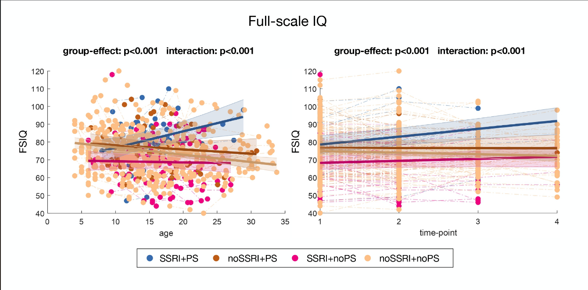
Supplementary Figures
Supplementary Figure 1. Developmental trajectories of full-scale IQ (FSIQ) into four subgroups of participants: (1) treated with both SSRIs and PS (SSRI+PS); (2) untreated with SSRIs but treated with PS (noSSRI+PS); and (3) treated with SSRIs but untreated with PS (SSRI+noPS); and (4) untreated with SSRIs and PS (noSSRI+noPS), across age and time-points.

Supplementary Figure 2. Data completeness across TPs for FSIQ analyses in SSRI-treated and SSRI-untreated groups.

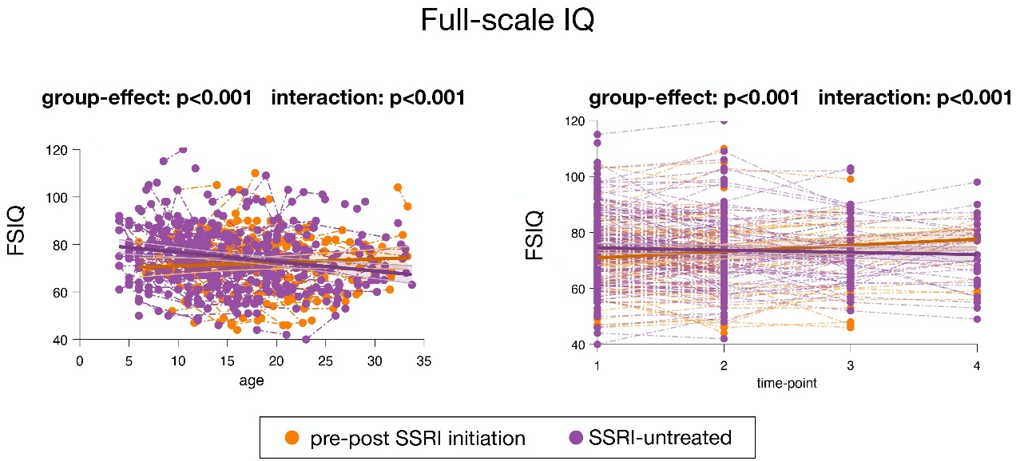

Supplementary Figure 3. Developmental trajectories of full-scale IQ in pre-post SSRI initiation participants and SSRI-untreated participants across age and time-points.

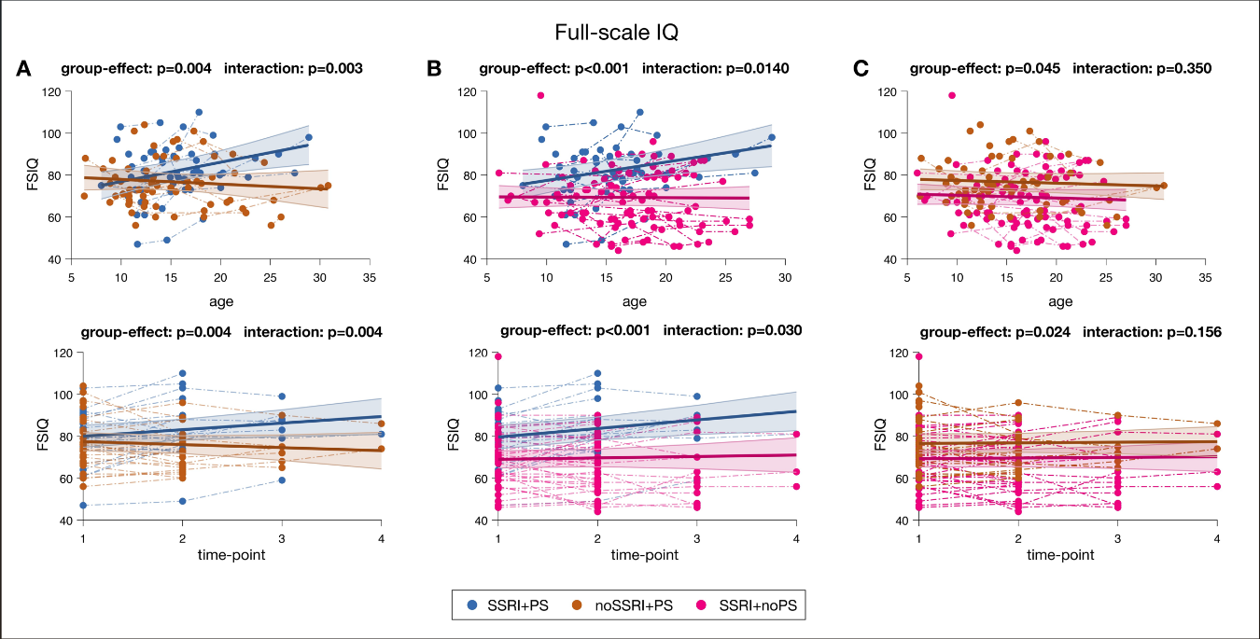

Supplementary Figure 4. Two-by-two comparisons of full-scale IQ (FSIQ) in participants with 22q11.2DS, stratified into three subgroups based on SSRI and/or psychostimulant (PS) treatment, across ages and time-points. (A) SSRI+PS vs. noSSRI+PS; (B) SSRI+PS vs. SSRI+noPS; (C) noSSRI+PS vs. SSRI+noPS.

