Disparities in treatment initiation following diagnosis of attention-deficit/hyperactivity disorder: A systematic review
Philip Wickham,¹ Saima Orangzeb,^{2,3,4} Jacqueline M. Cohen,⁴ Patricia Li,⁵ Thuy Mai Luu,⁶ Gabriel Côté-Corriveau,⁶ Farzana Uddin,⁷ Ugochinyere Vivian Ukah^{1,8*}

Affiliations:
¹Department of Medicine, McGill University Health Centre, Montreal, Canada
²Innlandet Hospital Trust, Hamar, Norway.
³Faculty of Medicine, University of Oslo, Oslo, Norway
⁴Department of Chronic Diseases and Centre for Fertility and Health, Norwegian Institute of Public Health, Oslo, Norway
⁵Department of Pediatrics, McGill University, Montreal, Quebec, Canada
⁶Department of Pediatrics, Sainte-Justine Hospital Research Centre, University of Montreal, Montreal, Quebec, Canada
⁷Department of Psychology, Concordia University, Montreal, Quebec, Canada
⁸Child Health and Human Development Program, Research Institute of the McGill University Health Centre, Montreal, Quebec, Canada

*Correspondence: Dr. Ugochinyere Vivian Ukah, RI-MUHC, CORE 2B41, 5252 Blvd. De Maisonneuve Ouest, Montreal, Quebec, H4A 3S9, Canada, Tel: 514-934-1934 ext 37009, Email: vivian.ukah@mcgill.ca

Short title: Disparities in ADHD treatment initiation

Counts: Abstract 245, Manuscript 5644 (3540 excluding Abstract, Keywords, and References), References 63, Figures 5, Supplemental Tables 5, Supplemental Figures 2
LIST OF TABLES AND FIGURES
SUPPLEMENT
eFigure 1. PRISMA flow diagram
eFigure 2. Association between insurance status and timing of ADHD treatment initiation after diagnosis
eTable 1. MEDLINE search strategy
eTable 2. Inclusion and exclusion criteria of included studies
eTable 3. Risk of bias assessment of included studies using the Newcastle–Ottawa scale for cohort and cross-sectional studies
eTable 4. Population characteristics of included studies
eTable 5. Reported outcomes, and diagnostic methods, covariates, and effect estimates of included studies
SUPPLEMENT
eFigure 1. PRISMA flow diagram

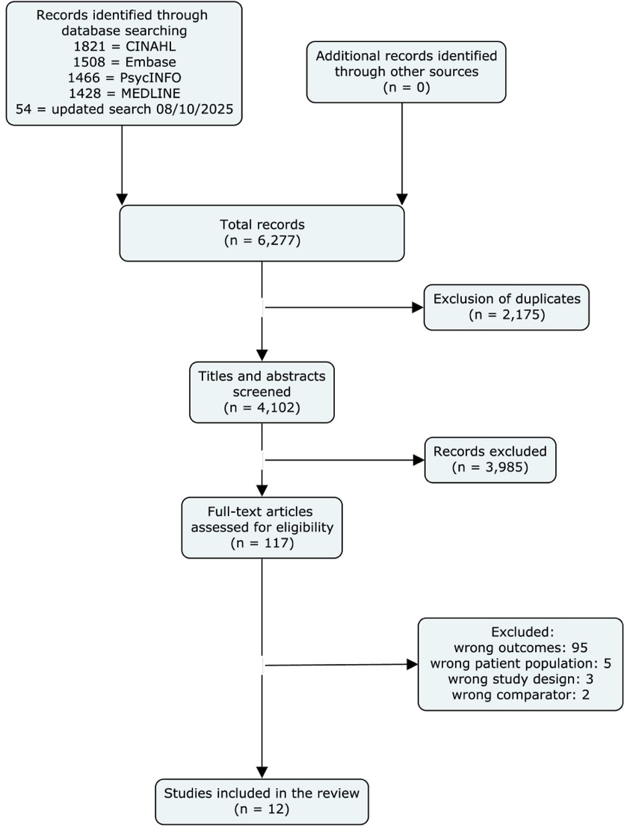
eFigure 2. Association between insurance status and timing of ADHD treatment initiation after diagnosis
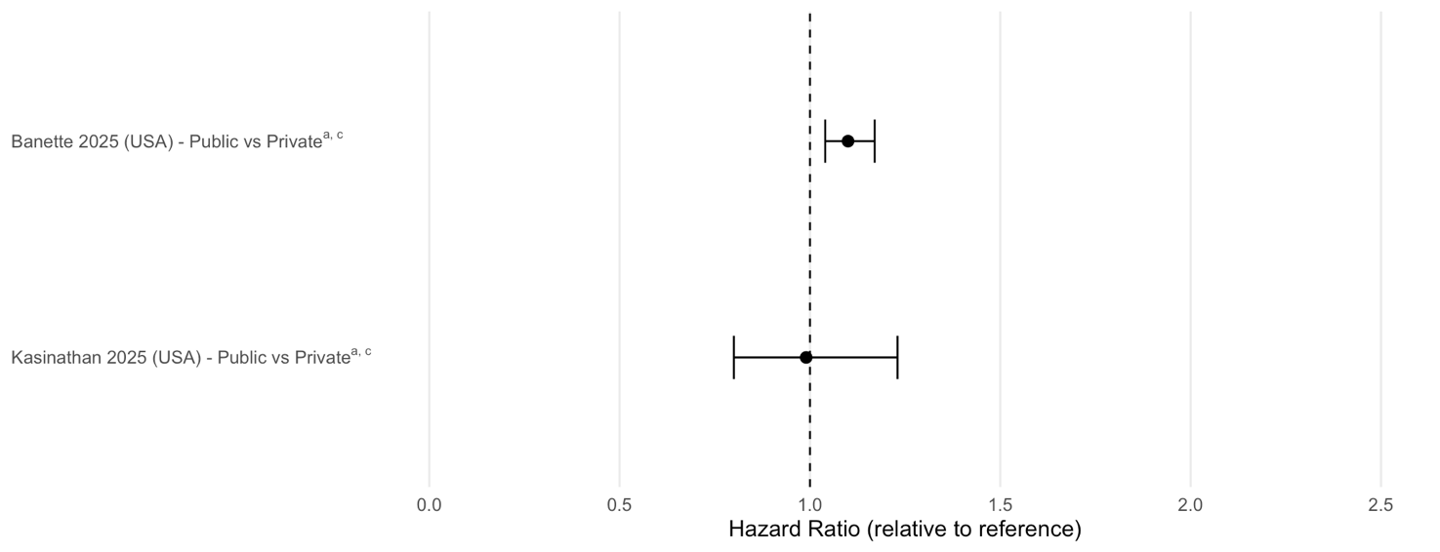
ªAdjusted for covariates
^{b}Odds ratio
^{c}Hazards ratio
eTable 1. MEDLINE search strategy
Ovid MEDLINE(R) ALL <1946 to July 10, 2025>
1 Time-to-Treatment/ or Treatment Delay/ 11526
2 ((earl* or late* or delay* or time* or timing* or access* or initiat* or uptake or enrol* or engage* or utiliz* or utilis* or recei* or use* or prescri*) adj3 (treat* or intervention* or care or servic* or therap* or medicat*)).tw,kf. 1730430
3 (earl* or late* or delay* or time* or timing * or access* or initiat* or uptake* or enrol* or engage* or utiliz* or utilis* or recei* or use* or prescri*).tw,kf. and Therapeutics/ 2358
4 1 or 2 or 3 1738307
5 attention deficit disorder with hyperactivity/ 37786
6 (attention deficit adj3 disorder*).ti,kf. 19566
7 adhd.ti,kf. 18952
8 Neurodevelopmental Disorders/ 6201
9 neurodevelopmental disorder*.ti,kf. 6696
10 exp infant/ or exp child/ or adolescent/ or exp pediatrics/ 4207277
11 (child or childhood* or children or pediatric* or paediatric* or infan* or baby* or babies or toddler* or boy* or girl* or kid$1 or school* or juvenil* or underage* or under age* or teen* or minor$1 or youth$1 or adolescen* or pubescen* or puberty).mp. 5458699
12 (infan* or child* or adolescen* or pediatric* or paediatric*).jw. 815768
13 or/10-12 5554614
14 exp health inequities/ or minority health/ or minority groups/ or "Ethnic and Racial Minorities"/ or "Health Disparate Minority and Vulnerable Populations"/ or exp population groups/ or exp ethnicity/ or race factors/ or exp racial groups/ or exp social class/ or exp socioeconomic factors/ or social problems/ or health equity/ or exp poverty/ or exp prejudice/ or social determinants of health/ or exp "emigrants and immigrants"/ or health services accessibility/ or Access to Primary Care/ or Right to Health/ or Transportation of Patients/ or Universal Health Care/ 996083
15 (disparit* or ethnic* or inequit* or inequalit* or intersectional or race* or racial or racism or racist* or minorit* or immigrant* or Socioeconomic* or Socio economic* or poverty or indigen* or discrimination or equit* or income or social class or prejudic* or social exclusion or marginali#ed or "people of? colo?r" or accessibility or vulnerab*).ti,ab,kf. 1441335
16 (barrier* or wait* time*).ti,ab,kf. 514361
17 (gender* or (boy* and girl*) or financ* or insurance).mp. 957628
18 14 or 15 or 16 or 17 3146995
19 5 or 6 or 7 or 8 or 9 54035
20 4 and 13 and 18 and 19 1428
eTable 2. Inclusion and exclusion criteria of included studies
Author last name, Publication year | Inclusion criteria | Exclusion criteria
Arya, 2015 | Newly registered patients aged 6–16 years attending the Child and Adolescent Outpatient Program (OPD) who fulfilled the DSM-IV-TR criteria for ADHD. | Patients with intellectual disabilities, major sensory-motor handicaps (blindness, hearing problem, paralysis), a physical disorder requiring priority medical management, and parents not willing to give consent.
Bannett, 2025 | Children aged 3-5 years seen in primary care clinics affiliated with eight academic institutions; seen ≥2 times with at least 6 months of follow-up; received at least one disorder-level ADHD diagnosis between ages 4-5 years. | Children not meeting the inclusion criteria (e.g., not seen in primary care, insufficient visits/follow-up, no ADHD diagnosis in the age window).
Chen, 2011 | Age <18, New ADHD diagnosis in 2000, No ADHD diagnosis in prior 3 years (1997–1999) | Children not meeting the inclusion criteria
Garbe, 2012 | Aged 3–17 years with a first diagnosis of ADHD or a prescription for methylphenidate or atomoxetine in 2005, continuously insured for at least 12 months before cohort entry. | A history of an ADHD diagnosis or a prescription for methylphenidate or atomoxetine in the 12 months before cohort entry.
Gubi, 2022 | Aged 6–17 years living in the Stockholm | Adopted individuals, missing data on parental country of origin or income, born abroad with two Swedish-born parents, unaccompanied refugee minors, psychiatric diagnosis prior to study start
Hong, 2014 | Child and adolescent outpatients aged 6 to 17 years, presented within the normal course of care with ADHD symptoms, no previous ADHD diagnoses or treatment, diagnosis made by investigator using DSM-IV-TR or ICD-10 criteria. | Severe mental retardation (unable to attend school), epilepsy, or schizophrenia, participation in a different interventional study or investigational drug trial
Huang, 2021 | Aged 3-19 years who received an ADHD diagnosis (ICD-9-CM: 314) from a board-certified psychiatrist. Only included 6 years + children in delayed initiation analyses as ADHD meds is only approved for patients 6 years and above in Taiwan. | None explicitly stated beyond the inclusion criteria
Kasinathan, 2025 | Aged 6-12 years seen at Stanford's Developmental-Behavioral Pediatrics (DBP) clinics with an ICD-10 ADHD diagnosis. At least two DBP visits and >1 month of follow-up. | Autism spectrum disorder diagnosis prior to or concurrent with first ADHD visit, ADHD diagnosis before age 6, ADHD medication prescription before the diagnostic visit
Lien, 2015 | Ages 3–5, at least two outpatient visits for ADHD in a six-month period after the initial diagnosis, Born between 2001–2003 | Children with an ADHD diagnosis who had fewer than two follow-up outpatient visits for the condition
Lindemann, 2012 | Aged 3–17 years in 2005, insured by one of the four statutory health insurance providers in the German Pharmacoepidemiological Research Database (GePaRD, Continuous insurance period of at least 2 years (1 year before and 1 year after a potential diagnosis). | ADHD dx marked “ruled out” or “suspected”. Missing information on sex or federal state of residence, Any ICD-10 codes for ADHD or prescriptions for methylphenidate/atomoxetine in the 365 days preceding a new diagnosis in 2005.
Martin, 2024 | Ages 3–30 years at the end of the study period. Born between 1989 and 2013; Living in Wales between 2000 and 2019; at least one year of follow-up data (minimum 365 noncontinuous days).  Received an ADHD diagnosis during their follow-up period. | Individuals with <365 days of data, who only had a record of ADHD diagnosis prior to age 3 and never again, prescribed ADHD medication but with no recorded ADHD diagnosis.
Shi, 2021 | 1 year of insurance coverage beyond the date of ADHD diagnosis, Born 2006–2012, continuous commercial insurance ≥4 years | Children who did not meet the inclusion criteria (e.g., gaps in insurance coverage).  Children diagnosed with ADHD before age 3 without subsequent visits were classified as not having ADHD

eTable 3. Risk of bias assessment of included studies using the Newcastle–Ottawa scale for cohort and cross-sectional studies
Cohort study questions | Author last name |  |  |  |  |  |  |  |  |  |  | Cross-sectional study questions | Author last name
Cohort study questions | Bannett | Chen | Garbe | Gubi | Hong | Huang | Kasinathan | Lien | Lindemann | Martin | Shi | Cross-sectional study questions | Arya
Representativeness of the exposed cohort | 1 | 1 | 1 | 1 | 0 | 1 | 0 | 1 | 1 | 1 | 1 | Representativeness of the cases | -
Selection of the non-exposed cohort | 1 | 1 | 1 | 1 | 1 | 1 | 1 | 1 | 1 | 1 | 1 | Sample size | -
Ascertainment of exposure | 1 | 1 | 1 | 1 | 1 | 1 | 1 | 1 | 1 | 1 | 1 | Non-Response rate | -
Demonstration that outcome of interest was not present at start of study | 1 | 1 | 1 | 1 | 1 | 1 | 1 | 1 | 1 | 1 | 1 | Ascertainment of the screening/ surveillance tool or exposure (max 2 scores) | 2
Comparability of cohorts on the basis of the design or analysis controlled for confounders (max 2 stars) | 2 | 2 | 2 | 2 | 2 | 0 | 2 | 2 | 0 | 2 | 2 | Comparability | -
Assessment of outcome | 1 | 1 | 1 | 1 | 1 | 1 | 1 | 1 | 1 | 1 | 1 | Assessment of Outcome | 1
Was follow-up long enough for outcomes to occur | 1 | 1 | 1 | 1 | 0 | 1 | 1 | 1 | 1 | 1 | 1 | Statistical test | 1
Adequacy of follow up of cohorts (complete/ loss to follow-up) | 1 | 1 | 1 | 1 | 1 | 1 | 0 | 1 | 1 | 1 | 0
Total | 9 | 9 | 9 | 9 | 7 | 7 | 7 | 9 | 7 | 9 | 8 | Total | 4

eTable 4. Population characteristics of included studies
Author last name/  Journal/  Publication year | Country | Study design/  Recruitment period | Sample size, N | Population characteristics | Type of treatment/ intervention | Exposure examined
Arya/  Asian Journal of Psychiatry/  2015 | India | Cross-sectional study/  August 2011 - July 2012 | 57 | Sex: 70.2% male, 29.8% female  Age at diagnosis: 85.9% aged 6-12 years, 14.0% aged 13-16 years  Domicile: 80.7% urban, 19.3% rural  Income: 49.1% low income (<₹10,000/month) | Non-pharmacological: child and adolescent mental health service (CAMHS) | Sex, urbanicity, socioeconomic status (SES; by monthly income brackets)
Bannett/  JAMA Network Open/  2025 | USA | Retrospective cohort study, PEDSnet database/ January 1, 2016 -December 31, 2023 | 9,708 | Sex: 76.4% male, 23.6% female  Median age at diagnosis: 5.31 years (IQR 4.86-5.66)  Race and ethnicity: 39.0% non-Hispanic White, 31.0% non-Hispanic Black, 18.1% Hispanic, 4.9% non-Hispanic multiple Races, 1.3% non-Hispanic Asian, 1.5% non-Hispanic Other, 4.1% Unknown.  Insurance: 52.9% Public, 36.3% Private, 10.8% Other/Unknown | Medication: Stimulants (methylphenidate, amphetamines) and non-stimulants (alpha-agonists, atomoxetine) | Sex, race and ethnicity, health insurance plan
Chen/  Journal of Child and Adolescent Psychopharmacology/  2011 | Taiwan | Retrospective cohort study (National Health Insurance Research Database (NHIRD))/ 1997 - 2002 | 10,153 | Sex: 77.4% male, 22.6% female  Age at diagnosis: 27.48% <6 years, 42.06% 6-8 years, 18.51% 9-11 years, 11.95% 12-17 years (for ADHD-only group)  SES (by Enrollment Category - EC): EC I (government or public education institutions): 13.8%, EC II (private enterprises): 46.8%, EC III (agriculture and private education): 30.2%, EC IV (military and minimum wage): 9.2%  Urbanicity: 37% urban, 58.1% suburban, 4.9% rural | Medication:  Methylphenidate | Sex, SES, region, urbanicity
Garbe/  Journal of Child and Adolescent Psychopharmacology/  2012 | Germany | Retrospective cohort study (one large German health insurance), 2005 –2008 | 6,210 | Sex: 76.8% Male, 23.2% Female.  Age at diagnosis: 3-5 years (8.7%), 6-8 years (36.0%), 9-11 years (32.5%), 12-14 years (17.2%), 15-17 years (5.6%) | Medication:  Methylphenidate or atomoxetine | Sex
Gubi /  Epidemiology and Psychiatric Sciences/  2022 | Sweden | Retrospective cohort study (Swedish data registry), 2006 –2015 | 444,196 for all psychiatric diagnosis. No sample specified for ADHD | Sex: ~50% male, ~50% female  Age at diagnosis: Varied significantly between groups; >50% in the 6–8-year age range  Migration background: Swedish (60.3%), Descendants (31.4%), non-refugee migrants (7.1%), Refugees (1.3%)  Parental income: refugees and migrants were >50% in the lowest quintile. | Pharmacological and non-pharmacological.  Medication: Antidepressants, ADHD medication, neuroleptics, anxiolytics, sedatives.  Non-pharmacological: Psychotherapy, parental support, psychoeducation, family therapy, social skills training | Parental migration background and time in Sweden, maternal region of origin.
Hong/  BMC Psychiatry/  2014 | Central Europe (Czech Republic, Hungary, Romania, Slovakia, Turkey) & East Asia (China, South Korea, Taiwan) | Prospective observational cohort, October 2005 to July 2006 | 1,068 | Sex: 82.2% male, 17.8% female  Region: 53% Central Europe, 47% in East Asia  Mean Age at diagnosis: 8.40 years (SD 2.41) (No Treatment), 9.12 years (SD 2.52) (Treatment) | Pharmacological and non-pharmacological.  Medication (45.5% methylphenidate), psychotherapy (psychoeducation and counselling, cognitive behavioural therapy, hypnotherapy, family therapy, or psychodynamic therapy), or both | Sex, region
Huang/  Journal of Child and Adolescent Psychopharmacology/  2021 | Taiwan | Retrospective longitudinal cohort, (NHIRD), 2001 - 2011 | 188,061 | Sex: 79.1% Male, 20.9% Female.  Age at first diagnosis (mean): 8.59 years (SD 3.23).  Income distribution (NT$): 20.0% low (<19,100), 48.7% middle, 31.2% high (>42,000)  Urbanization: level 1 (most urbanized, 17.8%), level 2 (30.5%), level 3 (8.7%), level 4 (7.5%), level 5 (most rural; 35.6%) | Pharmacological: Immediate-release methylphenidate, extended-release methylphenidate, atomoxetine | Sex, family income, level of urbanization
Kasinathan/  medRxiv (Preprint)/  2025 | USA | Retrospective cohort study (electronic health record (EHR) data from  Stanford’s Developmental-Behavioral  Pediatrics clinics), January 2016 – June 2024 | 823 | Sex: 75.7% Male, 24.3% Female.  Mean Age at Diagnosis: 8.2 years (SD=1.5).  Race/Ethnicity: White (35.4%), Hispanic (28.7%), Asian (9.5%), Black (1.9%). | Pharmacological: stimulants (methylphenidate, amphetamines) and non-stimulants (guanfacine, clonidine, atomoxetine) | Sex, race and ethnicity, health insurance type
Lien/  Psychiatric Services/  2015 | Taiwan | Retrospective longitudinal cohort (NHIRD) 2001 -2007 | 3,583 | Sex: 76% male, 24% female.  Age distribution (mean/median not provided): 31% age 3 at diagnosis, 38% age 4, 31% age 5 (average age of 4).  SES (Premium category): Poverty (2%), Near poverty (22%), Middle income (46%), High income (30%). | Pharmacological and non-pharmacological.  Medication: Methylphenidate (only ADHD medication covered by insurance).  Non-Medication: Psychotherapy (e.g., behavior modification, supportive psychosocial psychotherapy, family therapy) or Rehabilitation therapy (e.g., physical exercise, sensory integration training, occupational therapy) | SES (based on Taiwan’s National Health Insurance Program (NHIP) insurance premium, urbanicity
Lindemann/  Journal of Child and Adolescent Psychopharmacology/  2012 | Germany | Retrospective cohort study (German Pharmaco-epidemiological  Research Database (GePaRD)) 2004–2006 | 1,811,747 (for the whole incidence population); no sample size stated for new ADHD diagnoses | ADHD incidence more common in males than females (13.5 vs 4.4 per 1,000 person years); peak diagnostic age (years) = 8 (male), 9 (female) | Drug treatment with methylphenidate or atomoxetine. | Sex
Martin/  Journal of Child Psychology and Psychiatry/  2024 | Wales | Retrospective cohort study (Secure Anonymised Information Linkage (SAIL) databank), 2000-2019 | 16,458 (14,786 for <18 years) | Sex: 79.7% male, 20.3% female  Mean age at first ADHD diagnosis: Males = 10.9 years, Females = 12.6 years  Ethnicity: White (97.1%), Ethnic minority (2.9%)  SES measured by Welsh Index of Multiple Deprivation (WIMD) quintiles: least deprived (11.6%), level 2 (13.1%), least deprived (16.6%), least deprived (24.1%), most deprived (34.7%) | Medication: Stimulants and non-stimulants | Sex
Shi/  JAMA Network Open/  2021 | USA | Retrospective cohort study (OptumLabs Data Warehouse), birth cohort 2006–2012, followed through June 30, 2019 | 238,011 (total population), 11,401 (ADHD) | Sex: 71.9% boys, 28.1% girls  Mean age at ADHD diagnosis: 6.5 years (SD 1.9).  Race and ethnicity: White (78.8%), Asian (3.2%), Black (6.0%), Hispanic (9.1%), Other/Unknown (3.0%).  Income: <75k (22.8%), 75k to 124k (27.3%), 125k to 199k (19.2%), ≥200k (19.2%)  Census region: Midwest (24.6%), Northeast (11.8%), South (50.6%), West (13.1%) | Medication (having filled a prescription) and/or behavioral therapy (identified by Current Procedural Terminology codes) | Sex, race and ethnicity, household income, census region

eTable 5. Reported outcomes, and diagnostic methods, covariates, and effect estimates of included studies
Author last name, Publication year | Specified outcome | ADHD Diagnosis (Who made it/ how was it confirmed) | Covariates adjusted for | Reported effect estimates
Arya, 2015 | Average delay (in years) from ADHD onset to child and adolescent mental health service (CAMHS) | Confirmed via structured diagnostic interview (K-SADS-PL) and DSM-IV-TR; consensus by psychiatrist team | None | Mean/ median delay (years) in seeking help compared using Mann-Whitney U and Kruskal-Wallis tests:  • Sex: 3.5 years (male) vs 4.5 years (female) (p=0.406)  • Domicile: Rural vs urban; 5 years vs 3.05 years (p=0.021)  • Income/month: <10,000 vs 10,000-30,000 vs >30,000: 5 vs 2.35 vs 3 years (p<0.001)
Bannett, 2025 | Time from initial ADHD diagnosis to prescription (days) before age 7 years. Early treatment defined as being within 30 days of diagnosis. | Patients were included in the ADHD cohort if they received at least 1 disorder-level ADHD diagnosis (e.g., ADHD combined subtype) between ages 4 and 5 years in primary care clinics, diagnosed by primary care providers | Year of diagnosis, initial diagnosis type (disorder-level vs. symptom-level), comorbid conditions, primary care utilization (low/medium/high), and institution. | HR and 95% CI:  • Male vs. female (ref): HR 1.17 (95% CI 1.10-1.24)  • Race (ref = NHW): Hispanic: HR 0.75 (95% CI 0.70-0.81), NH Asian: HR 0.50 (95% CI 0.38-0.65), NH Black: HR 0.90 (95% CI 0.85-0.96)  • Public vs. private insurance: HR 1.10 (95% CI 1.04-1.17)
Chen,  2011 | Initiation of methylphenidate treatment (prescription) within one year of diagnosis. | ADHD was defined by ICD-9-CM 314.XX codes | All analyses were adjusted for all other variables listed in the respective tables (Table 2 for initiation, Table 3 for discontinuation). This includes demographic, clinical, and healthcare provider characteristics. | HR and 95% CIs:  ADHD only:  • Male vs. female (ref): HR 1.36 (1.21–1.54)  • SES (ref= EC I, highest SES):  EC II (high SES): HR 1.08 (0.94-1.23), EC III (lower SES): HR 1.19 (1.03–1.37), EC IV (lower SES): HR 1.20 (1.00–1.45)  • Urbanicity (ref = Urban):  Suburban: HR = 0.94 (95% CI: 0.87–1.02), Rural: HR = 0.98 (95% CI: 0.81–1.18),  • Regions (ref =Northern Region):  Southern: HR 1.58 (1.42–1.75), Eastern: HR 1.73 (1.24–2.42), Central: HR 0.86 (0.74–1.02)
Garbe,  2012 | Time to initiation of ADHD drug treatment (methylphenidate or atomoxetine) within a year of diagnosis | First diagnosing physician: Pediatrician (44.5%), child psychiatrist (30.0%). Confirmed via coded diagnosis algorithm (ICD-10-GM) from claims data | Age, ADHD subtype, psychiatric comorbidities, specialty of the first diagnosing physician. | HR and 95% CI  • Sex (ref =Female): Male HR: 1.16 (1.06–1.26)
Gubi,  2022 | Received prescription of drug within 3 months of diagnosis | Confirmed via ICD/DSM coding in administrative and clinical registers; BUP (Swedish data) register used DSM-based codes mapped to ICD-10 | Adjusted for age, sex, and parental income. | OR and 95% CIs:  • Migration group (ref = Swedish born):  Migrants: OR 0.49 (0.43–0.54)  • Maternal region (ref = Swedish born):  Sub-Saharan Africa: OR 0.50 (0.43-0.58), Asia: OR 0.45 (0.39-0.53), Eastern EU, RUS, &Baltics: OR 0.58 (0.50-0.67), Middle East & North Africa: OR 0.63 (0.57-0.70), South America: OR 1.02 (0.89-1.16), USA, Canada and Oceanic: OR 0.98 (0.72- 1.33), and Western & Southern Europe: OR 0.64 (0.52-0.79).  • Time since immigration (ref = Swedish born):  0-5 years: OR 0.62 (0.55-0.70), 6-10 years: OR 0.63 (0.53-0.74), 11-15 years: OR 0.77 (0.67- 0.88)
Hong, 2014 | Treatment initiation (pharmacotherapy and/or psychotherapy) at baseline, i.e., outpatient visit in which the patients were enrolled in the study. | Made by an investigator (psychiatrists & pediatrician enrolled patients) using standard diagnostic criteria (DSM-IV-TR) or ICD-10 | Age, gender, age at first symptoms, region, birth problems, family history of ADHD, and CGI-ADHD-S score, working mother, parental psychological distress, truancy, involvement in bullying, primary care visits for behavior, and being invited to social activities. | OR and 95% CIs:  Combined (overall cohort):  •Male vs female (ref): OR 1.24 (0.74, 2.07)  •East Asia vs central Europe (ref): OR= 0.87 (0.56-1.36)  East Asia:  •Male vs female (ref): OR 1.95 (1.02–3.73)  Central Europe:  •Male vs female (ref): OR 0.46 (0.16–1.33)
Huang,  2021 | Delayed initiation of ADHD medications, defined as an interval >365 days between ADHD diagnosis and initiation of ADHD medications (the date of prescription of ADHD medications) | Board-certified psychiatrist. Confirmed with ICD-9-CM in claims data. | None stated | OR and 95% CIs:  Children 6-11 years:  •Male vs female (ref): OR 1.20 (1.09–1.34)  •Urbanization (ref = level 1, most urban):  level 2: OR 0.92 (0.83–1.01), level 3: OR 0.67 (0.58–0.78), level 4: OR 0.81 (0.70–0.94), level 5 (most rural): OR 0.97 (0.89–1.07)  •Family income (ref = low income):  Mid: OR 1.03 (0.93–1.14), High: OR 1.52 (1.37–1.69)  Adolescents 12-19 years:  •Male vs female (ref): OR 1.45 (1.04–2.02)  •Urbanization, level 1 (ref): level 2: OR 0.80 (0.58–1.11), level 3: OR 0.76 (0.48–1.20), level 4: OR 0.63 (0.31–1.09), level 5 (most rural): OR 0.76 (0.55–1.56)  •Family income, low income (ref):  Mid: OR=1.15 (0.79–1.66), High: OR 1.28 (0.88–187)
Kasinathan,  2025 | Time from first ADHD diagnostic visit to first ADHD medication prescription (within 1 year of diagnosis). | Based on ICD-10 codes (F90.0–F90.9). Diagnosis made during developmental-behavioral pediatrics clinic visits by physicians, nurse practitioners, or psychologists | Patient observation period (number of days from first to last visit at DBP clinic). | HR and 95% CIs:  •Sex: Male vs Female (ref): HR 1.02 (0.82–1.26)  •Race (ref = White):  Asian: HR 0.65 (0.46–0.94), Black: HR 0.80 (0.39–1.64), Hispanic: HR 0.91 (0.72–1.16), Other: HR 0.41 (0.13–1.30)  •Public vs private insurance (ref): HR 0.99 (0.80–1.23)
Lien,  2015 | Treatment (medication/ psychotherapy) initiation within 2 months | ICD-9-CM 314.xx in claims data and Confirmed by clinicians after ≥2 outpatient visits within 6 months. Different types of diagnosing physicians. | Sex, age at diagnosis, residential region, income category, comorbidities, catastrophic illness, primary insured parent, provider type, hospital level, ADHD service volume, different diagnosing vs treating physician | OR and 95% CIs:  • SES, high income (ref):  Middle income: OR 0.90 (0.70–1.17), near poverty: OR 0.98 (0.72–1.33), poverty: OR 0.70 (0.23–2.12)  • Urbanicity (ref = urban):  Suburban OR 1.29 (1.02–1.64), rural: OR 1.10 (0.65–1.86)
Lindemann,  2012 | Initiation of drug treatment (methylphenidate or atomoxetine) at (a) time of diagnosis and (b) within one year of diagnosis | Confirmed via coded diagnosis algorithm (ICD-10-GM) from claims data, not by clinician review | None (descriptive only) | Percentage treated at time of initial diagnosis:  Male = 9.4% (95% CI: 8.9–10.0%) vs female = 9.1% (95% CI: 8.2–10.1%)  Percentage treated within 1 year of initial diagnosis:  Male = 37.7% (95% CI: 36.8–38.5%) vs female = 34.1% (95% CI: 32.6–35.6%)
Martin,  2024 | Age difference defined as time between ADHD diagnosis and ADHD medication (prescription) | Read codes from general practitioner records, ICD-10 from hospital records | Birth year and individual follow-up time were included as covariates in all regression models | • Female vs male (ref): HR 1.00 (95% CI: 0.97–1.02)
Shi, 2021 | Treatment receipt (medication fill) within 1 year of diagnosis | Pediatricians (~50%), and also by psychologists, family physicians, psychiatrists, and neurologists. Confirmed via clinical ICD codes in claims data; provider type documented | Race and ethnicity, sex, US Census region, and annual household income. | OR and 95% CIs:  •Female vs male (ref): OR 0.91 (0.82–1.02)  •Race and ethnicity (ref=White):  Asian: OR 0.54 (0.42–0.70), Black: OR 0.79 (0.64–0.98), Hispanic: OR 0.57 (0.48–0.67), Other/Unknown: OR 0.69 (0.52–0.91)  •Household income (ref = >$200K):  <$40K: OR 0.90 (0.71–1.14); $40K–74,999: OR 0.75 (0.63–0.89); $75K–124,999: OR 0.88 (0.75–1.02); $125K–199,999: OR 0.93 (0.79–1.09); Other/Unknown: OR 0.56 (0.45–0.70)  •Region (ref = Northeast):  Midwest: OR 2.95 (2.48–3.51), South: OR 2.12 (1.82–2.45), West: OR 1.63 (1.35–1.96)

