Supplementary Material to
“Does the Quality of the Relationship to Parents and Peers Predict Mental Health Service Use During Adolescence? A Prospective Community Study”
Mina Moeineslam, Silje Steinsbekk, Lars Wichstrøm, and Věra Skalická

S1. Additional Methodological Information
S1.1. Predisposing and Need Factors
Evidence on predisposing and need factors:
In accordance with Andersen’s model and to ensure a comprehensive approach, this study controls for predisposing and need-related factors—well-established predictors of adolescent service use. These factors are consistently linked to service utilization and are thus included as covariates to isolate the specific contribution of family-related influences. Previous research has identified several consistent predictors of adolescent service use. These include gender, with females typically using services more often than males (Burnett-Zeigler & Lyons, 2010; Fisher et al., 2018; Guo et al., 2015; Zwaanswijk et al., 2003); family socioeconomic status (SES), with studies reporting associations with both higher (Amone-P’Olak et al., 2010) and lower SES (Cheung et al., 2009; Palacio-Vieira et al., 2013; Reiß et al., 2021; Vu et al., 2018); parental divorce (Reijneveld et al., 2014); and parental mental health problems (Breland et al., 2014). Among need-related factors, adolescents’ own mental health problems (Laitinen-Krispijn et al., 1999; Splett et al., 2018), functional impairment (Ezpeleta et al., 2002; Wu et al., 2001), parental perception of need (Brattfjell et al., 2021; Kim & Kim, 2022), and exposure to stressful life events (Ezpeleta et al., 2002; McChesney et al., 2015) have all been shown to predict adolescents’ use of mental health services. Importantly, predisposing and need-related factors may also influence family dynamics. For instance, studies have shown that lower socioeconomic status (Li et al., 2014; Mansfield et al., 2013), parental mental illness (Marston et al., 2018; Wiegand-Grefe et al., 2019), adolescents’ mental health difficulties (Baena et al., 2021; Jiménez et al., 2019), and exposure to stressful life events (Shimizu et al., 2023; Stanek et al., 2020) are linked to reduced family functioning and cohesion. Therefore, the present study controls for these factors to isolate the distinct contribution of family enabling factors.
S1.2. Measures
Predisposing Factors:
Community health service use was measured with the CASA (Ascher & Burns, 1996). Parents reported at each wave, and from age 16 adolescents also provided self-reports. Parent and adolescent data were combined into a dichotomous indicator (≥1 session vs. none). Community services included non-specialist providers delivering mental health-related support in primary care, school-based, family support, and other community settings that could typically be accessed without referral to specialist mental health care. Examples included general practitioners, school health services, educational and counselling services, child and family support services, and private practitioners.
Parental depression and anxiety: Symptoms were assessed with a 24-item version of the widely used Hopkins Symptom Checklist–25 (HSCL-25; Derogatis et al., 1974), comprising 10 anxiety and 14 depression items rated on a 4-point scale, with higher values indicating greater overall distress. The measure showed high internal consistency (α = .89–.92).
Parental occupation: The attending parent reported both parents’ occupations, coded using the International Labour Organization’s six-level scheme (International Labour Office, 1990). The highest occupational level within the family was used.
Cohabitation status: At each wave, the participating parent reported changes in marital or cohabitation status, which was coded dichotomously as parents living together or not.
Biological sex was recorded at the first study assessment and coded as male or female.
Need Factors:
Emotional problems and disruptive behaviors: At each wave, parents and adolescents were interviewed separately using semi-structured clinical interviews; symptoms were coded as present if reported by either informant. The Child and Adolescent Psychiatric Assessment (CAPA) (Angold & Costello, 2000) was used at ages 12 and 14, the Kiddie Schedule for Affective Disorders and Schizophrenia (K-SADS) (Kaufman, Joan et al., 2016) at age 16, and the Structured Clinical Interview for DSM-5 Disorders–Present Version (SCID-5) (First et al., 2016) at age 18, all assessing symptom onset, duration, and intensity according to DSM-5 criteria (American Psychiatric Association, 2013). Emotional disorders included Major Depressive Disorder (MDD), dysthymia, generalized anxiety disorder, social anxiety disorder, specific phobia, and separation anxiety disorder (not assessed at age 18). Disruptive behaviors included Oppositional Defiant Disorder (ODD), Conduct Disorder (CD), and Attention-Deficit/Hyperactivity Disorder (ADHD) at ages 12–16, with only ADHD assessed at age 18. Interrater reliability for blinded ratings of 15% of sessions was high across instruments (ICCs: CAPA = .85–.90; K-SADS = .76–.95; SCID-5 = .87–.94).
Impairment: Psychiatric symptom impairment was assessed with the CAPA, K-SADS, and SCID-5. For each symptom, impact was rated according to the World Health Organization’s International Classification of Functioning, Disability, and Health (ICF; WHO, 2007), and ratings were summed into a total impairment score.
Perceived need for help: Perceived need for professional help was measured within the CAPA, K-SADS, and SCID-5 interviews. Interviewers used open-ended questions about emotional, behavioral, social, and attentional difficulties, with follow-up probes to clarify whether professional assistance was already received or considered necessary. Need was coded when either the parent or the adolescent indicated that at least one of 20 predefined problem areas (e.g., separation anxiety, depression, conduct problems, attention difficulties, or regulation issues) required professional help.
Stressful life events: The CAPA, K-SADS, and SCID assessed 16 serious negative life events during the previous two years (e.g., death of a close adult, serious accident, physical or sexual abuse). In the CAPA, events were reported by parents only, whereas in the K-SADS and SCID both parents and adolescents provided information. Events were coded as present if endorsed by either informant, and summed to create a total life-events score, with higher scores indicating greater exposure.
S1.3. Attrition Analyses
Attrition at ages 12 and 14 was not significantly predicted by any included variable. At age 16, attrition was lower among females (OR = 0.55, 95% CI [0.37, 0.82], p = .003) and among adolescents with greater internalizing problems (OR = 0.98, 95% CI [0.97, 0.99], p < .001). At age 18, internalizing problems were associated with higher attrition (OR = 1.12, 95% CI [1.06, 1.17], p < .001), while use of primary health care predicted lower attrition (OR = 0.89, 95% CI [0.83, 0.96], p < .001). Little’s MCAR test indicated data were not missing completely at random, χ²(6964) = 9255.17, p < .001; however, the normed chi-square value (χ²/df = 1.33) suggested only a small deviation from MCAR.

S1.4. Propensity Score Estimation
To account for a broad range of predisposing and need-related factors associated with specialty mental health service use, we estimated a propensity score representing each participant's probability of using specialty mental health services. Propensity scores are commonly used to summarize multiple covariates into a single measure of treatment or exposure propensity, thereby reducing model complexity and helping to adjust for confounding (Austin, 2011). The propensity score was estimated using logistic regression, with specialty mental health service use as the outcome and all predisposing and need-related variables as predictors. Predicted probabilities from this model were retained and used as the propensity score in subsequent analyses.

Figure S1
[omitted for blind review], Procedure and flow of participants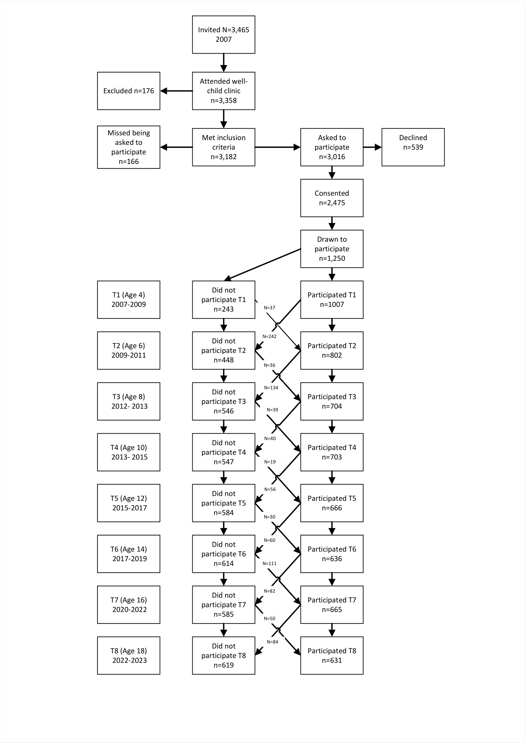
Note: T1 = Time 1, T2 = Time 2, etc. Participant numbers at each assessment point reflect the number of individuals invited to participate minus those who did not participate at the respective time points.

S2. Supplementary Correlation Analyses
Table S1
Bivariate Correlations Between Perceived Relationship Quality Factors and Specialty Service Use
 | Service use  (12 years) | Service use  (14 years) | Service use  (16 years) | Service use  (18 years)
Closeness with mother (12 years) | -.03 | -.14 | -.04 | -.01
Closeness with mother (14 years) |  | -.04 | -.03 | -.11
Closeness with mother (16 years) |  |  | -.02 | -.06
Closeness with mother (18 years) |  |  |  | -.03
Conflict with mother (12 years) | .03 | .11 | .07 | .17
Conflict with mother (14 years) |  | .04 | .00 | .17
Conflict with mother (16 years) |  |  | -.00 | .23
Conflict with mother (18 years) |  |  |  | .14*
Closeness with father (12 years) | -.05 | -.07 | -.06 | -.08
Closeness with father (14 years) |  | .00 | -.01 | -.15
Closeness with father (16 years) |  |  | -.02 | .02
Closeness with father (18 years) |  |  |  | -.03
Conflict with father (12 years) | .04 | -.03 | .01 | .07
Conflict with father (14 years) |  | .02 | -.02 | .08
Conflict with father (16 years) |  |  | -.04 | -.05
Conflict with father (18 years) |  |  |  | .23*
Closeness with friend (12 years) | .00 | -.02 | .09 | .10
Closeness with friend (14 years) |  | -.01 | -.04 | .02
Closeness with friend (16 years) |  |  | .08 | .07
Closeness with friend (18 years) |  |  |  | .02
Conflict with friend (12 years) | .02 | .07 | .06 | .14*
Conflict with friend (14 years) |  | -.02 | .03 | -.04
Conflict with friend (16 years) |  |  | -.16** | -.01
Conflict with friend (18 years) |  |  |  | .16*
Note: Asterisks indicate level of statistical significance: * p ≤ 0.05, ** p ≤ 0.01, ***p ≤ 0.001.

Table S2
Standardized Correlations Between Conflict and Closeness Within Mother, Father, and Friend Relationships Across Adolescence
Age | Mother  (Conflict–Closeness) | Father  (Conflict–Closeness) | Friend  (Conflict–Closeness)
12 years | -.31*** | −.18** | -.12*
14 years | −.33*** | −.28*** | −.16**
16 years | −.38 *** | −.35*** | −.21**
18 years | -0.45 *** | −.35*** | −.21***
Note. Values are standardized correlations (STDYX estimates) between conflict and closeness within each relationship domain at each wave. *p < .05, **p < .01, ***p < .001.

Table S3
Standardized Cross-Domain Correlations for Conflict and Closeness at Ages 12, 14, 16, and 18 Years
Age | Mother–Father Conflict | Mother–Friend Conflict | Father–Friend Conflict | Mother–Father Closeness | Mother–Friend Closeness | Father–Friend Closeness
12 years | .79*** | .39*** | .41*** | .57*** | .33*** | .32***
14 years | .74*** | .44*** | .42*** | .63*** | .24*** | .29***
16 years | .60*** | .43*** | .40*** | .52*** | .35*** | .26***
18 years | .56*** | .23*** | .38*** | .50*** | .24*** | .27***
Note. Values are standardized correlations between relationship domains measured at the same age. *** p < .001.

S3. Additional Model Parameters
Table S4
Standardized Autoregressive Paths for Predictors Across Adjacent Time Points
 | 14 years |  |  | 16 years |  |  | 18 years
 | β | 95% CI | p | β | 95% CI | p | β | 95% CI | p
Propensity score as covariate | .41 | (.26, .56) | <.001 | .50 | (.34, .67) | <.001 | .61 | (.49, .72) | <.001
Closeness with mother | .50 | (.41, .59) | <.001 | .43 | (.34, .52) | <.001 | .70 | (.62, .77) | <.001
Conflict with mother | .55 | (.47, .62) | <.001 | .37 | (.25, .49) | <.001 | .52 | (.39, .65) | <.001
Closeness with father | .63 | (.56, .69) | <.001 | .48 | (.37, .59) | <.001 | .78 | (.72, .84) | <.001
Conflict with father | .63 | (.56, .69) | <.001 | .41 | (.32, .51) | <.001 | .50 | (.38, .63) | <.001
Closeness with friend | .56 | (.47, .66) | <.001 | .36 | (.25, .48) | <.001 | .56 | (.48, .63) | <.001
Conflict with friend | .38 | (.30, .46) | <.001 | .37 | (.27, .46) | <.001 | .45 | (.37, .53) | <.001
Note. Values represent standardized coefficients and 95% confidence intervals, and exact p-values.

Table S5
Standardized Concurrent Covariances Between Relationship Quality Predictors and Specialty Service Use
Predictor  (same wave) | Service use  (12 years) |  | Service use  (14 years) |  | Service use  (16 years) |  | Service use  (18 years)
Predictor  (same wave) | Cov (SE) | p | Cov (SE) | p | Cov (SE) | p | Cov (SE) | p
Propensity score | .56 (.09) | < .001 | .48 (.09) | < .001 | .54 (.06) | < .001 | .44 (.08) | < .001
Closeness with mother | –.05 (.06) | .38 | .04 (.04) | .39 | .06 (.05) | .23 | .03 (.07) | .60
Conflict with mother | .05 (.06) | .34 | –.06 (.04) | .15 | –.07 (.05) | .19 | .06 (.06) | .27
Closeness with father | –.08 (.07) | .22 | .04 (.05) | .37 | –.04 (.07) | .54 | .03 (.08) | .72
Conflict with father | .05 (.06) | .41 | .03 (.04) | .54 | .04 (.07) | .55 | .10 (.06) | .10
Closeness with friend | .00 (.05) | .96 | .03 (.04) | .48 | .01 (.04) | .83 | -.00 (.06) | .98
Conflict with friend | .03 (.07) | .69 | –.02 (.05) | .69 | –.10 (.04) | .02 | .21 (.06) | < .001
Note. Values represent standardized covariances (standard errors in parentheses) between predictors and service use measured at the same time point.

S4. Sensitivity Analyses
Table S6.
Sensitivity analyses examining each relationship dimension separately as a predictor of subsequent specialty mental health service use
 | 14 years |  |  | 16 years |  |  | 18 years
 | β | 95% CI | p | β | 95% CI | p | β | 95% CI | p
Closeness with mother | −.03 | (−.09, .04) | .40 | −.03 | (−.09, .03) | .39 | −.03 | (−.09, .04) | .40
Conflict with mother | .06 | (−.01, .13) | .11 | .05 | (−.01, .11) | .11 | .04 | (−.01, .10) | .12
Closeness with father | −.01 | (−.08, .05) | .66 | −.01 | (−.07, .05) | .67 | −.01 | (−.07, .05) | .67
Conflict with father | −.06 | (−.12, −.00) | .04 | −.05 | (−.10, −.00) | .04 | −.05 | (−.09, −.00) | .04
Closeness with friend | .01 | (−.06, .08) | .77 | .01 | (−.05, .06) | .77 | .01 | (−.04, .05) | .77
Conflict with friend | .02 | (−.05, .09) | .57 | .02 | (−.04, .07) | .57 | .01 | (−.04, .06) | .57
Note. Values represent standardized coefficients and 95% confidence intervals, and exact p-values.

S5. Friendship Duration and Stability of Best-Friend Relationships
Table S7 presents the reported duration of friendship with the current best friend at each assessment wave. Across all waves, the majority of adolescents reported having known their current best friend for two years or more (83.6–94.1%). Because the identity of the best friend was not assessed longitudinally, it was not possible to determine whether adolescents reported the same best friend across assessment waves.
Table S7
Duration of Friendship With Best Friend Across Ages 12, 14, 16, and 18 Years
Friendship duration | Age 12 | Age 14 | Age 16 | Age 18
Less than 1 year | 14 (2.2) | 12 (2.0) | 13 (2.2) | 3 (0.5)
1 year | 45 (7.1) | 86 (14.4) | 76 (12.7) | 31 (5.4)
2 years or more | 578 (90.7) | 498 (83.6) | 509 (85.1) | 542 (94.1)
Valid n | 637 | 596 | 598 | 576
Note. Values are n (%). Percentages are based on valid responses.

S6. Additional Context for Specialty Mental Health Service Use
To contextualize patterns of specialty mental health service use, we examined concurrent associations with perceived unmet need and indicators of mental health difficulties. As shown in Table S8, adolescents reporting a perceived unmet need for mental health care were substantially more likely to use specialty mental health services than those without perceived unmet need at all ages. Service use among adolescents with perceived unmet need increased from 22.0% at age 12 to 41.7% at age 18, whereas service use remained comparatively low among those without perceived unmet need (1.7%–10.6%).
Figures S2–S4 further demonstrate that adolescents who used specialty mental health services consistently reported higher levels of mental health difficulties than their peers who did not use services. Specifically, service users exhibited greater disruptive behaviors (Figure S2), emotional problems (Figure S3), and functional impairment (Figure S4) at every assessment age. These findings suggest that specialty mental health service use was concentrated among adolescents experiencing elevated psychological symptoms and functional difficulties, particularly among those who perceived an unmet need for care.
Table S8
Specialty Mental Health Service Use by Perceived Unmet Need across Adolescence
Age | Service use (%) among adolescents without perceived unmet need | Service use (%) among adolescents with perceived unmet need
12 years | 1.7 | 22.0
14 years | 2.7 | 28.5
16 years | 10.6 | 32.3
18 years | 10.6 | 41.7
Note. Values are weighted percentages based on cross-tabulations between specialty mental health service use and perceived unmet need measured concurrently.

Figure S2
Disruptive Behaviors Among Adolescents With and Without Specialty Mental Health Service Use Across Adolescence
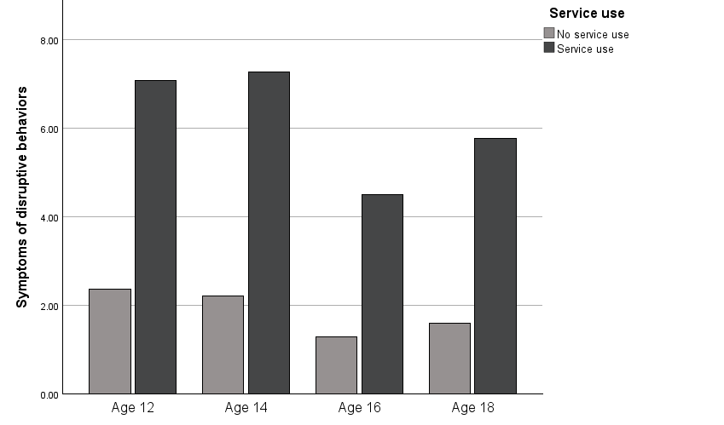
Note. Disruptive behaviors reflected symptoms of oppositional defiant disorder (ODD), conduct disorder (CD), and attention-deficit/hyperactivity disorder (ADHD) at ages 12–16. At age 18, disruptive behaviors reflected symptoms of ADHD only.

Figure S3
Emotional Problems Among Adolescents With and Without Specialty Mental Health Service Use Across Adolescence
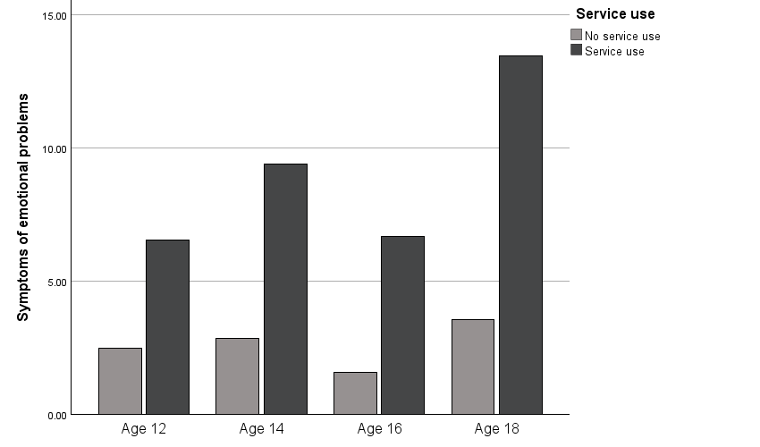
Note. Emotional problems reflected symptoms of major depressive disorder (MDD), dysthymia, generalized anxiety disorder, social anxiety disorder, specific phobia, and separation anxiety disorder at ages 12–16. At age 18, emotional problems reflected symptoms of MDD, dysthymia, generalized anxiety disorder, social anxiety disorder, and specific phobia; separation anxiety disorder was not assessed.

Figure S4
Functional impairment Among Adolescents With and Without Specialty Mental Health Service Use Across Adolescence

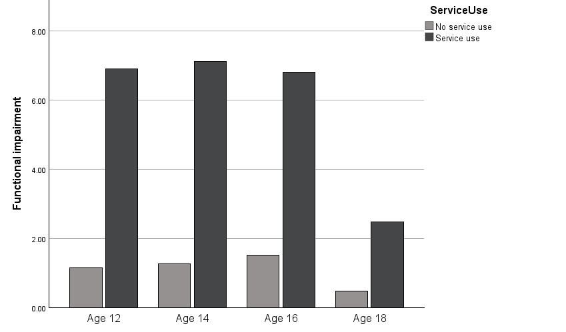
Note. The impairment measure differed across waves. At ages 12–16, impairment reflected symptoms of depressive, anxiety, obsessive–compulsive, eating, ADHD, oppositional defiant, and conduct disorders. At age 18, impairment reflected symptoms of depressive, anxiety, obsessive–compulsive, and ADHD disorders.

References
American Psychiatric Association. (2013). Diagnostic and statistical manual of mental disorders (5th ed.). American Psychiatric Publishing.
Amone-P’Olak, K., Ormel, J., Oldehinkel, A. J., Reijneveld, S. A., Verhulst, F. C., & Burger, H. (2010). Socioeconomic position predicts specialty mental health service use independent of clinical severity: The TRAILS study. Journal of the American Academy of Child & Adolescent Psychiatry, 49(7), 647–655. https://doi.org/10.1016/j.jaac.2010.03.007
Angold, A., & Costello, E. J. (2000). The Child and Adolescent Psychiatric Assessment (CAPA). Journal of the American Academy of Child & Adolescent Psychiatry, 39(1), 39–48. https://doi.org/10.1097/00004583-200001000-00015
Ascher, B. H., F., E. M. Z., & Burns, B. J., A., A. (1996). The child and adolescent services assessment (CASA) description and psychometrics. Journal of Emotional and Behavioral Disorders, 4(1), 12–20.
Austin, P. C. (2011). An introduction to propensity score methods for reducing the effects of confounding in observational studies. Multivariate Behavioral Research, 46(3), 399–424. https://doi.org/10.1080/00273171.2011.568786
Baena, S., Jiménez, L., Lorence, B., & Hidalgo, M. V. (2021). Family functioning in families of adolescents with mental health disorders: The Role of Parenting Alliance. Children, 8(3), 222. https://doi.org/10.3390/children8030222
Brattfjell, M. L., Jozefiak, T., & Wichstrøm, L. (2021). Predictors of community versus specialty mental health service use: A prospective cohort study. European Child & Adolescent Psychiatry, 30, 953–960. https://doi.org/10.1007/s00787-020-01575-8
Breland, D. J., McCarty, C. A., Zhou, C., McCauley, E., Rockhill, C., Katon, W., & Richardson, L. P. (2014). Determinants of mental health service use among depressed adolescents. General Hospital Psychiatry, 36(3), 296–301. http://doi.org/10.1016/j.genhosppsych.2013.12.003
Burnett-Zeigler, I., & Lyons, J. S. (2010). Caregiver factors predicting service utilization among youth participating in a school-based mental health intervention. Journal of Child and Family Studies, 19, 572–578. http://doi.org/10.1007/s10826-009-9331-5
Cheung, A., Dewa, C., Cairney, J., Veldhuizen, S., & Schaffer, A. (2009). Factors Associated with Use of Mental Health Services for Depressed and/or Suicidal Youth Aged 15–24. Community Mental Health Journal, 45(4), 300–306. https://doi.org/10.1007/s10597-009-9205-8
Derogatis, L. R., Lipman, R. S., Rickels, K., Uhlenhuth, E. H., & Covi, L. (1974). The Hopkins Symptom Checklist (HSCL): A self‐report symptom inventory. Behavioral Science, 19(1), 1–15. http://doi.org/10.1002/bs.3830190102
Ezpeleta, L., Granero, R., De La Osa, N., Domenech, J. M., & Guillamón, N. (2002). Perception of need for help and use of mental health services in children and adolescents. Do they share the same predictors? Psicothema, 14(3), 532–539.
First, M. B., Williams, J. B. W., Karg, R. S., & Spitzer, R. L. (2016). Structured clinical interview for DSM-5 disorders: Clinician version (SCID-5-CV). American Psychiatric Association Publishing.
Fisher, J. H., Lichvar, E., Hogue, A., & Dauber, S. (2018). Perceived need for treatment and engagement in mental health services among community-referred racial/ethnic minority adolescents. Administration and Policy in Mental Health and Mental Health Services Research, 45, 751–764. http://doi.org/10.1007/s10488-018-0863-0
Guo, S., Nguyen, H., Weiss, B., Ngo, V. K., & Lau, A. S. (2015). Linkages between mental health need and help-seeking behavior among adolescents: Moderating role of ethnicity and cultural values. Journal of Counseling Psychology, 62(4), 682. https://doi.org/10.1037/cou0000094
Haavet, O. R., Straand, J., Hjortdahl, P., & Saugstad, O. D. (2005). Do negative life experiences predict the health-care-seeking of adolescents? A study of 10th-year students in Oslo, Norway. Journal of Adolescent Health, 37(2), 128–134. https://doi.org/10.1016/j.jadohealth.2004.08.031
International Labour Office. (1990). International Standard Classification of Occupations: ISCO-88. International Labour Office.
Jiménez, L., Hidalgo, V., Baena, S., León, A., & Lorence, B. (2019). Effectiveness of structural–strategic family therapy in the treatment of adolescents with mental health problems and their families. International Journal of Environmental Research and Public Health, 16(7), 1255. https://doi.org/10.3390/ijerph16071255
Kaufman, J., Birmaher, B., Axelson, D., Perepletchikova, F., Brent, D., & Ryan, N. (2016). Schedule for Affective Disorders and Schizophrenia for School-Aged Children: Present and Lifetime Version (K-SADS-PL) DSM-5 November 2016 working draft. Yale University, Child and Adolescent Research and Education.
Kim, I., & Kim, N. (2022). Parental Perceived Need for Counseling for Adolescents’ Anxiety and Depression Symptoms: A Cross-Sectional Study. Counseling Outcome Research and Evaluation, 13(2), 91–100. https://doi.org/10.1080/21501378.2021.1874240
Laitinen-Krispijn, S., Van der Ende, J., Wierdsma, A. I., & Verhulst, F. C. (1999). Predicting adolescent mental health service use in a prospective record-linkage study. Journal of the American Academy of Child & Adolescent Psychiatry, 38(9), 1073–1080. https://doi.org/10.1097/00004583-199909000-00009
Li, X., Zou, H., Liu, Y., & Zhou, Q. (2014). The Relationships of Family Socioeconomic Status, Parent–Adolescent Conflict, and Filial Piety to Adolescents’ Family Functioning in Mainland China. Journal of Child and Family Studies, 23(1), 29–38. https://doi.org/10.1007/s10826-012-9683-0
Mansfield, A. K., Dealy, J. A., & Keitner, G. I. (2013). Family Functioning and Income: Does Low-Income Status Impact Family Functioning? The Family Journal, 21(3), 297–305. https://doi.org/10.1177/1066480713476836
Marston, N., Maybery, D., & Reupert, A. (2018). Parent perceptions comparing times of parental mental wellness and illness using a family functioning model. Journal of Family Studies, 24(3), 235–256. https://doi.org/10.1080/13229400.2016.1176591
McChesney, G. C., Adamson, G., & Shevlin, M. (2015). Service use patterns and mental health symptoms among adolescents exposed to multiple types of trauma. Journal of Adolescence, 40, 1–10. https://doi.org/10.1016/j.adolescence.2015.01.003
Palacio-Vieira, J.-A., Villalonga-Olives, E., Valderas, J. M., Herdman, M., Alonso, J., & Rajmil, L. (2013). Predictors of the use of healthcare services in children and adolescents in Spain. International Journal of Public Health, 58, 207–215. https://doi.org/10.1007/s00038-012-0360-2
Poulin, F., & Chan, A. (2010). Friendship stability and change in childhood and adolescence. Developmental review, 30(3), 257-272. https://doi.org/10.1016/j.dr.2009.01.001
Reijneveld, S. A., Wiegersma, P. A., Ormel, J., Verhulst, F. C., Vollebergh, W. A., & Jansen, D. E. (2014). Adolescents’ use of care for behavioral and emotional problems: Types, trends, and determinants. PLoS One, 9(4), e93526. https://doi.org/10.1371/journal.pone.0093526
Reiß, F., Schlack, R., Otto, C., Meyrose, A.-K., & Ravens-Sieberer, U. (2021). The Role of the Socioeconomic Status in Mental Health Care Utilization by Children and Adolescents in Germany: Results of the BELLA Study. Gesundheitswesen (Bundesverband Der Arzte Des Offentlichen Gesundheitsdienstes (Germany)), 83(11), 919–927. https://doi.org/10.1055/a-1335-4212
Shimizu, Y., Masukawa, K., Aoyama, M., Morita, T., Kizawa, Y., Tsuneto, S., Shima, Y., & Miyashita, M. (2023). The Impact of Stressful Life Events after Bereavement: A Nationwide Cross-sectional Survey. Journal of Pain and Symptom Management, 65(4), 273–284. https://doi.org/10.1016/j.jpainsymman.2022.12.012
Splett, J. W., George, M. W., Zaheer, I., Weist, M. D., Evans, S. W., & Kern, L. (2018). Symptom Profiles and Mental Health Services Received Among Referred Adolescents. School Mental Health, 10(2), 96–110. https://doi.org/10.1007/s12310-017-9244-1
Stanek, K. R., Noser, A. E., Patton, S. R., Clements, M. A., Youngkin, E. M., & Majidi, S. (2020). Stressful life events, parental psychosocial factors, and glycemic management in school‐aged children during the 1 year follow‐up of new‐onset type 1 diabetes. Pediatric Diabetes, 21(4), 673–680. https://doi.org/10.1111/pedi.13012
Vasiliadis, H.-M., Tempier, R., Lesage, A., & Kates, N. (2009). General practice and mental health care: Determinants of outpatient service use. The Canadian Journal of Psychiatry, 54(7), 468–476. https://doi.org/10.1177/070674370905400708
Vu, X.-B. B., Biswas, R. K., Khanam, R., & Rahman, M. (2018). Mental health service use in Australia: The role of family structure and socio-economic status. Children and Youth Services Review, 93, 378–389. http://doi.org/10.1016/j.childyouth.2018.08.001
Wiegand-Grefe, S., Sell, M., Filter, B., & Plass-Christl, A. (2019). Family functioning and psychological health of children with mentally ill parents. International Journal of Environmental Research and Public Health, 16(7), 1278. https://doi.org/10.3390/ijerph16071278
World Health Organization (WHO). (2007). International Classification of Functioning, Disability, and Health: Children & Youth Version: ICF-CY. World Health Organization. https://books.google.com/books?hl=en&lr=&id=SWFQDXyU-rcC&oi=fnd&pg=PP2&dq=International+Classification+of+Functioning,+Disability+and+Health&ots=GaKQlCw_Bw&sig=4inK3hGgWC_pf6_hgC9Tv11zmSo
Wu, P., Hoven, C. W., Cohen, P., Liu, X., Moore, R. E., Tiet, Q., Okezie, N., Wicks, J., & Bird, H. R. (2001). Factors associated with use of mental health services for depression by children and adolescents. Psychiatric Services, 52(2), 189–195. https://doi.org/10.1176/appi.ps.52.2.189
Zwaanswijk, M., Van Der Ende, J. A. N., Verhaak, P. F., Bensing, J. M., & Verhulst, F. C. (2003). Factors associated with adolescent mental health service need and utilization. Journal of the American Academy of Child & Adolescent Psychiatry, 42(6), 692–700. https://doi.org/10.1097/01.CHI.0000046862.56865.B7

