Supplementary materials for
Transcriptome analysis of a thermophilic and hydrogenogenic carboxydotroph Carboxydothermus pertinax

Yuto Fukuyama¹, Kimiho Omae¹, Takashi Yoshida¹, Yoshihiko Sako¹*

¹ Division of Applied Biosciences, Graduate School of Agriculture, Kyoto University, Kyoto 606-8502, Japan

*To whom correspondence should be addressed. Tel: +81-75-753-6217; Fax: +81-75-753-6226; E-mail: sako@kais.kyoto-u.ac.jp

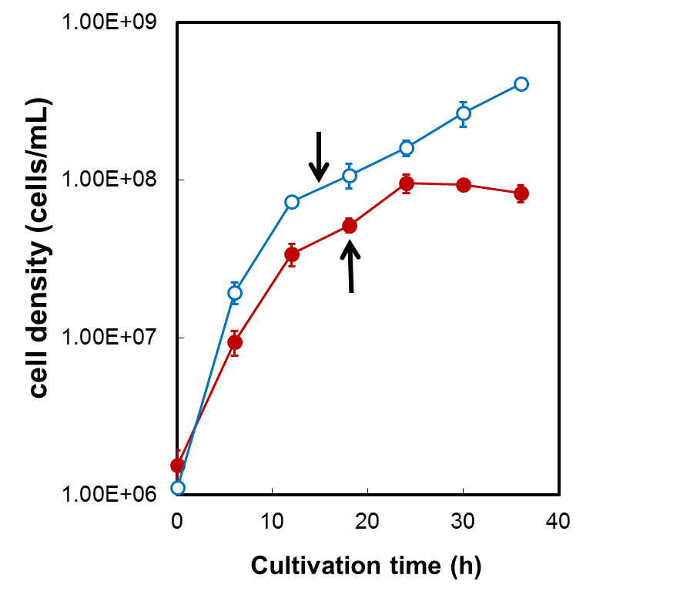
Fig. S1 Growth of C. pertinax under 100% CO and 100%N₂
Red closed circles, cell density under 100% CO; blue open circles, cell density under 100% N₂. Total RNA was extracted from C. pertinax when the cells reached late exponential phase as indicated by arrow. Plots represent the mean of three biological replicates. Error bars represent standard deviations.

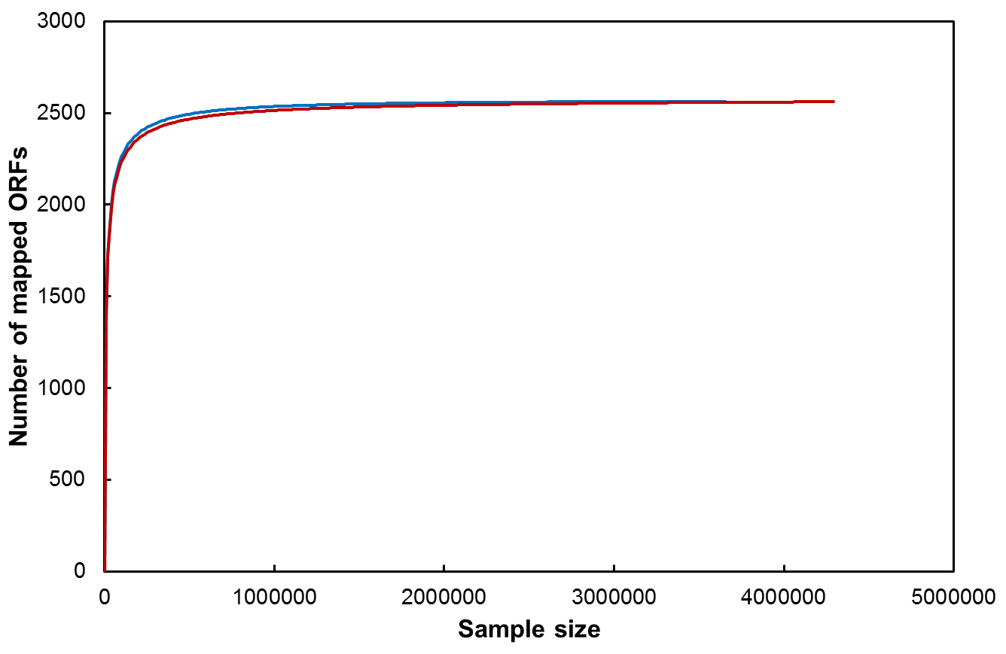

Fig. S2 Rarefaction curves of mapped reads from the cells grown under 100% CO and 100%N₂
Red line, CO100%; blue line, N₂100%.

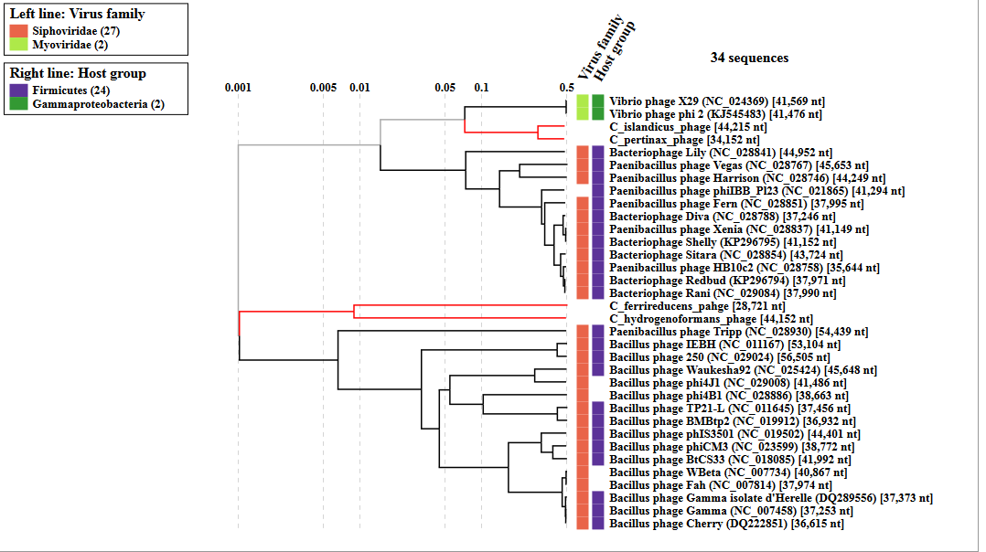

Fig. S3 A part of proteomic tree with 4 phages from 4 Carboxydothermus species
Branch lengths were logarithmically scaled from the root of the entire proteomic tree in VipTree database. Red branch represents phage in 4 Carboxydothermus species.

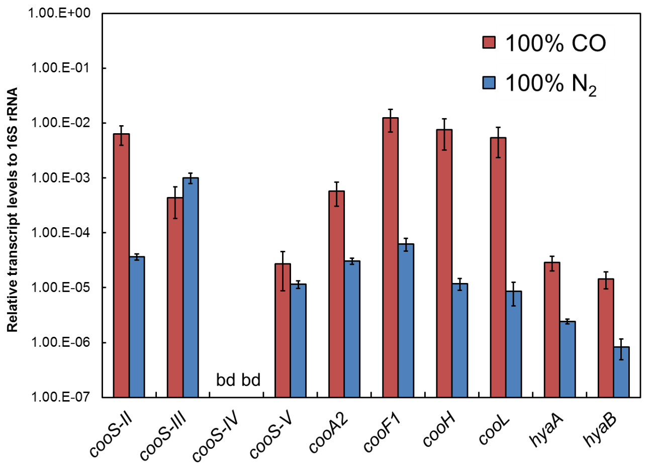
Fig. S4 Transcript levels relative to 16S rRNA using RT-qPCR method under 100% CO and100% N₂
C. pertinax transcript levels relative to the 16S rRNA gene are shown. Red bar, cells grown under 100% CO; blue bar, cells grown under 100% N₂. bd, below the limit of detection. Bars represent the mean of at least three biological replicates. Error bars represent standard deviations.

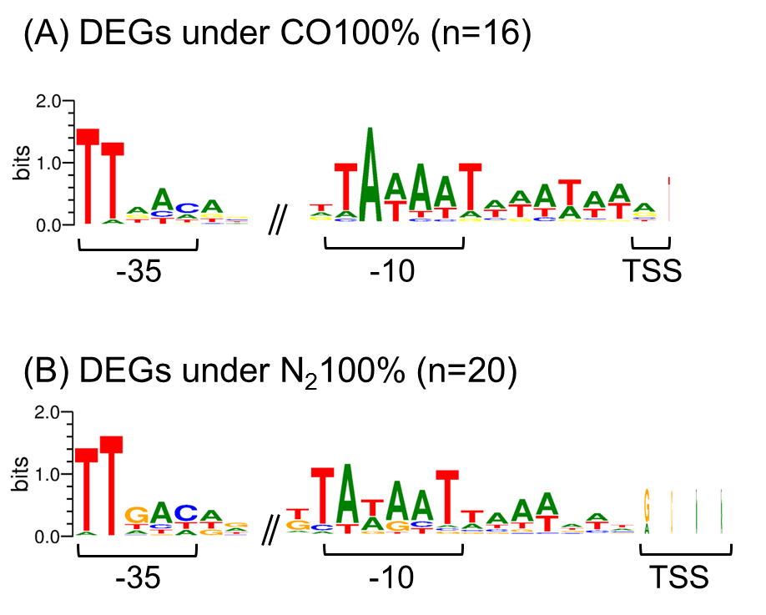

Fig. S5 Consensus sequence for primary sigma factors among upstream regions of the significantlly expressed operons under 100% CO (A) and 100% N₂ (B)
The -35 and -10 motifs were identified from upstream regions of DEGs containing gene cluster and sole DEGs. The height of the letters is proportional to their frequency.

