Supplementary information

Structure/function studies of the NAD⁺-dependent DNA ligase from the poly-extremophile Deinococcus radiodurans reveal importance of the BRCT domain for DNA binding

Supplementary Table S1. Cloning of DrLigA and DrLigAΔBRCT: List of primers.

Name | Sequence 5’ -> 3’
FPDrLigA | CATCACCATCACCATCACGAAAACCTGTATTTCCAGGGAGCAGTGCGTTACCCTGGGCGCATGA
RPDrLigA | GGGGACCACTTTGTACAAGAAAGCTGGGTCTCAGCTTTCAGCGGGGGCCGCC
FDRalle | GGGGACAAGTTTGTACAAAAAAGCAGGCTTCGAAGGAGATAGAACCATGCATCACCATCACCATCAC
RPbrct | GGGGACCACTTTGTACAAGAAAGCTGGGTCTCAGGTGCGGGTCACTTCCTCGG

SupplementaryTable S2. Description of the Thermofluor buffer screening conditions

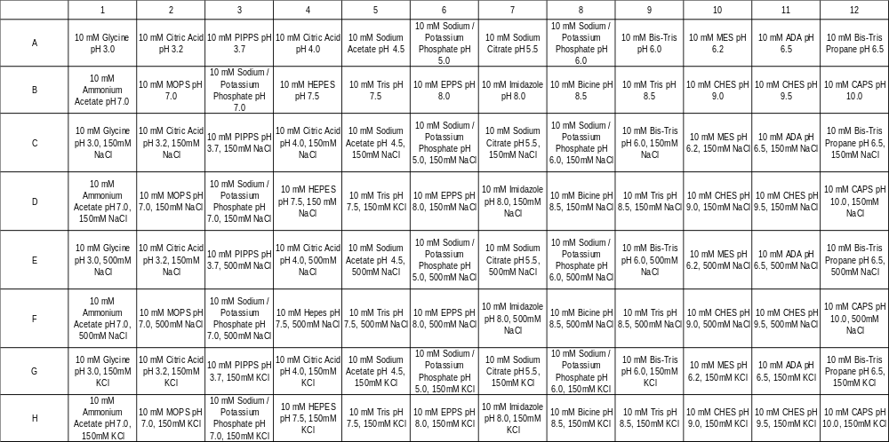
Supplementary Table S3. List of commercial high-throughput protein crystallization screens used
    - Structure Screen 1 & 2 (Molecular Dimensions)
    - JCSG⁺ Screen (Molecular Dimensions)
    - Morpheus (Molecular Dimensions)
    - Macrosool (Molecular Dimensions)
    - Stura FootPrint (Molecular Dimensions)
    - SG1 ShotGun (Molecular Dimensions)
    - PGA (Molecular Dimensions)
    - BCS (Molecular Dimensions)
    - JBScreen Nuc-Pro (Jena Bioscience)

Supplementary Table S4. Results overview for microseed matrix screening: DrLigA versus DrLigA∆BRCT

Crystals | No. hits
Crystals | DrLigA | DrLigA∆BRCT
JCSG+ Screen
Spherulites | 1 | 9
Cluster of needles/sea urchins | 6 | 9
Plates | 0 | 5
‘3D crystals’ | 1 | 0
Structure Screen 1 & 2
Spherulites | 2 | 6
Cluster of needles/sea urchins | 9 | 11
Plates | 0 | 6
‘3D crystals’ | 0 | 1

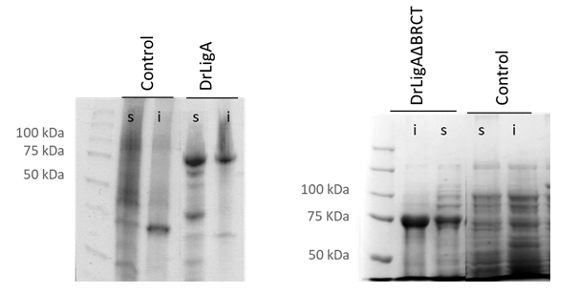 a

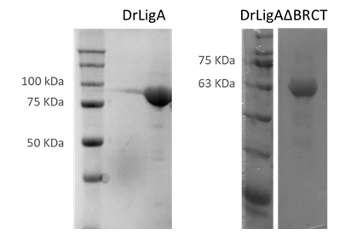 b

Supplementary Figure S1. Protein expression and purification: recombinant DrLigA and DrLigAΔBRCT. a) Protein expression in E. coli BL21* pRARE2, expression induced with 0.5 mM IPTG and performed for 3h at 37 °C. DrLigA and DrLigAΔBRCT overexpression in soluble (s) and insoluble fraction (i). Control - non induced cells. b) Analysis on SDS-PAGE gel of purified DrLigA (75.6 kDa) and DrLigAΔBRCT (65.5 kDa).

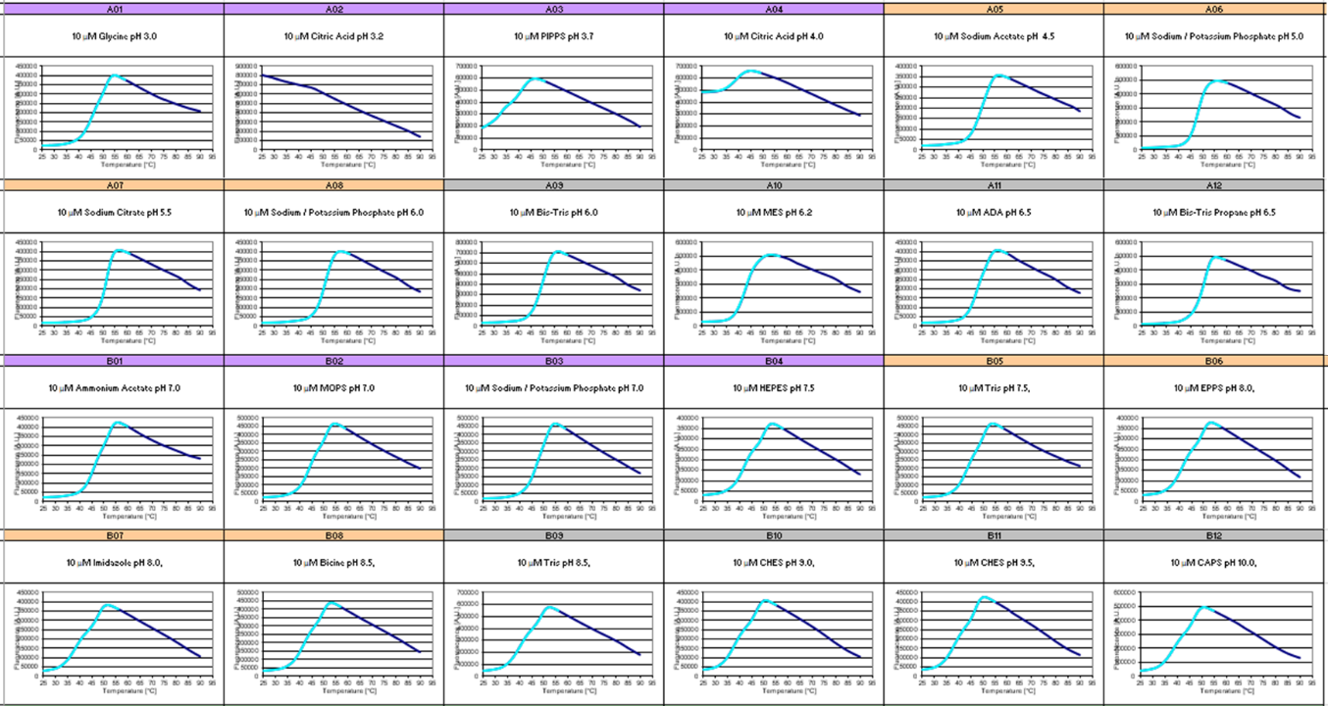
Supplementary Figure S2. Thermofluor buffer screening with DrLigA: results overview (96-well plate): S2 a – curves from well A1 to B12

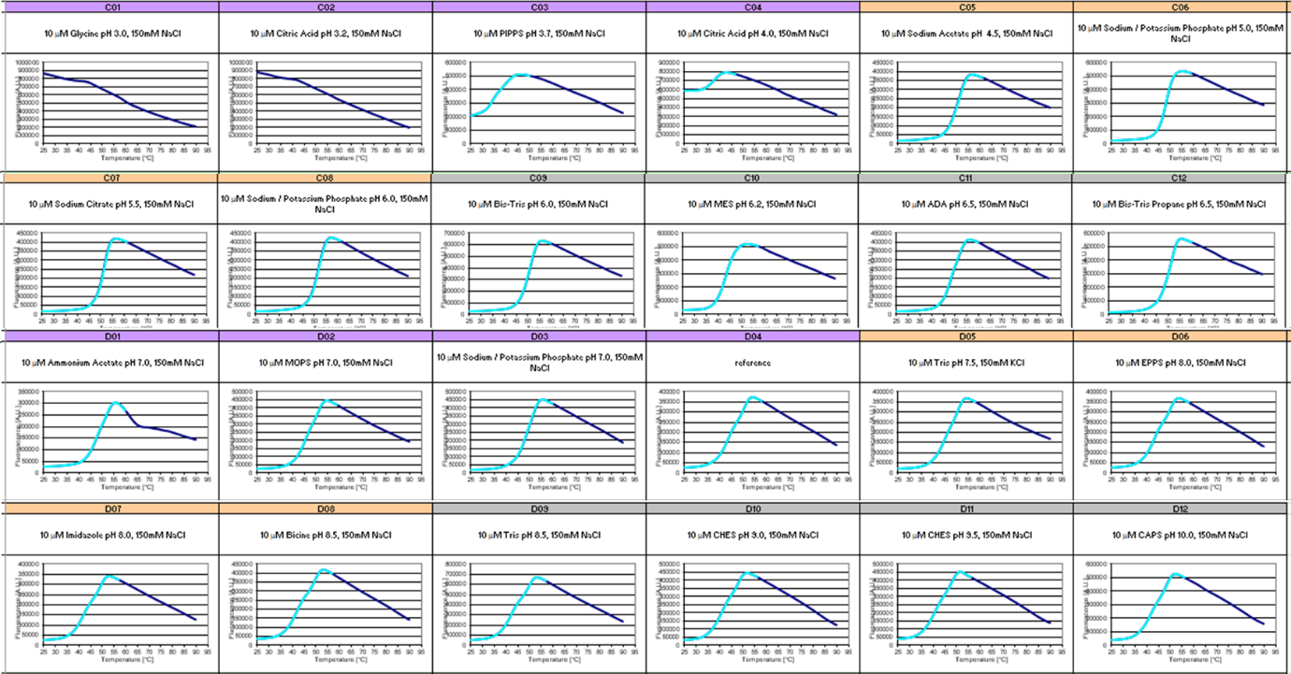

S2 b – curves from well C1 to D12

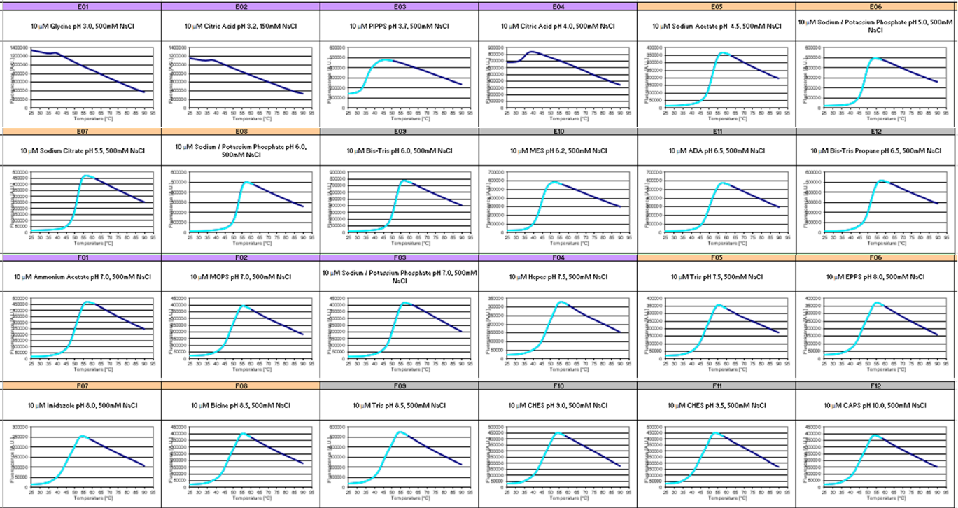

S2 c – Curves from well E1 to F12

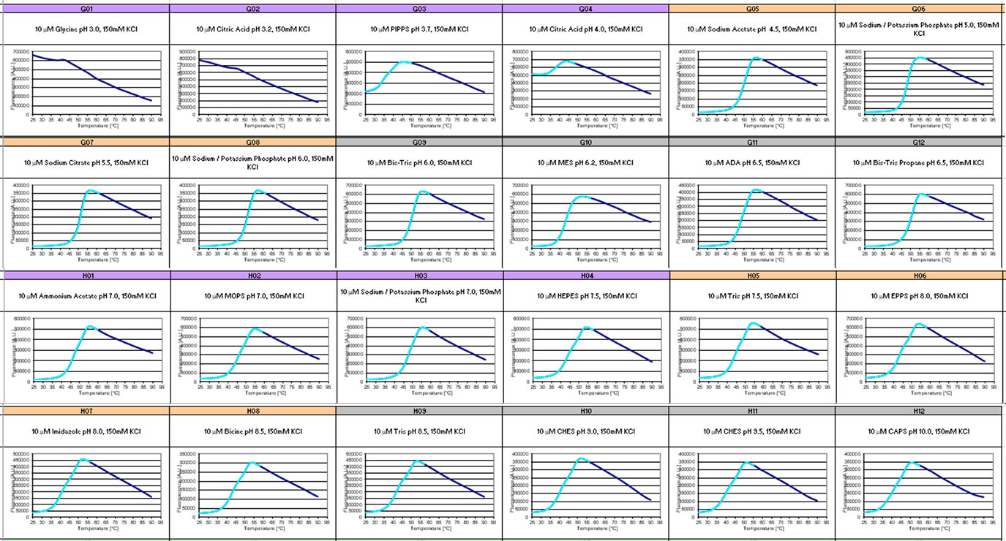

S2 d – curves from well G1 to H12
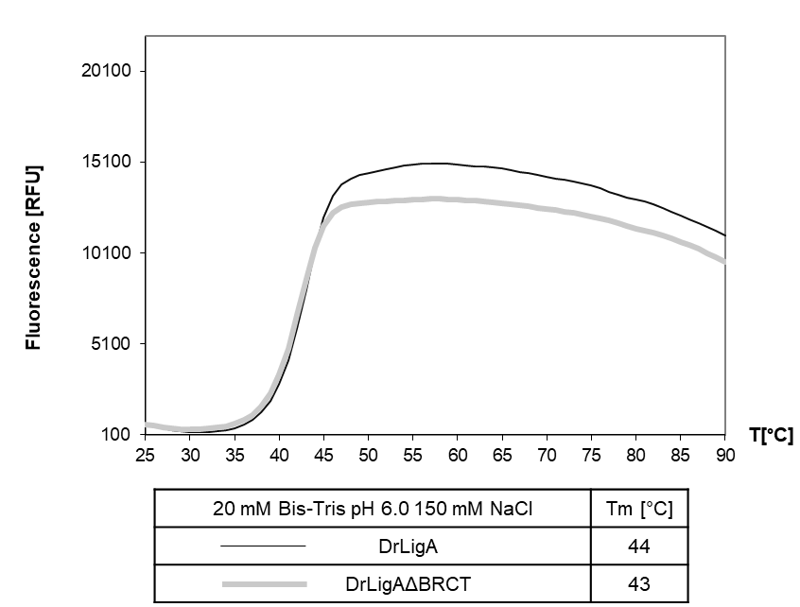
Supplementary Figure S3. Thermofluor results of DrLigA versus DrLigAΔBRCT: non normalized graphs and melting temperatures.

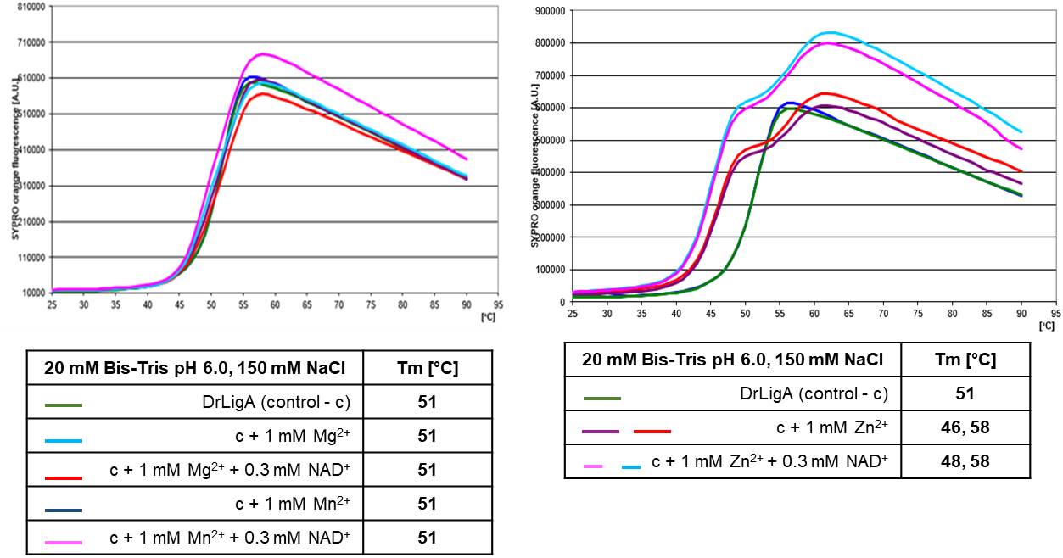
Supplementary Figure S4. Thermofluor results of DrLigA: non normalized graphs and melting temperatures. Assessment of different additives: 300 µM NAD⁺ with 1 mM Mg²⁺, 1 mM Mn²⁺ or 1 mM Zn²⁺.

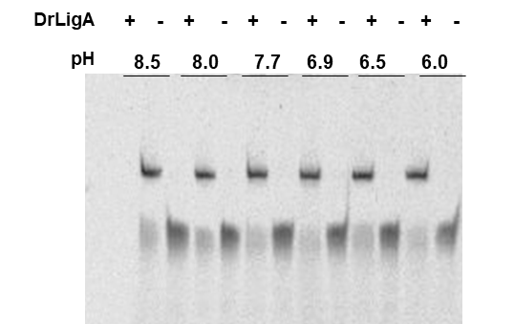

Supplementary Figure S5. Gel-based activity assays: DNA ligation by nick closure at different pH. DNA substrate consisted of L1 (FAM-AGGCCATGGCTGATATCGGA), L2 (Phos-TCCGAATTCGAGCT CCGTCG), and L3 (CGACGGAGCTCGAATTCGGATCCGATATCAGCCATGGCCT). The 20 nt substrate is fluorescein (FAM) labelled and contains a phosphate (Phos) in the 5’-end nick. When ligation occurs, a 40 nt product is formed. Symbol + represents added and - absent.

DrLigA DrLigA∆BRCT

Supplementary Figure S6. Molecular beacon-based activity assay with 330 nM of protein. DNA ligation by nick closure with DrLigA full-length versus truncated DrLigA∆BRCT. The increase in fluorescence was measured as relative fluorescence units (RFU) over time, and the ligation activity is represented as the initial velocity in mRFU per sec (mRFU/sec). Experiments performed at pH 7.0, with 1 mM Mn²⁺ and 5 µM NAD⁺. Error bars represent the standard deviation from the mean of duplicates.

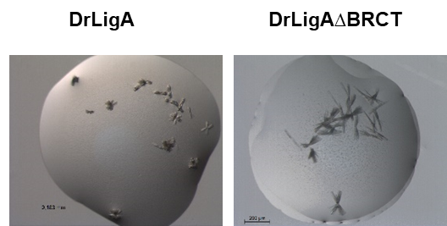
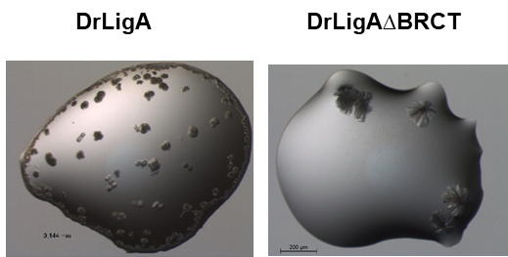

Supplementary Figure S7. Crystallization of DrLigA versus DrLigA∆BRCT. On the left, comparison of needle that were obtained in condition A3 of JCSG⁺ screen HT_96 (Molecular Dimensions). On the right, comparison between crystals of DrLigA and DrLigA∆BRCT in condition A8 of Structure Screen 1 & 2 HT_96 (Molecular Dimensions).
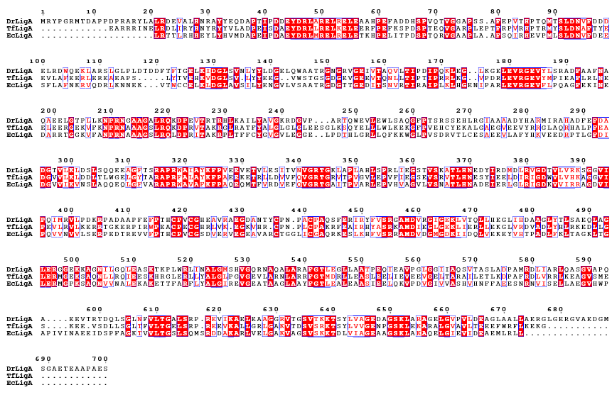

Supplementary Figure S8. Multiple sequence alignment of full-length sequence of DrLigA, ThLigA (T. filiformis), EcLigA (E. coli) performed with ESPript 3.0 (https://espript.ibcp.fr/ESPript/ESPript/). Conserved residues are enclosed in red boxes.

